An investigation into the impact of media on sleep quality, diet quality and self-esteem

BSc Applied Psychology
1502781
Dissertation in Psychology 2018

DECLARATION

This work has not previously been accepted in substance for any degrees and is not being concurrently submitted in candidature for any degrees.

Signed ………………………………………………………………. (candidate)

Date ………………………………………………………………….

STATEMENT 1

This dissertation is being submitted in partial fulfilment of the requirements for the degree of

BSc Applied Psychology

Signed ………………………………………………………………. (candidate)

Date ………………………………………………………………….

STATEMENT 2

This dissertation is the result of my own independent work/investigation, except where otherwise stated.

Other sources are acknowledged by giving explicit references. A reference list is appended.

Signed ………………………………………………………………. (candidate)

Date ………………………………………………………………….

STATEMENT 3

I hereby give consent for my dissertation, if accepted, to be available for photocopying and for inter-library loan, and for the title and summary to be made available to outside organisations.

Signed ………………………………………………………………. (candidate)

Date ………………………………………………………………….
ACKNOWLEDGEMENTS

I would first like to thank my supervisor, Karen Eaton-Thomas whose guidance and patience has helped me to conduct and complete my research to the best of my ability.
Undoubtedly, I would also like to thank my parents and grandparents for their continuous encouragement, advice and support in whatever I do.
Lastly, I would like to thank the 328 participants who made this research possible by taking time out to provide information and to complete the questionnaire.

TABLE OF CONTENTS

Declaration form………………………………………………………………………………i
Acknowledgements………………………………………………………………….………..ii
Table of Contents………………………………………………………………………..……iii
List of Tables………………………………………………………………………....…...….iii
Abstract…………………………………………………………………………….…………iv
- Introduction……………………………………………………………………………...1
1.1 Literature Review……………………………………………………………………6
1.1.1 Media and sleep quality……………………………………………………….....6
1.1.2 Media and diet quality…………………………………………………….……..9
1.1.2 Media and self-esteem…………………………………………………………..11
1.2 Rationale of research………………………………………………………………..13
1.3 Research aim………………………………………………………………………..15
1.4 Hypotheses…………………………………………………………………..……...16
- Methodology……………………………………………………………………………17
2.1 Design………………………………………………………………………………17
2.2 Participants…………………………………………………………………..……..17
2.3 Materials …………………………………………………………………………...18
2.3 Procedure…………………………………………………………………………...20
3. Results……………………………………...……………………………………..……21
3.1 Media and sleep quality…………………...…………………………………..…...21
3.2 Media and diet quality……………...………………………………………..….....23
3.3 Media and self-esteem………...………………………………………………..….25
4. Discussion…………………………………………………………………………..……26
4.1 Implications…………………………………………………...………………..….27
4.2 Limitations………..…………………………………………………………..…...30
4.3 Future research……….………….…………………………………………..…….33
4.4 Conclusion………..………………………………………………………..…..….34
References………………………………………………………..………………...……….35
Appendix……………………………………………………………..……………..………44

LIST OF TABLES

Table 1: Means and standard deviation of amount and type of media on sleep quality……………….………21
Table 2: Means and standard deviation of amount and type of media on diet quality…………………..…….23
Table 3: Means and standard deviation of amount and type of media on self-esteem levels…………...……..25

ABSTRACT

This study aimed to lessen the gap in the literature by demonstrating that an individuals sleep quality, diet quality and self-esteem is impacted by the type of media they engage with, and by the amount of time they spend engaging with it. The majority of previous research has concentrated on children and adolescents even though adults engage with some of the same media and in similar amounts. Thus, an online questionnaire via QuickSurveys.com was implemented to explore television (TV), social media, and YouTube usage. 328 British adult participants (94 male and 234 female) completed the questionnaire that was compromised of the UK children go online questionnaire (2004), the Pittsburgh sleep quality index (1989), the ‘How healthy is your diet questionnaire’ (2012), and the Rosenburg self-esteem scale (1965). The results revealed that not one of the media types had more of a significant impact than another, though those highly engaged in the media in general were more likely to experience poorer sleep quality, diet quality, and self-esteem. Guidance for future research is mentioned with an emphasis on the need for an improved questionnaire to allow for a more in-depth exploration.

INTRODUCTION

In recent years the world has experienced an evolution of progress in technology, and therefore a major development in media technologies that provide us with various information, numerous kinds of entertainment, and an easy or almost effortless way of communicating. Today’s typical media consumption including music, video blogging, TV, social-media, radio and gamming is instantly accessible through various devices of mobile phones, tablets, laptops and TVs (Brewer, 2011; Ferguson, 2015).
The increases of media consumption is believed to be due to the reduction of electronic prices and the development of technology such as the smart phone that allows instant media access (Zimmerman, 2008; Rideout & Hamel, 2006). Smart phones provide operating systems extremely similar to computers though they are far more convenient due to their smaller size. This has unsurprisingly led to a recent major breakthrough in smartphone and tablet ownership across all age groups (Statistacom, 2017).
The immediate accessibility of the media is what has allowed it to play such a significant central role in our lives, where most are almost oblivious to its vast presence and its influence on our decision-making, attitudes and beliefs (Fischoff, 2005). Recently, many have been curious to explore if it really is powerful enough to influence human lives and behaviour, and if so, to what extent (Giles, 2010).
Children and adolescences have consistently been a primary focus for media research, partly because of their development vulnerability and their heavy use of entertainment technology (Vandewater & Denis, 2011). However, it has now been found that social media use has significantly risen in adults, especially among young adults who now closely use social media as much as teenagers (Perrin, 2015). This finding seems fitting seeing as young adults are the first generation to grow up with social media (Levenson, Shensa, Sidani, Colditz & Primack, 2016). Importantly, older adults aged 65 years and older spend longer hours watching TV than 16-to-24-year olds, and 25 to 44-year olds are the heaviest users of the video sharing site YouTube (Statistacom, 2016).
To the researchers knowledge, there is a minimal amount of research that has studied the impact of the video-sharing site YouTube, and none has considered its impact on sleep quality, diet quality or self-esteem, even though the sites popularity has significantly increased in recent years (Ahern, Sauer & Thacker, 2015). Its popularity is believed to be due to improvements in technology, particularly the smartphone which has allowed for viewing on the go (Statistacom, 2018). Introduced in 2005, the biggest and greatest online video-sharing site YouTube allows users to upload and share videos for entertainment and advertising purposes including music, TV clips, video blogs, gaming videos, language lessons, educational content, and instructional videos (Youtubecom, 2018; Statistacom, 2018). Research from 2010 found that people typically spend 4 minutes more on YouTube than they do on Facebook, and more recent statistics have shown that people now spend an average of 40 minutes on YouTube per mobile session (Tiggemann & Miller, 2010; Statistacom, 2016).
Over the years, several theoretical explanations have attempted to explain why and how we use media. Different patterns of media exposure can be explained through the uses and gratification perspective which focuses on how people manage to fulfil their needs and wants through media communication. It would seem that an individual chooses which media they want to engage with by their personal interests (Baran & Davis, 1995), however the type of media and amount of usage is not just determined by needs and motives, but by a group of many components (Rubin, 1994, p. 419). These include an individual’s psychological and social environment, the various types of media accessible to them, other possible alternatives of communication available, and lastly, the behaviour of communication and its consequences (Rubin, 1994, p. 419).
Social media is a popular type of platform as it fulfils many components in one location. For some it can manage mood because of entertainment and information seeking, helps in the up-keeping of social relationships, is a distraction from concerns that some may have in ‘real life’, and allows for close observation of others (Ray, 2006; Matsuba, 2006). Admittedly, social media can be beneficial for communicating, socializing, enhancing learning and health information (O'Keeffe & Clarke-Pearson, 2011).
According to Harris (2004), some people may heavily engage in TV and certain TV programs because they believe to have built up some sort of ‘friendship’ with particular television personalities. This perspective could now also be applied to YouTube usage seeing as its users tend to subscribe to their favourite video makers to view and keep up to date with their new video releases (Lange, 2014). Therefore, some may believe that they have built up a friendship with their favorite video makers.
Instead of focusing on media selection through personal interests and desires, the Self-Determination Theory explains the motivation behind media selection. The difficulty of ‘normal’ life can allow some to turn to the media to allow them to feel part of something important by fulfilling their desire of accomplishment, freedom and social needs (Przybylski, Rigby & Ryan, 2010; Ferguson, 2015). Following on from the fundaments of the Self-Determination theory, the Fear of Missing Out (FOMO) demonstrates that with the continuous connection available to others through social media, its presence has intensified the need to know what others are saying and doing (Alt, 2015). It is believed that excessive media usage occurs because some consumers believe that missing out on something like particular events will result in diminishing of social opportunities and general happiness (Przybylski, Murayama, DeHaan & Gladwell, 2013; Alt, 2005). Though many theories have attempted to explain why and how we use the media, research based on these theories is required to determine if the media is causing significant negative impact in various elements that fulfil quality of life including sleep, diet, and self-esteem.
Multiple lifestyle and psychological factors are believed to contribute to the various sleep issues found in adults (Kim, Uchiyama, Okawa, Liu & Ogihara, 2000). With the rapid growth of electronic technologies and concerns of the decrease in sleep and its quality, a substantial amount of research has been devoted to investigate what role the media plays in the development of sleep issues (Levenson et al, 2016).
A 2011 poll found that 95% of its 16 to 64-year-old respondents use some sort of electronic media at night within one hour before they plan to sleep (Gradisar et al, 2013). The increase in internet use and television viewing is believed to have influenced poor sleeping patterns, and therefore resulting in chronic deprivation across the population (Bonnet & Arand, 1995). Even though it is advised that adults aim for around seven to nine hours of sleep per night (Hirshkowitz et al, 2015), according to the Cooper et al (2015), less than 40% of British adults actually achieve the recommendation. It is estimated that around one quarter to one third of adult’s experience disturbed sleep through insomnia, inadequate or disrupted sleep (Hirshkowitz et al, 2015; Kripke et al, 2002; Strine & Chapman, 2005).
The majority of past research has found the mass media to have an association with delayed bedtime and a reduction in sleep time among children (Tazawa & Okada, 2001; Nuutinen, Ray & Roos, 2013) adolescence (Van den Bulck, 2004; Gaina et al, 2006; Cain & Gradisar, 2010) and on adults (Long Xu et al, 2015; Levenson et al, 2016). Importantly, research has also found links between sleep, metabolism and weight control (Strasburger, 2011). The effects of shortened sleep duration could allow for a preference of fattening foods and snacking, and sleep disturbances may lead to fatigue, and therefore resulting in a need to increase calorie intake to function adequately (Nishiura et al, 2010; Strasburger, 2011).
In an attempt to identify the root cause of the increases in disordered eating, unhealthy food consumption and various eating disorders, attention has been directed to the way in which the media influences its consumers eating habits (Jordan, Kramer-Golinkoff & Strasburger, 2008).
For over two decades Britain has seen a growing trend in obesity with 2015 seeing 58% of women and 68% of men classified as either overweight or obese (Kaur, Choi, Mayo & Harris, 2003). The world-wide obesity epidemic is linked to reductions in physical activity and excessive amounts of foods with high amounts of fat and sugar, but there is currently no concise explanation as to why people are exercising less and eating more (Kraak, Gootman & McGinnis, 2006).
High durations of TV-viewing is believed to influence eating habits partly through food advertisements of snacks, soft drinks and fast-food (Meyer et al, 2008; Miller, Taveras, Rifas- Shiman & Gillman, 2008; Andreyeva, Kelly & Harris, 2011). Other research has also linked heavy interactive media use such as social media and videos to obesity (Schneider, Dunton & Cooper, 2007). Meanwhile, more recent research argues that social media creates awareness and promotes healthy eating, but sometimes to the unfortunate extremes of driving ideas of unrealistic thinness as the ideal body (Eldridge & Ensle, 2014; Jordan et al, 2008). This tends to result in poor body image which is not only associated with eating disorders, but also low levels of self-esteem (Stice & Bearman, 2001; McCabe & Ricciardelli, 2003). This is particularly prevalent in those highly exposed to movies, soap operas, and music videos (Tiggemann & Pickering, 1996).
The growing trends in eating disorders including obesity are one of the many tell-tale signs of a societal decrease in self-esteem levels (George, 2010). Self-esteem is described as someone’s general self-evaluation of their own worth, with a life-long need to maintain or raise it (Weiten, 2004). To do this, many seek for esteem enhancement through both online and offline media (Weiten, 2004; Krämer & Winter, 2008).
The design of social-network sites is for individuals to share information about themselves to others. This includes their likes/ dislikes and hobbies which are shared mostly by ‘wall posts’ and ‘status updates’-which tend to include photographs (Gonzales & Hancock, 2011). Personal information shared by individuals on social media can sometimes allow their viewers to become aware of their own flaws and shortcomings, therefore lowering their self-esteem (Heine et al, 2008).
A variety of research has found that there is a relationship between poor sleep quality and low levels of self-esteem (Fredriksen, Rhodes, Reddy & Way, 2004; Conti, Adams & Kisler, 2014), and a relationship between diet quality and self-esteem (Williams, Wake, Hesketh, Maher & Waters, 2005; Strauss, 2000).

1.1 Literature review
With so many forms of media and media content available, it has come to no surprise how much time individuals devote to it. There is a significant gap in the literature for media and adult research. Even though a considerable amount of research has looked at media impact, the majority has focused on children and adolescents.
1.1.1 Media and sleep quality
Previous sleep research has discovered the importance of good sleep on cognition, immune functioning, and the cardiovascular system. During sleep the brain strengthens and aids psychiatric health, and bodily growth and repair (Banks & Dinges, 2007; Grandner, Patel, Gehrman, Perlis & Pack, 2010; Van Cauter, Spiegel, Tasali & Leproult, 2008; Davis, Parker & Montgomery, 2004; Bates, Viken, Alexander, Beyers & Stockton, 2002). There are still concerns over the possible negative impact that certain media has on sleep quality. Many want to know why adults on average are spending 8.63 hours in bed each night but only sleep for 6.93 hours (Leng et al, 2013). Therefore, ongoing research continues to investigate the relationship between sleep quality and television, and social media usage.
Even though ‘traditional’ television is still popular across all age groups, availability of faster home internet speeds, smart TVs, smartphones and tablets have led to a transition to an ‘on-demand era’ allowing consumer’s access to television shows and movies whenever they want, and for as long they want (Ofcomorguk, 2017; Tryon, 2015). Many adults have admitted to feeling tempted to watch more TV because of the catch-up technology available to them, but it has consequently cost them sleep and left them feeling tired (Ofcomorguk, 2017). The potential of extending television viewing well into the night and ‘time-shifting’ is easily achievable when electronic media is available in the bedroom (Tryon, 2015). The issue with ‘time-shifting’ with TV, internet and social media use is that there is no defined beginning or end, bringing about overuse and sleep time displacements because of an unstructured time profile (Tryon, 2015; Zimmerman, 2008). Because social media and video sharing sites are typically used on hand-held smartphones and tablets, bedtime can easily be delayed because of the need to check out one more thing (Hiscott, 2015).
Various research has found that the more time children spend watching TV the more likely they are to have a decrease in sleep duration, delay in bedtime and an impact on awakening patterns (Oka, Suzuki & Inoue, 2008; Garmy, Nyberg & Jakobsson, 2012; Nuutinen et al, 2013). Electronic media in the bedroom has been linked to increase usage, later bedtime, sleep issues and shorter sleep duration (Shochat, Flint‐Bretler & Tzischinsky, 2010)
Surprisingly, Van den Bulck (2004) and Adam, Snell & Pendry (2007) found that reductions in sleep duration and bed times were associated with how much time children spend watching TV throughout the day, and not just at night.
However, recently Arora et al (2014) compared sleep quality with different types of media and discovered that difficulty falling asleep is more significantly associated with social media use and music listeners through smartphones and tablets rather than TV. This is likely to be due to a closer bright light that the screen emits which slows down melatonin production (Hiscott, 2015). Similarly Zimmerman, (2008) stated that it is very likely that different media formats will have different effects on sleep quality. Levenson et al (2016) also found that high quantities of social media use over long periods of time are associated with higher levels of sleep disturbance, which is likely to be due to the stimulating and rewarding feeling gained from social media. Research has revealed that children who have a TV in their bedroom sleep 18 minutes less per night than those without a TV, and those with gadgets such as a smartphone sleep 20.6 minutes less per night than those without (Hiscott, 2015).
However, those who experience some sort of pre-existing sleep issue may actually spend more time watching television or using social media because they are unable to sleep, by almost using them as a sleeping aid (Eggermont & Van den Bulck, 2006). This may be to pass the time while awake or as a distraction from the distress of not being able to sleep (Johnson, Cohen, Kasen, First & Brook, 2004; Levenson et al, 2016). Eggermont and Van den Bulck’s (2006) research found that for those who often use media as a sleeping aid, there is no verification that it is actually helping them sleep. Those participants engaged with more media and slept for less time, and as a result were significantly more tired during the day (Eggermont & Van den Bulck, 2006).
Gradisar et al (2013), Owens et al (1999) and Johnson et al (2004) have demonstrated the importance of researching the relationship between media and sleep habits in adults. Around two-thirds of young adults have reported not having enough sleep to manage daily functions and tasks (Gradisar et al, 2013), Owen et al (1999) revealed that parent TV viewing habits can shape both their children’s TV viewing and sleep habits, and lastly, Johnsen et al (2004) found that excessive television viewing does not just begin in childhood and end during adolescence, but the trend continues into early adulthood which is what later contributes to the development of sleep issues.

1.1.2 Media and diet quality
Life-style related behaviours are associated with eating habits and although complex, it is highly likely that the media influences and promotes disordered eating by encouraging unhealthy food consumption, and at the same time almost normalizing ideas of unrealistic thinness (Jordan et al, 2008).
Adulthood obesity is known to go hand in hand with a variety of chronic diseases (Giammattei, Blix, Marshak, Wollitzer & Pettitt, 2003). The medias contribution may be due to the promotion of eating whilst viewing and encouraging the consumption of low-quality foods in high-quantities, possibly tempting through junk and fast food advertisements (Zimmerman & Bell, 2010). In the past advertisements for food were typically through TV but advertisers now also focus on newer media where now nearly all fast food companies have Facebook, Twitter and YouTube accounts (Anasuri, 2016). Research carried out by Harris, Bargh & Brownell (2009) found that children eat 45% more when they are exposed to food advertising, but adults tend to go for both healthy and unhealthy snacks. Also, food advertising increased food consumption even though participants were not hungry.
Screen media can distract eating therefore contributing to an increase in calorie intake, also excessive screen time can displace physical activity (American Academy of Pediatrics, 2011; Rich, Bickham & Shrier, 2015). According to Jordan et al (2008), unhealthy eating is due to an individual’s choice of media content and the amount of time spent engaging.
Seventy-nine percent of adults use some sort of catch-up technology or subscription service where they are able to watch several episodes in one sitting typically through television, but also available through smartphones and tablets. Most feel that binge viewing can be relaxing and enjoyable (Ofcomorguk, 2017).
Longitudinal research Kaur et al (2003) found that adolescents who watch more than two hours of TV each day are twice as likely to be overweight compared to those who watch less than two hours a day. Also, BMI percentage increased by .9 with every additional hour of TV viewing between participants (Kaur et al, 2003). Similarly, Davison, Marshall & Birch (2006) found that children who watched more than two hours of TV per day at ages seven, nine and eleven were 13.2 times more likely to be overweight than those who never exceeded two hours. A randomized trial intervention for reducing TV viewing and computer use revealed that lower viewing times were associated with lower calorie intake and obesity levels (Epstein et al, 2008). Although computers and laptops can be used for various reasons, they are typically used for social networking and for viewing online videos (Strasburger et al, 2013).
Knowledge of the relationship between diet and social media is scarce even though researchers are aware of its popularity. Seeing as the main purpose of social media is for social interaction by connecting with friends, it is important to include research that has found a relationship between friends and peers on eating habits (Whiting & Williams, 2013; Paxton, Schutz, Wertheim & Muir, 1999).
Longitudinal research has revealed that obesity and eating disorders are spread through social ties (Christakis & Fowler, 2007). Recent findings from Fletcher, Bonell & Sorhaindo (2011) showed that friendships are what shape young people’s eating habits and bodyweight. Tiggemann & Miller (2010) looked at body image and media exposure in adolescent girls by comparing popular internet sites such as social media with television viewing and found that social media is more likely to bring about body dissatisfaction and consequently disordered eating. Social media of today provides us with information on what restaurant our friends have checked in to, and what healthy or unhealthy food they are consuming through uploaded photos of their dishes, usually to gain positive social feedback (Abbar, Mejova & Weber, 2015). Unfortunately, social feedback continues to support unhealthy restaurants and social approval through social media often urges unhealthy food choices (Mejova, Haddadi, Noulas & Weber, 2015).

1.1.3 Media and self-esteem
Good self-esteem is important for various reasons including positive peer relationships, and a significant component for behavioural and emotional outcomes (Martins & Harrison, 2012). The likelihood of the current societal decrease in self-esteem is due to inundated information from the mass media (George, 2010). Due of the various ways of communication available, it is likely that individuals attempt to sustain their essential need of good self-esteem by engaging with others through online and offline societies (Krämer & Winter, 2008).
Kraut et al (1998) and McKenna & Bargh (2000) found that Internet users who generally use it for communication purposes have lower well-being and self-esteem levels. Similarly, Mehdizadeh (2010) and Pettijohn, LaPiene & Horting (2012) also found a negative association with the intensity and number of times that Facebook was checked daily and self-esteem. It was stated that this is likely to be due to some valuing their self-esteem by the amount of friends they have, and therefore attempt to maintain their self-esteem in this way by holding more friends online (Pettijohn et al, 2012). Kalpidou, Costin, & Morris (2011) found a negative relation between the amount of time spent on Facebook and self-esteem. Individuals with low self-esteem are found to spend more time on instant messaging, mobile phones and other computer-based communication (Ehrenberg, Juckes, White & Walsh, 2008; Bianchi & Phillips, 2005; Joinson, 2004).
However, according to Krämer & Winter (2008), individuals who experience low self-esteem tend to use online media in an attempt to raise their self-esteem, so evidently greater online activity can be associated with lower self-esteem. Likewise, Sheldon (2008) stated that it is not that social media generates low self-esteem, but in fact those with low self-esteem tend to spend more time on social media because they are longing to connect with their friends online. This is the opposite need to those who enjoy being the centre of attention offline. Importantly, findings of Valkenburg, Peter & Schouten (2006) revealed that positive feedback on an individual’s social media page increased their self-esteem whereas negative feedback decreased self-esteem. In line with these findings, Women have disclosed browsing at other female Facebook profiles to carry out comparisons (Haferkamp, Eimler, Papadakis & Kruck, 2012).
Research has supported the notion that television viewing can also negatively impact self-esteem (Bassenoff, 2006). Excessive TV viewing ultimately leads to a reduction in peer interaction and other activities such as sports and hobbies that are known to boost self-esteem (Martins & Harrison, 2012).
Seeing as self-esteem is deemed as multidimensional construct, supposedly the media can influence other elements such as body dissatisfaction (Martins & Harrison, 2012). According to Derenne & Beresin (2006), it is not the amount of media but indeed the type of media that is associated with negative body image. However more recent research has found that body dissatisfaction is not influenced by TV exposure, and more time spent watching TV does not increase an individual’s changes of having low self-esteem (Ferguson, Munoz, Contreras & Velasquez, 2011; George, 2010). Similarly Tiggemann and Pickering (1996) found that negative body image is not associated with TV viewing, though it is in individuals who are heavily exposed to music videos. Even though YouTube was non-existent during Tiggemann and Pickering’s research, the findings are important and could be relevant to this research seeing as the most popular video on YouTube in February 2018 was a music video, and the most viewed YouTube channel was of a music label (Statistacom, 2018). This clearly demonstrates the need for YouTube research in order to analyse its possible impact on its consumers.
Another important finding to consider for this to this research is of of Syed-Abdul et al (2013) who found thousands of YouTube videos aimed at individuals with body dissatisfaction to promote anorexia as a lifestyle choice. With that being so, it could be quite likely that those with low self-esteem may use YouTube as almost a coping mechanism.

1.2 Rationale of research
While thousands of previous studies have looked at the impact of various media on sleep, diet and self-esteem, the majority has focused on children and adolescents. This is in-despite of older adults being the heaviest users of TV, 25-to 44-year old’s being the heaviest users of YouTube, and young adults being the first generation to grow up with social media and closely using it as often as adolescents (Perrin, 2015; Levenson et al, 2016; Statistacom, 2016). The reason for the unequal research in child versus adult research is likely due to developmental vulnerability (Vandewater & Denis, 2011), but research has highlighted the importance of adult research seeing as child TV viewing habits are influenced by their parent’s habits, and child viewing habits do not alter so the trend continues throughout life stages (Owen et al, 1999; Johnsen et al, 2004).
There is also a significant gap in the literature for research on the increasingly popular video-sharing site YouTube and specifically its impact on sleep, diet and self-esteem. With countless amount of research on television and social media impact, research on YouTube is sorely needed seeing as more time is spent on it than the popular social media platform Facebook (Tiggemann & Miller, 2010).
A worldwide survey revealed that good sleep is a vital associate for good health (Steptoe et al, 2006). One quarter to one third of adults experience some sort of disturbed sleep whether that be insomnia, inadequate amounts or disrupted sleep (Hirshkowitz et al, 2015; Kripke et al, 2002; Strine & Chapman, 2005). With sleep issues on the rise, figures released showed that in 2010/2011, NHS England spent £49.2 million on 15.2 million sleep medication prescriptions (Adams, 2012). For this reason alone, there is a need to investigate the factors that are fuelling the growing sleep crisis in order to understand how the problem should be managed seeing as poor sleep seriously affects health and diet (Nishiura et al, 2010).
Obesity is associated with major health issues which have a wide-reaching negative consequence on the affected individual’s health, NHS and economy, thus highlighting the necessity to discover its contributors (Sainsbury et al, 2018). It is well-known that overweight and obesity is due to physical inactivity and excessive unhealthy food consumption, but there is little distributed that has specifically compared different types of media (especially YouTube) and their impact on diet quality (Kraak et al, 2006). Importantly, obesity is a major risk factor that is associated with various psychological issues including low self-esteem (Jordan et al, 2008). Because social media and video-sharing are relatively new platforms, little is known about the possible impacts on the typically coupled undereating and body dissatisfaction. Although the opposite to over eating, under eating is also considered very unhealthy. This research hopes to reduce gaps in the literature by finding a direct association with eating habits and media usage.
Seeing as many previous research has found associations with poor sleep and low self-esteem, and poor diet and self-esteem, there is also an essential need to establish the medias influence on self-esteem (Fredriksen et al, 2004; Conti et al, 2014; Williams et al, 2005; Strauss, 2000). Although there has been plenty of research that considers social media and TV usage, little has looked at YouTube. According to the NHS, those with low self-esteem can benefit from talking therapies such counselling or cognitive behavioural therapy (CBT), however it is expensive, costing the NHS around £40 per session (nhs.uk, 2018). Therefore, the purpose of this investigation is to take the first steps in identifying and highlighting the relationships between media type and usage on sleep, diet and self-esteem to see how they are related, and to eventually aid in reducing the strain that they each have mainly on the NHS but the economy in general.

1.3 Research aim
For various reasons therefore, the aim of this research is to determine if an individual’s sleep quality, diet quality and self-esteem is impacted by the type of media (television, social media and YouTube), and by the amount of time spent engaging in the media.

1.4 Hypotheses
Through summary of the literature review, six hypotheses have been formulated. It is hypothesized that:
- Participants categorised as high media users (as measured on the UK children go online questionnaire (2004) scale) will have a significantly lower quality of sleep score on the Pittsburgh sleep quality index questionnaire (1989) than those participants categorised as low or average media users.
- Participants preferred choice of media (television, video sharing or social media) will significantly impact their score on the Pittsburgh sleep quality index questionnaire (1989).
- Participants categorised as high media users (as measured on the UK children go online questionnaire (2004) scale) will have a significantly lower diet quality score on the ‘How healthy is your diet questionnaire’ by the British heart foundation (2012), than those participants categorised as low or average media users.
- Participants preferred choice of media (television, video sharing or social media) will significantly impact their score on the diet quality questionnaire.
- Participants categorised as high media users (as measured on the UK children go online questionnaire (2004) scale) will have a significantly different score on the Rosenburg self-esteem scale (1965) than those categorised as low or average media users.
- Participants who prefer to use social media as their main media platform will have significantly lower self-esteem than those who prefer to use television or video sharing media.

- METHODOLOGY

  - Design

The current investigation employed a series of between subjects ANOVA’s. The purpose of this was to explore if the amount of time spent engaging in the media and the type of media usage (3 types) had an impact on an individual’s quality of sleep, quality of diet and levels of self-esteem. Independent variable 1 was the amount of time spent engaging in the media. This was measured in hours which then assigned participants into one of three levels for amount of time into either a low, medium or high category. Independent variable 2 was the type of media source that participants self-reported engaging with the most. Their choices were of either TV, YouTube or social media (specifically Facebook, Instagram and Snapchat). The independent variables were expected to affect the three dependent variables. The three dependent variables were quality of sleep, quality of diet and levels of self-esteem. This quantitative research was analysed through the statistical software package SPSS, version 24.
  - Participants

Participants were recruited through a survey website (Quicksurveys.com) where the online questionnaire was posted. The questionnaire was also accessible through a hyperlink that was posted on Facebook which directed participants to Quick Surveys. According to Sue & Ritter (2011), online surveys are effective as they can offer promised anonymity, which in return allows respondents to feel safer in providing honest answers. The target population were both male and females over the age of 18. The reason for this was because of the lack of research in this area on the impact of media in the adult population. All participants were at the time living in the UK and of an opportunity sample. The online questionnaire received a total of 350 participants but not all had completed so only 328 could be accounted for and included in the research (94 male and 234 female). 153 of the participants were in the 18-25 age category, 101 in the 26-40, and 74 in the 41 and above. After receiving a considerable amount of participants, the survey was closed and the results were analysed through SPSS.
  - Materials

A quantitative research survey by a 3-point Likert scale questionnaire gathered standardised information. An online questionnaire was deemed the most successful method seeing as it was able to measure and compare a wide variety of people. According to Fricker & Schonlau (2002), online surveys can gain high response rates and allow a quick collection of data. This is likely to be due to rapid advancements in technology and better convenience for participants (Riggle, Rostosky & Reedy, 2005).
The questionnaire consisted of 30 questions; one on gender, six on media type/usage, five on quality of diet, eleven on quality of sleep, and seven on levels of self-esteem. This finalised questionnaire (found in appendix A) was developed by selecting appropriate questions from four other questionnaires (found in appendix B) which each tested media usage/time, quality of sleep, quality of diet and levels of self-esteem. The original questionnaires were the UK children go online questionnaire (2004), the Pittsburgh sleep quality index questionnaire (1989), the ‘How healthy is your diet questionnaire’ by the British heart foundation (2012), and the Rosenburg self-esteem scale (1965).
The Pittsburgh sleep quality index questionnaire (1989) originally consisted of 25 items (including sub-questions) but as some were not suitable, the final questionnaire used ten items. The items were originally of open-ended questions and 4-point scale but were adapted to a 3-point scale. The Pittsburgh sleep questionnaire has repeatedly been used in research, but this adapted version had low reliability of .652. This is likely due to its reduced number of items. The lowest possible score on this section of the questionnaire was 10 meaning a poor sleep quality and the highest being 30 meant good sleep quality.
The ‘How healthy is your diet questionnaire’ by the British heart foundation (2012) originally consisted of 24 items though some were not suitable, so the final questionnaire was reduced to five items. The items were originally “yes/no” questions but they were adapted to a 3-point scale. Being that the final questionnaire only had five items, it is likely the reason for its low reliability of .530. The lowest possible score on this section of the questionnaire was 5 meaning poor diet quality and the highest score being 15 meaning good diet quality.
The Rosenburg self-esteem scale (1965) is a well-known and popular self-esteem questionnaire used in research with 10 items with a 4-point scale. The final questionnaire used seven of the ten items and was reduced to a 3-point scale. The reliability of the final questionnaire was high with the Cronbach’s Alpha showing .865. The scoring system was adapted to allow a lowest possible score of 7 to mean a low level of self-esteem and the highest being 21 meaning a high level of self-esteem.
As mentioned not every question from the original questionnaires were completely suitable, so the majority of questions needed to be adapted before they could be used for the finalised questionnaire. This was to ensure that they were totally relevant to the research topic area. Also, the questions needed to be changed to a 3-point scale to make it possible to assign participants into sub-groups. One of the sub-groups for example was the amount of time spent engaging in the media. The participants responses assigned them into either low media usage, medium media usage or high media usage. This was a similar system for ‘most used media type’ (TV, YouTube and social media), ‘quality of sleep’ (low, medium or high), ‘quality of diet’ (low, medium or high), and ‘levels of self-esteem’ (low, medium or high). Examples of questions found in the finalised questionnaire include ‘how long do you spend on social networking sites?’ with possible answers of 0-3 hours, 4-7 hours or 7+ hours, and ‘I feel that I have a number of good qualities’ with possible answers of disagree, neither agree/disagree and agree.
Participants were assigned into one of three groups depending on their answers for the questions. For example, if the participant responded with ‘never’ for four of the five questions on diet quality, they would be assigned to the ‘low group’ (low diet quality). This was calculated through the adapted scoring systems that can be found with the questionnaires in appendix B.
  - Procedure
Before releasing the online questionnaire, a pilot study was conducted to ensure that its design was efficient, its content was understandable, and to test how long it would take to complete. The researcher realised that the results from the pilot study suggested that the questionnaire was too long (51 questions), so the questions were modified and condensed to make the final questionnaire shorter with 30 questions. The purpose of this was to hopefully ensure that participants remained engaged throughout and answered all questions. Participants were informed that the final questionnaire was expected to take no longer that 10 minutes to complete.
The online questionnaire was open for six weeks on Quick Surveys, and a hyperlink was posted on various Facebook pages approximately 20 times in an attempt to recruit new participants. Participants were required to take their time to read and sign (by a ‘tick box system’) the informed consent form. This was to show that they understood their role of participation, that participation was voluntary, they were over 18 years old, and to state that they understood the procedure and research purpose of the questionnaire. If they failed to meet the age criteria and/or confirm their consent through the ‘tick box system’, they were automatically redirected to the end of the questionnaire and were unable to participate.
The consent form informed participants that the purpose of the research was to explore media use, diet and sleep quality. They were purposely not told (until debriefed) that the research was also testing levels of self-esteem. The reason for this was to hopefully receive more honest answers. They were informed that they had the right to withdraw their response during and after up until the 15th of February 2018. They were made aware that all data collected was anonymous and non-identifiable and that their name or contact details were not required. They were reassured about their right to confidentiality, and that all information was stored in a password protected file that was only accessible by the researcher and supervisor. The researchers student email was included in case of questions or concerns before or after participating, or if they wanted to withdraw their questionnaire.
After completion participants were reminded of anonymity, confidentiality and purpose of the research. They were informed that the research also tested their levels of self-esteem. The researcher understood questioning individuals on their self-esteem is a sensitive topic, so included relevant professional contact details in case of distress. The participants were thanked for completing and taking part in the research. The information form, consent form and debrief form can be found in appendix C.
- RESULTS
3.1 Media and sleep quality

Table 1: Means and standard deviation of amount and type of media on sleep quality
Amount of media usage | Popular media type | Mean | Std. Deviation | N
Low media usage | Social media | 23.77 | 2.77 | 81
 | TV | 22.00 | 3.74 | 7
 | Video | 22.90 | 3.98 | 10
 | Equal | 23.69 | 3.56 | 36
 | Total | 23.59 | 3.14 | 134
Average media usage | Social media | 22.20 | 3.57 | 87
 | TV | 22.42 | 4.51 | 19
 | Video | 22.94 | 4.00 | 17
 | Equal | 23.13 | 3.71 | 59
 | Total | 22.59 | 3.75 | 182
High media usage | Social media | 21.40 | 3.78 | 5
 | TV | 19.50 | 6.36 | 2
 | Equal | 19.20 | 4.65 | 5
 | Total | 20.16 | 4.23 | 12

Table 1 above shows little difference in mean scores for sleep quality between the different types of media in either of the low, average or high groups. Except for a slightly greater difference in scores between social media and equal media use in the high media use group. Once media usage was compared across the groups (low, average and high), the biggest difference in mean scores was found between high and low media use with low and average media use and average and high media use having very little difference between them. The main difference between groups was that no participants fell into the high media use category who used video sharing sites the most, meaning that analysis for sleep quality on this particular group was not possible, neither was it possible to compare scores with other groups. Those who engaged with social media the most in the low media use group showed to have the best sleep quality with a mean score of 23.77 and those who equally engage in all three types of media (social media, TV and video sharing sites) in the high media use group had the lowest quality of sleep with a mean score of 19.20.
A two-way between-groups ANOVA was conducted to explore the impact of the type of media and the amount of media on an individual’s sleep quality, measured by questions drawn from the Pittsburgh sleep quality index questionnaire (1989). Participants were divided into three groups for most popular type of media (TV, social media or video sharing sites) and further divided into three groups again for the amount of time spent engaging with the media (high, average or low). The interaction effect between the type and amount of media was not statistically significant, f (5, 317) = .834, P = .526. There was however a significance with the amount of time spent engaging with the media f (2, 317) = 3.121, P = .019. Post hoc comparisons through the Tukey test indicated that the mean score for low media usage (M= 23.60, SD= 3.14) was significantly different from high media usage (M= 20.17, SD= 4.23). There was no significant difference found between high and average media usage. The main effect for media type did not reach significance. Therefore, the hypothesis stating that participants categorised as high media users will have a significantly lower quality of sleep score on the Pittsburgh sleep quality index questionnaire (1989) than those categorized as low or average media users is accepted. However, the hypothesis that states that participants preferred choice of media will significantly impact their score from the Pittsburgh sleep quality index questionnaire (1989) was not accepted.
3.2 Media and diet quality

Table 2: Means and standard deviation of amount and type of media on diet quality
Amount of media usage | Popular media type | Mean | Std. Deviation | N
Low media usage | Social media | 10.43 | 1.70 | 81
 | TV | 10.00 | 2.30 | 7
 | Video | 9.70 | 2.75 | 10
 | Equal | 9.97 | 2.02 | 36
Average media usage | Social media | 10.78 | 1.90 | 87
 | TV | 10.63 | 2.67 | 19
 | Video | 10.29 | 2.20 | 17
 | Equal | 10.65 | 2.09 | 59
High media usage | Social media | 11.20 | 2.28 | 5
 | TV | 10.00 | .00 | 2
 | Equal | 14.00 | .70 | 5

Table 2 displays questionnaire scores for diet quality where a lower score meant a better diet. Mean scores suggest a slight difference in diet quality between low and high media use, and average and high media use, with very little difference between low and average media use. Through comparing the types of media, the table shows the greatest difference was found in the high media usage group where there was 4.00 difference in mean scores between TV and equal media use. The main issue when making comparisons was that there were no participants that use video sharing sites the most that fell into the high media usage group. This meant that there were no findings to analyse diet quality in the high video sharing sites use, neither was it possible to compare with the low and average video groups. Those who use video sharing sites the most in the low media usage group had the best diet quality with a mean score of 9.70 compared those who use all three types of media (social media, TV and video sharing sites) in the high media use group had the lowest diet quality with a mean score of 14.00.
A two-way between-groups ANOVA was conducted to explore the impact of the type of media and the amount of media on diet quality, however results from the Levenes test indicated that the data had violated the assumption of homogeneity of variances, therefore two one-way ANOVA`s were selected in order to apply the Games-Howell test for post hoc analysis.
A one-way between-groups ANOVA was conducted to compare diet quality with three different types of media (TV, social media and video sharing sites). The results indicated that the type of media on diet was not significant, f (3,324) = .601, P = .615. A further one-way between-groups ANOVA compared diet quality with the amount of time spent engaging in the media. The results indicated that a significant main effect was found, f (2,328) = 5.724, P = .004. As a result, the hypothesis that states that participants categorized as high media users will have a significantly lower diet quality score on the diet questionnaire by the British Heart Foundation (2012), than those categorized as low or average media users was accepted. However, the hypothesis that states that participants preferred media type will significantly impact their score on the diet quality questionnaire was not accepted.

3.3 Media and self-esteem

Table 3: Means and standard deviation of amount and type of media on self-esteem levels
Amount of media usage | Popular media type | Mean | Std. Deviation | N
Low media use | Social media | 16.32 | 3.84 | 81
 | TV | 16.14 | 4.94 | 7
 | Video | 17.60 | 3.47 | 10
 | Equal | 16.91 | 3.88 | 36
Average media use | Social media | 14.39 | 4.02 | 87
 | TV | 16.21 | 4.28 | 19
 | Video | 15.76 | 3.96 | 17
 | Equal | 14.52 | 4.31 | 59
High media use | Social media | 13.00 | 4.84 | 5
 | TV | 15.00 | 5.65 | 2
 | Equal | 11.80 | 2.77 | 5

Table 3 above shows no remarkable difference in mean scores between the different types of media (social media, TV, video or equal) for each amount of media usage group (Low, average or high). When media usage across the groups was compared, the biggest difference in mean scores were found between high media use and low media use. There was very little difference for mean scores between low and average media use, or average and high media use. The main difference between groups was that no participants fell into the high media use category who used video sharing sites the most, meaning that self-esteem levels could not be analysed for this particular group. Those who engaged with video sharing sites rather than any other media type showed to have the highest of self-esteem levels with a mean score of 17.60. The lowest of self-esteem levels with a mean score of 11.80 were those who engaged with the three media types equally in the high media use group.
A two-way between-groups ANOVA was conducted to explore the impact of the type of media and the amount of media on an individual’s self-esteem levels, measured by the Rosenburg self-esteem scale (1965). Participants were divided into three groups based upon their media preference (Television, social media or video sharing sites) and for the amount of time spent engaging with media (high, average or low). The interaction effect between the type and amount of media was not statistically significant, f (5, 317) = .417, p = .837. There was however a significant main effect between the amount of time spent engaging with the media f (2, 317) = 4.127, p = .017. Post hoc comparisons using the Tukey test indicated that the mean score for low media usage (M= 16.57, SD= 3.86) was significantly different from high media usage (M= 12.83, SD= 3.95). There was no significant difference found between high and average media usage. The main effect for media type did not reach significance. As a result, the hypothesis which states that participants categorized as high media users will have significantly different scores on the Rosenburg self-esteem scale (1965) than those in the low or average media use category is accepted. However, the hypothesis that states that participants who prefer to use social media as their main type of media will have a significantly lower level of self-esteem than those who prefer to use television or video sharing sites is not accepted.
- DISCUSSION

This study attempted to discover if certain types of media and the amount of time spent engaging in the media can impact upon an individual’s sleep quality, diet quality and self-esteem by focusing on television, social media, and YouTube usage. The purpose of this research was to build upon the limited scarce existing research that has looked at YouTube. Another purpose was to look at sleep quality, diet quality or self-esteem which has not be analysed collectively, nor compared by different types of media.

  - Implications
The main finding was that there was no difference between the three different types of media (TV, social media and YouTube) on sleep quality, diet quality and self-esteem levels. However, it was found that sleep quality, diet quality and self-esteem is impacted by the amount of time spent engaging with any of the three types of media. Therefore, three of the six hypotheses were supported by the findings.
Results showed that those classified as high media users in either of the media types had lower sleep quality scores than those who were average or low media users thus supporting the findings of Oka et al (2008), Garmy et al (2012) Nuutinen et al (2013), Adam et al (2007) and Van den Bulck (2004) who each found an association between high TV viewing time and poor sleep quality. The first hypothesis also supports Levenson et al (2016), that high amounts of social media usage is linked to sleep disturbances. The second hypothesis was not supported as there was no significant differences found between either of the media types on sleep quality. On that account, Zimmerman’s statement that different media will have different effects on sleep was not supported. Arora et al’s (2014) findings were also not supported that difficulty falling asleep is more likely to found in those who use social media and listen to music rather than TV. The possible reason for there being no differences between the media types is likely due to ‘media saturation’ and the development of smartphones and tablets (Rideout, Foehr & Roberts, 2010). Alternatively, it may be due to the rather new occurrence of media multitasking where people tend to watch TV and use the internet on a smart device at the same time (Rideout, Foehr & Roberts, 2010).
Results also revealed that high media users have a significantly lower diet quality than low or average users, and with that being the result, hypothesis three supported Kaur et al (2003), Davison et al (2006) and Epstein et al (2008) that the more time an individual spends using the computer or watching TV, the more likely they are to have a higher calorie intake and be overweight. Although this research did not particularly question participants on their computer usage, research has shown that computers are typically used for social networking and viewing videos online (Strasburger et al, 2013). The fourth hypothesis that certain media will impact on diet quality was not supported, thus not supporting Tiggemann & Miller (2010) who found that the internet use for instant messaging and social utilities such as Myspace and Facebook, were more likely to influence body dissatisfaction and disordered eating than television viewing. Presumably, there were no differences in eating habits between each of the types of media because of media saturation. For example, food advertisements are now not only found on TV but also social media and YouTube (Anasuri, 2006).
The fifth hypothesis that high media users would have a significantly different score on the self-esteem scale than low or average users was supported and therefore supported research that found that excessive amounts of media decreases self-esteem. Therefore, the present research supported Mehdizadeh (2010) and Pettijohn et al (2012) that those who check their social media pages more often are more likely to experience lower self-esteem. The findings also supported Kalpidou et al (2011) that extensive time on social media allows for lower self-esteem. Even though research has proposed that social media generates low self-esteem, it may however be that individuals that have low self-esteem use social media in an attempt to communicate with others better which will therefore boost their self-esteem (Krämer & Winter, 2008; Sheldon, 2008). Bassenoff (2006) and Martins & Harrison (2012) were supported, that excessive amounts of TV viewing negatively impacts self-esteem.
The sixth and final hypothesis was not supported as there was no significant difference found between those who use social media the most rather than TV and video sharing sites on self-esteem. Because of the large quantity of research emerging on the impact of social media on self-esteem, evidently it was presumed that social media would have more of an impact than TV and video sharing sites. Despite the quantity of social media research, the results were in confliction with Derenne & Beresin’s (2006) statement that negative body image is due to the type of media rather than amount of it as no differences were found between the three types of media. Even though the present research did not look at music videos in particular, music videos are extremely popular on YouTube (Statistacom, 2018), so Tiggemann & Pickering’s (1996) research was accounted for that music videos generated lower self-esteem than TV, but it was not supported by the present findings.
It is suspected that the reason why self-esteem was no lower in social media users is quite likely due to social support. Self-esteem is determined by peer influences and family relationships, so seeing that the purpose of social media is to generally connect and interact with friends and family, the concept is fitting that self-esteem is boosted through communication on social media (Whiting & Williams, 2013; Krämer & Winter, 2008; Harter, 1999).
Although there were no differences found between types of media which therefore did not support previous findings, it may be that previous evidence is out dated because of the rapid progress in technology development and changes in media. For example, the popular multifunctional smartphone keeps getting ‘smarter’ and to name just a few, it now allows its users to play games, watch TV and movies, listen to music and radio, and to use social networking on the go but yet in one location (Rideout, Foehr & Roberts, 2010; Miller, 2012). For this reason, it is believed that the three types of media that were analysed are almost merging together into one, virtually creating a media saturation effect. For instance, TV is still a primary method to watch programmes and episodes but almost one-third are watched on alternative technology such as laptops, tablets or smartphones (Strasburger et al, 2013). The previous research mentioned in the literature review that compared types of media was released between 1996 and 2014. When considering the rapid changes and developments of smartphones every year, the majority of research out there is immensely dated so new research is needed continuously.
  - Limitations
There are a number of limitations that need to be considered in this present study. Although it should be noted that because this specific topic area is relatively new, a broad range of information was needed as there was no concise research dedicated to the topic area as a whole, mainly because this study is unique in ways so there was little research that was specific enough.
Firstly, this is one of the few that has considered analysing adult behaviour with different types of media and different amounts of time spent engaging in the media. There was an immense gap in the literature for media and adult research, so even though not all hypotheses were supported, it has added to the scarce research out there.
Secondly, it is believed that this study is the first of its kind to consider the impact of the increasingly popular video-sharing site YouTube on sleep quality, diet quality and self-esteem levels. Although the results showed no differences between YouTube, TV and social media, it is particularly important to highlight that high media users in general (including high YouTube users) were more likely to experience poorer sleep, diet and self-esteem.
An online questionnaire was deemed appropriate as it was expected to gain the most amount of participants and allow for an assortment of information from a wide variety of people. However, because it was self-report, there is always a chance that the participants may have lied about some of their answers for social desirability.
Even though there were a valid amount of completed questionnaires, it is quite apparent that there was an unequal balance of participants in each sub-group. For example, 7 participants fell into the sub-group of low users of TV while 81 were low users of social media. In this respect time was an issue as more time would have allowed more people to complete the questionnaire and that being so, gain more participants in the lacking sub-groups.
Even though an online questionnaire was useful for recruiting participants, it may not have been totally suitable in testing this particular topic area. The results showed that more people engaged with social media rather than TV or YouTube. This could be due to the fact that the hyperlink to the questionnaire was repeatedly posted on social media. This could have limited the research in a number of ways, including the fact that some TV or YouTube viewers may not use social media, and there’s also the issue that some TV viewers do not use the internet. If there was a re-run of this study, a face-to-face questionnaire should be considered, yet they may be more costly and timely.
Finding suitable questionnaires for each media usage, sleep quality, diet quality and self-esteem was problematic as not one were completely fitting or appropriate for the topic area, so they were eventually adapted and condensed for suitability. After running a reliability analysis on the finalised questionnaire, just Rosenburg’s self-esteem scale (1965) was deemed a reliable scale. If there were more questionnaires out to use that had focused on this topic area specifically, reliability of questionnaires may have been more efficient and therefore reveal more information or increase the research findings’ validity. Having questionnaires with low reliability scores may have hindered the results and be the potential reason for finding insignificant differences between media groups.
The questionnaire was do-able in less than ten minutes to heighten the chances of gaining as many completes as possible. In cooperation with this, it was ensured that the questions were short and comprehensible to everyone who would be participating. Even though the all questions addressed the research aims, the questionnaire did however lack in detail. For example, throughout there were just three available answers for each question, although this was purposely designed for ease of analysis of the quantitative data when dividing participants into sub-groups. Also, there was no specific space where participants could give other or expand upon detail.
Because there was little guidance from previous research, it was difficult to determine what else to consider in the questionnaire that could have manipulated the findings. For instance, the time of day that people use the media was not considered, it may be that sleep quality is affected differently depending on what time people engage in media. The questionnaire also did not query participants levels of physical activity, if they worked or what their work entailed, or their mental state which could each affect media usage, sleep quality, diet quality, and self-esteem. This should have been considered seeing as physical activity has been found to improve sleep quality (Zimmerman, 2008), job type is known to affect diet quality (Shen & Dicker, 2008), and good self-esteem typically depends on good mental health (Bolognini, Plancherel, Bettschart & Halfon, 1996).
Another major limitation when considering the improvements in technology was that the study did not particularly consider media multi-tasking where individuals are able use several technologies concurrently. For example, it is feasible that many have the TV on while using their laptop or smart phone at the same time. This should have been queried in the questionnaire in order to understand how people use the media and with what devices. Furthermore, with recent improvements of TV, the research should have considered the growing trend of binge watching. The questionnaire asked participants how many hours they typically spend watching TV each day, but their daily viewing time could easily fluctuate. For example, some may spend a minimal amount of time watching TV during weekdays but ‘binge’ watch TV on the weekend thanks to improvements of catch up TV.
  - Future research
From the notion of the research restrictions found in the limitation section, a major hindrance to this research was the quality of the questionnaire and its lack of depth. To progress in this research area a more appropriate questionnaire design should be considered. Instead of just three options future research should think about supplying more options to increase scope and detail.
When analysing media impact, sleep, diet and self-esteem, future research should also consider looking at and questioning participants on various factors including the devices they use or own, compare differences among various job roles, check the times that participants are more likely to engage in the media, check how active they are, and lastly, check their state of mental health. After conducting this research, it is now believed that by adding these factors, future research could find a variety of significant findings important for the expansion of work in this field.
This research purposely looked at media impact and adults purely because of the lack of research out there as the majority is on children and adolescents. Future research should consider looking at media impact on children, adolescents and adults collectively to make comparisons in an attempt to understand how to reduce its potential impact across all ages.
Also, even though this present research did not attempt to make gender comparisons, future researchers should attempt to figure out a way to gain and reach out to males to participate to obtain a more well-rounded perspective.
Seeing as this research is believed to be one of the first to consider the impact of YouTube, for this reason more research is needed, especially when YouTube has experienced a substantial growth in popularity amongst all ages groups. To improve upon the design of this study, a better questionnaire would need to query how often people visit YouTube daily and for how long instead of asking how many hours per day they spend on the site as this is likely hard to estimate compared to TV viewing where time spent can be estimated by how many programs have been watched. Furthermore, future research should consider widening its research by including additional types of modern media such as online gaming seeing as a significant amount of young adults play online games extensively (Yee, 2006).
Lastly, future research should make comparisons or look further into the relationships between sleep, diet and self-esteem to have a better understanding of how they may influence each other or almost create a vicious circle.

  - Conclusion
The overall purpose of this research was to determine if certain media such as TV, social media or YouTube and the amount of time spent on them can significantly impact an individuals sleep quality, diet quality, and self-esteem. The conclusions add and go against the little existing and up to date research that is specific to this topic area. There were no differences found between different types of media, yet high media engagement was associated with poorer sleep quality, diet quality and self-esteem. There were no differences between low and average media users, and they did not show to experience significant sleep, diet, or self-esteem issues. Therefore, the results revealed that excessive amounts of media have negative effects, but continual research is needed to investigate and cover the depths and breadths of this rapidly evolving domain known as the mass media.

REFERENCES

Abbar, S., Mejova, Y., & Weber, I. (2015, April). You tweet what you eat: Studying food consumption through twitter. In Proceedings of the 33rd Annual ACM Conference on Human Factors in Computing Systems (pp. 3197-3206). ACM.
Adam, E. K., Snell, E. K., & Pendry, P. (2007). Sleep timing and quantity in ecological and family context: a nationally representative time-diary study. Journal of Family Psychology, 21(1), 4.
Adams, S.T.E.P.H.E.N. (2012, 11 May). The Telegraph. [Weblog]. Retrieved 16 March 2018, from https://www.telegraph.co.uk/news/health/news/9257191/Sleeping-pill-cost-to-NHS-almost-50m.html
Ahern, N. R., Sauer, P., & Thacker, P. (2015). Risky behaviors and social networking sites: how is YouTube influencing our youth?. Journal of psychosocial nursing and mental health services, 53(10), 25-29.
Alt, D. (2015). College students’ academic motivation, media engagement and fear of missing out. Computers in Human Behavior, 49, 111-119.
American Academy of Pediatrics. (2011). Policy Statement—Children, Adolescents, Obesity, and the Media. Pediatrics. 2011; 128 (1): 201–208. Pediatrics, 128(3), 594-594.
An, J., Sun, Y., Wan, Y., Chen, J., Wang, X., & Tao, F. (2014). Associations between problematic internet use and adolescents' physical and psychological symptoms: possible role of sleep quality. Journal of addiction medicine, 8(4), 282-287.
Anasuri, S. (2016). Mass Media Making Its Impact on Overweight and Obesity: A Developmental Overview. Journal Of Humanities And Social Science, 21(4), 29-39.
Andreyeva, T., Kelly, I. R., & Harris, J. L. (2011). Exposure to food advertising on television: associations with children's fast food and soft drink consumption and obesity. Economics & Human Biology, 9(3), 221-233.
Arora, T., Broglia, E., Thomas, G. N., & Taheri, S. (2014). Associations between specific technologies and adolescent sleep quantity, sleep quality, and parasomnias. Sleep medicine, 15(2), 240-247.
Banks, S., & Dinges, D. F. (2007). Behavioral and physiological consequences of sleep restriction. Journal of clinical sleep medicine: JCSM: official publication of the American Academy of Sleep Medicine, 3(5), 519.
Baran, S.J & Davis, D.K. (1995). Mass Communication Theory: Foundations, Ferment, and Future. : Wandsworth Publishing Company.
Bates, J. E., Viken, R. J., Alexander, D. B., Beyers, J., & Stockton, L. (2002). Sleep and adjustment in preschool children: Sleep diary reports by mothers relate to behavior reports by teachers. Child development, 73(1), 62-75.
Bessenoff, G. R. (2006). Can the media affect us? Social comparison, self‐discrepancy, and the thin ideal. Psychology of women quarterly, 30(3), 239-251.
Bianchi, A., & Phillips, J. G. (2005). Psychological predictors of problem mobile phone use. CyberPsychology & Behavior, 8(1), 39-51.
Bolognini, M., Plancherel, B., Bettschart, W., & Halfon, O. (1996). Self-esteem and mental health in early adolescence: Development and gender differences. Journal of adolescence, 19(3), 233-245.
Bonnet, M. H., & Arand, D. L. (1995). We are chronically sleep deprived. Sleep, 18(10), 908-911.
Brewer, G. (2011). Media Psychology. (1st ed.). England: Palgrave Macmillan.
British heart foundation. (2012). Bhforguk. Retrieved 28 November 2017, from https://www.bhf.org.uk/publications/health-at-work/health-at-work-how-healthy-is-your-diet-questionnaire

Bruni, O., Sette, S., Fontanesi, L., Baiocco, R., Laghi, F., & Baumgartner, E. (2015). Technology use and sleep quality in preadolescence and adolescence. Journal of clinical sleep medicine: JCSM: official publication of the American Academy of Sleep Medicine, 11(12), 1433.
Buysse, D. J., Reynolds, C. F., Monk, T. H., Berman, S. R., & Kupfer, D. J. (1989). The Pittsburgh Sleep Quality Index: a new instrument for psychiatric practice and research. Psychiatry research, 28(2), 193-213.

Cain, N., & Gradisar, M. (2010). Electronic media use and sleep in school-aged children and adolescents: A review. Sleep medicine, 11(8), 735-742.
Christakis, N. A., & Fowler, J. H. (2007). The spread of obesity in a large social network over 32 years. New England journal of medicine, 357(4), 370-379.
Conti, J. R., Adams, S. K., & Kisler, T. S. (2014). A pilot examination of self-esteem, depression, and sleep in college women. NASPA Journal About Women in Higher Education, 7(1), 47-72.
Cooper, A. J., Westgate, K., Brage, S., Prevost, A. T., Griffin, S. J., & Simmons, R. K. (2015). Sleep duration and cardiometabolic risk factors among individuals with type 2 diabetes. Sleep medicine, 16(1), 119-125.
Davis, K. F., Parker, K. P., & Montgomery, G. L. (2004). Sleep in infants and young children: Part one: normal sleep. Journal of Pediatric Health Care, 18(2), 65-71.
Davison, K. K., Marshall, S. J., & Birch, L. L. (2006). Cross-sectional and longitudinal associations between TV viewing and girls’ body mass index, overweight status, and percentage of body fat. The Journal of pediatrics, 149(1), 32-37.
Derenne, J. L., & Beresin, E. V. (2006). Body image, media, and eating disorders. Academic psychiatry, 30(3), 257-261.
Ehrenberg, A., Juckes, S., White, K. M., & Walsh, S. P. (2008). Personality and self-esteem as predictors of young people's technology use. Cyberpsychology & behavior, 11(6), 739-741.
Eldridge, A & Ensle, K. (2014). Can Social Media Impact Our Nutritional Habits?. Family and Community Health Sciences, 26(3), 1.
Epstein, L. H., Roemmich, J. N., Robinson, J. L., Paluch, R. A., Winiewicz, D. D., Fuerch, J. H., & Robinson, T. N. (2008). A randomized trial of the effects of reducing television viewing and computer use on body mass index in young children. Archives of pediatrics & adolescent medicine, 162(3), 239-245.
Ferguson, C. J., Munoz, M. E., Contreras, S., & Velasquez, K. (2011). Mirror, mirror on the wall: Peer competition, television influences, and body image dissatisfaction. Journal of Social and Clinical Psychology, 30(5), 458.
Ferguson, C.J. (2015). Media psychology 101. USA: Springer Publishing Company.

Fischoff, S. (2005). Media psychology: A personal essay in definition and purview. Journal of Media Psychology, 10(1), 1-21.
Fletcher, A., Bonell, C., & Sorhaindo, A. (2011). You are what your friends eat: systematic review of social network analyses of young people's eating behaviours and bodyweight. Journal of Epidemiology & Community Health, jech-2010.
Fredriksen, K., Rhodes, J., Reddy, R., & Way, N. (2004). Sleepless in Chicago: tracking the effects of adolescent sleep loss during the middle school years. Child development, 75(1), 84-95.
Fricker, R. D., & Schonlau, M. (2002). Advantages and disadvantages of Internet research surveys: Evidence from the literature. Field methods, 14(4), 347-367.
Gaina, A., Sekine, M., Kanayama, H., Takashi, Y., Hu, L., Sengoku, K., & Kagamimori, S. (2006). Morning‐evening preference: Sleep pattern spectrum and lifestyle habits among Japanese junior high school pupils. Chronobiology International, 23(3), 607-621.
Garmy, P., Nyberg, P., & Jakobsson, U. (2012). Sleep and television and computer habits of Swedish school-age children. The Journal of School Nursing, 28(6), 469-476.
George, C. M. (2010). The Influence of Television on Young Adult’s Self-Esteem. Initial Forays into Psychological Science, 10.
Giammattei, J., Blix, G., Marshak, H. H., Wollitzer, A. O., & Pettitt, D. J. (2003). Television watching and soft drink consumption: associations with obesity in 11-to 13-year-old schoolchildren. Archives of pediatrics & adolescent medicine, 157(9), 882-886.
Giles, D. (2010). Psychology of the Media. (1st ed.). England: Palgrave Macmillan.
Gonzales, A. L., & Hancock, J. T. (2011). Mirror, mirror on my Facebook wall: Effects of exposure to Facebook on self-esteem. Cyberpsychology, Behavior, and Social Networking, 14(1-2), 79-83.
Gradisar, M., Wolfson, A. R., Harvey, A. G., Hale, L., Rosenberg, R., & Czeisler, C. A. (2013). The sleep and technology use of Americans: findings from the National Sleep Foundation's 2011 Sleep in America poll. Journal of clinical sleep medicine: JCSM: official publication of the American Academy of Sleep Medicine, 9(12), 1291.
Grandner, M. A., Patel, N. P., Gehrman, P. R., Perlis, M. L., & Pack, A. I. (2010). Problems associated with short sleep: bridging the gap between laboratory and epidemiological studies. Sleep medicine reviews, 14(4), 239-247.
Haferkamp, N., Eimler, S. C., Papadakis, A. M., & Kruck, J. V. (2012). Men are from Mars, women are from Venus? Examining gender differences in self-presentation on social networking sites. Cyberpsychology, Behavior, and Social Networking, 15(2), 91-98.
Harris, J. L., Bargh, J. A., & Brownell, K. D. (2009). Priming effects of television food advertising on eating behavior. Health psychology, 28(4), 404.
Harris, R.J. (2004). A cognitive psychology of mass communication . (6th ed.). USA: Routledge.
Harter, S. (1999). The construction of the self: A developmental perspective. Guilford Press.
Heine, S. J., Takemoto, T., Moskalenko, S., Lasaleta, J., & Henrich, J. (2008). Mirrors in the head: Cultural variation in objective self-awareness. Personality and Social Psychology Bulletin, 34(7), 879-887.
Hirshkowitz, M., Whiton, K., Albert, S. M., Alessi, C., Bruni, O., DonCarlos, L., ... & Neubauer, D. N. (2015). National Sleep Foundation’s sleep time duration recommendations: methodology and results summary. Sleep Health: Journal of the National Sleep Foundation, 1(1), 40-43.
Hiscott, R. (2015). Smartphones and Tablets Disrupt Kids’ Sleep Even More Than TV. Neurology Now.
Johnson, J. G., Cohen, P., Kasen, S., First, M. B., & Brook, J. S. (2004). Association between television viewing and sleep problems during adolescence and early adulthood. Archives of pediatrics & adolescent medicine, 158(6), 562-568.
Joinson, A. N. (2004). Self-esteem, interpersonal risk, and preference for e-mail to face-to-face communication. CyberPsychology & Behavior, 7(4), 472-478.
Jordan, A. B., Kramer-Golinkoff, E. K., & Strasburger, V. C. (2008). Does adolescent media use cause obesity and eating disorders. Adolesc Med State Art Rev, 19(3), 431-449.
Kalpidou, M., Costin, D., & Morris, J. (2011). The relationship between Facebook and the well-being of undergraduate college students. CyberPsychology, behavior, and social networking, 14(4), 183-189.
Kaur, H., Choi, W. S., Mayo, M. S., & Harris, K. J. (2003). Duration of television watching is associated with increased body mass index. The Journal of pediatrics, 143(4), 506-511.
Kim, K., Uchiyama, M., Okawa, M., Liu, X., & Ogihara, R. (2000). An epidemiological study of insomnia among the Japanese general population. Sleep, 23(1), 41-47.
Kraak, V. I., Gootman, J. A., & McGinnis, J. M. (Eds.). (2006). Food marketing to children and youth: threat or opportunity?. National Academies Press.
Krämer, N. C., & Winter, S. (2008). Impression management 2.0: The relationship of self-esteem, extraversion, self-efficacy, and self-presentation within social networking sites. Journal of Media Psychology: Theories, Methods, and Applications, 20(3), 106.
Kraut, R., Patterson, M., Lundmark, V., Kiesler, S., Mukophadhyay, T., & Scherlis, W. (1998). Internet paradox: A social technology that reduces social involvement and psychological well-being?. American psychologist, 53(9), 1017.
Kripke, D. F., Garfinkel, L., Wingard, D. L., Klauber, M. R., & Marler, M. R. (2002). Mortality associated with sleep duration and insomnia. Archives of general psychiatry, 59(2), 131-136.
Lange, P. G. (2014). Kids on YouTube: Technical identities and digital literacies. Left Coast Press.

Leng, Y., Wainwright, N., Luben, R., Surtees, P., Khaw, K., & Brayne, C. (2013). Increased TV viewing time is associated with less sleep and more sleep difficulties in a large population-based cohort. Sleep Medicine, 14, e33.
Levenson, J. C., Shensa, A., Sidani, J. E., Colditz, J. B., & Primack, B. A. (2016). The association between social media use and sleep disturbance among young adults. Preventive medicine, 85, 36-41.
Livingstone, S. (2004). UKCGO (UK children go online) child questionnaire.
Long Xu, X., Zhu, R. Z., Sharma, M., & Zhao, Y. (2015). The influence of social media on sleep quality: a study of undergraduate students in Chongqing. China. J Nurs Care, 4(253), 2167-1168.
Martins, N., & Harrison, K. (2012). Racial and gender differences in the relationship between children’s television use and self-esteem: A longitudinal panel study. Communication Research, 39(3), 338-357.
Matsuba, M. K. (2006). Searching for self and relationships online. CyberPsychology & Behavior, 9(3), 275-284.
McCabe, M. P., & Ricciardelli, L. A. (2003). Body image and strategies to lose weight and increase muscle among boys and girls. Health psychology, 22(1), 39.
McKenna, K. Y., & Bargh, J. A. (2000). Plan 9 from cyberspace: The implications of the Internet for personality and social psychology. Personality and social psychology review, 4(1), 57-75.
Mejova, Y., Haddadi, H., Noulas, A., & Weber, I. (2015, May). # foodporn: Obesity patterns in culinary interactions. In Proceedings of the 5th International Conference on Digital Health 2015 (pp. 51-58). ACM.
Meyer, A. M., Evenson, K. R., Couper, D. J., Stevens, J., Pereria, M. A., & Heiss, G. (2008). Television, physical activity, diet, and body weight status: the ARIC cohort. International Journal of Behavioral Nutrition and Physical Activity, 5(1), 68.
Miller, G. (2012). The smartphone psychology manifesto. Perspectives on psychological science, 7(3), 221-237.
Miller, S. A., Taveras, E. M., Rifas- Shiman, S. L., & Gillman, M. W. (2008). Association between television viewing and poor diet quality in young children. Pediatric Obesity, 3(3), 168-176.
Nishiura, C., Noguchi, J., & Hashimoto, H. (2010). Dietary patterns only partially explain the effect of short sleep duration on the incidence of obesity. Sleep, 33(6), 753-757.
Nuutinen, T., Ray, C., & Roos, E. (2013). Do computer use, TV viewing, and the presence of the media in the bedroom predict school-aged children’s sleep habits in a longitudinal study?. BMC public health, 13(1), 684.
Ofcomorguk. (2017). Ofcom. Retrieved 14 March, 2018, from https://www.ofcom.org.uk/about-ofcom/latest/media/media-releases/2017/box-set-britain-tv-online-habits
Oka, Y., Suzuki, S., & Inoue, Y. (2008). Bedtime activities, sleep environment, and sleep/wake patterns of Japanese elementary school children. Behavioral sleep medicine, 6(4), 220-233.
O'Keeffe, G. S., & Clarke-Pearson, K. (2011). The impact of social media on children, adolescents, and families. Pediatrics, 127(4), 800-804.
Owens, J., Maxim, R., McGuinn, M., Nobile, C., Msall, M., & Alario, A. (1999). Television-viewing habits and sleep disturbance in school children. Pediatrics, 104(3), e27-e27.
Paxton, S. J., Schutz, H. K., Wertheim, E. H., & Muir, S. L. (1999). Friendship clique and peer influences on body image concerns, dietary restraint, extreme weight-loss behaviors, and binge eating in adolescent girls. Journal of abnormal psychology, 108(2), 255.
Perrin, A. (2015). Social media usage. Pew research center.
Pettijohn II, T. F., LaPiene, K. E., Pettijohn, T. F., & Horting, A. L. (2012). Relationships between Facebook intensity, friendship contingent self-esteem, and personality in US college students. Cyberpsychology: Journal of Psychosocial Research on Cyberspace, 6(1).
Przybylski, A. K., Murayama, K., DeHaan, C. R., & Gladwell, V. (2013). Motivational, emotional, and behavioral correlates of fear of missing out. Computers in Human Behavior, 29(4), 1841-1848.
Przybylski, A. K., Rigby, C. S., & Ryan, R. M. (2010). A motivational model of video game engagement. Review of general psychology, 14(2), 154.

Ray, M. E. (2006). Needs, motives, and behaviors in computer-mediated communication: An inductive exploration of social networking websites (Doctoral dissertation, Syracuse University).
Rich, M., Bickham, D. S., & Shrier, L. A. (2015). Measuring youth media exposure: a multimodal method for investigating the influence of media on digital natives. American Behavioral Scientist, 59(14), 1736-1754.
Rideout, V. J., Foehr, U. G., & Roberts, D. F. (2010). Generation M [superscript 2]: Media in the Lives of 8-to 18-Year-Olds. Henry J. Kaiser Family Foundation.
Rideout, V., & Hamel, E. (2006). The media family: Electronic media in the lives of infants, toddlers, preschoolers and their parents. Henry J. Kaiser Family Foundation.
Riggle, E. D., Rostosky, S. S., & Reedy, C. S. (2005). Online surveys for BGLT research: Issues and techniques. Journal of homosexuality, 49(2), 1-21.
Rosenburg, M. (1965). Society and the adolescent self-image. Princeton, NJ: Princeton University Press.

Rubin, A. M. (1994). Media uses and effects: A uses-and-gratifications perspective. J. Bryant & D. Zillmann (Eds.), Media effects: Advances in theory and research (pp. 417-436).
Sainsbury, K., Evans, E. H., Pedersen, S., Marques, M. M., Teixeira, P. J., Lähteenmäki, L., ... & Sniehotta, F. F. (2018). Attribution of weight regain to emotional reasons amongst European adults with overweight and obesity who regained weight following a weight loss attempt. Eating and Weight Disorders-Studies on Anorexia, Bulimia and Obesity, 1-11.
Schneider, M., Dunton, G. F., & Cooper, D. M. (2007). Media use and obesity in adolescent females. Obesity, 15(9), 2328-2335.
Sheldon, P. (2008). The relationship between unwillingness-to-communicate and students’ Facebook use. Journal of Media Psychology, 20(2), 67-75.
Shen, J., & Dicker, B. (2008). The impacts of shiftwork on employees. The International Journal of Human Resource Management, 19(2), 392-405.
Shochat, T., Flint‐Bretler, O., & Tzischinsky, O. (2010). Sleep patterns, electronic media exposure and daytime sleep‐related behaviours among Israeli adolescents. Acta Paediatrica, 99(9), 1396-1400.
Statistacom. (2018). Wwwstatistacom. Retrieved 4 March, 2018, from https://www.statista.com/topics/2019/youtube/
Statistacom. (2018). Average daily time spent watching TV per individual in the United Kingdom (UK) from 2010 to 2016, by age (in hours) Retrieved 16 March, 2018, from https://www.statista.com/statistics/269918/daily-tv-viewing-time-in-the-uk-by-age/
Statistacom. (2018). Distribution of YouTube users in the United Kingdom (UK) in 2015, by age group. Retrieved 14 March, 2018, from https://www.statista.com/statistics/590974/distribution-of-youtube-users-in-the-united-kingdom-uk-by-age-group/
Statistacom. (2018). Penetration of tablet computer ownership in the United Kingdom (UK) in 2013-2017, by age. Retrieved 21 January, 2018, from https://www.statista.com/statistics/650201/tablet-and-laptop-ownership-by-age-uk/
Statistacom. (2018). Smartphone ownership penetration in the United Kingdom (UK) in 2012-2017, by age. Retrieved 21 January, 2018, from https://www.statista.com/statistics/271851/smartphone-owners-in-the-united-kingdom-uk-by-age/
Statistacom. (2018). YouTube - Statistics & Facts. Retrieved 17 March, 2018, from https://www.statista.com/topics/2019/youtube/
Steptoe, A., Peacey, V., & Wardle, J. (2006). Sleep duration and health in young adults. Archives of internal medicine, 166(16), 1689-1692.
Stice, E., & Bearman, S. K. (2001). Body-image and eating disturbances prospectively predict increases in depressive symptoms in adolescent girls: a growth curve analysis. Developmental psychology, 37(5), 597.
Strasburger, V. C. (2011). Children, adolescents, obesity, and the media. Pediatrics, 128(1), 201-208.
Strasburger, V. C., Hogan, M. J., Mulligan, D. A., Ameenuddin, N., Christakis, D. A., Cross, C., ... & Moreno, M. A. (2013). Children, adolescents, and the media. Pediatrics, 132(5), 958-961.
Strauss, R. S. (2000). Childhood obesity and self-esteem. Pediatrics, 105(1), e15-e15.
Strine, T. W., & Chapman, D. P. (2005). Associations of frequent sleep insufficiency with health-related quality of life and health behaviors. Sleep medicine, 6(1), 23-27.
Sue, V. M., & Ritter, L. A. (2011). Conducting online surveys. SAGE publications.
Syed-Abdul, S., Fernandez-Luque, L., Jian, W. S., Li, Y. C., Crain, S., Hsu, M. H., ... & Liou, D. M. (2013). Misleading health-related information promoted through video-based social media: anorexia on YouTube. Journal of medical Internet research, 15(2).
Tazawa, Y., & Okada, K. (2001). Physical signs associated with excessive television‐game playing and sleep deprivation. Pediatrics International, 43(6), 647-650.
Tiggemann, M., & Miller, J. (2010). The Internet and adolescent girls’ weight satisfaction and drive for thinness. Sex roles, 63(1-2), 79-90.
Tiggemann, M., & Pickering, A. S. (1996). Role of television in adolescent women's body dissatisfaction and drive for thinness. International Journal of Eating Disorders, 20(2), 199-203.
Tryon, C. (2015). TV got better: Netflix’s original programming strategies and the on-demand television transition. Media Industries Journal, 2(2).
Valkenburg, P. M., Peter, J., & Schouten, A. P. (2006). Friend networking sites and their relationship to adolescents' well-being and social self-esteem. CyberPsychology & Behavior, 9(5), 584-590.
Van Cauter, E., Spiegel, K., Tasali, E., & Leproult, R. (2008). Metabolic consequences of sleep and sleep loss. Sleep medicine, 9, S23-S28.
Van den Bulck, J. (2004). Television viewing, computer game playing, and Internet use and self-reported time to bed and time out of bed in secondary-school children. Sleep, 27(1), 101-104.
Vandewater, E. A., & Denis, L. M. (2011). Media, social networking, and pediatric obesity. Pediatric Clinics, 58(6), 1509-1519.
Weiten, W. (2004). Psychology: Themes and Variations . Belmont, CA: Wadsworth/Thomson Learning. W. Weiten2004Psychology Themes and VariationsSixth Edition Belmont, CAWadsworth/Thomson Learning.
Whiting, A., & Williams, D. (2013). Why people use social media: a uses and gratifications approach. Qualitative Market Research: An International Journal, 16(4), 362-369.
Williams, J., Wake, M., Hesketh, K., Maher, E., & Waters, E. (2005). Health-related quality of life of overweight and obese children. Jama, 293(1), 70-76.
Www.nhs.uk. (2018). Www.nhs.uk. Retrieved 16 March, 2018, from https://www.nhs.uk/Livewell/mentalhealth/Pages/Dealingwithlowself-esteem.aspx
Yee, N. (2006). Motivations for play in online games. CyberPsychology & behavior, 9(6), 772-775.
Youtubecom. (2018). Youtubecom. Retrieved 4 March, 2018, from https://www.youtube.com/yt/about/
Zimmerman, F. J. (2008). Children's Media Use and Sleep Problems: Issues and Unanswered Questions. Research Brief. Henry J. Kaiser Family Foundation.
Zimmerman, F. J., & Bell, J. F. (2010). Associations of television content type and obesity in children. American Journal of Public Health, 100(2), 334-340.

APPENDIX

Appendix A: Final questionnaire

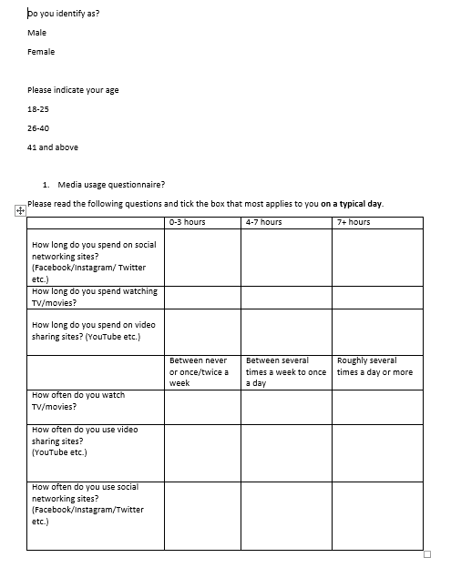
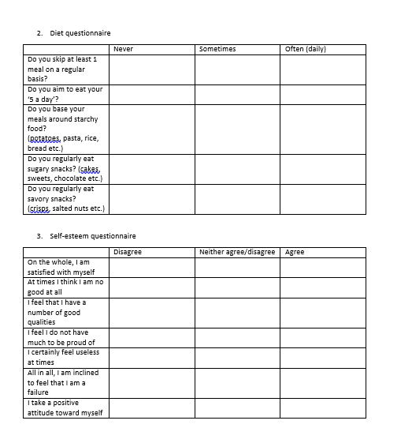

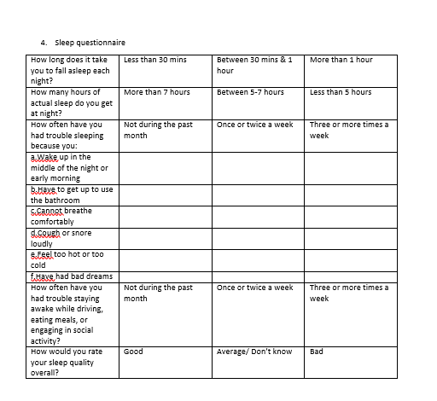
Appendix B: Original questionnaires

Appendix B (i) – The Pittsburgh sleep quality index questionnaire (1989) and scoring sheet
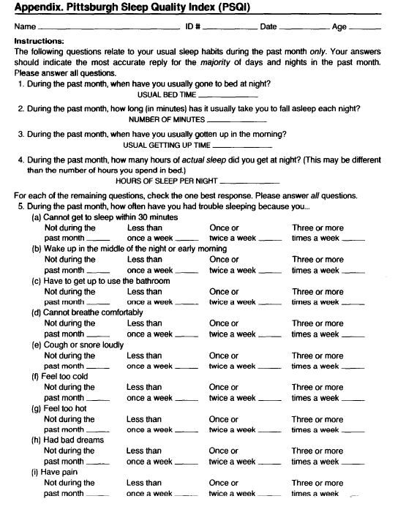
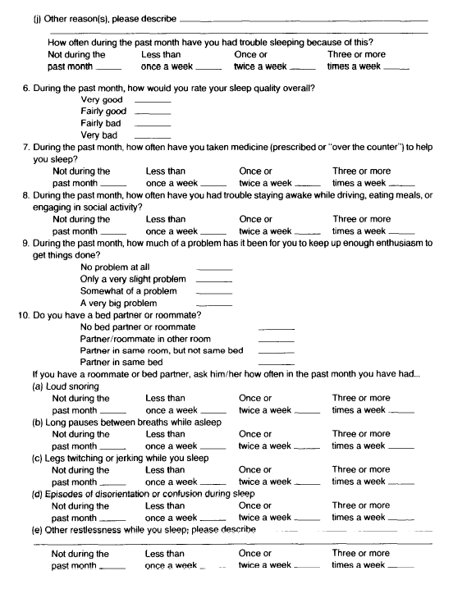

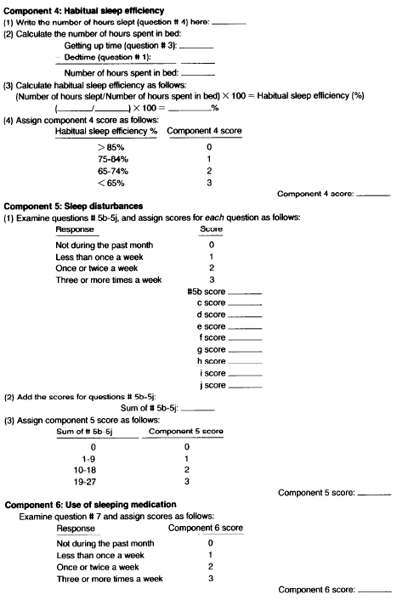
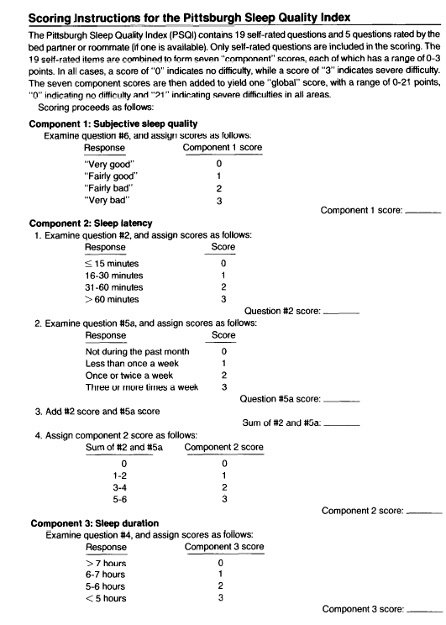

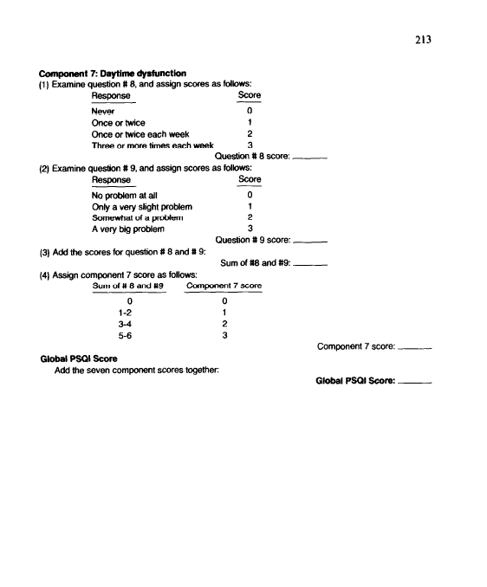

Appendix B (ii): ‘How healthy is your diet questionnaire’ and scoring system by the British heart foundation (2012)

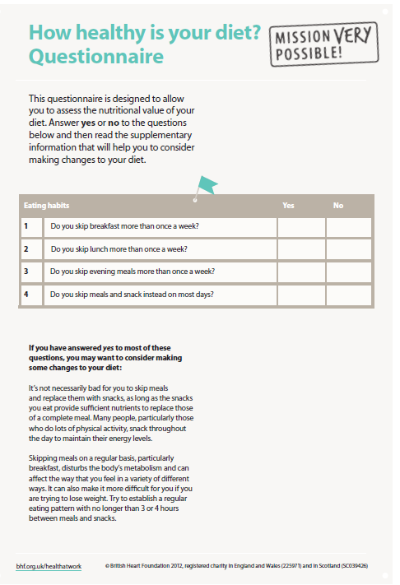
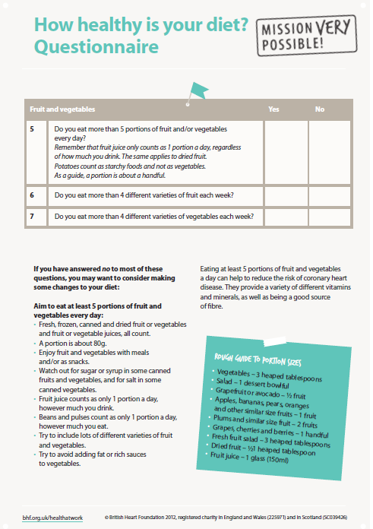

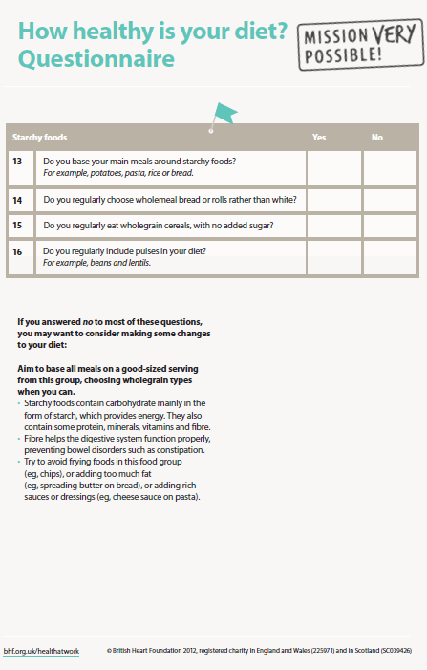
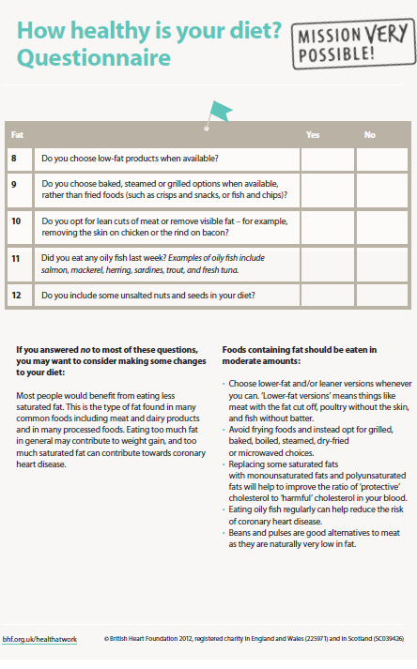

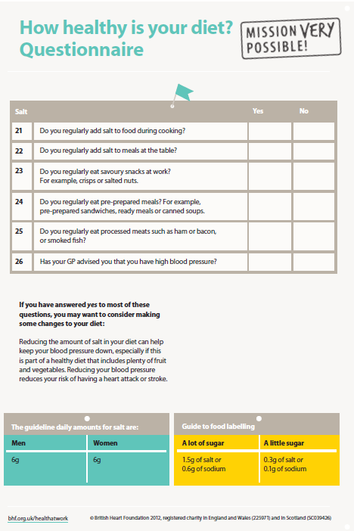
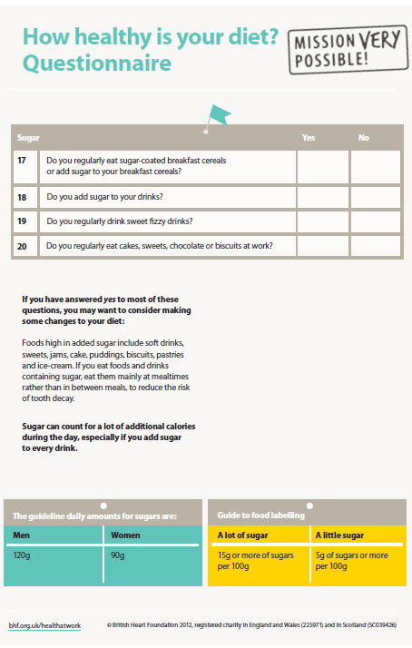

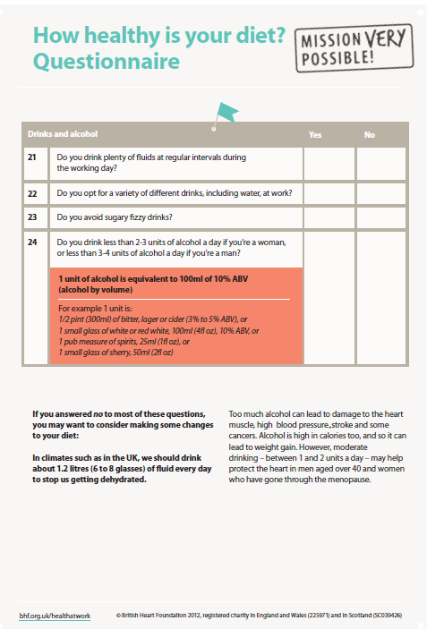

Appendix B (iii): The Rosenberg self-esteem scale (1965) and scoring sheet

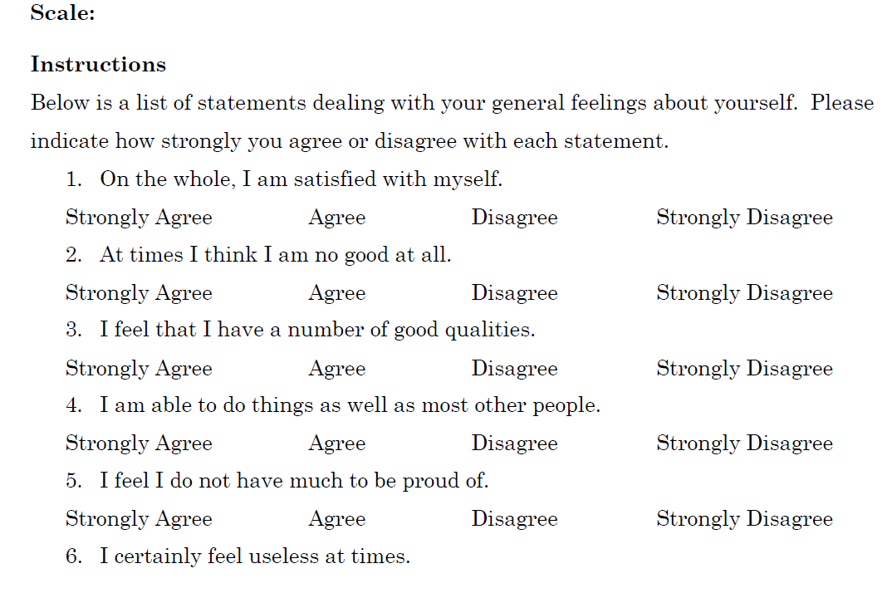
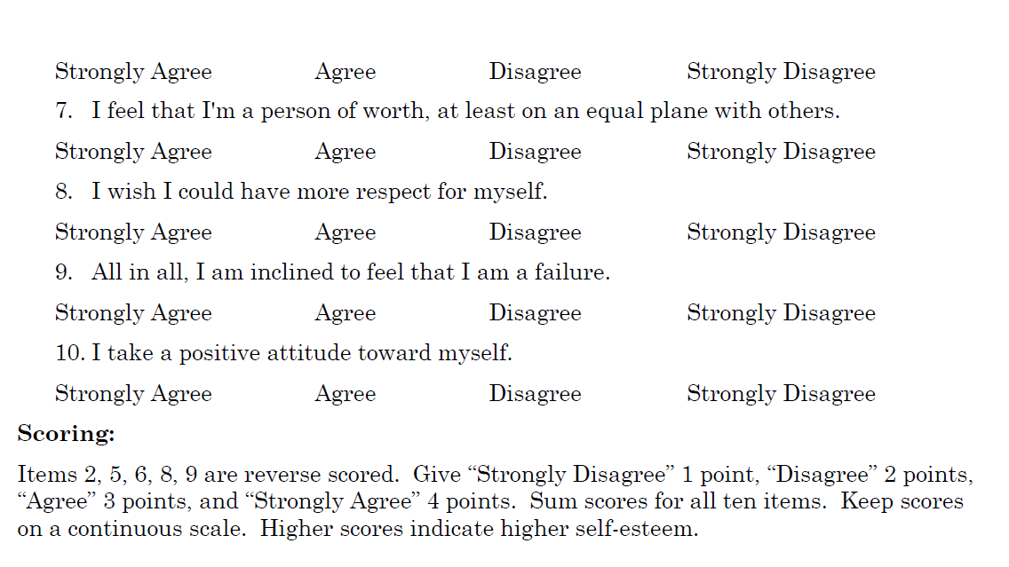

Appendix B (iv): The UK children go online questionnaire (2004)
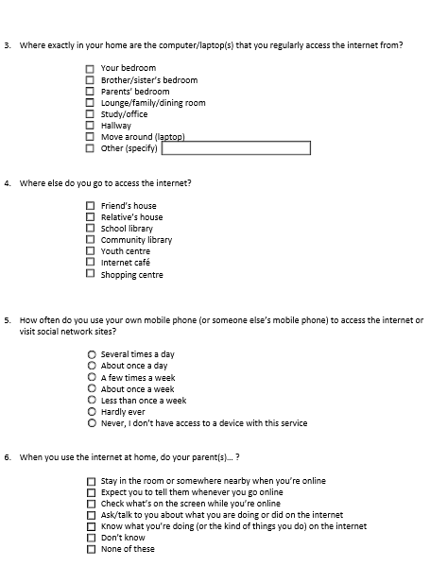
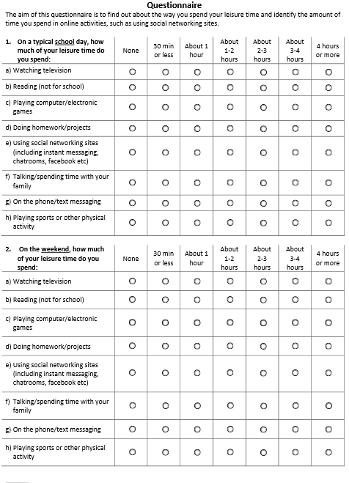
Appendix C: Ethical forms
Appendix C (i): Information sheet
Thank you for considering participation in my level 6 dissertation research that aims to explore the relationships between various types of media, sleep and diet. Please take time in reading the following information in regards to the survey.
If you decide to participate, you are asked to complete a questionnaire that should take around 10-15 mins.
Please remember that your participation is completely voluntary, and you have the choice to withdraw at any point (up until February 2018) without question. All data is anonymous and confidential- you will not be identifiable (you are not asked for your name, age or address).
If you have any questions before or after participating, please feel free to contact me (researcher) by E-mail; 1502781@uwtsd.student.ac.uk
Appendix C (ii): Consent form
Please read the following statements and if you agree, confirm your consent by ticking the boxes.
• I am 18 years old or above
• I have read and understood the provided information from the ‘information sheet’ that explains the research.
• I understand that participating in this research is voluntary and I can withdraw at any time without giving reason.
• I understand that any given personal information is confidential, and I will not be identifiable.
Appendix C (iii): Debrief form
Thank you for participating and completing the survey. Please remember that all information will remain anonymous and confidential. This research aims to explore if the media has an impact on someone’s sleep quality, diet quality and self-esteem. Sleep, diet and self-esteem issues have recently become a rapid, growing issue, that are today putting a tremendous amount of pressure on the NHS. This means that research in this area is vital in order to establish reasons as to why these issues are increasing at such an alarming rate. If any of the questions regarding to sleep, diet or self-esteem have triggered distress to you in anyway, please seek professional support through your GP where they can help you. You can also call/visit the following for relevant information:
NHS Direct Wales -0845 46 47
-or visit; www.nhs.uk
Mind-0300 123 3393
-or visit; www.mind.org.uk
If you have any other concerns or questions, please contact me (the researcher) by E-mail; 1502781@uwtsd.student.ac.uk

Appendix D: Online questionnaire
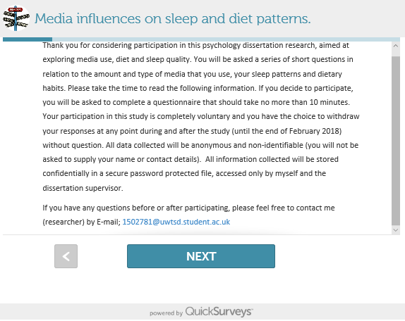
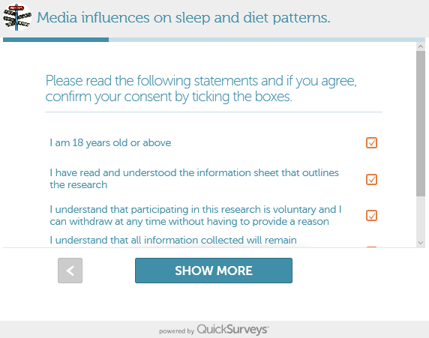
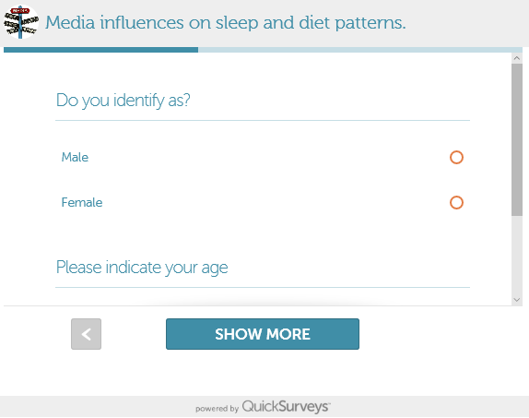
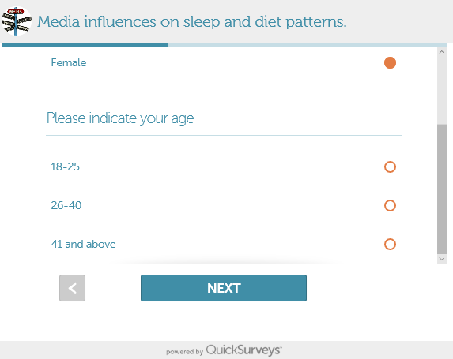
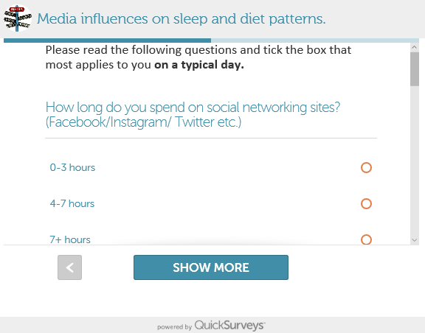
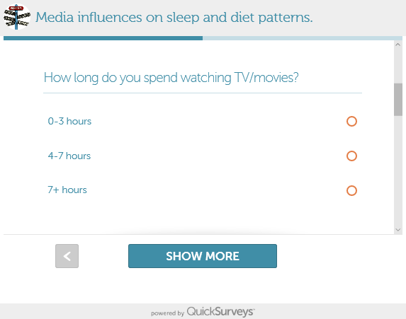

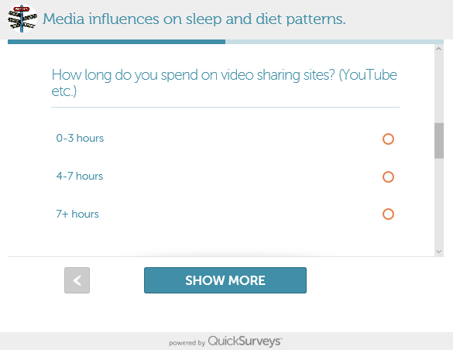
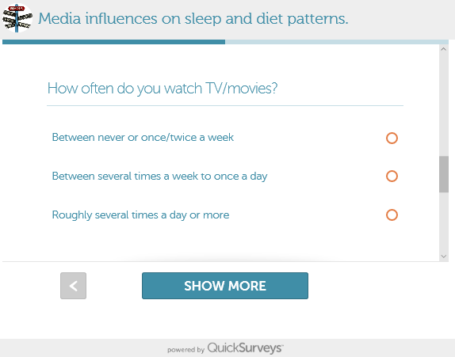
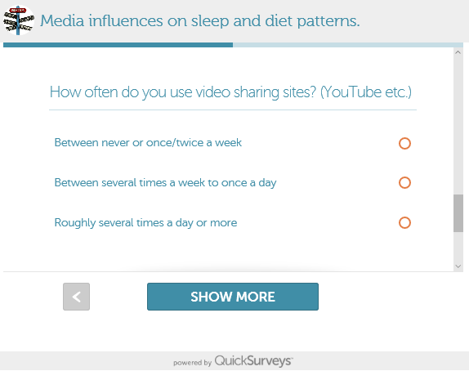
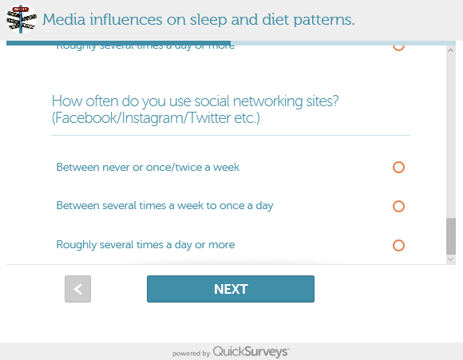
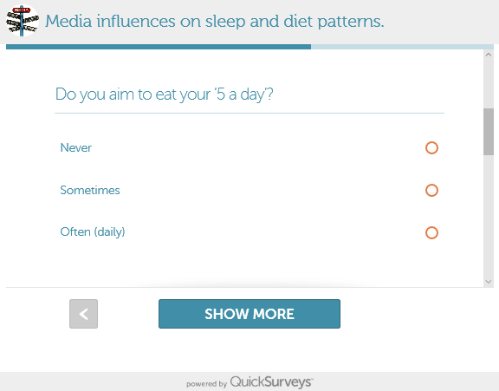
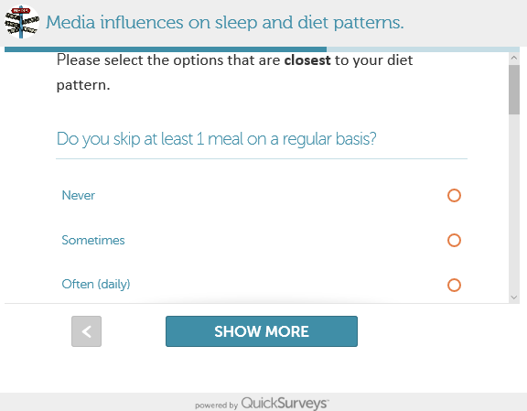
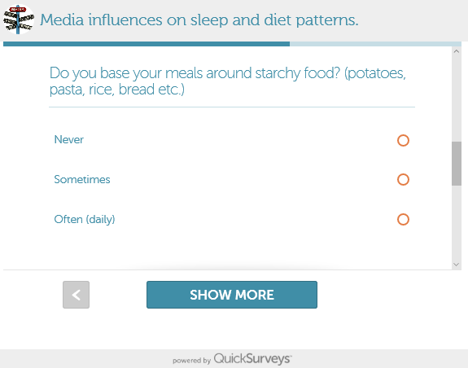
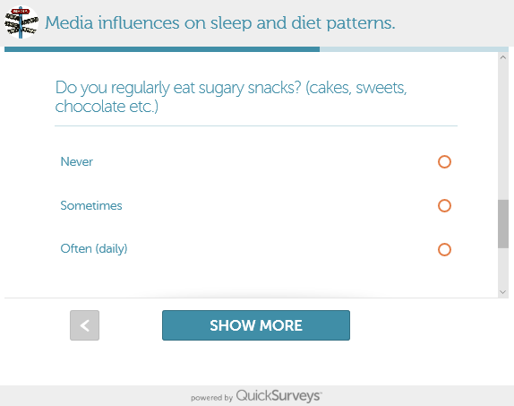
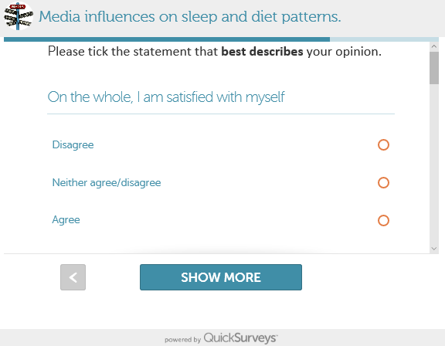
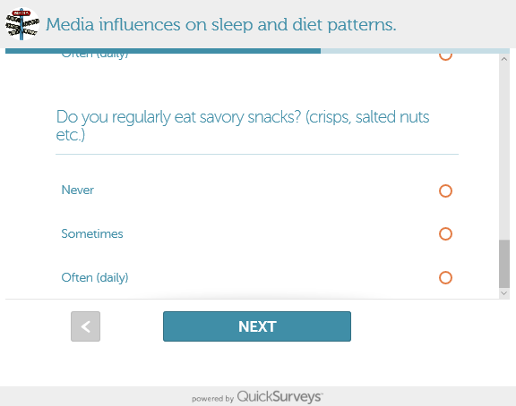

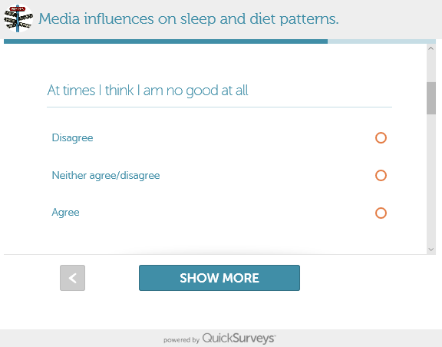
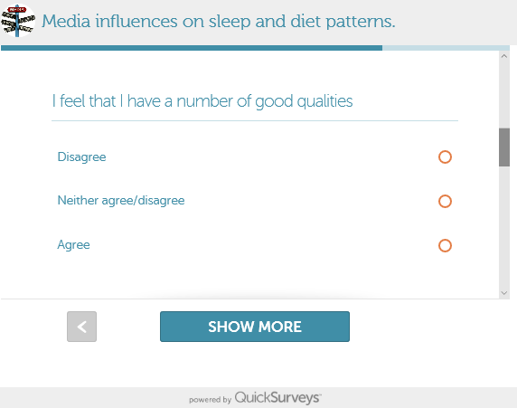
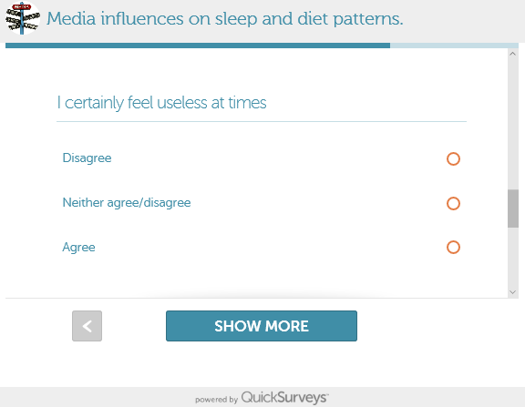
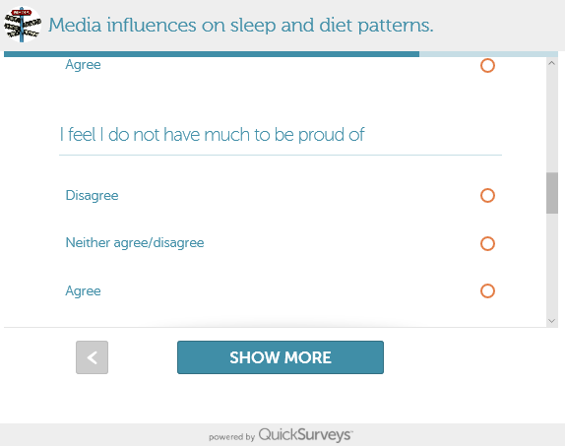
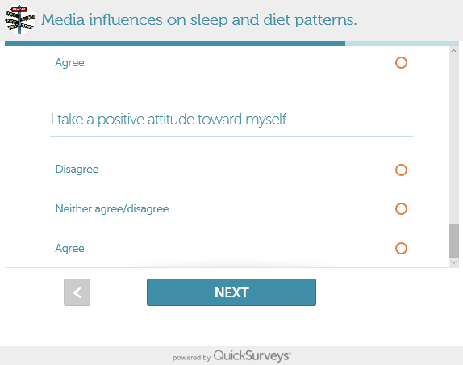
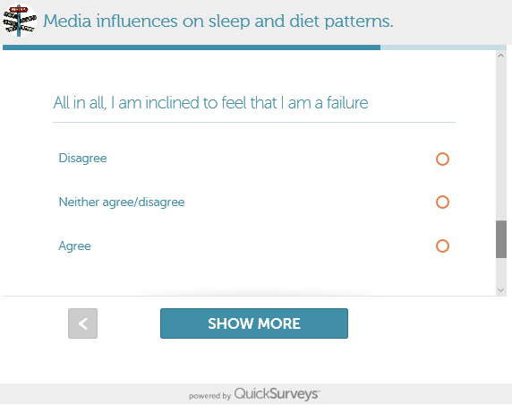
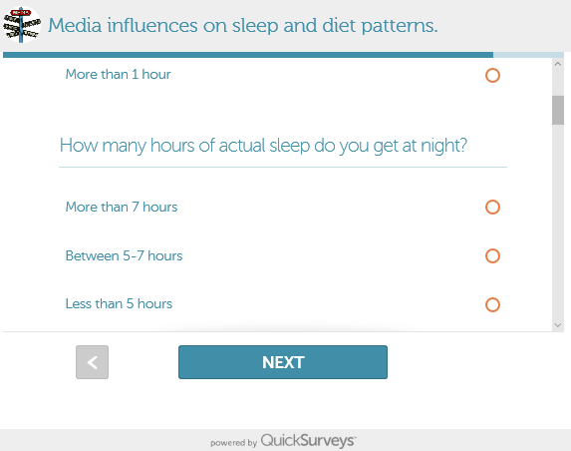
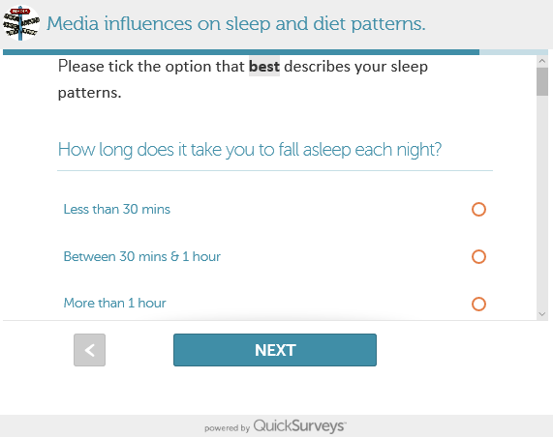
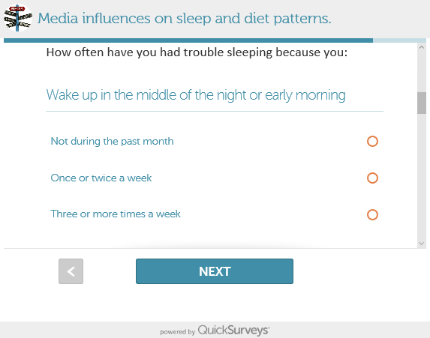
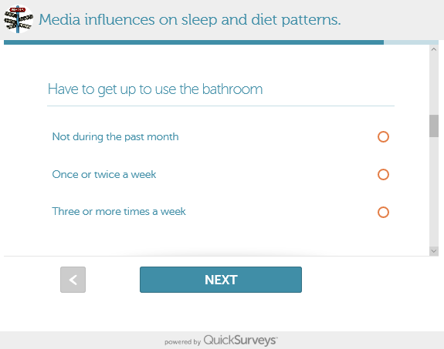
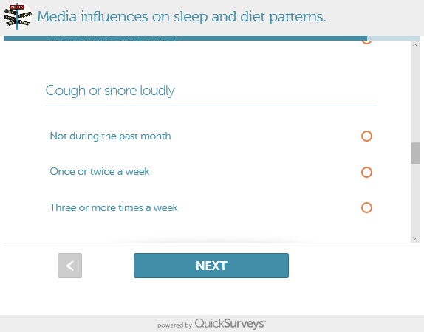
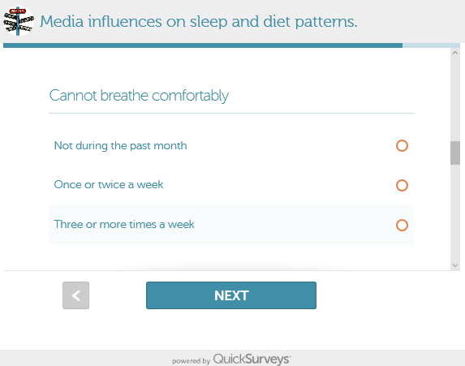

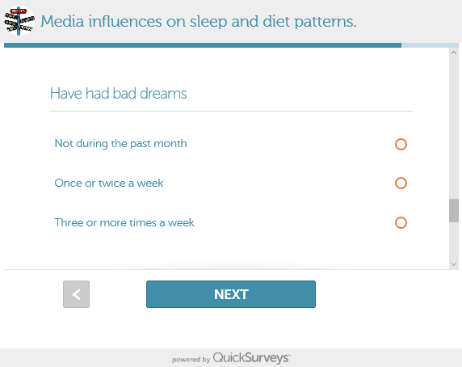
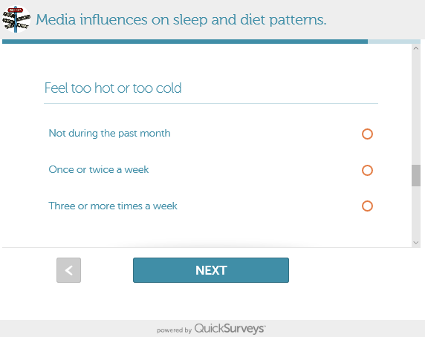

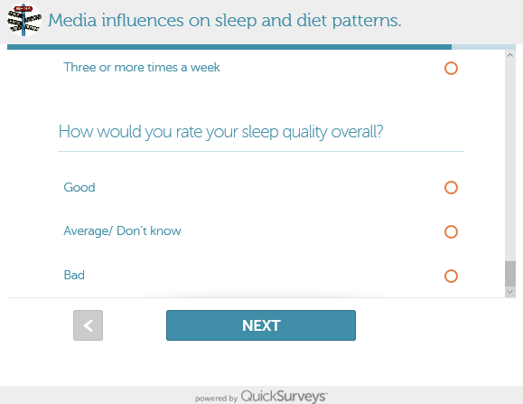
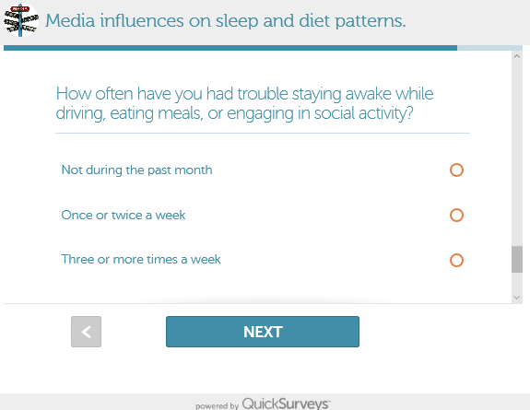

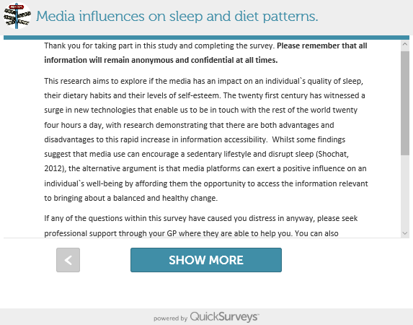

Appendix E: SPSS data
Appendix E (i): Diet
Between-Subjects Factors
 |  | Value Label | N
Amount of media usage | 1.00 | low media use | 134
Amount of media usage | 2.00 | average media use | 182
Amount of media usage | 3.00 | high media use | 12
Which media type the most | 1.00 | SNS | 173
Which media type the most | 2.00 | TV | 28
Which media type the most | 3.00 | video | 27
Which media type the most | 4.00 | equal | 100

Descriptive Statistics
Dependent Variable: Totaldiet
Amount of media usage | Which media type the most | Mean | Std. Deviation | N
low media use | SNS | 10.4321 | 1.70249 | 81
low media use | TV | 10.0000 | 2.30940 | 7
low media use | video | 9.7000 | 2.75076 | 10
low media use | equal | 9.9722 | 2.02112 | 36
low media use | Total | 10.2313 | 1.90730 | 134
average media use | SNS | 10.7816 | 1.90119 | 87
average media use | TV | 10.6316 | 2.67105 | 19
average media use | video | 10.2941 | 2.20127 | 17
average media use | equal | 10.5763 | 2.16718 | 59
average media use | Total | 10.6538 | 2.09339 | 182
high media use | SNS | 11.2000 | 2.28035 | 5
high media use | TV | 10.0000 | .00000 | 2
high media use | equal | 14.0000 | .70711 | 5
high media use | Total | 12.1667 | 2.20880 | 12
Total | SNS | 10.6301 | 1.82094 | 173
Total | TV | 10.4286 | 2.45596 | 28
Total | video | 10.0741 | 2.38466 | 27
Total | equal | 10.5300 | 2.22227 | 100
Total | Total | 10.5366 | 2.05249 | 328

Levene's Test of Equality of Error Variancesª
Dependent Variable: Totaldiet
F | df1 | df2 | Sig.
2.369 | 10 | 317 | .010
Tests the null hypothesis that the error variance of the dependent variable is equal across groups.
a. Design: Intercept + totaltimecategory + mostoftenmediatype + totaltimecategory * mostoftenmediatype

Tests of Between-Subjects Effects
Dependent Variable: Totaldiet
Source | Type III Sum of Squares | df | Mean Square | F | Sig. | Partial Eta Squared
Corrected Model | 90.604ª | 10 | 9.060 | 2.232 | .016 | .066
Intercept | 8556.172 | 1 | 8556.172 | 2107.535 | .000 | .869
totaltimecategory | 25.807 | 2 | 12.903 | 3.178 | .043 | .020
mostoftenmediatype | 24.364 | 3 | 8.121 | 2.000 | .114 | .019
totaltimecategory * mostoftenmediatype | 34.160 | 5 | 6.832 | 1.683 | .138 | .026
Error | 1286.957 | 317 | 4.060
Total | 37792.000 | 328
Corrected Total | 1377.561 | 327
a. R Squared = .066 (Adjusted R Squared = .036)

Multiple Comparisons
Dependent Variable: Totaldiet
Tukey HSD
(I) Amount of media usage | (J) Amount of media usage | Mean Difference (I-J) | Std. Error | Sig. | 95% Confidence Interval
 |  |  |  |  | Lower Bound | Upper Bound
low media use | average media use | -.4225 | .22935 | .158 | -.9626 | .1176
low media use | high media use | -1.9353* | .60714 | .004 | -3.3650 | -.5057
average media use | low media use | .4225 | .22935 | .158 | -.1176 | .9626
average media use | high media use | -1.5128* | .60052 | .033 | -2.9269 | -.0987
high media use | low media use | 1.9353* | .60714 | .004 | .5057 | 3.3650
high media use | average media use | 1.5128* | .60052 | .033 | .0987 | 2.9269
Based on observed means.
The error term is Mean Square(Error) = 4.060.
*. The mean difference is significant at the .05 level.

Totaldiet
Tukey HSD^{a,b,c}
Amount of media usage | N | Subset
Amount of media usage | N | 1 | 2
low media use | 134 | 10.2313
average media use | 182 | 10.6538
high media use | 12 |  | 12.1667
Sig. |  | .686 | 1.000
Means for groups in homogeneous subsets are displayed.
Based on observed means.
The error term is Mean Square(Error) = 4.060.
a. Uses Harmonic Mean Sample Size = 31.156.
b. The group sizes are unequal. The harmonic mean of the group sizes is used. Type I error levels are not guaranteed.
c. Alpha = .05.

Multiple Comparisons
Dependent Variable: Totaldiet
Tukey HSD
(I) Which media type the most | (J) Which media type the most | Mean Difference (I-J) | Std. Error | Sig. | 95% Confidence Interval
 |  |  |  |  | Lower Bound | Upper Bound
SNS | TV | .2015 | .41044 | .961 | -.8586 | 1.2615
SNS | video | .5560 | .41693 | .542 | -.5208 | 1.6328
SNS | equal | .1001 | .25311 | .979 | -.5537 | .7538
TV | SNS | -.2015 | .41044 | .961 | -1.2615 | .8586
TV | video | .3545 | .54347 | .915 | -1.0491 | 1.7581
TV | equal | -.1014 | .43080 | .995 | -1.2141 | 1.0112
video | SNS | -.5560 | .41693 | .542 | -1.6328 | .5208
video | TV | -.3545 | .54347 | .915 | -1.7581 | 1.0491
video | equal | -.4559 | .43699 | .724 | -1.5845 | .6727
equal | SNS | -.1001 | .25311 | .979 | -.7538 | .5537
equal | TV | .1014 | .43080 | .995 | -1.0112 | 1.2141
equal | video | .4559 | .43699 | .724 | -.6727 | 1.5845
Based on observed means.
The error term is Mean Square(Error) = 4.060.

Totaldiet
Tukey HSD^{a,b,c}
Which media type the most | N | Subset
Which media type the most | N | 1
video | 27 | 10.0741
TV | 28 | 10.4286
equal | 100 | 10.5300
SNS | 173 | 10.6301
Sig. |  | .556
Means for groups in homogeneous subsets are displayed.
Based on observed means.
The error term is Mean Square(Error) = 4.060.
a. Uses Harmonic Mean Sample Size = 45.182.
b. The group sizes are unequal. The harmonic mean of the group sizes is used. Type I error levels are not guaranteed.
c. Alpha = .05.

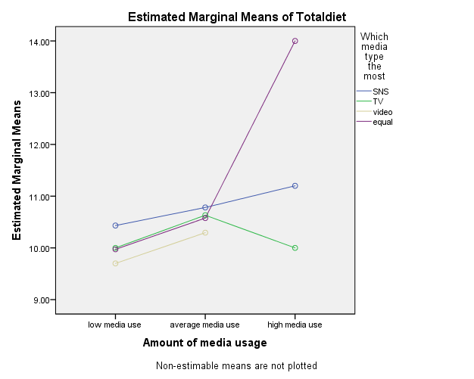

Appendix E (ii): Sleep

Between-Subjects Factors
 |  | Value Label | N
Amount of media usage | 1.00 | low media use | 134
Amount of media usage | 2.00 | average media use | 182
Amount of media usage | 3.00 | high media use | 12
Which media type the most | 1.00 | SNS | 173
Which media type the most | 2.00 | TV | 28
Which media type the most | 3.00 | video | 27
Which media type the most | 4.00 | equal | 100

Descriptive Statistics
Dependent Variable: Totalsleep
Amount of media usage | Which media type the most | Mean | Std. Deviation | N
low media use | SNS | 23.7778 | 2.77939 | 81
low media use | TV | 22.0000 | 3.74166 | 7
low media use | video | 22.9000 | 3.98469 | 10
low media use | equal | 23.6944 | 3.56827 | 36
low media use | Total | 23.5970 | 3.14588 | 134
average media use | SNS | 22.2069 | 3.57035 | 87
average media use | TV | 22.4211 | 4.51314 | 19
average media use | video | 22.9412 | 4.00735 | 17
average media use | equal | 23.1356 | 3.71139 | 59
average media use | Total | 22.5989 | 3.75472 | 182
high media use | SNS | 21.4000 | 3.78153 | 5
high media use | TV | 19.5000 | 6.36396 | 2
high media use | equal | 19.2000 | 4.65833 | 5
high media use | Total | 20.1667 | 4.23907 | 12
Total | SNS | 22.9191 | 3.31212 | 173
Total | TV | 22.1071 | 4.33196 | 28
Total | video | 22.9259 | 3.92160 | 27
Total | equal | 23.1400 | 3.78733 | 100
Total | Total | 22.9177 | 3.59951 | 328

Levene's Test of Equality of Error Variancesª
Dependent Variable: Totalsleep
F | df1 | df2 | Sig.
1.629 | 10 | 317 | .097
Tests the null hypothesis that the error variance of the dependent variable is equal across groups.
a. Design: Intercept + totaltimecategory + mostoftenmediatype + totaltimecategory * mostoftenmediatype

Tests of Between-Subjects Effects
Dependent Variable: Totalsleep
Source | Type III Sum of Squares | df | Mean Square | F | Sig. | Partial Eta Squared
Corrected Model | 242.975ª | 10 | 24.297 | 1.929 | .041 | .057
Intercept | 35942.805 | 1 | 35942.805 | 2852.887 | .000 | .900
totaltimecategory | 78.639 | 2 | 39.319 | 3.121 | .045 | .019
mostoftenmediatype | 13.748 | 3 | 4.583 | .364 | .779 | .003
totaltimecategory * mostoftenmediatype | 52.526 | 5 | 10.505 | .834 | .526 | .013
Error | 3993.803 | 317 | 12.599
Total | 176509.000 | 328
Corrected Total | 4236.777 | 327
a. R Squared = .057 (Adjusted R Squared = .028)

Multiple Comparisons
Dependent Variable: Totalsleep
Tukey HSD
(I) Amount of media usage | (J) Amount of media usage | Mean Difference (I-J) | Std. Error | Sig. | 95% Confidence Interval
 |  |  |  |  | Lower Bound | Upper Bound
low media use | average media use | .9981* | .40404 | .037 | .0467 | 1.9495
low media use | high media use | 3.4303* | 1.06954 | .004 | .9118 | 5.9489
average media use | low media use | -.9981* | .40404 | .037 | -1.9495 | -.0467
average media use | high media use | 2.4322 | 1.05788 | .057 | -.0588 | 4.9233
high media use | low media use | -3.4303* | 1.06954 | .004 | -5.9489 | -.9118
high media use | average media use | -2.4322 | 1.05788 | .057 | -4.9233 | .0588
Based on observed means.
The error term is Mean Square(Error) = 12.599.
*. The mean difference is significant at the .05 level.

Totalsleep
Tukey HSD^{a,b,c}
Amount of media usage | N | Subset
Amount of media usage | N | 1 | 2
high media use | 12 | 20.1667
average media use | 182 |  | 22.5989
low media use | 134 |  | 23.5970
Sig. |  | 1.000 | .509
Means for groups in homogeneous subsets are displayed.
Based on observed means.
The error term is Mean Square(Error) = 12.599.
a. Uses Harmonic Mean Sample Size = 31.156.
b. The group sizes are unequal. The harmonic mean of the group sizes is used. Type I error levels are not guaranteed.
c. Alpha = .05.

Multiple Comparisons
Dependent Variable: Totalsleep
Tukey HSD
(I) Which media type the most | (J) Which media type the most | Mean Difference (I-J) | Std. Error | Sig. | 95% Confidence Interval
 |  |  |  |  | Lower Bound | Upper Bound
SNS | TV | .8119 | .72304 | .676 | -1.0555 | 2.6793
SNS | video | -.0069 | .73447 | 1.000 | -1.9038 | 1.8901
SNS | equal | -.2209 | .44588 | .960 | -1.3725 | .9307
TV | SNS | -.8119 | .72304 | .676 | -2.6793 | 1.0555
TV | video | -.8188 | .95738 | .828 | -3.2914 | 1.6539
TV | equal | -1.0329 | .75891 | .525 | -2.9929 | .9272
video | SNS | .0069 | .73447 | 1.000 | -1.8901 | 1.9038
video | TV | .8188 | .95738 | .828 | -1.6539 | 3.2914
video | equal | -.2141 | .76981 | .992 | -2.2023 | 1.7741
equal | SNS | .2209 | .44588 | .960 | -.9307 | 1.3725
equal | TV | 1.0329 | .75891 | .525 | -.9272 | 2.9929
equal | video | .2141 | .76981 | .992 | -1.7741 | 2.2023
Based on observed means.
The error term is Mean Square(Error) = 12.599.

Totalsleep
Tukey HSD^{a,b,c}
Which media type the most | N | Subset
Which media type the most | N | 1
TV | 28 | 22.1071
SNS | 173 | 22.9191
video | 27 | 22.9259
equal | 100 | 23.1400
Sig. |  | .511
Means for groups in homogeneous subsets are displayed.
Based on observed means.
The error term is Mean Square(Error) = 12.599.
a. Uses Harmonic Mean Sample Size = 45.182.
b. The group sizes are unequal. The harmonic mean of the group sizes is used. Type I error levels are not guaranteed.
c. Alpha = .05.

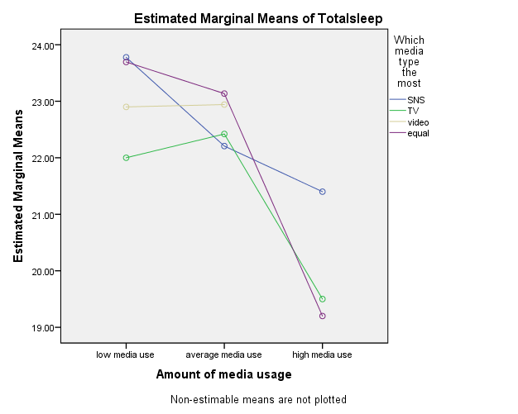

Appendix E (iii): Self-esteem

Between-Subjects Factors
 |  | Value Label | N
Amount of media usage | 1.00 | low media use | 134
Amount of media usage | 2.00 | average media use | 182
Amount of media usage | 3.00 | high media use | 12
Which media type the most | 1.00 | SNS | 173
Which media type the most | 2.00 | TV | 28
Which media type the most | 3.00 | video | 27
Which media type the most | 4.00 | equal | 100

Descriptive Statistics
Dependent Variable: Totalselfesteem
Amount of media usage | Which media type the most | Mean | Std. Deviation | N
low media use | SNS | 16.3210 | 3.84001 | 81
low media use | TV | 16.1429 | 4.94734 | 7
low media use | video | 17.6000 | 3.47051 | 10
low media use | equal | 16.9167 | 3.88679 | 36
low media use | Total | 16.5672 | 3.86316 | 134
average media use | SNS | 14.3908 | 4.02422 | 87
average media use | TV | 16.2105 | 4.28925 | 19
average media use | video | 15.7647 | 3.96121 | 17
average media use | equal | 14.5254 | 4.31260 | 59
average media use | Total | 14.7527 | 4.15572 | 182
high media use | SNS | 13.0000 | 4.84768 | 5
high media use | TV | 15.0000 | 5.65685 | 2
high media use | equal | 11.8000 | 2.77489 | 5
high media use | Total | 12.8333 | 3.95045 | 12
Total | SNS | 15.2543 | 4.06975 | 173
Total | TV | 16.1071 | 4.35753 | 28
Total | video | 16.4444 | 3.82636 | 27
Total | equal | 15.2500 | 4.29793 | 100
Total | Total | 15.4238 | 4.14570 | 328

Levene's Test of Equality of Error Variancesª
Dependent Variable: Totalselfesteem
F | df1 | df2 | Sig.
.565 | 10 | 317 | .842
Tests the null hypothesis that the error variance of the dependent variable is equal across groups.
a. Design: Intercept + totaltimecategory + mostoftenmediatype + totaltimecategory * mostoftenmediatype

Tests of Between-Subjects Effects
Dependent Variable: Totalselfesteem
Source | Type III Sum of Squares | df | Mean Square | F | Sig. | Partial Eta Squared
Corrected Model | 445.992ª | 10 | 44.599 | 2.732 | .003 | .079
Intercept | 17123.005 | 1 | 17123.005 | 1049.069 | .000 | .768
totaltimecategory | 134.722 | 2 | 67.361 | 4.127 | .017 | .025
mostoftenmediatype | 43.041 | 3 | 14.347 | .879 | .452 | .008
totaltimecategory * mostoftenmediatype | 34.031 | 5 | 6.806 | .417 | .837 | .007
Error | 5174.103 | 317 | 16.322
Total | 83649.000 | 328
Corrected Total | 5620.095 | 327
a. R Squared = .079 (Adjusted R Squared = .050)

Multiple Comparisons
Dependent Variable: Totalselfesteem
Tukey HSD
(I) Amount of media usage | (J) Amount of media usage | Mean Difference (I-J) | Std. Error | Sig. | 95% Confidence Interval
 |  |  |  |  | Lower Bound | Upper Bound
low media use | average media use | 1.8144* | .45988 | .000 | .7315 | 2.8973
low media use | high media use | 3.7338* | 1.21737 | .007 | .8672 | 6.6005
average media use | low media use | -1.8144* | .45988 | .000 | -2.8973 | -.7315
average media use | high media use | 1.9194 | 1.20410 | .250 | -.9160 | 4.7548
high media use | low media use | -3.7338* | 1.21737 | .007 | -6.6005 | -.8672
high media use | average media use | -1.9194 | 1.20410 | .250 | -4.7548 | .9160
Based on observed means.
The error term is Mean Square(Error) = 16.322.
*. The mean difference is significant at the .05 level.

Totalselfesteem
Tukey HSD^{a,b,c}
Amount of media usage | N | Subset
Amount of media usage | N | 1 | 2
high media use | 12 | 12.8333
average media use | 182 | 14.7527 | 14.7527
low media use | 134 |  | 16.5672
Sig. |  | .148 | .181
Means for groups in homogeneous subsets are displayed.
Based on observed means.
The error term is Mean Square(Error) = 16.322.
a. Uses Harmonic Mean Sample Size = 31.156.
b. The group sizes are unequal. The harmonic mean of the group sizes is used. Type I error levels are not guaranteed.
c. Alpha = .05.

Multiple Comparisons
Dependent Variable: Totalselfesteem
Tukey HSD
(I) Which media type the most | (J) Which media type the most | Mean Difference (I-J) | Std. Error | Sig. | 95% Confidence Interval
 |  |  |  |  | Lower Bound | Upper Bound
SNS | TV | -.8528 | .82297 | .728 | -2.9783 | 1.2727
SNS | video | -1.1901 | .83598 | .486 | -3.3492 | .9690
SNS | equal | .0043 | .50751 | 1.000 | -1.3064 | 1.3151
TV | SNS | .8528 | .82297 | .728 | -1.2727 | 2.9783
TV | video | -.3373 | 1.08970 | .990 | -3.1517 | 2.4771
TV | equal | .8571 | .86380 | .754 | -1.3738 | 3.0881
video | SNS | 1.1901 | .83598 | .486 | -.9690 | 3.3492
video | TV | .3373 | 1.08970 | .990 | -2.4771 | 3.1517
video | equal | 1.1944 | .87621 | .523 | -1.0686 | 3.4574
equal | SNS | -.0043 | .50751 | 1.000 | -1.3151 | 1.3064
equal | TV | -.8571 | .86380 | .754 | -3.0881 | 1.3738
equal | video | -1.1944 | .87621 | .523 | -3.4574 | 1.0686
Based on observed means.
The error term is Mean Square(Error) = 16.322.

Totalselfesteem
Tukey HSD^{a,b,c}
Which media type the most | N | Subset
Which media type the most | N | 1
equal | 100 | 15.2500
SNS | 173 | 15.2543
TV | 28 | 16.1071
video | 27 | 16.4444
Sig. |  | .497
Means for groups in homogeneous subsets are displayed.
Based on observed means.
The error term is Mean Square(Error) = 16.322.
a. Uses Harmonic Mean Sample Size = 45.182.
b. The group sizes are unequal. The harmonic mean of the group sizes is used. Type I error levels are not guaranteed.
c. Alpha = .05.

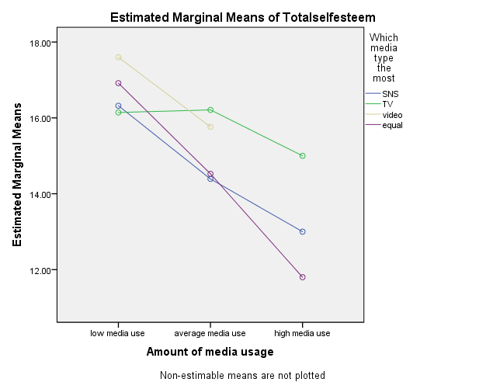

Appendix E (iv): Cronbachs alpha

Case Processing Summary
 |  | N | %
Cases | Valid | 328 | 100.0
Cases | Excludedª | 0 | .0
Cases | Total | 328 | 100.0
a. Listwise deletion based on all variables in the procedure.

Reliability Statistics
Cronbach's Alpha | Cronbach's Alpha Based on Standardized Items | N of Items
.530 | .544 | 5

Item Statistics
 | Mean | Std. Deviation | N
Do you skip at least 1 meal on a regular basis? | 2.0762 | .78029 | 328
Do you base your meals around starchy food? (potatoes, pasta, rice, bread etc.) | 2.2317 | .67817 | 328
Do you regularly eat sugary snacks? (cakes, sweets, chocolate etc.) | 2.2073 | .63028 | 328
Do you regularly eat savory snacks? (crisps, salted nuts etc.) | 2.0793 | .64000 | 328
fivereverse | 1.9421 | .74172 | 328

Inter-Item Correlation Matrix
 | Do you skip at least 1 meal on a regular basis? | Do you base your meals around starchy food? (potatoes, pasta, rice, bread etc.) | Do you regularly eat sugary snacks? (cakes, sweets, chocolate etc.) | Do you regularly eat savory snacks? (crisps, salted nuts etc.) | fivereverse
Do you skip at least 1 meal on a regular basis? | 1.000 | .099 | .123 | .129 | .187
Do you base your meals around starchy food? (potatoes, pasta, rice, bread etc.) | .099 | 1.000 | .302 | .310 | .033
Do you regularly eat sugary snacks? (cakes, sweets, chocolate etc.) | .123 | .302 | 1.000 | .331 | .261
Do you regularly eat savory snacks? (crisps, salted nuts etc.) | .129 | .310 | .331 | 1.000 | .151
fivereverse | .187 | .033 | .261 | .151 | 1.000

Summary Item Statistics
 | Mean | Minimum | Maximum | Range | Maximum / Minimum | Variance | N of Items
Inter-Item Correlations | .193 | .033 | .331 | .298 | 10.066 | .010 | 5

Item-Total Statistics
 | Scale Mean if Item Deleted | Scale Variance if Item Deleted | Corrected Item-Total Correlation | Squared Multiple Correlation | Cronbach's Alpha if Item Deleted
Do you skip at least 1 meal on a regular basis? | 8.4604 | 3.032 | .210 | .051 | .534
Do you base your meals around starchy food? (potatoes, pasta, rice, bread etc.) | 8.3049 | 3.087 | .279 | .148 | .484
Do you regularly eat sugary snacks? (cakes, sweets, chocolate etc.) | 8.3293 | 2.925 | .413 | .201 | .409
Do you regularly eat savory snacks? (crisps, salted nuts etc.) | 8.4573 | 2.995 | .365 | .168 | .436
fivereverse | 8.5945 | 3.025 | .247 | .101 | .507

Scale Statistics
Mean | Variance | Std. Deviation | N of Items
10.5366 | 4.213 | 2.05249 | 5

Case Processing Summary
 |  | N | %
Cases | Valid | 328 | 100.0
Cases | Excludedª | 0 | .0
Cases | Total | 328 | 100.0
a. Listwise deletion based on all variables in the procedure.

Reliability Statistics
Cronbach's Alpha | Cronbach's Alpha Based on Standardized Items | N of Items
.865 | .864 | 7

Item Statistics
 | Mean | Std. Deviation | N
On the whole, I am satisfied with myself | 2.1707 | .81732 | 328
I feel that I have a number of good qualities | 2.6402 | .62455 | 328
I take a positive attitude toward myself | 2.2805 | .79408 | 328
feelnogoodreverse | 1.8872 | .85461 | 328
notproudreverse | 2.2744 | .82266 | 328
feeluselessreverse | 1.8201 | .85023 | 328
feelfailurereverse | 2.3506 | .79116 | 328

Inter-Item Correlation Matrix
 | On the whole, I am satisfied with myself | I feel that I have a number of good qualities | I take a positive attitude toward myself | feelnogoodreverse | notproudreverse | feeluselessreverse | feelfailurereverse
On the whole, I am satisfied with myself | 1.000 | .420 | .581 | .474 | .299 | .436 | .442
I feel that I have a number of good qualities | .420 | 1.000 | .432 | .376 | .377 | .333 | .436
I take a positive attitude toward myself | .581 | .432 | 1.000 | .560 | .453 | .505 | .588
feelnogoodreverse | .474 | .376 | .560 | 1.000 | .470 | .666 | .592
notproudreverse | .299 | .377 | .453 | .470 | 1.000 | .442 | .566
feeluselessreverse | .436 | .333 | .505 | .666 | .442 | 1.000 | .562
feelfailurereverse | .442 | .436 | .588 | .592 | .566 | .562 | 1.000

Summary Item Statistics
 | Mean | Minimum | Maximum | Range | Maximum / Minimum | Variance | N of Items
Inter-Item Correlations | .477 | .299 | .666 | .368 | 2.232 | .009 | 7

Item-Total Statistics
 | Scale Mean if Item Deleted | Scale Variance if Item Deleted | Corrected Item-Total Correlation | Squared Multiple Correlation | Cronbach's Alpha if Item Deleted
On the whole, I am satisfied with myself | 13.2530 | 13.095 | .579 | .404 | .854
I feel that I have a number of good qualities | 12.7835 | 14.366 | .513 | .284 | .861
I take a positive attitude toward myself | 13.1433 | 12.600 | .702 | .517 | .837
feelnogoodreverse | 13.5366 | 12.200 | .713 | .552 | .835
notproudreverse | 13.1494 | 13.112 | .570 | .376 | .855
feeluselessreverse | 13.6037 | 12.479 | .663 | .502 | .842
feelfailurereverse | 13.0732 | 12.527 | .720 | .537 | .834

Scale Statistics
Mean | Variance | Std. Deviation | N of Items
15.4238 | 17.187 | 4.14570 | 7

Case Processing Summary
 |  | N | %
Cases | Valid | 328 | 100.0
Cases | Excludedª | 0 | .0
Cases | Total | 328 | 100.0
a. Listwise deletion based on all variables in the procedure.

Reliability Statistics
Cronbach's Alpha | Cronbach's Alpha Based on Standardized Items | N of Items
.652 | .642 | 10

Item Statistics
 | Mean | Std. Deviation | N
troublestayingawakereverse | 2.5152 | .69933 | 328
baddreamsreverse | 2.5244 | .69468 | 328
toohotortoocoldreverse | 2.3293 | .76714 | 328
coughsnorereverse | 2.5579 | .71442 | 328
cannotbreathreverse | 2.7043 | .58606 | 328
getupforbathroomreverse | 2.1159 | .80442 | 328
wakeatnightormorningreverse | 1.9787 | .81809 | 328
Hoursleepreversee | 1.8140 | .66281 | 328
howlongtosleeprevers | 2.2226 | .77569 | 328
ratesleepqualityreverse | 2.1555 | .76440 | 328

Inter-Item Correlation Matrix
 | troublestayingawakereverse | baddreamsreverse | toohotortoocoldreverse | coughsnorereverse | cannotbreathreverse | getupforbathroomreverse | wakeatnightormorningreverse | Hoursleepreversee | howlongtosleeprevers | ratesleepqualityreverse
troublestayingawakereverse | 1.000 | .544 | .184 | .163 | .179 | .203 | .158 | -.202 | .199 | .296
baddreamsreverse | .544 | 1.000 | .186 | .154 | .224 | .165 | .208 | -.080 | .197 | .272
toohotortoocoldreverse | .184 | .186 | 1.000 | .439 | .312 | .196 | .265 | -.210 | .175 | .267
coughsnorereverse | .163 | .154 | .439 | 1.000 | .403 | .222 | .188 | -.116 | .145 | .193
cannotbreathreverse | .179 | .224 | .312 | .403 | 1.000 | .216 | .255 | -.221 | .334 | .226
getupforbathroomreverse | .203 | .165 | .196 | .222 | .216 | 1.000 | .422 | -.154 | .164 | .194
wakeatnightormorningreverse | .158 | .208 | .265 | .188 | .255 | .422 | 1.000 | -.374 | .340 | .475
Hoursleepreversee | -.202 | -.080 | -.210 | -.116 | -.221 | -.154 | -.374 | 1.000 | -.419 | -.468
howlongtosleeprevers | .199 | .197 | .175 | .145 | .334 | .164 | .340 | -.419 | 1.000 | .318
ratesleepqualityreverse | .296 | .272 | .267 | .193 | .226 | .194 | .475 | -.468 | .318 | 1.000

Summary Item Statistics
 | Mean | Minimum | Maximum | Range | Maximum / Minimum | Variance | N of Items
Inter-Item Correlations | .152 | -.468 | .544 | 1.012 | -1.162 | .052 | 10

Item-Total Statistics
 | Scale Mean if Item Deleted | Scale Variance if Item Deleted | Corrected Item-Total Correlation | Squared Multiple Correlation | Cronbach's Alpha if Item Deleted
troublestayingawakereverse | 20.4024 | 10.675 | .392 | .346 | .612
baddreamsreverse | 20.3933 | 10.564 | .423 | .343 | .606
toohotortoocoldreverse | 20.5884 | 10.329 | .414 | .259 | .606
coughsnorereverse | 20.3598 | 10.574 | .403 | .284 | .609
cannotbreathreverse | 20.2134 | 10.884 | .447 | .273 | .607
getupforbathroomreverse | 20.8018 | 10.361 | .376 | .220 | .614
wakeatnightormorningreverse | 20.9390 | 9.898 | .464 | .390 | .592
Hoursleepreversee | 21.1037 | 14.748 | -.438 | .334 | .750
howlongtosleeprevers | 20.6951 | 10.671 | .332 | .271 | .624
ratesleepqualityreverse | 20.7622 | 10.304 | .421 | .374 | .604

Scale Statistics
Mean | Variance | Std. Deviation | N of Items
22.9177 | 12.957 | 3.59951 | 10

