William Baker
1703131

HTML & CSS Web Development

Introduction to Web Development

Kemi Ademoye

January 10th 2017

Contents
Introduction 3
Requirements 3
Site Map 3
Wireframe 4
Implementation 5
Evaluation 8
Accessibility 8
References 9

Introduction
This report will contain information about the process of creating a website using HTML and CSS. It will go into details of the requirements, design, and creation of the website. It also contains an overview of how the website functions, and an evaluation of how the website stands up in terms of accessibility and design.

Requirements
The website is for a business called Copybush Equine, they provide equine services and sales. The site is targeted towards people who may own horses that are looking for services such as liveries and schooling. It is also targeted towards people who may be looking to buy a horse or pony.

Site Map
Below is the site map, it shows how the pages are linked to each other.

Home
index.html

Services
services.html
For Sale
for-sale.html
Gallery
gallery.html
Contact
contact.html

Wireframe
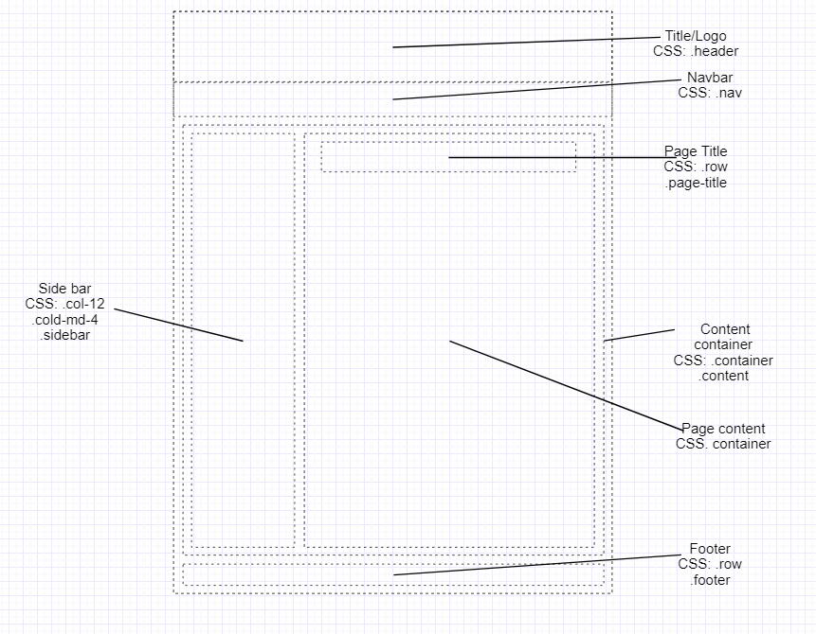

The image above shows the wireframe design of the site. This is the basic layout of the home page. You can see the different CSS classes that will be used to create each row, column, and container. Also included are the names of some custom CSS elements that will be used to further format the content. The rows for the side bar and main content of the page use col-12 for small size screens, this means that people viewing it will see it on two separate rows instead of one. This makes the page easily visible as otherwise the content would be spread apart too much and users would have to zoom in.

Implementation
Three of the pages show a sidebar, the sidebar contains multiple rows that when viewed on a smaller screen would take up the whole width of the page, rather than being in a sidebar. The sidebar contains a slideshow of images, as well as news content for the user to read.
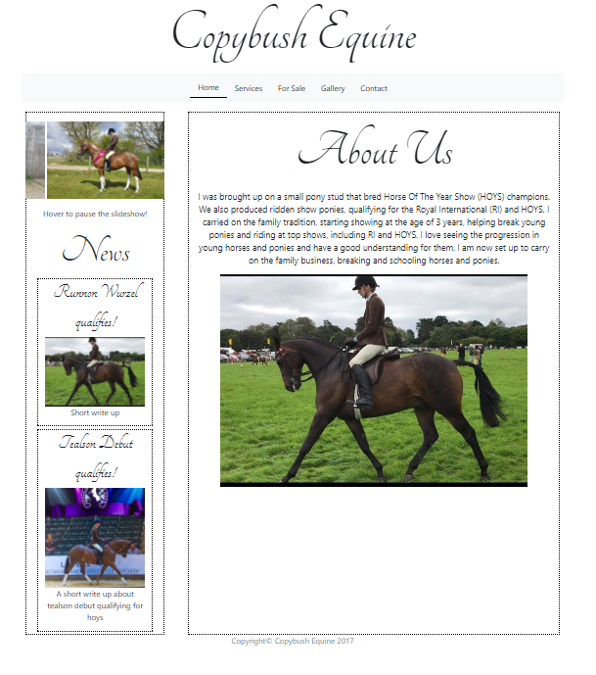
The image above is a screenshot showing the ‘home’ / index page. This page contains some basic information about the company such as what the website is about, where the company came from, and what they do. The user can hover the slideshow on the sidebar to stop the content from scrolling, this is available on all pages that have a sidebar or slideshow.

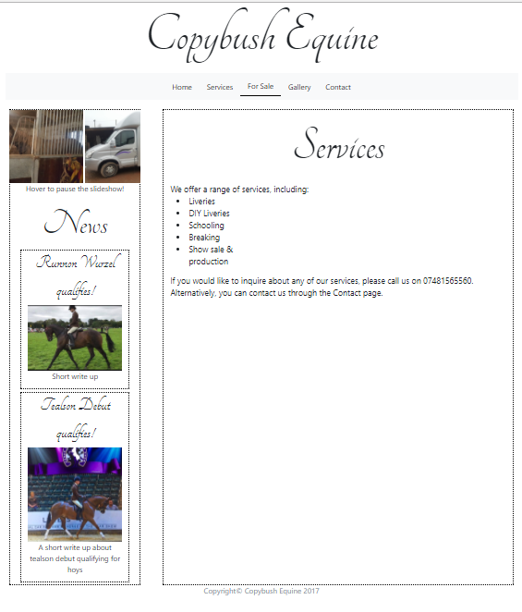
This is a screenshot showing the ‘services’ page, this is just a basic page listing the available services that are available from the company. This page could have been improved adding more content.

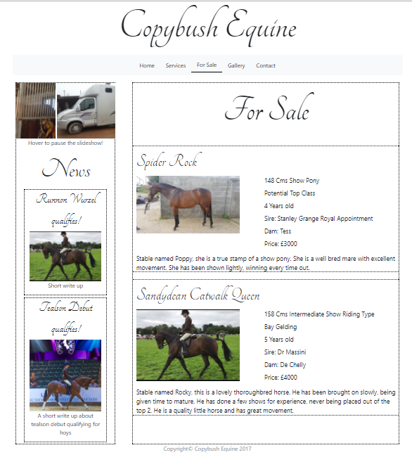
This is a screenshot showing the ‘for-sale’ page. This page contains advertisements for the horses that are for sale.

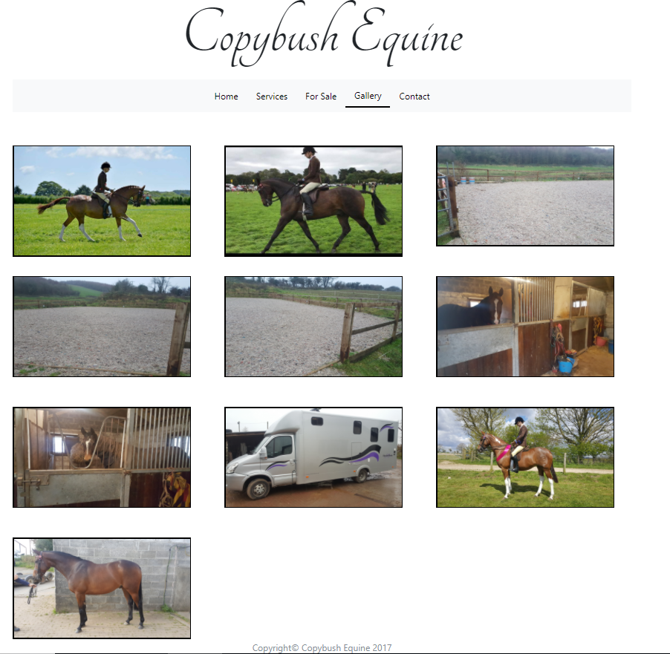
This is a screenshot showing the ‘gallery’ page, containing many different images of the horses and facilities.
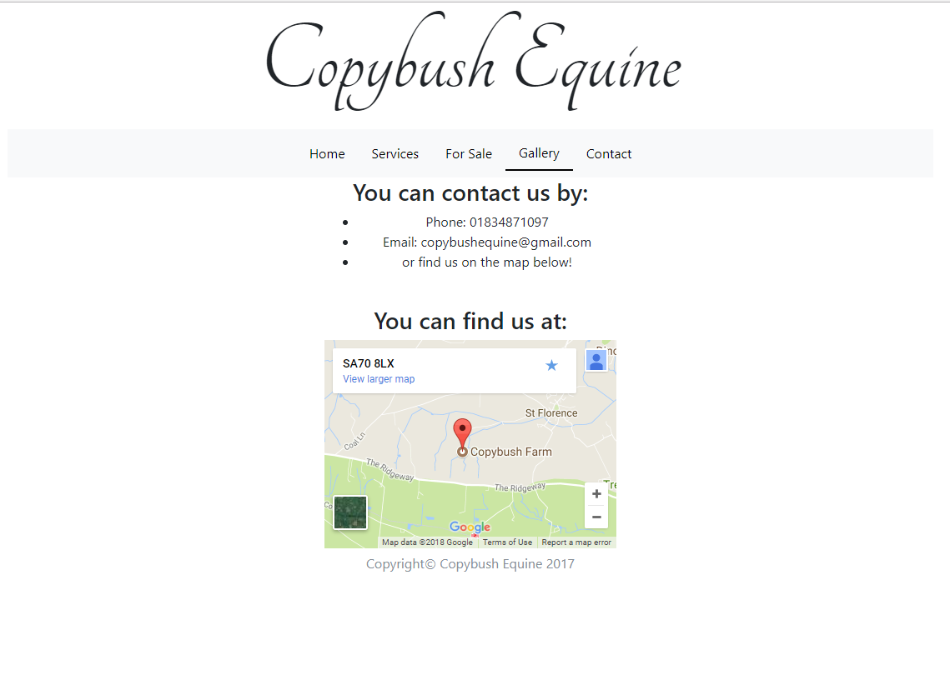
This is a screenshot showing the ‘contact’ page. On this page, there are different methods that can be used to contact the company. It also has a map showing where they are, this is achieved by using embedded Google Maps.

I used a few validation tools to check for any issues with both the HTML and CSS code. During the validation of the HTML, I found that there were a few errors with some of the images. The issue was that the images did not contain an alternative text in case the image is not found on the server. This could be easily fixed by adding the parameter to each of the images. I also validated the CSS and found that there were no issues.
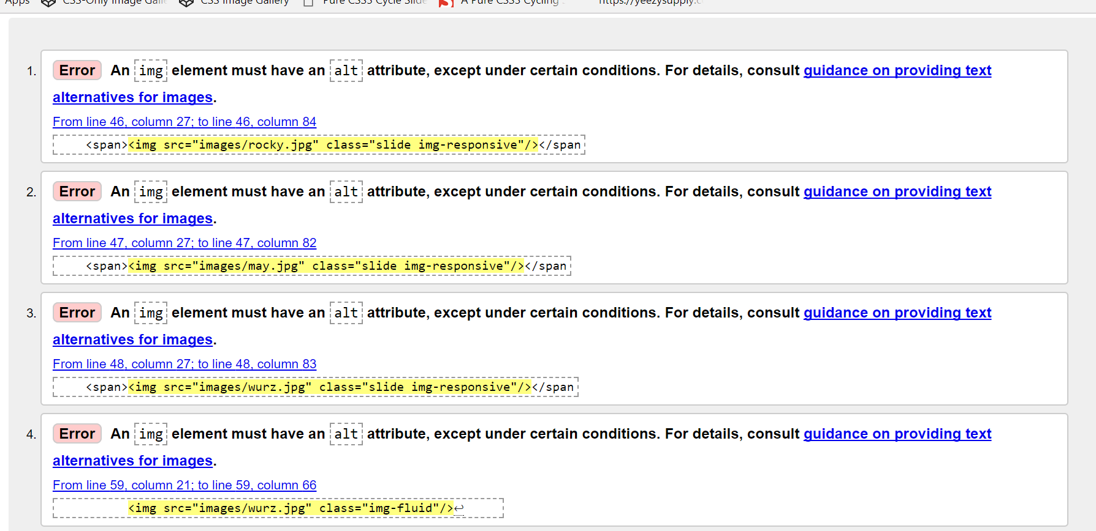
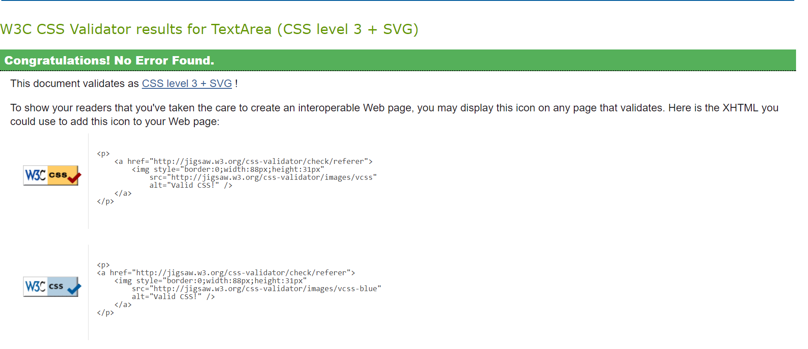

Evaluation

Accessibility
For a website to be used by all people, it must have good accessibility. This means that people with disabilities can use the website. The main type of disability focused on is people with visual impairments. This includes people who are fully blind and need to use screen readers, and people who have decreased vision or colour-blindness.

According to the [1]WCAG 2.0 guidelines, non-text elements of a web page should provide an alternative to allow visually impaired users to use the website. The Copybush Equine website contained images that did not provide an alternative text, this means that people using a screen reader will not be able to know what images are on the page. An alternative text tag is also useful for when someone has a slow internet connection, or if the image fails to load. If the images fail to load, the alternative text will be displayed instead of the image.
The content of the page is created using Bootstrap rows and columns. The content of the website is made in a way that makes it easily viewable on multiple devices and screen sizes. This is done through using different column sizes for different screen sizes. For example, on the sidebar column uses the CSS classes col-12 and col-md-3. Col-12 is full width and is used for screens that are XS or larger, whereas col-md-4 is one third of the screen width and is used on displays that are medium width or larger. This means that small screens will use a whole row to display the content whereas medium or larger screens will only take up one third of the page for the same content.
The headings of the website, used in the logo area of the website and as titles for each page, is set to use different sizes. Using a set font size for the headings meant that when the website was viewed on smaller devices, the heading would take up the whole size of the screen. To fix this, CSS was applied to change the size of the font based on the size of the screen.
To help the user understand which page of the site they are viewing, a CSS class was created. This class was called ‘.active’ and made the element use a ‘border-bottom’ tag, with a thickness of 2 pixels. This created a black line at the bottom of the element it was applied to. This class was used on the navigation bar, placed on the link for each page it was used on. For example, on the index page it was placed on the ‘home’ link. This made it so that a user would know what page they were on by simply looking at the underlined link on the navigation bar.
To check that the colours of the website were easily visible by people who are visually impaired, a simple online tool was used, found at https://contrastchecker.com/ [2]. This simple website allows you to enter the background and foreground colours used in the website. For the Copybush Equine, there were white for the background and black for the text. The contrast checker checks the colours against criterion from WCAG 2.0 [1], it also does some additional checks. One of the additional checks is the brightness and difference of the colours, this means that the colours are not too bright and not too close on the colour spectrum to reduce visibility. The other additional check carried out is a grayscale check, this converts the colours of the website to grayscale to check if people with colour-blindness can read them. Since the colours used were white and black, as far apart as you can get on the grayscale spectrum, the site passed.
The images on the site were set to take up the max width of the containers they were in. This means that on all sizes of screen, the images would be easily viewable. If they had been set to a static size, the images would look fine on a large screen but would be cut off the screen, making them hard to view on medium and small sized screens. Instead, they are scaled to take enough screen to be viewable on all sizes of screens, without replacing too much other content.
The overall design of the site was intentionally kept basic. The amount of information that was to be placed on the website, so creating a layout that was too spread out would make the site look empty and draw people away from the content. A sidebar containing a small slideshow and news provided the user with content that was easily viewable in a small area. Because of the amount of content on the page, it looks best on medium sized screens. This is because the content is enough to fill the whole screen. On larger screens the content can look underwhelming, and on smaller screens, the content takes a lot of scrolling due to the images taking up a large space on the screen.
To improve the site in the future, the first thing that would need to be done is to add alternative text to each of the images. This would allow visually impaired people to understand what is on the screen, as currently, a screen reader won’t be able to pick up anything from the images. Adding alternative text is as simple as adding an ‘alt’ tag to the images in the HTML code, meaning it would be a very short but very useful addition. Another improvement would to increase the amount of content in each page. Currently, some of the pages look a bit empty and could do with more writing and images to make them more visually appealing and to provide the user with information.

References

[1] | “Web Content Accessibility Guidelines (WCAG) 2.0,” 11 December 2008. [Online]. Available: https://www.w3.org/TR/WCAG20/.
[2] | “Contrast Checker,” Acart Communications, [Online]. Available: https://contrastchecker.com/.

marking criteria and Student FEEDBACK

This section details the assessment criteria. The extent to which these are demonstrated by you determines your mark. The marks available for each criterion are shown. Lecturers will use the space provided to comment on the achievement of the task(s), including those areas in which you have performed well and areas that would benefit from development/improvement.

Common Assessment Criteria Applied (Assignment 1) | Marks available | Marks  awarded
1. Research-informed Literature
Extent of research and/or own reading, selection of credible sources, application of appropriate referencing conventions.
A very limited list of references has been provided. Expand the scope of references consulted to help you improve the quality of your work. (Grade mark: 30.00%) | 5 | 1.5
2. Knowledge and Understanding of Subject
Extent of knowledge and understanding of concepts and underlying principles associated with the discipline.
Demonstrates a very good understanding of the standards to design and implement a website. See your report for some comments. (Grade mark: 75.00%) | 20 | 15
3. Analysis
Analysis, evaluation and synthesis; logic, argument and judgement; analytical reflection; organisation of ideas and evidence
Although you have provided a very good accessibility evaluation of the website and how this has been achieved in your website, you are expected to cross-reference your discussion with the WCAG guidelines. Relevant and well-thought-out recommendations have also been provided. (Grade mark: 67.50%) | 20 | 13.5
4. Practical Application and Deployment
Deployment of methods, materials, tools and techniques; application of concepts; formulation of innovative and creative solutions to solve problems.
An excellent attempt featuring a simple website with well-thought-out content. Well done. The main thing to note is to remember to add alternative text descriptions to improve the accessibility of your website. Also, consider making the logo a link back to the home page as users tend to expect this behaviour. It would have been nice to see some more variety to the content too. (Grade mark: 73.00%) | 50 | 36.5
5. Skills for Professional Practice
Attributes in professional practice: individual and collaborative working; deployment of appropriate media; presentation and organisation.
The report is well-written and presented. (Grade mark: 70.00%) | 5 | 3.5

Assignment Mark (Assessment marks are subject to ratification at the Exam Board. These comments and marks are to give feedback on module work and are for guidance only until they are confirmed. ) | Late Submission Penalties (tick if appropriate) |  | 70%
 | Up to one week late |  | 70%
 | 1st/2nd/3rd attempt? |  | 70%

