WEBSITE DESIGN

Digital Skills and Research Methods

BMSW4003

Created by Cristian-Marin Pena

1908795

July 10th, 2020

email: cp1908795@gmail.com
password: Pena1234

Based on the primary research, the four C’s of marketing communication and business plan, I have created a website that will maximize sales and publicity for the business.
Researching the four C’s and identifying the core elements, which are Consistency and Clarity, I have included my Poster design strategy in the website as well, as following:
For the first page of my website, called “Home”, I have chosen a picture representing a person surrounded by vegetation, practising Yoga, meant to make visitors feel relaxed and welcomed. The way she is dressed shows a sense of comfort and freedom of movement.
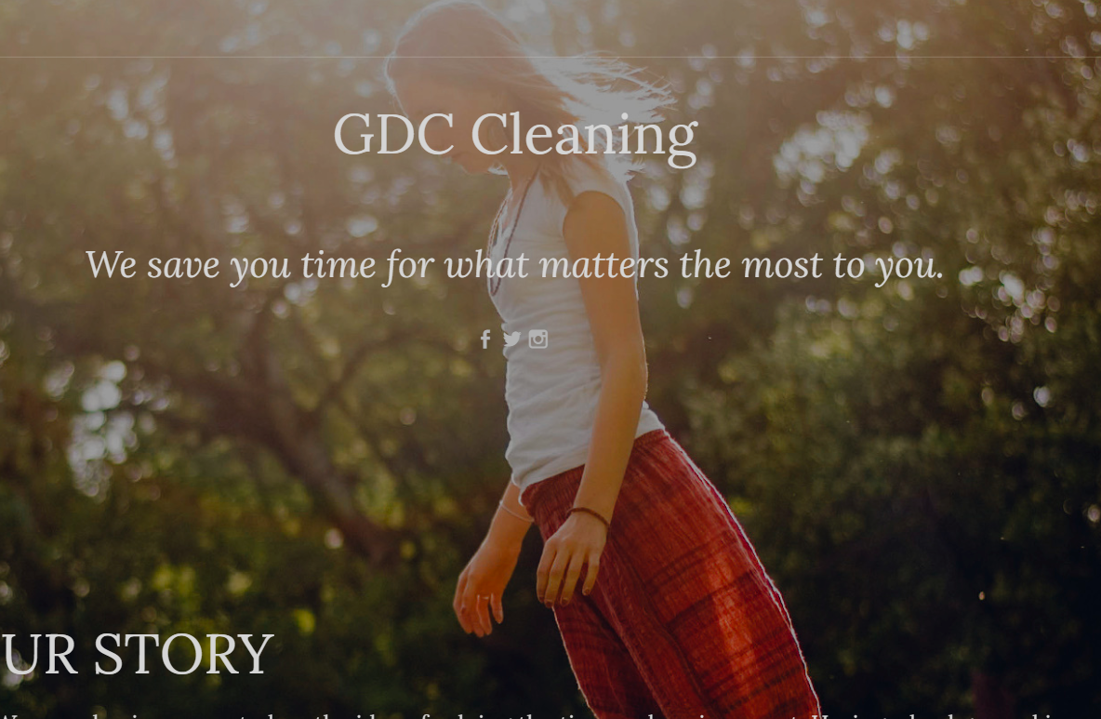

The name of the company can be found on the first line, written with large font containing upper characters designed to catch the visitor’s eye, followed by an idea that is in everyone’s interest, as we live in the era of speed and time is very precious.
Lower on the page I have created a section called “Our Story”, which reveals the idea that the business has been created on, the background of the owners and what they value, already promoting a few of our products and services, covering a larger spectre of our customers, which is family and friends.
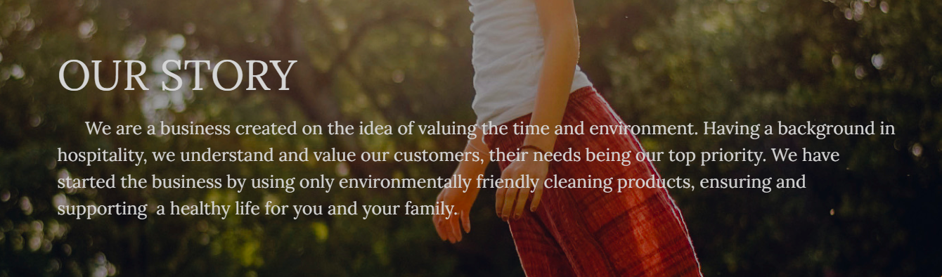

For the second page of my website, called “About”, I have chosen a background image that shows the nature of the business that I have created, choosing four colours that give life to the page.


The page contains three sections, as following:
- First section, revealing the aim of the business, the services it provides and the products it uses in providing the services.
- Second section designed to help visitors familiarise with our members of staff.
- Third section, providing a brief of out employees’ skills and experience combined with the level of knowledge related to the products and services that our business provides.


The images have been chosen in accordance with the message that each section is designed to send, as people tend to remember more of what they see and less of what they read.

For the third and last page, called “Contact us”, I have chosen a background image that send a sense of comfort and friendship when it comes to the relations between out staff and our customers, showing them that we are happy to help at any time with any issue and/or concern.
In the image a male and a female can be notices, as the questionnaire shows that the percentage of males and females in the audience are 50%-50%. In the top right corner of the page I have written our business’ contact details, ensuring they are easy to spot and read.
The page contains the business Social Networking icons, as the primary research shows that the age of our audience is between 26 and 45, meaning that social networking applications are used by al least half of our audience.
The last element that I have added on my page is a Contact form, which will help our customers to contact us even when they are not able to use their phones or when our contacting services are very busy.


