Introduction (200 words approx.)
Provide a brief background to your school and the class. Summarise why you have chosen to explore your particular research question.
This study will look at the misconceptions that a class of year 7 (11-12-year-old) students hold in the topic of Algebra. The name of the school that these students attend, which will be omitted and instead referred to as School X for reasons of anonymity, is very multicultural with 80% of the students being from minority backgrounds. School X is a school taught in English medium with students ranging from the ages of 11 to 18. School X has a rather large student body of 1,721 with 344 of these within its sixth form provision (ESTYN, 2017). The class itself is of lower intermediate level with 22 pupils in the cohort. One of the pupils is statemented and 2 others have some form of learning difficulty. The school as a whole has 32% of it’s pupils listed as receiving free school meals (FSM) with the class having five of its number within this category.
The question that this report will endeavour to answer is: what misconceptions do a year 7, intermediate class hold, and can these misconceptions be eradicated through teaching interventions designed to tackle these misconceptions? The methodology for these misconceptions will be discussed in the following sections as well as the layout and informants of the pre and post-test paper questions.

Literature Review (2,500 words approx.)
Evaluate academic, research and professional literature relating to your question. Identify key issues and concerns; examine any differing views and/or recommendations and explain how your teaching and learning decisions have emerged from your reading.
- Where are the questions from?
- What are they trying to test?
- Why?
- What are the expected results?
- Where do they come from?
- How can the misconceptions be tackled?
There are a number of misconceptions that are present within the topic of algebra. Some studies into these misconceptions have attempted to categorise them into a number of categories (see Appendix Figure 1). Not all of these categories were appropriate to include in the test areas as they are beyond the scope of learning and ability for the subject class of year 7 pupils.
Some may hold a misconception surrounding the use of the equals symbol. Foster (2007) and Molina et.al (2004) show that this is in part due to the equals symbols being seen as a function instead of a statement of equality where both sides have equal value. Molina, Ambose, & Castro (2004) records another misconception in the way the students wish to order the equation in a familiar and consistent way. When presented with $3+2=2+3$ some of the students rewrote as $3+2+2+3=10$. This does seem to link back to the idea that some students see the equals sign as a function and should therefore appear between the string of numbers and where the answer should be generated. This phenomenon has been noted by many researchers aside from the few mentioned above: (Booth & Koedinger, 2008) and (Knuth, Alibali, Hattikudur, McNeil, & Stephens, 2008) to name a few. In close relation to this there is a need of some students to generate only one single answer and that the equation can only be laid out as the problem on the left and the answer on the right (Knuth, Alibali, Hattikudur, McNeil, & Stephens, 2008) e.g. $7=5+2$ instead of the usual and expected $5+2=7$.
In order to confront these issues, Foster (2007) suggests an emphasis on the mathematical ideas being studied, in this case, solving equations. The idea being that the students will be able to derive meaning from the act of solving equations. This may prove challenging when considering the effect this may have on solidifying any long held misconceptions. In response of the issues with seeing the equals sign as a function, again Molina, Ambose, & Castro (2004), Vlassis (2002) and Foster (2007) concur that a conceptual understanding of the equation as a set of balance scales may be the most effective strategy in addressing this issue. Another such way can be found in a journal by (McNeil, Fyfe, Peterson, Dunwiddie, & Brletic-Shipley, 2011) where they suggest rearranging sums into an unfamiliar order may successfully show the true function of the equals sign, $7=5+2$instead of the usual $5+2=7$. Included in the presentations used during the lessons, slides dedicated to the use of a balance scale technique have been used in conjunction with this rearranging of equations. It has maybe been taken a step further by endeavouring to allow students to suggest other instances other than $5+2=7$ where balance between the two sides is maintained. In addition there are examples to discuss such as $7=5+2$ or $13=8+5=6+7$ where the order change may assist in helping the students realise the balancing role of the equals symbol but still closely links with the ideas of McNeil et al (2011). Ketterlin-Geller et al (2007) expands on this suggesting the use of a question such as $1+____=____$ where a student without a true conceptual understanding of the equals symbol will be unable to provide an answer, allowing for a true example of cognitive conflict (Margarita, 2001). Regarding the issuse of the pupils requiring a singular answer, Knuth et al (2008) suggest a discussion around the point of mulitiple acceptable answers provided that both sides of the equation remain a true statement of equality. Booth, Barbieri, Eyer, & Pare-Blagoev (2014) suggest that this misconception has a prominent effect on students toward the end of their study of algebra as the problems become more challenging and that this can have a descidedly negative effect on a students’ achievement in mathematics. Therefore any classroom time that is spent on the concetual and relational understanding surrounding the equals symbol is well spent.
Another such misconception in the area of algebra, concerning the simplification of expressions, can be found in the oversimplification of such expressions (Booth, Lange, Koedinger, & Newton, 2013) (Booth L. R., 1984). This may stem from the need of pupils to produce a single answer at the end of solving a mathematical problem as is the case when solving arithmetic problems (Knuth, Alibali, Hattikudur, McNeil, & Stephens, 2008). There tend to be a few main errors within the scope of oversimplification, but this report will focus on those with addition and subtraction as, again, the use of exponents would have been out of the reach of ability for the subject class. These include: detachment of negative signs in front of the expression components, where students would simplify $-6a+3a$ as $-9a$ or $4a+3-2a$ as $6a+3$(Seng, 2010) and; adding all components into a single answer, where a student might simplify $6a+3$ as $9a$. In planning for lessons there has been consideration in order to ensure that pupils understand what groups (variables or numbers) can be simplified and when they cannot. I have found his to be especially important when transitioning between simplifying like terms through addition and subtraction into multiplication of a number of terms. Often giving a non-example that allows students to question and test their understanding of these concepts can be effective in some cases.
In regards to the irradiation of this misconception Booth & Johnson (1984) suggests that there is a need to have students see the unlike terms as distinct groups and, linking back to the need that some students have to produce a single number as an answer, that it is also acceptable for answers such as $6+9=7+8$ to be produced. This will allow students to see that an answer of $4x+5$ is acceptable within the topic of algebra. Many bodies of research record the need to link many of the concepts within mathematics to the concrete examples that you may see in normal life. Watson (1990) suggests an easy method for the classroom being the use of boys and girlsacting as the two distinct groups that cannot mix. A link then can be made to the algebraic application where the students could then represent these groups mathematically, likely with $b+g$. There is also much to be said for a simple example of cognitive conflict (see Appendix Figure 2) allowing for students to reason their own mistake and the resulting mahtematical impossibility.
- Difficulty with comprehending variables
Some students have been shown to have difficulty with comprehending the role of the variables or unknowns in an equation. This becomes quite prevalent in the misconception where students see the role of the variable not as a representative of an unknown, but as a label (Booth, Lange, Koedinger, & Newton, 2013). Where some may solve $4x+25=73$ with the correct answer of $x=12$ others will solve this equation with the answer of $x=8$, where they have directly substituted to get $48+25=73$.
Unfortunately, there seems to have been little concerning inroads into the way in which one might irradiate this misconception with the role of variables. One might speculate that there will be value in extending the idea of Foster (2007) in which students will be able to derive their own meaning in the solution of many of these sorts of problems. Hopefully in this pursuit the students might realise the role of variables and perhaps an appreciation for the correct method for substitution that this misconceived method so closely mirrors.
- Q4 Brackets
Some students will be unable to discern the role of brackets as a multiplication device in algebra (Dickson, 1984). Question 4 of the test paper can only be answered correctly if the student understands that brackets are multiplied in the same way as one might multiply variables and a preceding number. Unfortunately there may also be an issue with the use of negative numbers in this question as well that may cause the students some issue, an issue that will likely follow them throughout their time in high school (Booth, Barbieri, Eyer, & Pare-Blagoev, 2014). Even high ability students have been documented to have trouble with expanding brackets with a negative pre-multiplier (Seng, 2010). Students in this study (Seng, 2010) made the highest percentage of negative number errors when it came to bracket expansion. Medium ability students tended to ignore the negative multiplier more readily than other groups, a point also noted by (Hall, 2002). I predicted this will likely be the most common cause of error on question 4 of the test paper not only as this is a medium ability class but also due to the form of the question where this will be the largest deciding factor. This question will also hold difficulty for those students that do not wholly understand the role of variables as a representation of an unknow value. If given the question in a different form (see Appendix, Figure 4) where all variables have been replaced with real numbers, then students who have good knowledge of the order of operations will likely have far less trouble in answering this question.

- Q6 Pattern
Issues with students missing, misinterpreting or applying pattern where there may be none within the subject of mathematics can have implications within the topic of algebra (Xiaobao, 2006). Being able to spot pattern between two algebraic equations can show a deeper understanding of the concepts behind solving equations. Although, using pattern within a question on solving equations may open up the possibility of multiple methods in which to solve the problem and therefore, make it difficult to measure which of these methods the students have used to solve the equation. The hope then, is that the students will see that there is a pattern present and make an assumption towards a correct or incorrect answer, whichever the case may be.
For the one method of solving this question, as an equation, then the results in the post-test may be improved by the interventions put in place for tackling misconceptions surrounding question 3. Improving general mathematical fluency could be the only way in which to assist with recognising the pattern and how the relationships will affect the answer (Schoenfeld, 1992). Knowledge gained during the course of the interventions put in place during this research will likely help somewhat but if one is to adhere closely to Schoenfeld’s (1992) suggestions then there should be time allotted to deep class discussion around this topic. This will hopefully allow the participants to reason their on conceptual understanding surrounding the use of pattern.
- Q7 Worded problems
Many students seem to show difficulty in solving equations and/or problems in an unfamiliar format, such as those in the form of worded problems (Clement J. , 1982). Some may be simply unaware of the requirements due to the information being disguised by the surrounding, unimportant jargon. Others elect to miss these sorts of questions entirely having already resigned themselves to their seemingly inevitable wrong answer (Senseoffailurewordproblems). These misconceptions can be separated into a number of categories including: assigning variables, noting constants and representing variable relationships (Clement J. , 1982). Clement (1982) studied another such misconception where the participating students reversed the values of the variables in the problem. An example of which might be $There are six times as many rasberries as strawberries$, when writing an equation that would represent this statement some students might write $6R=S$, a reversal of the true values of the subjects of this formed equation.
Kaput (1985) suggest that modelling of the concepts needed allows the students to build a bank of knowledge that they can then use and recreate in situations that call for them. This not an all to dissimilar approach as was previously mentioned from Foster (2007), having the students derive their own meaning through practice of the problems. Although, this concepts likely calls for, at least, an initial stage of hightened teacher lead or morer highly structered learning in which the students can build their models accruately for future use in worded problems.
- Q8 unsure of requirements- inequalities
From experience in teaching inequalities I have noted the difficulty that students sometimes have in giving a range of answers instead of the usual, and expected, single answers that are the perceived norm (Knuth, Alibali, Hattikudur, McNeil, & Stephens, 2008).
As a general point for the improvement of student performance in the area of algebra there is reason to encourage students to engage with incorrect examples and be able to explain why the example is incorrect and how it can be corrected (Booth, Lange, Koedinger, & Newton, 2013). Booth et.al (2014) also gives mention to the fact that there is little to support the encouragement of a multiplicity of methodologies in the pursuit of student flexibility in the solution of algebra problems as the study group seemed to show no discernible beneficial practises. There seems to be no little other way in which to address this misconception/ difficulty other than to ensure that a solid conceptual understanding is established.

School Policy and Practice (500 words approx.)
Examine briefly the school and/or departmental policy (where one exists) in your chosen area. Look at how it links (or doesn’t) with your readings. Where a specific policy is not available, explore any other guidance (schemes of work, for example) and practices.
The department has found much success in results from examinations and has achieved two excellent ratings in its 2017 ESTYN inspection. The teaching of topics within the department follow mostly instrumental methods with some rare instances of relational understanding where there is time to do so. There will be a need to expand on these practices in order to tackle some of the previously mentioned misconceptions as the current scope of the topics for this level of ability and the time constraints on teaching do not allow for a comprehensive covering of these misconceptions.
From personal experience there is a good community within the mathematics department at School X that allows for discussion of ideas that will help myself and other teachers in tackling misconceptions within algebra. The mathematics department at School X already utilises pre and post-testing to track the progress of its pupils and to indicate which topics require the most attention. As is the case for many high schools, the methods that are used in the solution of problems in all topics have been standardised across the department. As such the interventions will need to follow these guidelines, regardless of whether there are methods that are better supported by research to produce better results and deepen understanding. This will likely negatively affect the efficiency of the interventions that will be put in place. An example being the use of float and ping instead of the balancing method in solving equations. The use of the balancing method would better compliment the idea of the balancing scales suggested by Molina et al (2002, Foster (2007) and Vlassis (2002). The scheme of work (SOW) at School X (see Appendix, Figure 13) allows teachers to decide the order of lessons within each topic but these should be based on the results of the pre-test and cover the topics that scored the least.

Methodology & Ethics (1000 words approx.)
In the light of your evaluation of your reading and school policy/practice, outline the methods you have chosen to use in order to explore your research question. Read research methodology literature and select your methods and research tools wisely. Why have you chosen these research tools to examine your question? What are the benefits and limitations of your methodologies? You will be given some guidance as to how to best use key research tools for this assignment.
In accordance with the ethics policy of the university under which this research has been undertaken, the appropriate steps have been embarked upon to inform all the necessary parties. The students have been informed that their participation is of their own volition and that they may withdraw their permission to use the data collected from them at any time by informing the researcher. As the participants are all under the age of consent, School X has been asked to inform the parents/ guardians of the participants of the research that is being undertaken and give them opportunities to withdraw their charge’s data from the data pool. As the methods used during the course of this research would naturally occur under the preview of teaching and perhaps inform better teaching methods, there will be little further ethical dilemma from this aspect. All participants will remain anonymous as is with the name of the school, with their names instead appearing as e.g. “Pupil A”. In order for the research to have been undertaken as part of the university there has been a completed and approved ethics form that has withstood critique on behalf of the ethics board of the university. There will be no particular sampling method as the research has been undertaken within one class, as described above, wherein all pupils will take part. This is in keeping with the research question.
The participants will be asked to complete a series of eight questions each with a particular topic within the area of algebra. Each question endeavours to draw out a particular misconception that is associated with that topic. Data from the marking of these test papers will be analysed in order to see which misconceptions are held and by which pupils in the class in order for an appropriate teaching intervention(s) to be put in place. These interventions have the intention to assist the pupils in answering the question successfully when they next attempt the same question in the post-test. A comparison will then be draw between the results of the pre and post-tests to determine the effectiveness of the intervention(s) on the misconceptions that the pupils hold.
As there will be no interviews or follow up on the answers given in the pre-test to ascertain the exact cause of the incorrect answers given, it will fall to myself as the researcher to evaluate the cause to the best of my ability. This may have a negative effect on the interventions that will be put in place as they may not target the correct misconception, due to me having misunderstood where the misunderstanding of the topic area is occurring.
In order to test the presence of a misconception formed around the equals symbol, question 5 of the test paper contains an equality chain where each section of the equation should total 11. Inspiration for this question has been gleaned from the paper by Ketterlin-Geller et al (2007). In the answering of this question it should become evident which students see the equals symbol as an operation. It may however be difficult to discern between this misconception and some student’s needs to have a singular answer (Knuth, Alibali, Hattikudur, McNeil, & Stephens, 2008).
Question 1 (Booth & Koedinger, 2008) of the test paper endeavours to test for the presence of oversimplification misconceptions. Depending on the specific misconception the student may answer in any number of ways. If a is given as their answer, then the students have a concept of the variables and numbers being from two separate groups however they will have had to ignore the negative sign in front of the $x$ term (Seng, 2010). Part b would have shown a misconception with the index notation, but the negative signs would have been kept. Part c would have shown possibly the simplest form of oversimplification where the student has added all the terms together and therefore does not see them as distinct groups (Foster, 2007).
Question 3 of the test paper tests for misconceptions concerning variables as labels, as mentioned by Clement (1982), having drawn inspriation from their paper. Students that use variables as labels will select option a (see Appendix, Figure 3). There maybe some other misconcepotions that will cause the participant to answer this question incorrectly, such as ingnoring negative signs (Booth, Barbieri, Eyer, & Pare-Blagoev, 2014) (Seng, 2010), which will lead then to answer with d.
Question 6 shows the understanding of the role of equation in algebra. The question itself can be solved in a number of ways. One might find the answer through reasoning that if you take one more off of the unknown f then the answer must be one smaller. You may also approach this question through solving the equation to find a real value of f. I predict many students will be simply unsure of the requirements of this question and leave it blank. As is stated in Foxman (1991) APU report, from which inspiration for this question was drawn, there is potential for students to see the increasing number in the second equation as the deciding pattern and therefore that the answer will then need to be larger as well. As for interventions that may assist students in answering this question I hope to increase the rate at which this question is correctly answered by increasing knowledge around solving equations. This will leave the issue with students jumping to conclusions about the pattern but I would expect a small increase in correct answers to this question.
Question 7 has been designed to test the ability of the students to deal with information in worded problems. These questions are in accordance with the mathematics curriculum of Wales where, under the expressions and formulae section of the key stage 3 programme (Welsh Government, 2016, page 21) it states that students should be able to substitute positive whole number into two step equations. This is a large part of being able to answer the question and removes some of the other limits on the students being able to answer this question correctly that have been mentioned earlier. Any issues with reversal or assigning variables (Clement J. , 1982) should not appear as the expressions that will be needed have already been formed. The issue will appear with the particiapnts being unsure of what to do with these expressions and how they relate to one another.
Question 8 requires the teaching of inequalities. Materials for this lesson require the students to work in forwards and reverse when solving the practice questions. It is the intention of this practice to allow the students to gain a higher level of understanding of this topic from this exercise. As this class consists of year 7 pupils they will not have, and will not have covered during the interventions, how to solve inequalities. This is both good and bad within the context of the question as it means it will narrow the number of misconceptions that may appear in the solving of this question but will also likely increase the number of students that will opt to leave this question blank. It is possible to solve the problem posed through reasoning skills as there is a limited number of possible answers and a qualifier for which of these satisfy the inequality.
Evaluation (2000 words approx.)
Explore your sequence of lessons, making clear links between your practice and the reading which underpins it. Evaluate your tasks, resources, approaches and methods making close links to reading. Examine and present any results/findings clearly and provide links to your reading.
The sequence of lessons follows the SOW set out by the department that the teachers need to adhere to. There was also a specific way in which the topic content needed to be covered. As is to be expected the content laid out in the SOW was given priority over the teaching that would be in support of tackling the misconceptions that were being tested. There was, therefore a limit in the interventions that would be able to be included in the content of the lessons. There was also the need to include lessons designed by the department to cover aspects of the literacy and numeracy framework which then took more of the time in which the research could be carried out. The sequence of lessons followed a gradual progression through the topic of algebra and endeavoured to stick to the content laid out in the mathematics curriculum (Welsh Government, 2016). As such the lessons started with algebra simplification (not including exponents) which had been covered during the first part of teaching covering the topic of algebra, with more content being added to tackle specific misconceptions (as will be discussed in following paragraphs). Next came solving one and two step equations, again ensuring that specific misconceptions could be addressed, then moving on to inequalities. Worded problems have been introduced to the class before the official commencement of the research in the form of starters and some plenaries, so the students were not entirely unfamiliar with the requirements of these sorts of questions.
In accordance with the findings of Molina, Ambose, & Castro (2004), Vlassis (2002) and Foster (2007) that the use of a balance scale to cement the idea of equality when solving equations was included within lessons pertaining to solving equations. During this time there was also opportunity to expand on the idea of the acceptability of multiple parts to an answer suggested by Knuth et al (2008) and Ketterlin-Geller et al (2007) where a discussion was held over this point of contention. In relation to the idea that solving equations can allow students to derive their own meaning as suggested by (Foster, 2007), this point was explored briefly through the expected practice/ task stage of two step equation lessons. This practice had the intention of improving results around question 3 of the test paper and also potential for assisting with a number of other questions (2, 6 and 7). This process of allowing students to develop their own meaning and models through meaningful practice (Kaput, 1985) has been extended to a range of lessons and misconceptions. Questions 6, 7 and 8 all appear to be questions that would benefit from this method.
The comparison between the pre and post-test results show there was an overall improvement in the performance of the pupils. As there was such a range in the sample size the percentage of correct answers was used to make this comparison. A mean taken of the percentage of correct answers in the pre and post-test shows there was an increase from 24.2% to 30%. If the post-test is reduced to only those who took part in the pre-test also, then the results show a much greater increase in the percentage of correct answers between the pre and post-test (see Appendix, Figure 18). I will be using the larger sample that I was able to obtain because the students that were not present for the first lesson, in which the pre-test was undertaken, were later present for at least the majority of the intervention lessons that followed. I do believe that this makes them suitable measures for the success of the interventions and that the use of percentages of correct answers suitably accounts for the disparity in numbers of participants. There is also merit in the increase in reliability that the increased sample size brings to the data but does bring issues in measuring individual progress between the two testing periods.
When making the comparison between pre and post-test answers (see Appendix, Figure 6) there was an increase in the number of students that got the first question correct, from 0% to 14.3%. As is the case with the entirety of the results, there is a real chance that this is simply due to the increased sample size in the post-test phase of the research, bringing in mew participants that may not have had any misconceptions to begin with. On the pre-test 6 out of 13 pupils oversimplified by adding all the terms together. Three pupils left the question blank, one ignored the negative sign and three answers showed pupils attempting to assign a value on each of the answers (see Appendix, Figures 10, 11 and 12). On the post-test the most common misconception was with ignoring the negative sign (Seng, 2010) with 9 out of 21 of the class showing this misconception. Misconceptions with oversimplifying by adding all the components and confusion between operations and exponents had 2 out of 21 and 3 out of 21 students in their respective number. 5 out of the 21 students left no answer on the paper despite being prompted to do so. One student presented a misconception that was not found during the literature review phase of this research (see Appendix, Figure 7). The student, Pupil C, seems to have attempted to assign a value upon the question and the available answers leading to an inability to decide on the correct answer. This seems to bare close relation to the need to arrive a single answer and therefore, that multiple figures cannot be correct.
Question two part a was answered correctly at much the same rate between the pre and post-test whereas parts 2a and 2c both showed a percentage increase in correct answers (2b from 83.3% to 95.2% and 2c from 66.7% to 76.2%). 2 of the 13 students got 2a wrong and 1 got 2a and 2c wrong but this seems to have been due to errors in simple arithmetic (see Appendix, Figures 14, 15 and 16). Pupil V interestingly misinterpreted the question and instead gave the number of sides the shapes that were meant to represent unknown values (see Appendix, Figure 10). This could be indicative of a lack of understanding of the role of variables, but it is difficult to say in this context. Pupil G answered both of the first parts to this question correctly but left the final part blank (see Appendix, Figure 17) which was likely due to a lack of arithmetic ability.
Question 3 saw an increase in the percentage of correct answers between the pre and post-test with 25% and 52.4% respectively. This could have been affected by absence at the time of the pre-test and during the intervention stage, where the teaching needed to successfully answer this question could have been gained. Of the 13 students that took the pre-test: two left no answer; one answered with d; three answered c and 5 answered with d. For those who answer d they seem to have an issue with using the inverse operations, having not changed the $+15$ to a $-15$ when using the departmentally encouraged method of float and ping. On the post-test the most common wrong answer given was part a (a direct substitution).
Question 4 saw an increase in correct answers between the pre and post-tests with 0% and 9.5% respectively. This increase would be linked to the teaching of two step equations rather than the teaching of expanding brackets specifically. Knowledge that a number and term that are unseparated result in multiplication could allow a student to answer this question correctly. However, this increase is only the result of two participants getting the question correct, Pupil U and Pupil Q, with only Pupil U getting both questions 3 and 4 correct. I would expect any pupil who was able to answer question 3 correctly would be able to recognise the term and number multiplication so should be able to apply it on question 4. It is also possible that these correct answers are flukes on the part of these participants one of whom consistently achieve at the bottom end of the class in other testing. This does not necessarily indicate that the answer was a fluke but does draw doubt on the level of improvement between the pre and post-test.
Question 5 saw no improvement between the pre and post-test having been answered incorrectly in both tests by all participants. Those participants that did answer the question chose to leave the sum of each section instead of balancing all of the sections (see Appendix, Figure 10 for an example). It would seem that the participants did not grasp the true role of the equals symbol or the validity of multiple parts to each side, as was the intention of the interventions. As this is the case these interventions will certainly need to be reconsidered or perhaps completely reworked to produce some positive results in the future.
Question 6 saw one of the largest increases in correct answers between the pre and post-test from 8.3% in the pre-test to 28.6% in the post-test. This result could have benefitted from the teaching surrounding question 3 (two step equations), namely the practice and derived meaning that the students have gained through their practice of these sorts of problems (Foster, 2007). 7 out of the 21 students fell into the trap, assuming that as one of the numbers got larger the other would also. There were a number of interesting answers to which I have struggled to understand the cause/ thought process that lead the pupil in question to that answer (see Appendix, Figures 19-24).
Questions 7 and 8 saw the same results as question 5 with no improvement between the two tests and zero correct answers. Perhaps these questions were above the ability of this class but even so there ought to have been a slight increase in correct answers due to the interventions being put in place. Although inequalities would have been covered during the intervention teaching, so students should have been familiar with the concept of giving a range of answers, they seem to have been unable to find the constraints on these boundaries. From the lesson that was taught on this topic it was clear to see from the amount of assistance students needed to be able to answer simpler and more basic questions on inequalities that this question was not going to be answered with great accuracy. Perhaps this question also ought not to have been included as, evidently based on the results, this was beyond the scope of learning for this class.
Worded problems and forming equations often cause issue for many students (Clement J. , 1982) and the results from question 7 follow this pattern. The results from question 3 reflect this well, showing that students had more time than originally planned to practice solving two step equations (a part of this problem). This seems to have had little effect on tackling any misconceptions surrounding this question.
In the teaching of the solution to forming an equation to solve (question 7) it has been shown that there is no guarantee that the method to solve this type of problem will be adopted by the pupil reliably wherein the student will simply revert to their own intuitive method in order to solve the problem (Clement J. , 1982). It is therefore questionable as to what extent the teaching around these types of question can assist the students in consistently solving these types of problems instead adopting methods that will hopefully alter the student’s intuitive method. Perhaps exorbitant amounts of practise into these problems will produce the desired results and allow the students to develop models for solving many types of problems (Clement J. , 1982).

Conclusions (1000 words approx.)
Sum up your findings, making links to your reading. Your conclusions should be drawn clearly from the work your evaluation. Point towards future practice, making recommendations based on this piece of research.
For the majority of the misconceptions that were represented by the questions chosen, there was a slight increase in the percentage of correct answers. This suggest that the interventions that were put in place had some positive effect on the irradiation of the present misconceptions. The greatest gains in correct answers was on questions 3 and 6 (pattern and solving equations). As I followed the recommendations of Foster (2007), Molina et al (2004) and Vlassis (2002) loosly in the form of introducing the topic of solving two step equations, it is somewhat reasonable to conclude that there is some link to the increased success in this question and in tackling the present misconceptions. However, looking into the other questions which also included solving equation (question 7) where there was no imporvement in the percentage of correct answers (a mark of zero for all participants both tests) then it draws sceptasism towards the effectivness or at least the consistency of results produced by the interventions that were put in place. It is worth also considering the reliablility of the data as a result of the small sample size and then, for the post-test, the addition of participants that had not participated in the pre-test. This may have skewed the results towards either direction but I suspect it may have done so to the detriment of the question results at hand.
Questions 7 and 8 were both answered entirely incorrectly in both the pre and post-test suggesting that there was little effect from the teaching interventions. As the interventions included teaching a general understanding of the topics (inequalities and worded problems) it would seem that the level of understanding that was gained was not enough to increase results on these questions. This may also be due to the questions being at a too advanced level for the subject class. In the teaching of these topics it required a great deal of additional help from myself and others in the classroom to allow even a minority of the class to access the content, let allone be able to display a higher level of understanding, even after the interventions.
Question 2 saw improvement in parts b and c but little difference in part a. this is likely due to work associated with solving two step equations where students will have had many opportunites to interact with inverse opporations, ensuring that they are more capable in dealing with multiplication and negative terms moving to the opposite side of the equation.
Although there was one of the largest imporvemnets in correct answers on question 4 there are many factors that would lead one to doubt the validity of this imporvement. I would point to the input of new participants as the driving force of this improvement. It would therefore be unwise to conclude that these improvements were due to the interventions being an effective means to irradicate misconceptions. There would need to be further information from the participants that got the question correct to confirm that their reasoning in solving the question would truly lead them to the correct answer.
Question 1 was another that showed a relatively large improvement. It seems the suggestion of Booth & Johnson (1984) to encourage students to see variables as distinct groups has a positive effect on the misconceptions of this class. Although there was an imporvement, there ought to have been more correct answers had this misconception been thoughly tackled and not meerly migrated to other misconceptions in the same area. This improvement is difficult to qualify as only one of the students that had the question right on the post-test, had it wrong on the pre-test and therefore show that the improvement was due to an increase in knowledge, from whatever source, during the course of the research and not simply due to more compitant students returning from absence during the pre-test. The misconception involving the addition of all the terms in the expression does seem to have dimminished to the point of obsurety however, more work will need to be done in tackling issues with detaching negative signs (Seng, 2010) as this proved to be a common error and will likely lead to a further increase in success on this question.

Limitations and future development (800 words)
Identify the limitations of the study paying particular attention to areas of future classroom enquiry which will support your professional and personal development.
The sample size for this experiment was too small due to a trip at the start of the term. There has been some attempt to account for this by comparing percentages of correct answers between the pre-test and post-test (see Appendix, Figure 6). To properly investigate the effects of teaching on tackling misconceptions I should in future use a larger sample size and perhaps vary the ability level of the participants by including a sample class form both ends of the attainment spectrum.
There has also been a limit on the interventions that could be implemented due to the departmental scheme of work being so structured and precise. There was therefore little to no time to ensure that the teaching could have covered the content and discuss the misconceptions within the subtopics. In future I will ensure to seek greater permissions to cover the content and also endeavour to plan the interventions in such a way as to fit into the existing scheme of work more aptly. This will require more authorisation from the host school and perhaps, depending on the level of variation from the SOW and/or curriculum, a greater level of ethical clearance to perform the research.
The interpretations I could draw from the pre-test results were limited and meant that at times I could not put the correct interventions in place to tackle a specific misconception. In future I would like to include interviews in order to properly and more accurately interpret where the misunderstanding has occurred, where the pupil in question can explain their reasoning in full. These will need to be recorded on the basis of analysis and proof of completion. All of these points invite further ethical dilemmas and hurdles over which to jump that may hinder the research taking place. If the research becomes too hindered by the proposed inclusion of interviews, there may be a lesser but still somewhat effect addendum in the form of questions included on the paper that ask the participants the reasoning behind their answer. As this is outside the interview setting it does pose less of an ethical dilemma but unlike interviews runs a risk of participants opting to leave the question blank, leaving no data on which to base the interventions.
The application of interventions could also be helped by the design of questions wherein as few misconceptions as possible might rear their head in order to more easily identify the misconceptions that are present and therefore select the most appropriate interventions. This should allow for a more directed discussion around more specific points that will assist with tackling any misconceptions. I expect this will have a significant effect on the results in the post-test.
An improvement to the tackling of the misconception of the equals symbol I believe would be better addressed with the use of a real or virtual set of scales that the students can interact with in their own ways and derive their own meaning, as Foster (2007) recommended. The current state of the inclsuion of the balance scale does not allow for student interaction with the concept enough, remaining too treacher lead and therefore ingnoreable by the pupils. Althogh the pupils seemed to interact well with the disscussion around multiple answers being acceptable, this did not translate into increased numbers of pupils answering question 5 correctly. This may be where future research into the equals sign misconceptions can follow (Carpenter, Franke, & Levi, 2003) more closely and given the students a series of questions that slowely scale in difficulty (see Appendix, Figure 5).
Oversimplification misconceptions, question 1, showed improvement in the post-test showing that a mere disscussion and stressing from the teacher that the different variables exist in different groups has some postive effect on these misconceptions. However, in future research and teaching I would like to cement this idea further by ensuring the presence of concrete, physical objects are present to represent the different groups. This would more closely mirror the suggestions from (Watson, 1990) and hopefully build a less abstract model for the students to base their learning on.

Notes
Some of the questions shown on the test papers have been marked incorrectly when they’re correct. This has been corrected in the data.

References
Booth, J. L., & Koedinger, K. R. (2008). Key Misconceptions in Algebraic Problem Solving. Proceedings of the Annual Meeting of the Cognitive Science Society, 30, 571-576.
Booth, J. L., Barbieri, C., Eyer, F., & Pare-Blagoev, E. J. (2014). Persistent and Pernicious Errors in Algebraic Problem Solving. Journal of Problem Solving, 7, 10-23.
Booth, J. L., Lange, K. E., Koedinger, K. R., & Newton, K. J. (2013). Example problems that improve student learning in algebra: Differentiating between correct and incorrect examples. Learning and Instructiuon, 25, 24-34.
Booth, L. R. (1984). Algebra: Children’s strategies and errors. Windsor: NFER-Nelson.
Booth, L. R., & Johnson, D. C. (1984). Algebra: Children'Strategies and Errors: A Report of the Strategies and Errors in Secondary Mathematics Project. Windsor: Nfer Nelson.
Carpenter, T. P., Franke, M. L., & Levi, L. (2003). Thinking mathematically: Integrating arithmetic and algebra in elementary school. Portsmouth: Heinemann.
Clement, J. (1982). Algebra word problem solutions: Thought processes underlying a common misconception. Journal for Research in Mathematics Education, 13(1), 16-30.
Clement, J. (1982). Algebra word problems solutions: thought prcess underlying common misconceptions. Journal for Research in Mathematics Education, 13, 16-30.
Cometson, O. (2019). Investigating Issues in Secondary Education. Swansea: UWTSD.
Dickson, L. (1984). Children learning mathematics. (Cassel, Trans.) Oxford.
Foster, D. (2007). Assessing Mathematical Proficiency. 53.
Foxman, D. D. (1991). APU mathematics monitoring (phase 2). Slough: National Foundation for Educational Research.
Hall, R. D. (2002). Thought Process During Simplification of an Algebriac Expression. Retrieved from University of Exeter: http://socialsciences.exeter.ac.uk/education/research/centres/stem/publications/pmej/
Kaput, J. J. (1985). MULTIPLICATIVE WORD PROBLEMS AND INTENSIVE QUANTITIES: AN INTEGRATED SOFTWARE RESPONSE. Cambridge: Harvard Graduate School of Education.
Ketterlin-Geller, L. R., Jungjohann, K., Chard, D. J., & Baker, S. (2007). From arithmetic to algebra. Educational Leadership, 65(3), 66-71.
Knuth, E. J., Alibali, M. W., Hattikudur, S., McNeil, N. M., & Stephens, A. C. (2008). The importance of equal sign understanding in the middle grades. Mathematics Teaching in the Middle School, 13(9), 514-519.
Margarita, L. (2001). On the cognitive conﬂict as an instructional strategy for conceptual change: a critical appraisal. Learning and Instruction, 11, 357-380.
McNeil, N. M., Fyfe, E. R., Peterson, L. A., Dunwiddie, A. E., & Brletic-Shipley, H. (2011). Benefits of practicing 4 = 2 + 2: Nontraditional problem formats facilitate children’s understanding of mathematical equivalence. Child development, 82(5), 1620-1633.
Molina, M., Ambose, R., & Castro, E. (2004, 07 14). In the transition from arithmetic to algebra: misconceptions of the equal sign. Retrieved 04 15, 2019, from http://funes.uniandes.edu.co/552/1/MolinaM04-2889.PDF
Seng, K. L. (2010). An Error Analysis of Form 2 (Grade 7) Students in Simplifying Algebraic Expression: A Descriptive Study. Education and Psycology, 139-162.
Vlassis, J. (2002). The balance model: Hindrance or support for the solving of linear equations with one unknown. Educational Studies in Mathematics, 49(3), 341-359.
Watson, J. (1990). Research for teaching. Learning and teaching algebra. Australian Mathematics Teacher, 46(3), 12-14.
Watson, J. (1990). Research for teaching. Learning and teaching algebra. Australian Mathematics Teacher, 46(3), 12-14.
Welsh Government. (2016). Programme of Study for Mathematics, Key Stages 2-4. Retrieved from Laerning Wales: https://learning.gov.wales/docs/learningwales/publications/150717-nc-maths-en-v2.pdf
Xiaobao, L. (2006). COGNITIVE ANALYSIS OF STUDENTS’ ERRORS AND MISCONCEPTIONS IN VARIABLES, EQUATIONS, AND FUNCTIONS. Texas: Texas A&M University.

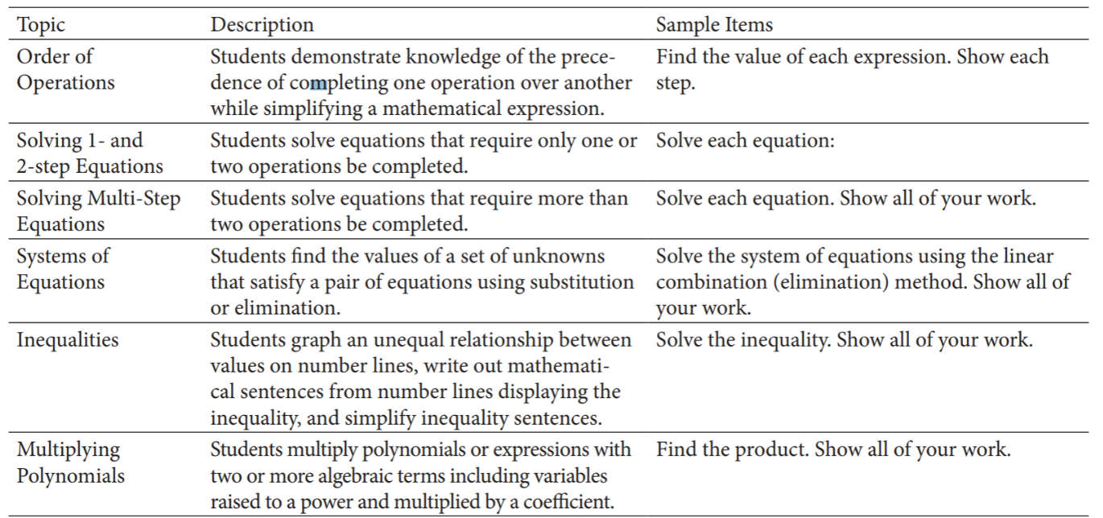
Appendix
Figure 1- (Booth, Barbieri, Eyer, & Pare-Blagoev, 2014)

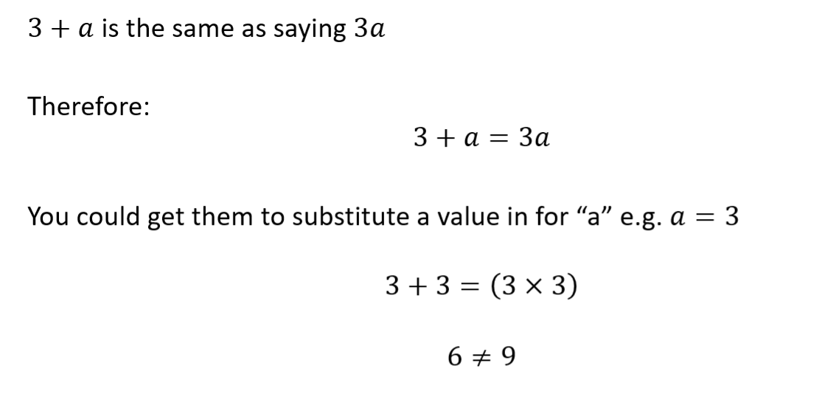
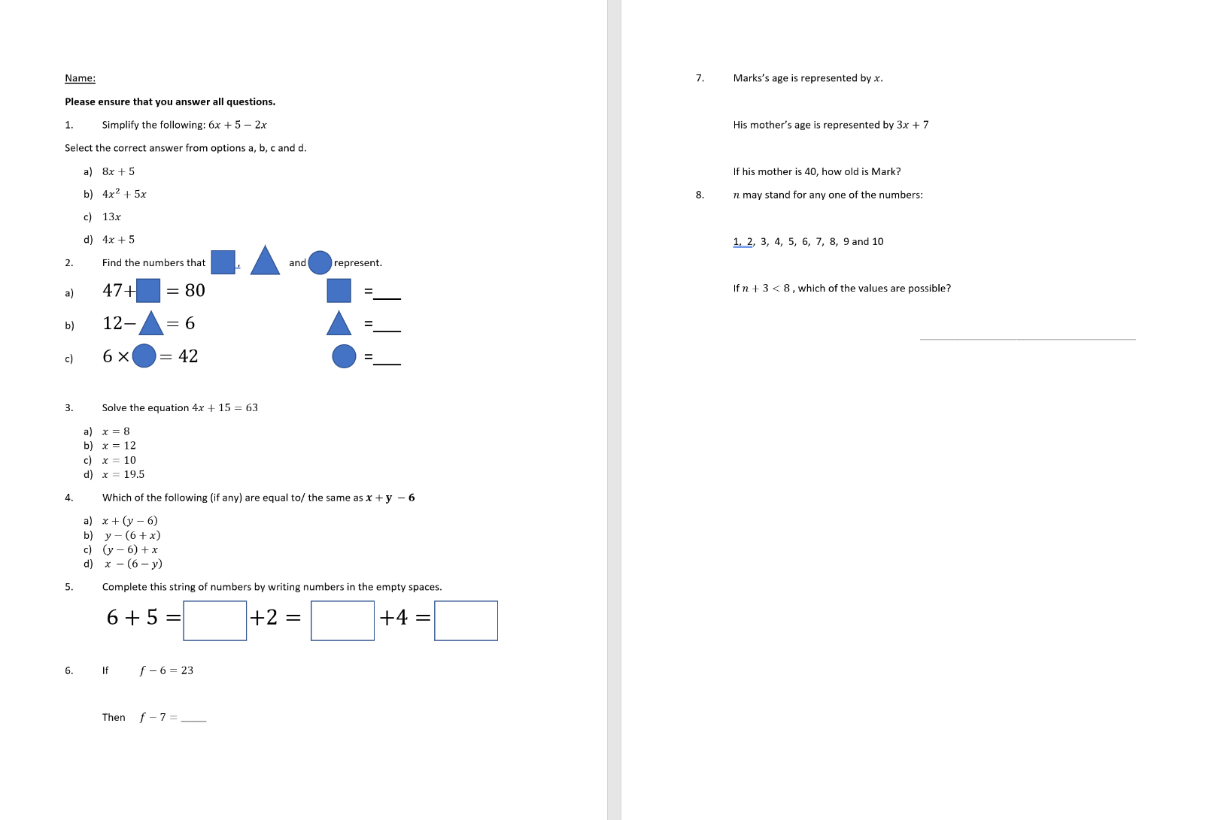
Figure 2- Example of cognitive conflict in collecting unlike terms
Figure 3- Test paper for pre and post-test

- 5 – 2 + 3
- (5 – 2) + 3
- 5 – (2 + 3)
- 5 + (3 – 2)

Figure 4- question 4 within variables represented by real values
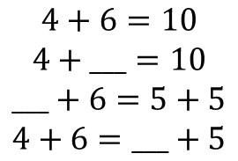

Figure 5- Scaling difficulty questions relating to equality misconception inspired by Carpenter et al (2003)

Figure 6- Test results comparison by percentage of correct answers

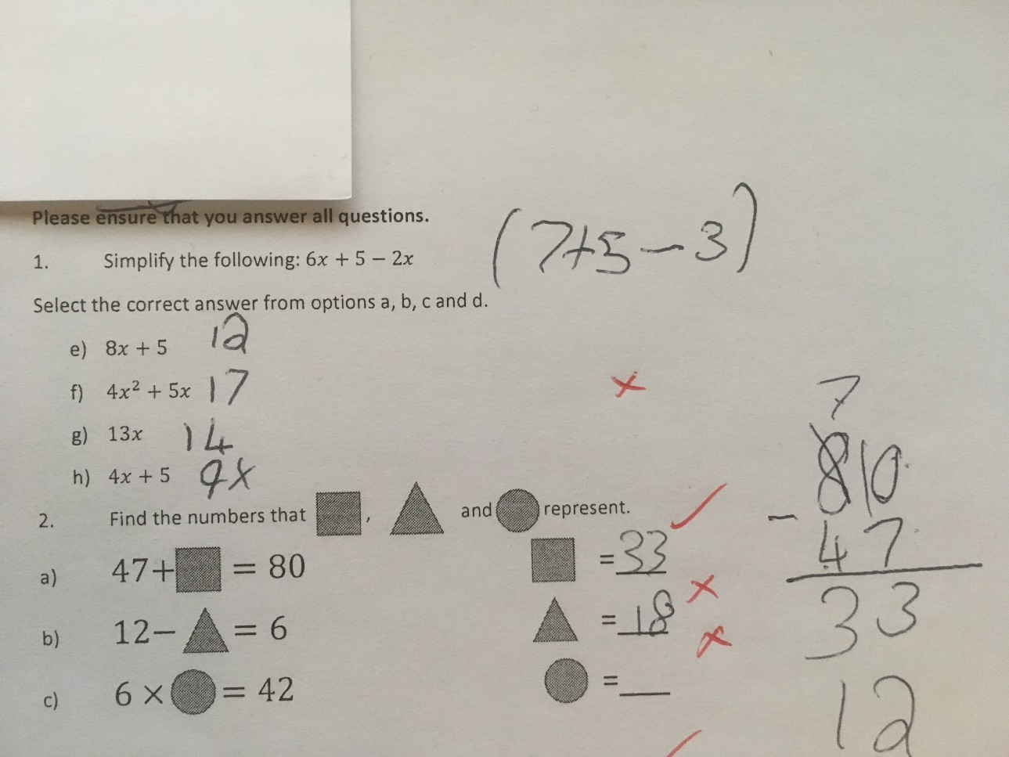
Figure 7- Sample of Pupil C's work showing unique solution to question 1 of the test paper
Figure 8- Pre-test raw data

Figure 9- Raw data from post-test
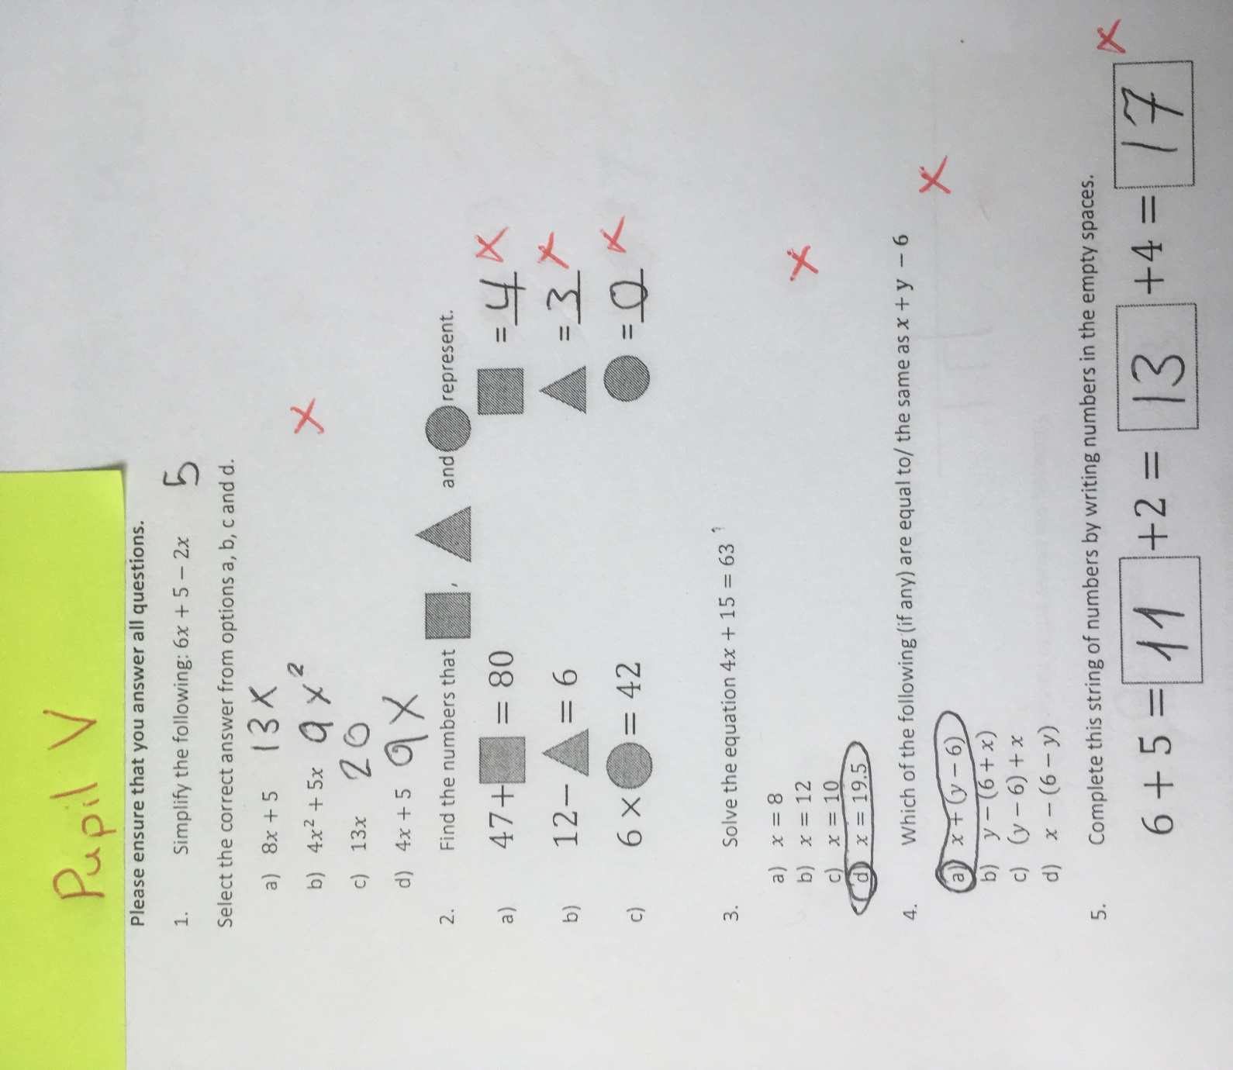
Figure 10- Pupil V test paper, questions 1-6
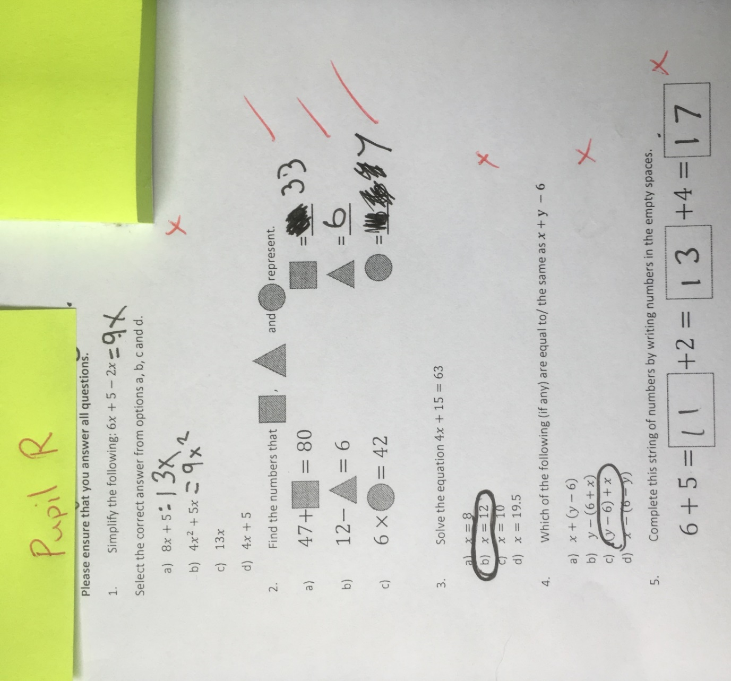
Figure 11- Pupil V test paper, questions 1-6
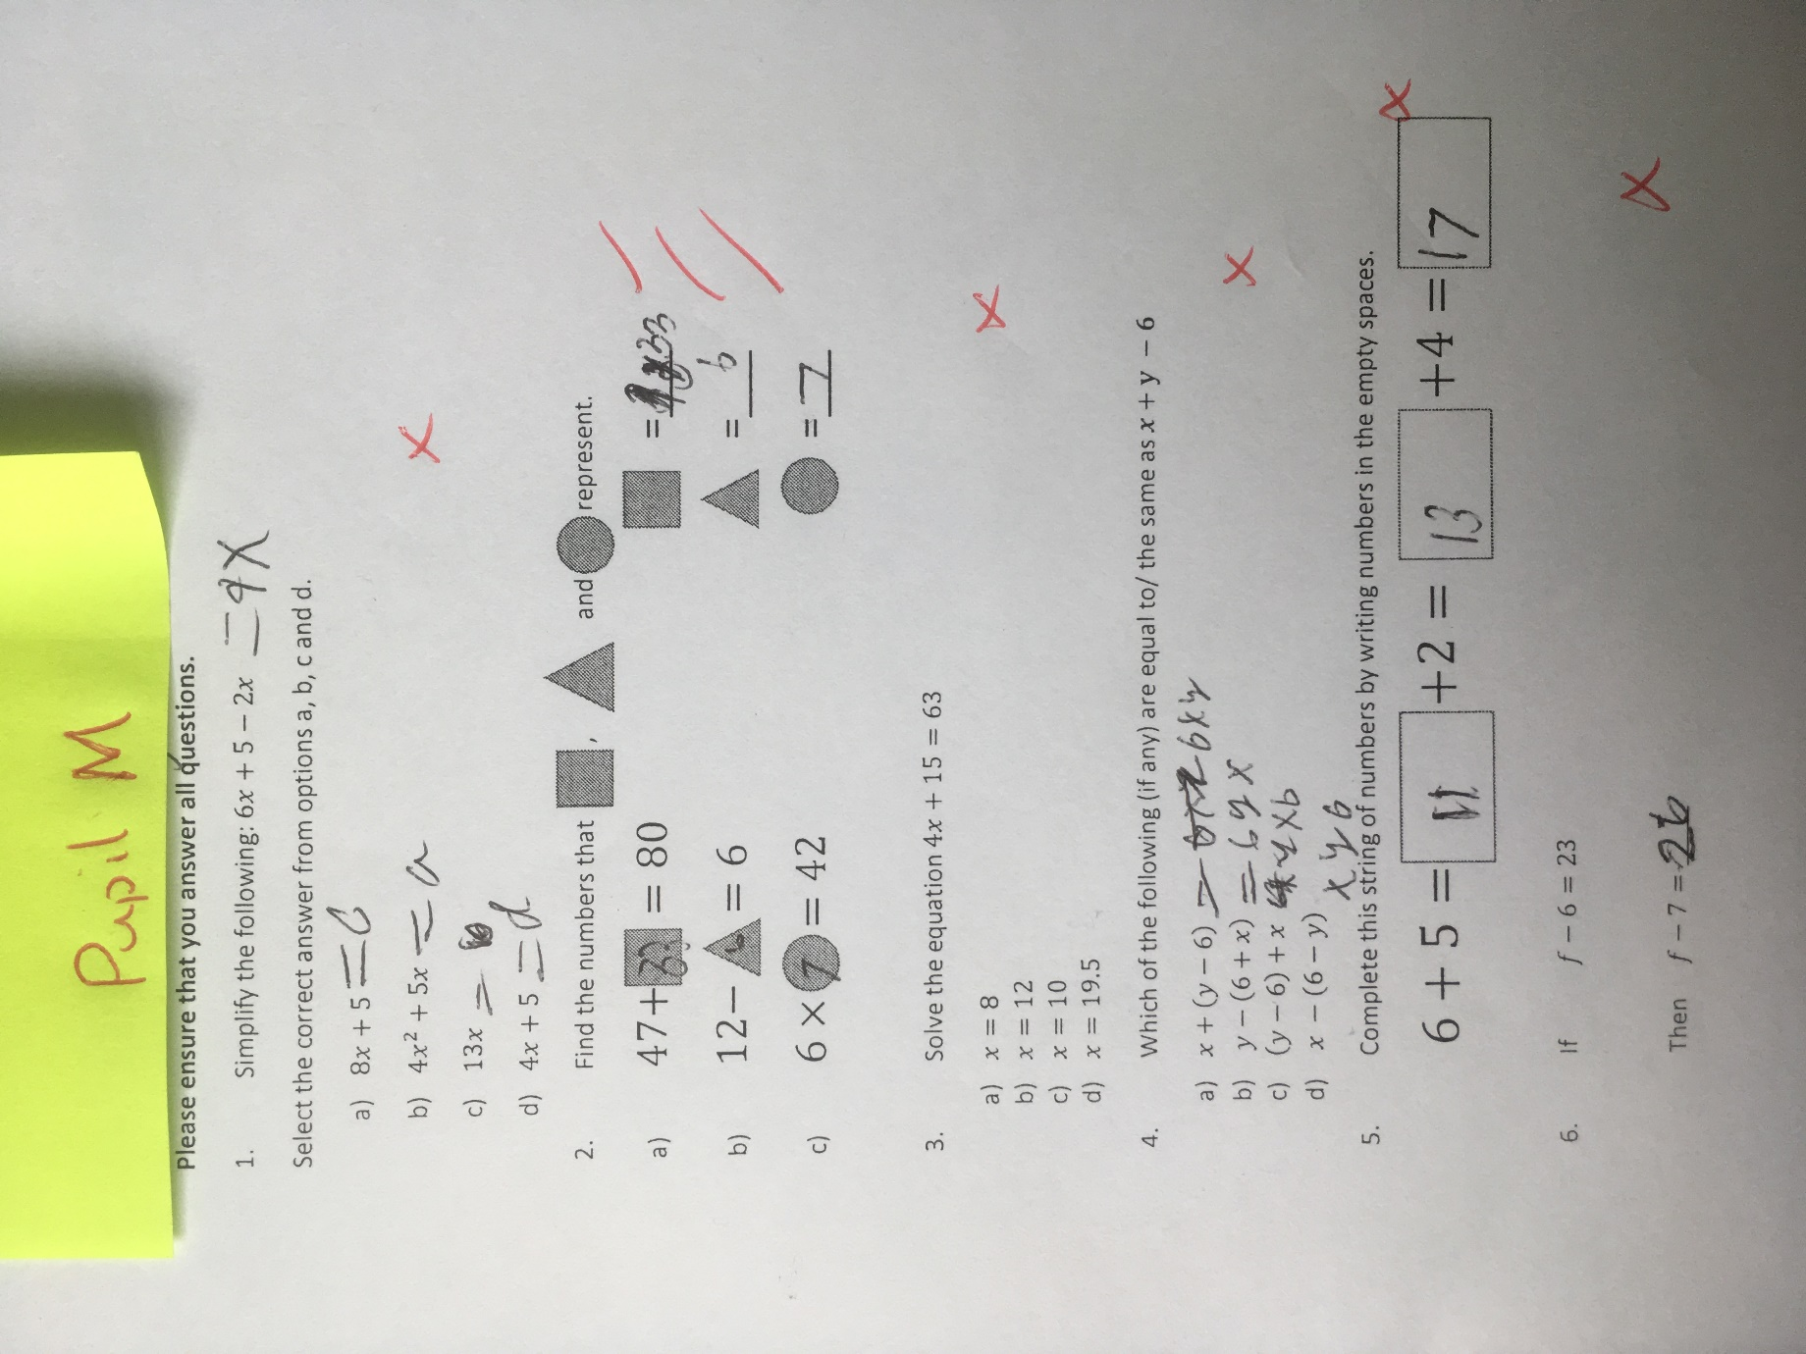
Figure 12- Pupil M test paper, questions 1-6

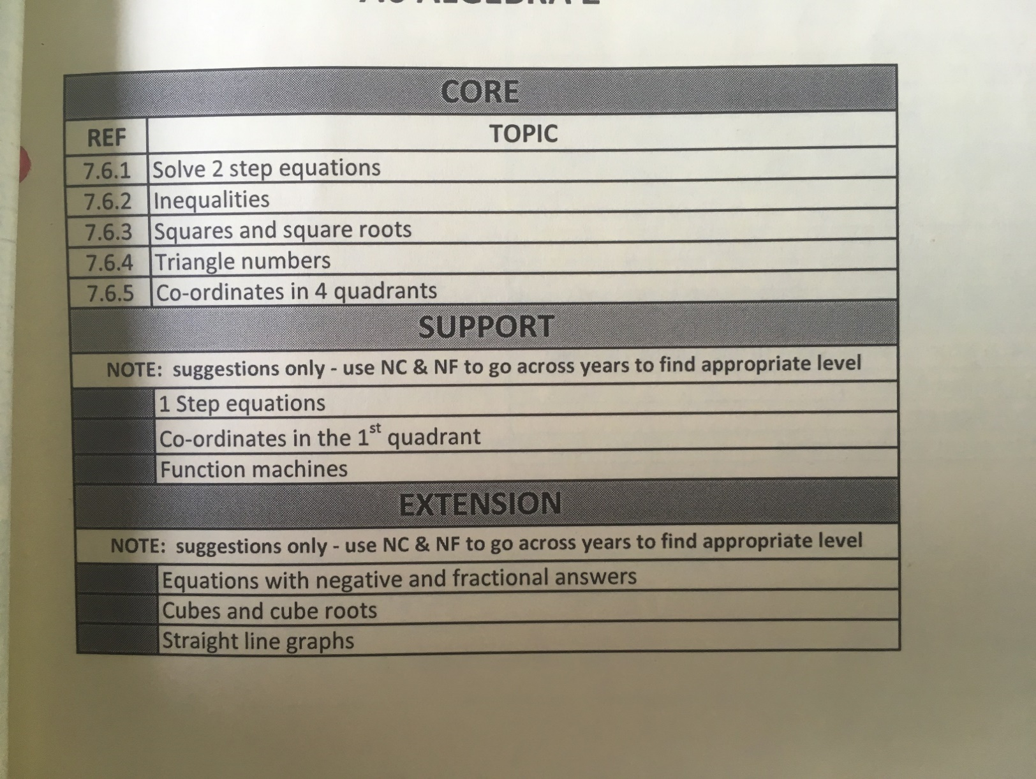
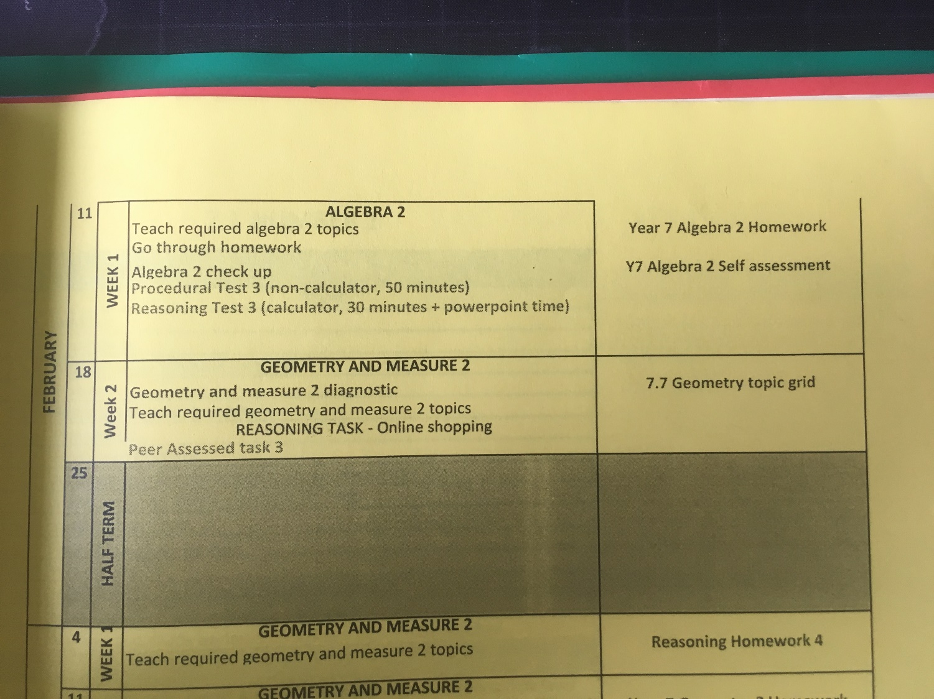
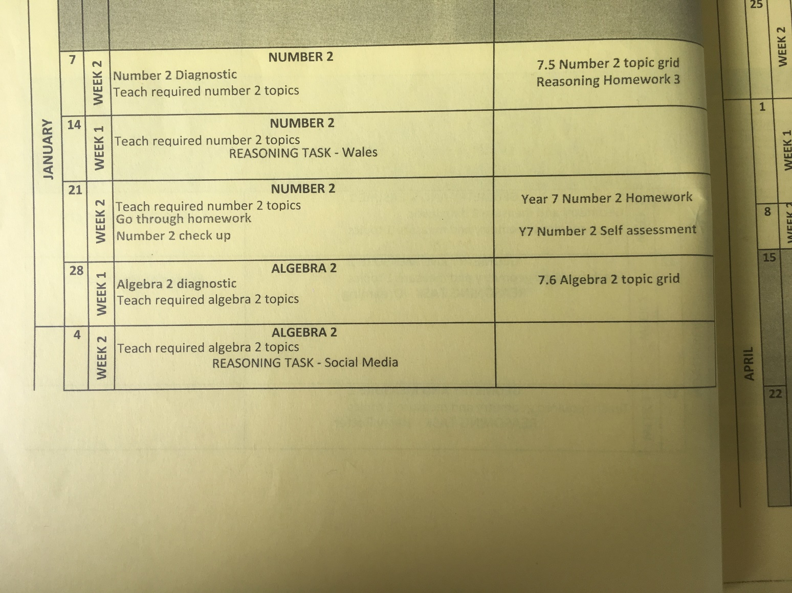
Figure 13- Scheme of Work for Algebra 2 at School X

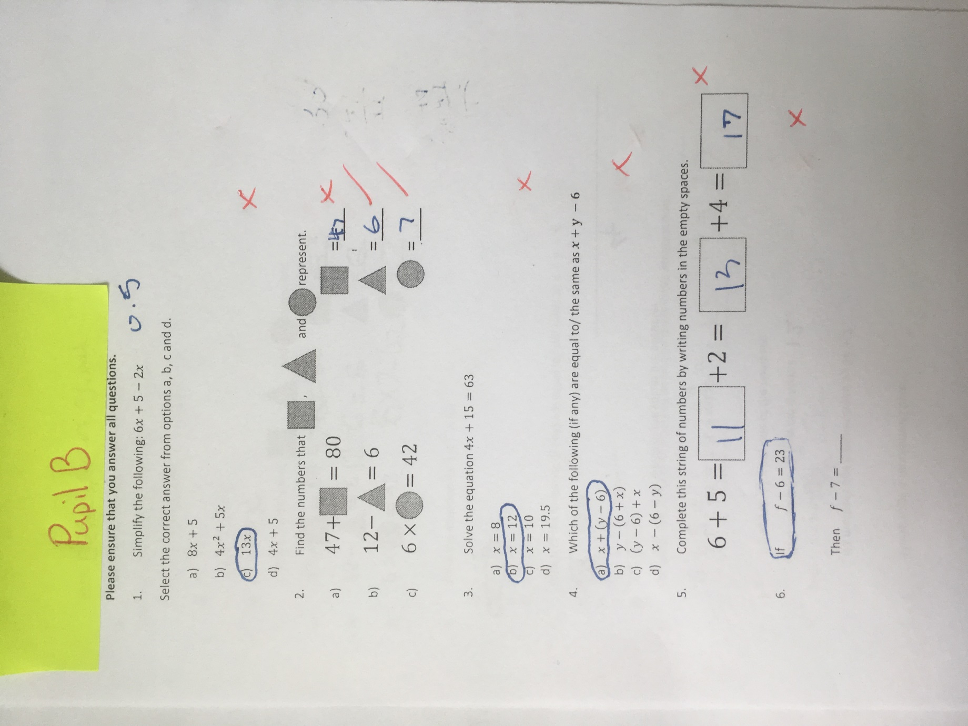
Figure 14-Pupil B test paper, questions 1-6
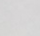
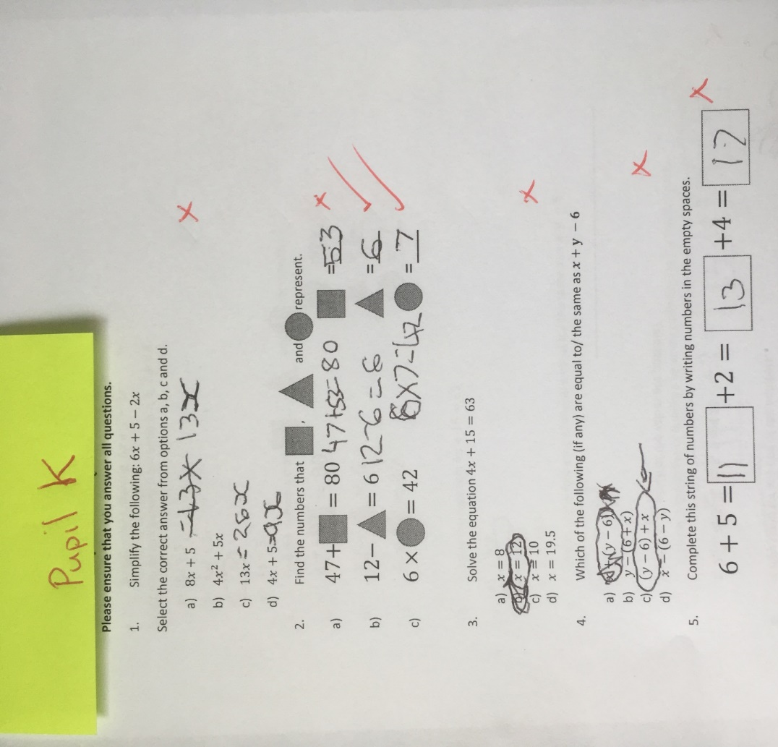
Figure 15- Pupil K test paper, questions 1-6
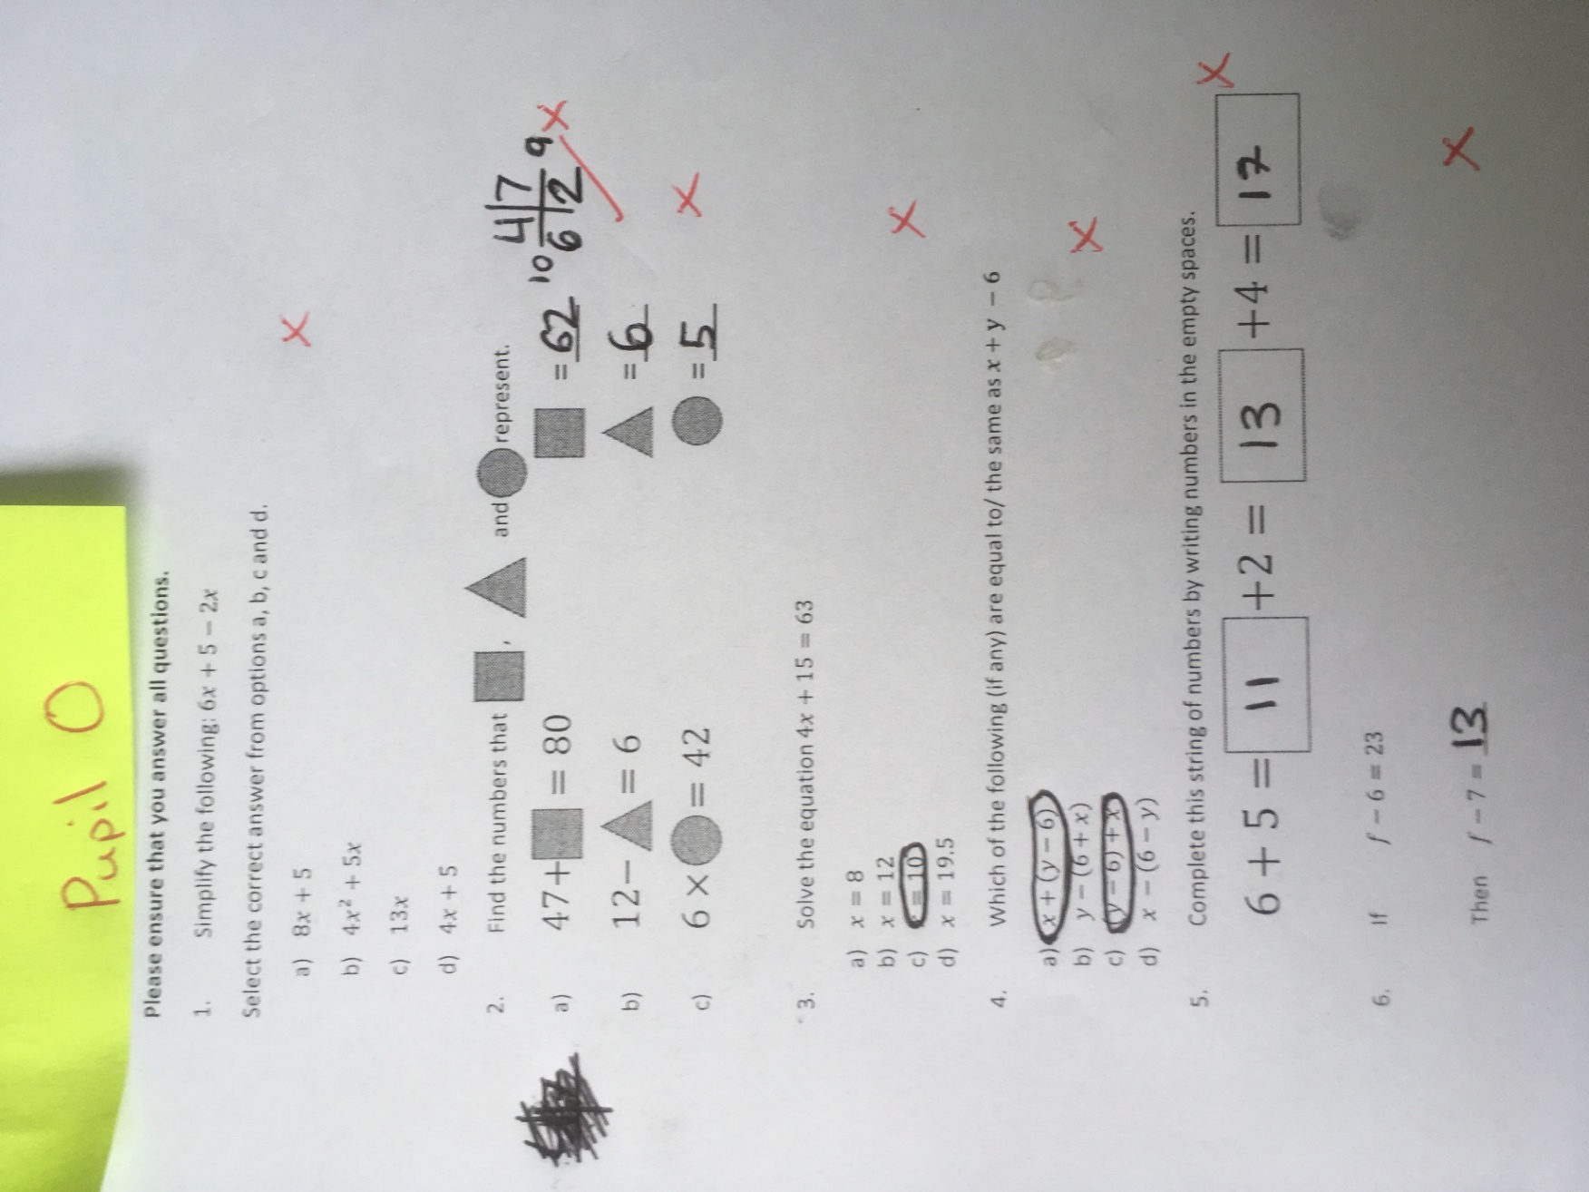
Figure 16- Pupil O test paper, questions 1-6
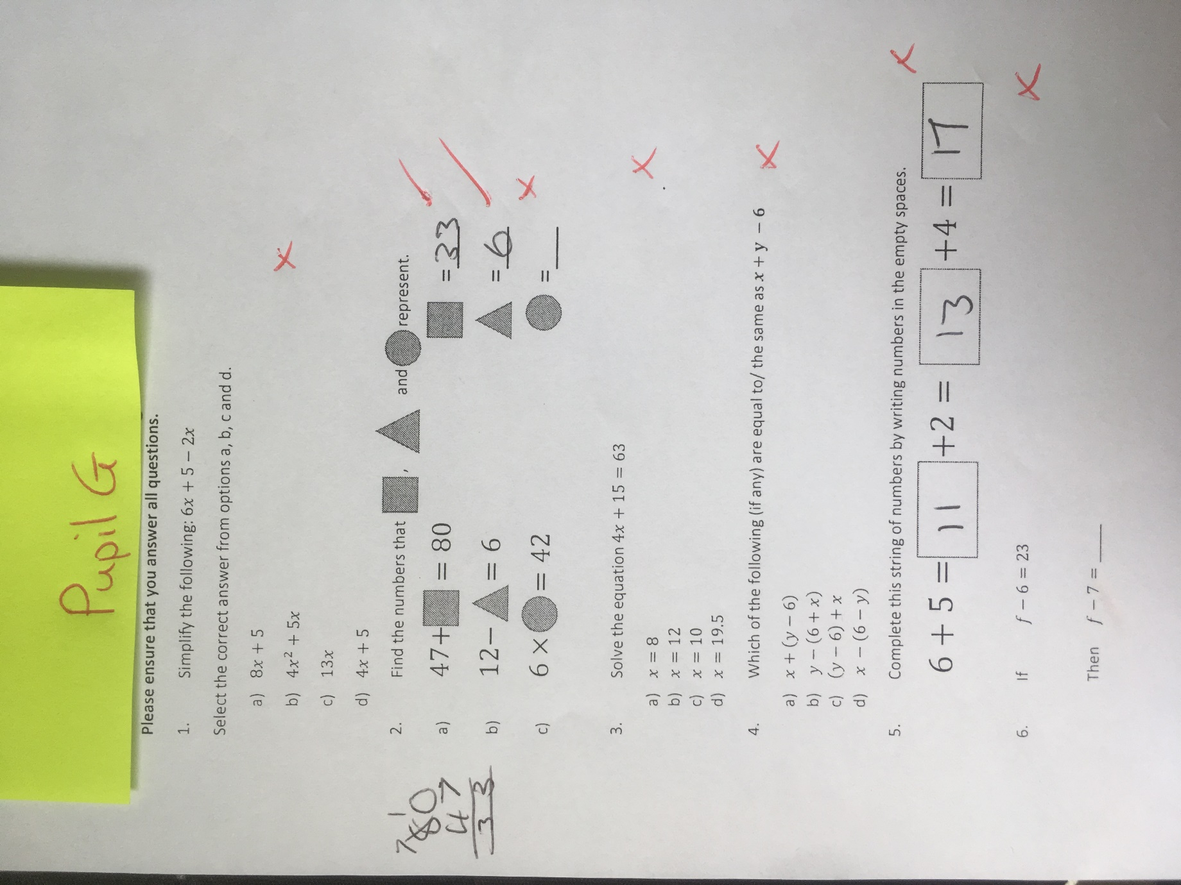
Figure 17- Pupil G test paper, questions 1-6

Figure 18- Pre and Post-test data with the post-test group reduced to those that also took the pre-test
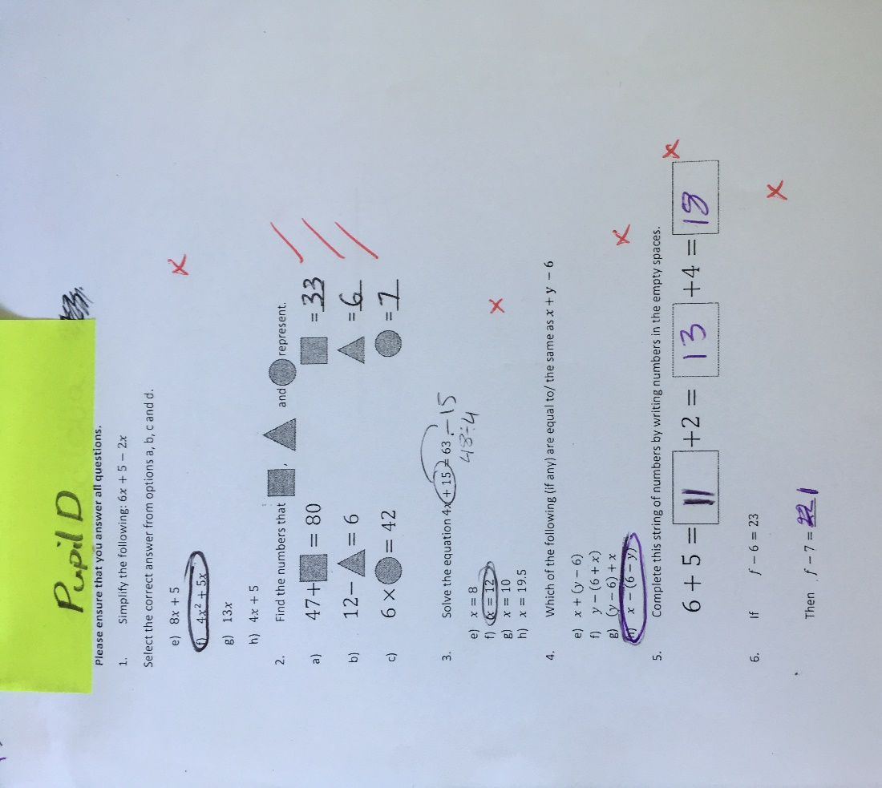
Figure 19- Pupil D post-test paper

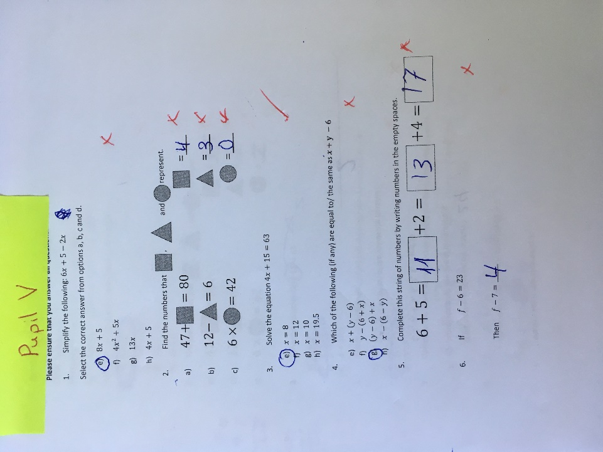
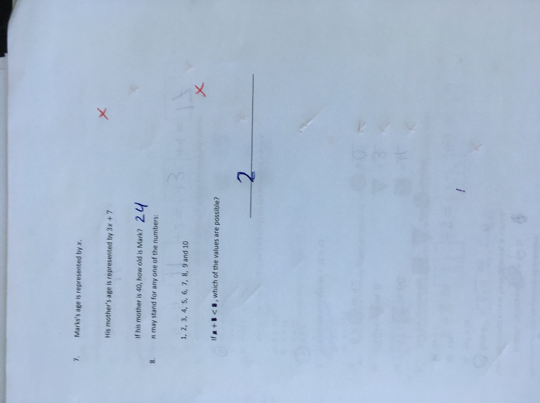

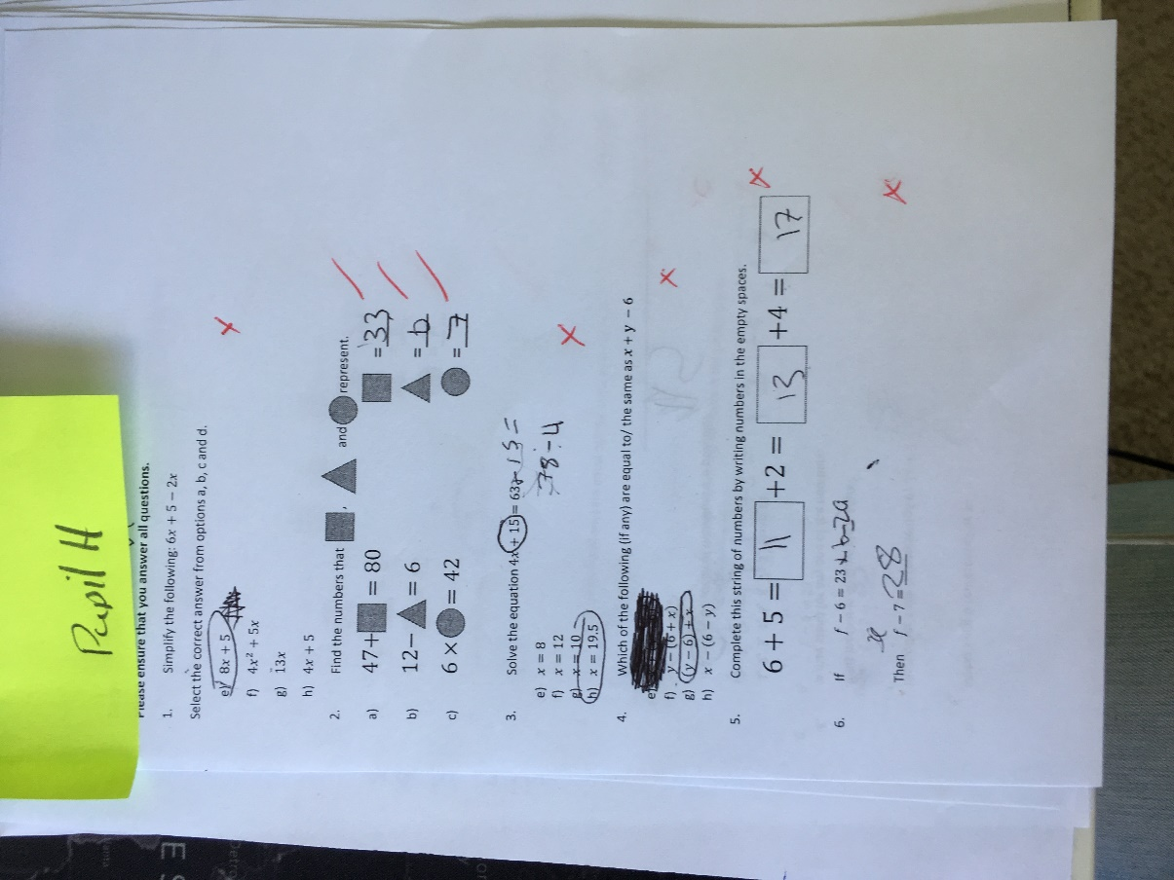
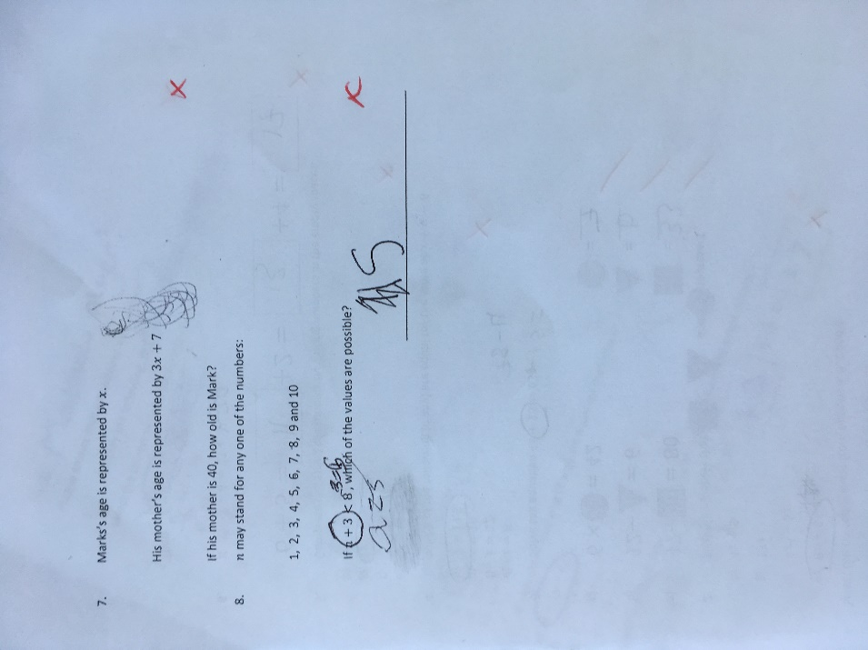
Figure 20-Pupil V post-test paper
Figure 21-Pupil H post-test paper
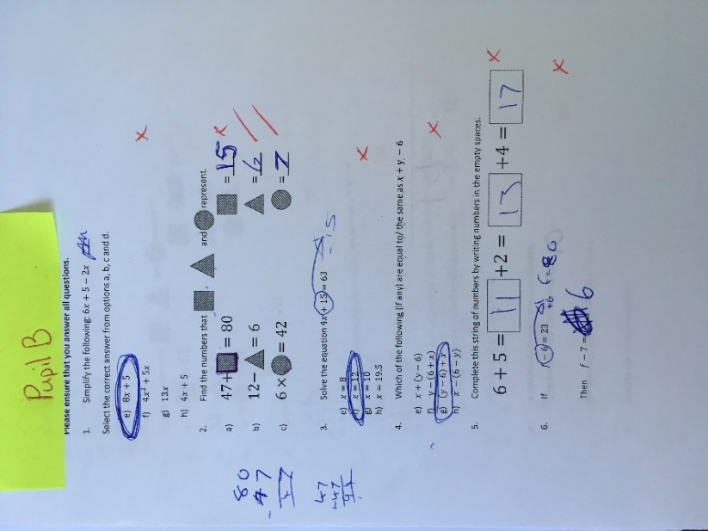
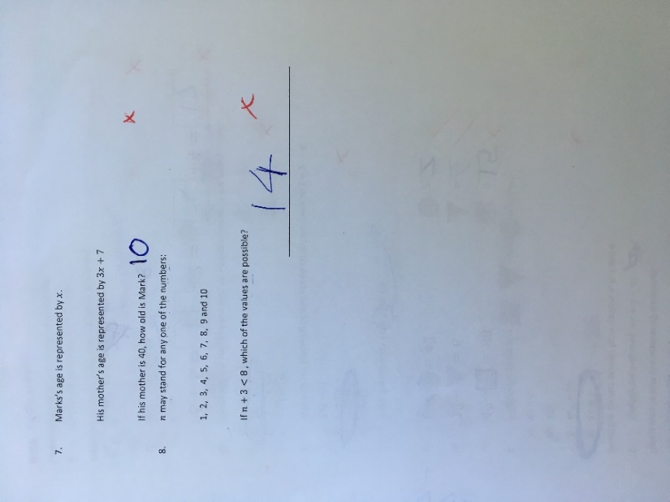
Figure 22- Pupil B post-test paper

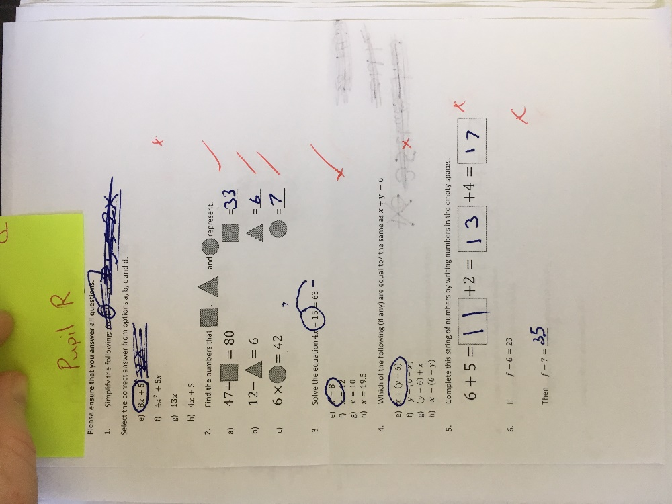
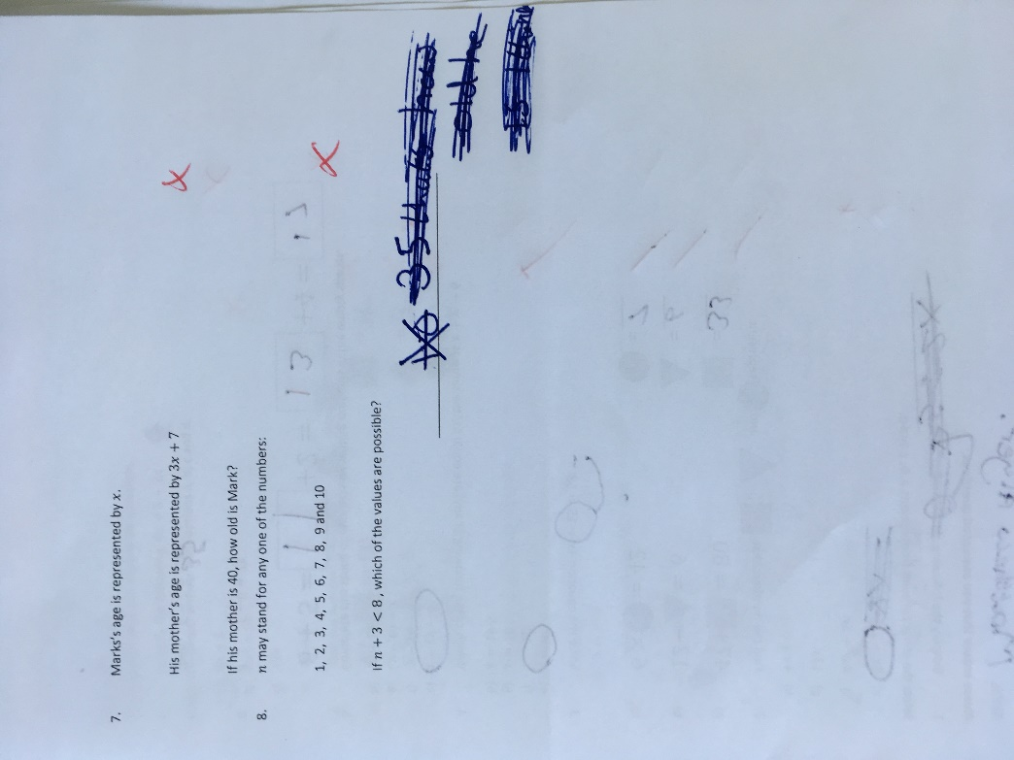

Figure 23- Pupil R post-test paper
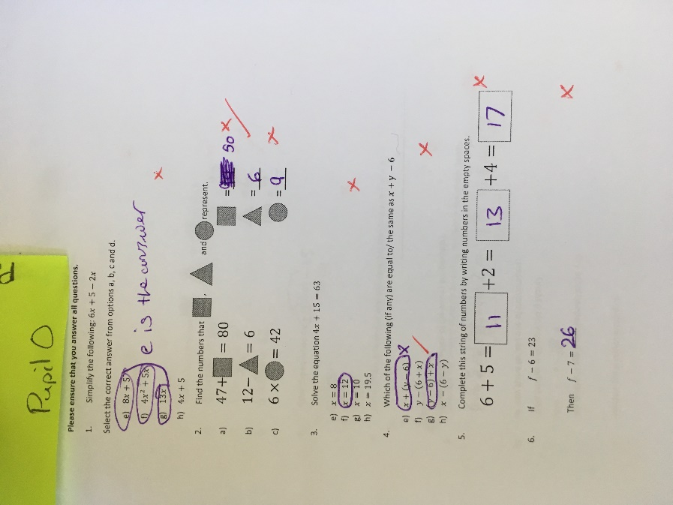
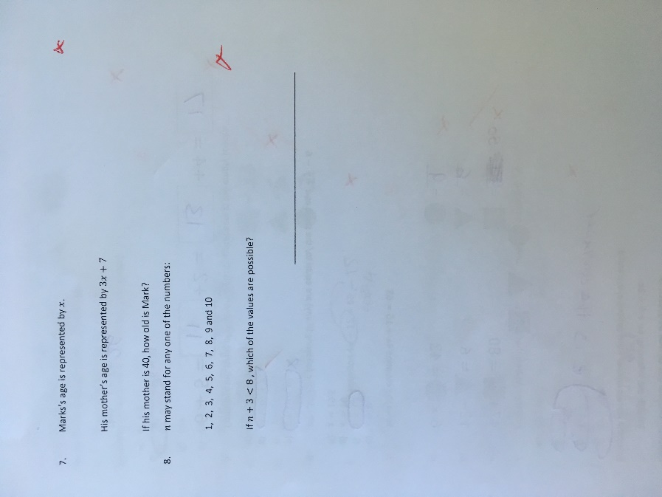
Figure 24- Pupil O post-test paper

