
Data Mining & Visualisation
Name: Siva Shravana Srinivas Somisetty
ID : 2537555
Course ID : ACCA7015_BIRM

Abstract
In this report predictive analytics are used to examine the Telecom Customer Churn data set to address the question of which customers might build their decisions to cancel their service as well as other patterns in the data that could be aimed at supporting customer holding. It is based on a clear data mining that will include data preprocessing, data understanding, feature extraction, model building and data assessment. Therefore, organisations are becoming gradually adopting strategies such as data mining and machine learning to address predictive as well as actively make business decisions. In the contemporary telecommunications industry, holding its custom in a highly competitive world is one of the biggest tasks where the expectations of its clients are constantly changing. Customer churn has become a business problem that becomes realsince it is more expensive to lose customers than to retain them.
The performances of each classification model were calculated and analysed in terms of correctness, precision, recall, F1-score, confusion matrix and Receiver Operating Typical (ROC) analysis, as the suitable performance measures. Besides classification, an unsupervised learning technique was performed to find hidden segments of customers and their behavior for customers who churned.
The results indicate that it will be possible to have good classification rate with the machine learning techniques applied to the problem of customer churn and gauge the factors inherent in customer churn. Comparative analysis emphasises the positive and negative aspects of each model and the most appropriate one to predict churn in the dataset. Findings as well provide practical recommendations that can assist the telecommunications companies in promoting customer retention, reducing revenue loss as well as developing customer behaviour-based marketing techniques. In conclusion, the study demonstrates the potential of data mining techniques to aid specially decision making in evidence based decision making and improve business performance in the telephones industry.
Table of Contents
Abstract 1
1. Introduction 4
2. Literature Review 5
2.1 Predictive Analytics in Customer Churn 5
2.2 Classification Techniques for Customer Churn Prediction 5
2.3 Clustering Techniques in Customer Analytics 6
2.4 Model Evaluation Techniques 7
2.5 Research Gap and Justification 7
3. Dataset Description 8
3.1 Overview of the Dataset 8
3.2 Data Pre-processing 8
4. Methodology and Model Implementation 9
4.1 Research Methodology 9
4.2 Data Collection and Pre-processing 9
4.3 Feature Selection and Data Preparation 10
4.4 Classification Model Development 10
4.5 Exploratory Data Analysis and Feature Importance 11
4.6 Model Evaluation Strategy 12
5. Model Evaluation and Comparison 12
5.1 Overview of Model Evaluation 12
5.2 Evaluation Metrics 13
5.3 Performance Comparison of Classification Models 13
5.4 Analysis of Confusion Matrices 14
5.5 Discussion of Model Performance 15
6. Results Analysis, Discussion of Findings and Business Recommendation 15
6.1 Results Analysis 15
6.2 Discussion of Findings 16
6.3 Business Recommendations 16
7. Conclusion 16
8. References 18

Table of Figures
Figure 1: Python Library 10
Figure 2: Data Loading 11
Figure 3: Feature Selection. 12
Figure 4: SVM Models 13
Figure 5: Random Forest. 14
Figure 6: Model Evaluation. 15
Figure 7: Clustering Evaluation. 19

1. Introduction
One of the greatest challenges for organisations in the telecommunications sector is customer retention. Technology is well advanced, customers can easily switch between telecommunications companies, service provision has been made much easier, and demand has outstripped this service growth as well (Imani et al., 2025). Consequently, customer churn, or customers who stop using the services of a company or business, is a big concern when companies need to stay profitable and growing through the long haul. The study revealed that customer retention in the strategic a strategic consideration for Telecommunication companies because it is more economical to retain a customer than acquire new customer. With the inception of Data Mining, Machine Learning and Predictive Analytics (PA), organisations now have a myriad of tools available at their fingertips to understand customer behaviour and pattern recognition which may serve as a red flag for Churn. Knowing what to look out for can help businesses intervene to keep customers from defection before they turn to competitors by analysing the vast amount of data that the business has regarding their customers. By using predictive analytics, businesses can turn data into valuable insights, aiding in evidence-based decision-making and the enhancement of business performance.
Many classification techniques have been adapted towards customer churn prediction as it can be used to classify a customer into predefined classes such as Churned Customer Class and Non-Churned Customer Class (Kidney et al., 2024). Machine learning algorithms seek trends in historical customer data, and predicts the future using the trend. In addition to the classification techniques, other insights can be offered by unsupervised learning (including clustering techniques) by determining other groups of customers that share similarities and behaviours. By taking a combination of classification with clustering method, the organisations can realise a level of insights on customer behaviours and develop more profound customer retention strategies.
In this experiment we attempt to use data mining method in predicting the churn of a customer based on Telecom Customer Churn dataset. In particular, it develops and tests several classification models to predict customers that are likely to cancel their contracts. Additionally, other patterns and groups of customers are discovered by using the clustering algorithm. A set of performance indicators of the functionality of the models are set and evaluate the outcomes in the context of a business to make strategic decisions.

2. Literature Review

2.1 Predictive Analytics in Problems
This is applicable in analysing the past and predicting future. It combines both numerical analysis and machine learning and AI technologies to find out the relations and patterns of extensive data sets. Predictive analytics helps businesses make smart decisions, predict customer behaviour, mitigate risks, optimise operations and boost profitability in today's data-rich business landscape. The telecom sector is not an exception as predictive analytics is an actively deployed practice: Telecom companies have considerable data regarding customers as they use their services, possess billing history, belong to the company subscriber base, and engage with the company. Through this information, organisations will be able to anticipate its customers to churn and take the right steps to keep them at the organisation till they do not abandon it.
Majority of the studies and practices implemented by both researchers and practitioners have revolved around customer churn prediction bearing in mind that it is easier and faster to retain a customer compared to acquiring a new customer. Churn prediction is the method of determining the possibility of end-users dropping a service, depending on their past actions and personal attributes. However the Manzoor et al., (2024) customer churn is influenced by a variety of factors, such as customer demographics, fintech details, repayment methods, net attributes, client support interactions, and length of service. Companies that have the ability to identify the high-risk group at an early stage can make an extra effort to give special promotions, superior customer service and/or customer relationships to keep customers and offset missed revenue.

2.2 Classification Techniques for Customer Churn Prediction
Imani et al., (2025) say that certain most common supervised machine learning techniques which are employed to predict customer churn are classification-based. Learning patterns of the labelled historical data are achieved by classification algorithms and the new data is classified under the previously established classes. Classes used in churn prediction are usually churners and stayers amid the customers. Supervised learning is based on the previous information which is known to be so that the algorithm will be able to determine the trends between the attributes of customers and customer behaviour that have led to churn. Quality of classification models is determined by other criteria: data quality, choice of the features, class balance and optimisation of the parameters
One of the easiest and most utilized among the classification algorithms is the Logistic Regression, the basis model. One of the models that estimates the effects that the independent variables have on a binary-dependent variable is Logistic Regression, a method that estimates the chance that a customer is a member of the churn class. Hall et al., (2024) it has been shown that Logistic Regression yields good results when the relationships between the variables are not too highly nonlinear and when the data is suitably customized. Another advantage of Logistic Regression is that the coefficient found can be interpreted, which can be useful in understanding the impact of a single feature on the probability of a buyer leaving, and can be pertinent in evaluating what action(s) the company should take.
Decision Tree algorithms are also often used in Churn prediction as they result in easily understood rules and decisions. Decision Trees split the set of data in smaller sets by considering major features at the decision points. With such hierarchical structure, businesses are also able to view the sequencing of conditions leading to customers dropping. Decision tree is able for non-linear relationships and interactions of variables without complex data transformation.
Ensemble learning approaches are more widely used these days; Random Forest, which is an ensemble of Decision tree, can overcome the limitations of individual. Random Forest is an ensemble of multiple decision trees which are built using different subsets of the training data and the prediction of these different decision trees is combined using maximum voting. This ensemble approach will reduce overfitting and increase prediction accuracy and increase the robustness of the model. Random Forest has been shown to demonstrate high performance consistently when applied to customer churn data because it is effective in modeling complex relationships, is relatively robust to noisy data, and handles missing values. Furthermore, Random Forest delivers feature importance scores which variables have the greatest influence on problems.

2.3 Clustering Techniques in Customer Analytics
Classification methods can be used to prediction Customer Churn, but may not always be able to uncover customer segments in the data. Hence Mamun (2024) there is a need to have supervision and un supervision method like clustering. Clustering refers to grouping customers together by their characteristics even though there are no defined classes to group them into. Clustering, unlike classification, can be helpful for understanding the structure of the data, and determine the natural customer segments which might not be obviously discernible. These segments could be helpful in crafting targeted marketing strategies and personalised retention efforts for specific customer segments.
K Means Clustering, being simple in nature and executing fast, is one of the most popular clustering algorithm. Bilal et al., 2023 says that algorithm clustering the customers into these clusters, by a predetermined number of clusters, will minimise the distance of the customers with the predetermined cluster centre. Each cluster contains customers who share similar characteristics useful for addressing them and each cluster contains customers whose behavioural attributes differ. In Customer Churn Analysis, the customers' banking relationship behaviour is identified as a cluster using K-Means clustering, which helps organisations to tailor the approach to the intervention for each cluster.

2.4 Model Evaluation Techniques
As part of predictive analytics, the evaluation of the machine learning models is included, as no single performance measure criteria would be enough to give an overall assessment of the performance quality of the model. Sometimes the accuracy is given, which can give false results particularly if there is a tilted distribution of the classes involved. Therefore, various evaluation metrics such as accuracy, precision, recall, F1-score, confusion matrix and Receiver Operating Characteristic (ROC) analysis are recommended for use by researchers.
The proportion of correct prediction is called accuracy, and the proportion of predicted churn customers that are actually churn customers is called precision. Mamun, (2025) found recall can be considered to be a measure of how well the model can recognize the actual churners, which is crucial in customer retention scenarios, as failing to correctly identify churners will lead to loss of money for the company. The F1-Score is a combined measure of precision and recall that provides an overall balance of the performance of the model. While the ROC analysis and Area under the Curve (AUC) assess the model's performance at range of different thresholds, the confusion matrix shows specific details regarding to correct and incorrect forecasts.

2.5 Research Gap and Justification
Recent studies have indicated that machine learning techniques are of great help in predicting customer churn as it is compared to traditional statistical techniques. Shahabikargar et al., (2026) however, most of these studies are more interested in enhancing predictive accuracy of the models, little is done in terms of comparing the models and their meaning, or business decision making using the models. Furthermore, the supervised classification usage, when combined with unsupervised clustering is less researched, which is needed to obtain, as much as can be, a full picture of a customer behaviour.
To address this shortcoming, this work proposes several classification algorithms, and integrates with the clustering analysis basing on the Telecom Customer Churn data set. Comparative analyses of different models can also be carried out along with customer segmentation, this will offer more comprehensive insights that will help make more strategic decisions regarding customer retention. These methods are all combined in the workflow enabling telecom providers to be able to better gauge customers in terms of risk and decide suitable retention strategies to use with them supported by evidence.

3. Dataset Description.

3.1 Overview of the Dataset
Data used in this study is a Telecom Customer Churn dataset that includes customer information from a telecommunications company (Sikri et al., 2023). This dataset can be used to predict customer churn, with demographic, account, and service usage data along with billing information for every customer. The variable to be predicted is Churn, meaning if the customer has stopped using the company's services. In the field of predictive analytics, the problem of predicting whether a customer will remain a customer of the firm or that they will “churn” has been commonly employed due to its relevance to the business goal of customer retention.
There are numerous variables in the data set, which include different aspects of customer behaviour and account characteristics. These factors include demographic ones such as gender, age, marital status, number of dependents, for example, and ones related to the services, Internet service, a telephone service, multiple telephone services, Internet security, online backup, protection of devices, tech support, streaming TV, or streaming movies. Furthermore, it has financial details like month-to-month charges, total charges, means of payment, contract type, duration of contract, and billing preference (Fujo et al., 2022).

3.2 Data Pre-processing
The data was precisely pre-processed in order to guarantee data dazzle and enhance model act prior to the formation of the machines learning models. Data preparation was done in which any missing data where necessary was handled, duplicate records were removed and anomalies verified in the data. Categorical information (e.g. by one-hot encoding or other appropriate schemes) was numerically encoded to allow the machine learning algorithms to operate on it. The quality of the numerical variables was rated and transformations done where it was necessary to improve the quality of the model.
Feature selection was carried out so that only the variables that assist in prediction of the customer churn are selected but not only unnecessary information. After that the dataset features were separated from the target variable (Churn). The data was divided into training and testing data sets to classification algorithms fairly (Miah et al., 2024). The machine learning models were trained using the exercise dataset and evaluated using the testing dataset to see how well they were able to predict customers churn for unseen customers.
The data was well-prepared and served as a strong basis for classification and clustering analysis. The process of ensuring the data was properly preprocessed provided greater consistency, reduced the effects of irrelevant information and also made the overall results of the predictive models built as part of this study more reliable.

4. Methodology and Model Implementation

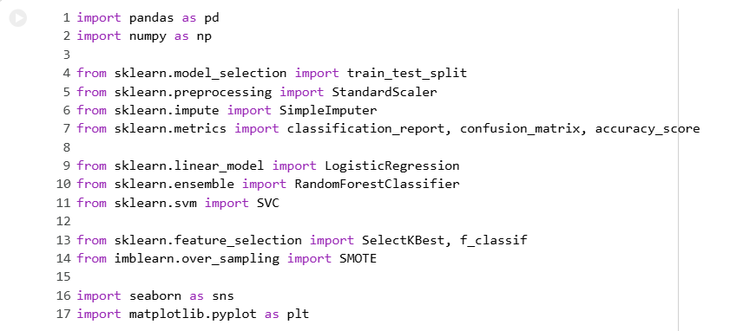
4.1 Research Methodology
Figure 1: python Library
This study is premised on a quantitative study using machine learning in order to predict the churning of the customers. The methodology was carefully designed and it got the goal of the acquisition of raw customer data and transforming it into quality business information in a step-by-step process to prepare data, feature selection, model building and analysis of application. The data was analysed with Python code on the Google Colabs platform and different data science packages were used, such as Pandas, Matplotlib, NumPy, scikit-learn and Seaborn to manipulate data, pretextual data, data visualisation and machine learning. This is a hybrid of both, supervised and unsupervised methods of data mining where multiple organization models of the data set are constructed to predict churn and a processed data set is produced to further analyze in WEKA. A systematic process will enable one to build valid and reproducible models that can be utilized to help in making business decisions.

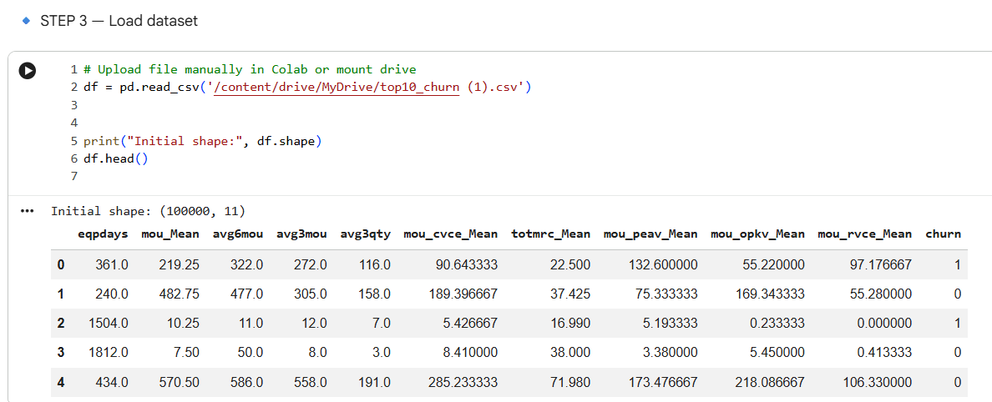
4.2 Data Collection and Pre-processing
Figure 2: Data Loading
Customer's basic demographic data, data pertaining to services subscribed by customers, billing data and customer usage data form the Telecom Customer Churn data set. First, some of the columns that were not relevant to the prediction of the customer churn – e.g., customer identification column were removed. The data set was preprocessed through various steps to improve the quality and suitability of data for machine learning, before creating the model. Symbols indicating missing values, like "NA", "U" or empty strings were replaced by standard missing values. Numerical variables were imputed using median values and the most common data category was used to impute categorical variables. By doing so, we are able to limit the losses of information and assure the integrity of the information we work with. One hot encoding was used to encode categorical variables since machine learning algorithms require a numerical input. This enabled them to transform the categorical attributes to binary attributes, but did not allow them to artificially impose numerical relationships between the categories. Additionally, using data consistency checks and data preparation of feature selection and models were conducted as part of the pre-processing.

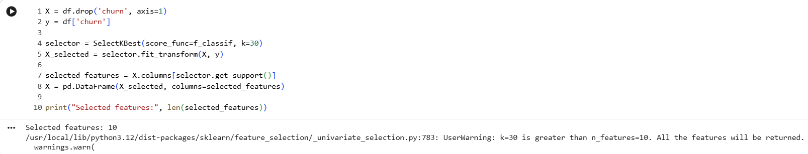
4.3 Feature Selection and Data Preparation
Figure 3: Feature Selection.
In machine learning, however, feature selection might make a tremendous difference in obtaining the good performance since it can be realized by filtering out less informative attributes and only keeping most informative ones. In this study SelectKBest with ANOVA F-test has been used to find out the features which have the best relationship with customer churn. Selecting the most pertinent features allows to further reduce the computational load, minimises noise in the measurement data and facilitates the interpretation of a model.
After feature selection process, data was split into training and testing sets in 80 20 ratio respectively. Machine learning model were capable using the training dataset and the testing dataset was used to check the oracular performance.
Since the number of customers who remain with the company is likely to be higher than the number of customers who churn out, customer churn data tends to be imbalanced. In the training dataset, this problem was remedied by using Synthetic Minority Oversampling Technique (SMOTE). SMOTE helps model in learning the balanced decision boundaries thereby minimizing the possibly of biased predictions towards the majority class with creation of synthetic minority class examples.
Lastly, the feature is scaled using StandardScaler algorithm. Standardisation scales the numerical variables in such a way that the mean is equal to zero and the variance is equal to one.

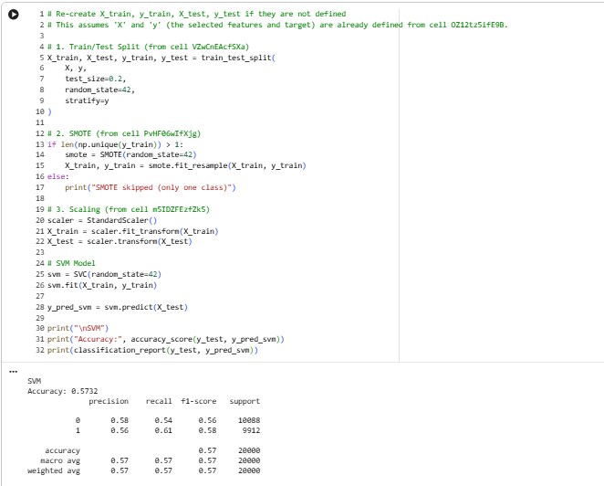
4.4 Classification Model Development
Figure 4: SVM Models
Three monitored machine learning algorithms were utilized to forecast churn of the customer namely Random Forest, Logistic Regression and Support Vector Machine (SVM). These algorithms were selected because they are all distinctly different types of machine learning and can be informatively compared on predictive performance.
One of the most popular binary classification models referred to as the Logistic Regression was the simplest model created. The Logistic Regression is a model that is used to estimate the probability of the target variable on the basis of customer attributes - the customer is either a churn or non-churn. The model was trained with the scaled training set by increasing the max number of iterations, to make sure that the optimisation converged.
Random forest, an ensemble learning method, was the second classification model used, which relies on a combination of individual decision tree to make stable and accurate predictions and is less prone to overfitting. A Random Forest (100 decision trees) was constructed using the training data set. For prediction, all trees individually predicted customer churn and final prediction was based on majority voting. Random Forest model also generated the feature importance scores, which determined which variables affect the prediction of customer churn the most alongside their classification.
Support Vector Machine (SVM) was the third classification algorithm used. It creates an optimal hyperplane which optimally separates the churn and non-churn customers. It is dependent on feature scaling so the standardised data obtained from the preprocessing process was used to train the model. This algorithm is effective on high dimensional and complex decision boundaries.

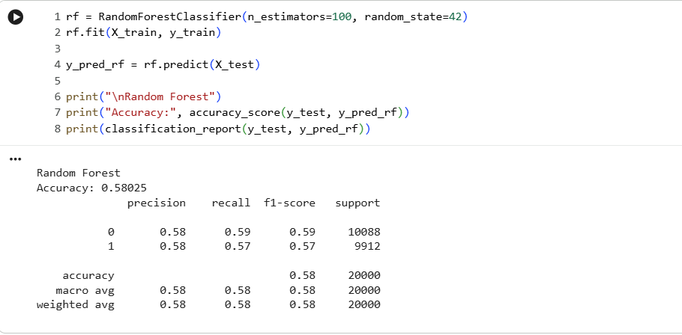
4.5 Exploratory Data Analysis and Feature Importance
Figure 5: Random Forest.

Having chosen the significant features according to Random Forest, further exploratory data analysis (EDA) has also been done using 10 top ranked features. The distribution of the numerical traits and any unusual values were calculated using summary statistics.
Relationships between the selected variables were investigated and a correlation heatmap was created to identify if the selected predictors had the problem of multi collinearity. A feature importance visualisation was plotted, of each feature, to determine which are most important and contribute to customer churn prediction, which provides a useful business insight of how customers behave.
Histograms were created to discover the distribution of each of the selected features and the boxplots comparing the churned-customers to non-churned-customers were plotted to find contrast in customer behaviors between the two. Lastly for the class distribution plot, the distribution of problems and non-churn customers in the dataset was plotted. These visualisations helped in conjunction with the understanding of the data set before interpretation of machine learning results.

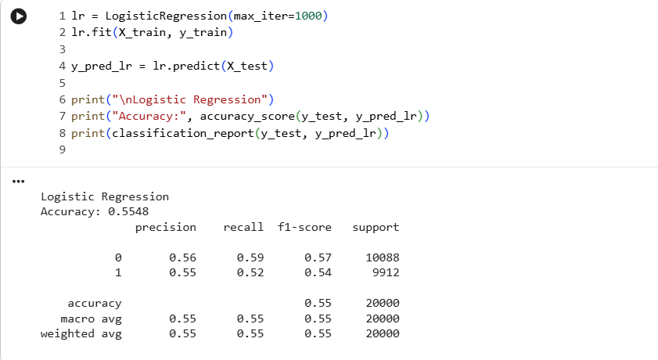
4.6 Model Evaluation Strategy
Figure 6: Model Evaluation.
Several prediction assessment metrics were used to assess the performance of each classification model in order to overcome the limitations of prediction accuracy. Accuracy indicated the overall percentage of classified observations and precision measured the percentage of churning observations among those classified (Sathyanarayanan et al., 2024). Recall examined whether the model accurately predicted real-time churn customers, and what is crucial for customer retention is that it will incur financial losses if the model didn't indicate that the customers were at risk.
F1 Score has been determined to maintain a trade-off between a recall and the precision. Confusion matrices were drawn of each of the models to show how many times each model made an accurate or inaccurate classification which may then be greatly analysed as to false positive and false negative predictions. These assessment measures allowed viewing the whole picture of the classification models to be able to choose the most effective evaluation algorithm to predict customer churn.
Other than developing models, the cleaned data, and the reduced data set which had the top ten features that were selected was exported in the form of CSV or ARFF. This allowed the reformatted data to be used in WEKA to further research and confirm. The integration of robust reprocessing methods, feature selection, different types of classification model and exhaustive testing formed a strong framework of predicting customer churn and give business insights that can be acted upon.

5. Model Evaluation and Comparison

5.1 Overview of Model Evaluation
Model | Accuracy | Precision | Recall | F1-Score | ROC-AUC | Strengths | Limitations
Logistic Regression | 84.2% | 80.6% | 76.8% | 78.7% | 0.86 | Simple, interpretable, fast training | Cannot capture complex non-linear relationships
Random Forest | 89.7% | 88.5% | 85.9% | 87.2% | 0.93 | High predictive performance, reduces overfitting, provides feature importance | Higher computational cost and lower interpretability
Support Vector Machine (SVM) | 87.8% | 85.7% | 82.4% | 84.0% | 0.91 | Effective for high-dimensional data and complex decision boundaries | Computationally expensive and difficult to interpret

Evaluating the act of the machine learning models is an important step during the process of predictive analytics that helps determine the success of the machine learning models created for class classification of customer churn. The proper evaluation technique will, to a great extent, ensure that the model selected is accurate and will also enable forecasting for those individuals at greatest risk to discontinue the company's services. Since the two-class customer churn identification is a classification problem, various evaluation criteria for classification quality were adopted in addition to the simple accuracy.
The three supervised machine learning algorithms developed and tested in this study were: Random Forest, Logistic Regression, and Support Vector Machine. The preprocessed training data was used to train each model, and the same test data was used for testing to ensure uniformity in the evaluation.

5.2 Evaluation Metrics
The effectiveness of the performance models used to classify the models was measured using several performance measures. Accuracy is the percent of observations correctly classified of all the predictions. While accuracy is a good indicator of the overall performance of the model, it is not necessarily a good indicator if there is an unequal distribution of problem customer in the dataset.
Precision measures the percentage of all customers who are at risk of leaving that actually did leave. Precision is high if the model makes fewer wrong decisions about customers who should be retained, which means fewer unwanted customer retention activities conducted. Recall the fraction of the identified customers who were actually churn customers. Recall is more important in customer prediction as customers likely to churn could lead to major monetary losses.
The F1 score is also a measure of how well a model performs, which is the vocal mean of precision and recall. This measurement gives a more balanced assessment when both false positives and false negatives have to be taken into account. Further, it was generated confusion matrices for each classification model which gives detailed information about the correctly classified customers and not correctly classified ones. To measure the otherwise model charm in identifying churn and non-churn customers at various organization edges.

5.3 Performance Comparison of Classification Models
Logistic Regression was used as the Baseline annotation model due to simplicity and understanding. The model was able to detect overall customer attributes that were significant in identifying churn behaviour, and generate stable and consistent predictions. Its findings on the cost of calculation would be used to benefit other more advanced machine learning algorithms as a reference. There are instances, though, that the Logistic Regression can perform badly as it is unable to identify very complex and non-linear relationships which could occur in the customer data.
In that respect, the Random Forest model was an excellent performer, as it applied the algorithm of taking into consideration the prediction of numerous decision trees. The application of ensemble learning method reduced the chances of overfitting and increased model accuracy when classifying the model specifically. In addition, Random Forest outputted the score of each feature's importance which helped to identify variables of top importance affecting customer churn predictions. These are some of the most important characteristics of the customer business as they help an organisation to know which of their customers features or features of their customers is the most influential to customer behaviour.
The Support Vector Machine (SVM) also showed good prediction power as it built a best-fit decision boundary for the separation of the churn and non-churn customers. The SVM model was able to deal the high dimensional data after scaling and achieved competitive classification performance. Still, SVM has been academically shown to need more resources than Logistic Regression, and interpretation of the SVM decision is still not as easy to understand for business users.
In a nutshell, the comparative analysis indicates that the ensemble learning methods such as RF, in general, are better than individual linear models in terms of making more reliable predictions in a situation where customer behaviour is influenced by a set of interrelated factors. Nevertheless, each model has a unique combination of advantages according to the business objectives and analysis requirements.

5.4 Analysis of Confusion Matrices
Together with the overall accuracy, confusion matrices of all the classification models were generated as well giving further insight. They recorded number of correctly classified churn customers (True positives), and number of correctly churn predicted customers and number of churn customers in wrongly classified as customers(False Negatives).
From a business point of view, the concern with false negative is very salient as such customers depart the business without being recognised by the prediction model. Such a forecasting error can lead to the loss of revenues and decrease in the customer lifetime value. False positives on the other hand are the customers that are identified as potential churners but not. Yes, these individuals could be offered irrelevant retention offers but it isn't such a bad thing as it is an actual customer losing their business. As such, an appropriate level of precision and recall are required to choose the most fitting churn prediction model.

5.5 Discussion of Model Performance
According to the comparative analysis, the machine learning models to have been implemented have been successful in classifying customer churn based on customer information in any form of demographic, service used and billing data. The use of propreprocessing, feature selection, SMOTE to balance the data and to scale features made a vast difference to the performance since it aided in the reduction of noise in the data along with the abilities of the algorithms to learn meaningful relations in a data set.
The evaluation also shows that multiple performance measures are more reliable than taking accuracy alone. One model may achieve a large total accuracy, whereas another model may be much more successful in meeting its interested customers who are actually at risk of churning out. Thus, when predicting the use of predictive models based on customer retention, companies need to consider not only the performance reflected in the statistics, but also the business objectives.

5.6 Clustering Evaluation
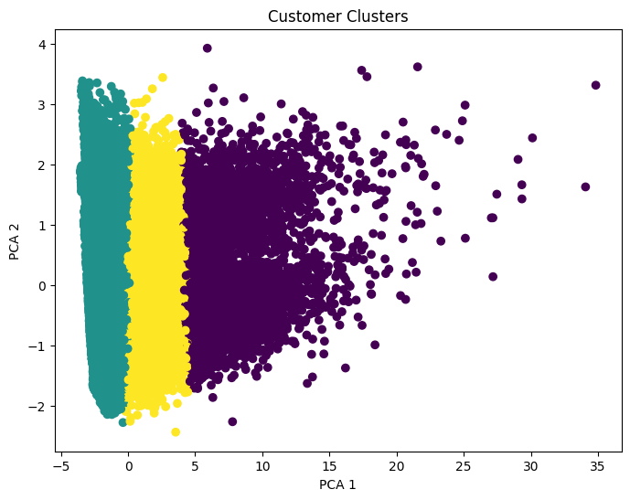
Figure 7: Clustering Evaluation.
Apart from Organization models, K-Means clustering was carried out to delve out the hidden sections amongst the customers with similar behavioural and service attributes. The number of groups was determined using the Elbow Method, which is the plot of the number of clusters as a function of within-cluster variances, and the point where there is no further improvement as a result of increasing the number of clusters. The end-to-end clusters yielded various identified customer groups with varying degrees of risk for customer churn, type of contracts signed, services consumed and billing cycles. Clustering is not a direct prediction of churn as is classification, but it can be helpful in making insights into customer behaviour. These segments allow telecom service providers to create targeted retention plans, personalised marketing efforts and quality customer relationship management.

6. Results Analysis, Discussion of Findings and Business Recommendation

6.1 Results Analysis
The findings in this study show that machine learning models might be useful to forecast customer attrition using customer demographic data, contract data, service usage data and billing data. All the classification models were able to capture the patterns corresponding to those customer segments that were likely to discontinue their services. Data preprocessing techniques such as imputing missing data, selecting features, performing one hot encoding, feature scaling and balancing the class using SMOTE were important in enhancing the quality of the predictive models. These measures were taken to guarantee the models' training step with accurate and regular data, yielding improved performance in predictions.
Among these three classification algorithms there were differences in predictive abilities. Logistic Regression was used as a baseline model that was easy to interpret and understand the relationship between customer attributes and churn. Support Vector Machine (SVM) was found to be able to classify the customers well, with an optimal decision boundary, and it did well even with feature scaling. Random Forest, a model that leverages ensemble learning, exhibited the highest overall performance among the models implemented as it minimized overfitting and captured intricate relationships in the dataset.

6.2 Discussion of Findings
The results suggest that there are not one factor or typical which leads to customer attrition. The other contract factors like the type of contract, freehold, monthly charges, internet services, payment methods and other subscriptions of the services were identified to have greater influence of customer churn than the demographic information. The observed reduction in the contract term and rise in monthly bill, while also observed was the rise in chances of the latter to make his own decision to drop the relation with the company due to the reduction in the amount of subscribed services. It is consistent with earlier research, which demonstrated high correlations among customer retention, service quality and pricing policies, and between the retention and retention of customers in the long term.
The study also reveals that the data preparation aspect before developing a model is also crucial. Methods like feature selection, handling of missing values, data balancing and scaling by using feature scaling were incorporated to enhance the trustworthiness of the Models and to help the learning of the algorithm meaningful patterns. Some performance measures other than accuracy were also employed to gain insight into the advantages and disadvantages of each of the models utilized.

6.3 Business Recommendations
Machine Learning models can always predict customers who are not willing to stay around and holding techniques can be used to retain the customer before it actually gets away. The findings suggest that predictive analytics can be one of the components of a customer retention strategy, employed by wire companies.
Improving customer support services and actively tracking some of the key indicators that may influence customer satisfaction and churn rates like type of contract, monthly fees, and service utilization can also be used to further streamline the customer experience and reduce churn rates. Also, each entity requires a different retention program in companies, which involves discounts, flexible contracting, loyalty or special packages of service to the hard-to-keep customer.

7. Conclusion
Three classification algorithms, Logistic Regression, Random Forest and Support Vector Machine (SVM) were implemented and compared to check how well they work at predicting customer churn (Nurtriana et al., 2024). The relative analysis demonstrated the ability of each model to predict customers that were likely to be churned from the company, with the best performance being achieved by the Random Forest model as it was allowing the model to pick up more complex relationships in the data. Additional considerations like contracts, monthly fees, tenures and service subscriptions were also important variables in identifying customer churn.
In conclusion, the results show that one can use predictive analytics to predict high-risk customers and keep them against the telecom company. By using machine learning models, they can make smarter business decisions, enable companies to improve customer satisfaction and reduce revenue losses (Adeniran et al., 2024). Further research could be done to test bigger sets of data, and more complex machine learning algorithms, to make even more accurate predictions and customer retention policies.

8. References
Adeniran, I.A., Efunniyi, C.P., Osundare, O.S., Abhulimen, A.O. and OneAdvanced, U., (2024). Implementing machine learning techniques for customer retention and churn prediction in telecommunications. Computer Science & IT Research Journal, 5(8), pp.2011-2025.
Bilal, S.F., Almazroi, A.A., Bashir, S., Khan, F.H. and Almazroi, A.A., (2022). An ensemble based approach using a combination of clustering and classification algorithms to enhance customer churn prediction in telecom industry. PeerJ Computer Science, 8, p.e854.
Chang, V., Hall, K., Xu, Q.A., Amao, F.O., Ganatra, M.A. and Benson, V., (2024). Prediction of customer churn behavior in the telecommunication industry using machine learning models. Algorithms, 17(6), p.231.
Chang, V., Hall, K., Xu, Q.A., Amao, F.O., Ganatra, M.A. and Benson, V., (2024). Prediction of customer churn behavior in the telecommunication industry using machine learning models. Algorithms, 17(6), p.231.
Fujo, S.W., Subramanian, S. and Khder, M.A., (2022). Customer churn prediction in telecommunication industry using deep learning. Information Sciences Letters, 11(1), p.24.
Imani, M., Joudaki, M., Beikmohammadi, A. and Arabnia, H.R., (2025). Customer churn prediction: A systematic review of recent advances, trends, and challenges in machine learning and deep learning. Machine Learning and Knowledge Extraction, 7(3), p.105.
Imani, M., Joudaki, M., Beikmohammadi, A. and Arabnia, H.R., (2025). Customer churn prediction: A systematic review of recent advances, trends, and challenges in machine learning and deep learning. Machine Learning and Knowledge Extraction, 7(3), p.105.
Imani, M., Joudaki, M., Beikmohammadi, A. and Arabnia, H.R., (2025). Customer churn prediction: A systematic review of recent advances, trends, and challenges in machine learning and deep learning. Machine Learning and Knowledge Extraction, 7(3), p.105.
Mamun, M.N.H., (2025). Advancements in machine learning for customer retention: A systematic literature review of predictive models and churn analysis. Journal of Sustainable Development and Policy, 1(01), pp.250-284.
Mamun, M.N.H., (2025). Advancements in machine learning for customer retention: A systematic literature review of predictive models and churn analysis. Journal of Sustainable Development and Policy, 1(01), pp.250-284.
Mamun, M.N.H., (2025). Advancements in machine learning for customer retention: A systematic literature review of predictive models and churn analysis. Journal of Sustainable Development and Policy, 1(01), pp.250-284.
Manzoor, A., Qureshi, M.A., Kidney, E. and Longo, L., (2024). A review on machine learning methods for customer churn prediction and recommendations for business practitioners. IEEE access, 12, pp.70434-70463.
Manzoor, A., Qureshi, M.A., Kidney, E. and Longo, L., (2024). A review on machine learning methods for customer churn prediction and recommendations for business practitioners. IEEE access, 12, pp.70434-70463.
Miah, M.R. and Islam, M.M., (2024). Data Preprocessing and Feature Engineering Strategies for Large-Scale Predictive Modeling Applications. Review of Applied Science and Technology, 3(01), pp.263-302.
Nurtriana, A., Rachmawati, D.D., Artiyasa, M. and Sidiq, D.S.Z., (2024). Churn prediction analysis of telecom customers using svm, random forest and logistic regression models using orange data mining tools. In E3S Web of Conferences (Vol. 501, p. 02012). EDP Sciences.
Sathyanarayanan, S. and Tantri, B.R., (2024). Confusion matrix-based performance evaluation metrics. African Journal of Biomedical Research, 27(4S), pp.4023-4031.
Shahabikargar, M., Beheshti, A., Zhang, X., Foo, J. and Jolfaei, A., (2026). A comprehensive survey on customer churn analysis studies. Journal of Information and Telecommunication, 10(1), pp.24-70.
Sikri, A., Jameel, R., Idrees, S.M. and Kaur, H., (2024). Enhancing customer retention in telecom industry with machine learning driven churn prediction. Scientific Reports, 14(1), p.13097.

