Blwyddyn / Year: 1/2  Welsh Lesson Summary / Plan and Resources. | Maes Dysgu a Phrofiad /  Area of Learning and Experience:  Language, Literacy and Communcation.  Curriculum for Wales - Purpose of developing ambitious, capable learners who can use Welsh effectively as part of everyday communication and ethical, informed citizens who value the Welsh language and culture.  This lesson contributes to pupils becoming:  Ambitious, capable learners who can communicate effectively in Welsh.  Healthy, confident individuals who express themselves clearly.  Ethical, informed citizens who appreciate the Welsh language as part of their heritage.  Enterprising, creative contributors who can collaborate and share ideas.  It aligns with Progression Step 2 by:  ✔ Developing confidence in using familiar phrases.  ✔ Responding to simple questions.  ✔ Showing understanding through actions and answers. | Amcan y wers / Aims of the lesson:  - To reinforce pupils' knowledge of Welsh sounds and vocabulary.  - To introduce and practise the phrase "Mam, ga i?" in context.  - To develop confidence in asking and responding in Welsh.  - To support pupils in understanding and using key Welsh words through reading and speaking activities.  - The lesson video will be editied on imovie some bits of the lesson may be removed.
Gwybodaeth flaenorol /  Previous knowledge:  - Pupils have been learning Welsh sounds through Tric a Chlic.  - They have prior experience with basic Welsh vocabulary.  - They have practised responding to simple questions in Welsh. | Geirfa allweddol /  Key vocabulary:  Ffocws iaith / Language focus:  - Mam (Mum)  - Ga i…? Can I have…?  - Iawn, wrth gwrs. Yes, of course.  - Na. No.  Asking for items using "Mam, ga i?"  Responding correctly with Iawn, wrth gwrs or Na.  - Recognising and recalling previous Welsh sounds and words | Gweithgareddau addysgu a dysgu /  Teaching and Learning Activities:  Welsh Sounds Recap  - Start the lesson by reviewing all the Welsh sounds learned in previous lessons. – Encoruage pupils to remeber the english and then remeber the welsh if i give the picture.  - Engage pupils in recalling sounds using Tric a Chlic strategies.  - Explain the phrase "Mam, ga i?" and model how it is used in conversation.  - Demonstrate responses using "Iawn, wrth gwrs." and "Na."  Reading Activity  - Read a book together that includes relevant vocabulary.  - Ask pupils to identify and translate objects into English.  - Provide hints when needed before giving the correct answer.  As the teacher - Encourage them to use classroom objects to make it practical and visual. Rotate pairs to allow practice with different partners and build confidence.  Plenary  Gather pupils on the carpet and review the phrase "Mam, ga i...?" and possible responses.  Invite volunteers to perform a mini role-play for the class, using props if available. End with repetition of the key vocabulary. Finish by asking pupils how using Welsh in real-life situations (like asking for things) helps them become more confident speakers.
Adnoddau / Resources:

Sounds.
Mam ga i book.
Exercise books.
Pencils.
Paper.
Scissors.
Glue.

tric a chlic welsh recording.MOV
Lesson Evaluation

This evaluation critically examines a Welsh Tric a Chlic lesson that was taught to a year one and two class. The lesson focused on strategies to improve pupils’ ability to recognise Welsh words and to verbally construct sentences.
The aim for the Welsh Government is for there to be one million Welsh speakers by 2050 (Welsh Government, 2017). Teaching Welsh is crucial because it helps maintain welsh culture and identity and provides access to a greater range of opportunities in Wales (A living language: a language for living – Moving forward Policy statement Live Learn enjoy, n.d.).

Pupil Engagement -
During the lesson, each pupil demonstrated active engagement. Research states that pupils are more likely to maintain focus and take part in class discussions when they are actively involved in their education (Thompson, 2023). The video demonstrates that every child was able to respond and show active participation throughout the class.
Although there was a high level of involvement during the lesson, its critical to think about whether all pupils paid attention the whole time. To guarantee that every pupil is continuously engaged in creating Welsh sentences, For my future lessons I might incorporate the use of individual response techniques for example lollipop sticks or mini whiteboards.

Active Learning and Collaboration -
Throughout the lesson there was a lot of active learning and collaboration in this lesson. During the lesson, group and partner work allowed pupils to engage in meaningful language practice. The research highlights that this provides learners the chance to learn together and support their existing ideas while also introducing them to new ones (Admin, 2013). Vygotsky’s social interactionist theory aligns with this, which emphasises the importance of peer interaction in language development (Vygotsky, 1978).
However, if children were in groups with different skills, pupils may have been more engaged since children in lower ability groups may have struggled more and been less confident that children in higher ability groups.

Use of Prior Knowledge -
Assessing prior knowledge at the start of each topic is crucial since it enables the teacher to address gaps and misconceptions (Cornell University, 2024). At the start of the lesson, I revisited Welsh sounds and activated prior knowledge, allowing all pupils to make connections between new learning and what they already know. I continuously asked children what the object or word was in English, this made sure that all pupils understood the meaning rather than just recognising the word.

Multisensory Learning -
I utilised multisensory activities for learning to get pupils engaged with the lesson. Multisensory learning makes education inclusive and ensures that all pupils are involved (Main, 2021). The lesson included auditory elements, such as listening to Welsh sounds, visual matching pictures to the words, and kinaesthetic activities, such as performing their work at the front of the class. As this offers a variety of sensory input forms that meet various learning styles, this teaching approach is in line with Bruner’s scaffolding theory (Bruner, 1966), which enables pupils to process language more efficiently.
Reflecting on my teaching, even though this approach has its advantages, there could have been more opportunities. In my future teaching, I will incorporate real-world authentic contexts of Welsh, including an activity for role-play where pupils employ the phrases in in context.

Scaffolding and Differentiation -
For pupils with different levels of ability, I successfully differentiated the lesson. To strengthen recognition, lower ability pupils were given the book to match words and pictures. Middle ability were given words and pictures and they had to write the response. Higher ability were encouraged to perform their Welsh language skills in front of the class. This links with Vygotsky’s Zone of Proximal Development, which highlights the importance of pupils given tasks that are difficult as literature states all pupils should be challenged while remaining engaged at their own level (Wood, Bruner and Ross, 1976).
However, in order to make this lesson better next time, I will pair up pupils’ higher ability and lower ability so that pupils can gain confidence and learn new skills. Children were allowed to choose their partners, which is the only reason that this wasn’t done in this lesson.

Welsh Language Development -
Pupils showed improvement throughout the lesson, this implies that it was an effective way to enhance Welsh Language acquisition. The lesson’s main strength was the way I reinforced prior knowledge by repeating Welsh words and sounds. However, since it’s an effective way to get pupils engaged in the classroom and give them a connection to the wider world by having them solve real-world problems, I will incorporate real-world authentic learning into my teaching going forward (Finch, 2023).

Resources.
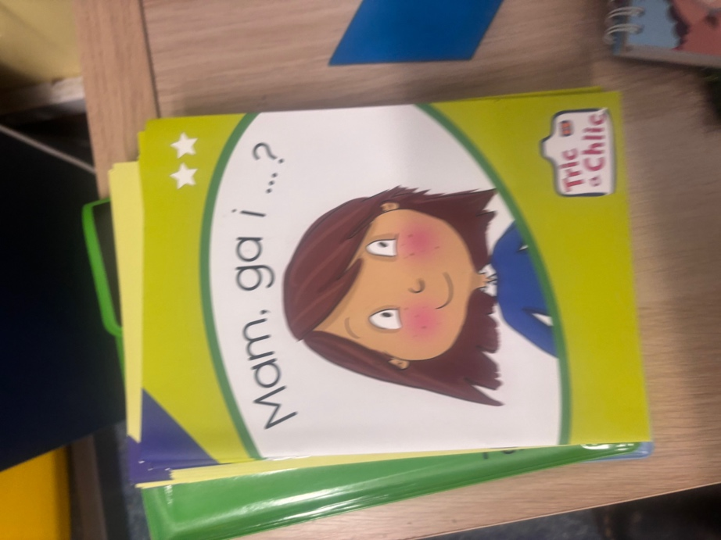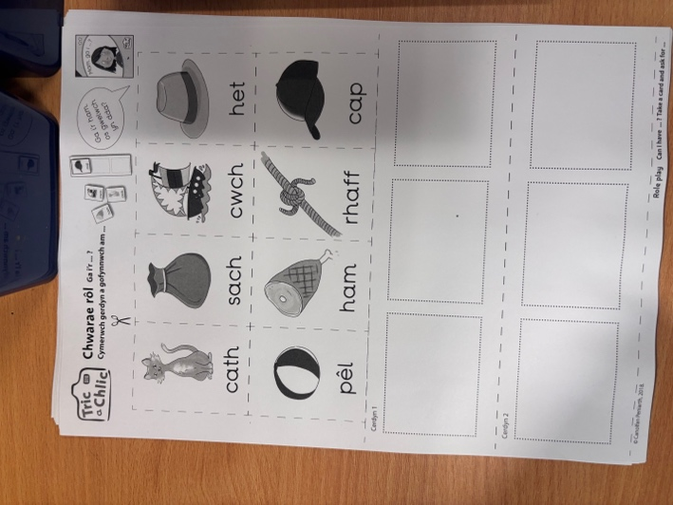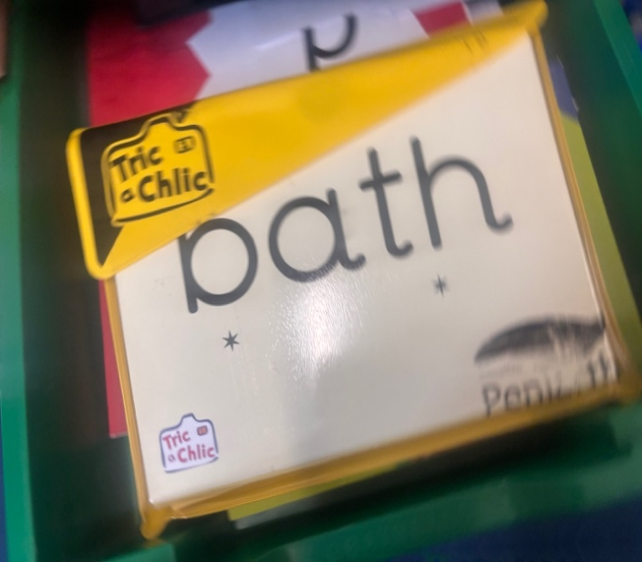

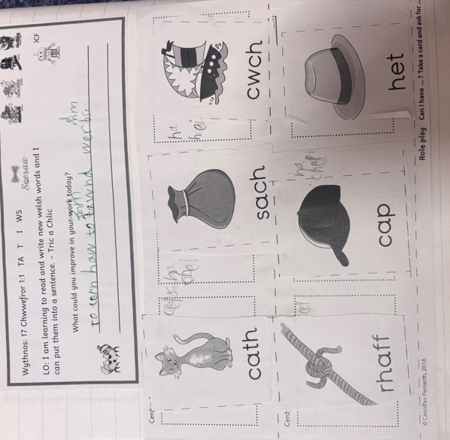
References.

A living language: a language for living - Moving forward Policy statement Live Learn Enjoy. (n.d.). Available at: https://www.gov.wales/sites/default/files/publications/2018-12/welsh-language-strategy-2012-to-2017-moving-forward.pdf.

Admin (2013). The use of group work in primary schools - Printable Early Years Resources (EYFS & KS1) for Teachers & Parents. [online] Earlylearninghq.org.uk. Available at: https://www.earlylearninghq.org.uk/blog-contributers/dr-david-smawfield/the-use-of-group-work-in-primary-schools/.

Bruner, J. (1966). Toward a Theory of Instruction. Harvard University Press.

Cornell University (2024). Assessing Prior Knowledge & Addressing Learning Gaps | Center for Teaching Innovation. [online] Cornell.edu. Available at: https://teaching.cornell.edu/teaching-resources/assessment-evaluation/assessing-prior-knowledge-addressing-learning-gaps.

Finch, M. (2023). Authentic Learning: Bringing Real-World Relevance to the Classroom. [online] Educationadvanced.com. Available at: https://www.educationadvanced.com/blog/authentic-learning-bringing-real-world-relevance-to-the-classroom.

Main, P. (2021). Multisensory learning in the classroom: A teacher’s guide. [online] www.structural-learning.com. Available at: https://www.structural-learning.com/post/multisensory-learning-in-the-classroom-a-teachers-guide.

Thompson, L. (2023). The Importance of Student Engagement: Why Active Participation is Essential for Learning | Edu Engagement. [online] eduengagement.com. Available at: https://eduengagement.com/posts/the-importance-of-student-engagement/.

Vygotsky, L. S. (1978). Mind in Society: The Development of Higher Psychological Processes. Harvard University Press.

Welsh Government (2017). Cymraeg 2050 A million Welsh speakers. [online] Available at: https://www.gov.wales/sites/default/files/publications/2018-12/cymraeg-2050-welsh-language-strategy.pdf.

Wood, D., Bruner, J., & Ross, G. (1976). The Role of Tutoring in Problem Solving. Journal of Child Psychology and Psychiatry, 17(2), 89–100.

