A Guidance Handbook for Early Years Keyworkers During Childhood Transitions and Development Ages 2-3 Years

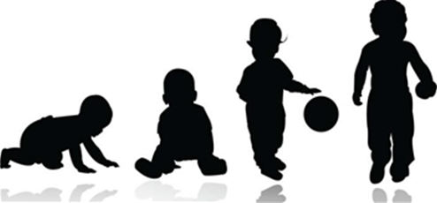
(Source: NHS Cambridgeshire Community Services 2020)

Human Development

EAEE4003
Elinor Griffiths- 2011225

Contents | Page
Introduction | 3
Mission Statement | 4
The Purpose of the Handbook | 4
Settling in Policy | 5
Transitions | 6
Role of the Adult During Transition | 7
Development | 8
Brain Development | 9
Learning through Play | 10
Childhood Theorists | 12
Jean Paiget | 12
The Needs of the Child | 14
Abraham Maslow | 14
Partnerships and Interventions | 15
Parent Partnerships | 15
Reference List | 16

Introduction

Child development is the change in the child that occurs over time and follows a pattern that moves towards greater complexity and enhances learning and understanding. Meggitt, C (2012a p.1) defines ‘developmental norms are sometimes called milestones- they describe the recognised pattern of development that children are expected to follow’ these developmental milestones refer to the sequencing of physical, language, intellectual and emotional changes and growth from birth to adulthood.

Transition can affect all areas of a child’s development. Stated by Meggitt (2011a p.87), there are four main areas that can be affected:

- Emotional- transition can affect a child’s emotional development as it affects personal experiences which may involve home events, such as parents separating, bereavement and entering or leaving care.

- Physical- physical development can be affected if the child is moving to a new educational setting or a new home or care environment.

- Intellectual: intellectual development can be harmed if the child is moving from nursery to a primary setting as this is a big change for them in their eyes.

- Physiological- physiological harm can occur later I life when a young person experienced puberty, and if the child has a long-term medical condition.

Mission Statement

Every child has the right to a voice and Article 12 of the United Nations convention on the Rights of the child (UNCRC) ‘establishes the right of every child to freely express her or his views, in all matters affecting her or him, and the subsequent right for those views to be given due weight, according to the child’s age or maturity” (United Nations, 2009)

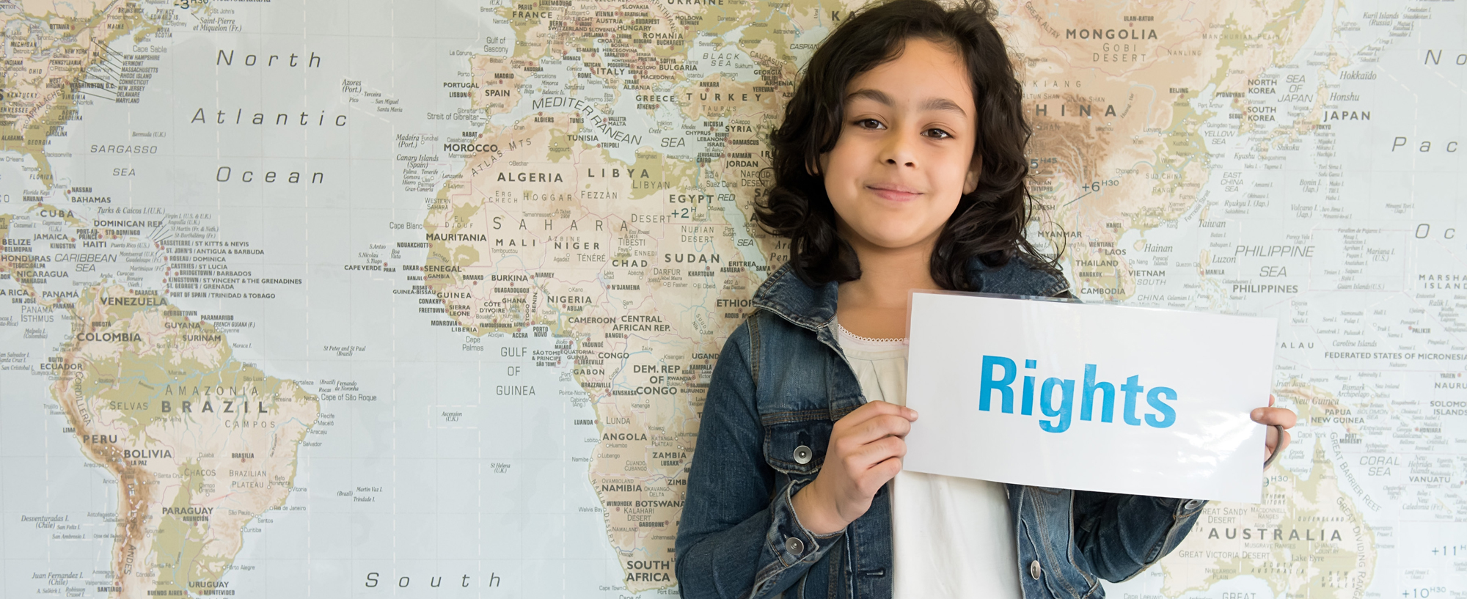
(source: Unicef UK 2020)

The Purpose of the Handbook

The purpose of this handbook is to benefit early years childcare practitioners to learn and recognise the expected outcomes of a child. This handbook specifies the expected milestones of young children whom are aged 2 to 3 years, this handbook is specifically designed for keyworkers, working with children in pre-school (flying start) settings.

This handbook highlights few of a child’s developmental journey towards the early years learning goals. Childcare practitioners, especially the child’s key person, must have realistic expectations on the child and is highly dependent on their child development knowledge and understanding. (Lindon 2012 p.2)

Settling in policy

The setting acknowledges the importance of parents and staff working together to help children settle in and develop confidence to participate in all the activities offered. Some children take longer than others to do this and we respond to their needs on an individual basis.

To help children settle quickly and feel comfortable and confident in their new surroundings parents are advised to dress their child in clothes that are suitable for messy play and help their child towards independence (for example, toileting).
- The setting keeps spare clothes available for use in the event of an accident, but parents may want to provide a change of clothes for their own child
- Parents and their child are invited to meet before registering so that their needs and requirements can be discussed
- Parents are welcome to stay with their child for the whole or part of sessions until they and their child feel confident
- Children may bring their comfort objects with them until they feel confident about being without them
- Parents are encouraged to discuss the settling in process for their child with managers at any time.

(Playgroup, 2020)

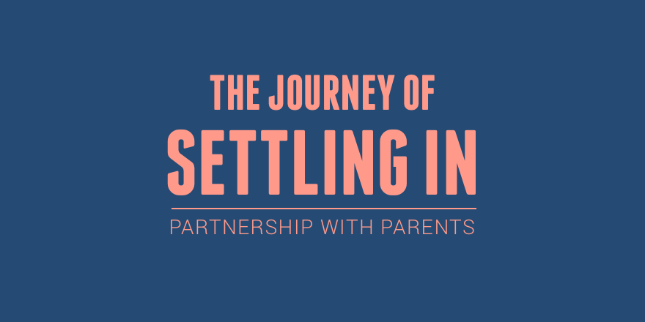
(source: Geelen, 2016)

Transitions

‘Research suggests that transitions are central to young children’s development and emotional well-being, and the way in which the first transitions are handled could have a significant impact on the child’s capacity to cope with change’ (Walker, E 2002). Transitions are key events in all our lives and all children experience transition in their lives. They typically occur when a child moves from one care/setting to another. Typical transfers can include starting a new setting, moving within a setting or home living arrangements.

Expected Transitions

Between the ages of 2-3 years, this handbook specifies children starting a nursery/playgroup, which is their first transition and the second transition is when children move to a primary school setting once they reach the age of three.

Unexpected Transition

Not all transitions can be anticipated and can include the home living environment, which will affect their personal development and emotional aspects. These include
- Birth of a new baby in the family
- Unexpected change of school or childcare provision
- New home
- Family: violence, divorce separation/ new family
- Serious illness of death in family.

How Does Transition Affect Behaviour?

Transitions can have negative effects on some children and can causes changes in behaviour. Meggitt (2011b p.88) indicates young children could display more frequent outbursts of temper and aggression towards adults, often shouting or swearing, depending on what they’ve heard. Regression is also a sense of behavioural affects which means the child reverting to behaviour which is usually seen in younger children. A sign of this is when the child uses ‘babyish’ speech and words. Separation anxiety can occur, and this can be seen by young children becoming clingy either to their parent or key person to be reassured.

Role of the Adult During Transition

How does transition affect a child’s development?

Transition occur when there are changes or movement from one position or stage to another in a child’s or young person’s life and all children and young people will experiences changes in their lives, as these are natural events in everyday lives. Transition can affect all areas of development.

How can practitioners support a child in transition?

Key Person

Practitioners must support young children during transitions as, just like adults, they experience feelings. In all early years settings, children must be assigned a key person ‘whom a child has more contact then other adults within the setting; this adult demonstrates a special interest in the child (and their family) through close daily interaction’ (Smith 2012 pg. 49) and the child’s key person must help ensure that the child’s learning and care is adapted to meet their individual needs. To cope with transition, the key person must reassure the child to maintain their feelings, help in adapting to different group situations and aid the child to adjust to different, and new, social rules and expectations.

To make a smooth transition for children, it is important for practitioners to have effective preparation in place. It is crucial this gets done, as during transitions, a child may experience a wide range of feelings and emotions. Children experience these emotions because they are losing familiar adults and possibly feel unsettles. In order to make an effective transition, practitioners must:
- Prepare the child before hand
- Listen to the child’s concerns and reassure them
- Be honest and truthful with them
- Be positive
- Arrange to visit new settings beforehand
- Allow children to freely discuss the transition as much as they like
- Teach children strategies to cope and deal with their concerns.

(Forbes 2009a p.128)

Development

Development is the change in the child which occurs and progresses overtime. These changes follow an orderly pattern of milestones that stride towards greater complexity and enhances survival. There are five main periods of development which are:
- Prenatal development period is the first, which occurs from conception to birth (development in the womb)
- Infancy and toddlerhood development are the second, which occurs onwards from birth to age 2 years
- Early childhood development occurs between the ages of 2 to 6 years
- Middle childhood development occurs from the ages of 6 to 12 years
- Lastly, adolescence development occurs for older children between the ages of 12 to 19 years

This handbook specifies the ages around infancy and toddlerhood development and early childhood development. It is important to remember that all children are different and development differently to other children it is also important not to compare and use this against them we must look at the individual child as a whole.

(King, R 2012)

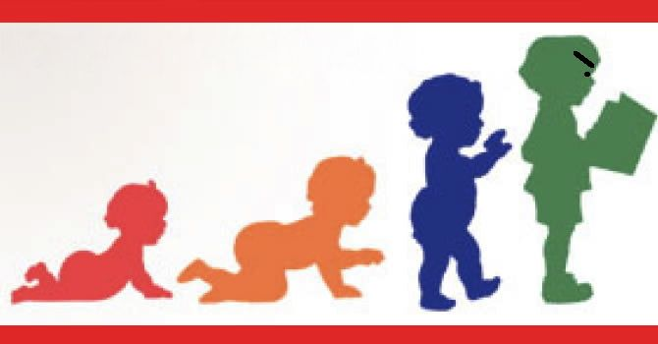
(source: Duvall 2014)

Brain Development

The brain has more capacity than we can ever use and over time and through emotional and physical damage, synapses are destroyed. The brain of a young child develops through experiences and physical and neurological development is entirely linked. It is impossible for the brain to develop without physical experience.

Neglected Brain Development

According to Children’s Bureau (2019 p.3) ‘maltreatment can cause victims to feel isolated, fear and disrupt, which can translate into lifelong psychological consequences that can manifest as educational difficulties, low self-esteem, depression and trouble forming and maintaining relationships”. Therefore, increases the child’s risk of emotional, behavioural, cognitive and attentional disorders.

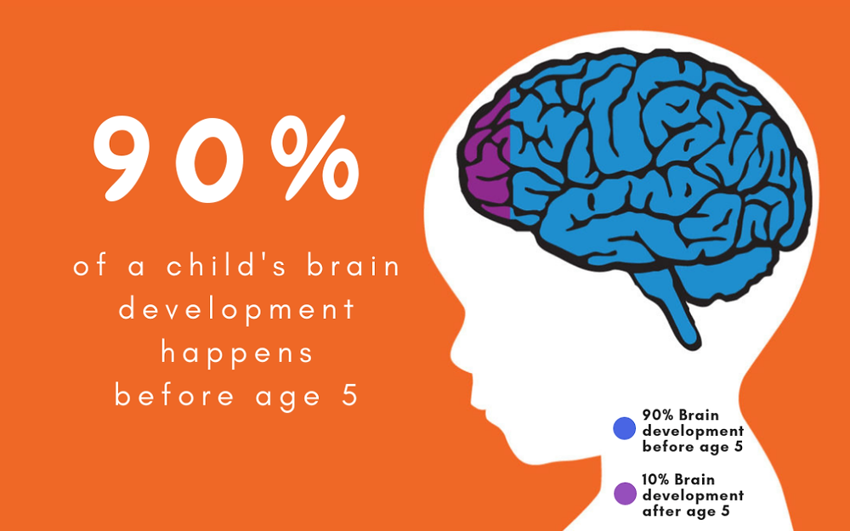
(Source: J.P. Kids & Company, 2019)

Nature verses Nurture

Nature and nurture both play an important role in child development as every aspect of the child’s brain development is merged by both nature (children simply mature as they grow) and nurture (the environment shapes what children become) and according to Calk (2018) “nature refers to things like the genetic traits inherited from our parents and grandparents, while nature refers to the different environmental factors that have influenced brain development over the years”.

Learning Through Play

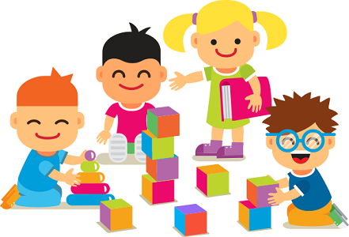
(Source: Edmentum Blog, 2017)

At the age of 2, play improves the child’s holistic developmental needs and its vital that children have access to effectual play experiences as they can learn about the world around them and skills they can improve on. Holistic development means seeing a child as a whole and ‘refers to human development that is meant to involve all parts of a person’ which means it accommodates a child’s physical, emotional and social development and mental growth. (Bajwa 2016). It’s important that we look out for any early identifications for a child who could need extra support in their holistic development areas. Play guides children and helps them to make sense of their learning and helps young children develop their intelligence and cognitive development and helps children make sense of their lives (Bruce 2001).

How Does Play Support Development?

Play is an essential element of a child’s development as it creates opportunities for children to learn about the world in which the child inhabits. As children play, their brain develops, their muscles grow and they develop good social skills and improve life skills as they learn to share, take turns, make their own choices and understand the feelings of others. Play benefits and improves all areas of development.

Emotional- Emotional development focuses on the development of children’s self-esteem, feeling and awareness of other feelings. Play can heal emotional pain as it can reduce fear, stress and anxiety to create more joy, intimacy, self-esteem and mastery. Play can also help a child improve their emotional flexibility and openness, and creates a sense of calmness, resilience and adaptability and ability of the child to help them deal with change and transition.

Social- Children’s participation in a wide range of activities throughout the Foundation Phase should be encouraging as the Welsh Government (2008 p.29) states that play ‘should encourage them to develop the appropriate skills to communicate and develop positive relationships with others to become independent learners and members of their communities’ and play can increase empathy, compassion and sharing and models relationships based on inclusion rather than exclusion.

Physical- ‘Children are motivated by play opportunities and games that involve them in physical activity and increases a range of motions, agility, co-ordination, balance, flexibility and fine and gross motor skills (Welsh Government (2008 p.10). play decreases stress, fatigue and depression and creates positive emotions and increases the efficiency of immune, endocrine and cardiovascular systems.

Language and communication- Some children use simple language in play and communicate understanding of basic instructions and listen to and join in with rhymes, songs and stories. Through play, children use and communicate through verbal and non-verbal interactions. Play should allow children to express themselves, their needs and their feelings, use facial expression, body gestures and eye contact to express.

Observing and Assessing Children’s Development

Having up to date observations on a regular basis helps us see what a child is achieving and what we can do to follow up. By this we can incorporate their interests into their next stages of development. Practitioners must reflect back on the child’s observations and development records to use them for planning the child’s next steps. According to Aussie Childhood Network (2015) ‘reflective practice is learning from everyday situations and issues and concerns that arise which form part of our daily routine while working in an early childhood setting. This enables us to develop and extend on children's learning and build upon their knowledge and skills.’ These observations can be reflected on own work in ways you can improve to help the child’s development.

Childhood Theorists

The key issue for childcare practitioners relating to the promotion of positive development outcomes for children and young people consists of knowledge of theorists and understanding which theorists link to their developmental areas. A child development theory is a combined compilation of beliefs about why children and young people behave, think and feel as they do.

Purpose

The purpose of childhood theorists is to help guide practitioners and other childcare professionals by ensuring that there is an underlying purpose for routines and that the educational process of young children is carried out consistently.

Jean Piaget

Jean Piaget’s (1896-1980) theory is based on the idea that the developing child builds cognitive structures for understanding and responding to physical experiences within the environment. He formulates four stages of intellectual-cognitive development and the process by which children progress through them. Which consists of sensorimotor stage, pre-operational stage, concrete operational stage and formal operational stage.

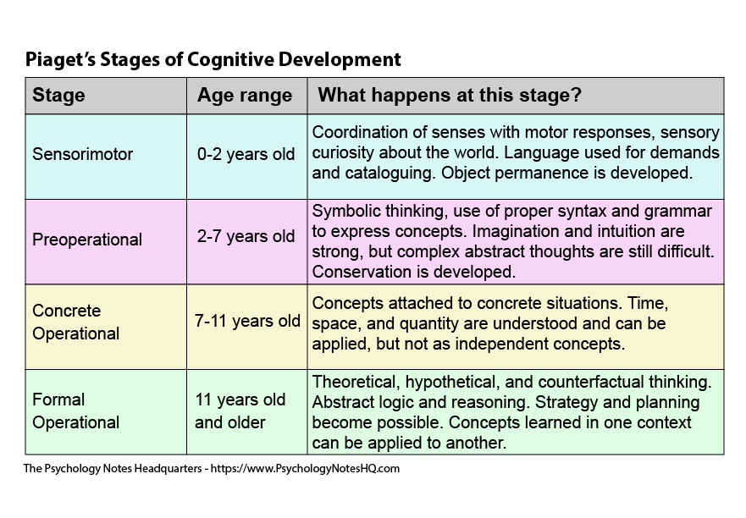
(Source: The Psychology Notes Headquarters, 2020)

Piaget was interested in intellectual development and Pound (2014) claims Piaget ‘argued that there was a natural sequence for the development of thought governed by what he termed ‘genetic epistemology’’. Tassoni (2005) also states that Piaget ‘believed that children develop a number of patterns of behaviour of actions, which then they apply to similar situations’ Piaget called these patterns ‘schemas’. Schemas in child development are biological and socio-cultural and are a natural part of children’s play and development and explains why some children show such determination and purpose to express actions in a certain way.

Here are the most common Schemas identified in early years settings. These are trajectory, containment, connecting, transporting, orientation and positioning. Picture diagram below, as shown by Sands (2014) states what to look for in a child with expected schema.

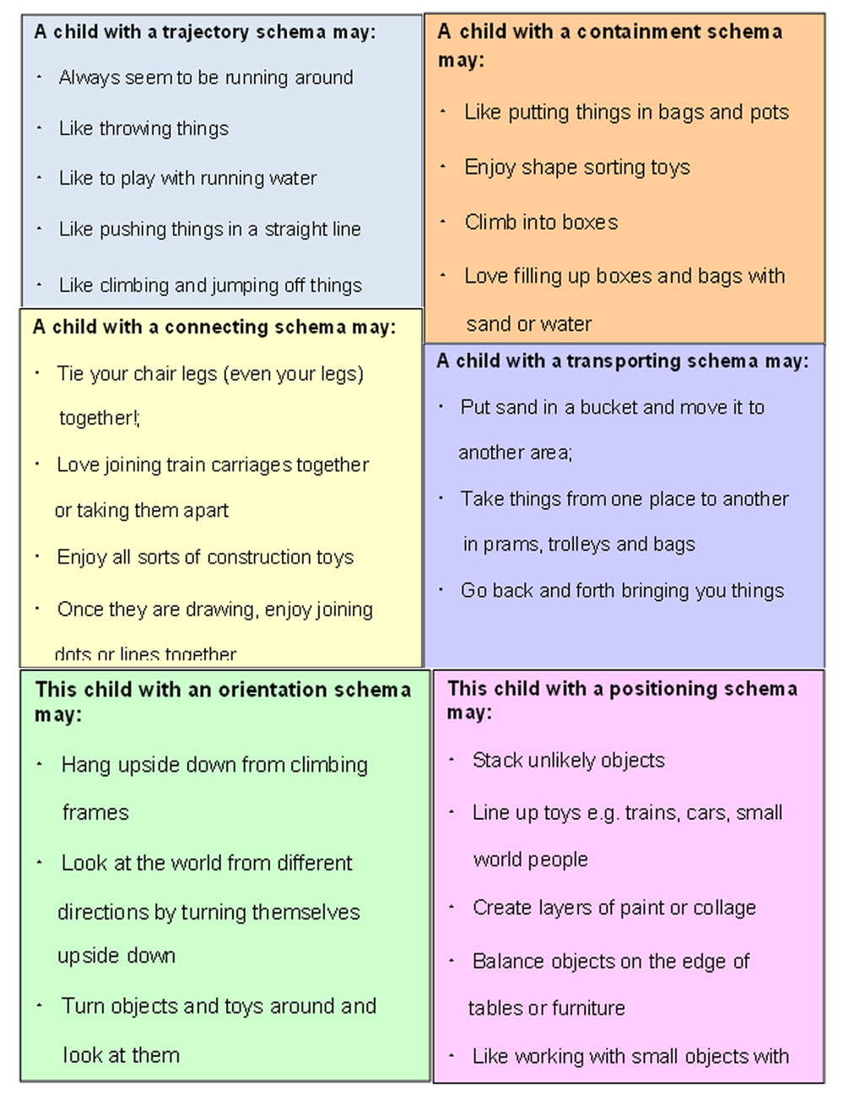
(source: Sand, C 2014)

The Needs of the Child

You are likely to have a wide range of children in the setting, all of whom have different needs and abilities. It is important partitioners ensure the environment and practice meets their care, learning and play needs. An example of a child who will struggle during transition is a child with a diagnosed Autism Spectrum Disorder (ASD).

NHS Wales (2020) states that it is estimated that about 1 in 100 people in the UK has ASD, and children with ASD will find changes extremely difficult when transitioning between home and the setting. Many children with ASD manage differently, and for some, structure in the setting can help children cope better than the unstructured they may have at home.

Manikiza (2015 p.32) advises practitioners to help children with Autism Spectrum Disorder’s, and they should:
- Be consistent with a routine both at the beginning and end of day
- Encourage parents to prepare the child for changes
- Prepare the child for the transition to school and arrange visits to the new environment well in advance.

Routines set by adults help children to know what to expect Forbes (2009b p.253) states that ‘there should be a degree of flexibility in them, as any routine should focus on meeting both individual and group needs’ when settling children into transition.

Abraham Maslow

Abraham Maslow (1908-1970) was a humanist theorist who claims our actions are motivated in order to achieve certain needs. he was best known for creating Maslow’s Hierarchy of Needs.

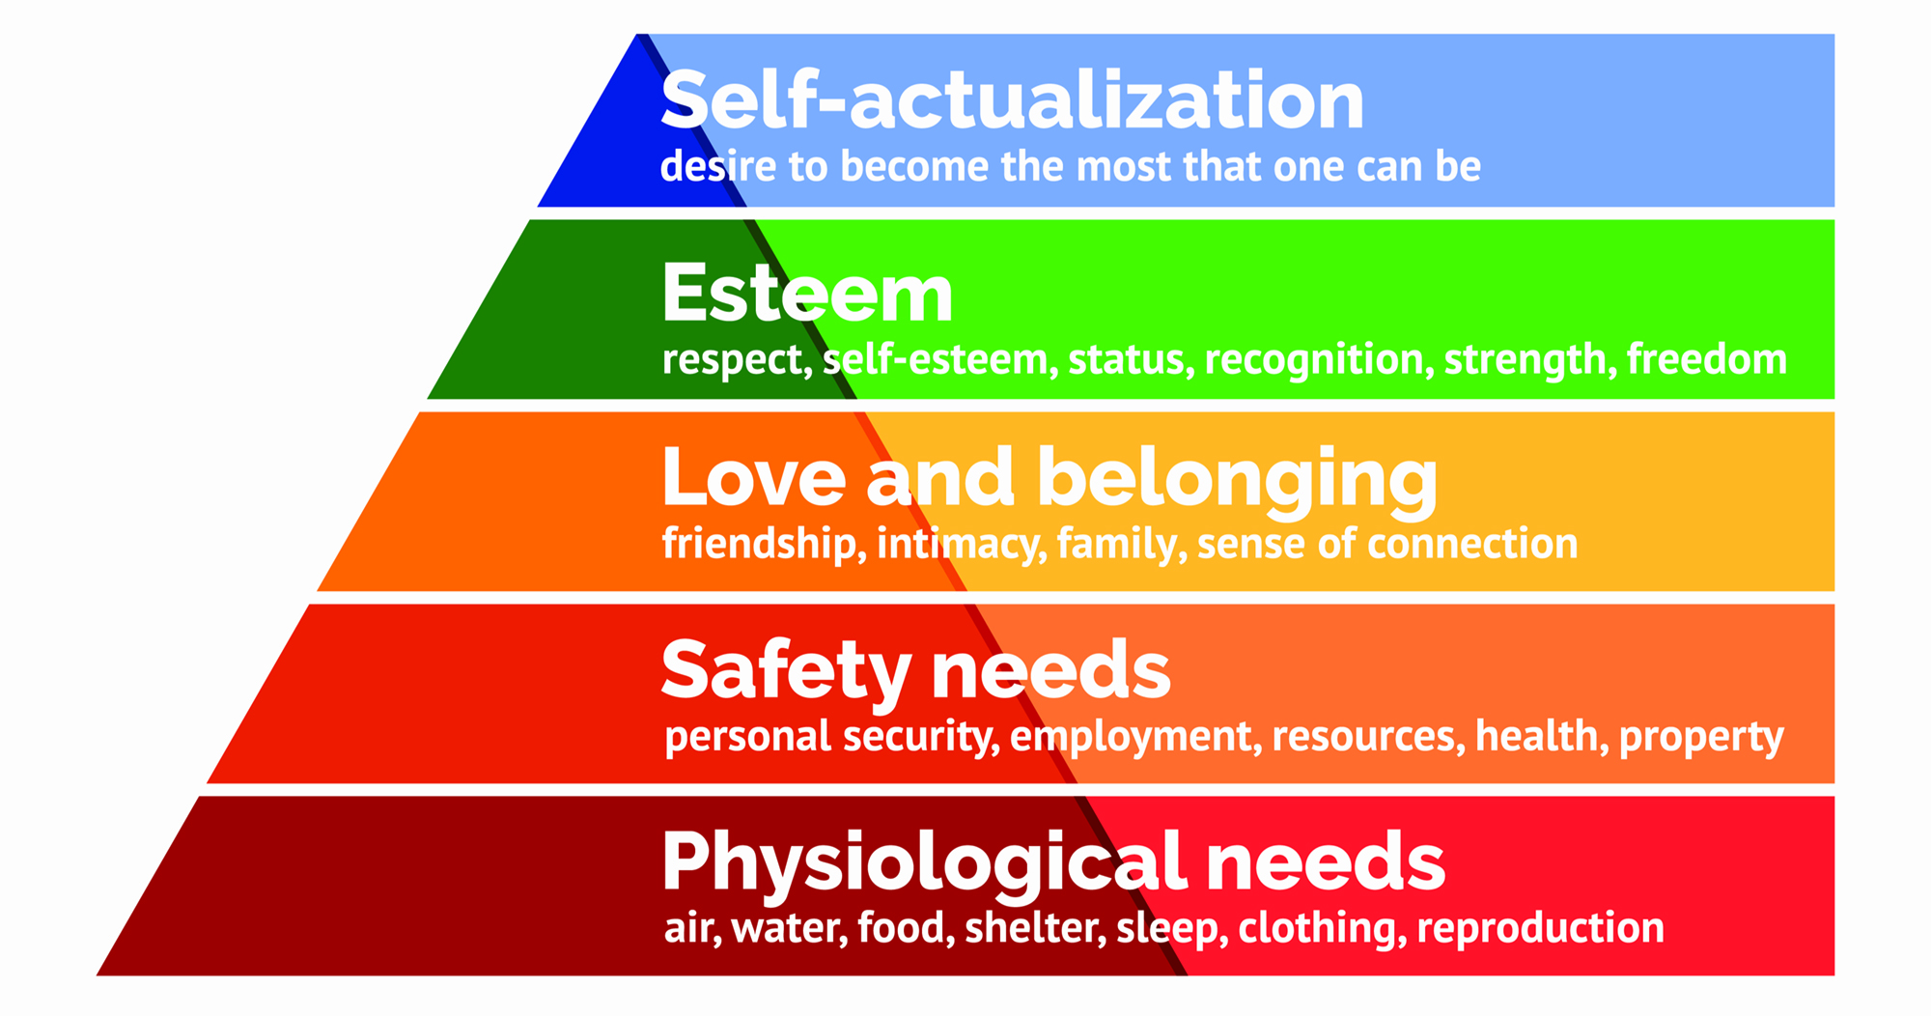
(source: McLeod, S. 2020)

The hierarchy is displayed as a pyramid because the lower level is made up of basic needs, whereas the more complex needs are located at the top. Khan (2016) explains that the five-stage model can be divided into basic needs and growth needs, which relate to children fulfilling their human potential. Maslow believed every child is capable and has the desire to move up the hierarchy. However, the progress can often be disrupted by failure to meet lower level needs. This can happen due to transitions and how it affects the child’s feelings and emotions, causing them to regress.

Partnerships and Interventions

The following table diagram written by Forbes (2009c p.130) shows there are many agencies that work closely with young children, which can help practitioners, if there are concerns over a child’s development.

Agency | How can they help?
Child’s Doctor | Assesses the child’s health and growth and development.
Play Therapist | Assesses the child’s behaviour, expression and learning
Child Psychiatrist | Assesses the child’s emotion
Health Visitor | Looks at and assesses the child’s health, growth and development for children under 5.
Play Therapist | Assess and observe how the child plays and uses problem solving skills
SENCO | Special Education Needs Coordinator
Speech and Language therapist | Assesses the child’s speech and language capabilities

Parent Partnerships

According to Tassoni, P et al (2002 p.420) ‘it is important that a partnership with parents is at the centre of positive care and education for young children. It is this partnership that will help early years practitioners to gain the information they need about a child to facilitate effective communication.’ When having a stable relationship with parents and carers they feel more involved in their children’s learning and development and they feel valued and respected, this helps them and practitioners exchange information about their children and know more about their child’s experiences outside the home environment and can use this information to support their learning and development more effectively.

