
Business Plan
LCBB5001 – Entrepreneurship Lecturer name: Nishi Ramsurrun
Word count: 2037
Name: Petya Encheva Petrova Student number: (2111477)



Table of contents:

Introduction…………………………………………………………………………..p.2

Business description/market opportunities……………………………p.2

Industry analysis…………………………………………………………………….p.3

Operations and management team plan……………………………….p.5

Operations………………………………………………………………………..p.5

Revenue and Loss prevention……………………………………………p.5

Management plan……………………………………………………………..p.6

Market plan and strategy……………………………………………………….p.7

Financial Plan…………………………………………………………………………p.8

Conclusion……………………………………………………………………………..p.9

References…………………………………………………………………………..p.10

Introduction

Welcome to the flavourful world of Mystic Clouds Lounge. Our shish bar is poised to revolutionize the culinary landscape by offering a unique dining experience centred around the art of grilling succulent meats, vibrant vegetables, and tantalizing flavours on skewers. At Mystic Clouds Lounge, we pride ourselves on blending tradition with innovation, creating a vibrant atmosphere where guests can indulge in exquisite shish kebabs crafted with passion and expertise. In this business plan, we will delve into the details of our concept, market analysis, operational strategies, and financial projections. Join us on this journey as we unveil our vision to redefine the shish dining experience and establish Mystic Clouds Lounge as a cornerstone of culinary excellence in our community.

2. Business Description/Market Strategy


Mystic Clouds is a vibrant and dynamic establishment that offers a unique fusion of traditional hookah culture with modern entertainment and hospitality. Located in Enfield, our shisha bar is designed to provide an unforgettable experience for patrons seeking relaxation, socialization, and enjoyment in an inviting atmosphere.

At Mystic Clouds Lounge, our vision is to redefine the shisha experience by creating an oasis of relaxation, luxury, and cultural fusion. We aspire to be the leading destination where patrons can indulge in premium shisha blends, savour exquisite cuisine, and immerse themselves in a sophisticated ambiance that celebrates tradition and innovation (Kotler & Keller, 2016). On the other hand, our mission is to promote cultural exchange. We celebrate diversity and multiculturalism by embracing a variety of shisha flavours, culinary influences, and artistic expressions. Huqqa Shisha Bar serves as a hub for cultural exchange, fostering connections and understanding among our diverse clientele (Nicosia, 1966).

The main objective for the shisha bar is to introduce three new signature shisha blends withing six months. (Brown, S. n.d.)
- Specific: Develop and introduce three new signature shisha blends that reflect unique flavours and appeal to diverse tastes.
- Measurable: Track the successful development and launch of three new shisha blends within the specified timeframe
- Achievable: Collaborate with expert mixologists, conduct taste test, and gather customer feedback to refine the new blends.
- Relevant: Offering innovative and exclusive shisha flavours will differentiate the bar from competitors and attract shisha enthusiasts.
- Time based: Introduce the three new signatures shisha blends within six months of initiating the product development process.

The segmentation that Mystic Clouds is using is demographic. The shisha bar is segmenting young adults and millenniums such as students, workers and tourists. The target age is between 18 and 30. The shisha bar is targeting individuals who value socialising, relaxation, and cultural experiences. Mystic Clouds lounge could position itself as a chic and upscale destination that offers an authentic and immersive hookah experience in a stylish and welcoming environment. By emphasizing high-quality shisha blends, exceptional service, and a vibrant ambiance, "Mystic clouds Lounge" aims to differentiate itself as the premier destination in the area. (Patel, R. n.d.).

Mystic Clouds Lounge is a Limited Company (LTD). Some advantages could be the limited liability where shareholders’ liability is limited to the amount they have invested in the company. Personal assets are generally protected from the company’s debt and liabilities. Another advantage is the tax efficiency from which the company is benefiting such as lower corporate tax rates, tax deductible business expenses and opportunities for tax planning. (Choi, K. 2019).
On the other hand, there are some disadvantages as well such as complexity and administration. The LTD companies are subject to more complex legal and administrative requirements, including company formation, compliance with regulations, and filing annual accounts. Another disadvantage could be the less flexibility. Limited companies may have less flexibility in certain areas compared to sole proprietorships or partnerships, such as restrictions on profit distribution and decision-making processes. Moreover, setting up and operating a limited company can involve higher costs compared to other business structures, including registration fees, accounting fees, and ongoing compliance costs. (Porter, M. 2019).

3. Industry Analysis

Porters five forces: (Porter, 2008).
- Threat of new entrants.
- High start-up costs – significant initial investment in licenses, equipment and décor which acts as a barrier to entry.
- Brand loyalty – existing customer loyalty in competitors, making it difficult for new entrants to attract customers.

- Power of suppliers.
- Tobacco suppliers – the tobacco suppliers have significant bargaining power due to limited suppliers for shisha bars and high switching costs.
- Equipment supplier – Suppliers of the equipment for shisha may have moderated bargaining power if there are few alternative sources.

- Power of buyers:
- Customer switching costs – easily they can move to other shisha bars.
- Price sensitivity – competitors in the area and chance of losing customers who are price sensitive.
- Threat of substitutes:
- Social venues – other cafes, lounges or bars can serve shisha flavours.
- Home smoking – customers can smoke shisha at home, especially if they perceive it to be cheaper or more convenient.

- Intensity of competitive rivalry:
- Competitors: the amount of shisha bars in the area and their proximity to each other affect competitive rivalry.
- Product differentiation – offering unique flavour, ambiance or entertainment has a big advantage on customers.

VRIO Analysis: (Barney, J 2014).
- Valuable:
- Unique shisha blends – offering exclusive flavours that are not readily available elsewhere.
- Prime location – strategic location in busy traffic area and popular nightlife district.
- Experienced staff – employing skilled shisha masters.

- Rare:
- Shisha ingredients – rare, exotic, and organic ingredients for shisha blends.
- Exclusive partnership – partnership with suppliers and entertainment venues.
- Unique ambiance – creating a one-of-a-kind atmosphere there that sets the shisha bar apart from competitors.

- Inimitable:
- Brand reputation – building a strong reputation and loyal customer base through customer satisfaction.
- Cultural authenticity – incorporating cultural elements or tradition into the shisha bar experience. It could be challenging for competitors.
- Patented process – shisha bar patenting blends and unique operational methods where competitors cannot copy.

- Organised to exploit:
- Effective marketing strategies – using the correct marketing strategy to promote the shisha bar’s unique services.
- Staff training programs – implementing training programs for staff to ensure consistent service quality.

Operations and management team plan
  - Operation

By effectively managing the business processes and supply chain, Mystic Clouds Lounge can ensure the consistent delivery of high-quality shisha products and services, resulting in customer satisfaction and loyalty. Procurement of raw material such as high-quality shisha tobacco, flavourings, charcoal and other necessary ingredients from trusted suppliers such as ‘Xquisite smoke’. They provide not only flavours but also equipment kit for shisha. Having a strong relationship with suppliers will ensure timely delivery and consistent quality (Xquisite smoke, n.d.). Moreover, managing inventory levels of shisha tobacco and other consumables to meet customer demand while minimising stock excess. Following this process, Mystic clouds lounge has a tracking system to monitor stock levels and reorder points. Next stage is the shisha preparation according to standard recipes and customer preferences. This can happen by training staff in the proper handling and preparation of shisha to ensure the needed consistency and quality. The customer service is very important as interacting with customers helps to understand their preferences and provide personalised recommendations. Also getting a positive experience comes from managing the orders efficiently. We are getting to the operations managements where day to day operation of the shisha including staffing, scheduling and facility maintenance. Implementing operational procedures to ensure smooth workflow and adherence to health and safety regulations thanks to strong management team. Mystic clouds cares about quality so there are regular quality checks on shisha blends, equipment and facilities to maintain high standards. Addressing any issues regarding quality, helps to uphold customer satisfaction. In addition to that, optimising the supply chain helps reducing costs and improve overall efficiency. Collaborating with suppliers and distributors improves the streamline procurement and distribution process for the business. Finally, implementing continuous improvement initiatives to enhance process, products and service thanks to customer feedback. (Nexsys, 2023).

  - Revenue and loss prevention
Sales will be mostly derived from tobacco income, which have a relatively cheap cost of selling. Food and beverages, which are sold to some but not all consumers who order tobacco, are secondary revenue streams. Over the first three years of business, Mystic Clouds lounge anticipates significant growth as it develops its community component and starts offering customer-directed programming.

By implementing lean management strategies, shisha bars can minimize waste, optimize operations, and prevent loss, ultimately leading to improved profitability and sustainability. This happens through identifying and eliminate waste by conducting analysis for excess inventory, overproduction, waiting times and defects in shisha preparation. Developing standardised operating procedures for all aspects of shisha preparation, customer service and cleaning routines improve consistency and streamline operations. Another way of preventing loss is implementing JIT inventory management by adopting approach to inventory management to minimise excess stock and storage costs. Order inventory based on actual demand to reduce inventory holding costs and prevent loss due to spoilage or obsolescence. (White, R. 2001).

  - Management plan

Mystic Clouds Lounge is managed by Petya Petrova, who is Bulgarian but lives in Enfield. She has developed the concept for the lounge after researching and having experience as a manager. She will manage store operations and make day-to-day decisions while handling inventory management. Her job role will be general manager/Director.

Initially, there will be one cooking staff member, two wait staff members, two bartenders and one shisha maker. This will increase to three culinary staff, six wait staff, and three bartenders and two shisha makers. Bartenders and wait personnel make less money because tips make up a large portion of their pay. These staffing projections are predicated on the bar operating 80 hours a week. 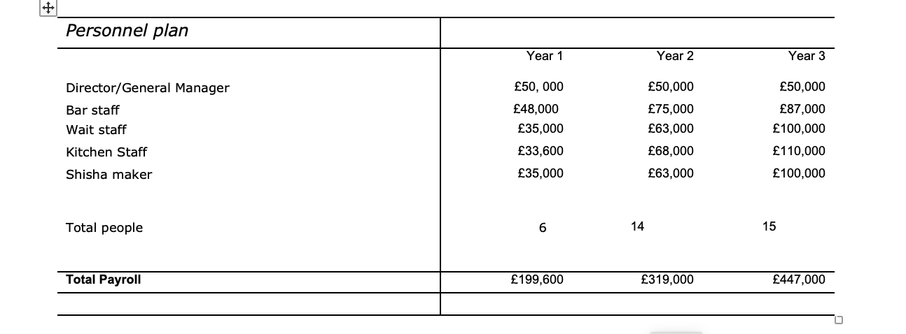

Marketing plan and strategy
Marketing Mix
- Product – Mystic clouds will offer a variety of shisha flavours, beverages and food to cater different tastes and preferences through diversity menu so they can meet customers’ needs and expectations.
- Price – prices for drinks will range from £6 for simple coffees. Up to £12 for mocktails/cocktails. Prices for appetizers will range from £5 to £9 for single servings and£14 to £20 for group dishes. Shisha’s prices will vary between £15 to £25 depending on the type of flavour. They can take a single head or mix and match which will have additional charge of £2. Ice pipes will be available for the price of £3.
- Place – the shisha bar will have a unique atmosphere with comfortable seating, music and décor to enhance the overall customer experience. There will be a stage where live entertainment will take place like belly dancer, fire show, magician etc. assuring that these events are acceptable for Mystic clouds management and all its customers.
- Promotion – Mystic clouds lounge will use digital marketing through social media by advertising its products and services so it can attract more customers. Also, there will be a cross promotion used for Mystic Clouds where they can expand their reach, sales and build mutual beneficial partnerships with other shisha bars. For examples, Haart lounge, which is near Enfield, can collaborate with Mystic Clouds to offer special discounts or promotions to each other’s customers.

Financial Plan
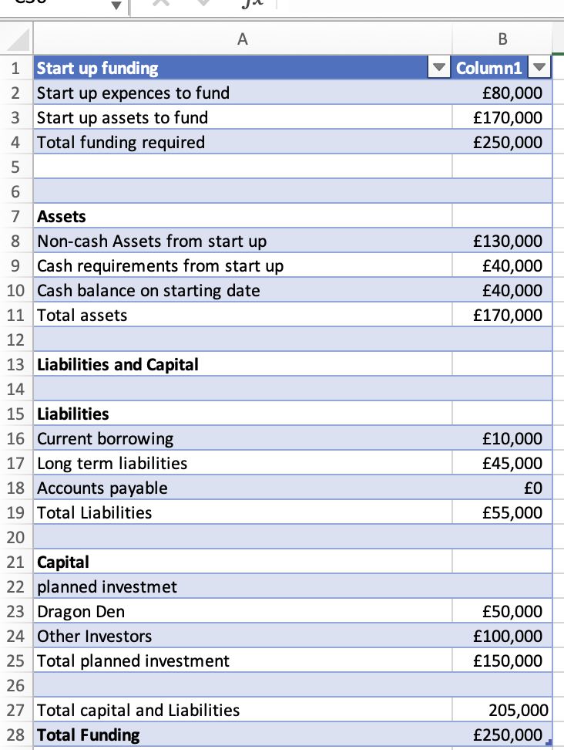
While the owners will make significant investments in the firm, outside investors will supply the majority of the start-up money, with an extra long-term loan secured by the bar's assets. The balance will be made up of credit card debt. (Poalo Alto, n.d.)
Investors will receive 40% of the shares for their investment, while the current partners are contributing significant sweat and financial equity of their own.

The money coming from Dragon Den (£50,000) will be used for equipment and to hire staff members.

Profit and Loss sheet

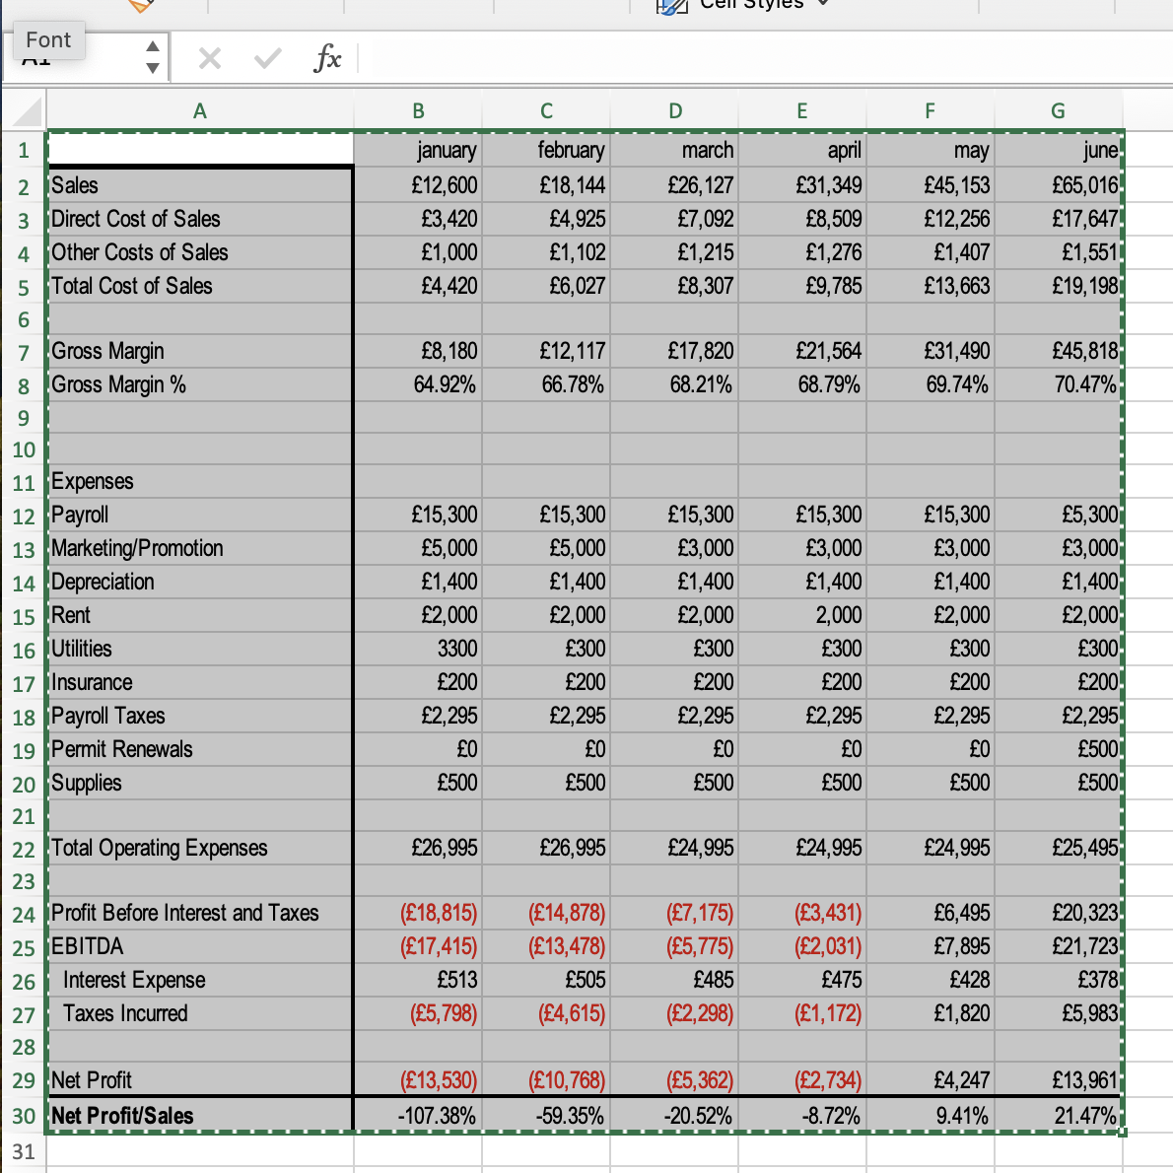

Conclusion
In conclusion, Mysctic Clouds lounge’s business plan focuses on the key elements of how it can become successful. Through meticulous market research, we have identified a niche audience of shisha enthusiasts seeking an upscale, yet relaxed environment to indulge in their passion. By leveraging our prime location, innovative marketing strategies, and strategic partnerships, we aim to attract and retain a loyal customer base while continuously adapting to meet evolving consumer preferences.
Despite potential challenges and risks, we are prepared to mitigate them through careful planning, flexibility, and a focus on continuous improvement.

References:

- Alto, P. (n.d.). Hookah Bar Business plan. Bplans. Available at: https://www.bplans.com/hookah-bar-business-plan/ accessed on 22.04.2024
- Barney, J. B., & Hesterly, W. S. (2014). Strategic Management and competitive advantage: Concepts and cases. Pearson (accessed on 22.04.2024)
- Brown, S., Williams, L., & Garcia, M. (Year). "Targeting Young Adults and Professionals: The Key Market Segments for Hookah Shisha Bars - Insights from Oasis Lounge." Journal of business and management, 30(2), pp. 221-235 (accessed on 22.04.2024)
- Choi, K., & Wang, H. (2019). "Understanding Limited Liability: The Advantages of Limited Company Structures." Journal of Corporate finance, 42, pp. 101-115(accessed on 22.04.2024)
- Kotler, P., & Keller, K. L. (2016). Marketing Management. Pearson Education Limited. Available at Pearson. (Accessed on 22.04.2024)
- Nexsys (2023). 8 key business processes for a seamless supply chain management. Nexsys. Available at: https://www.nexsys.co.uk/knowledge-hub/eight-key-business-processes-for-a-seamless-supply-chain-management/ (accessed on 22.04.2024)
- Patel, R., Jones, D., & Lee, K. (Year). "Behavioral Segmentation Analysis of Hookah Shisha Bar Customers: A Longitudinal Study." International journal of service industry management, 20(4), p. 567-580 (accessed on 22.04.2024)
- Porter, M. E. (2008). "The Five Competitive Forces That Shape Strategy." Harvard Business Review, 86(1), pp. 78-93 (accessed on 22.04.2024)
- Porter, M., & Johnson, D. (2019). "Complexity and Administration: Challenges of Limited Company Structures." Journal of business administration research, 12(2), pp. 201-215 (accessed on 22.04.2024)
- White, R. (2001). The relationship between JIT practices and type of production system. Omega, 29(2), pp 113-124. (Accessed on 22.04.2024)
- Xquisite Smoke (n.d.). Get the best prices on wholesale shisha supplies. XquisiteSmoke. Available at: https://xquisitesmoke.com/shisha-wholesale/#:~:text=Xquisite%20Smoke%20supplies%20Shisha%20pipes,discounted%20prices%20and%20online%20ordering. (Accessed on 22.04.2024)

