Future Developments in the Field of Marketing

Student Name : Vijeyalashimi Gersone
Student ID : 181644
Lecturer Name : Gwyneth Jones
Module : BMMB7026

Executive Summary
The incorporation of modern technology and digital media into company processes is known as digital transformation, and it is the subject of this report's exploration (Ramond, 2015). Suherlan and Okombo (2023) cite the following as examples: using social media, opening online storefronts, and digitizing internal procedures. By switching from conventional to digital channels, improving customer interaction, and increasing revenues, digital transformation transforms marketing (Wegnar, 2019). Digital marketing has several benefits over conventional marketing, including increased reach among audiences and more accurate consumer segmentation that strengthens relationships with target consumers. Businesses that use digital marketing have witnessed significant increases in sales (Jain & Yadav, 2017).
The study emphasizes the greater returns and efficacy of digital marketing as compared to traditional approaches, underscoring its strategic significance in contemporary company. Businesses need to adjust to new technologies as they traverse this digital transition in order to stay competitive and promote long-term growth

Introduction

Marketing
A marketing campaign is a set of actions carried out by a company or a person with the goal of selling, marketing, or distributing goods or services to customers or prospective clients (Suherlan and Okombo, 2023).
Marketing strives to meet the requirements and wants of the consumer while accomplishing certain company goals, including raising revenues, expanding market share, or raising brand awareness (Rooswelt, 2020). The following are some essential components linked to the idea of marketing:
Product or Service:
Fits the demands and desires of the clientele.
Creating new products, enhancing current ones, or tailoring them to certain markets.
Price:
Generates revenues while reflecting the worth of the item or service to consumers.
Promotion includes:
Public relations, digital marketing, sales promotions, advertising, and other forms of communication that educate and sway people about goods or services.
Place (Distribution):
Effective and efficient distribution, encompassing supply chain management and appropriate channel selection.
Customer Value: Establishing enduring connections with clients, offering post-purchase assistance, and guaranteeing client contentment.
Brand and company identity:
Shapes consumer opinion and fosters a devoted following.
Analysis and Measurement:
Makes choices based on solid evidence by measuring campaign performance using data and analytics.

1.2 Overview of Future insights
Long-term business viability in today's fast-paced economy depends on customer pleasure. If enterprise marketing management is to assure successful strategies, it must adjust to new media and technology, especially e-marketing. Challenges to traditional approaches include market segmentation, disregard for regulations, and fierce rivalry from international firms (Fillis, Johannson and Wagner, 2004). The influence of e-marketing, which highlights the value of education, has not been deemed worthy. In order to contend with intricate global marketplaces and volatile markets, businesses need to continuously assess and maximize their marketing resources. In order to effectively coordinate tasks with limited resources, intelligent individuals are essential (Lajevardi, 2016).
The demands and expectations of customers are what drive businesses in this day and age, which we call the "age of the customer." Marketers that strive to comprehend and establish a connection with clients on their own terms have produced the consumer experience as a marketing technique (Iskiev, 2021). Success requires the capacity to respond and assist customers at all stages of their journey. The likelihood that a high-performing marketing team has included a consumer journey strategy into their overall company plan is 8.8 times higher than that of an underperforming team (Miles et al., 1978). Businesses that are successful provide clients with essential goods and services at a cost they can pay, adding value to their relationship. These businesses employ marketing techniques to ensure that the goods and services they provide meet consumer demand (Markgraf, 2023). The purpose of applying a range of marketing approaches is to more fully comprehend the wants of consumers and supply for them. Companies that construct winning marketing programs experience big sales quantities and the proper profit margins (Akramov, 2012). Establishing the goal of a business and putting rules in place to accomplish it is an aspect of marketing. The design and execution of these strategies to accomplish business objectives in accordance with the business's mission constitute a marketing strategy. These tactics can range from broad ones for certain marketing domains, such as product differentiation, price reduction, and market segmentation, to more specialized ones (Jain and Yadav, 2017). The main reason to implement a marketing plan is competition. In businesses where a single company holds a monopoly, little marketing is necessary to encourage consumer spending. For instance, utility firms have stable demand and entrenched market positions, therefore marketing is less important (Markgraf, 2023).
Information technology is used in marketing, which is a combination of art and science to improve commercial operations. It is used in businesses and organizations with a focus on innovation via marketing management (Ladford, 2017). Technology provides advantages in today's fast-paced industry, such as online decision-making, follow-up automation, and client attraction. It can, however, be expensive and difficult to handle fast. For the purpose of marketing a product, technology must be introduced and used properly. Marketers innovate continuously and adjust to shifting consumer preferences. In the quick-paced market of today, success is ensured by the proper combination of innovation and technology (Markgraf, 2023).

Digital Transformation in Marketing
A company's exploration into the digital realm and all the adjustments that entails is known as digital transformation. It may also be described as the action a business takes to integrate digital media and technology (Ramond, 2015). A business experiences a digital transformation, for instance, when it begins to use social media, launches an online store to sell its goods, or integrates digital technology into internal operations (Suherlan and Okombo, 2023). Organizations must focus on digital marketing even if conventional marketing is still necessary and should be a component of our plan (Wegnar, 2019). The advantages of digital marketing are larger as marketers can reach a wider audience using digital media. Hence, compared to traditional marketing, the return is more. More accuracy in consumer segmentation is another advantage of digital marketing. This enables us to develop more potent methods for establishing a connection with our target customer. Every business that has undergone the digital marketing revolution has seen a notable rise in revenue (Jain and Yadav, 2017).

The Effect of Technology on Marketing Function
With the rapid improvements in communication and information technology, the use of technology in marketing has undergone substantial shift in the modern day. These technological developments have not only profoundly affected the marketing strategies used by companies, but they additionally irreversibly changed consumer behavior (Suherlan and Okombo, 2023). Technological developments have given businesses access to an abundance of innovative resources and instruments to help them plan and organize their marketing efforts. These revolutionary innovations span a broad spectrum of subjects, from the intricate realms of social media and online advertising to the intricacies of advanced data analysis (Sleiman et al., 2021). This dynamic infusion of technological advances into the marketing scene has revealed a vibrant tapestry of new opportunities, enabling the realization of more targeted and efficient outreach techniques. Technology has also brought about an era of hyper personalization, when consumer experiences are meticulously tailored to match individual preferences, creating a lasting and meaningful connection (Tapp and Hughes, 2004).

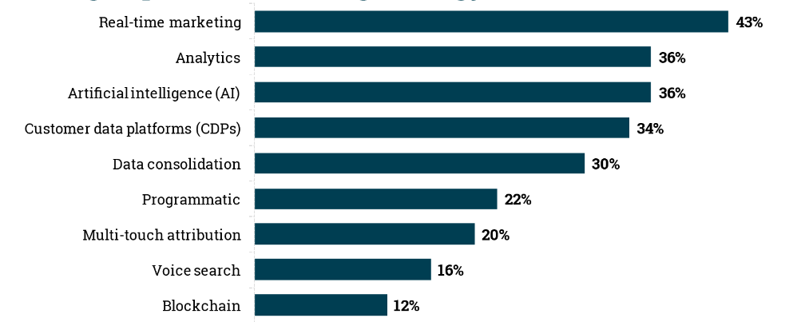
The most influencive Emerging Technology in this Year
Figure No.01: Analysis of Emerging Marketing Technologies
Source: https://www.marketingcharts.com/
According to a recent Ascend2 company’s survey, marketers believe that technology like AI, analytics, and real-time marketing will influence marketing strategy in 2024.Which developing technology, in the opinion of the 270 marketers polled, will have the biggest influence on marketing strategy as a whole in the upcoming year? Real-time marketing will have the most effect for the majority (43%). Over a third (36%) of respondents believe that analytics will have an influence on marketing strategy as a whole in this new era (Lashbrook, 2021).

Technologies that will have an Influence on Marketing globally during the Next 10 Years (Starting in February 2020)
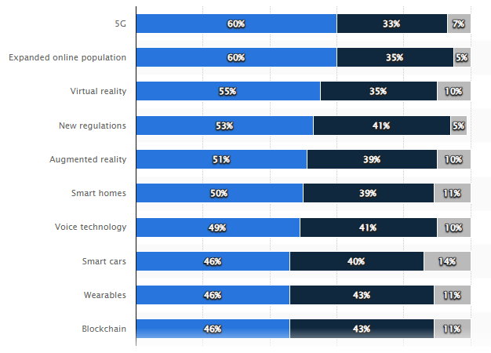
Figure No 02: Technological Innovation in Marketing Forecast for 20 years
Source: https://www.statista.com/
In a 2020 study of marketing executives from 30 different countries, 60% of participants stated they anticipated that the worldwide growth of the internet population and 5G will have a significant influence on marketing within the next ten years. Fifty percent of the responders mentioned smart home technologies in the same sentence (Navarro, 2022).

The Effect of Machine Learning and Artificial Intelligence on Digital Marketing Strategies
The fields of machine learning (ML) and artificial intelligence (AI), which deal with developing intelligent systems that are capable of doing tasks that typically require human intelligence, are closely related to one another (Mauro, Sestino and Bacconi, 2022). Among the numerous industries that AI and ML are revolutionizing as cutting-edge technology is digital marketing. These developments have the ability to drastically alter how businesses engage with their target audience, make the most of their marketing expenditures, and deliver superior outcomes. In this digital age of abundant data and complex consumer behavior, AI and ML provide powerful tools to access intelligent data, customize marketing campaigns, and enhance customer experiences (Sleiman et al., 2021).

The Advantages of Personalized and Data-Driven Marketing
- Improved segmentation and targeting of customers through the use of thorough customer profiles.
- Forecasting and foreseeing consumer behavior and trends.
- Enhanced decision-making based on insights from data.
- Personalized content recommendations lead to higher engagement and conversion rates.

Impact of Big Data on Marketing Strategies
An era of abundant data has been ushered in by the digital age. Companies such as yours are continuously creating and gathering data from a wide range of sources, such as sensor data, website traffic, and social media engagements and online transactions (Ani, 2024). Big data, an ever-expanding collection of information, is transforming marketing tactics and enabling companies to connect and comprehend their target markets like never before (Hoffman et al., 2021). Businesses are able to pinpoint areas for improvement, inefficiencies, and bottlenecks by analyzing operational data. Better profits, cheaper expenses, and more effective operations might all come from this optimization. This optimization may lead to cost savings, improved resource management, and simplified processes (Vadowt, 2023). Big data analytics draws attention to market gaps and requirements, which encourages innovation. Businesses are able to recognize emerging trends, evaluate the potential of novel products and services, and adjust their product lineups to meet changing customer needs (Wegnar, 2019).

Big Data in Marketing: Principal Advantages and Difficulties
- Comprehensive customer understanding: Big data offers in-depth information of consumer preferences, actions, and past purchases.
- Well-informed decision-making: Data-driven choices improve marketing effectiveness by lowering dependence on intuition.
- ROI optimization: By identifying high-performing channels and initiatives, big data increases return on investment.
- Tailored experiences: By anticipating client demands, big data improves customer pleasure and loyalty.
- Competitive advantage: Businesses may efficiently satisfy customer expectations and adjust to market changes by leveraging the insights provided by big data, which others may have overlooked.

Omnichannel Marketing
The deliberate blending of all your offline and online marketing channels into one cohesive, customer-focused experience is known as omnichannel marketing (Hilton, 2020). It involves more than just employing several channels; it involves making sure those channels function as a cohesive unit to deliver a consistent experience. Put otherwise, omnichannel refers to giving customers the same interaction with a business anywhere online, in-person, over the phone, or somewhere else.

6.1 Why is Omnichannel Marketing Important?
Develop a unified customer experience over all touchpoints to increase loyalty and trust. Regardless of the channel, they will value how simple it is to plan and oversee their roof repair process. Maintaining a unified tone and message for the business on all media strengthens its identification and builds rapport with prospective clients searching for a trustworthy roofing service.By utilizing the advantages of several channels, omnichannel tactics influence with greater efficacy and effectiveness connect with the target audience. More quality leads and scheduled appointments may result from this.

Strategies for an Effective Omnichannel Marketing Campaign
Understand different touchpoints company:
- Tailor messaging and content to each stage of the journey.
Consistent Branding
- Maintain a consistent brand voice across all channels.
- Personalize marketing messages based on customer data.
Optimize for Different Devices
- Ensure website and online booking system are responsive and user-friendly.
Integrate Channels
- Break down silos between marketing channels for a unified experience.
Invest in CRM Tools
- Manage customer data and interactions across channels.
Track and Analyze Results
- Regularly monitor omnichannel campaign performance.

Evolving Role of Social Media in Marketing
Social media now plays a crucial role in our everyday lives by affecting the connections, sharing, and communication we have with others. It has also had a major impact on the marketing environment throughout time (Rooswelt, 2020). What started off as a private chat platform has grown into a powerful marketing tool that businesses of all sizes use to engage with their target audience, build brand awareness, and enhance sales (Tapp and Hughes, 2004). Working together, interacting, and sharing content is made simpler by social media. There are many other formats available for these social media platforms and apps, such as wikis, podcasts as well as social blogs, blog posts, ratings, social recording, videos, and images (Jamil et al., 2022). Businesses, political organizations, and social network users are using social media more and more for communication. Governmental and commercial organizations utilize social media for marketing and advertising. Social media lowers the cost and time involved in integrated marketing operations by facilitating smooth dialogues and exchanges among consumer stakeholders and events, media, internet resources, and merchants (Jain and Yadav, 2017).

Social Media Marketing Statistics For 2024
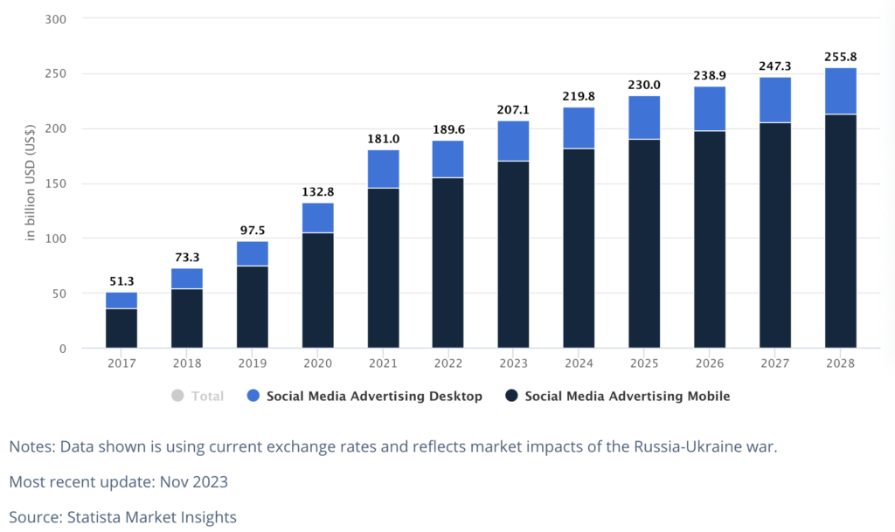
Figure No 03: Social media advertising statistics
Source: https://www.statista.com/
It is projected that $219.8 billion will be spent overall on social network advertising by 2024.By 2028, mobile will be responsible for $255.8 billion of social networking site ad spending, according to current forecasts. The estimated growth rate for overall advertising expenditure by 2024 is 6.1%. Social media ads account for 28.8% of all digital advertising spending. Approximately 8.7% of a company's total revenue is dedicated to advertising (Vicky, 2024).
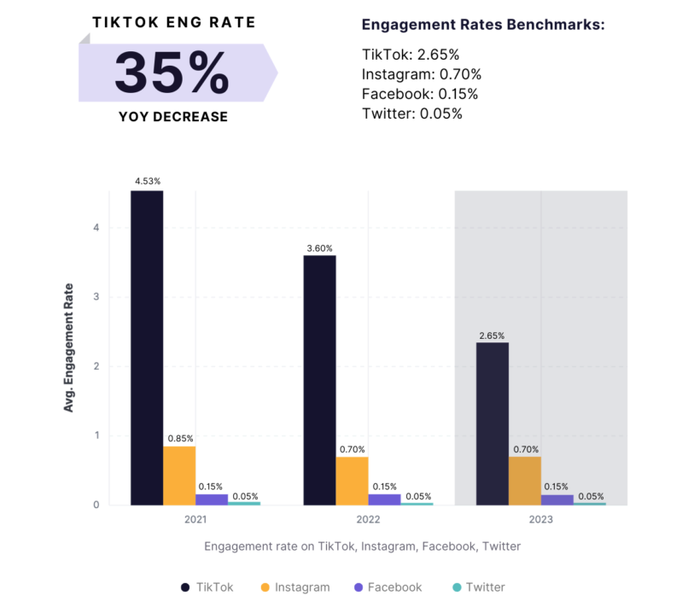
Figure No.04: Social Media Followers-2024
Source: http://socialinsider.com/
Forty-three (43%) percent of marketers want to augment their Instagram investment in 2023.Instagram's position as the preferred social media platform for influencers is under threat from TikTok. Nevertheless, comparatively strong engagement rates, new e-commerce capabilities, and significant ad investment indicate that Instagram's future remains bright (Cooper, 2021).

Advantages of Social Media Marketing
Increased Brand Recognition: Social media marketing raises brand awareness and exposure.
Targeted Marketing: Advanced targeting tools for customized ads are available on social media networks (Hoffman et al., 2021).
Cost-Effective Advertising: Social media advertising is more affordable for companies of all sizes compared to traditional advertising techniques.
Real-time Engagement: Interacting with the audience in real-time fosters a sense of community and builds trust (Jamil et al., 2022).
Crucial Information: Analytics tools for monitoring interaction, click-through, and sales conversions are available on social media sites (Lashbrook, 2021).
Global Reach: Social media enables communication across geographical boundaries.
User- generated content (UGC): Content created by users has the potential to strongly recommend a brand (Markgraf, 2023).

Social media marketing's drawbacks
Time-consuming: Maintaining an active social media presence requires consistent effort, which interferes with other obligations (Ramond, 2015).
Negative Effects: Online platforms can encourage critical remarks, making it necessary to appropriately address grievances and evaluations.
Modifications to Platform Algorithms: Material exposure is impacted by social media networks' frequent modifications (Suherlan and Okombo, 2023).
Ad Saturation: When newsfeeds are overloaded with ads, viewers may become weary of them, which makes it harder to draw in and hold their interest (Wegnar, 2019).
Privacy Concerns: In order to safeguard brands and stay out of trouble with the law, honest and ethical treatment of customer information is essential.
Platform Dependency: Social media success is reliant on the platforms, which may have an effect on marketing initiatives (Rooswelt, 2020).
Interaction: To truly stand out in a congested digital world, one must be creative and innovative due to intense competition (Navarro, 2022).

Content Marketing and Storytelling
Since the beginning of time, storytelling has been a fundamental component of human communication. The art of delivering a compelling story has the ability to attract listeners, arouse emotions, and leave enduring memories a skill that has been used from the earliest days of oral tradition and continues into the current era of digital marketing (Charles, 2023). Storytelling is a powerful strategy in content marketing because it helps connect with the target audience and clearly convey your business message. It also helps grab their attention. For businesses producing a blog post, video, or social media campaign, a compelling story may enhance the material and create a genuinely memorable impression (Arora, 2023).
A crucial marketing technique, storytelling help establish emotional connections with customers, set company’s brand apart from the competition, gain their trust, and express the beliefs. It emotionally connects with the viewer, deepening their comprehension and admiration of the brand (Kumenan, 2016). Shared narratives distinguish brand and show that businesses are aware of what customers require. They also encourage loyalty and a solid bond between your business and customers by inspiring and motivating them. Using narrative in marketing may help to establish a powerful and memorable brand experience (Fujii, 2022).

Benefits of Storytelling
Grabs Audience Attention: Using narratives in marketing materials may pique readers' curiosity and increase their openness to brand messaging (Guilliame, 2019).
Enhances Memorability of Information: Audiences are better able to recall brand messaging when they are told stories.
Highlights and Enhances the Human Element: Telling real-life tales has the power to emotionally engage an audience and foster loyalty and trust (Hoffman et al., 2021).
Encourages Readers to Act: Well-written narratives have the power to move readers to take movement and encourage them to interact with goods or services (Kumenan, 2016).

Content Marketing Storytelling Types
Branded Storytelling:
- Creates a narrative around the brand, including its history, values, and personality.
- Utilizes company blogs, "About Us" pages, and other content.
Customer Storytelling:
- Focuses on the experiences of customers and how the brand has helped them.
- Uses customer testimonials, success stories, and case studies.
Product Storytelling:
- Focuses on the benefits of the product and how it can help the target audience solve problems.
- Uses product descriptions, demo videos, and other product-focused content.
Industry Storytelling:
- Focuses on the broader industry and how the brand fits in it.
- Uses thought leadership pieces, industry news, and other content positioning the brand as an expert (Mauro, Sestino and Bacconi, 2022).

Content Marketing Challenges
- Small businesses struggle with content marketing due to time and skill constraints, leading to outsourcing and disrupting business operations (Lim, 2020).
- The attention economy's intense competition has sparked a fierce arms race among bloggers, putting pressure on them to consistently deliver exceptional content.
- Content producers often find half of blog posts and articles on professional sites terrible, while some sites use name recognition to avoid half-assed content (Vadowt, 2023).
- Content marketing is shifting towards paid promotion on platforms like Facebook, Twitter, and LinkedIn for targeted audience growth, despite organic social media promotion still being effective (Wegnar, 2019).

Sustainable and Ethical Marketing in the Digital Age
In a globe where customers are becoming more aware of their influence on the environment, the concept of marketing is changing dramatically. In the field of digital marketing, sustainability and ethical behavior are becoming essential elements that are forming a new trend that appeals especially to younger consumers (Viji, 2023). Not only are millennial and Gen Z environmentally savvy, they are eco-champions. They cast their financial votes by selecting brands that share their beliefs. According to studies, 62% of Gen Z and 72% of millennial are prepared to pay more for environmentally friendly products that address social concerns. It's similar like rejecting a tidal wave to ignore this shift (Greneda, 2017).
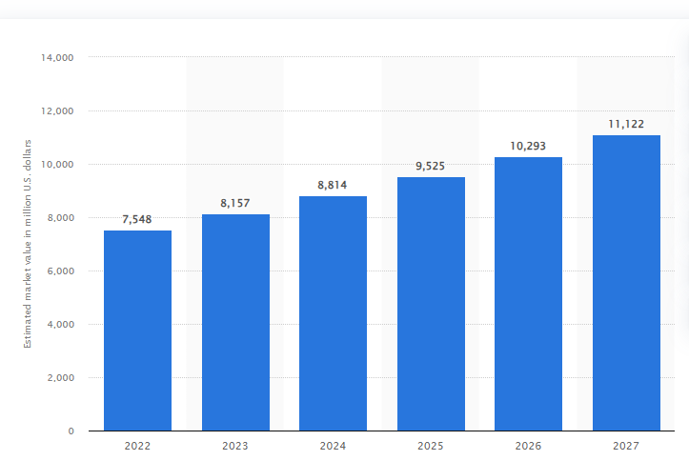
Figure No.05: The global ethical fashion market's estimated worth between 2022 and 2027
Source: https://www.statista.com/
Given the wide range of criteria and viewpoints about what defines an ethical company, it is challenging to define ethical fashion. This statistic describes it as fair trade, eco-friendly, and devoid of exploitation or abuse at any stage in the supply chain (Smith, 2023). The ethical fashion market is predicted to grow by over three billion dollars between 2021 and 2025, reaching a valuation of over 10 billion dollars. This market includes sustainable clothing, but the fashion industry significantly impacts the environment, releasing over a billion metric tons of carbon dioxide annually, which is expected to rise to over 1.5 gigaton by 2029 (Navarro, 2022).

Principles of Sustainable Marketing
- Consumer-Focused Marketing: Responds to the needs, goals, and aspirations of consumers in the direction of a more moral and environmentally conscious society (Gregory, 2020).
- Purpose-Driven Marketing: Emphasizes a company's dedication to making a difference that goes beyond profits.
- Value to customers marketing: Highlights a product's worth in addition to its features and advantages (Iskiev, 2021).
- Societal marketing: Concentrates on enlightening, creating awareness, and motivating constructive changes in society and the environment rather than only profit-driven goals.
- Creative Marketing: Discovers fresh approaches to address environmental issues while engrossing the viewer (Prashar, 2024).

Benefits of Ethics and Sustainability in Business
- Enhancement of company image and brand reputation: Consumers and society at large tend to perceive businesses more favorably when they exhibit a commitment to sustainability and ethics.
- Enhanced trust among stakeholders: Implementing moral and sustainable business practices may boost the trust and allegiance of clients, partners, and staff, leading to more enduring and cooperative partnerships (Homes, 2015).
- Risk reduction: Businesses that follow moral and sustainable business practices are less vulnerable to reputational, legal, and regulatory risks, which may save money and save their brand (Chanshu, 2023).
- Talent attraction and retention: Skilled workers who are looking to work for companies that share their values find companies that prioritize sustainability and ethics to be more appealing.
- Improvement of operational efficiency: The incorporation of sustainable practices can result in cost savings over the long run by increasing efficiency, decreasing waste, and optimizing resources (Fillis, Johannson and Wagner, 2004).

Challenges and Future Opportunities:
- Challenges include, but are not limited to, cultural opposition inside firms, immediate financial outcomes demands, and a lack of common measurements and reporting guidelines for sustainability(Chanshu, 2023).
- Possibilities include: rising customer demand for sustainable and ethical goods and services; technical developments facilitating creative responses to social and environmental problems; and a rise in stakeholder and business collaboration to tackle difficult problems (Greneda, 2017).

Conclusion
The study's findings unequivocally show that technology is a key factor in how consumer behavior and marketing paradigms are changing.
These changes significantly impact the conditions under which companies interact with clients in the dynamic digital era, providing significant value and ensuring the preservation and enhancement of their competitive advantage in an increasingly complex marketplace (Tapp and Hughes, 2004).
Since the market and company are dynamic, marketing will continue to evolve in order to better serve its stakeholders and clients. The industry has seen various stages. It is important to acknowledge that all marketers need to possess enough understanding regarding the impacts of globalization, privatization, and liberalization (Olson, Slater and Hult, 2005). They can't disregard deregulation and new developments in technology. In this fiercely competitive market, they have to strive to please all of their stakeholders, workers, and customers, among others, if they hope to survive (Ramond, 2015). Businesses have a significant obligation to address environmental problems and advance public health.What role can businesses play, Well, by ensuring that their activities don't negatively impact public health or the environment. This include using eco-friendly products, cutting back on pollution, and being aware of how one's activities impact the environment (Smith, 2023). Technological developments, shifting customer tastes, and an increasing focus on ethical and environmentally friendly practices are shaping the marketing landscape of the future. In order to be competitive, marketers need to be flexible and adjust to these developments. Brands may provide customers memorable and captivating experiences by utilizing AI, social commerce, interactive content, customization, and upcoming technologies (Mauro, Sestino and Bacconi, 2022).

Reference list
Akramov, T. (2012). Marketing Strategy: Concepts And Implication. European Journal of Business and Economics, 4(45). doi:https://doi.org/10.12955/ejbe.v4i0.158.
Ani, A. (2024). Big data impact on marketing strategies. [online] Geeks For Growth. Available at: https://geeksforgrowth.com/blog/impact-of-big-data-on-marketing-strategies/#:~:text=By%20leveraging%20big%20data%20analytics [Accessed 1 Jul. 2024].
Arora, S. (2023). The Power of Storytelling in Content Marketing. [online] Growth-natives. Available at: https://growthnatives.com/blogs/content-marketing/power-of-storytelling/.
Carroll, A. (2021). What is a Digital Transformation in Marketing? [online] www.bostondigital.com. Available at: https://www.bostondigital.com/insights/what-digital-transformation-marketing.
Chaitanya, K., Saha, G.C., Saha, H., Acharya, S. and Singla, M. (2023). The Impact of Artificial Intelligence and Machine Learning in Digital Marketing Strategies. European Economic Letters (EEL), [online] 13(3), pp.982–992. doi:https://doi.org/10.52783/eel.v13i3.393.
Chanshu, O. (2023). Sustainable Marketing, Importance, Strategies, Benefits, Challenges, Implementing, Examples. [online] theintactone. Available at: https://theintactone.com/2023/05/13/sustainable-marketing-importance-strategies-benefits-challenges-implementing-examples/.
Charles, C. (2023). The Art of Storytelling in Content Marketing. [online] AIContentfy. Available at: https://aicontentfy.com/en/blog/art-of-storytelling-in-content-marketing.
Colin, E. (2021). Big Data in Marketing: Exploring Applications, Benefits, and Challenges | ADA. [online] www.ada-asia.com. Available at: https://www.ada-asia.com/insights/applications-of-big-data-in-marketing.
Cooper, P. (2021). 130+ Social Media Statistics that Matter to Marketers in 2019. [online] Hootsuite Social Media Management. Available at: https://blog.hootsuite.com/social-media-statistics-for-social-media-managers/.
Fillis, I., Johannson, U. and Wagner, B. (2004). Factors impacting on e‐business adoption and development in the smaller firm. International Journal of Entrepreneurial Behavior & Research, 10(3), pp.178–191. doi:https://doi.org/10.1108/13552550410536762.
Fujii, S. (2022). Storytelling in Content Marketing: How to Tell Stories that Sell. [online] ClearVoice. Available at: https://www.clearvoice.com/resources/how-to-tell-stories-that-sell/.
Glazer, R. (1991). Marketing in an Information-Intensive Environment: Strategic Implications of Knowledge as an Asset. Journal of Marketing, 55(4), pp.1–19. doi:https://doi.org/10.1177/002224299105500401.
Gregory, E.T. (2020). Content marketing challenges and how to overcome them. [online] Longitude. Available at: https://longitude.ft.com/10-content-marketing-challenges-and-how-to-overcome-them/.
Greneda, I. (2017). Sustainable and Ethical Marketing: The New Norm in Digital Media. [online] www.linkedin.com. Available at: https://www.linkedin.com/pulse/sustainable-ethical-marketing-new-norm-digital-media-launchcomms.
Guilliame, F. (2019). Storytelling Marketing 101 : Learn the Magic Techniques of Storytelling in Content Marketing. [online] https://greatcontent.com/. Available at: https://greatcontent.com/storytelling-in-content-marketing/.
Hilton, W. (2020). Omnichannel Marketing: Creating a Seamless Customer Experience. [online] www.linkedin.com. Available at: https://www.linkedin.com/pulse/omnichannel-marketing-creating-seamless-customer-experience-beoic#:~:text=The%20benefits%20of%20omnichannel%20marketing [Accessed 1 Jul. 2024].
Hoffman, D.L., Moreau, C.P., Stremersch, S. and Wedel, M. (2021). The Rise of New Technologies in Marketing: a Framework and Outlook. Journal of Marketing, [online] 86(1), pp.1–6. doi:https://doi.org/10.1177/00222429211061636.
Homes, G. (2015). Ethics and Sustainability: Positive Impact on Business. [online] www.linkedin.com. Available at: https://www.linkedin.com/pulse/ethics-sustainability-positive-impact-business-socratica-learning-avrrf#:~:text=Benefits%20of%20Ethics%20and%20Sustainability%20in%20Business%3A&text=Increased%20stakeholder%20confidence%3A%20Adopting%20ethical [Accessed 2 Jul. 2024].
Iskiev, M. (2021). The HubSpot Blog’s 2022 Marketing Industry Trends Report: Data from 1,000+ Global Marketers. [online] Hubspot.com. Available at: https://blog.hubspot.com/marketing/hubspot-blog-marketing-industry-trends-report.
Jain, E. and Yadav, A. (2017). Marketing and Technology: Role of Technology in Modern Marketing. IOSR Journal of Business and Management, [online] 19(05), pp.49–53. doi:https://doi.org/10.9790/487x-1905064953.
Jamil, K., Dunnan, L., Gul, R.F., Shehzad, M.U., Gillani, S.H.M. and Awan, F.H. (2022). Role of Social Media Marketing Activities in Influencing Customer Intentions: a Perspective of a New Emerging Era. Frontiers in Psychology, [online] 12(1), pp.1–12. doi:https://doi.org/10.3389/fpsyg.2021.808525.
Kumenan, J. (2016). How to Implement Content Marketing and Storytelling Effectively | ADA. [online] www.ada-asia.com. Available at: https://www.ada-asia.com/insights/content-marketing-and-storytelling [Accessed 1 Jul. 2024].
Ladford, T. (2017). The State of Marketing Report: Industry trends, data and insights. [online] Salesforce. Available at: https://www.salesforce.com/ca/hub/marketing/state-of-marketing-report/.
Lajevardi, M. (2016). Marketing Future and Future Markets. Journal of Accounting & Marketing, 05(04). doi:https://doi.org/10.4172/2168-9601.1000205.
Lashbrook, J. (2021). Which Emerging Tech Do Marketers Think Will Most Impact Strategy This Year? [online] Marketing Charts. Available at: https://www.marketingcharts.com/customer-centric/analytics-automated-and-martech-115717.
Lim, W. (2020). Advantages and Disadvantages of Social Media Marketing. [online] Equinet Academy. Available at: https://www.equinetacademy.com/benefits-of-social-media-marketing/.
Markgraf, B. (2023). Rationales for Marketing Strategies. [online] Small Business - Chron.com. Available at: https://smallbusiness.chron.com/rationales-marketing-strategies-51401.html.
Mauro, A.D., Sestino, A. and Bacconi, A. (2022). Machine learning and artificial intelligence use in marketing: a general taxonomy. Italian Journal of Marketing, [online] 2022(45). doi:https://doi.org/10.1007/s43039-022-00057-w.
Miles, R.E., Snow, C.C., Meyer, A.D. and Coleman, H.J. (1978). Organizational Strategy, Structure, and Process. The Academy of Management Review, [online] 3(3), pp.546–562. doi:https://doi.org/10.2307/257544.
Navarro, J.G. (2022). Technologies impacting marketing 2020. [online] Statista. Available at: https://www.statista.com/statistics/1203323/technologies-impact-marketing/.
Olson, E.M., Slater, S.F. and Hult, G.T.M. (2005). The Performance Implications of Fit among Business Strategy, Marketing Organization Structure, and Strategic Behavior. Journal of Marketing, 69(3), pp.49–65.
Prashar, P. (2024). Sustainable Marketing Principles and Strategies for Ethical Growth. [online] CueBlog. Available at: https://www.cueforgood.com/blog/sustainable-marketing-principles/.
Ramond, T. (2015). What is digital transformation in marketing? [online] global.thepower.education. Available at: https://global.thepower.education/blog/what-is-digital-transformation-in-marketing [Accessed 1 Jul. 2024].
Rooswelt, W. (2020). The Ever-Evolving Role of Social Media in Marketing. [online] www.linkedin.com. Available at: https://www.linkedin.com/pulse/ever-evolving-role-social-media-marketing-ahmed-zahran#:~:text=Social%20media%20platforms%20have%20become [Accessed 1 Jul. 2024].
Sleiman, K.A.A., Cai, X., Lan, J., Lei, H. and Liu, R. (2021). Relationship Marketing and Information Technology’s Impact on Customer Satisfaction and Commitment. Open Journal of Business and Management, 09(03), pp.1030–1049. doi:https://doi.org/10.4236/ojbm.2021.93055.
Smith, P. (2023). Ethical fashion worldwide market value 2020-2025. [online] Statista. Available at: https://www.statista.com/statistics/1305641/ethical-fashion-market-value/.
Suherlan, S. and Okombo, M.O. (2023). Technological Innovation in Marketing and its Effect on Consumer Behaviour. Technology and Society Perspectives (TACIT), [online] 1(2), pp.94–103. doi:https://doi.org/10.61100/tacit.v1i2.57.
Tapp, A. and Hughes, T. (2004). New technology and the changing role of marketing. Marketing Intelligence & Planning, 22(3), pp.284–296. doi:https://doi.org/10.1108/02634500410536876.
Vadowt, R. (2023). BIG DATA ANALYTICS AND ITS IMPACT ON MARKETING STRATEGY. [online] Medium. Available at: https://medium.com/@ibsanalytics.editorials/big-data-analytics-and-its-impact-on-marketing-strategy-9cdc8485f318.
Vicky, Y. (2024). 50+ of the Most Important Social Media Marketing Statistics for 2023. [online] Sprout Social. Available at: https://sproutsocial.com/insights/social-media-statistics/.
Viji, B. (2023). The Rise of Sustainable and Ethical Marketing in the Digital Age. [online] Medium. Available at: https://medium.com/@sociallyidigitize/the-rise-of-sustainable-and-ethical-marketing-in-the-digital-age-4061f0325768.
Wegnar, D. (2019). Business Strategies and Their Marketing Implications | PDF | Strategic Management | Competition. [online] Scribd. Available at: https://www.scribd.com/document/326862932/Business-Strategies-and-Their-Marketing-Implications [Accessed 30 Jun. 2024].

