My relationship with housework has always been positive, particularly when it comes to organisation and cleanliness. I oversaw running the bed and breakfast that belonged to my family for fifteen years. I discovered that the part of the job that entailed cleaning was one that I particularly enjoyed, even though it was a difficult job overall.

Since I can remember, I've always been the one who my friends and family members turn to for assistance when it comes to cleaning and organising their homes. People frequently inquire as to whether, in the event that I started a cleaning firm, I would continue to perform cleaning services for them on a regular basis.
We already own four residences in addition to a factory, so we can get our business up and running as soon as possible. When another year has gone by, I can't wait to do a status check on my firm and see how it's doing.

Introduction -

The cleaning and domiciliary services industries will be the focus of my business, which will be organised as a private partnership. My partner in business and I have concluded that we will each own an equal share of the company going forward. I will give half of it to my spouse and keep the other half for myself as my own share. The primary objective of the company will be to offer various kinds of cleaning services to customers, and those customers will have the option of supplying their own cleaning products in exchange for a reduction in the hourly rate that is charged. The hourly amount that the company charges will include the provision of these services.

Financial information and related details the entire sum that is going to be spent is going to be ten thousand pounds. This amount will be no more than the maximum amount of working capital required for three months, which is £4,500. The entirety of the start-up costs will be covered by personal resources; my partner and I both plan to contribute of 5,000 pounds, making the total contribution 10,000 pounds. It is anticipated that a total amount of money equal to £13,000 will be spent on this endeavour. This amount will be no more than the maximum amount of working capital required for three months, which is £4,500. The personal savings equating to a total of £3000, the secured bank loan equal to a total of £5000, and the leasing and contract hire agreements amounting to a total of £5000 are going to be used to pay for the entire start-up expenditures.

As a business, we will concentrate our efforts on residential home cleaning contracts and commercial property cleaning contracts as our key areas of specialty in the cleaning industry. Will establish its administrative headquarters in the Swansea region, and the initial scope of its service area will encompass a radius of up to five miles in any direction from the heart of the city. After that, the service area will be expanded further afield as the company develops and expands throughout the launch period. This will take place after the launch. Together with my company partner, we are going to handle the initial marketing obligations and take care of all the cleaning contracts. In addition to that, we are going to fill out our team with new members. When the business increases the scope of its operations.
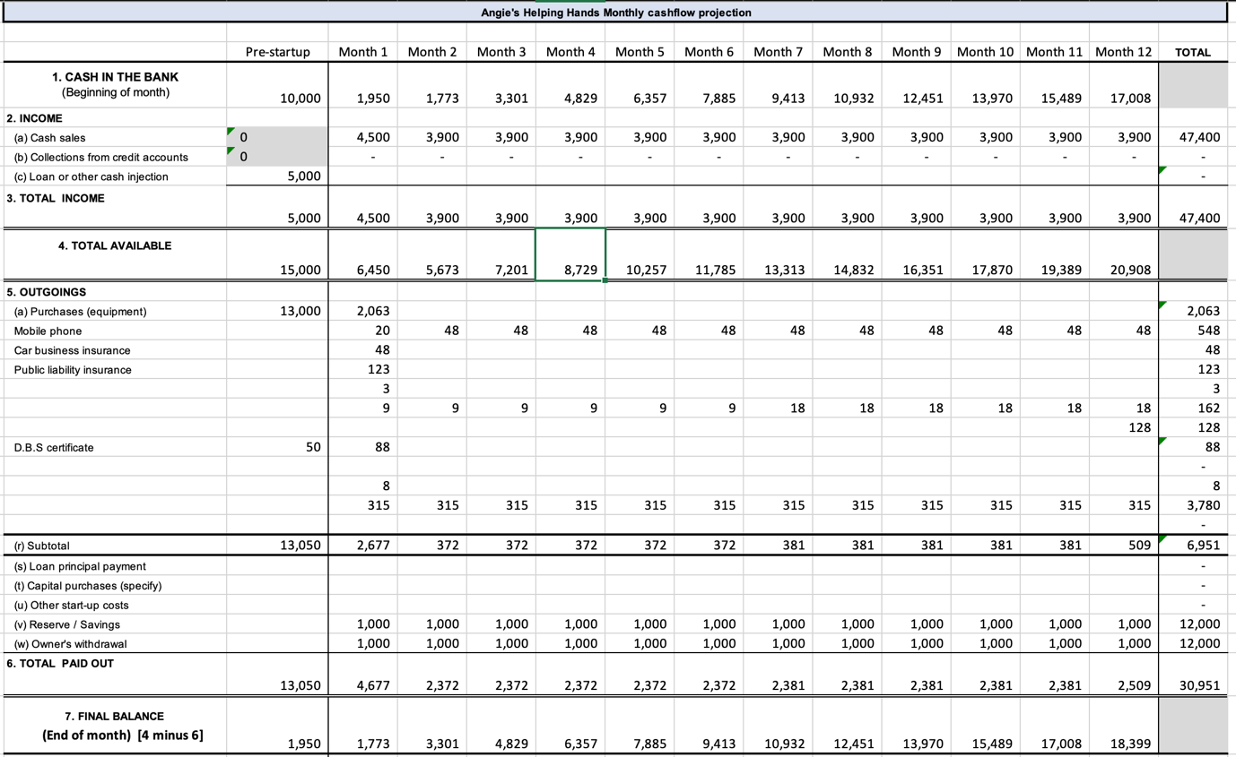

In this line of work, our company will focus on providing residential home cleaning as well as commercial property cleaning contracts. Will have its headquarters in the Swansea region, and its initial service area will extend up to five miles in any direction from the city centre. Subsequently, the service area will be expanded farther afield as the company develops and expands over the launch period. My business partner and I are going to take care of all the cleaning contracts and handle the initial marketing responsibilities. In addition, we are going to hire staff members. When the company expands its operations.

Marketing: A monthly budget will be allotted to us for marketing on social media platforms such as Facebook, Instagram, and Twitter. In addition to this, we would distribute flyers in the immediate area surrounding the locations of our existing customers. Now, we are hoping that this will produce more clients in the area, which will reduce the amount of travelling that our team must do. In addition to this, we would offer incentives to our current customers who brought us new business. This may come in the form of reduced prices for a specific time, such as three hours, or meal vouchers redeemable at local eateries.

Differentiating factors of a company. Our one-of-a-kind selling proposition is that we offer locally discounted rates and that all our customers' cleaning requirements will be met by personnel who are both completely qualified and highly experienced.

The price of living issue will lower the market prospects in certain markets, but it will also expand in others where people are working longer hours in their businesses.
The PEST analysis refers to economic variables as the primary external influence on the firm.
The straightforward nature of our company and the services that we offer is one of our greatest strengths. Because of our minimal overhead costs and the ease with which we can hire new employees, we are not constrained in any way.
On the market, there are a substantial number of cleaners and cleaning agencies; nevertheless, on average, only forty percent survive for more than a year and a half. We will be focusing our efforts on the middle sector of the market, which consists of businesses that are insured, trained, and protected for health and safety. This sector is the sweet spot and provides the highest level of safety.

We intend to compete in the market for cleaning services, which includes residential and commercial buildings on a smaller scale.
In the Swansea area, there are 115,200 homes that we may focus our attention on.
must focus on our selected audience and broaden the scope of our company from the beginning, to avoid the strain of rapid expansion.

Strategy for Generating Revenue and Setting Prices

The hourly wage for cleaning can range anywhere from £17.50 to £28 for sole proprietors who do not have insurance to £22 for fully guaranteed, fully trained, and health and safety-protected cleaners. Sole proprietors who do not have insurance should expect to make the lower end of that range. It is possible for large commercial cleaning companies to charge as much as £28 per hour for their services. We offer a very reasonable price for our services. The hourly charge of £22.00 includes the cost of cleaning the carpets, and the cost of small consumables is an additional £60.00 per hour. The rate per hour is £60, and it applies to cleaning in private homes, Air B&Bs, and small business establishments.
Our company will be run out of our home in Swansea, and the garage of our house will serve as storage for all the cleaning products and goods that we will have.

We will offer our commercial cleaning services to the businesses in the surrounding area, as well as the educational institutions and other commercial buildings that require cleaning. Residential cleaning contracts are often smaller in scope and pay less than commercial cleaning contracts, even though commercial cleaning contracts may be more challenging to acquire. Commercial cleaning contracts are typically larger and pay more. The amount of money you make in this line of work can be roughly estimated by looking at the number of commercial contracts you have and the rate that you charge for each such contract.

Procedures involved in production and distribution.

We intend to purchase a comprehensive inventory of cleaning materials in order to serve both residential and commercial clients, and these purchases are already in the planning stages. We will make use of the funds from our original investment in order to purchase all of the necessary equipment in order to satisfy all of the cleaning contracts, or at the very least, we will engage into contract hire arrangements. This will allow us to meet our obligations under the cleaning contracts.

The launch of the company will necessitate the acquisition of certain pieces of machinery and supplies, including but not limited to commercial vacuum cleaners, household vacuum cleaners, mops, buckets, industrial steam cleaners, industrial wet suction cleaners and cleaning chemicals.

My business partner and I have decided that in the beginning, we will be in charge of all of the marketing and cleaning responsibilities. This will be the case up until the point where the amount of hourly work that we have generated or acquired is greater than the number of hours that we are able to physically devote to the company at this point in time. As soon as we get to this point, we are going to initiate the process of employing extra staff members on an hourly basis so that we can handle the increased amount of work.

In terms of people, staff, and vendors:

We have established as our primary objective the recruitment of three members of staff during the first three months of our business' operation, and we intend to increase this number as the volume of work expands. We will make all our purchases at either places that sell goods on a cash-and-carry basis or retail shops that are experts in the field of selling cleaning supplies. In addition to this, we are going to do a search on the internet for possible suppliers. provided that the rates are competitive with or cheaper than those of other firms, including those that offer delivery services.

The structures and operations

We are going to develop a database in the form of an Excel spreadsheet so that we can keep tabs on the various contracts that are associated with each member of the workforce. We will also be provided with a breakdown of the hours worked as well as specific contracts, which will make it feasible for us to submit suitable invoices to the customers. This will make it easy for us to keep track of all bookings and employee hours in preparation.

When a reservation is made, we will document all of the information that is required in order for us to fulfil the terms of the contract in the most efficient manner possible. In other words, the present date and time, in addition to the total number of hours required to complete the assignment. the character of the labour that needs to be carried out. The minimum number of hours that must be worked in accordance with the terms of the contract, as well as the hourly rate that must be reached a consensus on. After that, depending on our requirements, we will either be able to delegate the contract to a single member of our team or to a group of employees working together.

Compliance with the law and health and safety concerns

Our number one priority is to always watch out for the wellbeing and security of both our employees and our clients.
Our staff members will receive training on how to safely use the various pieces of cleaning equipment as well as the chemicals that go along with them. It is imperative that we make certain that:

The appropriate use of personal protective equipment (PPE), which may include but is not limited to masks, gloves, and goggles.

Chemicals that are used for cleaning must be properly stored, used, and handled at all times.

The use of the cleaning equipment in a manner that does not present any danger.

In order to avoid injuring yourself, there are some procedures that should be followed when lifting heavy objects.

Standard operating procedures and other methods for dealing with biological hazards, such as mould or blood, are examples of these procedures.

In addition, we need to conduct risk assessments on a regular basis in order to identify potential hazards in the workplace and formulate plans for preventing accidents. This will allow us to keep our employees safe.

Compliance with the Regulations

Due to the fact that we are a company that specialises in cleaning, we are compelled to adhere to the rules and regulations that are listed below:

Procedures for Registering Businesses and Acquiring the Necessary Licences

In order to register the company and acquire any licences or licences that may be necessary, we will submit the requisite paperwork to the appropriate regulatory organisations. As a result of this, it is really important for you to do research into the customs that are typical in your region.

Insurance
We will hold both general liability insurance to cover any damages or injuries that may be caused by our services, as well as workers' compensation insurance to cover any injuries that may be received by our staff, in the event that they are injured in the course of performing their duties.

Regulations governing employees It is essential that we comply with all of the regulations governing employees. Legislation prohibiting discrimination, regulations managing employee benefits, laws establishing a minimum salary, and rules governing overtime compensation are all examples of this type of legislation. In addition to this, we need to make sure that we are accurately classifying workers in line with the law (that is, as employees or contractors). Specifically, we need to make sure that we are classifying workers as employees.

Rules and Requirements Regarding Health and Safety
For instance, if we were to conduct business in a legal manner in the United Kingdom, we would have to comply with the Health and Safety at Work Act of 1974, the Control of Substances Hazardous to Health legislation of 2002 (COSHH), and any other relevant legislation. This would allow us to legally conduct business there. Companies are required under these standards to create a risk-free environment for their workers to perform their jobs while also taking precautions to reduce the risk posed by any potential dangers.

Protection of Personal Information
Because we will be collecting personal information from consumers as well as workers, we are required to comply with data protection legislation in the UK, such as the Data Protection Act 2018 or the General Data Protection Regulation (GDPR) of the EU. These requirements are in place because we will be collecting personal information. Since we are going to be collecting this information, we are obligated to comply with these laws.

Executive Summary
Angie's Helping Hands is a cleaning company that has its headquarters in Swansea and provides its services to residential and commercial customers located inside the city as well as in the areas immediately around it. The company has made it a priority to provide maid services of the highest possible standard of excellence. Angie's Helping Hands is well positioned to become the go-to option for cleaning services in Swansea as a result of its strong commitment to reliability, thoroughness, and client contentment ever since it was first created. This has put Angie's Helping Hands in a position where it is well positioned to become the go-to option for cleaning services in Swansea.
The company offers a wide variety of cleaning services, ranging from basic household cleaning and janitorial work to the comprehensive cleaning of commercial premises. Among the services that are provided by the company is carpet cleaning. In addition, Angie's Helping Hands is a market leader in the provision of value-added services to customers, such as deep cleaning, window cleaning, carpet cleaning, and seasonal cleaning services. These are examples of the kinds of services that are included in this category. These services are tailored to satisfy the various needs of our clientele in order to best serve them.

As part of their aim to improve the quality of life in their community, Angie's Helping Hands uses only eco-friendly cleaning chemicals and cutting-edge cleaning procedures that eliminate allergens, bacteria, and viruses in order to make the area they work in healthier and cleaner. This is done in order to create a healthier and cleaner environment. This commitment to environmentally responsible cleaning not only serves to safeguard the health of our customers and staff, but it also adds to the general endeavour to decrease the negative influence that our business has on the surrounding environment.
We take measures to ensure that our industrious and knowledgeable staff complies with all of the relevant health and safety laws. In addition, they have undergone comprehensive training in the most efficient cleaning processes. Because we comply with all applicable legislation and maintain comprehensive insurance coverage, our clients have full faith in the quality of the services that we provide.
Angie's Helping Hands stands out in comparison to other local cleaning firms not only due to the fact that our prices are more reasonable than those of our competitors but also due to the fact that we are committed to providing services of the best possible grade and putting the requirements of our customers first. We don't just want to meet the standards of cleanliness that our customers have set for us; we also want to exceed those standards whenever it's possible to do so.
Angie's Helping Hands intends to greatly expand their market share in the Swansea cleaning sector by putting into action a sound marketing strategy that will enable them to engage with prospective customers using both digital and conventional modes of communication. This will enable them to significantly grow their market share. We are committed to developing enduring relationships with our clients that are based on confidence in each of the involved parties as well as the consistent execution of cleaning services that are of the highest possible standard.

Summary
My business partner and I are going into business together to start a cleaning firm that will offer cleaning services for residential, commercial, and apartment buildings.
My entire life, I've had this desire to start my own business, and I honestly believe that the time has come for me to make that dream a reality.
Because we each had some savings (three thousand dollars each), we reasoned that we should go into business jointly rather than starting our own company separately. Since we want to use the money to buy all of the essential materials, tools, and stock, we won't have to take out any loans in order to get our business off the ground.

