

Name: Iulia Ramona Florescu
Student ID: 2233853
Module: Marketing Fundamentals
Module Code: LCBB4004
Lecturer: Tushara Balendran
Title: Assessment 2

Table of Content

1. Introduction ………………………………………………………………………………. 3
2. Definition of marketing ………………………………………………………………...... 4
3. Marketing process, diagram of stages in the marketing process ………………….. 4
4. Situational analysis …………………………………………………………….......................... 5
5. Pestle analysis ………………………………………………………………………….. 6
6. Porter five forces …………………………………………………………………........ 12
7. Advantages and disadvantages of Porter’s five forces ……………………………. 13
8. Future recommendations for the company ……………………………………….... 14
9. Conclusion ……………………………………………………………………………… 14
10. Reference list …………………………………………………………………………. 16

Introduction
Marketing is the process through which individuals and groups obtain their needs and wants by exchanging and creating product value with others. In simple terms, marketing is the delivery of customer satisfaction at a point. John Lewis Partnership is known as the UK's largest employee-owned business and parent organisation. It is a parent organisation of two well-known retained organisations of the UK, known as Waitrose and John Lewis (Johnlewispartnership, 2023). The revenue of the organisation was 3.85 billion pounds in 2022 (Statista, 2023).
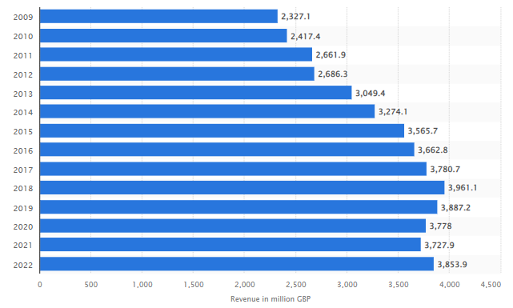
Figure 1: revenue of John Lewis
(Source: Statista, 2023)
The organisation runs based on five values implemented by its partners such as “do right”, “All or Nothing”, “Give more than you take”, “Be yourself always”, and “We, not me”. The study is going to analyse the external and internal environment as well as a competitive environment for the future growth of the organisation.

2. Definition of marketing
According to the American Marketing Association (AMA) marketing is the activity, set of institutions and processes for creating, delivering, communicating, and exchanging offerings that value for customers, parents, society, and clients at large (AMA, 2023). On the other hand, in the opinion of Kotler (Kotler et al., 2015), marketing can be depicted as “the science and art of exploring, creating and delivering value to satisfy the needs of a target market at a profit”. Marketing determines the needs and desires of people. It defines, quantifies, measures the size of the identified market and the design as well as promotes the appropriate goods and services”.

3. Marketing process, diagram of stages in the marketing process
The marketing process can be defined as the series of steps which allow organisations to identify the problems of the customers, analyse the opportunities of the market and create materials of marketing to reach the desired audiences. It is the process through which the organisations create value for the customers and build strong relationships with the customers in order to capture the value from consumers in return (Armstrong et al., 2014).
There are four stages of the marketing process such as strategic marketing analysis, marketing mix, marketing implementation, and marketing control.
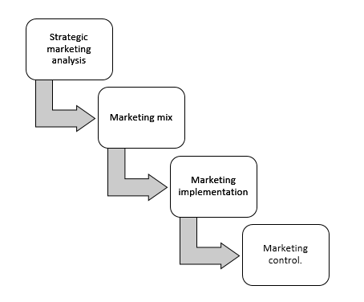
Figure 2: Stages of the marketing process
(Source: Created by the learner)

4. Situational analysis
Situational analysis can be defined as the process of identifying an organisation's current definition through which it is able to understand its strengths and weaknesses, threats and external opportunities.
External analysis
External analysis can be defined as the procedure through which an organisation objectively assesses the changes in the industry, as well as the broader world which could affect their current operations of the business. Organisations ensure that they can adapt to the changes and achieve success within the industry. There are six elements of external analysis such as political, technological, social, economic, environmental and legal.
Objectives
- The objective of marketing is to satisfy the needs of the group of consumers better than the competition
- Focusing on the use of the controllable influences of a firm in order to satisfy the customers.
Strategy
Marketing strategy can be defined as the overall game plan in order to reach prospective consumers and turn them into their products and services. There are four types of marketing strategies for products which are also known as the 4Ps of marketing such as product, price, promotion and place.
Implementation and control
Marketing implementation and control is the process to implement a detailed project plan which aligns with the overall strategic objectives of the organisation. On the other hand, control is the process to ensure the strategic milestone are achieved after the implementation of the plan.

5. Pestle analysis
According to Kotler et al. (2015), the macro environment is those elements which create opportunities and impose threats to the units of business. It includes the demographic, economic, environmental, political, and legal environments.

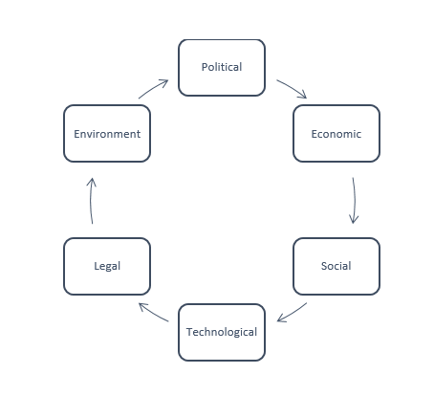
Figure 3: PESTLE Elements
(Source: Created by the learner)
PESTLE
Factors | Elements | Implications
Political | Brexit: Brexit is the incident of leaving the EU on 31 January 2020 (BBC, 2020).  Trade policies: The UK has more than 71 free trade policies signed with the EU after Brexit. | Brexit has an unfavourable impact on the retail industry due to the increment of trade tariffs, shifts in the labour market and changes in consumer buying behaviour and attitudes. For instance, John Lewis has to close eight of its stores and seven stores of Waitrose as they were making losses due to Brexit which is a threat to the organisation. (Johnlewispartnership, 2023).  The trade policies will create favourable conditions for the retail industry as the organisations will be able to trade in European countries without additional charges. Hence, John Lewis will have the opportunity to expand their business in nearby countries, thereby increasing the revenue and profitability of the organisation.
Economic | GDP of the UK: The GDP of the UK grew by 0.1% in the last three months of 2023 (Gov, 2023).  The inflation rate of the UK: The inflation of goods was 0.1% in 2021 which has increased to 12.7% in 2023 (Gov, 2023). | The increased GDP will create a favourable condition in the retail industry as the investment will be more due to stable economic conditions. For instance, John Lewis invested in womenswear as a new product in 2023.  The increased inflation rate of the UK will create an unfavourable condition for the retail sector as the price of the products will increase affecting the profitability of the industry. This will also impose a threat to John Lewis as increasing product prices can affect its competitiveness in the market. For example, the price of the John Lewis department store chain has increased the cost of the products due to an increment in the price of raw materials (Reuters, 2023).
Social | Changing consumer trends: There are four major consumer trends in the retail sector of the UK in 2023 such as unlocking value, experience innovation, planet and society and people and leadership (Deloitte, 2023).  The population of the UK: The population rate of the UK was 67.26 million in 2020 (Statista, 2023). It has increased to 68.27 million people in 2023. | This will create an unfavourable condition for the UK retail industry as it has brought economic uncertainty as well as increased the cost of business to maintain the sustainability and people aspect of the business (Deloitte, 2023). As a result, it will also increase the operational cost of John Lewis imposing a financial threat to the organisation.  The increased population will create a favourable condition for the retail industry as it will increase the consumption of the products and services thereby increasing in revenue of the industry. As a result, it will create an opportunity for the organisation to increase the sales of the company by attracting new customers in future. For instance, the sales of the organisation were 3,778 million in 2020. It has increased to 3,853 million in 2022 (Statista, 2023).
Technological | Internet penetration rate: in 2021 the internet penetration rate was 91.4% which is expected to rise to 93.8% in 2026 (Statista, 2023).  Bureaucracy in innovation: UK is observed to have had high growth in bureaucracy in past decades, especially in the R & D. This causes unnecessary pauses in research activities (Gov, 2023). | The increased rate of internet penetration will create a favourable condition for the retail industry as the industry will be able to invest more in digital marketing to increase the number of customers in future. Hence, it will also create an opportunity for John Lewis to streamline communication and collaboration with the customers to improve their services and attract more customers. For instance, the organisation has made new strategic partnerships with Dunnhumby and Eagle Eye and created many loyalty programmes online to improve their customer service (Johnlewispartnership, 2023).  The bureaucratic nature of the managers will create an unfavourable condition as it will hinder the process of research and development and ways of innovation in product and services of the retail industry. For instance, according to Bottomley (2021), bureaucracy has influenced cross-border trade, e-commerce, owners and distributors negatively. As a result, it will impose a threat to John Lewis, as hindering the process of innovation may affect the competitiveness of the organisation.
Legal | Health and safety act 1974: The Health and Safety at work act 1974 is an important piece of legislation for the workplace as it ensures the safety of the employees to look for the health of their employees (legislation, 2023).  Equality Act 2010: This act protects people from discrimination in the workplace and the wider society by protecting nine characteristics of them (legislation, 2023). The gender pay gap is increasing with time as men earn 12.2% more than women vs 11.9% in 2017. | The health and safety act 1974 will create favourable conditions for the retail industry as the organisations will be able to ensure the safety of the employees and will contribute to the effectiveness of their human resources. As a result, it will create an opportunity for John Lewis to imply organisational policies to maintain the health and well-being of the employees, thereby, retaining them and increasing their capacity. For instance, the organisation has a partnership with NHS that enables them to provide in-house treatment facilities to their employees free of cost (Johnlewispartnership, 2023).  The increased gender pay gap in the UK retail industry will create an unfavourable condition as the organisation will not be able to adhere to the Equality Act of 2010 to provide equal opportunity and wages to female employees. However, the gender pay gap in John Lewis reduced from 9% to 7.9% while the average of the industry is 13.5% (Wickes, 2023). Hence, it will create an opportunity for the organisation to attract and retain employees and provide female employees with equal wages and opportunities.
Environmental | Environment Act 2021: The environment act allows the UK to impose better environment protection legislation by setting new targets for water, air quality, waste reduction and biodiversity (legislation, 2023). As per this law, the government has set a target to achieve net Zero by 2050.  Use of sustainable resources: The UK government is promoting alternative sources that help to increase the granularity of SDG indicators (Gov, 2023). 85% of consumers in the UK are willing to adopt sustainable lifestyle choices after the pandemic (Deloitte, 2021). The reports of Statista show that two third of the people of the UK are willing to pay more for sustainable food products (Statista, 2023). | This will create an unfavourable condition for the retail industry as the organisations need to invest in improving their infrastructure to meet the targets set by the government. The retail industry is working to minimise waste and reuse materials in order to reduce the environmental impact and achieve the ambition of Zero waste by 2050 (Gov, 2023).  This will create a favourable condition for the retail industry as the organisation will be able to sell products at higher prices as the cost of the products increases in the process of making it sustainable. Hence, it will also create an opportunity for John Lewis to adopt sustainable practices in order to improve its overall business sustainability. To make their business sustainable the organisation is collecting eradicating waste, reducing greenhouse gas emissions, adapting green supply chains and fair deals for products, raw materials and so on (john Lewis partnership, 2023).
Table 1: PESTLE analysis of John Lewis
(Source: Created by the learner)

6. Porter five forces
Porter ‘s five forces can be defined as the framework that helps to examine the level of competition within the industry by analysing five forces such as the new entrants, bargaining power of the buyers, suppliers, threat of substitute services and products, as well as intensity of competition.
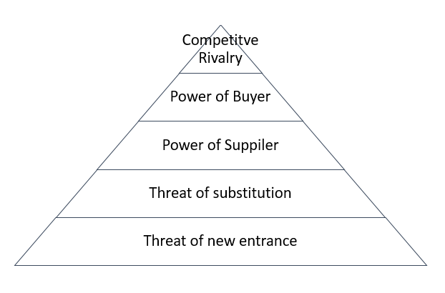
Figure 4: Porter’s Five Forces
(Source: Created by the learner)
Competitive rivalry: The competitive rivalry in the UK retail industry is high. There are many competitors in the industry such as Tesco PLC, J Sainsbury, ASDA, and so on (Statista, 2023). It will create an unfavourable condition as the organisation need to reduce the price of the products and keep the product quality high to remain competitive in the market (Gov, 2023). Hence, it is recommended to John Lewis that the organisation can create product variation and provide various discount options and loyalty programmes to stay ahead of the competition.
Buyer power: The purchasing power of the people of the UK is high. It is a threat to John Lewis as the customers have many options to purchase products from other organisations, thereby lowering the profitability and revenue of the organisation. The use of CRM to keep a note of the customer's choices and preferences, as well as creating personalised services and customer loyalty programmes helps to engage the customers and retain them. Hence, John Lewis can provide personalised offers to loyal customers to retain them.
Supplier’s power: The power of suppliers is high in the UK retail industry as the number of suppliers is high which provides them the power to regulate the price of raw materials as well as final products. This is a threat to the industry as, the supply chain disruption has increased the price of the products and reduced the availability of many products in the retail sector (Partington, 2023). Hence, it can be suggested to the organisation diversify its supply chain in order to reduce dependency on them as well as add more suppliers to increase the supply chain.
Threat of substitution: The threat of substitution in the UK retail industry is low due to the existing intense competition in the industry. In addition to that, it will require huge capital in order to operate in the retail industry as well as gain a competitive advantage over large players such as Tesco, Asda, Mark and Spencer and others. Hence, it is recommended to the organisation improve its customer service as well as marketing strategies to keep the audience engaged and retain them to maintain revenue and profitability.
Threat of new entry: The threat of new entrances is moderate in the UK retail industry. It is said that if the industry has low brand loyalty as well as few government legislations, the threat of new entrants will be relatively low as the organisations will be able to carve some market share. According to Statista, the customer satisfaction score has increased by 1.6% in the UK (Statista, 2023). This will also increase brand loyalty in the future creating moderate pressure on organisations to retain their consumers. Hence, it is recommended that the organisation can improve their product quality, and regulate its pricing and customer service to engage customers. This will help them to generate a loyal customer base and stay ahead of the threat of new entry.

7. Advantages and disadvantages
According to Isabelle et al. (2020), utilising Porter’s five forces helps organisations to gauge the danger of new entrants as well as increases the threat of substitution, buyers, suppliers and others. It also helps the organisations to show which entities are more powerful so that strategies can be designed to overcome them. Thus, in the opinion of Baxter (2019), the analysis of the power of the suppliers and consumers helps organisations to determine to acquire whether they need more buyers or suppliers in order to expand their business, as well as design a customer value chain. In the case of John Lewis, the organisation has adequate strategies to keep their customers engaged. However, the organisation needs to improve and diversify their supply chain to stay ahead of the competition. As opined by Juliana and Nyoman (2019), Porter’s five force tool is helpful in analysing the external factors that affect an organisation. John Lewis external factors such as the power of buyers, suppliers and competition in the market can be identified. However, using this framework the internal strengths and weaknesses cannot be evaluated.

8. Future recommendations for the company
In order to recommend appropriate strategies the Ansoff Matrix can be applied. It will help to identify the correct growth strategies based on the strengths and challenges of the organisation. There are two strategies of Ansoff which are discussed below:
Product development: As the organisation has many branches across the UK and a good customer base, the organisation can apply product development strategies. The product development strategy helps an organisation to increase its competitive marketability. In order to develop a new product, the organisation need to conduct market and consumer research that will strengthen the market position as well as understand the current challenges in the market.
Market development: There are 34 John Lewis shops in the UK along with 329 outlets of Waitrose. However, large organisations such as Tesco (4673), and Asda (633) have more shops in the UK which help them to gain a competitive advantage. Hence, John Lewis could increase the number of stores in various locations in the UK in order to improve the availability of their products and gain a competitive advantage.

9. Conclusion
To conclude it can be said that, John Lewis is one of the major players and well-known organisations in the UK retail industry. It has been found from this report, that external factors such as trade policies of the government, increasing rate of GDP, population, internet penetration rate, health and safety policy, as well as the use of sustainable resources will create an opportunity for growth of the organisation. On the other hand, Brexit, increasing inflation, bureaucracy in research and development, Environment acts and others are imposing a threat on the organisation. Further, it has also been found that external conditions such as competition, and the power of buyers and suppliers are also affecting John Lewis negatively. Considering the strengths of the organisation, two strategies such as market penetration and product development can be suggested to John Lewis to improve their market position.

10. Reference list
AMA, 2023. Definitions of Marketing. [Online] Available at:<https://www.ama.org/the-definition-of-marketing-what-is-marketing/:> [Accessed on 04 May 2023]
Armstrong, G., Adam, S., Denize, S. and Kotler, P., 2014. Principles of marketing. Pearson Australia.
Baxter, G., 2019. A strategic analysis of Cargolux Airlines International position in the global air cargo supply chain using Porter’s Five Forces Model. Infrastructures, 4(1), p.6.
BBC, 2020. Brexit: What happens now?. [Online] available at:<https://www.bbc.com/news/uk-politics-46393399:> [Accessed on 04 May 2023]
Bottomley, T. 2021. Brexit, borders and bureaucracy: how British fashion brands are coping. [Online] available at:<https://www.theindustry.fashion/brexit-borders-and-bureaucracy-how-british-fashion-brands-are-coping/:> [Accessed on 04 May 2023]
Deloitte, 2023. Four out of five UK consumers adopt more sustainable lifestyle choices during COVID-19 pandemic. [Online] available at:<https://www2.deloitte.com/uk/en/pages/press-releases/articles/four-out-of-five-uk-consumers-adopt-more-sustainable-lifestyle-choices-during-covid-19-pandemic.html. [Online]
Gov, 2023. Consumer price inflation, UK: March 2023. [Online] available at:<https://www.ons.gov.uk/economy/inflationandpriceindices/bulletins/consumerpriceinflation/march2023#:~:text=The%20CPIH%20inflation%20rate%20is,down%20from%2013.4%25%20in%20February:> [Accessed on 04 May 2023]
Gov, 2023. Gross Domestic Product (GDP). [Online] available at:<https://www.ons.gov.uk/economy/grossdomesticproductgdp:> [Accessed on 04 May 2023]
Gov, 2023. Reducing bureaucratic burden in research, innovation and higher education. [Online] available at:<https://www.gov.uk/government/publications/reducing-bureaucratic-burdens-higher-education/reducing-bureaucratic-burdens-on-research-innovation-and-higher-education:> [Accessed on 04 May 2023]
Gov. 2023. UK Sustainable Development Goals: use of non-official sources. [Online] available at:<https://www.ons.gov.uk/economy/environmentalaccounts/methodologies/uksustainabledevelopmentgoalsuseofnonofficialsources:> [Accessed on 04 May 2023]
Gov. 2023.At a glance: summary of targets in our 25 year environment plan [Online] available at:<https://www.gov.uk/government/publications/25-year-environment-plan/25-year-environment-plan-our-targets-at-a-glance#:~:text=National%20Adaptation%20Programme-,Minimising%20waste,waste%20by%20end%20of%202042:> [Accessed on 04 May 2023]
Isabelle, D., Horak, K., McKinnon, S. and Palumbo, C., 2020. Is Porter's Five Forces Framework Still Relevant? A study of the capital/labour intensity continuum via mining and IT industries. Technology Innovation Management Review, 10(6).
johnlewispartnership, 2023. Our strategy. available at:<https://www.johnlewispartnership.co.uk/content/dam/cws/pdfs/Juniper/ethics-and-sustainability/Progress-Report-2022/Our-Strategy.pdf:> [Accessed on 04 May 2023]
johnlewispartnership, 2023. Health and Wellbeing. [Online] available at:<https://www.johnlewispartnership.co.uk/work/health-and-wellbeing.html:> [Accessed on 04 May 2023]
Johnlewispartnership, 2023. Impact of Brexit on Apparel: Retail trends. [Online] available at:<https://www.retail-insight-network.com/comment/impact-of-brexit-on-apparel-retail-trends/:> [Accessed on 04 May 2023]
johnlewispartnership, 2023. John Lewis Partnership accelerates investment in customer loyalty. [Online] available at:<https://www.johnlewispartnership.media/news/jlp/25042023/john-lewis-partnership-accelerates-investment-in-customer-loyalty> [Accessed on 04 May 2023]
johnlewispartnership, 2023. Staying safe during Covid-19. [Online] available at:<https://www.johnlewispartnership.co.uk/meta/staying-safe-during-covid-19.html:> [Accessed on 04 May 2023]
Johnlewispartnership, 2023. STRATEGIC REPORT. [Online] available at:<https://www.johnlewispartnership.co.uk/content/dam/cws/pdfs/Juniper/ARA-202/John-Lewis-Partnership-2021-Annual-Report-and-Accounts-Strategic-Report.pdf:> [Accessed on 04 May 2023]
Juliana, J.P.E. and Nyoman, Y.N., 2019. Factors influencing competitiveness of small and medium industry of Bali: Porter’s five forces analysis. Russian Journal of Agricultural and Socio-Economic Sciences, 89(5), pp.45-54.
Kotler, P., Burton, S., Deans, K., Brown, L. and Armstrong, G., 2015. Marketing. Pearson Higher Education AU.
Legislation, 2023. Environment Act 2021. [Online] available at:<https://www.legislation.gov.uk/ukpga/2021/30/enacted#:~:text=An%20Act%20to%20make%20provision,that%20fail%20to%20meet%20environmental:> [Accessed on 04 May 2023]
Legislation, 2023. Equality Act 2010. [Online] available at:<https://www.legislation.gov.uk/:> [Accessed on 04 May 2023]
Legislation, 2023. Health and Safety at Work etc. Act 1974. [Online] available at:<https://www.legislation.gov.uk/ukpga/1974/37/contents:> [Accessed on 04 May 2023]
Partington, R., 2021. Retail sales in Great Britain fall amid supply chain disruption. [Online] available at:<https://www.theguardian.com/business/2021/sep/17/retail-sales-in-great-britain-fall-amid-supply-chain-disruption:> [Accessed on 04 May 2023]
Statista, 2023. How much more shoppers would pay for sustainably sourced food in the United Kingdom (UK) as of August 2021. [Online] available at:<https://www.statista.com/statistics/1291366/willingness-to-pay-more-for-sustainable-food-uk/#:~:text=According%20to%20a%20survey%20carried,extra%20for%20such%20food%20products:> [Accessed on 04 May 2023]
Statista, 2023. Customer satisfaction with industry sectors in the United Kingdom (UK) in 2021 and 2022. [Online] available at:<https://www.statista.com/statistics/879013/customer-satisfaction-by-industry-sector-united-kingdom-uk/:> [Accessed on 04 May 2023]
Statista, 2023. Internet usage in the United Kingdom (UK) - Statistics & Facts. [Online] available at:<https://www.statista.com/topics/3246/internet-usage-in-the-uk/#topicOverview:> [Accessed on 04 May 2023]
Statista, 2023. Leading 10 UK retailers in 2021, based on worldwide retail sales. [Online] available at:<https://www.statista.com/statistics/438358/leading-10-retailers-united-kingdom-uk-based-on-sales/#:~:text=This%20statistic%20shows%20the%20leading,U.S.%20dollars%20worth%20of%20sales:> [Accessed on 04 May 2023]
The guardian, 2023. John Lewis may find that cuddly co-investors don’t exist. [Online] available at:<https://www.theguardian.com/business/nils-pratley-on-finance/2023/mar/22/john-lewis-may-find-that-cuddly-co-investors-dont-exist:> [Accessed on 04 May 2023]
Walker, G. 2023.Brexit, borders and bureaucracy: logistics experts offer advice for fashion exporters. [Online] available at:<https://www.theindustry.fashion/brexit-borders-and-bureaucracy-logistics-experts-offer-advice-for-fashion-exporters/:> [Accessed on 04 May 2023]

