Reflection on my Welsh Development
The Cymraeg I Bawb programme provided by Yr Athrofa has enhanced my confidence in my use of the Welsh language. Prior to the commencement of the course, I almost never incorporated Welsh into my vocabulary as I had not practiced my skills since GCSE. However, I have always valued the importance of developing language skills as it provides greater opportunities, a deeper connection with one’s heritage and stimulates cognitive. The course has allowed me to evaluate my current skill set and identify methods to further improve my Welsh, such as partaking in courses with external agencies and using incidental Welsh in my everyday life. My self-esteem has flourished, and I am no longer overly concerned with errors in pronunciation, rather, I embrace the effort made my myself and my students in promoting our home language.
Teaching in a Secondary setting has enlightened me to the variations in Welsh language capabilities. My first placement school incorporated incidental Welsh occasionally across all departments but lacked the professional development for staff to further extend this in order to enrich the learners experience. The short time spent at my second placement school exemplified how commitment to staff development models excellence in learners. Often learners would question a teacher yn Gymraeg, converse with their peers and naturally use incidental Welsh.
My observation from placement 1 commented me on my organic and consistent use of incidental Welsh, something I pride myself on. A standout moment during my teacher training is when a year 9 student who had attending a Welsh Medium primary school was under the assumption that I was a fluent Welsh speaker because of my use of Welsh in the classroom. This is evidence that the Cymraeg I Bawb sessions have advanced and progressed my understanding of the language as well as my confidence in using phrases in my lessons.
While the Welsh sessions were helpful in many aspects, certain elements could be adapted to ensure each trainee teacher is getting the most from the programme. For instance, I was placed in a group of primary educators. In creating a continuum of learning, knowledge of both phases is necessary, however I felt as though the sessions were highly orientated around primary education. A lot of the phrases and terms being taught would not be used in a secondary setting; therefore, I feel as though this was an inefficient use of time. Had I been placed in a secondary group and/or subject specific the lessons could have been tailored to meet the needs to the student teachers. Furthermore, many of the teachers I worked with would question my extensive use of Welsh during my lessons. Once I explained it is a requirement for the PGCE programme more support was shown. Possibly, more communication between the class teachers and the university would lead to consistency in expectations.
In continuing my professional development, I will seek our Welsh Language workshops and courses that could enhance my classroom practice. Moreover, I would love to complete a Welsh sabbatical in my future career. In respect of the Governments initiative for 1 million Welsh speakers by 2050 I will be placing my son in a Welsh Mediums school. My experience on the Cymraeg I Bawb programme has enlightened me to the opportunity’s bilingualism brings.
Future development: love to complete a sabbatical year focusing on Welsh language. In respect of the welsh government initiative 1 million speakers by 2050 I will be looking for a welsh medium education for my son as my experience on the PGCE has enlightened me to the opportunity’s bilingualism brings.

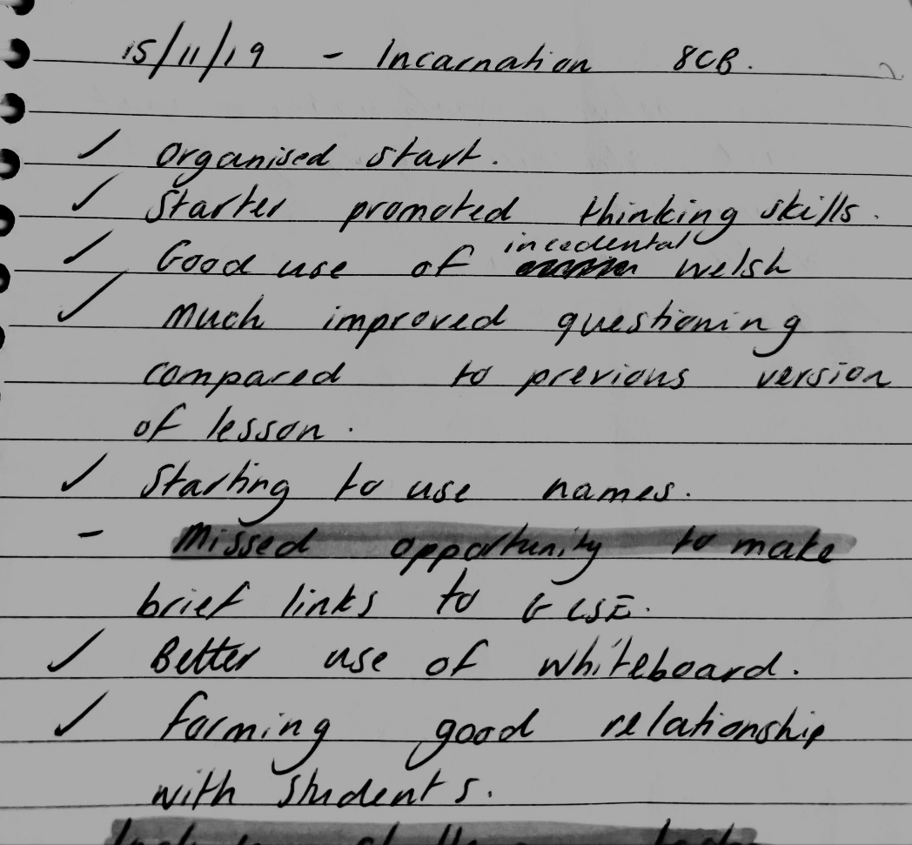
Tutor Comments

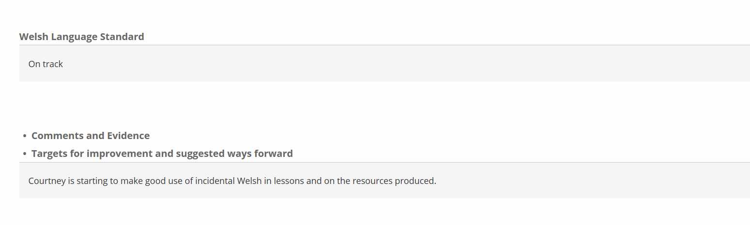

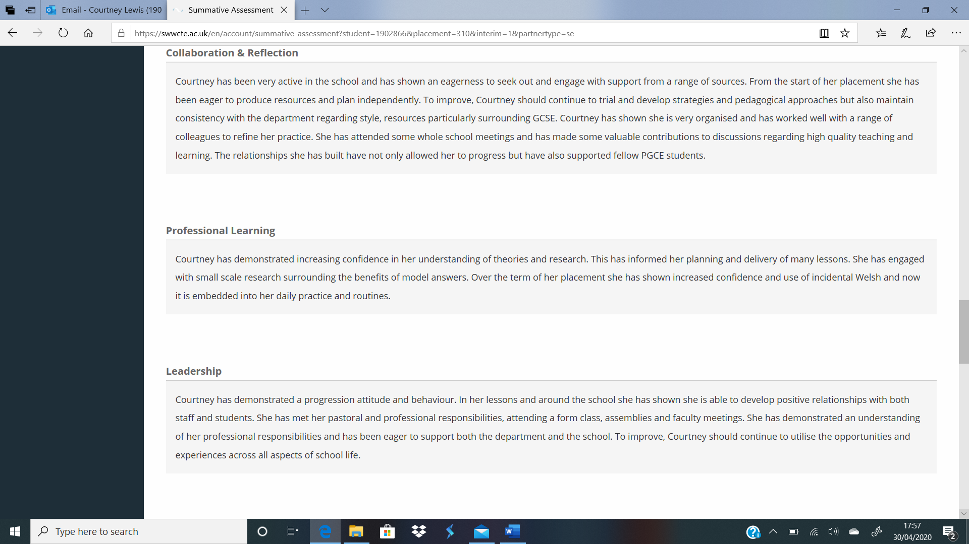

Evidence of incorporation of Welsh

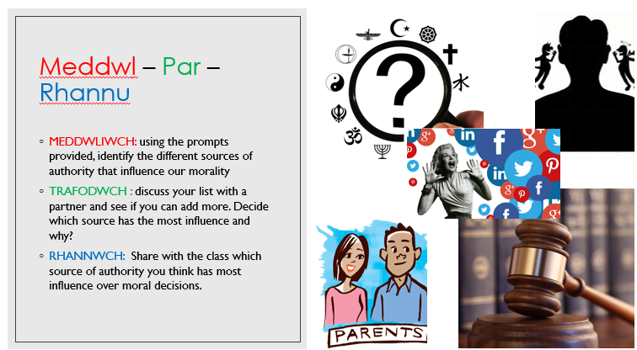

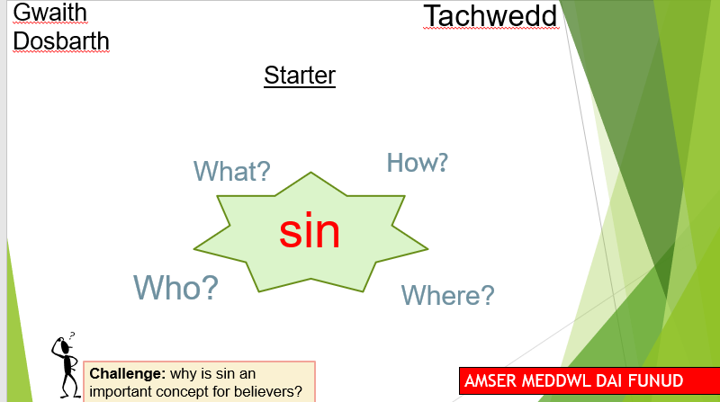

Further Development


