

Postgraduate/Distance Learning
Assignment coversheet & feedback form

THIS SHEET MUST BE THE FIRST PAGE OF THE ASSIGNMENT YOU ARE SUBMITTING (DO NOT SEND AS A SEPARATE FILE)

For completion by the student:
Student Name: Sandrine McLocklin

Student University Email: 2312282@student.uwtsd.ac.uk
Module code: HPCA7016  Module title:  Researching Contemporary Cosmologies | Student ID number:  2312282 |  |  | Educational support needs:  No
Assignment due date: 3/5/24
This assignment is for the 1st 2nd 3rd 4th 5th 6th module of the degree
I confirm that this is my original work and that I have adhered to the University policy on plagiarism.
Signed …………………Sandrine McLocklin…………………………………………
Email submission:if you are submitting this form via email, please tick this box X□
(as a substitute for your signature) to confirm that you agree to the above declaration.
Assignment Mark
1st Marker’s Provisional mark
2nd Marker’s/Moderator’s provisional mark
External Examiner’s mark (if relevant)
Final Mark

NB. All marks are provisional until confirmed by the Final Examination Board.

For completion by Marker 1 :
Comments:

Marker’s signature: |  |  | Date:
For completion by Marker 2/Moderator:

Comments:

Marker’s Signature: |  | Date:
External Examiner’s comments (if relevant)

External Examiner’s Signature: |  | Date:

Exploring the connection between astrology and some management practices known as personality testing in relation to personal cosmologies.

5227 words

Introduction
This research examines the potential connection between astrology and management practices, specifically psychometric testing, exploring lived experiences. Contrasting astrology rooted in a premodern perspective, and psychometric testing entrenched in a modern viewpoint, this study investigates if these systems have possible shared influences on the construction of personal cosmologies. The intention is to potentially bridge the gap separating the paradigms in which these systems are embedded, especially addressing the modern tendency to refute the validity of ancient and so-called primitive traditions, including astrology.
Based upon the elemental framework dating back to Empedocles and Hippocrates in the fifth century BC, astrology is broadly defined by Curry as ‘the practice of relating the heavenly bodies to lives and events on earth, and the tradition that has thus been generated.’ Such tradition includes the study of the birth chart which, according to Ptolemy, can reveal the ‘destiny and disposition of every human.’
Psychometric testing originated in the late nineteenth century rooted in empirical science. McKeen Cattell ‘saw the potential for synergising (..) psychophysics with (…) mathematical approach to the examination of individual differences,’ to categorise individuals according to a set of behavioural attitudes and typologies.
In addition to a literature review, an outline of the methodology and ethical considerations are presented, followed by the interpretative analysis of five key findings as they have emerged from the collected data. The first finding highlights how perspectives are influenced by their generational paradigms, and from a Whiteheadian standpoint, how personal understandings evolve in line with their changing environment. The second finding explores cultural biases, drawing on Eagleton's ideas to illuminate the mechanisms shaping perceptions and experiences. The third point examines how these systems impact individual and collective cosmologies, acting as intermediaries, aligning with Latour's notion that non-beings, like beings, possess agency. The fourth finding, through by the practices and discourses of the participants, delves into the shared religious characteristics within these systems, drawing on Eliade's concept of an inherent human inclination towards sacredness. The final section examines ancient philosophical concepts, such as Platonic and Aristotelian perspectives, and their shared function as individuals pondered existential questions. The conclusion reflects on the research process and its findings in relation to these systems’ influences on individuals' cosmologies, while offering personal perspectives.

Theoretical Framework
According to Philipson and Case, the ‘astrological archetypes are silently inherited by a psychological science that, in turn, informs certain organisational practices.’ One of them, the Myers-Briggs Type Indicator, or MBTI,® widely used in corporate and educational environments, is based upon Jung's 'Psychological Types,' themselves rooted in premodern cosmology. This corroborates an ‘astro-archaeological’ link underlying modern rationalist world and the field of modern psychology.’ Similar systems, mapping out human traits and behaviours, have since been developed, evolving with current market trends and technologies. Despite their shared ‘cosmological and epistemological lineage’ little if any serious research on the connection between astrology and the fields of organisation and management, seems to have been conducted. This appears to remain the case regardless of their cultural and commercial significance. According to specialist sources, there is an ever-growing need for assessment in the recruitment sector with significant economic interests; while Campion claimed that ‘an estimated 25% of the adult population of the US, UK and France’ believe in astrology.
The New Age movement ‘coincided with a breakdown of traditional religious customs, replaced with others sets of rituals and beliefs,’ paving the way for psychological astrology and self-assessment methods which gained momentum during that period. As both systems appear to evolve with the cultural norms of their era, showing as Eagleton put it, that ‘rules, like cultures, are neither sheerly random nor rigidly determined.’ And, reasserting the claim that psychometric systems seem to partially address the human need for ‘self-knowledge and spiritual fulfilment,’ some providers claim that the objective is to foster self-understanding with the promise of ‘powerful assessments that improve communications, drive teamwork and collaboration, and create understanding.’ This, in turn, seems to echo voices within psychological astrology, such as Rudyard writing that ‘the birth chart and the way it unfolds its human potential (…) provides you with technical means,’ while Greene underscored the role of the planets as symbols of psychological processes, ‘which individuals may utilise…as a means for greater consciousness and fulfilment.’ These analogous discourses provide individuals with a set of language and codes, which, aligned with Whitehead cosmology, emphasise the nature of reality as a web of interconnected and subjective experiences perpetually fluctuating, rather than inert substance.
Another study, led by Arnoult and Cayla and connecting anthropological theories to organisational comprehension, could shed a light on the significance of these systems and their role as sense-making tools. They argued that commercial organisations through a process of ‘othering, materialisation, personification, and animation (…) bring their ideal consumer to life (with) a quasi-magical fascination towards consumer voices, images, and objects.’ This seems to align with Latour’s theory that social phenomena emerge from the interconnection of relationships between human and non-humans and the complexity of these networks as they shape reality. Underlining the interdependence of human and non-human entities, Latour emphasised human responsibility and advocated for a more inclusive worldview. Thus, the practice of instrumentalising images and symbols as intermediaries, between what there is and what there could be, bears a resemblance with the astrological chart and psychometric profile in so far as they contribute to the shaping of personals’ cosmologies and therefore to the construction of reality.
Moreover, Ammerman's claim that the study of lived religion implies ‘finding religion in everyday life,’ like looking for Waldo in a picture book, resonates with the notion of fetishization and Brady’s idea of the personal chart as a sacred space. In addition, Durkheim’s concept of ‘collective effervescence,’ corroborates Eliade’s views on a religious predisposition inherent to humankind, as these systems provide ways to connect individuals. Finally, despite their distinct paradigmatic origins, both systems could be sharing similar teleological functions. As Philipson and Case cautioned against a fragmented conception of the individual by placing ‘psychology on an entirely scientific footing,’ Ammerman claimed that the lenses of academic studies in the field of sociology of religion need to be broadened. Therefore, examining the lived experiences of individuals as they have engaged with these premodern and modern systems, with their contrasting worldviews, could expand the discussion.

Methodology
Based upon Bryman stating that ‘cross-sectional’ quantitative data allows ‘to discover the ways and degrees to which variables relate to each other,’ and Hennik, Hutter and Bailey stating that the purpose of qualitative research is to understand sensitive and ‘complex issues (such as) people’s beliefs and behaviours’ within the context of their experiences,’ this research has used a mixed approach by means of a questionnaire followed by interviews. With Judith Bell saying that interviews allow to ‘follow up ideas, probe responses and investigate motives and feelings,’ the aim was to gain an initial overview before gathering personal opinions. The primary objective was to assess the understanding and lived experience of the astrological and psychometric testing systems, from a phenomenological standpoint, through a balanced representation (see figures 1&2).

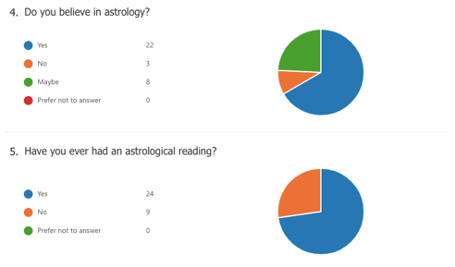
Figure 1. Astrology representation
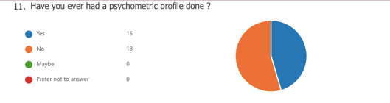
Figure 2. Psychometric tests representation

The online questionnaire consisted of seventeen questions with a variety of answering options, such as multiple-choice, linear scale, short and long answers, with items such as: whether they ever had a chart reading and/or done a psychometric profile; how they related to it at personal level; the value of any insights they may have gained; the potential influence on their worldviews. Thirty-three respondents answered the survey, allowing for a broad overview in relation to each system. This was followed by a narrative inquiry consisting of eight semi-structured in-depth interviews. Participants were selected to ensure a balanced representation, allowing to gather textual data through ‘the collection and development of stories’ as a ‘meaning making process.’ These interviews provided a deeper understanding of personal experiences, offering subjective insights into how these systems impact individual worldviews, crucial to the interpretative analysis process.

Ethics
Consent: All participants provided informed consent and were informed of the purpose of the research and procedures. Participation was voluntary, with the option to opt out of questions or the study at any time.
Confidentiality: Data will be securely and confidentially stored in the university IT systems for three years. Pseudonyms and codes have been used for anonymity where applicable and participants were given the opportunity to validate the transcripts.
Position: As a practicing astrologer and an accredited practitioner in behavioural assessments, I have had a longstanding interest in this research area. I have often felt frustrated by the tendency to disregard astrology in corporate, and supposedly educated circles, with the general view that psychology, in particular the type used by human resources, is solely a creation of modern science. This prompted me to investigate if the gap between these two seemingly opposed universes could be bridged. With the participants selected from my astrological and professional networks, I adopted an insider position. This allowed me to formulate the questions accurately, using a language that would make sense to the participants and engage empathically with them. A certain level of familiarity with some of the participants allowed for some valuable insights that might have been kept private otherwise. The questionnaire was fully anonymised bringing a healthy element of detachment on both sides.
Reflexivity: As Dwyers’ stated, ‘there is no neutrality.’ Aware of the personal preconceptions and biases attached to an emic interpretation, I ensured to focus on the participants’ lived experiences rather than on my own. Following on Northcote’s claim that ‘the responsibility lies with the researcher to determine on where to place the brackets,’personal beliefs and preconceptions arose, which had to be addressed to carry on as objectively as possible. However, if both respondents’ and participants’ experiences have been collected with a care to represent their views accurately and to report findings with integrity, the following interpretative analysis remains by essence subjective.

Interpretative Analysis
Co-creation
‘The things which are temporal arise by their participation in the things which are eternal.’
The first finding is the connection between the age of the participants (see figure 3), and their perspectives on astrology or psychometric testing. Their views appear to be largely aligned with their own generational paradigms, shaping their perspectives within specific socio-cultural discourses.

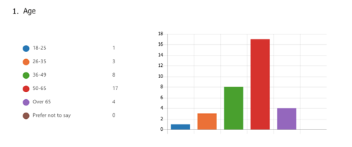
Figure 3. Age groups
The older cohort, known as the Boomers, grew up just after the post-World War II era, in ‘a time of economic prosperity and rapid technological progress,’ with a desire for ‘greater personal autonomy and self-determination.’ Most placed higher value on science and empiricism, preferring psychometric testing systems ‘to assess behaviours,’ and ‘to interact more effectively,’ consistent with an Aristotelian worldview based upon phenomenological approaches as expressed by this respondent:’ ‘There is no influence of planets to a person's life or personality, (contrary to) psychometric testing based on psychology and scientific research.’
The group aged between 36-65, known as Generation X, displayed a broader range of responses, showing at once open-mindedness but also critical thinking in line with their generational traits of welcoming diversity and independence. They considered these systems as being either 'useful', or 'interesting', or as objects of 'curiosity.' Entrapped between modernity and postmodernity, one participant comment encapsulated the transitional nature of their cohort: ‘In the world of astrology there's the mystic Meg (…) which isn't that helpful, because (some people) fervently believe in the science, and (…) then (…) it's been around for grizzillions of years, there must be something in it.’
At the other end of the spectrum, the younger generations, Y and Z, associated with postmodern worldviews embracing plurality, and challenging positivist approaches, as they search for alternative models. As ‘millennial ecology repositioned cultural progress as a source of environmental collapse to critique the narrative of capitalist progress,’ they found appeal in premodern worldviews and systems which have the potential to impact the world positively: ‘astrology would probably give the collective more compassion and understanding,’ said a young participant reflecting on her chart reading. However, regardless of the generational gaps, views on the astrology and psychometric testing systems seem to expose the ongoing creative processes involved in shaping reality.
According to Whitehead, individuals’ understanding appear to be shaped by culturally embedded experiences that are influenced by the interaction of language, symbols, and ideas within various discourses. Through these discourses, individuals, construct narratives and co-create their reality. Therefore, as a metaphysical concept, reality, in a constantly evolving world, is a process of becoming rather than a ‘static substance.’

Cultural Bias
‘There is what we do the world and what the world does to us.’
The second key finding highlighted the presence of cultural biases within these systems. As the study mainly included mature respondents from different ethnic backgrounds, responses reflected a valuable degree of hindsight. The survey showed that astrology was generally viewed as useful for understanding and coping with events, whereas psychometric tests were often perceived as tools for evaluating behaviour and prompting behavioural changes (see figures 4&5).

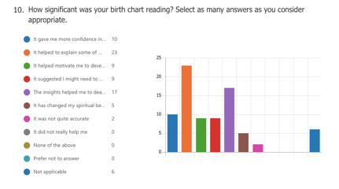
Figure 4. Significance of chart reading experience

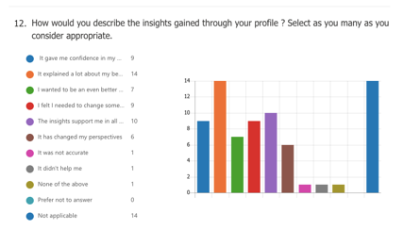
Figure 5. Significance of psychometric experience
The cultural shift of the mid-twentieth century placed intense focus on the development of human potential. The rising popularity of psychological astrology challenged predictive astrology, which according to Rudhyar ’far too often lead to evasion from reality.’ At the same time, psychometric testing, emphasising individual performance and team effectiveness, gained significant traction. Thus, in line with these discourses, some reported that astrology ‘feels like therapy’ providing ‘a new perspective to who I was at the time’ as well as being ‘life-affirming.’ Another explained that ‘I have learnt to be more patient and accepting of others.’ Similarly, a psychometric profile can ‘questions existing behaviours (…) to change for the better.’ As one said, ‘I somewhat adapted my behaviour at peak times for meeting a partner signing a contract.’
However, if one comment pointed to some cultural difference with astrological systems: ‘in India, we believe more in moon sign, and not in sun sign,’ psychometric testing methods were criticised more severely. Some reproached that the psychometric assessments were ‘literally man-made’ products, with one practitioner saying: ‘I realised I was recruited to a mould, and I was recruiting to a mould too;’ and another deploring: ‘the arrogance from Western models to impose their systems on other cultures;’ or unambiguously: ‘the reports that I supply because they're from the States, they unfortunately have quite a hefty Capital C, Christian element.’ And, in a distant echo to Bacon referring to ‘culture and manurance of minds,’ Meredith Belbin, wrote that his eponym method could contribute to the making of ‘a new generation of outstanding men and women (…) more attuned to the shape of society emerging in the new millennium.’ However, illustrating Eagleton’s mechanism of adaptation, as the ‘determinism on one hand and the autonomy of spirit of the mind on the other,’ one astrologer reflected that most consultations are ‘overall (…) really about the future…like watching the weather on tv;’ while one practitioner said, ‘I've had to develop a particular way to do a workshop.’ A reminder of Herder’s cautionary advice that ‘what one … holds indispensable to the circle of its thoughts…has never entered the mind of a second, and by a third has been deemed injurious.’ Thus, awareness and creativity seem essential to deal with cultural biases, suggesting that these systems shape individuals’ experiences as much as they are shaped by them. As these cultural narratives appear to form a ‘kind of ethical pedagogy,’ they weave through the fabric of the astrological and psychometric systems as the ‘unconscious verso of the recto of civilised life.’ Whether they discriminate or empower depends on whether they are lived as a civilising process or as a way of life, since ‘as self-cultivators, we are clay in our own hands..priest and sinner in the same body.’

Transformation and Networks
‘No one has ever heard of a collective that did not mobilize heaven and earth in its composition’
The third finding highlights the transformative mechanisms inherent to both systems and their epistemological and metaphysical implications.
For most, engaging in a chart reading or a team training session using psychometric tools, can help resolve difficulties, and create pathways towards transformation. Thus, one participant comparing her birth chart to a mirror: ‘seeing myself for the first time, properly, fully and totally me (…) I'm actually going through a period of struggle at the moment emotionally, (but) I'm definitely not going down the same paths that I've been before.’ Another claimed that ‘the reading has changed my views on the world.’ Having one’s psychometric profile done could yield similar experiences. One practitioner explained: ‘the team know they have a project, and behaviour assessments actually unlock some of the tension, actually quite often a form of therapy as well.’
Arnoult and Cayla’s process of fetishization, by which organisations bring their consumers to life using posters, avatars and so forth, as a way of materialisation and ‘sense making that is sensuous and magical,’ seems analogous to the astrological and psychometric testing systems in so far as they, too, can bring meaning and inspiration. As they become the physical and symbolical avatar of the objective(s) sought by their owners, meaning is constructed: ‘For them, the psychometric profile has a value..it is precious..so many people have been trying to pierce the mystery of what it is ..being human.’
As the astrological chart or the psychometric profile appear to influence individuals’ worldviews, their role as intermediaries is exposed, challenging the boundaries between nature and culture, in a reflection of Latour’s hybrids, or quasi-objects, concept. These quasi-objects, that is all entities formed and influenced by human interactions, such as the systems under study, become intricately entangled within the networks that created them and those they contribute to form. Thus, Latour argued that these non-human objects can extend and shape human capabilities, acting as ‘prosthesis,’ becoming active participants in social and cognitive processes. This seems corroborated by a consultant describing her reading as a ‘pivotal’ moment, or by that practitioner: ‘Hey presto! conflict resolved (..)it builds bridges into one another's world.’ Moreover, reasserting Latour’s theory, arguing that quasi-objects by virtue of their affiliation to an ever-expanding modern world proliferate, psychometric tools seem to multiply too. One remarked: ‘there are so many of them now, I am losing track.’ The astrological system too is expanding its networks through the technological platforms: ’I have downloaded an app to read (my horoscope).’ In an illustration of cultural hybridation, premodern and modern cosmologies seem to converge in occurrences of technological enchantment, as the quasi-objects are also able to convey delight and magic, when opening one’s profile is ‘like a child opening presents on Christmas day.’
Finally, as advocated by Latour, it seems necessary to move beyond a binary system, towards one in which beings and non-beings would share the same metaphysical value, since they all contribute to individuals' experiences and personal cosmologies, and therefore they are inextricably part of the reality that is shaped, with crucial consequences for humanity’s survival.

Sacred Worlds
‘For religious man, every world is a sacred world.’’
If religion seems ‘more suited to a premodern or ‘primitive’ world,’ ‘the next finding follows Ammerman’s claim that each society provides its own cultural building materials for religious expression.’ According to the survey, most respondents hold some religious beliefs (see figure 6).

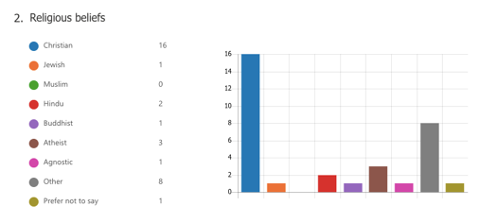
Figure 6. Religious Beliefs

If, for most, having a chart reading has no impact on religious beliefs, those who had their psychometric profile done, felt connected to the broader world (see figures 7&8).
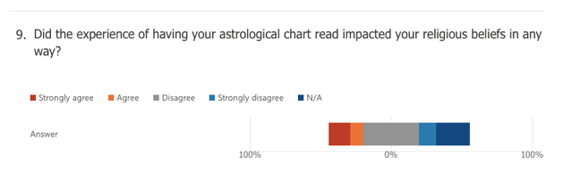
Figure 7. Astrology and beliefs
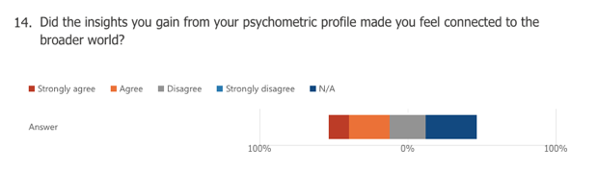
Figure 8. Psychometric tests and connection to the world
Etymologically, the word ‘religion,’ means ‘to bound,’ referring to the profound human desire for connection, and aligning with Ammerman's claim that everyday religion is also a sense of ‘solidarity and transcendence.’ Theorised by Durkheim, these experiences of ‘collective effervescence’ which ‘must be periodically ‘recharged’ by means of intermittent physical assembly,’ can be facilitated by astrology and psychometric tests, as they ‘provide a route to understanding each other that might not otherwise have been there’ said one practitioner. Team training sessions, in which psychometric profiles are shared and compared, illustrate this phenomenon: ‘It's ..you know, lots of giggles and laughing and tripping over and what have you.’ The contrast, is that a typical birth chart reading tends to be a private experience: ‘just to know myself…a lifelong fight to know myself.’ These experiences and practices reflect an essential dichotomy, with one system pointing inwards, and the other outwards, resonating with their shared premodern lineage and typology as previously established. And, far from being incompatible, these systems operating on different polarities, complement one another by providing individuals with ‘a system of symbolic acts that is based upon arbitrary rules.’ Thus, the ritualisation of their practices offers a platform for transformation, suited to the individuals’ needs in relation to their environments; as Matthews pointed, ‘a good cosmology (…), is good for its adherents.’ Quoting Jung, one respondent said: ‘going through the horoscope is equal to six months of psychological counselling;’ and another: ‘I've had people in tears (…) resigning from their job as a result of my workshop, believe it or not.’
Moreover, with Brady arguing that the ‘horoscope (is) the astrologer’s map’ in echo to Eliade’s ‘imago mundi’, the agency of inanimate entities and their capacity to establish connections is further illuminated. As one expressed the chart symbolic significance: ‘I could have it on my wall, that’s my portrait!’ Both the chart and the profile appear to hold a central place, physically and metaphorically: ‘it's all about that macro connection to the micro,’ explained one astrologer; while another participant describing a team session said: ‘you just have twenty, thirty people standing there around the mat.’ For Eliade, the idea of centrality is related to the symbolism of the axis mundi as the grounding point for the ‘creation of the world.’ Thus, the ‘cosmic pillar,’ as an enduring representation of the essential connection between two modes of being, sacred and profane, the above and the below, represents within these practices, a sensuous and magical creative act.
The language too reflects the spiritualisation of these customary practices: ‘I call it veneration or therapy, spending time with the planet of the day.. it's a ritual,’ said one astrologer. And, reasserting Phillipson and Case study, some psychometric methods incorporate spiritual elements in their language too, with a profile referred to as ‘what's called a mandala.’
Be the ‘merrymaking’ around a team profile, or the ritualistic practice of spending time with the planets, or the awe felt at contemplating one’s personal profile that can feel: ‘like a gift,’ these ‘repeated initiatory experiences of ‘death’ and ‘resurrection,’’ exhibit, as much in their practices as in the objects that support them, the structures of premodern religious traditions. Therefore, modern worldviews, firmly grounded in science, are testimony to the persistence of what they are trying to abolish, with the implication that these systems partake in the same ancient sacred patterns ‘ready to be re-actualised.’
Thus, as individuals and collectives participate into the universal drama of existence, each recognising themselves in others, or in objects as symbols, become something else while remaining what they are. And, the astrological chart or the psychometric profile as instruments for the expression of sacred manifestations, or ‘hierophanies,’ further illuminate their share lineage and astro-psychological functions, becoming as Glucklich put it of astrology, ‘a sensory and intellectual engagement in a pattern of physical and mystical relations…a kind of mental ecology.’

Being Human
‘Only philosophy gives true knowledge.’
The last point explores the philosophical influences underpinning both systems, as they support individuals managing life's ups and downs, emphasising notions of self-awareness and personal responsibility (see figures 2&3).
From the narrative data collected, the majority of those associated with astrology seemed to be inspired by platonic worldviews; while those associated with psychometric testing, appeared to be more aligned with Aristotelian perspectives. Thus, seeking meaning and transcendence in the idea of a cosmic order, evocative of a Platonic thought describing how ‘God kindled a light which now we call the Sun (so) that all the creatures entitled thereto might participate in number, learning it from the revolution of the Same and Similar,’ one participant commented: ‘ the birth chart reading gave me reasonable grounds to believe some things in my life were preordained;’ or that other one: ‘there's such beauty and symmetry with nature and us.’
In contrast to Plato’s vertical representation of the cosmos, those involved with psychometric testing tended to present a more horizontal perspective, aligning with an empirical, purposeful Aristotelian cosmology with elements of Stoicism. Thus, for them: ‘psychometric feels more evidenced,’ and if ‘the psychometric profile opens up a book of information about them, it's up to them whether they turn the pages.’ These principles seem to be demonstrated in team training programs, based upon individuals’ understanding of their personal profiles. As each member gravitates towards its best place, or role, within the team, those who had previously gathered around the mat, which is divided into sectors representing specific behavioural tendencies, ‘position themselves in various parts and it's almost like a funnel.’ The result is that the team, or the collective, becomes more effective in the knowledge of their individuals’ strengths and weaknesses, but also as they may have resolved potential conflicts due to a lack of understanding of one another: ‘suddenly I knew why he was getting on my nerves.’ One practitioner concluded with a quote attributed to Aristotle himself: ‘the whole is greater than the sum of its parts.’ Nevertheless, and significantly in the context of this research, the outcome is not fixed as the choice to utilise the knowledge gained lies with the individuals: ‘they are the master or mistress of their information once they've got it.’ And, if psychometric testing methods, in their majority, put themselves on an entirely scientific footing, in opposition to astrology seen as the ‘supernatural cousin’ of astronomy,’ they seem to share premodern epistemological viewpoints as they combine what Aristotle’s defined as the four causes for all things. In addition to their material cause, that is individuals or teams, and their efficient cause, that is the chart or the profile, they also include a formal cause, that is a conceptual basis, and a final cause, that is a teleological function. Mechanistic modern views in contrast only consider efficient and material causes within their scientific frameworks, and they do not integrate the formal or final causes, hence reaffirming the premodern affiliation of psychometric systems.
In addition to these philosophical connections, common metaphysical concerns also emerged. In the face of the fragility of human condition, views which had been largely influenced by their socio-cultural conditionings, seem to be called into question when one is confronted with loss: ‘We both thought that it would be easier for the person who was left.. But in fact, I do think he's gone somewhere...You know, stardust… and he’s still out there somewhere… that has been a lot more helpful (…) it’s kind of changed my mind a bit.’
Thus, astrology and psychometric testing systems’ role as guiding agents is highlighted as they lead individuals and collectives towards their objectives and provide comfort and hope in the face of adversity. Their transitional and initiatory functions accompany the process of maturation, to which human beings are subjected physically and spiritually, leading individuals from one mode of being to another. Thus, as these philosophical models meet, in line with Eagleton's concept of a ‘transfiguring tension,’ verticality and horizontality reunite, to form the symbol of the cross as embodiment of the fixity of human incarnation, yet its ability to free itself by learning from and adapting to the limitations of its condition. Individuals through this tension can navigate the ‘perilous’ yet salutary passage,’ that is the transition from rigidity to stability, from imbalance to equilibrium, and in so far as human existence is fulfilled, it is itself an initiation.’
Therefore, there seems to be in ancient philosophy, as well as in both systems, ‘a kind of…hope.. that there's something else out there, so it’s just like we’re not just a bunch of.. I don't know what.. pile of flesh that's born and die and there's something bigger.. you see?’
in echo to Plato, individuals’ now ‘reinforced by the right education training,’ are richer for the knowledge they have acquired.

Conclusion
‘Such is the ancient matrix, the one we have never abandoned.’
Using a mixed methodology, this research explored the connections between astrology and psychometric testing in relation to individuals’ cosmologies. The findings vindicated the initial motivation that prompted this research, that is that astrology and psychometric testing as representatives of two seemingly antagonist worldviews, shared many traits, and unexpected themes also emerged. The findings seem to be reasserting Phillipson and Case study, as the results suggest that despite the perceived divide between premodern and modern worldviews, correlations between the astrological and psychometric systems exist at multiple levels. As ‘everything is cultural,’ individuals' cosmologies and generational affiliations influence these systems as much as these also influence the ever- evolving, and necessarily subjective, worldviews. The mechanisms at play within both systems, strive to establish a state of equilibrium, reflecting a division that they attempt to resolve, and paraphrasing Eagleton, being at once the problem and the solution. However, further research could be conducted to encompass a wider range of religious beliefs and a more balanced generational representation.
As the astrological chart and the psychometric profile seem to be instrumental in shaping experiences and perspectives, the agency of objects and the necessity to challenge human-centred worldview is highlighted. In an interconnected universe, the considerate management of the proliferation of hybrids could play a crucial role in addressing ecological issues. Thus, Latour urges us to reconsider the metaphysical significance of inanimate objects, and ‘change our ways of changing.’ These implications extend beyond the scope of this study and offer avenues for further exploration. The findings also uncovered the inherent human disposition towards sacredness. ‘Here too the gods are present.’ Ammerman's Waldo, is to be found on every page of the book of human experience, blurring the lines between modern and pre-modern, with the book itself appearing to be somewhat irrelevant: ‘It doesn't matter what it is. There just need to be an ‘it.’’
Finally, in a nod to Latour and Whitehead, the philosophical roots underpinning the participants’ experiences find some common ground in Neoplatonism, being itself, a hybrid philosophy and an occurrence of complexity converging towards unity. As the common thread running through this research points towards a simplified and unified perspective, with ‘the ultimate principle (…) (lying) in the nature of things that the many enter into complex unity.’ As such, both the chart and the profile provide individuals with a map, towards wisdom or knowledge, the ultimate destination, whether their compass is set on a Platonic or an Aristotelian worldview.
And, as individuals confront their humanity ‘freedom through self-understanding’ can be achieved despite, or perhaps thanks to, the discomfort and pain that these processes imply, eventually leading to what Greene called ‘the exhilaration of psychological freedom.’ With these systems, contributing to the construction of personal cosmologies as they deploy their harmonising telos, in line with ancient philosophical principles.
In conclusion, it seems as Eliade stated, that ‘a purely rational man is an abstraction,’ and if Latour claimed that ‘we have never been modern,’ we might never have been pre-modern either. Just human beings in becoming so ‘the task of continuing to find Waldo is one we can happily share.’

Bibliography

- Ammerman, N. T. “2013 Paul Hanly Furfey Lecture: Finding Religion in Everyday Life.” Sociology of Religion, vol. 75, no. 2, 2014, p.191. JSTOR, http://www.jstor.org/stable/24580196. Accessed 5 Mar. 2024
- Aristotle, Physics, (208B11) trans. F. M. Cornford and PH Wickstead, Cambridge, Mass,, London, 1930
- Arnoult. E.J., Cayla.J., ‘Consumer Fetish: Commercial Ethnography and the Sovereign Consumer’, DOI: 10.1177/0170840615580012. Sage. 2015
- Belbin, Meredith., The Coming Shape of Organization. Butterworth Heinemann. Oxford. ©Meredith Belbin. 1998
- Bell, Judith, and Stephen Waters, Doing Your Research Project: A Guide for First-Time Researchers, 7th edition. (London: Open University Press, McGraw-Hill Education, 2018)
- Bryman, Alan., Quantity and Quality in Social Research (London: Routledge, 1992)
- Campion, N. & Greene, L. (eds.) Astrologies, Plurality and Diversity. University of Wales Trinity Saint David, Lampeter: Sophia Centre Press.
- Campion, Nicholas., Astrology and Cosmology in the World’s Religions (New York: New York University Press, 2012)
- Campion, Nicholas., Astrology and Popular Religion in the Modern West Prophecy, Cosmology, and the New Age Movement (Farnham; Ashgate, 2012)
- Casey, E.S. 2013. The fate of place: a philosophical history (Berkeley: University of California Press)
- Curry, Patrick, ‘Astrology’, in Boyd, Kelly (ed.) The Encyclopaedia of Historians and Historical Writing, 2 Vols. London: Fitzroy Dearborn 1999, Vol. 1.
- Durand, Marion, Simon Shogry, and Dirk Baltzly, "Stoicism", The Stanford Encyclopedia of Philosophy (Spring 2023 Edition), Edward N. Zalta & Uri Nodelman (eds.), URL = <https://plato.stanford.edu/archives/spr2023/entries/stoicism/>.
- Durkheim, Émile. The Elementary Forms of Religious Life. Oxford: Oxford University Press.1912
- Dwyers, S.& Buckle, J. The Space Between: On Being an Insider-Outsider in Qualitative Research. International Journal of Qualitative Methods, Vol.8 issue 1, 2009
- Eagleton, Terry, The Idea of Culture (Oxford: Blackwell, 2000)
- Eliade, Mircea, The Sacred and the Profane: The Nature of Religion (New York: Harper & Row, 1961)
- Eliade, Mircea., Shamanism, Archaic techniques of ecstasy (translated from the French by Willard R. Trask). Arkana, penguin Group, London, England. p.483
- Glucklich, Ariel., The End of Magic (New York; Oxford University Press, 1997). p.12
- Greene, Liz., Saturn: A New Look at an Old Devil (Boston, Mass: Weiser, 1976)
- HandWiki. "Personality Test" Encyclopedia, https://encyclopedia.pub/entry/29094
- Hennink, M., Hutter, I. & Bailey A., Qualitative Research Methods. London: Sage. 2020
- Herder, Johann Gottfried. Outlines of a Philosophy of the History of Man / Translated from the German of John Godfrey Herder, by T. Churchill. Trans. T. O. Churchill. Second edition. London: Printed by Luke Hansard, for J. Johnson, 1803. p. 362
- Holmes, Arthur., A History of Philosophy. Aristotle’s Metaphysics 1. https://youtu.be/kLKHpSPoNKI?si=ePadpuYilzRz0xGK
- Johnson, Laura. “(Environmental) Rhetoric’s of Tempered Apocalypticism in An Inconvenient Truth.” Rhetoric Review, vol. 28, no. 1, 2009, pp. 29–46. JSTOR, http://www.jstor.org/stable/25655928. Accessed 16 Oct. 2023.
- Latour, Bruno., We Have Never Been Modern (Cambridge, Mass: Harvard University Press, 1993)
- Mathews, Freya, The Ecological Self, Savage, MD: Barnes and Noble, 1991, p.109.
- Northcote, J. ‘Objectivity and the Supernormal: The Limitations of Bracketing Approaches in Providing Neutral Accounts of Supernormal Claims.’ Journal of Contemporary Religion, Vol.19, No. 1, 2004
- Phillipson, Garry, and Peter Case, 'The Hidden Lineage of Modern Management Science: Astrology, Alchemy and the Myers-Briggs Type Indicator', Culture and Cosmos, Vol. 5 no 2, Winter/Autumn 2001
- Plato, Timaeus, (44C-E) (translated by R.G. Bury) Loeb Classical Library. Harvard University Press, Cambridge, Massachusetts, London, England, 1929
- Plato, Phaedo, (83A), trans. H.N. Fowler, Cambridge Mass., London Harvard University Press, 1914.
- Ptolemy, Tetrabiblos, in Gunzburg, D., How Do Astrologers Read Charts? Published in 'Astrologies: Plurality and Diversity', edited by Nicholas Campion and Liz Greene, 181-200. Ceredigion: Sophia Centre Press, University of Wales, Trinity Saint David, 2011.
- Robinson, E., Schofield, C., Sutcliffe Braithwaite, F. and Thomlinson, N. (2017) Telling stories about Post-war Britain: popular individualism and the ‘Crisis’ of the 1970s. Twentieth Century British History, 28 (2). pp. 268-304. ISSN 1477-4674 DOI: https://doi.org/10.1093/tcbh/hwx006
- Rudhyar, Dane., ‘The Birth Chart as a Celestial Message from the Universal Whole to an Individual Part.’ An Address to the 1976 Convention of the American Federation of Astrologers. Rudhyar Archival Project. Cyberworld. Khaldea
- Sherburne, D.W., ‘Whitehead Alfred North’ in Robert Audi (ed.), The Cambridge Dictionary of Philosophy. Cambridge: Cambridge University Press. (1995).
- Vine, T. (2023). Is physical co-presence a prerequisite for Durkheimian collective effervescence? Reflections on remote working during the COVID-19 pandemic. Culture and Organization, 29(5), 380–396. https://doi.org/10.1080/14759551.2023.2201004 Accessed 19 Apr. 2023
- Westling, Louise. “Conclusion.” The Logos of the Living World: Merleau-Ponty, Animals, and Language, Fordham University Press, 2014, pp. 135–44. JSTOR, https://doi.org/10.2307/j.ctt13x064j.8. Accessed 9 Nov. 2023
- Whitehead, Alfred, North, Process and Reality (1929); Corrected Edition, ed. David Ray Griffin and Donald W. Sherburne (New York: Free Press,1978)
- Wikipedia contributors, "Baby boomers,” Wikipedia, The Free Encyclopedia, https://en.wikipedia.org/w/index.php?title=Baby_boomers&oldid=1216995645. Accessed 8 Apr. 2024.
- www.belbin.com
- www.britannica.com/topic/ritual
- www.discprofile.com
- www.forbes.com/sites/forbeshumanresourcescouncil/2019/04/02/the-abcs-of-generations-x-y-and-z/?sh=1a543345672b
- www.linkedin.com/pulse/psychometric-tests-market-growth-opportunities-report-vinayak-patil/
- www.luminalearning.com

Appendix

Survey QR code:



Full summary of results:

https://forms.office.com/Pages/AnalysisPage.aspx?AnalyzerToken=0FFf7x4KPgMivdIg0RL7iZUxOg29E9LK&id=-REPTm4EBUWcuNshUjEeIYjtU_FJFvFGpDQoNN1lJahURTEwWk1UVlpWRVYzQzBNTklGR01JTzJOWi4u

Overview of results:
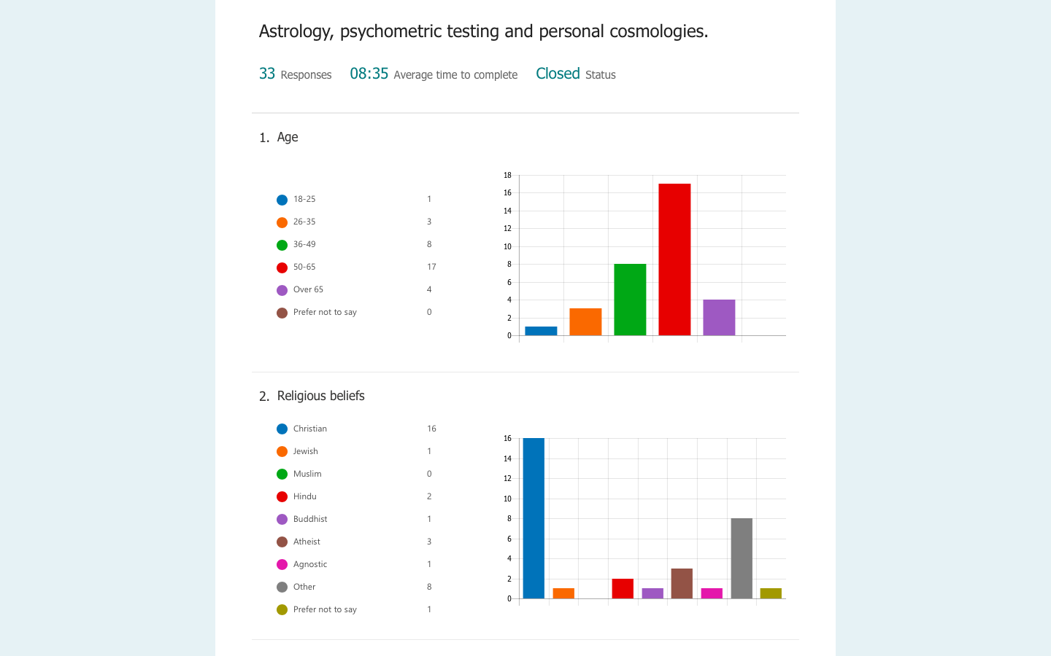
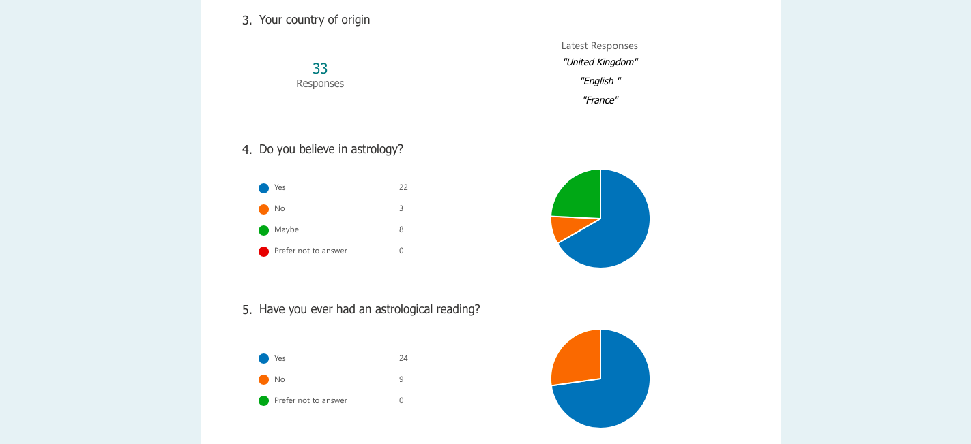
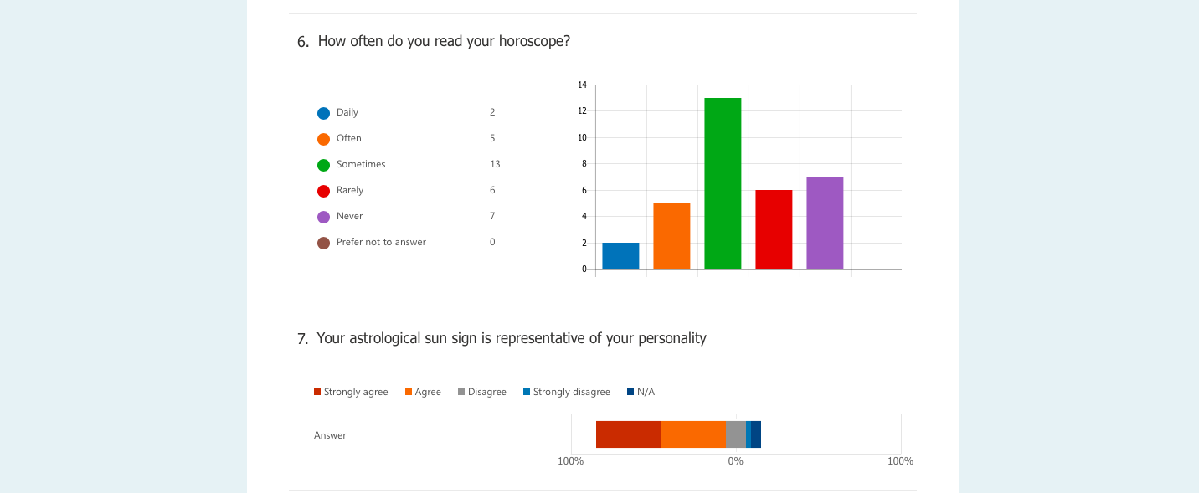
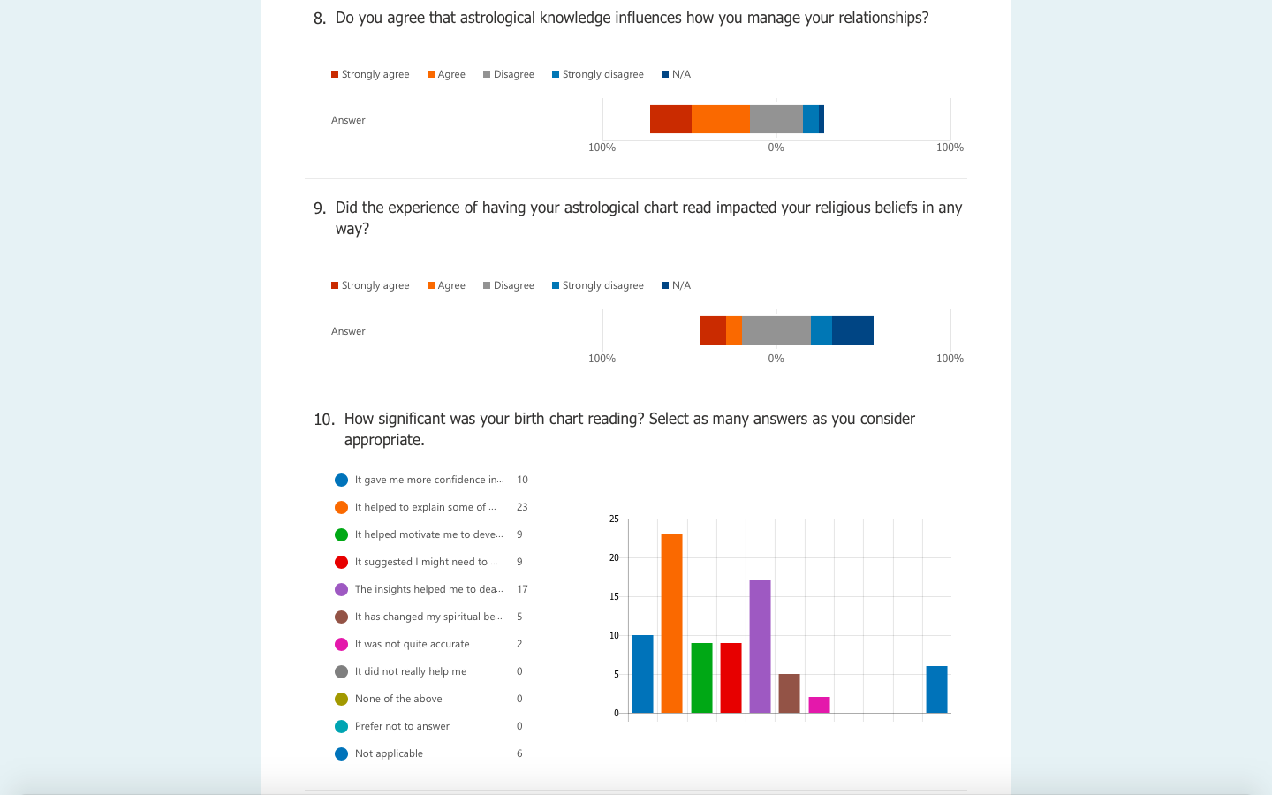
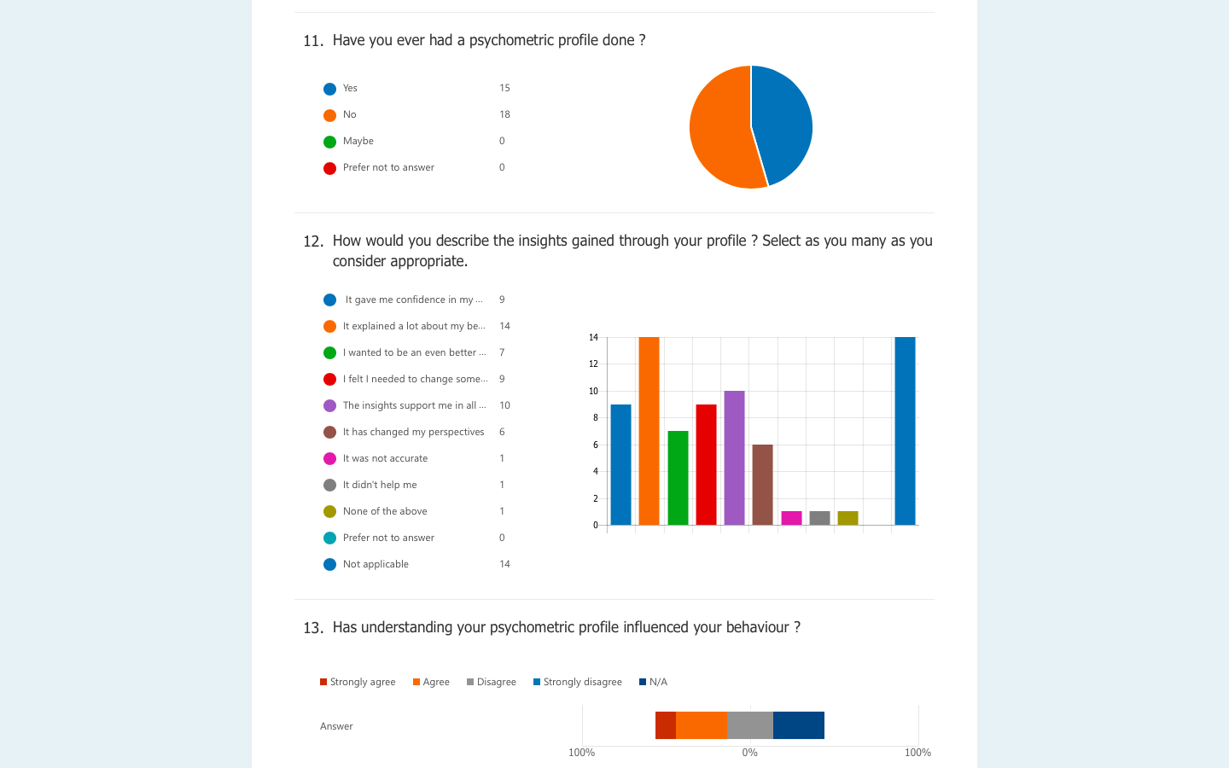
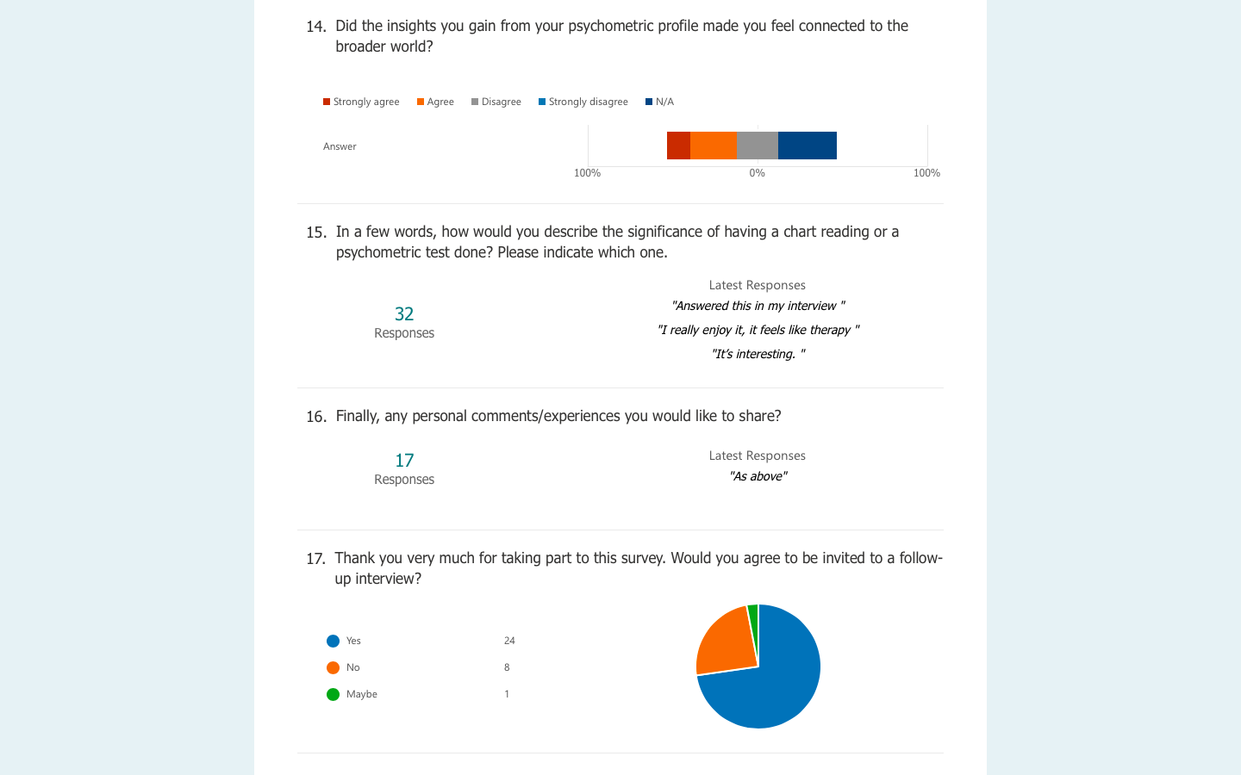

Phillipson, Garry, and Peter Case, 'The Hidden Lineage of Modern Management Science: Astrology, Alchemy and the Myers-Briggs Type Indicator', Culture and Cosmos, Vol. 5 no 2, Winter/Autumn 2001. p.56
Patrick Curry, Patrick, ‘Astrology’, in Boyd, Kelly (ed.) The Encyclopaedia of Historians and Historical Writing, 2 Vols. London: Fitzroy Dearborn 1999, Vol. 1, p.55
Ptolemy, Tetrabiblos, in Gunzburg, D., How Do Astrologers Read Charts? Published in 'Astrologies: Plurality and Diversity', edited by Nicholas Campion and Liz Greene, 181-200. Ceredigion: Sophia Centre Press, University of Wales, Trinity Saint David, 2011. p.181
HandWiki. "Personality Test" Encyclopedia, https://encyclopedia.pub/entry/29094 (accessed March 12, 2024)
Phillipson, Garry, and Peter Case, 'The Hidden Lineage of Modern Management Science: Astrology, Alchemy and the Myers-Briggs Type Indicator', Culture and Cosmos, Vol. 5 no 2, Winter/Autumn 2001, p.54
Ibid., p.55
Short, Rennie, J., in Phillipson. G., Case, P., The Hidden Lineage of modern Management Science; Astrology, Alchemy and the Myers-Briggs type indicator, Culture and Cosmos, Vol.5 no2, Winter/Autumn 2001, p.56
Phillipson, Garry and Peter Case, 'The Hidden Lineage of Modern Management Science: Astrology, Alchemy and the Myers-Briggs Type Indicator', Culture and Cosmos, Vol. 5 no 2, Winter/Autumn 2001, p.53
https://www.linkedin.com/pulse/psychometric-tests-market-growth-opportunities-report-vinayak-patil/
Campion, Nicholas., Astrology and Popular Religion in the Modern West Prophecy, Cosmology, and the New Age Movement (Farnham; Ashgate, 2012). p.1
Campion, Nicholas., Astrology and Cosmology in the World’s Religions (New York: New York University Press, 2012) p. 188
Eagleton, Terry, The Idea of Culture (Oxford: Blackwell, 2000). p.4
Phillipson, Garry, and Peter Case, 'The Hidden Lineage of Modern Management Science: Astrology, Alchemy and the Myers-Briggs Type Indicator', Culture and Cosmos, Vol. 5 no 2, Winter/Autumn 2001, p.68
www.discprofile.com
Rudhyar, Dane., ‘The Birth Chart as a Celestial Message from the Universal Whole to an Individual Part.’ An Address to the 1976 Convention of the American Federation of Astrologers. Rudhyar Archival Project. Cyberworld. Khaldea
Greene, Liz., Saturn: A New Look at an Old Devil (Boston, Mass: Weiser, 1976). p.2
Whitehead, Alfred, North, Process and Reality (1929); Corrected Edition, ed. David Ray Griffin and Donald W. Sherburne (New York: Free Press,1978)
Arnoult. E.J., Cayla.J., ‘Consumer Fetish: Commercial Ethnography and the Sovereign Consumer’, DOI: 10.1177/0170840615580012. Sage. 2015
Ibid., p.1361
Latour, Bruno., We Have Never Been Modern (Cambridge, Mass: Harvard University Press, 1993)
Ammerman, N. T. “2013 Paul Hanly Furfey Lecture: Finding Religion in Everyday Life.” Sociology of Religion, vol. 75, no. 2, 2014, p.191. JSTOR, http://www.jstor.org/stable/24580196. Accessed 5 Mar. 2024.
Brady, B. (2011). 'The Horoscope as an 'Imago Mundi': Rethinking the Nature of the Astrologer's Map'. In: Campion, N. & Greene, L. (eds.) Astrologies, Plurality and Diversity. University of Wales Trinity Saint David, Lampeter: Sophia Centre Press. p.47
Durkheim, Émile. The Elementary Forms of Religious Life. Oxford: Oxford University Press. 1912
Eliade, Mircea, The Sacred and the Profane: The Nature of Religion (New York: Harper & Row, 1961)
Phillipson, Garry, and Peter Case, 'The Hidden Lineage of Modern Management Science: Astrology, Alchemy and the Myers-Briggs Type Indicator', Culture and Cosmos, Vol. 5 no 2, Winter/Autumn 2001, p.53
Ammerman, N. T. “2013 Paul Hanly Furfey Lecture: Finding Religion in Everyday Life.” Sociology of Religion, vol. 75, no. 2, 2014, p.189. JSTOR, http://www.jstor.org/stable/24580196. Accessed 5 Mar. 2024.
Bryman, Alan., Quantity and Quality in Social Research (London: Routledge, 1992). p.11
Hennink, M., Hutter, I. & Bailey A., Qualitative Research Methods. London: Sage. 2020.p.10
Questionnaire and summary of responses in Appendix
Participants’ quotes in Italic.
Bell, Judith, and Stephen Waters, Doing Your Research Project: A Guide for First-Time Researchers, 7th edition. (London: Open University Press, McGraw-Hill Education, 2018). p.178
Bryman, Alan., Quantity and Quality in Social Research (London: Routledge, 1992). p.53
Participants accredited or trained to deliver psychometric testing are referred as ‘practitioners’
Gray 1998:12 in Bell, Judith, and Stephen Waters, Doing Your Research Project: A Guide for First-Time Researchers, 7th edition. (London: Open University Press, McGraw-Hill Education, 2018). p.21
Gudmunsdottir 1996 :295 in Bell, Judith, and Stephen Waters, Doing Your Research Project: A Guide for First-Time Researchers, 7th edition. (London: Open University Press, McGraw-Hill Education, 2018). p.21
Participants’ quotes and comments are in Italic
Dwyers, S.& Buckle, J. The Space Between: On Being an Insider-Outsider in Qualitative Research. International Journal of Qualitative Methods, Vol.8 issue 1, 2009.p.77
Northcote, J. ‘Objectivity and the Supernormal: The Limitations of Bracketing Approaches in Providing Neutral Accounts of Supernormal Claims.’ Journal of Contemporary Religion, Vol.19, No. 1, 2004. p.p.85.98
Whitehead, Alfred, North, Process and Reality (1929); Corrected Edition, ed. David Ray Griffin and Donald W. Sherburne (New York: Free Press,1978). p.40
Wikipedia contributors, "Baby boomers,” Wikipedia, The Free Encyclopedia, https://en.wikipedia.org/w/index.php?title=Baby_boomers&oldid=1216995645 (accessed April 8, 2024).
Robinson, E., Schofield, C., Sutcliffe Braithwaite, F. and Thomlinson, N. (2017) Telling stories about Post-war Britain: popular individualism and the ‘Crisis’ of the 1970s. Twentieth Century British History, 28 (2) ISSN 1477-4674 DOI: https://doi.org/10.1093/tcbh/hwx006 . p.1
Casey, E.S. 2013. The fate of place: a philosophical history (Berkeley: University of California Press)
https://www.forbes.com/sites/forbeshumanresourcescouncil/2019/04/02/the-abcs-of-generations-x-y-and-z/?sh=1a543345672b
Ibid.
Bryman, Alan., Quantity and Quality in Social Research (London: Routledge, 1992). p.15
Johnson, Laura., “(Environmental) Rhetoric’s of Tempered Apocalypticism in An Inconvenient Truth.” Rhetoric Review, vol. 28, no. 1, 2009, pp. 29–46. JSTOR, http://www.jstor.org/stable/25655928. Accessed 16 Oct. 2023.
Whitehead, Alfred, North, Process and Reality (1929); Corrected Edition, ed. David Ray Griffin and Donald W. Sherburne (New York: Free Press,1978)
Sherburne, D.W., ‘Whitehead Alfred North’ in Robert Audi (ed.), The Cambridge Dictionary of Philosophy. Cambridge: Cambridge University Press. (1995). P.852
Eagleton, Terry, The Idea of Culture (Oxford: Blackwell, 2000). p.2
Rudhyar, Dane., ‘The Birth Chart as a Celestial Message from the Universal Whole to an Individual Part.’ An Address to the 1976 Convention of the American Federation of Astrologers. Rudhyar Archival Project. Cyberworld. Khaldea
Bacon, Francis., in Eagleton, Terry., The Idea of Culture (Oxford: Blackwell, 2000). p.1
www.belbin.com
Belbin, Meredith., The Coming Shape of Organization. Butterworth Heinemann. Oxford. ©Meredith Belbin. 1998. P.118
Eagleton, Terry, The Idea of Culture (Oxford: Blackwell, 2000). p.4
Herder, Johann Gottfried. Outlines of a Philosophy of the History of Man / Translated from the German of John Godfrey Herder, by T. Churchill. Trans. T. O. Churchill. Second edition. London: Printed by Luke Hansard, for J. Johnson, 1803. p. 362
Eagleton, Terry, The Idea of Culture (Oxford: Blackwell, 2000). p.7
Ibid., p.7
Ibid., p.6
Latour, Bruno., We Have Never Been Modern (Cambridge, Mass: Harvard University Press, 1993). p.107
Arnoult. E.J., Cayla.J., ‘Consumer Fetish: Commercial Ethnography and the Sovereign Consumer’, DOI: 10.1177/0170840615580012. Sage. 2015. p.1368
Latour.B., ‘On The Modern Cult of the Factish Gods’ (Translation Porter & H. MacLean). Durham NC: Duke Press University in Arnoult. E.J., Cayla.J., ‘Consumer Fetish: Commercial Ethnography and the Sovereign Consumer’, DOI: 10.1177/0170840615580012. Sage. 2015. p.1370
Latour, Bruno., We Have Never Been Modern (Cambridge, Mass: Harvard University Press, 1993). p.p.108-109
Ibid., p.p.142-145
Eliade, Mircea, The Sacred and the Profane: The Nature of Religion (New York: Harper & Row, 1961). p.29
Ibid., p.191
Ammerman, N. T. “2013 Paul Hanly Furfey Lecture: Finding Religion in Everyday Life.” Sociology of Religion, vol. 75, no. 2,2014, pp. 189–207. JSTOR, http://www.jstor.org/stable/24580196. p.193. Accessed 5 Mar.2024
Ammerman, N. T. “2013 Paul Hanly Furfey Lecture: Finding Religion in Everyday Life.” Sociology of Religion, vol. 75, no. 2,2014, pp. 189–207. JSTOR, http://www.jstor.org/stable/24580196. 2024.p.193. Accessed 5 Mar.2024
Durkheim, Émile. The Elementary Forms of Religious Life. Oxford: Oxford University Press.1912
Vine, T. (2023). Is physical co-presence a prerequisite for Durkheimian collective effervescence? Reflections on remote working during the COVID-19 pandemic. Culture and Organization, 29(5), 380–396. https://doi.org/10.1080/14759551.2023.2201004. Accessed 19 Apr. 2023.
Phillipson, Garry, and Peter Case, 'The Hidden Lineage of Modern Management Science: Astrology, Alchemy and the Myers-Briggs Type Indicator', Culture and Cosmos, Vol. 5 no 2, Winter/Autumn 2001, p.67
www.britannica.com/topic/ritual
Mathews, Freya, The Ecological Self, Savage, MD: Barnes and Noble, 1991, p.109.
Brady, Bernadette., ‘The Horoscope as an ‘Imago Mundi’’: Rethinking the Astrologer’s Map. In Campion, N. & Greene, L. (eds.) Astrologies, Plurality and Diversity. University of Wales Trinity Saint David, Lampeter: Sophia Centre Press. p.47
Ibid., p.22
Eliade, Mircea, The Sacred and the Profane: The Nature of Religion (New York: Harper & Row, 1961) p.p.32-47
Phillipson, Garry, and Case, Peter., 'The Hidden Lineage of Modern Management Science: Astrology, Alchemy and the Myers-Briggs Type Indicator', Culture and Cosmos, Vol. 5 no 2, Winter/Autumn 2001. p.63
www.luminalearning.com/products/lumina-spark
Eliade, Mircea, The Sacred and the Profane: The Nature of Religion (New York: Harper & Row, 1961). p.205
Ibid.p.209
Ibid.p.203
Ibid.p.204
Ibid., p.12
Eliade, Mircea, The Sacred and the Profane: The Nature of Religion (New York: Harper & Row, 1961)
Glucklich, Ariel., The End of Magic (New York; Oxford University Press, 1997). p.12
Plato, Phaedo, (83A), trans. H.N. Fowler, Cambridge Mass., London Harvard University Press, 1914.
Plato, Timaeus,38C, (translated by R.G. Bury) Loeb Classical Library. Harvard University Press, Cambridge, Massachusetts, London, England, p.81
Durand, Marion, Simon Shogry, and Dirk Baltzly, "Stoicism", The Stanford Encyclopedia of Philosophy (Spring 2023 Edition), Edward N. Zalta & Uri Nodelman (eds.), URL = <https://plato.stanford.edu/archives/spr2023/entries/stoicism/>.
Aristotle, Physics, (208B11) trans. F. M. Cornford and PH Wickstead, Cambridge, Mass,, London, 1930
Belbin, Meredith., The Coming Shape of Organization. Butterworth Heinemann. Oxford. ©Meredith Belbin. 1998
Aristotle, Physics, (11.3) trans. F. M. Cornford and PH Wickstead, Cambridge, Mass,, London, 1930
Holmes, Arthur., A History of Philosophy. Aristotle’s Metaphysics 1. https://youtu.be/kLKHpSPoNKI?si=ePadpuYilzRz0xGK
Eagleton, Terry, The Idea of Culture (Oxford: Blackwell, 2000). p.5
Eliade, Mircea., Shamanism, Archaic techniques of ecstasy (translated from the French by Willard R. Trask). Arkana, penguin Group, London, England. p.483
Eliade, Mircea, The Sacred and the Profane: The Nature of Religion (New York: Harper & Row, 1961). p.209
Plato, Timaeus, (44B-C) (translated by R.G. Bury) Loeb Classical Library. Harvard University Press, Cambridge, Massachusetts, London, England, p.99
Latour, Bruno., We Have Never Been Modern (Cambridge, Mass: Harvard University Press, 1993). p.107
Phillipson, Garry, and Case, Peter., 'The Hidden Lineage of Modern Management Science: Astrology, Alchemy and the Myers-Briggs Type Indicator', Culture and Cosmos, Vol. 5 no 2, Winter/Autumn 2001
Westling, Louise. “Conclusion.” The Logos of the Living World: Merleau-Ponty, Animals, and Language, Fordham University Press, 2014, pp. 135–44. JSTOR, https://doi.org/10.2307/j.ctt13x064j.8. Accessed 9 Nov. 2023
Eagleton, Terry, The Idea of Culture (Oxford: Blackwell, 2000). p.31
Latour, Bruno., We Have Never Been Modern (Cambridge, Mass: Harvard University Press, 1993). p.145
Heraclitus in Latour, Bruno., We Have Never Been Modern (Cambridge, Mass: Harvard University Press, 1993). p.65
Ammerman, N. T. “2013 Paul Hanly Furfey Lecture: Finding Religion in Everyday Life.” Sociology of Religion, vol. 75, no. 2, 2014, p.191. JSTOR, http://www.jstor.org/stable/24580196. Accessed 5 Mar. 2024.
Stanford
Whitehead, Alfred, North, Process and Reality (1929); Corrected Edition, ed. David Ray Griffin and Donald W. Sherburne (New York: Free Press,1978), p.21.
Greene, Liz., Saturn: A New Look at an Old Devil (Boston, Mass: Weiser, 1976). p.4
Eliade, Mircea, The Sacred and the Profane: The Nature of Religion (New York: Harper & Row, 1961). p.209
Ammerman, N. T. “2013 Paul Hanly Furfey Lecture: Finding Religion in Everyday Life.” Sociology of Religion, vol. 75, no. 2, 2014, p.204. JSTOR, http://www.jstor.org/stable/24580196. Accessed 5 Mar. 2024.

