Assignment title: System Improvement Programme

Programme Name: MSc Digital Skills for Health and Care Professionals

Academic Year: 1

Module name: Digital Technology in Health and Social Care

Student Name & id: 2211943

Total word count: 4261

Date of Submission: 16th December 2022

Table of Contents

Introduction 2
Business problem 4
Justification 4
Aims and Objectives 6
Literature Review 7
Project Management Methodology 11
Project Scope 14
Organisational Structure 14
Stakeholders 15
Implementation 17
The Project Team 17
Work Breakdown 18
Detailed Task List 20
Resources 21
Evaluation 21
Discussion 22
Conclusion 23
Reference 23

Introduction
The Welsh Government has called for a ‘revolution from within’ to support the current and future requirements of the people of Wales; merging health and social care to provide a seamless whole system approach that is equitable, efficient, effective, and fit for the future; with changing pressures and needs of the public (WAG 2021, WAG 2021a). This streamlined approach aims to accommodate the current pressures facing Government services: an aging population, change in expectations, lifestyle changes and emerging technologies in a peri / post pandemic world facing austerity, workforce shortages, and varied geography providing challenges that require consideration (Frennert et al 2022).

The coming winter is deemed to strain services significantly (NHS Scotland 2022). With an ongoing pandemic and the onset of flu season, pressures on health services are forecast to be extreme (NHS England 2022). Wales has published guidance deferring responsibility to Health Boards noting planning is a year-round event (WAG 2022b). As part of the support for the coming winter (WAG 2022b), 111 is noted to be to a trusted provider to support Welsh Assembly Government’s (WAG’s) ‘revolution’ and direct patients to the right service first time, hopefully easing strained services, and public demand expected to inundate emergency, hospital, and general practice.

A summary of the pressures can be presented as a multifaceted and complex situation with multiple overlapping factors, in the pictographic: -
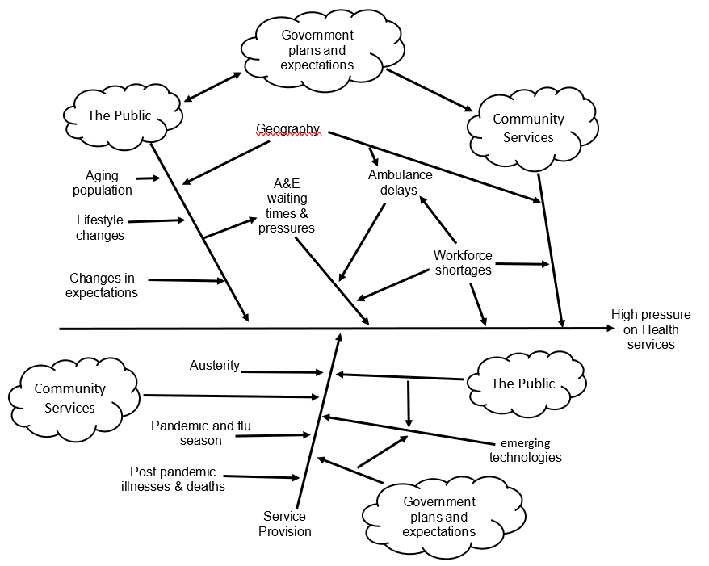

NHS 111 Wales is an integral service managed by the Welsh Ambulance Service Trust (WAST). The service provides free accessible health information and advice, together with guidance and access to appropriate services for further interventions as required by the residents and visitors of Wales via telephone, email, or post.

NHS 111 Wales operationally comprises of Call Handlers (CH) who prioritise calls and either redirect or queue them for an appropriate specialist to ring back. Health Information Advisors (HIA), answer Internet and non-clinical enquiries; Dental Nurses (DN) triage and refer dental callers to dental or emergency services; and Nurse Advisors or Paramedic Advisors (HCPs), triage and provide clinical advice. The aim of each of these specialities is the appropriate referral onto a relevant service for safe, efficient, and effective care. An appropriate referral to suitable services might include self-care advice, dental access, Pharmacy, Physiotherapy, Social care, General Practitioner (GP) input, out of hours (OOHs) GP advice or review, attendance to Accident and Emergency department (A&E) or the emergency services, Police, Ambulance or Fire Service. Senior Nurse Advisors (SNAs) oversee the service, managing and monitoring service provision and call safety on designated queues for each speciality, while being the clinical lead on shift to support all specialities.

There has been extensive research worldwide into the benefits of telephone triage, also known by pseudonyms such as telehealth, telemedicine, remote triage; to name a few. Gustafsson & Eriksson (2021) identified numerous articles in their systemic review identifying telehealth as cost effective, efficient, and safe in opposition to an earlier paper that identified there was insufficient evidence to support this (Lake et al 2017).

To be truly cost effective, efficient, and safe, a telephone triage specialist must have extensive knowledge of services available, how to refer and access the services and how to safeguard or protect the patient, together with the confidence and skills to do so. A waterfall project management methodology will be applied to develop a whole system improvement programme, identifying how data will be used to improve outcomes safely, ethically, and appropriately, within the multidisciplinary setting of NHS Wales. Through collaborative partnership work, the benefits for the patient can enhance care, whilst achieving the revolution from within to support the current and future requirements of the people of Wales. To achieve this, an improved use of data generated by services, is required to identify the complete journey of the patient accessing NHS 111 Wales. At present, limited data is available to identify if correct outcomes or pathways for patients are advised or enabled. A business problem presents that the data available is not utilised, despite the wealth of data accessible (WAG 2019a). To enhance outcomes for patients, feedback from the patient and digital data from health services, is available but not collated, to enable an audit of the patient journey, supporting the learning health and care system, as proclaimed by the Welsh Government (WAG 2021a).

To summarise: -
A patient journey and feedback system is required within 12 months, for NHS 111 Wales to utilise data from Welsh Government supported digital platforms, to support, educate and develop the service for the people of Wales.

Justification

Currently, there are multiple digital platforms in use within the Welsh NHS (WAG 2019a, NHS Wales 2022). Agrawal and Prabakaran (2020) note the benefit of utilising the data already gained, but fragmented. Through the vision of the digital patient, the definition of which varies significantly (WAST 2020, digital-patient.net 2022); the proposed changes will support the vision of WAG and WAST, while reducing health care costs meeting the ethos of right care, right place, first time (WAST 2020, WAG 2021). The benefits to staff are considerable, reinforcing safe, efficient, effective care in keeping with the NMCs Code of Conduct (NMC 2015) and the Health and Care Professions Council (HCPC 2014), whilst the benefits to patients will be safe, efficient, effective care enabling cost effective care, an essential criterion in the current economic climate.

Incorporating a format of the ‘Digital patient’ within the next 12 months, as per WAST (2020) strategy; will empower staff to improve practice, improving the patient experience and journey. Through the 7 portals listed in Digital Strategy for Health and Social Care (WAG 2019a) patient journey information is available but not currently utilised.

Attached to each patient digital record, a simple clickable questionnaire will be available with a feedback section for health care professionals involved throughout the journey:
is the referral appropriate
was treatment prescribed
could this have been done different
Additional optional comments section should be available requesting how to make the patient journey more efficient, feedback for fellow clinicians.

Patient feedback of perceptions of interactions, their journey, pathway through the healthcare system and how they deem this could be improved utilising both digital and non-digital methods. Paper feedback as well as text, email and website options should all be available during and after the patient journey (WAG 2021b). For ease of use, a clickable or tick box option should be available with space for comments to explain if desired on all formats.

An audit / review of the patient journey should be available utilising the data available from the health and social care packages currently in use, and available to all stakeholders with relevant key information for each stakeholder area, i.e., NHS 111 Wales receives feedback on the appropriateness of referrals, any bottlenecks, shortfalls, or evidence of good practice.

Information / feedback needs to be segmented to enable open, honest feedback without distressing patients or staff. With staff and users aware of who will see what information prior to completion. This information should be available to Line Managers and Informatics analysts for reporting, review, and constructive feedback. Utilising Leavitt’s Diamond Model in a pictographic: -
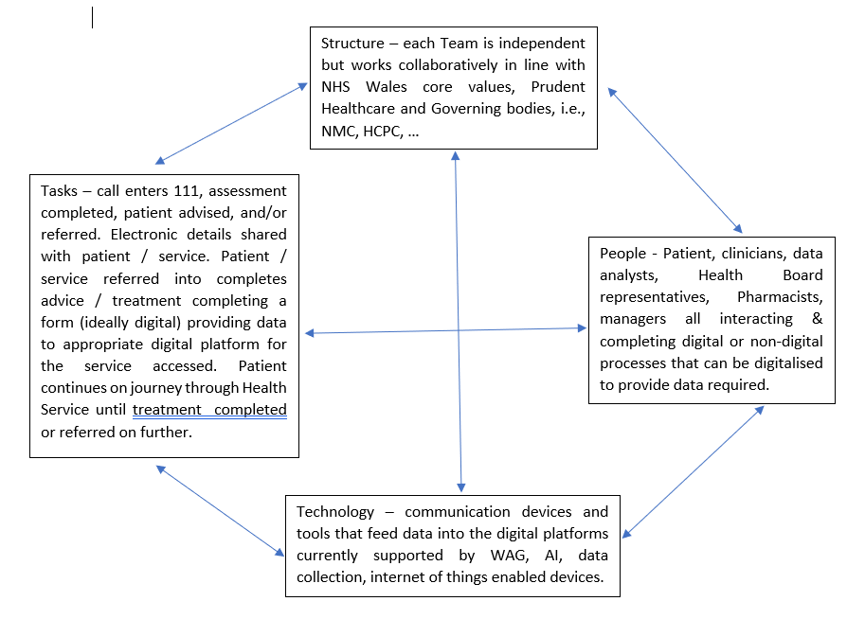
Aims and objectives

The aim is to implement a feedback system utilising the software packages supported by Welsh Government, whilst enabling patients and users of the programmes, to provide feedback.

The objectives will be: -
The software product developed will have a portal for a patient journey to be summarised noting timeframes of each stage of the journey, that can be reviewed and correlated with the outcomes of the NHS Wales 111 service, enabling a learning and.
Key events will be available including referral, treatment and feedback from professionals and patients.
A searchable facility will deliver summaries as required or defined by the user, utilising the data available within NHS Wales Health and Social Care Services.
Access will be restricted in-line with Information Governance policy and guidance, requiring a National Active Directory EXchange (NADEX) login.

Literature review

Several searches have been completed utilising the following databases: IEEE, ProQuest, and Google Scholar using a number of keywords that can be streamlined to patient flow, patient journey, health information systems and digital solutions. Each completed independently and then cross searched to narrow the results which were streamlined further by adding peer review, a recent 5-year timeframe and restricted to English language. Following review of the results, the reference lists of appropriate articles were appraised to identify further relevant research identifying articles, some outside of the 5-year timeframe, but of pertinence.

The business problem identified is noted to be of relevance across the world, with research and numerous articles from Europe, China, America, and Australia. Ly, Runacres and Poon (2021) identifying a similar issue in Australia focusing on the last 12 months of a palliative patient’s life. The findings identified barriers to effective care and the opportunities available to improve end of life care enabling true efficient, effective patient centred and proactive care through multiple healthcare settings encountered.

Gonzalez-Alonso, Vilar and Lupiañez-Villanueva (2017) note the key to developing services is the through the analysis of the data which can integrate social, demographic, environmental and behavioural aspects; as well as the medical information incorporating the plethora of mediums populating big data, which the authors jargonistically call ‘heterogeneity’, a term that has been noted as being utilised frequently through several articles in relation to this field.

Mei (2021) identified similar issues, noting risks and benefits accompany the use of health information technologies (HIT) which may enhance patient care, patient safety and patient involvement. Two of the many obstructions to successful use of HIT are noted to be clinician behaviour and Governance. It can be argued the psychology of health is often overlooked in favour of human physiology, with very few articles identifying the impact on the data generated.

It can be argued, as implied by Mei (2021), Governance and psychology can be seen as central to facilitating the characteristics or ‘V’s of data. The ‘V’s of data vary depending on the author, as 3, 4 or 5 values that are essential for consideration. Kunar and Singh (2019) present 4’Vs’ of Healthcare, incorporating Volume, Variety, Velocity and Veracity simply: -
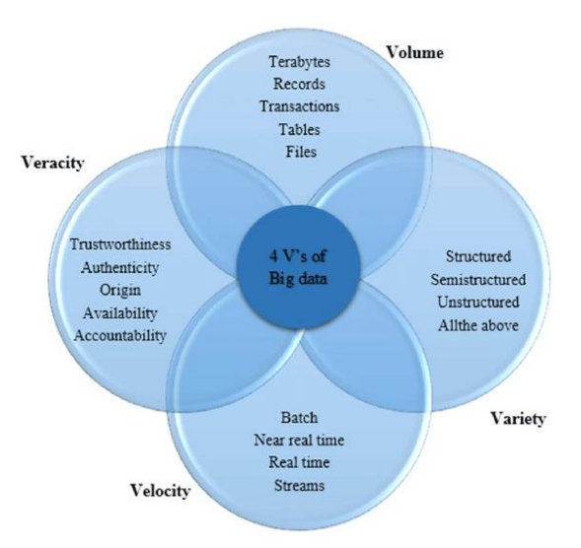
Yu et al (2019) identified these 4’V’s contribute to Viceconti, Hunter and Hose (2015)’s 5th ‘V’, Value, which could be argued as the central circle of Kunar and Singh’s (2019) Venn diagram.

The V’s are essential consideration: -
Volume - the quantity of data generated
Variety – different categories including images such as xrays, scans; documents, health related data such as vital signs, blood results, etc. These are often classified as structured, unstructured or semi structured.
Velocity - the speed of generation of ‘new’ data
Veracity – the quality, credibility or reliability of the data
Value – in the data. Viceconti, Hunter and Hose (2015) referred to financial value. Alternatively, Mei (2021) would argue value is a combination of the veracity and timeliness of the data.
All are deemed to contribute to ‘Big’ data which is defined as more than the volume of data. Machado, Peixoto and Sousa (2022) indicate the ‘V’s are big data whilst Kunar and Singh published, Big data is heterogenous, essentially a combination of the variety, volume and velocity of data generated.

Kumar and Singh (2019) may argue, to incorporate a further complexity, such as human psychology is beyond current technological achievements. Kumar and Singh (2019) identified 3 phases of Artificial Intelligence (AI).
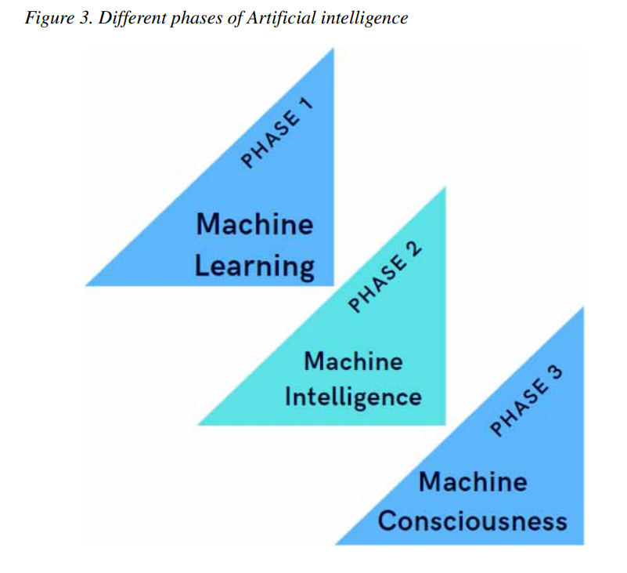
(Kumar and Singh 2019, Chapter 3, page 80).
Phase 1 – a system working on one problem, analysing within pre-set parameters prejudice. If an issue arises, the system fails / errors occur. Also referred to as artificial narrow intelligence.
Phase 2 – a system as smart as the average human. Known as artificial general intelligence.
Phase 3 – a system smarter and faster than humans in every avenue.

Slack and Jones (2019) provide an alternative definition this seemingly overly simplistic definition, noting AI is processing that replicates or surpasses human thinking. Slack and Jones also note, human behaviour is largely predictive, with AI able to process trends and habits to make a reasonable judgement of outcomes. Kumar and Singh (2019) fear medical errors and injuries by AI, due to lack of cross checking and inaccuracy. This fails to note, humans make errors too with AI processing currently due to programming and interpretation of the information available. Utilising the phases, this could be estimated to be attuned to Phase 2, Machine Intelligence.

The definition and role of AI is beyond the remit of this work. Slack and Jones (2019) note the processing of Big data is enhanced through the use of AI, revealing hidden patterns, identifying insights and noting correlations more efficiently than Humans.

The combination of the data available to Wales Health and Social care services, via the recognised programmes (WAG 2019a) collectively present Big data that can be analysed to identify areas where efficient, effective change can support system wide advances, improving patient care and safety whilst being cost efficient, an essential consideration during austere times (Gonzales-Alonso, Vilar and Villanueva 2017).

From a nursing and medical perspective, quality and safety are key considerations. Sanders et al (2020) described quality as critical to high quality patient services, with collecting patient experience data as essential.

McCarthy et al (2016, 2020) explored ‘3 Pillars of Quality’, patient experience, clinical effectiveness, and patient safety. Patient experience is noted to be central to developing effective HIT systems through patient journey mapping, without which developments are deemed doomed to fail. Antonacci et al (2021) note this is a common failure amongst the manufacturing industry, failing to incorporate all stakeholders limiting the effectiveness of mapping tools. Failing to be holistic and narrowing the focus too closely, has a negative impact on patient flow (Nguyen et al 2022). Focusing on one department or area as opposed to the whole system, is counterproductive; comparing this to the human body, no one system is completely independent of another.

Kumar and Singh (2019) identify the analysis of Big data, leads to 5 pathways that result in a quality, safe and efficient service, envisioning WAST (2020) and WAG (2021) right care, right place: -
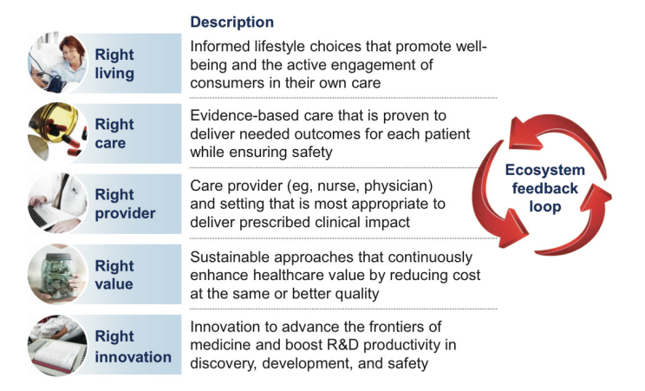
Kunar and Singh (2019).

Project Management Methodology

Kononenko and Kharazii (2014) proposed several ways of identifying project management methodology. Following an in-depth discussion of three different tools for choosing a methodology, a number of assertions are made: -
- the preference, knowledge and skillset of the project manager
- the preference parent company
- is certification required
- a rigid or agile methodology is required

Kononenko and Lutsenko (2018) discuss hybrid methodologies to avoid the pitfalls or weaknesses of traditional methodologies whilst uniting strengths of an Agile approach, to deliver a more holistic framework. It can be argued, kindred to Antonacci et al (2021), Woźniak (2021) argues that choice of methodology must incorporate the preferences of the client to avoid dissatisfaction, without which, the use of various tools have no more success than any other method of choice. Kisielnicki and Misiak (2017) and Gemino, Reich and Serrador (2021), both argue in opposition to this stance. Kisielnicki and Misiak (2017) argue projects fail due to the changing evolving needs of a business, whilst the project remains static in its objectives. A bias towards Agile methodologies can be identified throughout Kisielnicki and Misiak (2017) article whilst Gemino, Reich and Serrador (2021), appear strongly in favour of hybrid methodologies. Islam and Evans (2020) identify projects fail due to a lack of structured project management in their research identifying the key success factors of Prince2 methodology.
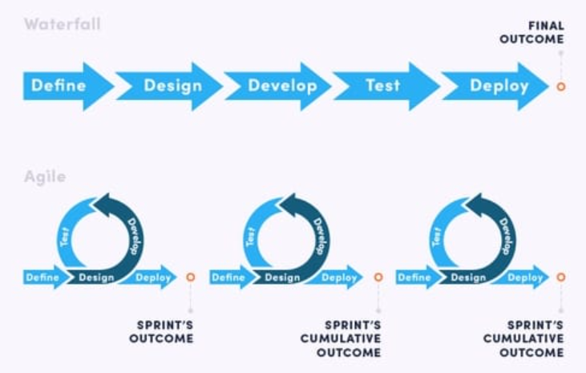
Selleo (2022) pictographic the compares both methodologies.
In contrast, Project-Management (2022) simplified the pictographic: -
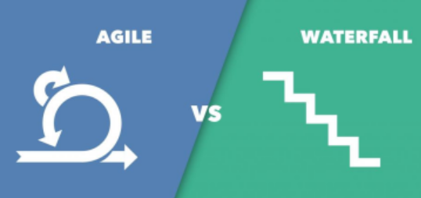
For the business problem to improve the NHS 111 Wales service, through the development of a ‘learning health and care system’ (WAST 2021a), whilst utilising the data available, the project management method of choice is Prince2, identified as a UK Government standard utilised throughout the UK, Europe, and Australia (PM 2022). Prince2 or Projects IN Controlled Environments (PM 2022) places the business problem at the centre of the project with a regular review to ensure the continued viability of the project persists whilst enabling all stakeholders remain involved, noted to be essential for success (Antonacci et al 2021). This methodology is identified as flexible, suitable for highly complex projects involving a wide range of interested parties, whilst also accommodating risk, significance, and criticality (Anon 2009), all deemed essential criteria when applied to the health care sector. It is noted to be a predictable, comprehensive, process centred, linear, managed methodology (Kisielnicki and Misiak 2017), some of the factors Islam and Evans (2020) identify as essential for success.

The project is divided into stages for senior management or the project board to oversee and monitor, with each stage providing a decision and commitment point before proceeding. This is deemed essential to maintain relevance and continued viability of the project (Anon 2009).

The 8 management stages are: -
Directing the project – the remit of the Project Board
Starting the project – pre-project review / investigation – the project manager
Initiating the project – scope and plan of the project -
Control – day to day management activities
Delivery – breaking down the project into defined work sections
Stage Boundaries – reporting and review of each stage of the project
Planning – the iterative steps required to plan and re-plan the project
(Anon 2009). Pictograph below in summary: -
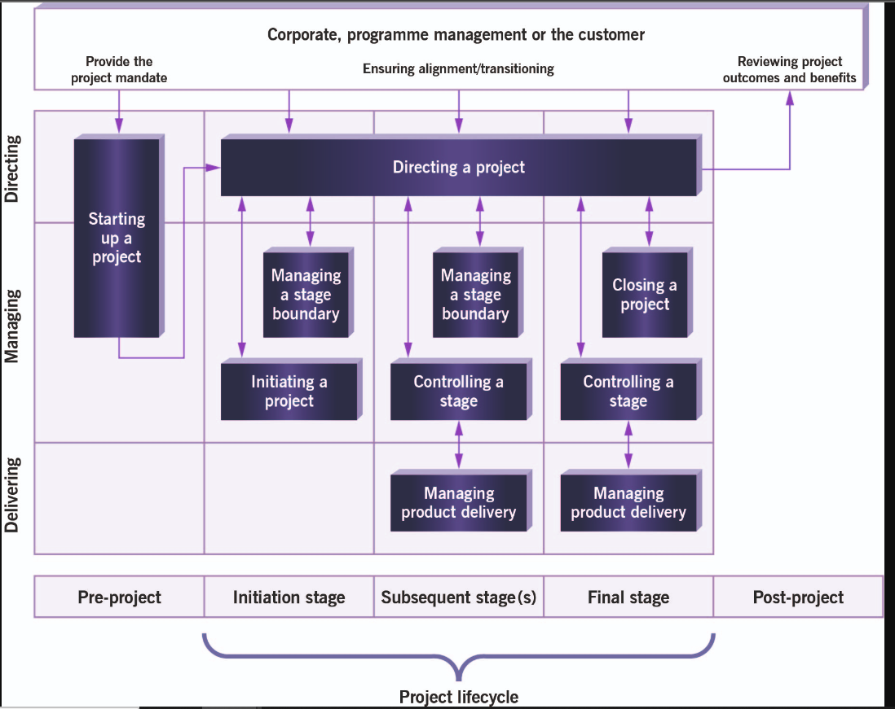
(QRP 2022)

Project Scope

A feedback summary system will be available within 12 months for NHS 111 Wales utilising data from Welsh Government supported digital platforms as listed by WAG (2019a).
The software product developed will have a portal for a patient journey to be summarised noting timeframes of each stage of the journey, that can be reviewed and correlated with the outcomes of the NHS Wales 111 service.
Key events will be available including referral, treatment and feedback from professionals and patients.
A searchable facility will deliver summaries as required or defined by the user, utilising the data available within NHS Wales Health and Social Care Services.
Access will be restricted in-line with Information Governance policy and guidance, requiring a National Active Directory EXchange (NADEX) login.

Organisational structure
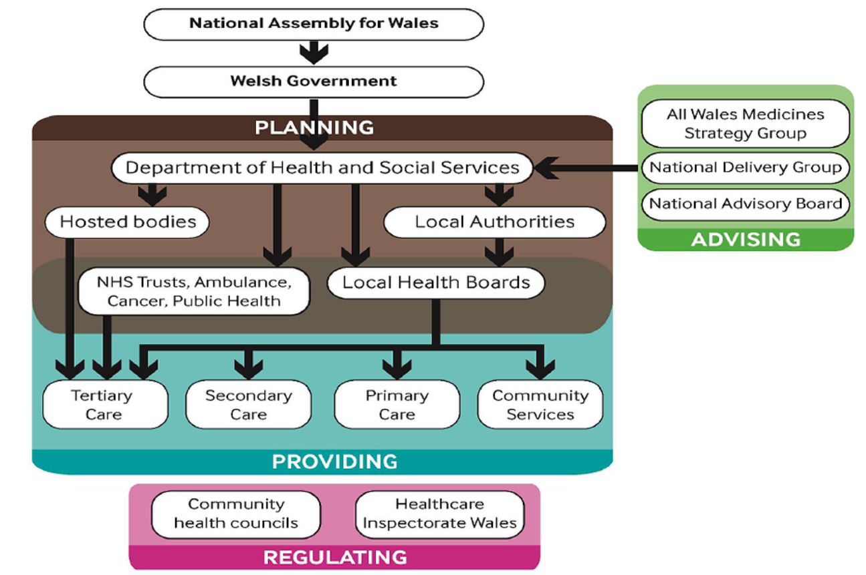
(Wixstatic 2022)

With the WAST Operations Team: -
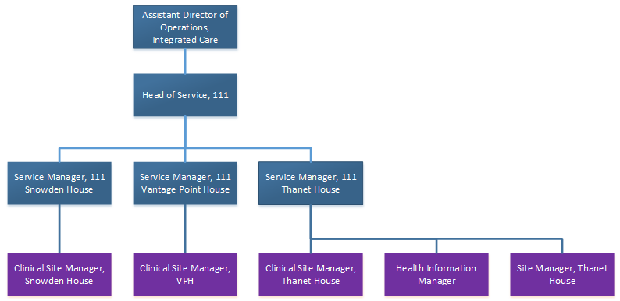

The patient is central to all interactions.

Stakeholders
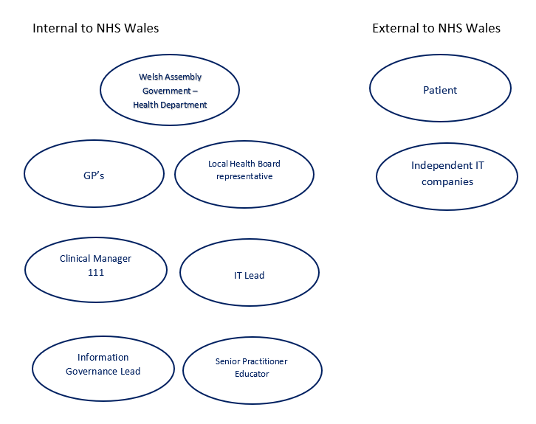
Each of the above stakeholders are interested parties who must be involved in the process. The Welsh Assembly Government contract and define targets for the Health Boards, who have a key interest in the results of any queries as related to local areas, services offered and areas for development / improvement. Health Boards work in partnership / feed into the Welsh Government, who also set standards and hold the Health Boards accountable for services.

GP’s have a responsibility to complete records and provide feedback in a timely matter Nguyen et al (2022) identified timely access to high quality information is essential to reinforce and support decision making, delays in documentation or feedback, can result in less trustworthy or incomplete records (Mei 2021).

Clinical Managers are responsible for clinical guidance for the 111 staff. The Clinical Manager will ensure the project deliver usable data for NHS 111 Wales.

IT Lead will oversee the hardware and software responsibilities, what is needed, how it can be maintained, the knowledgeable bridge for the services and companies that provide the IT requirements to deliver the service / process required to achieve the project scope.

Patients are key to reporting, both for feedback and through involvement, taking ownership of their health and Wellbeing. The more informed the patient, the more successful the treatment (Sanders et al 2020).

Independent IT companies are those with contracts in place to support WAG or WAST with IT products, programmes, hardware, what is required / deemed essential to business continuity.

Implementation

Implementation of the project to complete the business plan, requires careful planning and collaborative working. The following are essential elements of the project management cycle.
The Project Team

Parallel to Islam and Evans (2020), a similar team structure is to be comprised with 3 members in corporate management, 3 members in project board including executive, senior user, and senior supplier, 1 project manager, 4 members as team manager, 2 members in development team and 2 project assurance officers.

Utilising the stakeholders relevant to the project, the project board will compile of a Health Board representative (GP), a WAST representative and a patient’s representative; the senior user is the Clinical Manager, the senior supplier, an IT Lead, and the project assurance officer is the Senior Practitioner Educator and the training / education team.

Following confirmation of acknowledgement from all stakeholders, together with agreement of the criteria / outcomes of the work to be completed, confirmation of the work breakdown structure is defined as follows: -

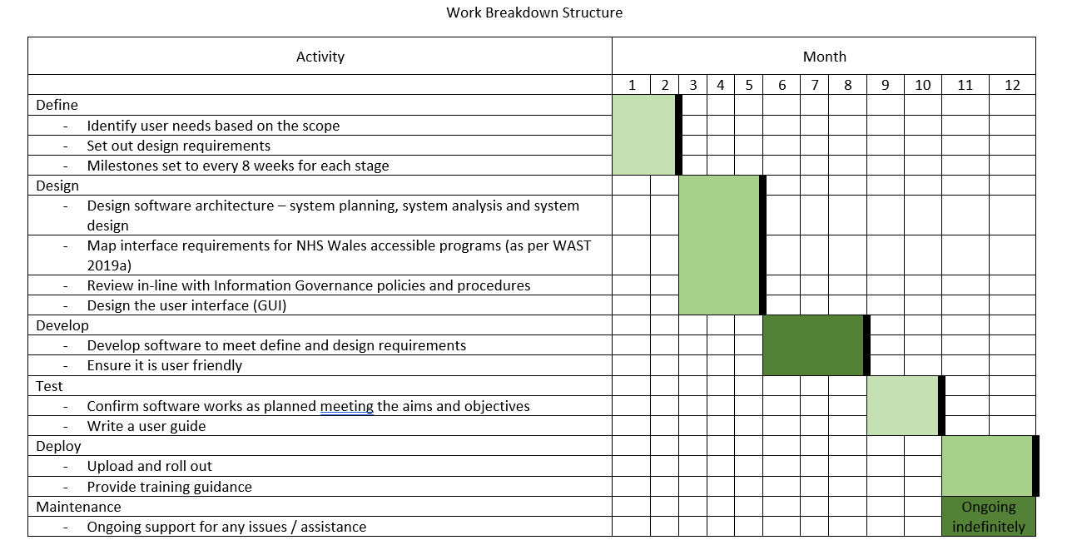

After each stage is completed, the thick black line denotes a milestone for review: -
Are the aims and objectives still being met
Is the scope of the project still accomplishable
Are there any risks, assumptions or issues that need to be accommodated and planned for.
Are there any dependencies that need to be fulfilled, prior to moving to the next stage
Are there any opportunities that can enhance or improve the project so far
What are the learning outcomes obtained so far. Do these need to be incorporated or accommodated.

The work breakdown structure can be broken down further into tasks and roles that are required to be completed in a certain order. Some tasks require the preceding task to be completed. In some projects, tasks can be done by different teams at the same time, however, only after certain other tasks are completed or before another task is commenced. The detailed task list below is fairly linear: -
Detailed Task List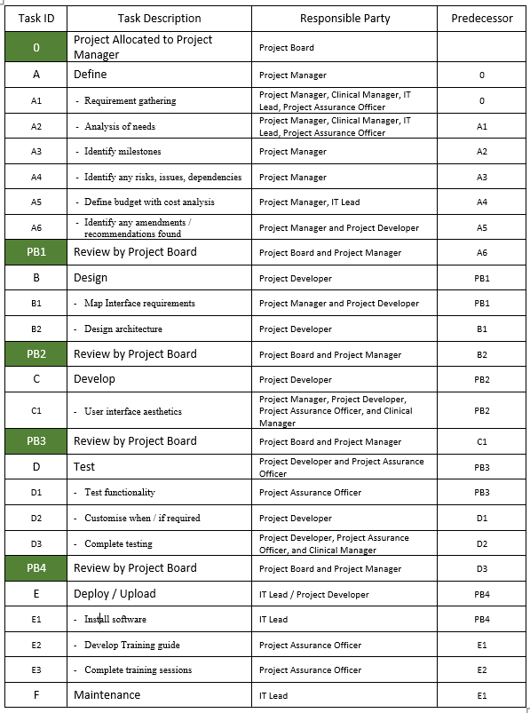
Resources

The key resource for the project is time and manpower. The IT hardware is primarily already in use and updated on a regular basis due to the nature of the Organisation being a telecommunications Hub for Health and Social Care.

The IT Lead, works closely with several software companies, supporting the needs of the service. Contracts are already in place supporting service provision, further development and financial implications are to be discussed with the Project Board. Budget and cost analysis should be completed prior to commencing the Design stage with preliminary meetings with a Software Developer identified as a project developer throughout the detailed task list.

Evaluation

In parallel to Kaushal et al (2017) noting stakeholders have competing views of bottlenecks and concerns, Sligo et al (2017) identified different stakeholders will view the success of a project dependant on the view and requirement of the stakeholder; for instance, an Organisation may view functionality, and efficiency as successful in comparison to a project manager who may view a project completing on time and within budget as a success.

The evaluation of the project where into a digital solution to the business problem identified, can be seen to be effective if the aims and objectives are achieved. Involving all stakeholders, close communication, and interaction with the project board at each stage completion, and review of the scope will keep this project on track for success from definition, through design, into the development and then the testing stages prior to deployment and use.

Aligning requirement of software with an expectation will also ensure a successful project. Achieving this for all stakeholders is a challenge. Informally, incorporating the requirements and the expectations in the objectives and confirming all stakeholders are satisfied with each stage, will support a successful project.

There are several evaluation frameworks available (Craven et al 2016, Greenhalgh and Abimbola 2019) that can be utilised to evaluate the at different stages of the project. These formal frameworks can vary in complexity.

Discussion

Service improvement through patient journey mapping is not unique. Patient journey mapping has been completed all over the world, Europe, China, USA, Australia; in various specialities and healthcare providers (Kaushal et al 2017; Yu et al 2019; Ly, Runacres and Poon 2021; Nguyen et al 2022).

McCarthy et al (2020) note wider system improvements through enhance understanding and a shared commitment with improved empathy amongst the multi-disciplinary or multi-agency service. A poor patient journey is seen to add to financial pressure, poor patient health outcomes and patient satisfaction.

A possible criticism of the project discussed above, could be a whole system review method is being utilised for one element of the patient journey / process of accessing health and social care services.

Equally, it could be argued, NHS 111 Wales, does feed into numerous other aspects / services within the Welsh Health service. Making the patient journey more efficient, will lead to a more cost-efficient service highlighting areas for development for all areas of the service enabling the learning health and social care. The potential for the data to be analysed to support and improve wider system improvements are significant. The key is instigating the initial links between all the programs currently in use, not to mention the impetus to do so.

A further criticism is the role of Information Governance has been superficially mentioned. The current Data Protection Laws and Information Governance guidance would identify data should only be accessed only, when necessary, with minimal identifiable data being utilised (IGMAG 2022). For the overall journey, this requires anonymising or pseudo-anonymising as referenced by Viceconti, Hunter and Hose (2015), who noted the considerations involved in such an action.

Conclusion

Service improvement is a complex multi-faceted process requiring a wide knowledge base and support from multiple professionals to safeguard patients, incorporating numerous stakeholders to maximise success.

This system improvement programme commenced under one guise and has developed into patient mapping with the intended improvement accommodated, and future benefits identified. The intended programme started with a local, low-level concern that has developed into significant high-level implications for Health service policy, potentially impacting all agencies that fall within the remit of Department of Health and Social Services within Welsh Government.

References

Agrawal, R. and Prabakaran, S. (2020) ‘Big data in digital healthcare: lessons learnt and recommendations for general practice’, Heredity, 124(4), pp. 525–534. Available at: https://doi.org/10.1038/s41437-020-0303-2.

Antonacci, G., Lennox, L., Barlow, J., Evans, L. and Reed, J., (2021) Process mapping in healthcare: a systematic review. BMC Health Services Research, 21, pp. 1-15.

Anon (2009) PRINCE2 pocketbook. 4th ed. London: TSO.

Digital-patient.net (2022) Digital Patient https://www.digital-patient.net/#:~:text=The%20digital%20patient%20is%20a%20known%20phrase%20in,of%20generating%20a%20virtual%20living%20version%20of%20yourself. (accessed 29 October 2022).

Frennert, S., Erlingsdóttir, G., Muhic, M., Rydenfält, C., Milos Nymberg, V., Ekman, B. (2022)
‘Embedding and Integrating a Digital Patient Management Platform Into Everyday Primary Care Routines: Qualitative Case Study’ JMIR Form Res 2022;6(2):e30527 doi: 10.2196/30527

Gemino, A., Reich, H. B. and Serrador, P.M. (2021) ‘Agile, Traditional, and Hybrid Approaches to Project Success: Is Hybrid a Poor Second Choice?’, Project management journal, 52(2), pp. 161–175. Available at: https://doi.org/10.1177/8756972820973082.

Gonzalez-Alonso, p., Vilar, R., and Lupiañez-Villanueva, F., (2017) "Meeting Technology and Methodology into Health Big Data Analytics Scenarios," 2017 IEEE 30th International Symposium on Computer-Based Medical Systems (CBMS), pp. 284-285, doi: 10.1109/CBMS.2017.71.

Greenhalgh, T. and Abimbola, S., (2019) The NASSS framework-a synthesis of multiple theories of technology implementation. Stud Health Technol Inform, 263, pp.193-204.

HCPC (2014) Paramedics Standards of Proficiency https://www.hcpc-uk.org/standards/standards-of-proficiency/paramedics/ (accessed 26 October 2022).

IEEE Xplore digital library (no date) Institute of Electrical and Electronics Engineers.

IGMAG (2022) NHS Wales Information Governance Policy https://dhcw.nhs.wales/ig/ig-documents/ig-framework/all-wales-information-governance-policy-v1-pdf/#:~:text=The aim of this Policy is to provide,%28ICO%29%2C Department of Health and other professional bodies. (Accessed 14 December 2022).

Islam S., and Evans, N., (2020) Key Success Factors of PRINCE2 Project Management Method in Software Development Project’ International Journal of Engineering Materials and Manufacture, 5(3). Available at: https://doi.org/10.26776/ijemm.05.03.2020.02.

Kaushal, K.K., Kaushak, S., Choudhury, A., Viswanathan, K., Chellappa, B., Natrarajan, S., Pickett, L., Dutt,V. (2017) "Patient Journey Visualizer: A Tool for Visualizing Patient Journeys," 2017 International Conference on Machine Learning and Data Science (MLDS), pp. 106-113, doi: 10.1109/MLDS.2017.19.

Kisielnicki, J. and Misiak, A.M. (2017) ‘Effectiveness of Agile Compared to Waterfall Implementation Methods in it Projects: Analysis Based on Business Intelligence Projects’, Foundations of management, 9(1), pp. 273–286. Available at: https://doi.org/10.1515/fman-2017-0021.

Lake, R., Georgio, A., Li, J., Ling, L., Byrne, M., Robinson, M., Westbrook J.I., (2017) ‘The quality, safety and governance of telephone triage and advice services - an overview of evidence from systematic reviews’, BMC health services research, 17(1), pp. 614–614. Available at: https://doi.org/10.1186/s12913-017-2564-x.

Kisielnicki, J., and Misiak, A. M., (2017) ‘Effectiveness of Agile compared to Waterfall implementation methods in IT projects: analysis based on business intelligence reports’, Foundations of Management, vol 9 (2017) ISSN 2080-7279 DOI: 10.1515/fman-2017-0021

Kononenko, I., and Kharazii, A. (2014) ‘The methods of selection of the project management methodology’, International Journal of Computing, 13(1) 2014, 1-2, ISSN 2312-5381.

Kononenko, I.V. and Lutsenko, S.Y., (2018) Evolution of the generalized body of knowledge on project management. Bulletin of the National Technical University" KhPI". Series: Strategic management, portfolio, program and project management, (1 (1277)), pp.10-17.

Kumar, S., and Singh, M., (2019) ‘Big Data Analytics for Healthcare Industry: Impact, Applications, and Tools’ Big Data Mining and Analytics, 2(1), pp. 48–57. Available at: https://doi.org/10.26599/BDMA.2018.9020031.

Ly, S., Runacres, F. and Poon, P., (2021) Journey mapping as a novel approach to healthcare: a qualitative mixed methods study in palliative care. BMC Health Services Research, 21, pp. 1-9.

Maassen, M.A., (2018) ‘Product development models in the IT sector-From Waterfall to Agile Project Management Model s in the case of AVIRA SOFT S.R.L’, Proceedings of the 12th International Conference of Business Excellence 2018, 12(1), pp. 568–578. Available at: https://doi.org/10.2478/picbe-2018-0051.

Machado, J.M., Sousa, R. and Peixoto, H. (2022) Big data analytics and artificial intelligence in the healthcare industry. Edited by J.M. Machado, R. Sousa, and H. Peixoto. Hershey, Pennsylvania: Medical Information Science Reference.

McCarthy, S., O'Raghallaigh, P., Woodworth, S., Lim, Y.L., Kenny, L.C. and Adam, F., (2016) An integrated patient journey mapping tool for embedding quality in healthcare service reform. Journal of Decision Systems, 25, pp. 354-368.

McCarthy, S., O'Raghallaigh, P., Woodworth, S., Yoke, Y.L., Kenny, L.C. and Adam, F., (2020) Embedding the Pillars of Quality in Health Information Technology Solutions Using “Integrated Patient Journey Mapping” (IPJM): Case Study. JMIR Human Factors, 7(3).

Mei, R., (2021) "Health Informatics and Healthcare Delivery: From the Cost-effectiveness Perspective," 2021 7th International Conference on Information Management (ICIM), 2021, pp. 62-65, doi: 10.1109/ICIM52229.2021.9417045.

Nguyen, Q., Wybrow, M., Burstein, F., Taylor, D. and Enticott, J., (2022) Understanding the impacts of health information systems on patient flow management: A systematic review across several decades of research. PLoS One, 17(9).

NHS England (2022) Winter resilience https://www.england.nhs.uk/winter/ (accessed 26 October 2022).

NHS Scotland 2022 Health and social care: winter resilience overview 2022 to 2023 https://www.gov.scot/publications/health-social-care-winter-resilience-overview-2022-23/ (accessed 26 October 2022)

NHS Wales (2008) Health in Wales 1000 Lives Campaign
http://www.wales.nhs.uk/news/9633/ Health%20in%20Wales%20%201000%20Lives%20Campaign (accessed 14 December 2022)

NHS Wales (2022) Systems and services https://dhcw.nhs.wales/systems-and-services/ (accessed 29/10/2022).

NMC (2015) The Code: Professional standards of practice and behaviour for nurses, midwives and nursing associates https://www.nmc.org.uk/standards/code/ (accessed 26 October 2022).

OGC (2002) Prince2 Pocketbook Crown Copyright HMSO

PM (2022) What Is PRINCE2? Principles, Aspects, Roles & Processes (projectmanager.com) https://www.projectmanager.com/blog/prince2-methodology (accessed 8 December 2022).

Project-Management (2022) Agile vs Waterfall - Software Development Methodologies https://project-management.com/agile-vs-waterfall/ (accessed 11/12/2022).

ProQuest Central (no date).
https://www.proquest.com/central/index?parentSessionId=JuVhawzGA48h%2BJV7kLrjP8vXmrKS%2FT0mISqO0L4LOGo%3D&accountid=130472

QRP (2022) PRINCE2_Processes https://www.qrpinternational.ch/wp-content/uploads/sites/10/2020/02/PRINCE2_Processes.jpg (accessed 8 December 2022).

Gustafsson, S. and Eriksson, I. (2021) ‘Quality indicators in telephone nursing – An integrative review’, Nursing open, 8(3), pp. 1301–1313. Available at: https://doi.org/10.1002/nop2.747.

Sanders, C., Nahar, P., Small, N., Hodgson, D., Ong, B.N., Dehghan, A., Sharp, C.A., Dixon, W.G., Lewis, S., Kontopantelis, E. and Daker-White, G., (2020) Digital methods to enhance the usefulness of patient experience data in services for long-term conditions: the DEPEND mixed-methods study. Digital methods to enhance the usefulness of patient experience data in services for long-term conditions: the DEPEND mixed-methods study - Abstract - Europe PMC NIHR Journals Library, Southampton (UK) (accessed 02 November 2022).

Sanders, C., Nahar, P., Small, N., Hodgson, D., Ong, B.N., Dehghan, A., Sharp, C.A., Dixon, W.G., Lewis, S., Kontopantelis, E. and Daker-White, G., (2020a) Patient and public involvement. In Digital methods to enhance the usefulness of patient experience data in services for long-term conditions: the DEPEND mixed-methods study. NIHR Journals Library.

Sasubilli, G., and Kumar, A., ‘Machine Learning and Big Data Implementation on Health Care data,’ (2020) 4th International Conference on Intelligent Computing and Control Systems (ICICCS), pp. 859-864, doi: 10.1109/ICICCS48265.2020.9120906.

Selleo (2022) Agile Software Development Process – Everything You Need to Know https://selleo.com/blog/agile-software-development-process-everything-you-need-to-know (accessed 11 December 2022).

Slack, N. and Brandon-Jones, A. (2019) Operations management. 9th ed. Harlow: Pearson.

Sligo, J., Gauld, R., Roberts, V., Villa, L. (2017) ‘A literature review for large-scale health information system project planning, implementation and evaluation’, International Journal of Medical Informatics, 97 (2017) 86-97 http://dx.doi.org/10.1016/j.ijmedinf.2016.09.007.

Viceconti, M., Hunter, P., & Hose, R. (2015) Big Data, Big Knowledge: Big Data for Personalized Healthcare. IEEE Journal of Biomedical and Health Informatics, 19(4), 1209–1215. https://doi.org/10.1109/JBHI.2015.2406883

WAG (2019) Securing health and wellbeing for future generations https://www.gov.wales/sites/default/files/publications/2019-04/securing-health-and-well-being-for-future-generations.pdf (access 26 October 2022).

WAG (2019a) A Digital Health and Social Care Informed Heath and Care; A Digital Health and Social Care Strategy for Wales https://gov.wales/sites/default/files/publications/2019-03/informed-health-and-care-a-digital-health-and-social-care-strategy-for-wales.pdf (access 26 October 2022).

WAG 2021 A Healthier Wales https://gov.wales/sites/default/files/publications/2021-09/a-healthier-wales-our-plan-for-health-and-social-care.pdf (access 26 October 2022).

WAG (2021a) National Clinical Framework 8.0
https://gov.wales/sites/default/files/publications/2021-09/a-healthier-wales-our-plan-for-health-and-social-care.pdf (access 26 October 2022).

WAG (2021b) Digital strategy for Wales https://gov.wales/digital-strategy-wales-html (accessed 21 November 2022).

WAG (2022b) Written Statement: Planning resilient urgent and emergency care services for winter https://gov.wales/written-statement-planning-resilient-urgent-and-emergency-care-services-winter (accessed 21 November 2022).

WAST (2020) Welsh Ambulance Service Disruptive Excellence WAST Digital Strategy

Woźniak, M. (2021) ‘Sustainable Approach in IT Project Management—Methodology Choice vs. Client Satisfaction’, Sustainability (Basel, Switzerland), 13(3), p. 1466–. Available at: https://doi.org/10.3390/su13031466.

Wixstatic (2022) Welsh nhs
https://static.wixstatic.com/media/34898c_3a92bc4d33914ea5bdcf97ef645021ed~mv2.png/v1/fill/w_935,h_622,al_c,usm_0.66_1.00_0.01/welsh%20nhs.png (accessed 11 December 2022).

Yu, Y., Li, M., Liu, L., Wang, J., (2019) ‘Clinical Big Data and Deep Learning: Applications, Challenges, and Future Outlooks’, Big Data Mining and Analytics, 2(4): 288-305. https://doi.org/10.26599/BDMA.2019.902000

