Evolution of Graphics in Games
Student Name: Kai Hakkeem Bentley – Jennings
Student Number: 1807048
Course: Foundation Applied Computing
Module Name: Academic Writing (John – Semester 2)
Module Code: M4X01498
Date: 03/05/2019

Table of Contents
Introduction – Page 3
2D Graphics – Page 3
Pseudo 3D (2.5D Graphics) – Page 4
3D Graphics - Page 5
Conclusion – Page 5
References – Page 6

Introduction
In this assignment I will be talking about how graphics have evolved since its inception. Starting with 2D graphics such as Vector polygons and Raster sprite work graphics moving towards 2.5D illusions of a 3D landscape and eventually bridging to full 3D environments and modelling.
2D Graphics
Invented in the 1950s and utilized in the late 1970s, vector graphics geometric models use mathematical equations to create polygon shapes which are displayed on screen. The graphics keep the screen black instead of completely covering the monitor like Raster graphics, only displaying what is drawn from the equations. Due to its ‘simplistic’ design it was possible to program movement of around 40 objects on screen compared to 10 from Raster. [1]
A common example that uses vector graphics is the 1979 game Asteroids during the ‘Golden Age’ of arcade games. An article by Vectr explains in some detail that Vector graphics can be scaled into larger sizes and retain their quality in the image at a small file size, compared to Raster graphics usually saved in .jpegs which used coloured square pixels which degrades the higher scale they become from their original size with the pixels becoming far more noticeable. [2]


*Fig. 1 created by Taipei Government licensed under Taipei OpenData license. ‘Rebuilt’ by https://twitter.com/yurenju

Pseudo 3D (2.5D Graphics)
2.5D Graphics better known as Pseudo 3D, as it impersonates a 3D perspective whilst limited to 2D resources. Wyatt explains a method for causing a minor perception for a 3D landscape using Parallax Scrolling, whereby a background is slowly moving in the background whilst the player moves left or right. This creates “an illusion of depth and distance between layers.” [3]
These normally use an Isometric view with such games being Civilization, X-COM and Elite. ‘Filmation’, a method of attempting to represent a 3D environment was the first attempt at such a milestone for the KnightLore game and ever since several games utilized this and further simplifying the process as time went on. [4]
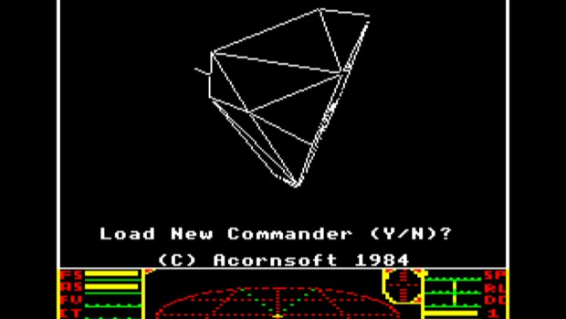
*Fig. 2 Taken from Kotaku https://www.kotaku.co.uk/2014/08/28/elite-musical-thing-exists
For the F-Zero game on the Super Nintendo Entertainment System (SNES) it used something called ‘Mode 7’, which was the eighth background layer type for the Super NES that rotated with directional input and steering as it was more suited for the racing genre of games. The real illusion here is that the vehicle the player controls is not actually moving, but instead the track which is just one large sprite moves as you ‘turn.’ [5]
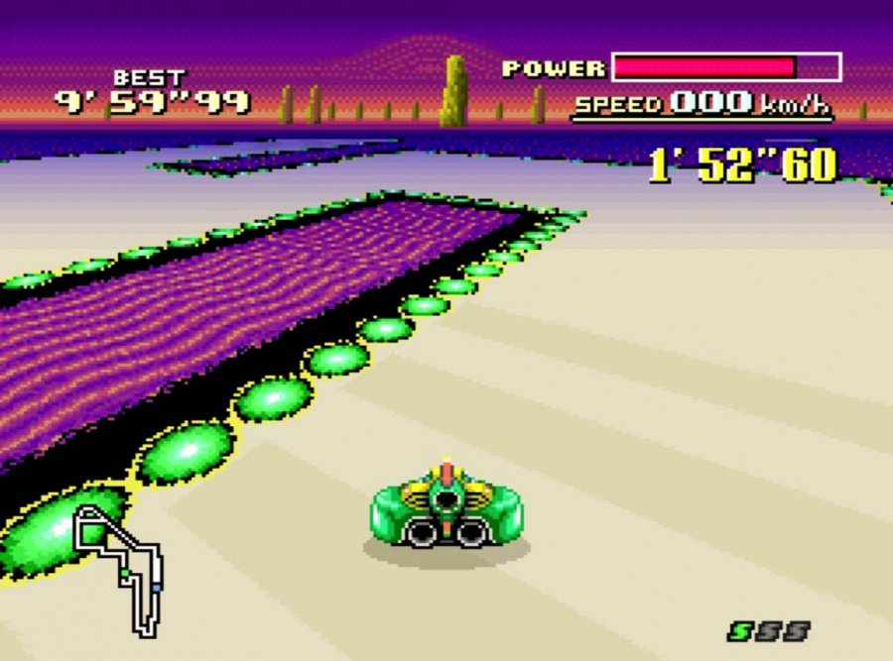 *Fig. 3 Taken from NintendoLife http://www.nintendolife.com/news/2016/08/video_relive_the_wonders_of_the_super_nintendos_famous_mode_7
3D Computer Graphics
Despite the previous segments making up all games before the release of the very first 3D game Wolfenstein in 1992 (Despite not using 3D objects for characters, relying on sprites) and later Quake in 1996 which is a completely true 3D game using 3D model objects; it was in 1972 that the a 3D model of a hand and human face was first created by E. Catmull and F. Parke. [6]
Quake was the first true 3D game with the environment and all its assets being totally in 3D, was motivated by ‘Virtua Fighter,’ a pseudo 3D fighting game developed by Sega for the Mega Drive. The ambition to almost mimic the fighting from Sega’s intellectual property was however dropped closer to release and stuck to its core mechanics instead. [7]
Conclusion
Advancements in graphics have come a long way since text-based games and rogue-likes using keyboard characters as a display for an area, to Raster sprite work being used for arcade games in the late 70s alongside Vector based graphics for a smoother yet basic gaming experience with more life on the screen at certain points. The Pseudo 3D tricks to impersonate a fuller environment and much more depth to the games, with many building simulations driving towards these tactics for a ‘realistic’ approach and experience. And later the profit drivers for Nintendo, Sega and Atari as gaming became more popular when it got more accessible and visually appealing. Ever since the Game Boy, the market for gaming has been seen as an incredibly lucrative asset.
Ever since Quake, the quality has been on the increase as further generations of consoles have been released. With Rockstar, Konami, Kojima Productions and many other companies striving towards more cinematic experiences, it’s now reaching a point where some games have more of a tendency to be viewed as a movie with little interaction.

References
[1] M. J. P. Wolf, The Video Game Explosion: A History from PONG to Playstation and Beyond, ABC-CLIO, 2008, Chapter 12, p. 67 https://books.google.co.uk/books?id=XiM0ntMybNwC&pg=PA71&dq=top+gunner,+last+vector+based+arcade+game&hl=en&ei=1F8wTrrTMIfmiALT3dgr&sa=X&oi=book_result&ct=result&redir_esc=y#v=onepage&q=top%20gunner%2C%20last%20vector%20based%20arcade%20game&f=false
[2] “What are Vector Graphics,” Vectr [Online] https://vectr.com/tutorials/what-are-vector-graphics/ [Accessed 26th April, 2019]
[3] P. Wyatt, “The Art of Parallax Scrolling” August 2007 [Online] https://web.archive.org/web/20091007223458/http://mos.futurenet.com/pdf/net/NET165_tut_flash.pdf [Accessed 3rd May, 2019]
[4] S. Collins, “Game Graphics During the 8-bit Computer Era,” Siggraph, Paragraph title: “3D Graphics on an 8-bit Computer?” May 1998 [Online] https://www.siggraph.org//publications/newsletter/v32n2/contributions/collins.html [Accessed 29th April, 2019]
[5] E. J. M. Ritz, “An Introduction to Mode 7 on the SNES,” One More Game-Dev and Programming Blog, July 15th, 2013 [Online] https://ericjmritz.wordpress.com/2013/07/15/an-introduction-to-mode-7-on-the-snes/ [Accessed 1st of May, 2019]
[6] Sean P., “Pixar founder's Utah-made 'Hand' added to National Film Registry,” The Salt Lake Tribune, Dec. 29th, 2011 [Online] https://archive.sltrib.com/article.php?id=53193670&itype=CMSID [Accessed 2nd of May, 2019]
[7] "Does John Romero Still Enjoy Shooting People?" Next Generation, Vol. 30, p. 11, June 1997 [Online] https://archive.org/stream/NextGeneration30Jun1997/Next_Generation_30_Jun_1997#page/n11/mode/2up [Accessed 3rd of May, 2019]

