Information Engineering
ACCAB4013

Networking and Cyber Security BSc

Timothy Ferfers
1903054

Analysis of System Requirements

Kids Club Cymru childcare facility
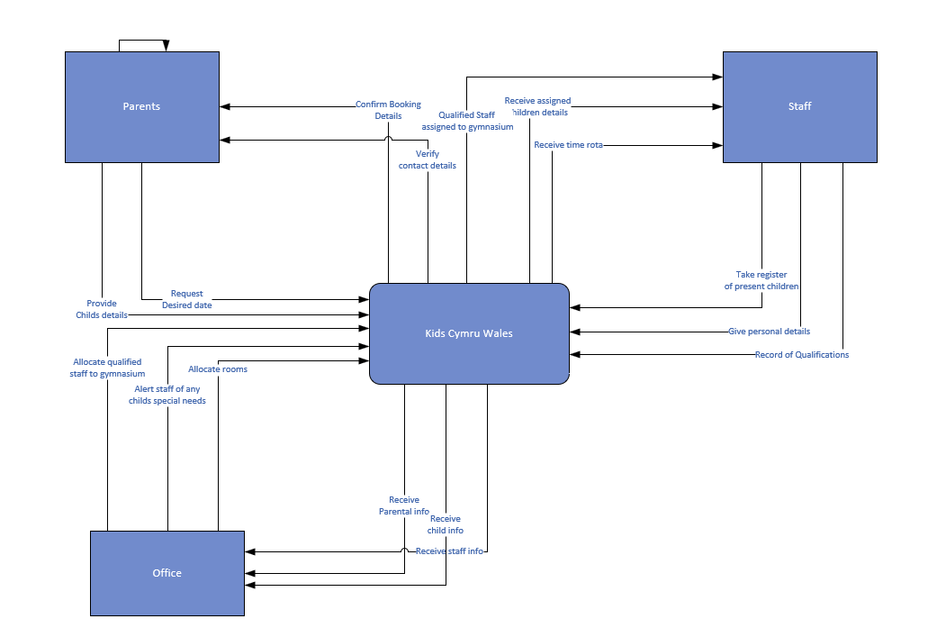
Systems Analysis



