Software Development

Part A - Understanding

What is a variable and why are they important in writing programs?
A variable is a value stored within a program. Variables values can be set a few different ways. One such way is they can be hard coded. This means that are set by the developer of the program. For example a developer could set a decimal value for pi, using the following code: “float pi = 3.14159; “. This declares a variable named pi, and sets the value of the variable to 3.14159.
Another way a variables value can be modified is as a result of code within the program modifying the value. For example if a cumulative score was being kept within a program, code would be modified with the following: “total = total + 10”. The code modifies the total variable by adding 10 to the value, this could be as a result of a user scoring 10 points in the game. Then if the score value was at 20, following the user scoring 10 points the total variable would be 30.
Another way to modify the value stored for a variable is that the user enters a value for a variable. For example the below code prints on screen asking for the user to enter their favourite number. Their input is then collected using the ‘scanf’ function:
printf (“please enter your favourite number:”);
scanf(“%d”, &favnumber);

Variables are essentially a means of storing information in a program, however the information is captured. This is Important as it allows a programmer to capture input and enable programs to be functional for different purposes.

Explain why the for-loop can also be referred to as a counting-loop and give an example of when you would use it.
A for-loop is a counted loop, meaning that a program including a for-loop will repeat a section of a program for a set number of times. See an example below;
For (i = 0; i < 5; i++)
{* repeating section*
}
The above code outlines a for-loop that will repeat for five times. An integer value ‘i’ is being used, with the value set to zero. The next statement says to enter the loop as long as the value is below five. The last statement means to add on one to i, each time. This can be useful when a programmer knows how many times they need a program to repeat one section of code, for example collecting values to enter into an array. The for-loop is essentially the opposite of a while-loop. For comparison the While-loop will repeat for a long as a given statement is true, below is an example of code for a while loop:
While (answer == ‘y’)
{*repeating section*
}
The code enters the loop, so long as the variable answer is equal too ‘y’. For example, this could be used to ask a user if they want they want to keep playing a repeatable game; so long as they answer ‘y’ the loop will repeat.

Explain what an array is, what their features are, and give an example of when you would use one.

"An array is a collection of data items, all of the same type, accessed using a common name.” [1]
This means that an array is essentially a variable containing multiple values. For example to declare an integer array the code would be: “int array[3];”.
The array[3] variable, would hold three values; array [0], array[1] and array[2]. Array [0] could be equal to three, whereas array [1] equal to five and array [2] equal too eight. But each of these values share a “common name”; array. Such an array could be used in a for-loop to collect multiple values, all used for a common purpose, therefore sharing a common name.
As well storing multiple values under a common name, an array can be used as a two-dimensional table full of values, be declaring an array such as: int array[5][4]. This array would have five rows and four columns. This can be used within a program for a game such as battleships.

Part B – Implementation

Exercise 1

Pseudocode
- Declare variables for age, height and name.
- User inputs name
- User inputs age
- User inputs height
- Output users: name, age and height.

Code
/* Exercise One*/

#include <stdio.h> // including standard input output library

void main()
{

int age; // declaring an integer
float height; // declaring decimal value
char name[12]; // declaring char variable with an array for a string.

printf("what is your name?\n"); // prints on screen requesting users name
scanf("%s", &name);//collecting a string, entered by the user. Storing value as name variable

printf("what is your age?\n"); // print on screen requesting users ago
scanf("%d", &age); // setting value for age variable
while ((age <= 0) || (age > 120)) // validates that user is using a sensible age
{
printf("Please enter a valid age: \n"); // prints to user requesting a valid age, if outside of desired range
scanf("%d", &age); // updates age variable with an age within range
}

printf("What is your height in cm?\n\n"); // print on screen asking for users age
scanf("%f", &height); //collects users age

printf("Name is %s\nAge is %d\nHeight is %.2fcm \n\n", name, age, height); // prints each variables value, with the decimal (float) value being printed to 2 decimal places.

}

Testing
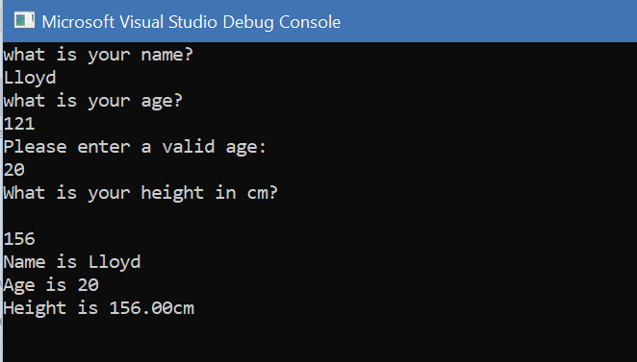
Shows user inputting name.
User enters invalid age, therefore they are prompted to enter a valid age.

User enters height.
All values are printed.

Exercise 2

Pseudocode
- Declare variables for circle radius, pi, triangle base, triangle height, circle area, triangle area, circle diameter, and shade area.
- Print requesting user inputs circle radius
- User enters radius of circle.
- Circle area is calculated.
- Circle area is printed on screen for user
- Circle diameter is calculated.
- Print requesting user enter triangle base.
- User enters triangle base.
- Base length is validated, as cannot be longer than circle diameter.
- Print requesting user enter triangle height.
- User enters triangle height.
- Height length is validated, as cannot be longer than circle diameter.
- Triangle area is calculated and stored.
- Triangle area is printed on screen.
- Triangle area is taken away from the circle area, this provides value for shaded area.
- Shaded area is printed of screen for user.

Code
/*Excercise 2*/
#include <stdio.h>

void main()
{
float base; //declaring triangle base variable
float height; //declaring triangle height variable
float radius; //declaring circle radius variable
float trianglearea; // declaring triangle area variable
float circlearea; //declaring circle area variable
float circlediameter; // declaring circle diameter variable
float shade; // declaring shade variable
float PI = 3.14159; //declaring pi variable, and setting value to PI

printf("Please enter the radius of your circle(cm): \n"); // print on screen asking user to enter radius
scanf("%f", &radius); // user enters value for radius

circlearea = PI * (radius * radius); // calculate circle area
printf("circle area = %.2f cm(to 2 decimal places)\n\n\n", circlearea);

circlediameter = radius * 2;

printf("Please enter the length of the triangle base(cm): \n");
scanf("%f", &base);

while (circlediameter < base)
{
printf("Please reenter value, triangle base cannot be larger than circle diameter ( %.2f) : \n", circlediameter);
scanf("%f", &base);
}

printf("Please enter the height of the triangle(cm): \n");
scanf("%f", &height);

while (circlediameter < height)
{
printf("Please reenter value, triangle height cannot be larger than circle diameter ( %.2f) : \n", circlediameter);
scanf("%f", &height);
}

trianglearea = (base * height) / 2;
printf(" Triangle area is %.2f cm (to 2 decimal places)\n\n", trianglearea);

shade = (circlearea - trianglearea);
printf("*** The Shaded area is %.2f cm , equal to 2 decimal places ***\n", shade);
}

Testing
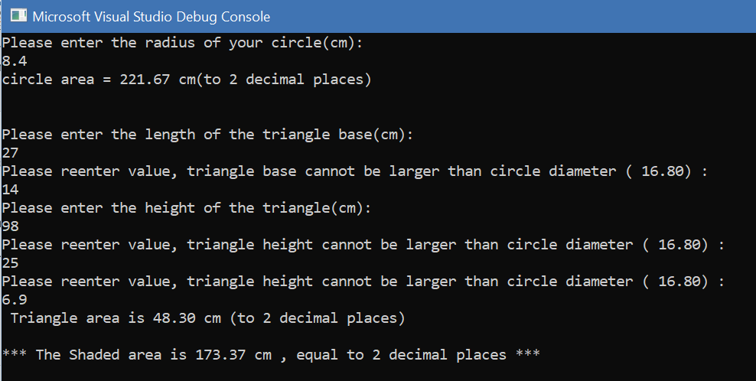

User enters a decimal (float) value.
Circle area is calculated correctly: 3.14159 * (8.4 *8.4). 8.4 * 8.4 = 70.56. 70.56 * 3.14159 = 221.67 (to 2 dp).
User enters length of triangle base. User is informed base is longer than diameter. User re-enters a correct value and works ok. Triangle area is calculates correctly: 14*6.9=96.6 / 2 = 48.3.
Shaded area is calculated correctly 221.67 – 48.3 = 173.37.

Exercise 3

Pseudocode
- Declare a variable array.
- Program loops for 5 counts
Loops requests product price 1 – 5 within loop.
User enters product value 1-5
Product prices are validated and cannot be 0 or below (negative values)
Product values are recorded in array
- Values are printed on screen for user.
- All values are added up, which equal the total price.
- Twenty percent of the total price is calculated and recorded.
- Twenty percent is added to the total price, this equals the total price with vat.
- Total cost including vat is printed on screen for user.

Code

#include <stdio.h>

void main()
{
float productprice[5]; // setting an array where decimal values can be inputted
float totalprice = 0; // setting total price variable
float totalwvat; // setting decimal variable
float vat;
int i;
char ps = 156; /* setting variable called 'ps' for pound sign. ascii value for pound sign in this complier is 156 (otherwise would be 163) ref: https://www.go4expert.com/forums/i-display-sign-printf-t16928/ */
char answer;

for (i = 0; i < 5; i++) // for loop, counting for 5 times

{
printf("Please enter product price number %d: \n%c",i+1,ps); // prints asking for user to input product price
scanf("%f", &productprice[i]); // collects product price

while (productprice[i] <= 0) // confirms product price is over 0
{
printf("value out or range. Please re-enter your value: \n %c", ps); // prints explaining user has entered an invalid value
scanf("%f", &productprice[i]); //updates value for variable in array
}
}

printf("Values are:\n"); //prints values
for (i = 0; i < 5; i++) // loop to print each value
{
printf(" %c%.2f\n", ps, productprice[i]); //prints each value, along with a pound sign
}

for (i = 0; i < 5; i++) // loop to add up each value to the total price variable
{
totalprice = totalprice + productprice[i]; // calculation to add up total price

}

vat = (totalprice / 100) * 20; // calculation to work out vat
totalwvat = totalprice + vat; // calculation to work out total price, including vat

printf("total cost of your 5 items, including vat is: %c%.2f",ps, totalwvat); // prints out total cost including vat

}

Testing
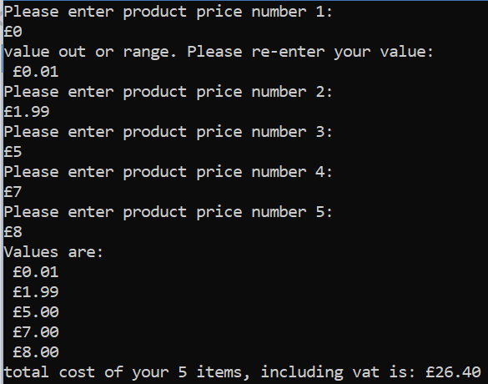
User enters value outside out range (zero or below).
User is prompted to re-enter a value.
Next value is over zero, so is allowed to enter.
All float values are allowed.
Total cost of items is: £22, 20% of this is £4.40. Therefore total cost of £26.20 is correct.

Exercise 4

Pseudocode
- Declare variables
- Print on screen advertising fruit machine game
- Print on screen asking if user wants to play
- Capture user input, would they like to play
- Enter loop, so long as answer is ‘y’ or ‘Y’
  - Loop 3 times: each time generating a different number for a value in the array
  - Print on screen the three random numbers from generate random function.
- IF three numbers match, and include a five: add 2000 points to total score, print on screen “you have won the jackpot”, print points on screen
- IF three numbers match, and don’t include a five: add 20 points, print on screen “you win” and print points on screen.
- IF two numbers match, and are fives: add 100 points. And print “you win” and print points and screen.
- ELSE any other outcome: you lose, your points are: *print points*
- Print “do you want to play again?”
- Capture input. If y or Y will re-enter loop to play again inn stage 5..

Code
#include <stdio.h>
#include <stdlib.h>
#include <time.h>

int genrand(void);//prototype
/* sort random number generator for 3 numbers. think about validation rules to filter each outcome*/

int main()
{
int n[3], i, total = 0; // declaring integer variables, and variable array
char answer; // declaring a character variable
srand(time(NULL)); // declaring for random numbers

printf("***FRUIT MACHINE GAME***\n"); // prints on screen advertising fruit machine game
printf("Do you want to play? (Y/N)? \n"); // prints on screen asking if user would like to play game
scanf(" %c", &answer); // collects users response

while (answer == 'y' || answer == 'Y') // loop to be entered if user wishes to play game
{
for (i = 0; i < 3; i++) // counted loop running 3 times, each time generating a random number for one of the array values
{
n[i] = genrand(); // running genrand function, for value in array
}

printf("***FRUIT MACHINE GAME***\n"); // prints on screen advertising fruit machine game
printf("******%d %d %d******\n", n[0], n[1], n[2]); // print 3 random numbers

if ((n[0] == n[1]) && (n[1] == n[2]) && (n[0] == 5)) // check all numbers match and that they are all 5's
{
total = total + 2000; // adds 2000 to total score, as if statement means jackpot is won
printf("you win the JACKPOT, your points are %d\n", total); // prints on screen that user has won jackpot

}
else if ((n[0] == n[1]) && (n[1] == n[2])) //checks that all numbers are the same
{
total = total + 20; //adds 20 to total as all 3 numbers are same
printf("you win, your points are %d\n", total); // prints that user has won, and their points
}
else if ((n[0] == n[1]) && (n[0] == 5)) // confirms number 1 and 2 are the same, and they are both 5's
{
total = total + 100; // adds 100 points are 2 5s equal 100 points
printf("You win, your points are %d\n", total); // prints that user has won, and prints points on screen
}

else if ((n[1] == n[2]) && (n[1] == 5)) // checks if number 2 and 3 are the same, and that they are 5s
{
total = total + 100; // adds 100 points are 2 5s equal 100 points
printf("You win, your points are %d\n", total);// prints that user has won, and prints points on screen
}

else if ((n[0] == n[2]) && (n[0] == 5)) // checks if number 1 and 3 are the same, and that they are 5s
{
total = total + 100;// adds 100 points are 2 5s equal 100 points
printf("You win, your points are %d\n", total);// prints that user has won, and prints points on screen
}

else { // any other outcome means user has won no points
printf("you lose, your total points are %d\n", total ); //prints that user has lost, along with their total points
}

printf("Do you want to play again? Y/N: \n"); // prints on screen, asking if user wants to play again
scanf(" %c", &answer); // collects users response, updating answer variable based upon users response
}

}

int genrand(void) //function to generate random numbers
{
int rannum; // declaring interger variable
int low = 1; // declaring interger variable, and setting value to 1
int high = 5; // declaring interger variable, and setting value to 5

rannum = rand() % (high - low + 1) + low; // generates random number

return rannum; } // returns value to main fuction

Testing
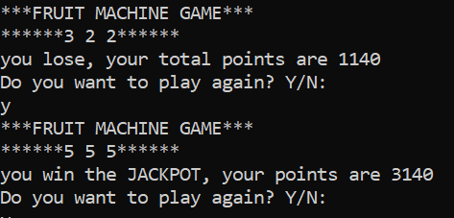
User has won jackpot, 2000 points have been added to the score.
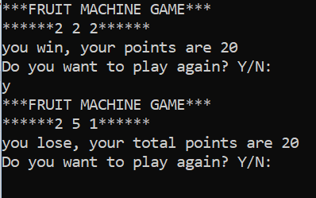
User has 3 numbers the same, which are not fives. They are notified they have won, and given 20 points.
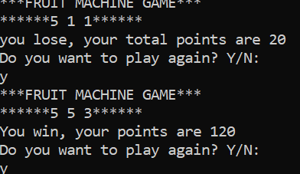
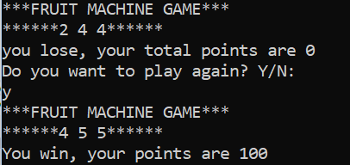
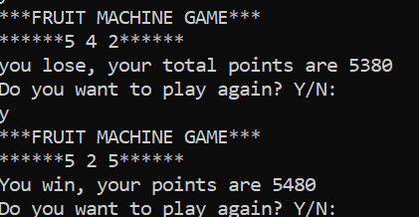
The three screenshots above and to the left, highlight the user scoring two fives in any order. Each time they are notified that they have won and awarded 100 points as expected.
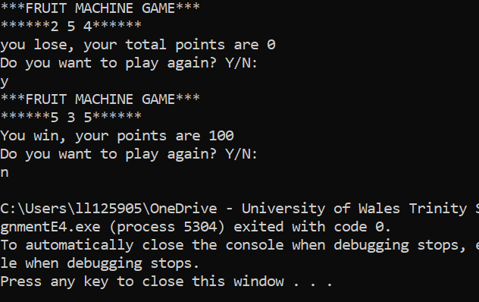

To the left, the screenshot highlights that the user exits the game after selecting ‘n’

Summary, problems and Solutions
Whilst programming the code, there were certain challenges and issues that were encountered, such issues are highlighted below;

Exercise 1
This question asked for a user’s age, height and name to be collected. This was a basic program and using printf to inform which information was being requested and then scanf to collect the information entered. These values were stored as variables then printed back to the user.

Exercise 2
The question included a diagram of a triangle within a circle, and it was required to calculate the area of both shapes, then take away the area of the triangle away from the circle. One validation check that I included was to check that the triangle base and height weren’t longer than the diameter of the circle (the diameter being worked out by multiplying the radius by two).

Exercise 3
The question asked for five product prices to be collected, then the total price along with vat printed back to the user. I felt an array was the best solution to collect and store values, using a counted loop for five counts to collect values. This worked successfully, however to format the program better, I looked into inputting a ‘£’ sign. After research I inputted a character variable called ‘PS’ (pound sign), and assigned is the ASCII value of 156 [2]. Then to calculate vat, calculated the total price, and worked out 20%. The 20% was then added to the total and printed to the user.

Exercise 4
The question asked that a fruit machine generated three random numbers, and if certain criteria was matched the user would be awarded points to be added onto their score. Therefore I decided that an array holding the three values would be best suited; this array could then be used in conjunction with a for-loop, to loop for three counts and generate each value. This was initially an issue, as I had included the “srand(time(NULL));” into the loop, when looping, this then generated the same three numbers each time. To solve this, I moved the code into the main section, meaning it was only included once. This was then ok. I then included IF/ELSE IF & ELSE statements to advise the user if they had been awarded any points.

References

[1] | Unknown. [Online]. Available: https://www.cs.uic.edu/~jbell/CourseNotes/C_Programming/Arrays.html. [Accessed 24 Feburary 2019].
[2] | Unknown, “i-display-sign-printf-t16928,” 15 April 2009. [Online]. Available: https://www.go4expert.com/forums/i-display-sign-printf-t16928/. [Accessed 23 Feburary 2019].

