

Student Name:Regina Bempah Owusu
Student ID: 2427848
Module name: Protecting and Supporting Families in Health and Social care
Module code: BMH5021
Lecturer name: Shaila Hussain
Assessment Title: Components 2: Written Report
Assessment (REPORT): An examination and analysis of how the ‘Early Help’ system is signposted to UK families by their local authority website
Introduction
Local Authorities: Leicestershire County Council, Southwark Council, Norfolk County
The safeguarding of children and young people in England operates as a continuous spectrum of support, ranging from universal preventative services to intensive statutory intervention. Central to this system is the concept of early help, defined as support provided as soon as problems emerge, before they escalate into serious risks to a child’s welfare (Department for Education [DfE], 2023). Strategic safeguarding, by contrast, refers to the system-wide leadership, policy, and accountability structures designed to ensure all agencies work together to protect children and promote their development.
This assignment explains what the early help system is, examines its legal and policy foundations, and analyses how it interrelates with strategic safeguarding. It draws specifically on the policies, procedures, and public documentation of three contrasting local authorities: Leicestershire County Council, Southwark Council, and Norfolk County Council. These examples illustrate how the national framework is adapted to meet different demographic, geographic, and socioeconomic n
Early help is not a single service but a coordinated approach to assessment and support available to all families, regardless of whether there are immediate concerns about safety. It is voluntary, family-centred, and focused on building resilience rather than reacting to crisis. The overarching principle is set out in Working Together to Safeguard Children (DfE, 2023): “Providing help early reduces the likelihood that problems will become more serious and prevents the need for more intensive and costly intervention later.”
All three local authorities follow the national four-tier model, which creates clarity about the level of support required:
Tier 1 – Universal Services: Available to all children and families. This includes schools, health visitors, GPs, libraries, children’s centres, and housing advice. It forms the first point of contact where emerging needs are noticed.
Tier 2 – Targeted Early Help: For families with additional or emerging needs that cannot be met by universal services alone. This is where the Early Help Assessment (EHA) and Team Around the Family (TAF) model is used.
Tier 3 – Family Help / Children in Need: For families with more complex or persistent needs, supported under Section 17 of the Children Act 1989. This is the threshold between voluntary support and statutory intervention.
Tier 4 – Statutory Intervention: For children at risk of significant harm, requiring Section 47 enquiries, child protection plans, or placement in care.
Leicestershire County Council
Leicestershire serves a mixed population of urban centres, market towns, and rural villages. Its Early Help Strategy 2024–2028 positions the service as “the front door to support” (Leicestershire County Council, 2024). Delivery is through a network of Family Hubs, multi-agency teams, and voluntary sector partners. The process is standardised: any professional or family can make a referral; an EHA is completed to identify strengths and needs; a Lead Practitioner is appointed; and a TAF is formed to coordinate support. Reviews take place every 6–12 weeks, with clear criteria to close cases, continue support, or escalate.
Southwark Council
Southwark is an inner-London borough with high population density, significant diversity, and higher levels of poverty and inequality than the national average. Its model is titled Prevention, Early Help and Support, delivered through “Best Start Family Hubs” (Southwark Council, 2025). The approach is explicitly strengths-based and trauma-informed, focusing on the whole family. It prioritises issues such as housing instability, parental mental health, migration support, and reducing health inequalities. Data shows that around 82% of families supported at Tier 2 show measurable improvement within six months, reducing the need for escalation (Southwark Safeguarding Children Partnership, 2024).
Norfolk County Council
Norfolk is a large, predominantly rural county with dispersed communities and longer travel distances. Its Early Help Service operates through a centralised structure covering 12 local areas, supported by outreach workers and mobile teams (Norfolk County Council, 2024). The authority uses a single, shared online system for assessments and plans, designed to overcome barriers of distance and communication. A key focus is addressing rural isolation, economic disadvantage, and vulnerability to exploitation such as county lines activity.
3. Strategic Safeguarding: Definition and Legal Context
Strategic safeguarding refers to the leadership, governance, and oversight arrangements that ensure children are protected across all agencies. It is not a service itself, but the system of rules, policies, and accountability that governs how services operate.
- 3.1 Legal and Policy Framework
The duties are set out in key legislate:  C
Children Act 1989: Establishes the principle that the welfare of the child is paramount and introduces Section 17 (support for children in need) and Section 47 (enquiries where harm is suspected).
Children Act 2004: Imposes duties on local authorities, health bodies, and the police to cooperate (Section 10) and to make arrangements to safeguard and promote welfare (Section 11).
Working Together to Safeguard Children (2023): The statutory guidance that requires every area to form a Local Safeguarding Partnership (LSP) to lead strategic planning, monitor performance, and learn from serious incidents.
Strategic safeguarding responsibilities include:
Learning from reviews of cases where harm has occurred.
4. The Interrelation Between Early Help and Strategic Safeguarding
Agreeing and publishing thresholds of need and risk;
Ensuring multi-agency training and information sharing;
Reviewing data to identify trends and gaps;
Overseeing the quality of services across the continuum of support;
The relationship between early help and strategic safeguarding is integrated, continuous, and mutually dependent. Early help is the operational foundation; strategic safeguarding provides the framework, direction, and accountability.
4.1 The Continuum of Support
Safeguarding is often misunderstood as only involving child protection or crisis response. However, national guidance makes clear that prevention is the first and most effective form of safeguarding. The model operates as a seamless journey:
Universal → Early Help → Family Help → Child Protection → Care 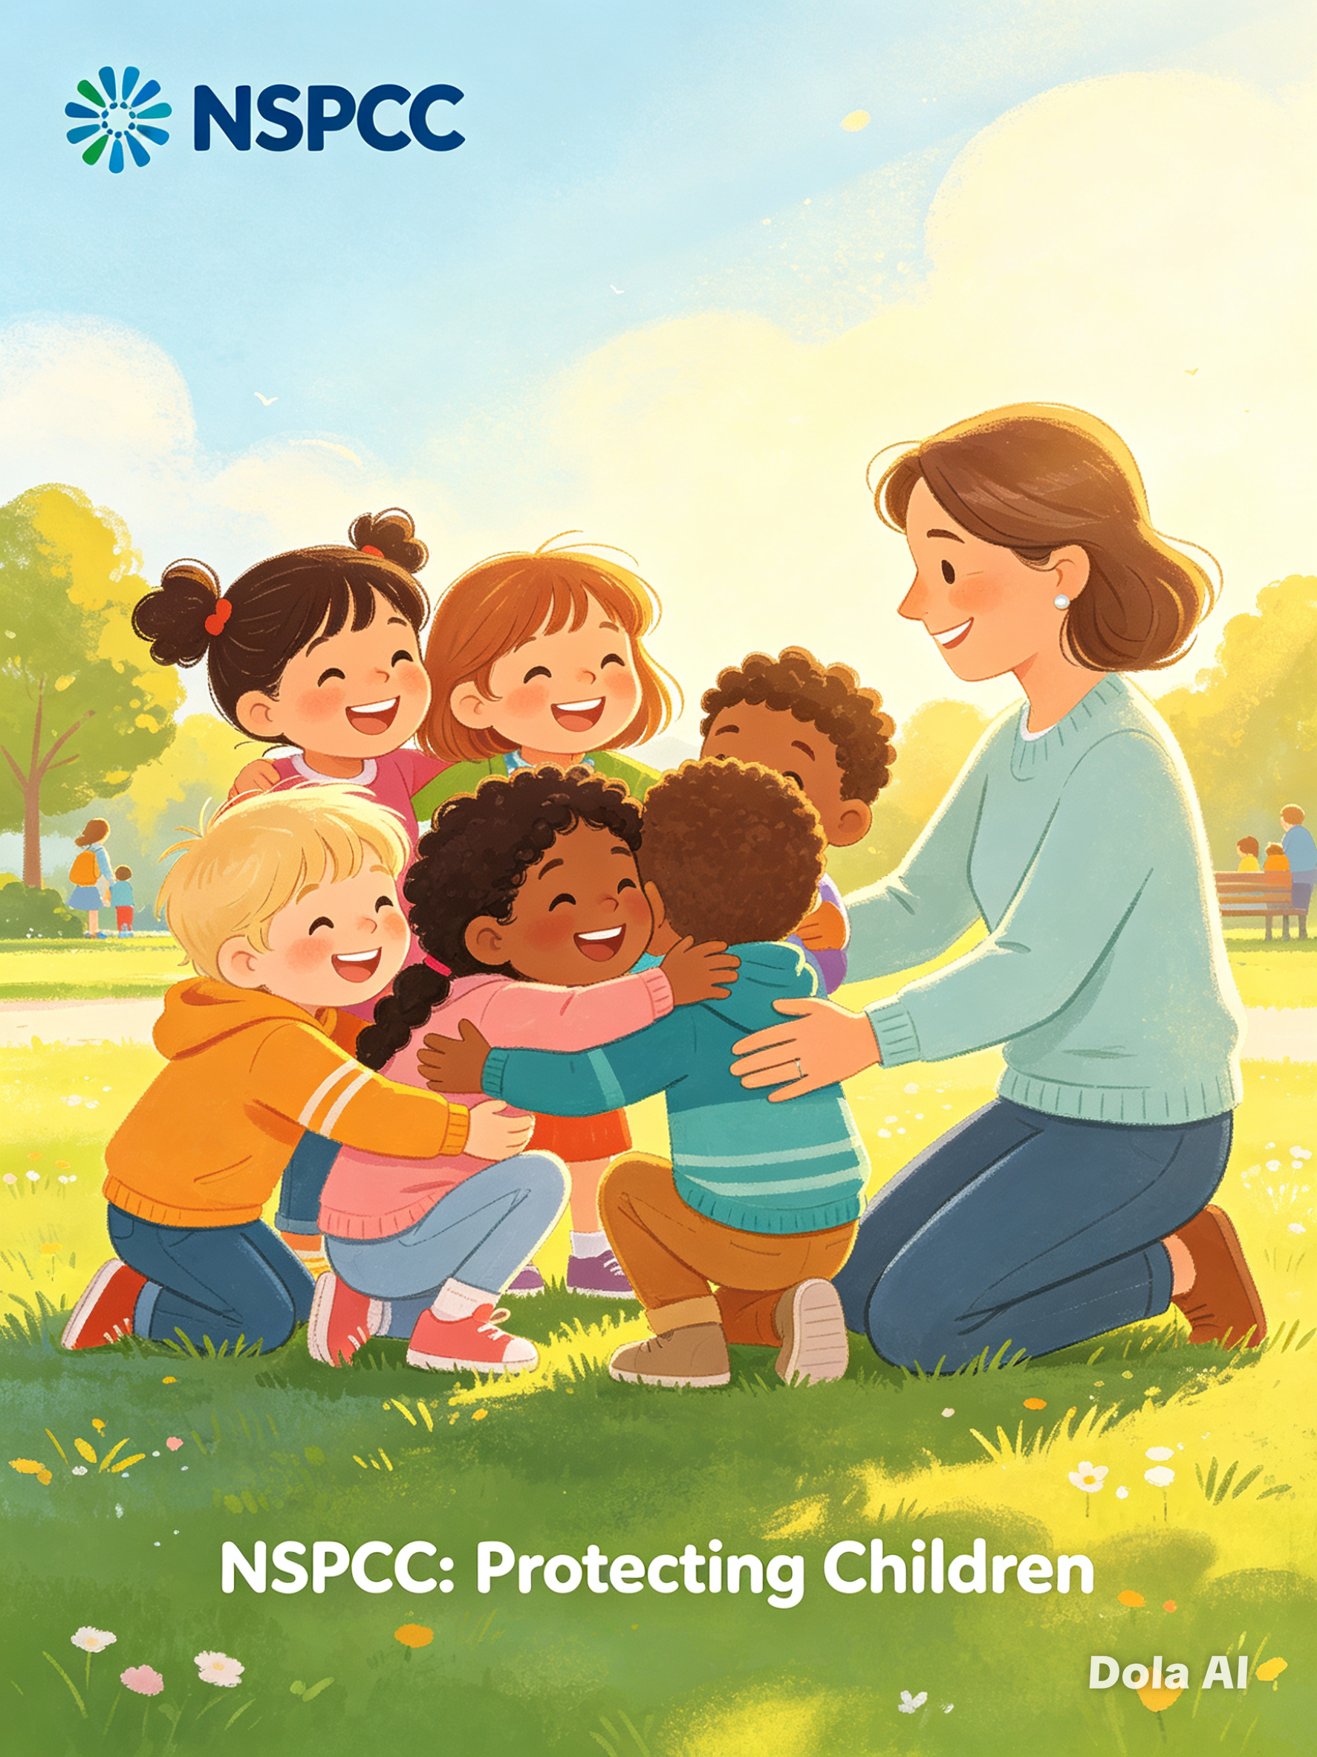
Preventing escalation: Research from the Association of Directors of Children’s Services (ADCS, 2025) shows that effective early help resolves 60–70% of family needs before they develop into risks of significant harm. This reduces pressure on statutory services and improves long-term outcomes.
Clear boundaries: Strategic safeguarding sets the Threshold Document, which defines exactly when support remains voluntary and when it must become statutory. This is the critical link. For example, Leicestershire, Southwark and Norfolk all publish joint threshold documents approved by their LSPs, ensuring consistency across agencies.
4.2 Governance and Accountability
Early help does not operate independently; it is overseen and monitored by the LSP as part of the wider safeguarding system.
Policy alignment: Each local authority’s early help strategy is explicitly linked to its safeguarding strategy. Southwark Council (2025) states: “Prevention and early help are core components of our safeguarding offer, not separate from it.” Norfolk County Council (2024) adds: “All early help activity contributes directly to the delivery of our strategic safeguarding outcomes.”
Data and performance monitoring: Strategic safeguarding partners use early help data to assess whether the system is working. Indicators include: referral rates, waiting times, outcomes achieved, and the percentage of cases that escalate to higher tiers. Leicestershire’s Safeguarding Dashboard uses this data to adjust funding and service delivery (Leicestershire County Council, 2025).
Escalation pathways: When early help is not sufficient, clear safeguarding protocols ensure concerns are passed quickly to social care. Conversely, when a child’s risk reduces, the safeguarding system allows cases to step back down to early help for ongoing support. This “step-up, step-down” model is essential for efficiency.
4.3 Information Sharing and Workforce
A functional link depends on shared information and consistent training.
Information sharing: Safeguarding rules define when and how data can be shared. All three authorities use secure systems such as Liquid Logic or Mosaic, with protocols that allow sharing with consent — or without consent if there is a risk of harm.
Workforce standards: All early help practitioners must complete safeguarding training up to Level 2 or 3, ensuring they can recognise signs of abuse and follow safeguarding procedures. This ensures that the “frontline” of early help is also the first line of protection.
5. Comparison of Local Practice
While the national framework is the same, local implementation varies according to context:
Table
Feature Leicestershire Southwark Norfolk
Context Mixed urban/rural, growing population Dense, diverse, high deprivation Large, dispersed rural area
Early Help Model Family Hubs + targeted multi-agency teams Best Start Hubs + whole-family approach Area-based teams + mobile outreach
Safeguarding Link Integrated into Leicester, Leicestershire & Rutland LSP Central priority of Southwark LSP Governed by Norfolk Safeguarding Protocol
Key Strength Strong SEND and mental health integration Effective at reducing inequalities Clear procedures and consistent practice
Key Challenge Variation in access between city and rural areas High demand and funding constraints Geographical distance and slower response times
Weaknesses Inconsistent navigation early help information appears under children and safeguards support making it harder to local quickly. Variation in guidance information differs slightly between unban and rural districts.
Source: Local Safeguarding Partnership Annual Reports 2023–2025
6. Impact, Benefits and Challenges
6.1 Evidence of Impact
The value of the link between early help and safeguarding is supported by both national and local evidence:
Cost-effectiveness: The DfE (2025) estimates that every £1 invested in early help saves between £4 and £6 in later statutory intervention costs.
Outcomes: Areas with strong early help systems see a 30–50% lower rate of children entering care (ADCS, 2025).
Family experience: Surveys across the three authorities show that over 80% of families report feeling listened to and more confident after receiving support (Leicestershire, 2025; Southwark, 2024; Norfolk, 2025).
6.2 Systemic Challenges
Despite this, the system faces significant pressures:
Funding constraints: Between 2010 and 2024, spending on early help in England fell by approximately 42%, while demand rose by 25% due to the cost-of-living crisis (ADCS, 2025).
Threshold drift: As budgets reduce, some families are only accepted for support once their needs are more severe, moving them closer to statutory intervention.
No statutory duty: Unlike child protection, early help is not a legal duty, making it vulnerable to cuts during financial reviews.
Capacity gaps: Waiting lists are common in Southwark and rural parts of Norfolk, meaning delays in support.
Conclusion Recommendations
The early help system is the preventative foundation of the strategic safeguarding system. It provides the support that stops problems from becoming risks, while strategic safeguarding provides the leadership, rules, and accountability that ensure consistency and safety.
In Leicestershire, Southwark, and Norfolk, the approach is broadly the same — aligned to national law and guidance — but adapted to fit local needs. The evidence confirms that when the link between these two systems is strong, children and families have better outcomes, and resources are used more efficiently.
However, the system remains fragile. For early help to continue fulfilling its role as the first line of safeguarding, it requires sustained investment, clear governance, and recognition that prevention is as important as protection
References List.
Department for Education (DfE). (2023). Working Together to Safeguard Children: Statutory Guidance. London: The Stationery Office.
Available at: https://www.gov.uk/government/publications/working-together-to-safeguard-children--2
Department for Education (DfE). (2025). Early Help: Cost and Impact Review. London: DfE.
Available at: https://www.gov.uk/government/publications/early-help-supporting-families-evidence-review
Association of Directors of Children’s Services (ADCS). (2025). The State of Early Help in England 2025. London: ADCS.
Available at: https://www.adcs.org.uk/publications/the-state-of-early-help-2025/
Association of Directors of Children’s Services (ADCS). (2025). Safeguarding Pressures Report Phase 9. London: ADCS.
Available at: https://www.adcs.org.uk/publications/safeguarding-pressures-phase-9/
Leicestershire County Council. (2024). Early Help Strategy 2024–2028. Leicester: LCC Children’s Services.
Available at: https://www.leicestershire.gov.uk/sites/default/files/2024-08/Leicestershire-Early-Help-Strategy.pdf
Leicester, Leicestershire & Rutland Safeguarding Partnership. (2025). Thresholds and Continuum of Support. Leicester: LLR SCP.
Available at: https://www.llrsafeguarding.org.uk/procedures/thresholds/
Southwark Council. (2025). Prevention, Early Help and Support Strategy. London: Southwark Council.
Available at: https://www.southwark.gov.uk/children-and-families/early-help-and-family-support
Southwark Safeguarding Children Partnership. (2024). Continuum of Help and Support / Threshold Document. London: Southwark SCP.
Available at: https://safeguarding.southwark.gov.uk/p/safeguarding-children/prevention-early-help-and-support/
Norfolk County Council. (2024). Early Help Assessment and Support Protocol. Norwich: NCC Children’s Services.
Available at: https://www.norfolk.gov.uk/children-and-families/early-help-and-family-support
Norfolk Safeguarding Children Partnership. (2026). Continuum of Needs Guidance. Norwich: Norfolk SCP.
Available at: https://www.norfolklscb.org/people-working-with-children/norfolk-continuum-of-needs-guidance
HM Government. (1989). Children Act 1989. London: The Stationery Office.
Available at: https://www.legislation.gov.uk/ukpga/1989/41/contents

