A Secondary Quantitative Analysis of Online Retail Sales Trends by Store Type in Great Britain Using ONS Retail Sales Index Internet Sales Data

(University of Wales Trinity Saint David)
Student Name: Shahed Rayhan
Student ID: 2520888
Lecturer: Maggie Zhang
Module: (BMMB 7028)

Submission date: 08-10-2026

Table of Contents
1.0 Business Context and Research Rationale 3
2.0 Research Problem, Gap and Originality 4
3.0 Research Aim, Questions and Objectives 5
3.1 Research Aim 5
3.2 Research Questions 6
3.3 Research Objectives 7
4.0 Data Source, Scope and Dataset Validity 7
4.1 Proposed period and unit of analysis 8
5.0 Literature and Contextual Issues 9
5.1 Online retail and omnichannel strategy 9
5.2 Digital retail, customer experience and channel choice 10
5.3 Store-type variation and managerial relevance 10
5.4 Critical Synthesis and Literature Gap 11
6.0 Proposed Variables and Measures 12
7.0 Methodology and Analytical Strategy 13
7.1 Advantages and disadvantages of the chosen method 14
8.0 Methodological Critique and Alternatives Considered 15
9.0 Ethics, Data Quality, Positionality and Trustworthiness 16
10.0 Expected Contribution and Digital Retail Priority Profile 17
11.0 Limitations, Resources and Feasibility 18
12.0 Proposed Time Plan 19
13.0 Conclusion 20
References 21

1.0 Business Context and Research Rationale
Online retail is no longer just a temporary response to the pandemic. It has become part of the everyday retail landscape for British consumers (Grewal, Roggeveen and Nordfält, 2017; Ecommerce Europe and EuroCommerce, 2025). However, this does not mean all types of stores can reap the rewards of online channels equally. There are different online sales patterns that can be observed in food retailers, department stores, clothing retailers, household goods retailers, other non-food stores and non-store retailers, due to the various products and the different delivery models, fulfilment costs and customer decision processes of these retailers. A discussion of “online retail growth” can therefore mask the significant variations in growth rates for retail categories (British Retail Consortium, 2026).
The Retail Sales Index internet sales dataset provides the ONS with a series of internet sales data for Great Britain, by store type, month and year (Office for National Statistics, 2026b). The latest version is 19 June 2026 and the next will be published 24 July 2026. This makes the data current, official and directly applicable to the secondary quantitative proposal. The ONS reported that online spending values rose by 3.4 % in the three months to May 2026 compared with the three months to February 2026. And by 9.8 % compared with the same period in 2025 (Office for National Statistics, 2026d). These figures show that e-commerce remains a current retail issue, but they do little to explain performance differences between store types (Office for National Statistics, 2026c).
This proposal therefore concentrates on differences in the trends of online retail transactions in Great Britain between stores. The study will not gather primary survey information, and will not develop a machine-learning model. Instead, it will employ SPSS to conduct descriptive statistics, time-based comparisons, percentage-point change, charts and exploratory matched store-type comparison. The goal is to convert official retail indicators to a meaningful digital retail priority profile. This is suitable for an MBA level business research study as the investigation links credible data, retail theory and managerial decision making and retailers have to determine the level of attention and investment that they should place in their online channel.

2.0 Research Problem, Gap and Originality
The challenge is that whilst official retail statistics are typically delivered as monthly economic updates, managers may require a more strategic look at the impact that these figures have on channel investment. While ONS data can reveal whether online spending has increased or decreased, retailers will still need to know whether a store type is displaying stable online growth, if the spending on the internet is volatile, whether its online performance is lower or appears more mature. This is important because investments are different in each scenario. A volatile category could benefit from an improved inventory mix or improved fulfilment capabilities and a category with lower online penetration could benefit from a redesign of the customer journey, website optimisation or a review of the product-channel fit (Hausman and Siekpe, 2009; KPMG, 2026).
The literature to date on omnichannel retailing indicates that two key challenges for retailing are channel integration and the design of the customer journey and the co-ordination of online-offline aspects of the channel (Neslin et al., 2006; Verhoef, Kannan and Inman, 2015; Piotrowicz and Cuthbertson, 2014; Cao and Li, 2015). However, a substantial amount of this research is customer-based, firm-specific or sector-wide. Meanwhile, public ONS data provide a national overview, but are not always developed beyond descriptive reporting of management implications. The limited conversion of the existing indicators of official internet sales into store-type management priorities is thus a gap for further research.
The originality of the study proposed is not overstated. In no way is it stating that there are no studies on the trends of online retailers. Instead, the novelty is the fact that it uses a focused secondary quantitative analysis of the most recent official ONS internet sales data, and presents a picture of online sales patterns by store type that can be translated into a pragmatic digital retail priority profile. The study goes beyond just reporting the numbers on the big headlines and explores which type of stores are more likely to be strong, weak or volatile online. This offers a practical addition for retail managers, particularly when they are looking to justify omnichannel investments, promotions, fulfilment and enhancing customer experiences with data.

3.0 Research Aim, Questions and Objectives

3.1 Research Aim
This study aims to compare, analyse and provide a picture of the level, trend and volatility of the proportion of retail sales for selected store types that are conducted online in Great Britain from January 2022 to May 2026, on the basis of the ONS Retail Sales Index internet sales dataset.
This aim defines the outcome, categories, period, data source and intended managerial application. It also sets a clear boundary: the study will compare aggregate store-type patterns, but will not forecast sales or claim that an observed pattern was caused by a particular customer behaviour or retailer strategy.

3.2 Research Questions
The study is guided by the following overarching research question:
How do the level, trend and volatility of online sales share differ by store type in Great Britain, and what do those differences imply for digital retail strategy?
The overarching question will be answered through four linked research questions:
RQ1: How does the typical monthly online sales share differ across the six selected store types during the study period?
RQ2: How does online sales share change over time within each selected store type?
RQ3: Which selected store types display greater or lower volatility in monthly online sales share?
RQ4: How can relative online penetration and volatility be combined into a transparent digital retail priority profile?
The questions are directly answerable using store type, month and online sales share in the ONS dataset. RQ1 will use summary statistics and matched store-type comparison; RQ2 will use time-based charts and percentage-point change; RQ3 will use dispersion measures; and RQ4 will combine the level and volatility results. This alignment connects the aim, objectives, variables and methodology without extending the data to customer-level or causal explanations.

3.3 Research Objectives
The research objectives are to:
- Quantify and compare the typical monthly online sales share of the six selected store types.
- Evaluate the direction and magnitude of change in online sales share within each selected store type.
- Measure and compare the stability and volatility of monthly online sales share across the selected store types.
- Construct and critically interpret a reproducible digital retail priority profile based on relative online penetration and volatility.
Each objective states an intended research outcome and maps directly to RQ1-RQ4. Reviewing literature, assessing the dataset and cleaning data remain necessary research activities, but they are not presented as objectives.

4.0 Data Source, Scope and Dataset Validity
The main secondary data source will be the ONS Retail Sales Index – Internet Sales dataset. The data are for Internet sales in Great Britain by store type, month and year (Office for National Statistics, 2026b). The index is calculated using the Monthly Business Survey – Retail Sales Index (Office for National Statistics, 2025) which is a sample survey undertaken in Great Britain on a monthly basis. The survey is conducted with around 5,000 retailers, which includes all large retailers and a sample of smaller retailers. This will give a strong foundation for a student secondary data research proposal.
The dataset is suitable because the study concerns patterns associated with store type and time rather than individual attitudes. A primary questionnaire would not be appropriate to measure national internet sales by store type and a company case study would only be relevant to a single company. The ONS source is preferable to older public e-commerce transaction data because it is current, official and regularly updated. The study will, however, recognise its boundaries. The published data can be used to provide only aggregate statistics, so that the analysis to be proposed does not explain the individual motivations of consumers and the choice of operations made by the firms. It can detect trends and differences in online sales indicators, but it cannot establish why a particular store type succeeds or fails.

4.1 Proposed period and unit of analysis
The unit of analysis will be one store-type-month. The 53 monthly observations will be available for each of the six categories (predominantly food stores; non-specialised stores, including department stores; textile, clothing and footwear stores; household goods stores; other non-food stores; and non-store retailing) and the fixed period will be January 2022 to May 2026 inclusive. The primary measure will be monthly internet sales as a percentage of total retail sales within each category.
The fixed-time post-pandemic period is both short enough to be relevant to management and long enough to not use a single outlier month as a trend. Aggregate totals of retail and predominantly non-food series will remain only as context indicators as these will otherwise contain duplicated information when aggregated with their component categories. Selected shares are not seasonally adjusted and monthly plots will be interpreted in context of 12-month moving averages and same-month year-on-year percentage-point changes.
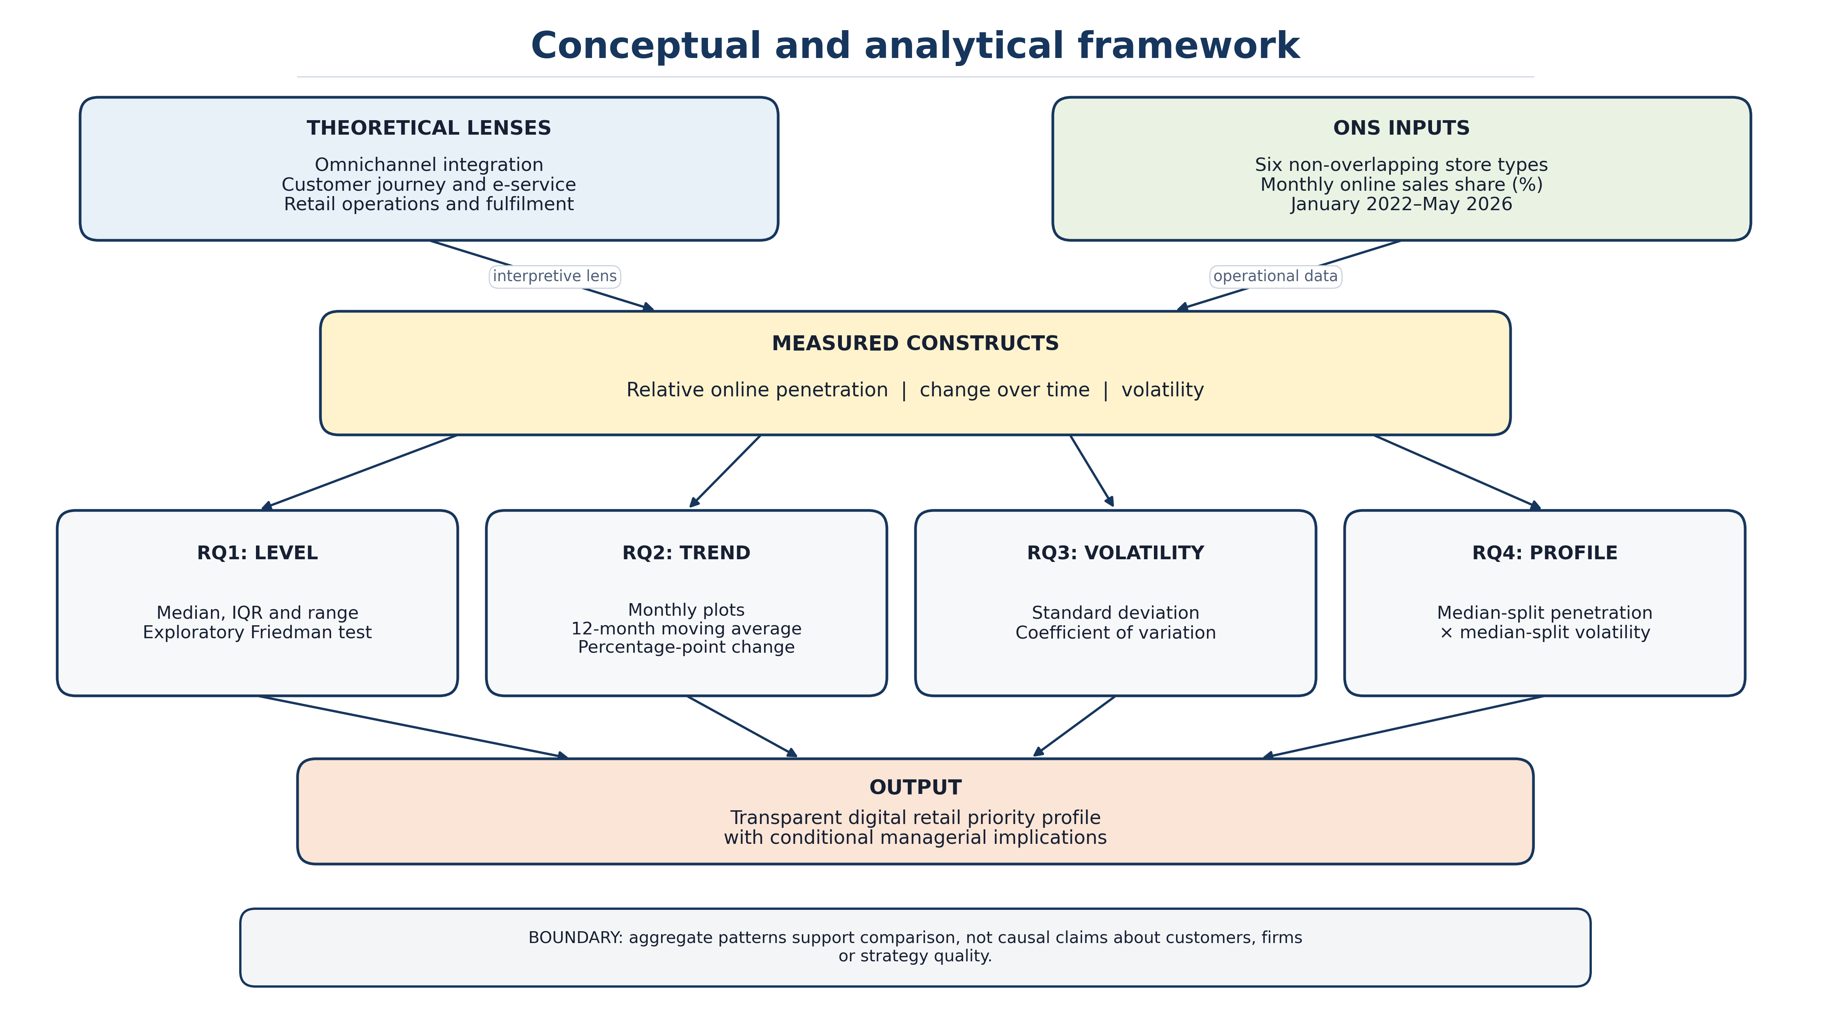

Figure 1: Conceptual framework showing how literature informs the measured variables, RQs, analysis and managerial output.

5.0 Literature and Contextual Issues

5.1 Online retail and omnichannel strategy
Online retailing needs to be read in the context of the greater trend from multichannel retailing to omnichannel retailing (Brynjolfsson, Hu and Rahman, 2013). Multichannel retailing is defined as using more than one channel, omnichannel retailing focusses on the coordination between the channels and the integration of the customer experience (Verhoef, Kannan and Inman, 2015; Beck and Rygl, 2015; Herhausen et al., 2015; Pantano and Viassone, 2015). This is important because online sales performance extends beyond web traffic (Ailawadi and Farris, 2017). It is influenced by the retail organisation of pricing, delivery, availability, returns, store fulfilment and customer service in both digital and physical channels (Bell, Gallino and Moreno, 2018). It is therefore useful to analyse online sales by store type because this can indicate where online channels might be more entrenched in the retail model.
According to Neslin et al. (2006), channel coordination and customer behaviour, as well as channel evaluation, are the main problems of multichannel management. As in the case of Gallino and Moreno (2014) who demonstrate that combining the online and offline channels can influence customers' behaviour more than just generate online sales. These arguments are relevant to the proposed study since differences in stores may be more than just the customers' preferences. They can also be an indicator of the design of the supply chain, the capacity to fulfil orders, the appropriateness of the product and the retailer's investment in online systems.

5.2 Digital retail, customer experience and channel choice
The literature of the customer experience is also very helpful (Rose et al., 2012; Capgemini Research Institute, 2026). Lemon and Verhoef (2016) posit that the customer experience is built over a series of touchpoints, and Kannan and Li (2017) highlight the new data-driven challenges and opportunities brought about by digital marketing (Chaffey and Ellis-Chadwick, 2022; Kotler, Kartajaya and Setiawan, 2021; Ofcom, 2026). Online retail stores could have different performance depending on store type (e.g. convenient delivery expected vs. inspection, fitting or immediate possession expected) (Melis et al., 2015). Therefore, the study proposed below will not be based on the technological aspect of online sales. Rather, it will explore the analysis in terms of the customer journey, service quality and channel-fit (Gefen, Karahanna and Straub, 2003; Wolfinbarger and Gilly, 2003; Gao and Jiang, 2025; Moliner-Tena and Tortosa-Edo, 2026).

5.3 Store-type variation and managerial relevance
One of the challenges in retail operations is that the overall online sales data can mask variation in sales by category. This is true, for instance, of non-store retailing as compared to food stores or department stores. Clothing and footwear may face fit-related returns, while household goods may involve complex delivery requirements. This means that retailers do not necessarily require the same digital approach. Depending on store type, priorities may include online fulfilment, delivery reliability, product information, digital merchandising or click-and-collect integration (Gao and Su, 2017; DHL eCommerce, 2026). A store-type comparison is therefore central to the proposal. This can help the study to deliver more specific findings on business recommendations, rather than generalisations about online retail growth.

5.4 Critical Synthesis and Literature Gap
There are three relevant, but separate lenses in the literature. Omnichannel research points to the need for coordination between channels (Neslin et al., 2006; Verhoef, Kannan and Inman, 2015), customer-journey research shows touchpoints and service-quality issues (Lemon and Verhoef, 2016; Parasuraman, Zeithaml and Malhotra, 2005), and operations research focuses on inventory and fulfilment mechanisms (Gallino and Moreno, 2014; Hübner, Wollenburg and Holzapfel, 2016). These studies are, however, more likely to be customer or firm level than the ONS series are. Online sales share can therefore not be used as a direct indicator for the quality of integration, customer experience or operational capability, and the theories cannot be used to explain the movements in categories. The current disparity is between in-depth academic explanations and official statistics that are typically presented as economic indicators. The study fills that void by applying theory as an interpretive lens, and only measuring online penetration, change and volatility and then translating measured components into a conservative and reproducible priority profile.

Literature theme | Relevance to proposed study | Indicative sources
Omnichannel retailing | Explains why online sales should be considered alongside channel integration and store-type strategy. | Neslin et al. (2006); Verhoef, Kannan and Inman (2015); Beck and Rygl (2015)
Customer journey and digital experience | Supports interpretation of online sales as part of wider customer experience, not only technology adoption. | Lemon and Verhoef (2016); Kannan and Li (2017); Parasuraman, Zeithaml and Malhotra (2005)
Retail operations and fulfilment | Helps explain why store types may differ because of delivery, inventory and operational constraints. | Gallino and Moreno (2014); Hübner, Wollenburg and Holzapfel (2016); Rigby (2011)
Secondary quantitative methodology | Supports the use of official aggregate statistics, SPSS and careful non-causal interpretation. | Saunders, Lewis and Thornhill (2019); Bryman (2016); Field (2018); Pallant (2020)
Table 1: Literature themes informing the proposed study.

6.0 Proposed Variables and Measures
The primary measure will be monthly internet sales as a percentage of total retail sales within each selected store type (Office for National Statistics, 2026a). Store type will be the six-category grouping variable and month will be the time variable. Derived measures will include percentage-point change, a 12-month moving average, standard deviation and coefficient of variation (CV = standard deviation/mean × 100). Missing observations will remain missing rather than being converted to zero, and all transformations will be recorded in the SPSS syntax and cleaning log.
Construct | Operational measure | Role in analysis
Online penetration | Monthly internet sales as a percentage of total category retail sales. | RQ1: median, interquartile range, minimum, maximum and ranked comparison.
Store type | Six non-overlapping ONS store categories; aggregate series used only as context. | Grouping variable for all four research questions.
Time pattern | Month, January 2022-May 2026; 12-month moving average. | RQ2: direction and longer-term pattern of change.
Change / volatility | Percentage-point and same-month year-on-year change; standard deviation and CV. | RQ2 measures change; RQ3 compares absolute and relative dispersion.
Priority classification | Category median share crossed with category CV using disclosed six-category median cut-offs. | RQ4: reproducible, exploratory managerial profile.
Table 2: Operational variables and their alignment with the research questions.

7.0 Methodology and Analytical Strategy
The research philosophy used is positivist as it focuses on measurable indicators and statistical methods are used to determine the numerical patterns. A deductive approach will be taken as the study will start from a literature on retail and omnichannel, then the ideas will be incorporated into an official secondary data (Sekaran and Bougie, 2016). This study takes a mono-method quantitative design with the method of secondary data analysis (Babbie, 2020; Bell, Bryman and Harley, 2022; Creswell and Creswell, 2018). This is appropriate because the aim is not to explore individual meaning, but to compare the pattern of sales of various store types and times, online.
The analysis, which is planned to be conducted using SPSS, is transparent and suitable for the research questions. Once the ONS tables have been reshaped into one row per store-type-month the researcher will check series codes, dates, duplicate and missing value, and derived variables to the source workbook. RQ1 will be addressed with the median, IQR, minimum and maximum, and will include an exploratory Friedman test with result reporting as Kendall's W as effect size, for the six categories compared with matched months. Monthly line charts, 12-month moving averages (MMAs) and percentage-point changes will be used for RQ2. For RQ3 standard deviation and coefficient of variation are used. RQ4 will compare the median share and CV of every category with the six-category median share and CV. Since the months are serially correlated, consider the p-value for inference in each case as exploratory, rather than proof of independent or causal effects.
RQ / stage | SPSS activity | How it answers the question
Preparation | Verify period and series; reshape to long format; label variables; check duplicates and missing values. | Creates a transparent, repeatable store-type-month analysis file.
RQ1: typical level | Median, IQR, range and ranked chart; exploratory Friedman test and Kendall's W. | Compares the magnitude of monthly online share across matched categories.
RQ2: trend | Monthly lines, 12-month moving average and percentage-point changes. | Shows the direction and magnitude of within-category change over time.
RQ3: volatility | Standard deviation and coefficient of variation by store type. | Compares absolute and relative dispersion in monthly online share.
RQ4: profile | Cross category median share with category CV using stated median cut-offs. | Produces a reproducible, non-causal priority quadrant.
Table 3: SPSS analysis plan aligned with each research question.

7.1 Advantages and disadvantages of the chosen method
The strengths of the selected method are that it is feasible, transparent and is a method well suited to the research question posed (Collis and Hussey, 2014). The study is able to concentrate on secondary analysis as the data has been gathered and published by the ONS, thus avoiding the need to access retailers and/or customers. This also helps to create comparability, as definitions are the same for all stores and time periods. Further, SPSS output can be displayed in tables and graphs which are easily understood by business users. This is important because the merit of the proposal is not statistical complexity but the ability to yield an easy to understand interpretation for managers.
The drawbacks too are significant. The researcher has no control over the way the ONS questions were asked and is not able to include qualitative explanations and access the strategic decision making process of individual retailers. However, there can be differences between store types which are obscured from aggregate data. For instance the same retailer could offer an excellent online experience and a poor payback or returns as well as fulfilment service and another retailer could struggle with the fulfilment and payback but offer a great online experience. This limitation will be managed by avoiding overclaiming. The study will use terms such as pattern, trend and association, and will recommend additional firm-level qualitative research for questions that secondary data cannot answer.

8.0 Methodological Critique and Alternatives Considered
A qualitative design was considered but not adopted as the primary design. Retail managers could be interviewed with the aim of understanding the reasons behind the changes in sales performance in the category over time and these could be analysed thematically (Braun and Clarke, 2006; Robson and McCartan, 2016). However, national comparisons would not be available at the store type/month and year level using interviews. A secondary quantitative design is a more appropriate design for the research question which is deliberately concerned with patterns of aggregate retail sales in Great Britain.
Also a case study design was considered (Yin, 2018). One retailer's case study may give some interesting specifics on fulfilment, product mix, website design and customer service. However, one case would not reveal store-type trends in online sales. Furthermore, it may be challenging to obtain a retailer's internal sales data that is accessible online and this may lead to confidentiality problems. As compared to the data from the ONS, this data is already public and can be structured and used in an MBA proposal schedule.
Machine learning and advanced forecasting were also rejected. Forecasting might be useful in retail analytics but it would take the concept out of its emphasis on methodology, data source, research design and critical evaluation that is the focus of the Business Research module. The analysis proposed will be designed to be accessible: descriptive statistics, simple inferential tests (where appropriate) and comparison of trends. This decision should not be considered a weakness, when it is made for good reason. It is reflective of the purpose of the study, an easy to use store-type priority profile, not a technical prediction tool.

9.0 Ethics, Data Quality, Positionality and Trustworthiness
The ethical risk in this study is low as it has used secondary data that are publicly available. There will be no contact with customers, no personal or company level confidential information will be gathered, and no customers, employees or retailers will be contacted. Nevertheless, ethical care is still required. The researcher should use ONS data in an accurate manner, not manipulate the data, acknowledge any limitations and refrain from using data from aggregate store-type patterns to make sense of each individual retailer.
The dataset is an official source and documentation is provided with official methodology for data quality. The Retail Sales Index QMI includes information about the strengths, limitations and methods used in producing the data, such as coverage of Great Britain (Office for National Statistics, 2025) and the sample-based Monthly Business Survey. Retail sales statistics are also considered to be accredited official statistics and meet the standards of trustworthiness, quality and value (Office for National Statistics, 2026d). However, there are some limitations which will be recognised during the analysis, including the possibility of revisions, the seasonal nature of the data, sampling error, non-sampling error and the absence of Northern Ireland from the Great Britain dataset.
Documenting decisions regarding data cleaning procedures will enhance the consistency and reliability of the data, and maintaining consistency in SPSS labels with those of the original ONS tables will help to ensure that labels are used correctly. Validity will be supported by aligning each indicator with the research objectives. For instance, online sales share will measure the performance of digital retail and month and store type will provide trend and category comparisons. If something is available, it does not mean that it should be used as a variable; it must be in line with the study's conceptualization.
Positionality of the researcher is of relevance as well. The researcher does not have access to the primary data source – ONS statistician or retail manager. This outside perspective minimises the chance of influencing data gathering, and means that there is less context understanding. Therefore, an increase in online sales does not necessarily indicate an improved strategy; some stores may have a greater need to physically inspect the product, shop locally or have a specific product that they feel they can only sell in their store. Careful language, separating out the statistical pattern from managerial interpretation, and recognition of the need for more qualitative work, will be used to achieve reflexivity.

10.0 Expected Contribution and Digital Retail Priority Profile
The contribution is methodological and practical. On the methodological side, the research will illustrate a clear link between the defined ONS variables and the research questions and the predefined SPSS results. In practice, it will generate an exploratory digital retail priority profile based on two existing outputs of the analysis: relative online penetration – each category’s median monthly online sales share and relative volatility – the coefficient of variation for each category’s monthly online sales share. Higher and lower positions will be determined by the medians between the 6 categories instead of being judged subjectively.
The four quadrants guide further managerial investigation rather than dictate investment. Higher penetration with lower volatility implies capacity and fulfilment resilience is an issue of maintaining and optimising existing capability; higher penetration with higher volatility indicates capacity resilience investigation is an issue. A low penetration with high volatility is a pressure point that needs to be identified prior to investing, while a low penetration with low volatility suggests that the product-channel fit and customer-journey design are an issue. These interpretations are in line with the omnichannel and customer-journey and retail-fulfilment literature, but profitability and customer/firm evidence would still need to be established prior to action.
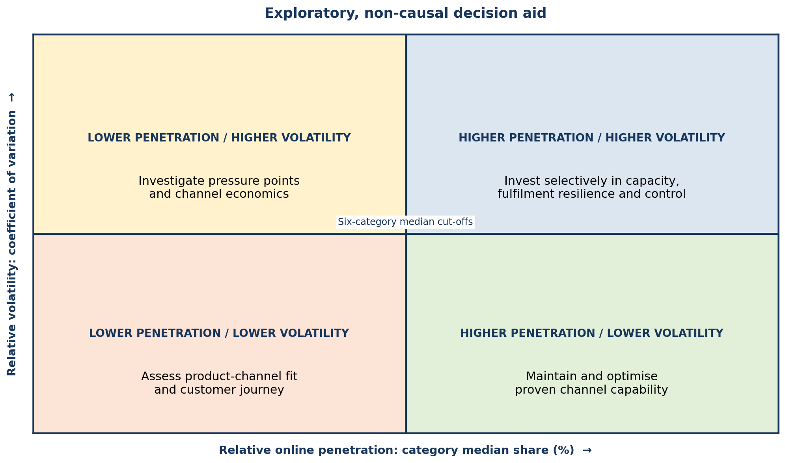
Figure 2: Digital retail priority profile with explicit measures, directions and relative cut-offs.

11.0 Limitations, Resources and Feasibility
Some limitations need to be acknowledged. The study uses secondary data, which means that the researcher has no control over the questionnaire, and has no option to add variables at the customer level or request an explanation of the strategy from retailers. Secondly, the analysis is aggregate and therefore does not enable the identification of individual retailer performance. Thirdly, monthly data may be volatile and the study should consider monthly movement in the context of longer time periods, e.g. 12-month moving averages or annual movements. Finally, the data can only show associations and variations between two or more variables, not that a particular omnichannel strategy brought about the trend.
The project is feasible because the public ONS data can be downloaded and the analysis can be conducted in SPSS and Excel. Time to clean the data, select variables, and review literature and carefully interpret the results is the primary resource needed. There will be no budget for travel, participant recruitment, transcription of interviews and primary data. If the constraints are clearly addressed, the study is feasible within a student research proposal.
Another feasibility consideration is the scope of the analysis. The proposal should not try to give a complete economic report or analyse all the tables available. Rather, it will choose a small number of store types and indicators which directly address the research question. This will make the project easier to handle and minimise the chances of descriptive output without critical analysis. The focus of the study will then be more on interpretation than on a large number of charts.
Resource or issue | Requirement | Feasibility comment
Data access | ONS Retail Sales Index internet sales spreadsheet | Publicly available and regularly updated.
Software | Excel and SPSS | Suitable for cleaning, charts and basic statistical comparison.
Time | Eight-week proposal-to-analysis schedule | Feasible if the analysis period is clearly defined.
Ethics | Secondary public data only | Low risk; accurate citation and careful interpretation required.
Table 4: Resource implications and feasibility of the proposed study.

12.0 Proposed Time Plan

Figure 3 shows an overview of the research period of eight weeks. The sequence is intentionally not of a primary survey project, as the primary concerns are not necessarily the recruiting of participants and access to interviews, but the preparation of the data, variable selection and interpretation of aggregate statistics.
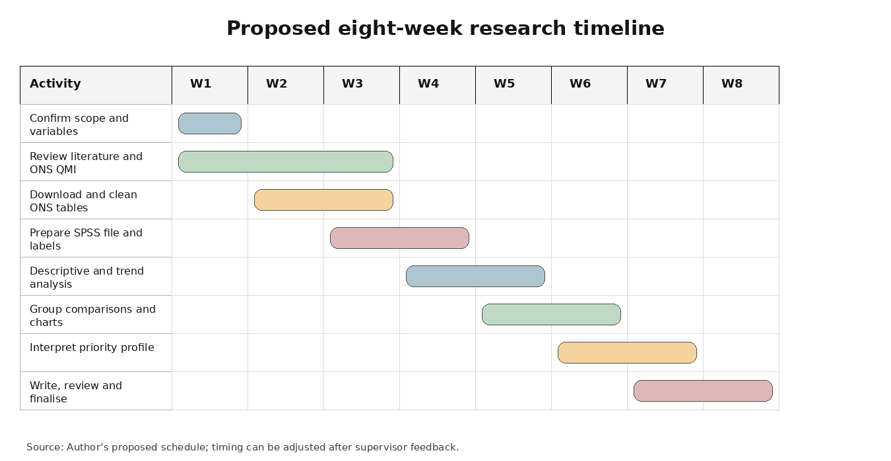
Figure 3: Proposed Gantt chart for the research process.

13.0 Conclusion
This proposal sets out a secondary quantitative study of online retail penetration, trends and volatility across six Great Britain store types from January 2022 to May 2026. The explicit aim, four outcome-based objectives and four research questions are linked to defined ONS variables and specified SPSS procedures. Omnichannel, customer-journey and retail-operations literature will guide interpretation without being treated as directly measured causes. The study will produce descriptive evidence, an exploratory matched comparison and a transparent priority profile, while recognising seasonality, serial dependence, aggregation and the absence of firm-level explanations. Its bounded MBA-level contribution is therefore an evidence-led screening tool for managerial investigation rather than a forecast or a judgement of individual retailer success.

References
Ailawadi, K.L. and Farris, P.W. (2017) ‘Managing multi- and omni-channel distribution: Metrics and research directions’, Journal of Retailing, 93(1), pp. 120–135. Available at: https://doi.org/10.1016/j.jretai.2016.12.003.
Babbie, E. (2020) The Practice of Social Research. 15th edn. Boston, MA: Cengage.
Beck, N. and Rygl, D. (2015) ‘Categorization of multiple channel retailing in multi-, cross-, and omni-channel retailing for retailers and retailing’, Journal of Retailing and Consumer Services, 27, pp. 170–178. Available at: https://doi.org/10.1016/j.jretconser.2015.08.001.
Bell, D.R., Gallino, S. and Moreno, A. (2018) ‘Offline showrooms in omnichannel retail: Demand and operational benefits’, Management Science, 64(4), pp. 1629–1651. Available at: https://doi.org/10.1287/mnsc.2016.2684.
Bell, E., Bryman, A. and Harley, B. (2022) Business Research Methods. 6th edn. Oxford: Oxford University Press.
Braun, V. and Clarke, V. (2006) ‘Using thematic analysis in psychology’, Qualitative Research in Psychology, 3(2), pp. 77–101. Available at: https://doi.org/10.1191/1478088706qp063oa.
British Retail Consortium (2026) ‘Consumer demand cools as temperatures soar’, 11 August. Available at: https://brc.org.uk/news-and-events/news/corporate-affairs/2026/ungated/consumer-demand-cools-as-temperatures-soar/ (Accessed: 27 August 2026).
Bryman, A. (2016) Social Research Methods. 5th edn. Oxford: Oxford University Press.
Brynjolfsson, E., Hu, Y.J. and Rahman, M.S. (2013) ‘Competing in the age of omnichannel retailing’, MIT Sloan Management Review, 54(4), pp. 23–29. Available at: MIT Sloan Management Review (Accessed: 27 August 2026).
Cao, L. and Li, L. (2015) ‘The impact of cross-channel integration on retailers’ sales growth’, Journal of Retailing, 91(2), pp. 198–216. Available at: https://doi.org/10.1016/j.jretai.2014.12.005.
Capgemini Research Institute (2026) What Matters to Today’s Consumer 2026. Available at: Capgemini Research Institute (Accessed: 27 August 2026).
Chaffey, D. and Ellis-Chadwick, F. (2022) Digital Marketing. 8th edn. Harlow: Pearson.
Collis, J. and Hussey, R. (2014) Business Research: A Practical Guide for Undergraduate and Postgraduate Students. 4th edn. Basingstoke: Palgrave Macmillan.
Creswell, J.W. and Creswell, J.D. (2018) Research Design: Qualitative, Quantitative, and Mixed Methods Approaches. 5th edn. Thousand Oaks, CA: SAGE.
DHL eCommerce (2026) 2026 E-Commerce Trends Report. Available at: DHL eCommerce report (Accessed: 27 August 2026).
Ecommerce Europe and EuroCommerce (2025) European E-Commerce Report 2025. Available at: EuroCommerce (Accessed: 27 August 2026).
Field, A. (2018) Discovering Statistics Using IBM SPSS Statistics. 5th edn. London: SAGE.
Gallino, S. and Moreno, A. (2014) ‘Integration of online and offline channels in retail: The impact of sharing reliable inventory availability information’, Management Science, 60(6), pp. 1434–1451. Available at: https://doi.org/10.1287/mnsc.2014.1951.
Gao, F. and Su, X. (2017) ‘Omnichannel retail operations with buy-online-and-pick-up-in-store’, Management Science, 63(8), pp. 2478–2492. Available at: https://doi.org/10.1287/mnsc.2016.2473.
Gao, W. and Jiang, N. (2025) ‘Enhancing omnichannel customer experience: From a customer journey design perspective’, Journal of Theoretical and Applied Electronic Commerce Research, 20(4), article 277. Available at: https://doi.org/10.3390/jtaer20040277.
Gefen, D., Karahanna, E. and Straub, D.W. (2003) ‘Trust and TAM in online shopping: An integrated model’, MIS Quarterly, 27(1), pp. 51–90. Available at: https://doi.org/10.2307/30036519.
Grewal, D., Roggeveen, A.L. and Nordfält, J. (2017) ‘The future of retailing’, Journal of Retailing, 93(1), pp. 1–6. Available at: https://doi.org/10.1016/j.jretai.2016.12.008.
Hausman, A.V. and Siekpe, J.S. (2009) ‘The effect of web interface features on consumer online purchase intentions’, Journal of Business Research, 62(1), pp. 5–13. Available at: https://doi.org/10.1016/j.jbusres.2008.01.018.
Herhausen, D., Binder, J., Schoegel, M. and Herrmann, A. (2015) ‘Integrating bricks with clicks: Retailer-level and channel-level outcomes of online–offline channel integration’, Journal of Retailing, 91(2), pp. 309–325. Available at: https://doi.org/10.1016/j.jretai.2014.12.009.
Hübner, A., Wollenburg, J. and Holzapfel, A. (2016) ‘Retail logistics in the transition from multi-channel to omni-channel’, International Journal of Physical Distribution & Logistics Management, 46(6/7), pp. 562–583. Available at: https://doi.org/10.1108/IJPDLM-08-2015-0179.
Kannan, P.K. and Li, H.A. (2017) ‘Digital marketing: A framework, review and research agenda’, International Journal of Research in Marketing, 34(1), pp. 22–45. Available at: https://doi.org/10.1016/j.ijresmar.2016.11.006.
Kotler, P., Kartajaya, H. and Setiawan, I. (2021) Marketing 5.0: Technology for Humanity. Hoboken, NJ: Wiley.
KPMG (2026) KPMG’s Consumer Pulse: Q2 2026. Available at: KPMG UK (Accessed: 27 August 2026).
Lemon, K.N. and Verhoef, P.C. (2016) ‘Understanding customer experience throughout the customer journey’, Journal of Marketing, 80(6), pp. 69–96. Available at: https://doi.org/10.1509/jm.15.0420.
Melis, K., Campo, K., Breugelmans, E. and Lamey, L. (2015) ‘The impact of the multi-channel retail mix on online store choice: Does online experience matter?’, Journal of Retailing, 91(2), pp. 272–288. Available at: https://doi.org/10.1016/j.jretai.2014.12.004.
Moliner-Tena, M.A. and Tortosa-Edo, V. (2026) ‘Online customer experience and online customer engagement with e-commerce: Comparing online and omnichannel consumer journeys’, Electronic Markets, 36, article 20. Available at: https://doi.org/10.1007/s12525-026-00881-4.
Neslin, S.A., Grewal, D., Leghorn, R., Shankar, V., Teerling, M.L., Thomas, J.S. and Verhoef, P.C. (2006) ‘Challenges and opportunities in multichannel customer management’, Journal of Service Research, 9(2), pp. 95–112. Available at: https://doi.org/10.1177/1094670506293559.
Ofcom (2026) Media Nations: UK 2026. Available at: Ofcom report (Accessed: 27 August 2026).
Office for National Statistics (2025) Retail Sales Index (RSI) QMI. Available at: ONS (Accessed: 27 August 2026).
Office for National Statistics (2026a) Internet Sales as a Percentage of Total Retail Sales (Ratio) (%). Available at: ONS, series J4MC (Accessed: 27 August 2026).
Office for National Statistics (2026b) Retail Sales Index Internet Sales. Available at: ONS dataset (Accessed: 27 August 2026).
Office for National Statistics (2026c) Retail Sales, Great Britain: July 2026. Available at: ONS (Accessed: 27 August 2026).
Office for National Statistics (2026d) Retail Sales, Great Britain: May 2026. Available at: ONS (Accessed: 27 August 2026).
Pallant, J. (2020) SPSS Survival Manual: A Step by Step Guide to Data Analysis Using IBM SPSS. 7th edn. Maidenhead: Open University Press.
Pantano, E. and Viassone, M. (2015) ‘Engaging consumers on new integrated multichannel retail settings: Challenges for retailers’, Journal of Retailing and Consumer Services, 25, pp. 106–114. Available at: https://doi.org/10.1016/j.jretconser.2015.04.003.
Parasuraman, A., Zeithaml, V.A. and Malhotra, A. (2005) ‘E-S-QUAL: A multiple-item scale for assessing electronic service quality’, Journal of Service Research, 7(3), pp. 213–233. Available at: https://doi.org/10.1177/1094670504271156.
Piotrowicz, W. and Cuthbertson, R. (2014) ‘Introduction to the special issue information technology in retail: Toward omnichannel retailing’, International Journal of Electronic Commerce, 18(4), pp. 5–16. Available at: https://doi.org/10.2753/JEC1086-4415180400.
Rigby, D. (2011) ‘The future of shopping’, Harvard Business Review, 89(12), pp. 65–76. Available at: Harvard Business Review (Accessed: 27 August 2026).
Robson, C. and McCartan, K. (2016) Real World Research: A Resource for Users of Social Research Methods in Applied Settings. 4th edn. Chichester: Wiley.
Rose, S., Clark, M., Samouel, P. and Hair, N. (2012) ‘Online customer experience in e-retailing: An empirical model of antecedents and outcomes’, Journal of Retailing, 88(2), pp. 308–322. Available at: https://doi.org/10.1016/j.jretai.2012.03.001.
Saunders, M., Lewis, P. and Thornhill, A. (2019) Research Methods for Business Students. 8th edn. Harlow: Pearson.
Sekaran, U. and Bougie, R. (2016) Research Methods for Business: A Skill-Building Approach. 7th edn. Chichester: Wiley.
Verhoef, P.C., Kannan, P.K. and Inman, J.J. (2015) ‘From multi-channel retailing to omni-channel retailing: Introduction to the special issue on multi-channel retailing’, Journal of Retailing, 91(2), pp. 174–181. Available at: https://doi.org/10.1016/j.jretai.2015.02.005.
Wolfinbarger, M. and Gilly, M.C. (2003) ‘eTailQ: Dimensionalizing, measuring and predicting etail quality’, Journal of Retailing, 79(3), pp. 183–198. Available at: https://doi.org/10.1016/S0022-4359(03)00034-4.
Yin, R.K. (2018) Case Study Research and Applications: Design and Methods. 6th edn. Thousand Oaks, CA: SAGE.

