

MPP MANAGING PEOPLE
ASSIGNMENT

REPORT 4800 WORDS
DUE DATE: 27TH AUGUST 2021
LECTURER: MARY MARCH

SEMRA H. SAKOVA ZENGIN
(2024733)

Contents
INTRODUCTION 3
THE CHANGING HR FUNCTION 3
CONTEMPORARY APPROACH TO HUMAN RESOURCES: PROFESSION MAP 5
EMPLOYMENT RELATIONS 5
EMPLOYMENT LEGISLATIONS 6
DISPUTES 7
ENDING THE CONTRACT 7
DISMISSAL 8
FIRE AND REHIRE TACTICS 8
FIRE AND REHIRE PRACTICES DURING COVID-19 8
THE BACKGROUND OF THE BRITISH GAS COMPANY’S FIRE AND REHIRE TACTICS 9
Company Overview of British Gas 9
British Gas Company’s Fire and Rehire Tactics 10
EMPLOYMENT ENGAGEMENT 11
WELLBEING 13
CONCLUSION 13
RECOMMENDATIONS 14
References 15

INTRODUCTION
Organizations follow various strategies in order not to stay behind in the tough market race. It is vital for organizations to be able to manage staff costs, which are constant expenses, in difficult periods such as the Covid-19 pandemic. Well-established British companies such as British Gas, Saintsbury's and Weetabix have resorted to some methods in order to reduce their employee costs in this difficult period. The 'Fire and Rehire' tactic was the most striking of these methods and was met with a reaction by the public. This article reviews the practice of 'fire and rehire' tactics in the labor market by different organizations in the UK. The legal consequences of changing the terms of contract employment are discussed. The effect of changes in business conditions on employee engagement is examined. In this conflict, HR participation and traditional HRM models’ competencies are questioned.

THE CHANGING HR FUNCTION
HRM is the basis of all managerial activities in a business. Human resource management can be explained from two different perspectives. The first of these is personnel management, which constitutes the body of management activities. The other is a philosophical approach that goes beyond human-centered activities. The second perspective offers an innovative approach to the traditional understanding of personnel management. The role of HR functions in a business can be explained by a good definition of the four key objectives (Torrington, et al., 2014).
Staffing Objectives: It includes defining different employee groups in the processes of selecting, recruiting and retaining the right people and the right talents and designing the structure of the organization so that the business has a competitive advantage in the market it is in.
Performance Objectives: Well-motivated and committed employees can show their performance at the highest level. Managers can increase workforce performance through methods such as the reward system, training and development processes, and setting performance targets.
Changing-management Objectives: Changes that occur in an organization take different forms. There may be changes such as the reorganization of organizational activities, the introduction of new people into certain roles, the revision of the organizational structure, as well as cultural changes such as the change of long-term organizational norms and philosophy. Timely and effective employee participation is important to support these changes. In some situations where there are impositions, differences of opinion can also be experienced. In order to effectively manage this disagreement, high participation of individuals should be ensured in the decision-making process and expectations should be carefully managed.
Administration Objectives: In line with managerial goals, there is a need to keep necessary data about individual employees, a record of their achievements in terms of performance, attendance and training records, terms and conditions of employment, and personal details. Providing detailed monthly pay tables for all employees, deducting Taxation and National Insurance, arranging for payment of pension fund contributions, monitoring health and safety systems, contracting new employees, issuing statutory sick pay and statutory maternity pay, as well as maternity and paternity leave are the administrative activities that must be carried out in accordance with the laws. While the personnel management approach mentioned here is workforce-centred, the new and different HRM approach that has become popular in the last two decades of the twentieth century is resource-centred. It focuses on the needs of management for the provision and deployment of human resources. It focuses on demand rather than supply, planning and control rather than mediation. The HR function, which has added a new one to its activities over the years, will continue to evolve with the changing management approach (Torrington, et al., 2014).
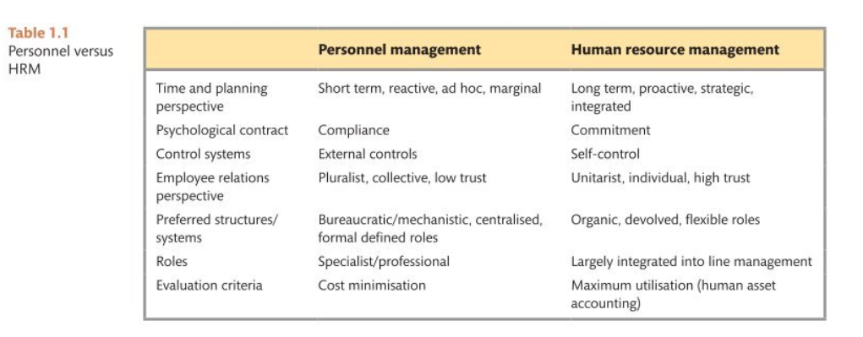
If the disagreement between the British Gas company and its employees is handled in terms of human resources functions, the company takes a traditional approach to personnel management functions rather than human resources management. The company’s attitude towards its employees is short-term and marginal in terms of time and planning. The psychological contract between the company and the employees is more about compliance rather than commitment. The company's perspective understanding of employee relations is pluralistic and based on low trust as it forces its engineers to sign collective fire and rehire contracts. The preferred management system in the company consists of bureaucratic, centralised and formally defined roles. The main reason why the company referred this method such a disagreement during the pandemic process is to reduce cost expenses, so the evaluation criterion of human resources is minimising the costs instead of making maximum utilization of the human assets that the company has.

CONTEMPORARY APPROACH TO HUMAN RESOURCES: PROFESSION MAP
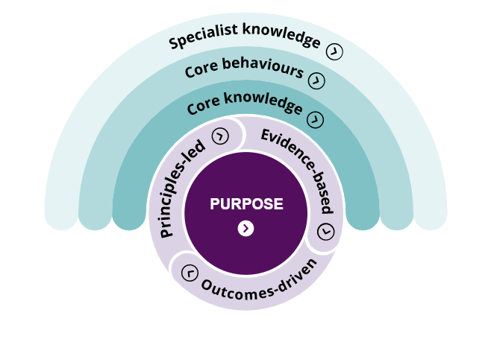
According to the CIPD professions map, all efforts are to achieve a certain purpose. The main purpose is to try to bring out good works. A roadmap should be determined by using specialized knowledge, core knowledge, and core behaviours in the most effective way. Employee experience, employee relations, inclusion and diversity, learning and development, organisation development and design, people analytics, resourcing, reward, talent management creates the specialist knowledge. And the core behaviours are about the ethical practice, professional courage and influence, valuing people, working inclusively, commercial drive, passion for learning, insights focused, situational decision-making. Core knowledge is also needed to adapt to rapidly changing external conditions. People practice, culture and behaviour, business acumen, evidence-based practice, technology and people and change are the fundamentals of core knowledge. All these knowledge and behaviours should be brought together and effectively in order to use it under the leadership of evidence-based outcomes-driven and principles-led. Evidence-based means to make the right decisions in any situation. Behavioural science, academic research, organizational knowledge, and stakeholder concerns are all relevant evidence. Decisions should be made by considering the risks taken and the value of joining the organization in outcomes-driven studies. Three basic principles must be followed in order to make the right decisions beyond the rules and laws. These are work matters, people matter and professionalism matters (CIPD, 2021).

EMPLOYMENT RELATIONS
A successful organization can be run without involving employees in management activities. However, organizations conducted by taking the opinions of employees have a more sustainable success. Ultimately, it is the duty of the managers to take the final decision, but more participation of the employees and their ability to express their opinions can lead the organization to make more accurate decisions because hierarchically, employees are closer to the lower layer and especially to the customers. In addition, employees are happy to have an idea about the decisions taken about the Company. This can increase their commitment to the organization. For a more effective management approach, especially employee participation should be ensured. Marchington and Cox published an escalator model in 2007 to rate employee participation in the company. The lowest level of this model is information, and the highest level is control. The authority to make decisions without taking the opinions of the employees at the knowledge level completely belongs to the management. At the control level, which is the highest level, the control authority belongs entirely to the employees. There are three different transition levels between these 2 levels in the form of communication, consultation and determination. There is an exchange of ideas between employees and managers at the Communications level, but the real decision-making authority belongs to the managers. At the consultation level, personnel fully express their opinions and take key decisions, but decision-making responsibility rests with the managers. In the co-determination step, decisions are taken with the participation of managers and personnel. Although the official use of decision making at this level is rare in the UK, it is a legally supported practice in Northern European countries (Torrington, 2017).
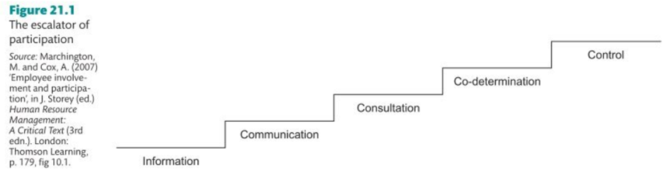
If the fire and re-hire tactics of British Gas company is handled in terms of employee involvement and participation, this situation can be associated with the information level, which is the lowest level of the participation escalator. Company managers determined the conditions regarding fire and re-hire plans without consulting their employees, without asking their opinions and demands. In addition, the organization did not give importance to the opinions of the employees regarding the working terms and conditions in the new contracts and forced the employees to obey the obligations of new contracts.

EMPLOYMENT LEGISLATIONS
Legal regulations regarding HRM are effective in areas such as hiring and selection, paying employees, regulating working time, determining leave rights, ensuring an appropriate level of health and safety, relations with unions, retirement and firing (Torrington, et al., 2014). In the UK, most employment laws are classified as 'civil law' or 'private law'. This law enters into force through court when the claimant sues the respondent for compensation or other remedies. A claimant is generally an employee, former employee, or person whose job application has been unsuccessful. The claimant uses the court and labor court system to argue that the defendant (current or former employer) has done them some form of harm and has done so unlawfully (Taylor, 2021).

DISPUTES
Conflicts within an organization may arise from rumours and relationships that adversely affect individual and group interests. These conflicts can be between individuals and/or groups, or between employees and their employers. The subject of recent government policy reform in the UK is to try to solve problems as soon as possible by keeping them in-house. According to research in Ireland and Wales (Roche and Teague 2011, Hann et al. 2016) three different types of workplace disputes have been defined. These are: individual disputes (between individual employees and their employers) conflicts between employees (between colleagues but not directly involving the employer) group disputes (between groups of workers and their employers). Small organizations use off-site providers, such as HR consultants, who reflect their more limited resources to resolve conflicts they encounter in the workplace. Larger organizations use their own HR functions but prefer law firms in limited situations where they use off-site providers. In organizations with an HR function, the organization is very likely to seek advice on disputes from this source. Many large organizations have established formal policies to prevent all 3 types of conflict (individual, inter-employee conflict and group conflict). They stated that they implement their policies flexibly rather than rigidly (Hann & Nash, 2020).
The dispute, experienced during the implementation of the fire and re-hire plans in British Gas Company, can be defined as group disputes. This dispute occurred because of the disagreement between British Gas managers and their employee groups. Although the unions stepped in to end this conflict, the strict attitude of the management continued the conflict. As a large company, the HR function of British Gas had to take measures to overcome this dispute as lightly as possible.

ENDING THE CONTRACT
There are three types of dismissal requests that can be brought to court of law in the UK. The rights related to the wrongful dismissal law are the longest-existing rights. A person claiming to have been unfairly dismissed complains that the manner of dismissal violates the terms of the employment contract. Constructive dismissal occurs when the employee feels compelled to resign as a direct result of the employer's actions. In this area, the law aims to deter employers from trying to avoid layoffs by forcing people to resign. The third most common category is unfair dismissal. This dismissal category, which poorly meets the expectations of the law set out in the Employment Rights Act 1996 (Torrington, et al., 2014).

DISMISSAL
An employer must demonstrate that the reason for firing an employee is for one of five reasons: 'another significant reason', the employee's 'ability or qualifications', the employee's 'behaviour', severance pay employee, violation of a duty or statute. If the employer cannot show the reason for the dismissal, the dismissal is considered unfair. And claims of unfair dismissal should be enforced in employment tribunal. To file an unfair dismissal complaint with an employment tribunal, the person must be an employee, have been employed continuously for two years or more, have not been employed in the police service or the armed forces, and have been normally employed Great Britain (Cabrelli, 2012).
Many employment rights only begin after two years of employment. Until then, workers can be dismissed with one week's notice. In many firms, the longer employees work, the more entitlements they receive on dismissal, on better terms. In this case, at the end of the dismissal and reemployment process, the rights of the workers for the time they worked will be reset. Long-time employees should not be treated as new hires if they are laid off and rehired immediately or by the following week (King, 2021).

FIRE AND REHIRE TACTICS
Firing and rehiring means that an employer fires an employee and offers to rehire them on new terms and conditions that are more favourable to the employer. This practice is not illegal. However, the employer still claims unfair dismissal. This may be legal if employers have valid reasons to do so and an appropriate consultation process has been initiated prior to any dismissal. However, if the company has enough employees, the employer also has a legal duty to first advise on collective dismissals. It is the Employment Tribunals that will examine and question an employer's grounds for dismissal and rehiring (MarketLine, 2021).

FIRE AND REHIRE PRACTICES DURING COVID-19
Due to changing working and business conditions, managers expect employees to adapt to the new situation. In order to be able to accept the new situation, new contracts are offered to the employees. This requires some fire and rehire practices. Throughout 2020, public attention to the use of fire and rehire practices has increased in the context of the COVID-19 pandemic. This included examples of industrial unrest linked to the use of dismissal and re-engagement by a few large employers in England. The pandemic has required many employers to take a radical view of business, both in rapidly adapting to emergencies and ensuring their long-term sustainability. It has been seen that some employers use layoff and rehire practices to overcome this situation. It has also been observed that some employers use it as an excuse to mitigate the negative effects of the pandemic and as a tactic to harm real workplace dialogue about change. There are instances where fire and rehiring were used in a wide variety of workplace conditions, both before and during the COVID-19 pandemic. These included: redundancy scenarios associated with both minimizing redundancies and maximizing overall staffing by making relevant changes to remaining staffing contracts, to improve the terms and conditions of both business transfers and other contexts; bringing temporary or permanent flexibility to contracts in terms of working hours, shift patterns, pay entitlements, or employment security. Media reports of fire and re-retrieval use focused specifically on a small number of cases in the aviation sector (including British Airways, Heathrow Airport Ltd and catering firm Dnata Catering UK) and British Gas (Centrica), University of Sheffield and Tesco. Each of these examples includes disputes between large employers and unions (Acas Officials, 2021). The government does not record the number of fire-rehire implementations, which means that more and more companies are resorting to this method. According to research, these practices are used not only among large companies, but also by small businesses and employers. While fire and rehiring are more associated with high street retailers, there is also growing news that the practice is being promoted by employers in multiple industries, including banking (MarketLine, 2021). Dismissal and rehiring are not illegal, but employers must formally consult workers and unions and comply with established notice periods. When the process is not followed properly, workers can take legal action through labor courts or courts. Employees and unions may object to firing and rehiring because it was not done fairly, such as when some groups of workers are treated better than others. The Labor Party, the SNP and the Liberal Democrats think fire and rehiring should be prohibited by law. The government does not plan to ban it, against this Boris Johnson thinks firing and rehiring cannot be considered a negotiation tactic. Government minister Paul Scully said employers should use it as a last resort when they can lay off workers (King, 2021). An exact assessment of the number of employees forced into the fire and rehiring practice is unknown. However, the TUC estimated that since March 2020, around 9% of employees have been told to reapply for worse conditions. Other major recent fire and rehiring disputes involve shoe retailer Clarks, Argos, Tesco and Asda. British Airways cargo workers went on strike over a fire and rehiring dispute (MarketLine, 2021).

THE BACKGROUND OF THE BRITISH GAS COMPANY’S FIRE AND REHIRE TACTICS
After the general information about the British Gas company, examining the reasons and details of the fire and rehire practices used against its employees during the Covid-19 Pandemic process.

Company Overview of British Gas
British Gas is a renewable energy company offering integrated photovoltaic and renewable energy technology solutions. The company provides services such as commercial gas boiler installations, gas appliance service, connections and metering, sewer and plumbing repairs and repair and maintenance contracts, as well as energy consulting and auditing, monitoring, analysis and meeting and regulatory advice. The company provides solar photovoltaic (PV) panels, solar thermal panels, air source heat pumps, ground source heat pumps and biomass boilers. British Gas is headquartered in Windsor, England (Marketline, 2016).

British Gas Company’s Fire and Rehire Tactics
Fire and rehire proposals led to strongly supported strike votes in a few cases where large-scale strike action took place in Centrica, better known to the public as British Gas (Acas Officials, 2021). Fire and rehiring with legal basis should be used in some special cases. If an employer practice this in the wrong circumstances, the results can materially damage the firm's brand value and reputation. British Gas suffered weeks of negative publicity stemming from a dispute with the GMB union. Indeed, the dispute resulted in British Gas workers going on a strike. At issue was British Gas's request to apply a 15% payout rate. With this negative publicity, British Gas has caused many delays in customer service visits to its hundreds of thousands of customers. British Gas also had to suspend the sale of its standard boiler service insurance (MarketLine, 2021). British Gas launched fire and rehiring plans last summer. He claimed this was done to increase the productivity of engineers who installed and repaired boilers and heating systems for the company's 9 million service customers nationwide. Employees would accept new terms or face dismissal, including increased working hours and reduced wages on weekends and public holidays. It has given its employees until 1st April 2021 to accept these conditions. Under the new contracts, full-time engineers will be required to work an additional three hours per week, or a total of 40 hours per week, and will not be paid a higher wage to work as needed on weekends and public holidays. British Gas has promised to pay for overtime hours for two years and will then make that amount available as a performance bonus (Ambrose, 2021). As a result of the dispute that lasted for more than 6 months between British Gas managers and members of GMB, the energy union, representing employees, around 7,000 of engineers went on a 43-day strike action. According to the claims of the GMB union, this strike caused backlogs and cancellations in repairs to 250,000 homes and 350,000 scheduled annual maintenance services. Company officials stated that the gaps caused by the strike were filled by giving priority to vulnerable and elderly people Consequently, on the 43rd day of strike, when the time given by British Gas company to gas service engineers expired, thousands of them signed these new contracts in order not to be unemployed. However, more than 500 of workers who did not want to sign to this bullying were also unemployed. British Gas said around 2% of its employees had chosen not to submit the new contracts and would therefore leave the firm (Espiner, 2021). Energy union GMB has declared the end of the long and hard-fought British Gas fires and rehiring dispute after workers 3:1 backed a new, improved wage deal. After gruelling negotiations between the GMB and British Gas, a new deal offers improvements in overtime rates and non-social hours pay, limits the amount of non-social work undertaken, reverses the decision to close defined benefits schemes to new start-ups, and opens the door for employees who left the business to return. Moreover, this new agreement provides a way forward. The GMB union appreciates the stance and tremendous sacrifices of the workers during the conflict process (GMB Union, 2021).

EMPLOYMENT ENGAGEMENT
Managers cannot force staff to commit to the organization. However, they can create the necessary environment to create this commitment. The term 'employee commitment', which has been very popular recently, is formed by the successful increase of individual performance within the organization. Employees affiliated with the organization know what is expected of them in the context of work, they work devotedly to their work, and they are happy and satisfied with the work they do (Torrington, et al., 2014). Engagement is the cohesion and effort that the employee spends while focusing the energy on a specific goal, and the personal initiative towards organizational goals is clearly seen by others. According to the research published by MacLeod and Clarke in 2009, employee engagement can take different forms, but three views stand out. These are work commitment, organizational commitment and analytical approach. According to the analytical approach, work commitment and organizational commitment are combined (Armstrong, 2012).
The Components of Employee Engagement
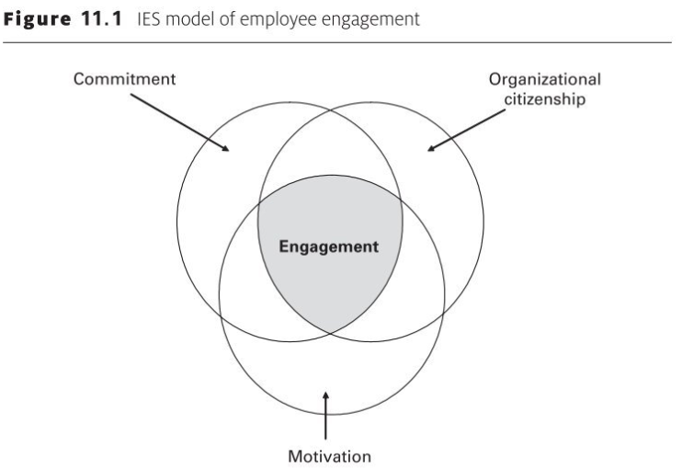
The components of engagement have been modelled by The Institute for Employment Studies (IES). Engagement is the level of employee involvement and identification with the organization. Organizational citizenship behavior is employee behavior that goes beyond the sense of duty, is optional, and is not explicitly recognized by the official reward system of the employer organization and contributes to organizational effectiveness. Motivation is the force that creates, directs and sustains the behavior. If the behavior is due to the work itself or self-generated factors, this is intrinsic motivation. Extrinsic motivation is when behavior occurs when something is done or when people do it to motivate them. It is the job itself, not pay or recognition, that creates positive feelings of commitment in employees. Engaged employees feel that their work is an important part of their lives. Developing a culture that generally promotes positive attitudes towards work, encourages interest and excitement in people's work, reduces stress, and recognizes the importance of social interaction will be a strategy for increasing work engagement through the work environment. Employees who entertain themselves in the work environment, are supported and developed by the management, and are self-satisfied and respected in the workplace will provide the best service (Armstrong, 2012).
Drivers of Employee Engagement
In order to manage a process related to employee engagement, it is necessary to understand the factors affecting it. Needs such as business difficulty, autonomy, diversity, feedback, harmony, opportunities for development, rewards and identification are the drivers that managers need to know in order to show a quality leadership. In this context, particularly line managers play a key role in building commitment by clearly defining the purpose of the organization, appreciating the contribution and efforts of the employees, acting as individuals to the employees and making sure that the work done is effectively and efficiently. The high job responsibilities and the high performance expected from the employee affect employee loyalty. Giving employees the right to take initiative in their work allows them to take their work planning seriously, knowing that they are in control in independent environments. Work environments should be created where individuals can demonstrate their different abilities through different activities. Employees should be provided with clear and direct feedback on the effectiveness and performance of their work. The compatibility between the employee's work environment and co-workers causes individuals to form consistent behaviors in the work environment. Opportunities offered to employees to improve themselves cause them to attach more meaning to their work and feel satisfied. Direct or indirect rewards and recognitions offered to employees after doing a good job are among the drivers that can be used to ensure employee loyalty. (Armstrong, 2016).
Organizational Engagement
Organizational commitment can be achieved with an effective management approach that supports the work and well-being of its employees, creates environments where they can transfer their knowledge and skills to their work, creates a strong and positive work culture, and attaches importance to organizational values. High-participation management, providing more opportunities for 'employee voice', developing a 'big idea' and cultivating a culture that encourages positive attitudes in work environments are approaches to building organizational commitment in work environments (Armstrong, 2016).

Measuring Engagement
Engagement surveys have an important role in the implementation and development of engagement strategies applied in an organization. Surveys conducted on basic themes such as employer's pride, employer satisfaction, job satisfaction, personal support from supervisors, understanding the connection between the job and the mission of the organization, and the opportunity to perform well in difficult jobs, allow the organization to have an opinion about the employee engagement to the organization (Armstrong, 2016).

WELLBEING
One of the general contributions HR can make is to promote employee well-being. Contributions to improving the quality of the work environment, including improving employee well-being, health and safety, reducing stress and work-life balance, as well as problems that people may encounter at work (Armstrong, 2016).

CONCLUSION
In the UK labour market, the 'fire and rehire' tactics, although not against the law, are not in widespread use. However, some companies that want to reduce their cost expenses have resorted to 'fire and rehire' tactics, especially to reduce their employee costs by excusing the static business market brought by the Covid-19 pandemic process. British Gas Company is among the companies that apply for this method. Unfairly changing the terms of contract employment entails certain legal obligations for companies. Employees who think that they have been unfairly dismissed can apply to the labour courts and get their rights back by legal means. Negotiating through unions is the best way to combat these seemingly unfair but legitimate tactics for employees who are subjected to 'fire and rehire tactics' by companies. Companies that employ the 'fire and re-hire tactics' harm the workplace work culture as they force their employees into undesirable and bullying working conditions, even if they do not face legal obligations by the labour courts. Not allowing the employees to determine their own contract conditions, not paying attention to the employees of the company in any external difficulties, and imposing sanctions on the employees who try to continue their work in difficult life conditions such as the pandemic will also reduce the commitment of the employees to the organization. The organizational citizenship component will be weakened in the employees who sign the new contract imposed by the British Gas company in order not to be unemployed. Motivation and commitment will decrease over time due to distrust of managers. The disregard of the 'employee voice', which is one of the requirements of organizational engagement, and the formation of a workplace culture based on distrust will also prevent the formation of organizational engagement. In this context, companies such as British Gas, which try to manage their contemporary employment relations with traditional personnel management methods, may face various difficulties and reputational losses. Companies that can offer strategic solutions to disputes that may arise in modern working conditions, in a suitable framework with HRM, will continue their existence by adding value.

RECOMMENDATIONS
The dispute that British Gas had with employees and unions damaged the company's reputation. Although many companies went through difficult times during the Covid-19 process, the government provided the necessary support for the companies to get out of this process with the least damage. Nevertheless, British Gas tried to use the Covid-19 pandemic process in his own interests without considering the situation of its employees who had to work remotely and take compulsory leave. However, this method should be one of the last to apply. Before applying for this method, employees must be given appropriate notice and offered the opportunity to accept or reject the new terms. In cases where the employer is obliged to implement the changes and it is not possible to agree with the employees, fire and rehire tactics can be applied. In cases where they are compelled to use it, it is necessary to ensure that the employees are dismissed fairly from their original contracts by following a fair procedure with a fair justification. Because firing a person will give the right to demand unfair dismissal if they have two years of service. If 20 or more employees are laid off, employers may face expensive penalties for collective filings with employment tribunals. This situation will both leave companies that want to reduce their employee costs in financial difficulties and cause the brand value to depreciate in the public sense.

References
Acas Officials, 2021. ACAS. [Online]
Available at: https://www.acas.org.uk/fire-and-rehire-report/html
[Accessed 10 August 2021].
Ambrose, J., 2021. theguardian. [Online]
Available at: https://www.theguardian.com/business/2021/apr/01/thousands-british-gas-customers-switch-fire-rehire-plan
[Accessed 28 June 2021].
Armstrong, M., 2012. Armstrong's Handbook. 3rd ed. s.l.:Kogan Page.
Armstrong, M., 2016. Armstrong's Handbook of Management and Leadership for HR. 4th ed. Philadelphia: Kogan Page.
Cabrelli, D., 2012. Employment Law. 3rd ed. s.l.:Pearson Education.
CIPD, 2021. CIPD. [Online]
Available at: https://peopleprofession.cipd.org/profession-map
[Accessed 20 6 2021].
Espiner, T., 2021. BBC. [Online]
Available at: https://www.bbc.com/news/business-56746656
[Accessed 30 July 2021].
GMB Union, 2021. GMB. [Online]
Available at: https://www.gmb.org.uk/news/british-gas-fire-rehire-dispute-over-after-gmb-members-back-improved-pay-deal
[Accessed 25 August 2021].
Hann, D. & Nash, D., 2020. ACAS. [Online]
Available at: https://www.acas.org.uk/disputes-and-their-management-in-the-workplace-a-survey-of-british-employers
[Accessed 12 August 2021].
King, B., 2021. bbc. [Online]
Available at: https://www.bbc.com/news/business-57670287
[Accessed 8 August 2021].
Marketline, 2016. MarketLine. [Online]
Available at: https://advantage-marketline-com.ezproxy.uwtsd.ac.uk/Company/Summary/british_gas_solar_gd_11292
[Accessed 24 August 2021].
MarketLine, 2021. MarketLine. [Online]
Available at: https://advantage-marketline-com.ezproxy.uwtsd.ac.uk/News/fire-and-rehire-on-the-rise-banks-must-use-it-as-a-last-resort-and-get-it-right_59400
[Accessed 23 August 2021].
Taylor, S., 2021. CIPD. [Online]
Available at: https://www.cipd.co.uk/knowledge/fundamentals/emp-law/about/uk-court-system-factsheet#12905
[Accessed 20 August 2021].
Torrington, D., 2017. Human Resource Management. 10th ed. s.l.:Pearson Education.
Torrington, D., Hall, L., Taylor, S. & Atkinson, C., 2014. Human Resource Managemant. 9th ed. Harlow: Pearson Education.
Wahab, A. & Green, M., 2021. CIPD. [Online]
Available at: https://www.cipd.co.uk/knowledge/fundamentals/relations/diversity/factsheet
[Accessed 12 August 2021].

