Reidy Luke
2028866@uwtsd.student.ac.uk
Abstract
A report containing a self-reflection of various professional, academic and life skills.
Reflection on study skills
Ordnance, Munitions and Explosives Level 4 Apprenticeship – Study Skills Module – Assignment 1 – University of Wales Trinity St. David

Contents
1. Introduction 3
2. Presentation 3
2.1 Overview of Task 3
2.2 Selection of slides 3
2.3 What was learned (Key points I learned from) 5
2.4 How can it be improved 5
3. Skills Evaluation 11:15 – 13:00 6
3.1 Skills for Success 6
3.1.1 Higher Education 6
3.1.2 Employment 7
3.2 Self Evaluation Exercises 20mins 8
3.2.1 Strengths and Weaknesses 8
3.2.2 Personality Tests 8
3.2.3 Personality Summary 11
3.2.3 Career Suggestions 11
3.3 Goals 10mins 11
3.4 SMART Action Plans 12
4. Application 13
4.1 Looking after your data 13
4.1.1 Backup Strategy: 3 Different Places 13
4.1.2 Disaster Scenario 13
4.1.3 Ransomware Report 14
4.2 Time management and Self-Organisation 14
4.2.1 Actions for improvement 14
4.2.2 E-Portfolio 15
5. Conclusion 17
6. Recommendations 17
7. Bibliography 17
8. Appendices 18
Appendix 8.1 Skills Evaluation Questionnaires and Surveys 18
Moodle self-evaluation form 18
Appendix 8.2 Ransomware class exercise 19
Appendix 8.2 The Threat of Ransomware 19
Appendix 8.2 What is ransomware? 19
Appendix 8.2 Who could use it? 19
Appendix 8.2 What is CryptoWall? 19
Appendix 8.2 How it gets on the system 20
Appendix 8.2 What impact could it have? 20
Appendix 8.2 How can we fight it? 20
Appendix 8.2 How can we prevent it? 20
Appendix 8.2 Conclusion 20
Appendix 8.2 References 21

Introduction
This report aims to understand various professional, academic and life skills in order to improve, or gain further skills in necessary areas. This report covers a wide range of topics ranging from interpersonal skills to data handling behaviours, and attempts to self-assess both the current skill level, and a plan to improve them where necessary.

Presentation

2.1 Overview of Task
As part of the module, a timed presentation was delivered in front of the classroom on the topic of ‘Who we are’, with each student discussing the following topics over 5 minutes:
- Personal history,
- Personality,
- Strengths and weaknesses,
- Likes and dislikes,
- Goals from the course,
- Where we will be in 10 years
Prior to the delivery of this presentation, I attended a single lecture on presentation skills, delivered as a webinar. Most of my skills and knowledge going into this activity were based upon the points learned in that session, which included tips for being personable and expressive with body language and speech. Another tips was to design the slides to be eye catching, yet not dominate the content. I wanted to avoid simply reading off the screen.
Here are some example slides from the presentation:

2.2 Selection of slides
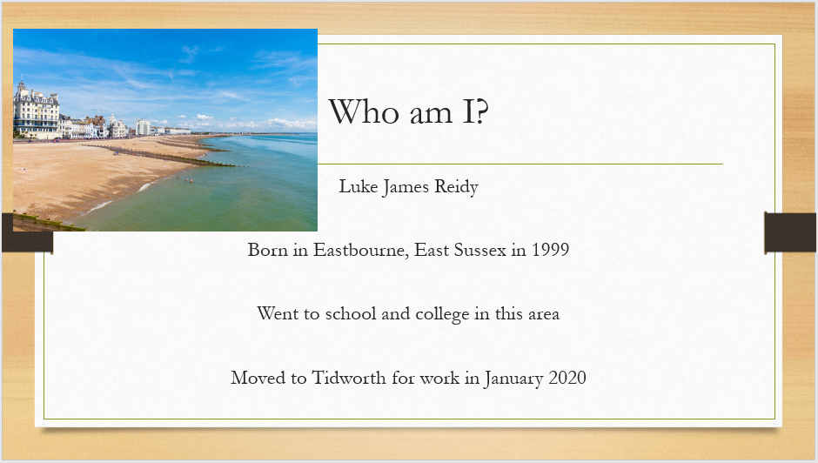
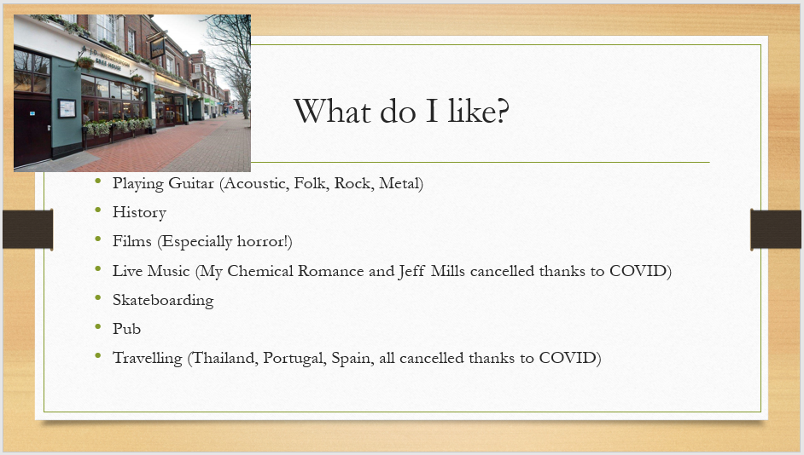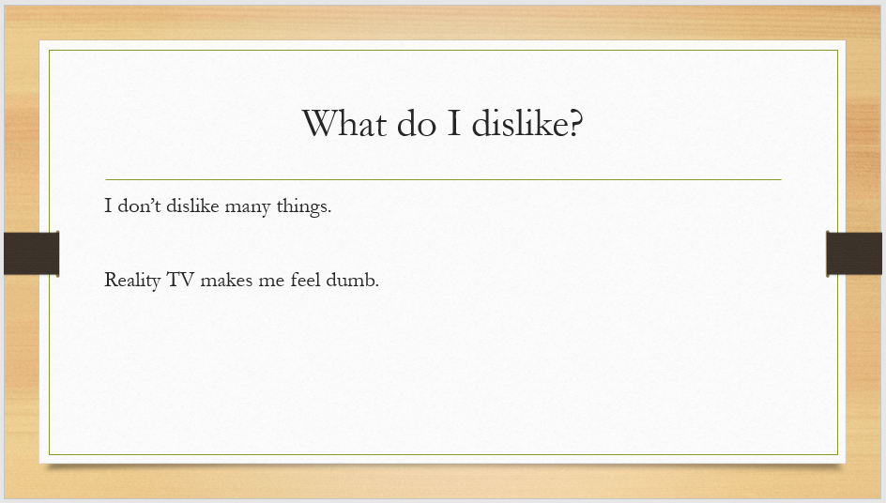

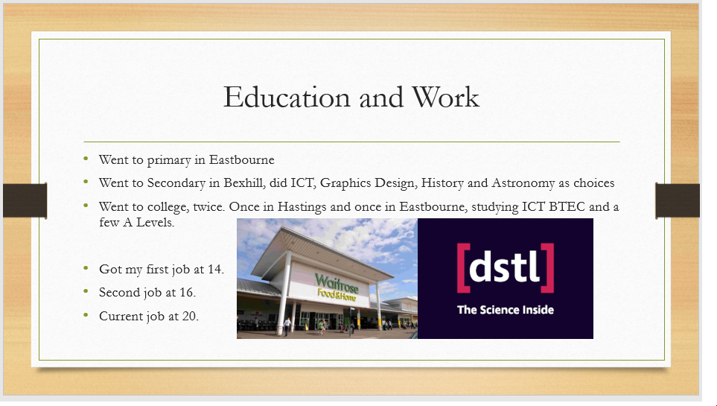

2.3 What was learned (Key points I learned from)
When developing the slides for the presentation, the student had kept in mind their past presenting style, which had proven to be successful when the following aspects were applied:
- Small elements of humour
- Conversational delivery style
- Not reliant on slides, somewhat improvisational
Upon reflection, the ultimate goal of these three elements was to achieve greater confidence in the vocal and physical delivery of the presentation, as this was a limiting factor in many past attempts. The focus on these factors led to a lack of focus on other areas, namely:
- Good structure
- Slide content
This lack of focus resulted in a priority on one style of preparation which has been used in the past: the repeated recital of the presentation to a recording device, which is then listened back to and re-attempted. Through repeated improvisation the presentation content is developed beforehand as a vocal performance, rather than using PowerPoint slides as the basis for the structure.
This results in both the positive effect of increasing confidence and humanising the delivery, but also the negative effect of a lack of structure, as well as risking tangents, something which the lecturer pointed out in their assessment of the presentation.

2.4 How can it be improved
Two key aspects of the presentation were assessed:
- ‘Quality of the PowerPoint visuals’: Marked 65% (32.5/50)
  - “Try to stick to san-serif fonts for slides.”
  - “Generally clean + good looking slides.”
  - “Maybe make some of the images bigger – also include more.”
- ‘Personal skills in delivering the PowerPoint’
  - “Very confident delivery.”: Marked 70% (35/50)
  - “Clear + easy to understand.”
  - “Good audience interaction – very engaging.”
  - “Timing @ 7:20 [minutes] ran on a bit at the end.”
  - “Sometimes went off on a bit of a tangent!”
The key points made by the lecturer seem to line up with the self-analysis for the most part, notably in the emphasis on confident and engaging delivery, with a tendency to lose delivery pace and talk too much about single points or tangential thoughts.
Following the lecturers advice, a greater focus on developing the slides would greatly benefit and compliment the delivery style, which in itself should be tightened up to ensure an appropriate amount of time is spent on each talking point. Some methods for achieving these improvements have been investigated:
- Solent University recommends flash cards with limited notes to help keep each point succinct [1]. The article contains various suggestions towards how they should be created and used. In future presentations, I will look to use flash cards during either the practice, or the delivery of the presentation.
- Increasing the quality of the PowerPoint itself by:
  - Including more imagery across the presentation, and making the images larger, to stand out more to the viewer. [2]
  - Including more content and text on certain slides to achieve a consistent flow of information throughout. This will help me spend a more equal amount of time on each slide.
  - Using a clearer font style.

Skills Evaluation 11:15 – 13:00

3.1 Skills for Success

3.1.1 Higher Education
There are various skills and behaviours which are commonly recognised by experts as vital for success in a higher education setting, and one’s ability to assess and improve these skills will be an important factor in future achievement.
Clark University talks about dealing with the newfound freedom of being a college student, and states that the following skills can help “develop your own internal structure and be successful in college” [3]:
- “Time Management
- Stress Management
- Study Skills
- Money Management
- Assertiveness Skills
- Well Developed Self-care skills
- Keeping safe and avoiding risky behaviour
- Seeking assistance when needed
- Respecting the rules and policies
- Displaying honesty, integrity and perseverance”.
One of the skills mentioned is ‘time management’, which is very important for success in not only academia or employment, but also success for life in general. Being able to spend an appropriate amount of time on each task, with enough time to develop ideas and deal with issues, is vital for dealing with the larger workloads and simultaneous tasks of higher education. Being able to properly prioritise tasks and assignments is an important aspect of time management, Graduatecoach.co.uk states: “As University students, you are often set multiple assignment deadlines over a short space of time so it is imperative that you are able to prioritize the order in which the assignments need to be completed.” [4]
Being able to use our time effectively is just as important, and so that we don’t waste time attempting to organise thoughts when carrying out a task, a good planning method should be used. Graduatecoach.co.uk suggests “to break the planning process down… into three sections: Research, Paragraphs and Bullet Points.” [4] This proposal aligns with the content learned in class, where good report writing skills involves having a complete plan for the structure, headings and contents of the report before beginning the writing process.
English.com makes reference to the ‘Global Scale of English (GSE) Teacher toolkit’, which organises the skills that a higher education student is expected to have into the following categories:
- “Academic Discourse – skills for communicating effectively in debates, discussions and presentations
- Academic Text Strategies – skills for analyzing academic texts in greater detail
- Academic Strategies – skills for understanding and responding critically to lectures
- Composition – skills for effective academic writing
- Comprehension – skills for understanding academic texts and lectures” [5]
The common theme of skills seems to centre on having good note taking strategies, good comprehension of lecturers and course content, as well as strong interpersonal skills.

3.1.2 Employment
In the workplace, many of the skills required in higher education can be applied in similar ways, but there are often other factors at play influencing our stress levels and ability to complete the tasks. The nature of the workplace often means there is greater stress when tasks are not completed to a good standard as other people are often reliant on that task being done. The role of interpersonal skills plays a larger role in the workplace as well, as teamwork is much more necessary with larger projects and workloads.
Time management and stress management are two highly linked skills, but additional care should be taken to identify stress levels, as “job stress [can] significantly reduce the performance of an individual”, as found in this study from 2018 [6]. Appropriate action should be taken to reduce these levels to be better able to produce high quality work.
Whilst there are many specific skills required in many industries, some skills are common across nearly all workplaces. When looking to hire someone, an employer will often consider the skills of each of their candidates and compare them to make a hiring decision, meaning these skills are vital to ensure success in the job market. According to careers.govt.nz, Employers usually consider:
- “Positive Attitude
- Communication
- Teamwork
- Self-management
- Willingness to learn
- Problem solving/decision making
- Resilience” [7]
A common theme in these skills is the ability to stay positive and resilient when things are going wrong, and this is something which a new student might not be skilled at when first entering the workforce, so it is important to consider. Indeed.com recommends positive thinking, claiming that it can help “reduce stress levels”, “boost productivity”, and “increase resiliency”, allowing someone to “move forward decisively and seek help when they need it to get the job done.” [8]

3.2 Self Evaluation Exercises 20mins

3.2.1 Strengths and Weaknesses
Before carrying out the personality tests, I attempted to understand my weaknesses and strengths in the presentation. I believed my strong points were centred on ICT and computing skills, having been exposed to that area for most my life, and I have always enjoyed picking up new skills, and knowledge, which perhaps translates into being skilful at learning.
Strengths, Skills and Qualities:
- Use of IT and a range of resources to find information.
- Confidence to try new things and express my ideas
- I have good note taking strategies.
- I can write things in my own words.
What I need to work on, develop or improve:
- Time management and organisation.
- Workload management.
- Not saying no to new tasks
- Inconsistent strategies to begin a task

3.2.2 Personality Tests
During class, a self-assessment of our personality types was attempted, using a range of different tests. These results were compared with each other test, as well as the initial assessment of our personalities during our presentation. After aggregating the results of all the tests, there are some trends and patterns in my personality that have become obvious.

3.2.2.1 IPIP BFFM ‘Big Five’ Personality Test
The first test I carried out was the IPIP Big Five Factor Markers test, with results seen in the image below.
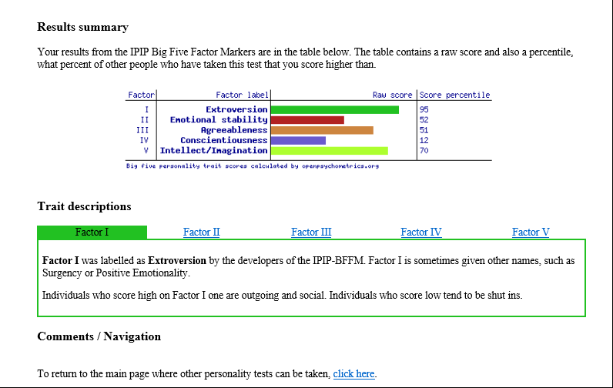
The highest score achieved was on the extroversion factor, and the lowest on the conscientiousness factor. This likely means I am somewhat impulsive and disorganised, but very outgoing.

3.2.2.2 Jungian/Myers-Briggs Personality Test
The next test carried out was the Jungian/Myers Briggs test, with results in the image below.
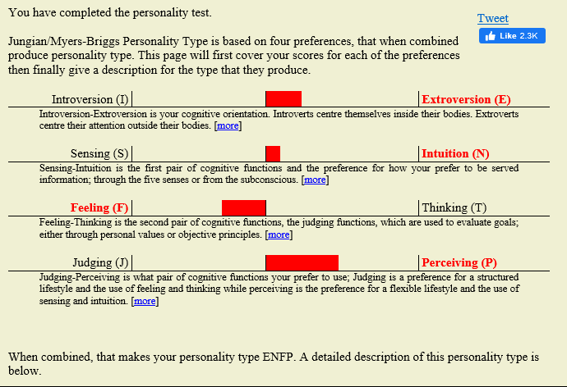
The test resulted in ‘ENFP’, who are, according to openpsychometrics.com: “initiators of change” and “tireless in the pursuit of new-found interests”. I carried out the same test again using a different website, which led to the same result.
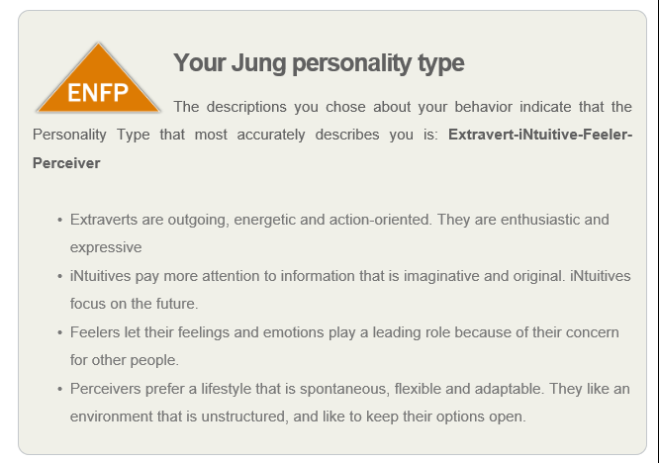

3.2.2.3 Holland’s Theory RIASEC
Next, the ‘RIASEC’ test was carried out. “Holland’s Theory posits that people can be categorised according to six personality types – Realistic, Investigative, Artistics, Social, Enterprising and Conventional.” [REF]
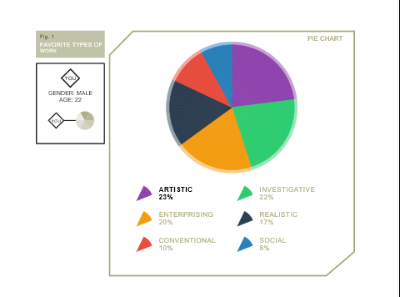
My results seem to point towards someone who is more artistic, investigative and enterprising (making up 65% of the pie chart), rather than realistic, conventional or social (making up 35% total). According to self-directed-search.com, an artistic type “usually likes to work with ideas more than things. They are usually described as open, creative, independent, emotional, impulsive and original.” [REF]

3.2.3 Personality Summary
The reason for doing multiple tests is to avoid confirmation bias as much as possible, which is a risk when carrying out self-assessments.
I have completed the Myers Briggs personality test on many occasions in the past, to varying results, leading me to the conclusion that these tests very often tell us what we want to hear. Only by doing multiple different ones, and at different points in life, can they start being useful as tools to track how we grow, change and develop over time.
When developing the presentation, my opinion of my personality was that I enjoy learning new things and picking up new skills, hence “I love to learn new knowledge and new skills” on the ‘My Strengths’ slide.
Additionally, I can be an over thinker, and spend too much time thinking about an issue before taking action. However, being something that I was conscious about, it was also something I was attempting to improve upon, by being quicker to start taking actions with a task.
As I was in a mind-set of trying to be more impulsive, and reduce time spent worrying or thinking about a task, the personality tests have resulted in a more extroverted and impulsive assessment, rather than the introverted over thinker that I expected. However, this doesn’t necessarily mean the results are skewed; rather that my attempts at improving those aspects have been somewhat successful.

3.2.3 Career Suggestions
Carrying out the 123test.com careers test, I received a top result of Jeweller. This does not at all line up with my goals or desires, and stuck out as an overly simplistic test, as it simply asks you to select one like and one dislike from 15 sets of 4 professions. This test works with the Holland code test, discussed earlier, but tries to assign a specific career or profession to the Holland code, which I think is somewhat subjective.

3.3 Goals 10mins
Following the assessment of my strengths and weaknesses, I now know which areas will require attention.
In the short term (multiple months), I will seek to improve my time management skills and task approach skills. I want to be working at a higher level in the future, and these skills will be absolutely necessary for continued professional development.
In the long term (multiple years), I want to explore options in highly skilled and potentially dangerous lines of work, such as Non-Governmental Activities in war-torn regions. In my presentation, I expressed this desire, and making it happen will require a lot of work, which is detailed in the following section:

3.4 SMART Action Plans
My Priorities: What I am going to do, when and how:
SHORT TERM GOALS | What? | When? | How?
1. | Improve my time management skills | August | By using a centralised calendar to track and predict tasks and actions.
2. | Improve my workload management | September | Set times to achieve specific steps within a task, and move tasks ahead according to deadlines.
3. | Get more organised | October | Prepare for future events well in advance, ensuring all aspects are double checked.
4. | Create a unified task approach strategy | November | Ensure consistency by creating a set of templates and procedure documents explaining usual strategies.

How will I measure if I have improved?
- If I can use my calendar for all actions, and stick to following it, then I shouldn't be late or miss any deadlines. I should feel less stressed with upcoming targets.
- If I can track each distinct action retrospectively with a task, I'll know I succeeded.
- By not failing to be prepared for any event or meeting, having all required notes and resources available.
- If I am using the templates I create often, and it reduces overall workload in the early sections of a task.
LONG TERM GOALS | What? | When? | How?
1. | Pass OME HNC | May 2024 | Ensuring I stay on top of all assignment work, and continue to develop the professional side of the apprenticeship by exploring opportunities, networking and ensuring I use the templates provided to track my progress
2. | Work for an NGO | Jan 2030 | Continually developing useful practical and professional skills, as well as establishing a network beyond the organisation via secondments and visits.

Application

4.1 Looking after your data

4.1.1 Backup Strategy: 3 Different Places
In order to ensure data is protected from the many different risks at play on the wider web, a good backup strategy must be in place. Keeping data in 3 different places ensures that in the event of any catastrophic failure, there is always a second line of defence, mitigating the potential for data loss. Any system with a single point of failure is generally a badly designed system, and our backup systems are no exception to this rule.
The practical application of this involves keeping data in three locations, where if one was to fall, the other two would be separated enough to stay active. This means having physical storage separated by distance, digital storage separated by using different passwords and storing on entirely different networks, or even using the cloud to store things independently of any one device.
In the current implementation of the backup system, data is stored primarily within the E-Portfolio, with cloud storage being used to both transfer documents between devices, but also to provide a second layer of backups. Finally, a third, completely separate device that is not turned on very often is used to store the final layer of backups.
Data is transferred between these systems via email and software methods, rather than physical devices such as USB memory sticks being used to transfer data.

Part of any good backup system is a backup schedule, ideally automated. With this cycle, information is stored on cloud storage at the same time as the E-Portfolio, and larger, more final pieces of work are stored on the client archive storage unit. Generally, the later in the backup chain, the longer between backups, but there is always room for exception when following the golden rule of ‘better safe than sorry’. Important documents and photos are backed up straight away, whereas some items may only be backed up to the cloud storage if they are not as vital.

4.1.2 Disaster Scenario
There are many different events or scenarios that can have an effect on your data. Some of the most notable are: [9]
- Power surges, and other natural events inflicting damage to storage devices on a network, causing data loss. The E-Portfolio is stored on a laptop, the cloud based system should stay up, and the client archive is on a separate power network completely.
- Malicious software attacks, involving a virus which corrupts or encrypts data, or simply locks the user out of the computer, making the data inaccessible. In the event of this scenario, the cloud storage and the client storage should still remain accessible. The client storage is very infrequently turned on, so risk of infection is much lower.
- User error, involving accidental deletion of data, forgetting passwords, damaging equipment or misplacing physical storage media. This exposes the greatest risk, but would be difficult to accidently delete all three copies of data. However, if all passwords are forgotten, or if schedules are not followed, the backup system can become ineffective.

4.1.3 Ransomware Report
In class, a report was completed on a type of ransomware called ‘Cryptowall’ [see appendix]. The crypto wall virus is an example of a highly dangerous and effective virus which inflicted a lot of damage on businesses and users.

4.2 Time management and Self-Organisation

4.2.1 Actions for improvement
What steps to take to enhance productivity?
After identifying the need for improved time management, it was decided to start using an electronic calendar to track tasks, deadlines and events. I use the Outlook e-calendar when at work and university to organise my days, as can be seen in the following image (some information redacted.)
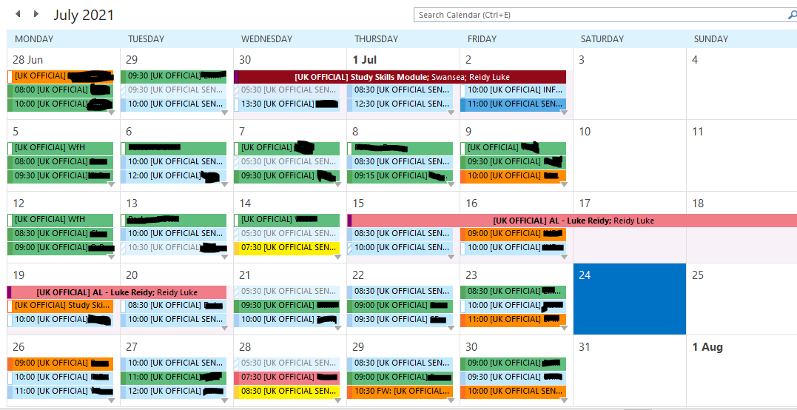
The calendar uses colour coding so that I can quickly determine what type of event the item is
- Pink: Miscellaneous, Breaks, Holidays, Driving time
- Green: Regular transactional tasks
- Blue: Irregular specific tasks or meetings
- Orange: Important Meetings
- Brown: Academic time
At the start of each day, I will set my agenda by filling the day with tasks or meetings. If I don’t think I can achieve it on the same day, I will move it to the next one, ensuring a continuous pipeline of tasks and activities, meaning I always know what is next. This calendar is also visible to my colleagues, and allows me to make sure other people know what I’m doing or where I am, and vice versa, helping reduce stress from colleagues across the workplace.

4.2.2 E-Portfolio
When designing my E-Portfolio in the past, I have attempted a few different methods. Before the course, I used a model that looked like this:
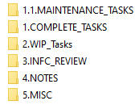
Keeping numbered folders helps quickly reach the desired location, as it will always been in the same order, and allowed for a hierarchical folder structure. Documents were divided by their formatting and importance, with main tasks being stored in the WIP folder, self-assessments in the review folder, and notes in the notes folder and everything else in the miscellaneous items folder.
I would go on to use a model more akin to this, which separated documents by work area.
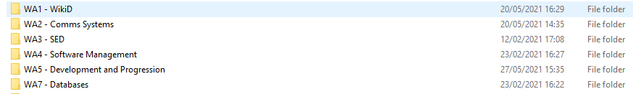
And finally, since starting the course and learning more about E-Portfolios, I am using the following model:
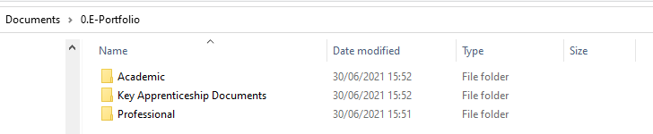
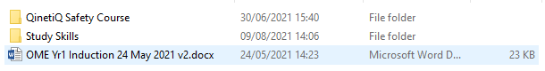
Previous methods that I used suffered primarily from having too many parent level folders, meaning it took longer and longer to find information as more of the structure became filled out. This current model improves on that aspect, as it cuts down the number of parent folders to just three, dividing work based on its intended purpose. This increases the speed of use, and therefore overall efficiency, and reduces the stress that hard-to-navigate folder structures can bring.

Conclusion
Throughout the process of self-reflection and evaluation, I have been able to pick up on many aspects of my skills, behaviours, personality, and honestly assess them so that I can identify where I can improve and increase my abilities. It has been a useful process to carry out, as it has also allowed me to break down the steps that I must take in achieving my goals, as well as identifying areas in which I struggle; notably Time Management. Moving forward into my course and employment, the awareness of my skills and the continued practice of self-reflection will be vital for success.

Recommendations
Personality Tests:
https://openpsychometrics.org/
https://www.123test.com/jung-personality-test/
https://www.123test.com/career-test/
https://self-directed-search.com/riasec-theory/

Bibliography

[1] | Solent University, “Solent Online Learning - Successful Presentations,” Solent University, [Online]. Available: https://learn.solent.ac.uk/mod/book/view.php?id=116232&chapterid=15270. [Accessed 9 August 2021].
[2] | Al, “ShapeChef - PowerPoint Tips and Tutorials,” 21 August 2017. [Online]. Available: https://www.shapechef.com/blog/how-to-choose-images-for-your-powerpoint-presentation. [Accessed 9 August 2021].
[3] | “Clarke - Essential Skills for College Students,” Clarke University, [Online]. Available: https://www.clarke.edu/campus-life/health-wellness/counseling/articles-advice/essential-skills-for-college-students/. [Accessed 9 August 2021].
[4] | GraduateCoach, “GraduateCoach - Organisational Skills for Students [5 Top Tips],” 7 December 2020. [Online]. Available: https://graduatecoach.co.uk/organisational-skills-for-students/?nowprocket=1. [Accessed 9 August 2021].
[5] | R. Cleeve, “5 academic skills to prepare your students for higher education,” 22 October 2018. [Online]. Available: https://www.english.com/blog/academic-skills-for-higher-education/. [Accessed 9 August 2021].
[6] | S. Ajayi, “Effect of Stress on Employee Performance and Job Satisfaction: A Case Study of Nigerian Banking Industry,” 2018.
[7] | Tertiary Education Commission - New Zealand Government, “Skills employers are looking for,” 26 February 2020. [Online]. Available: https://www.careers.govt.nz/plan-your-career/get-ideas-for-your-career/skills-employers-are-looking-for/. [Accessed 9 August 2021].
[8] | Indeed Editorial Team, “Positive Thinking in the Workplace: Benefits and Tips,” 5 March 2021. [Online]. Available: https://www.indeed.com/career-advice/career-development/positive-thinking-in-your-career. [Accessed 9 August 2021].
[9] | Paceadmin, “4 Data Loss Scenarios that can Happen to You!,” 12 December 2013. [Online]. Available: https://pacetechnical.com/2013/12/12/4-data-loss-scenarios-that-can-happen-to-you/. [Accessed 9 August 2021].

Appendices

Appendix 8.1 Skills Evaluation Questionnaires and Surveys

Moodle self-evaluation form
- I have the confidence to try new things and express my ideas: 5
- I am self-motivated and will persevere with difficult tasks: 3
- I am organised and can meet set deadlines: 3
- I am able to find information from different resources easily: 5
- I can read complicated texts and understand the general meaning: 3
- I am able to select what is relevant and what is irrelevant in text: 4
- I can compare different opinions and decide what are the best grounds for deciding who is right: 4
- I can write things in my own words: 4
- I am able to reflect and evaluate my own work: 3
- I have good strategies for starting a new task/assignment: 3
- I have good time management skills and can organise my workload effectively: 2
- I am able to make, store and find my notes: 4
- I am able to manage a range of writing skills appropriately: 3
- I am able to think critically and analytically, and evaluate arguments: 4
- I have good memory strategies: 4
- I know how to use IT to help academic study: 5
- I am confident at preparing and delivering oral presentations: 3

Appendix 8.2 Ransomware class exercise

Appendix 8.2 Cryptowall: The dangers of Ransomware
  - By Luke Reidy

Appendix 8.2 Contents
The Threat of Ransomware 2
What is ransomware? 2
Who could use it? 2
What is CryptoWall? 2
How it gets on the system 2
What impact could it have? 3
How can we fight it? 3
How can we prevent it? 3
Conclusion 3
References 3

Appendix 8.2 The Threat of Ransomware

Appendix 8.2 What is ransomware?
Ransomware is a form of malware (software that negatively affects a computer system) that makes your data inaccessible (usually via encryption), unless you pay a ransom fee to the attackers.

Appendix 8.2 Who could use it?
A wide range of hostile actors use ransomware to generate funds. A disgruntled employee might be tempted to use their access, or a hostile nation might attack essential government systems.

Appendix 8.2 What is CryptoWall?
Cryptowall is a form of ransomware which carries out a range of potential actions on infected systems: [1]
- It attaches to the start-up program on the device, attempting to hide within.
- It targets and deletes backup copies of data.
- It scans your device for passwords and potentially banking information.
- It disables basic operating system processes.
- It scans your device for personal data, such as documents and photos, and it encrypts it all, making it inaccessible.
There are multiple versions and forms of CryptoWall from a range of hacker groups, which can have varying effects on a system.

Appendix 8.2 How it gets on the system
There are a range of methods through which the ransomware gets onto a computer or network: [2]
- Phishing Emails – A commonly used method, where hackers attempt to trick a user into opening a link or attachment on an email. These emails are often disguised as something mundane or official.
- Remote Desktop Protocol (RDP) – Where remote access, from someone such as an IT administrator, is hijacked, and used to infect the device.
- USB and removable media – If a USB with malware is plugged into a device, it could become infected.
- Compromised web pages – Webpages that have been designed or hijacked, in order to trick the user into clicking a link or running a program that will infect the device.
Additionally, more advanced ransomware can spread from device to device, infecting a whole network; this occurred during the 2017 ‘WannaCry’ ransomware attack, which spread to over 75,000 computers in over 99 countries, including 48 National Health Trusts. [3]

Appendix 8.2 What impact could it have?
Ransomware targets all sorts of organisations, but often times attacks companies where the loss of data would have catastrophic consequences. If a company doesn’t have the appropriate backup measures and security systems,

Appendix 8.2 How can we fight it?
Malware is usually designed to be difficult to fight. Often times without proper preparation, systems are entirely lost to ransomware. Restarting the PC won’t do anything, but you do have some choices:
- Unplug the infected devices to prevent any spread. Disconnect them entirely from the network.

Appendix 8.2 How can we prevent it?
In previous ransomware attacks, often times the threat could have been mitigated by following basic security measures. This involves: [1]
- Keeping up to date with security updates and operating system updates.
- Never clicking on untrustworthy links or attachments.
- Using an anti-virus system.
- Using a firewall.
- Using a backup system.
- Teaching good practice to users.

Appendix 8.2 Conclusion
In summary, ransomware attacks are one of the prime threats to any business or data storage system, and as a result a large amount of effort should be allocated to prevent future attacks from occurring, or being as devastating. This means implementing proper backup systems with multiple separated points of failure.

Appendix 8.2 References

[1] | J. Petters, “Varonis,” 17 June 2020. [Online]. Available: https://www.varonis.com/blog/cryptowall/. [Accessed 01 July 2021].
[2] | A. Challita, “www.itproportal.com/,” 09 August 2018. [Online]. Available: https://www.itproportal.com/features/the-four-most-popular-methods-hackers-use-to-spread-ransomware/. [Accessed 01 July 2021].
[3] | “www.bbc.co.uk,” BBC, 13 May 2017. [Online]. Available: https://www.bbc.co.uk/news/world-europe-39907965. [Accessed 01 July 2021].

