Digital Skills and Research Methods

Assessment 2

Malgorzata Smialkowska
ID. 2133603
Table of Contents
1. Introduction 1
2. Rationale of the Research 1
3. Research Aim and Objectives 2
4. Literature review 3
5. Research Methodology 4
6. Primary data analysis 5
7. Secondary data analysis 10
8. Conclusion and Recommendation 11
Reference 12
Appendix 14
Google Survey Form 14
Questionnaire 14

Table of Figures
Figure 1 Virtual Learning Environment creates the option for inclusive learning practices for the students 5
Figure 2 Students are way more engaged with VLE in the educational system 6
Figure 3 Personalised learning is the effective benefit of VLE for student satisfaction 7
Figure 4 VLE can create more isolation for the student under poor human-to-human contact 8
Figure 5 Virtual Learning Environment lowered the final grade of students 9

Title: “Impact of Virtual Learning Environment (VLE) – Moodle on students’ learning experience at the University of Wales Trinity Saint David London Campus (UWTSD)”

1. Introduction
The educational institution has been adopting technologies for various purposes, from developing lesson planning to manage communication (Kilcoyne and Habig, 2016). But, usages of the technologies for developing and managing virtual learning environments for education have been effective enough in education. A virtual learning environment (VLE) is clearly a web-based platform required for education, digitisation of online learning and classroom environment. The Moodle software is used for the virtual learning and engagement of the students (Frosch and Goldstein, 2021). However, there are certain impacts available on students’ learning progress and experiences under VLE. This research study has chosen to analyse the impacts of the virtual learning environment on the student’s learning activity and experiences in UWTSD.

2. Rationale of the Research
Educational organisations are applying technologies and the internet to make changes to education and lesson planning (Hwang and Wao, 2021). The development of a virtual learning environment influences the engagement of students, lesson planning and inclusive practice, flexibility in the classroom and an approach towards a learner-centred class environment. Also, VLEs influence the learning progress and experiences of the students. The application of technologies has already helped the students of UWTSD to value the virtual learning environment in different ways (Nowfeek and Rupasinghe, 2022). Also, some of the students would definitely have different opinions regarding the benefits and challenges of VLE. In this situation, this research study has options to develop skills related to education and usages of technologies in the educational organisation.

3. Research Aim and Objectives
The aim of the study is to investigate the influences of the Virtual Learning Environment (VLE) on the experiences and learning of the students of (the UWTSD), London Campus. For the completion of the research study, the research objectives are as follows:
- To assess the concept and factors related to Virtual Learning Environment or Moodle Software for students in (UWTSD).
- To investigate the factors contributing to the learning experiences of the students in (UWTSD).
- To analyse the impacts of VLE on the learning experiences of the students in (UWTSD).
- To recommend effective strategies for managing factors and aspects related to VLE for students’ learning experiences and activities in (UWTSD).

4. Literature review
An educational organisation has been approaching a virtual learning environment for benefitting the students and management. Kilcoyne and Habig (2016) stated that the usage of technologies and the internet have helped educational organisation to implement a virtual learning environment. The virtual learning environment has contributed to distance learning, even during the pandemic. In contrast, NASHAAT et al (2021) argued that educational organisations tend to approach inclusive practice with the virtual learning environment. Hence, the learner-centred environment is created with the help of a virtual learning environment. On the other hand, Yuhanis Omar (2021) mentioned that a virtual learning environment contributes to lesson planning and engagement of the students while managing resource utilisation.
According to Ajami and Haidar (2018), student learning experience and progress are highly related to the environment created by the teacher and organisation. But, O’Connor and Larkin (2019) responded that a student would have a positive learning experience due to the engagement and inclusive practices in the classroom. In contrast, Hwang and Wao (2021) argued that inclusive practices cannot contribute to a proper learning experience unless the students have access to resource and learning in the classroom. Hence, educational organisations care for the communication and engagement of the students for better learning.
Yuhanis Omar (2021) stated that the virtual learning environment has contributed to fast and distance learning for the student. During the pandemic, the virtual learning environment has helped the students to gain their learning and knowledge from the teachers. On the other hand, NASHAAT et al (2021) argued that with the help of a virtual learning environment, the students can be easily engaged as the teacher tends to accept the inclusive practice. In contrast, Hwang and Wao (2021) mentioned that a virtual learning environment influences the resource planning and utilisation of materials effectively. However, Nowfeek and Rupasinghe (2022) responded the virtual learning environment has certain limitation and impacts on the mind-set of the learners. Studies showed that the learners have lower grades due to the virtual learning environment as they are not able to grab proper learning online.

5. Research Methodology
The researcher has chosen to collect both primary and secondary research data from the sources. In this situation, the mixed research design has been followed for collecting both qualitative and quantitative data. At first, the researcher has chosen the positivism research philosophy for the study. Positivism research philosophy contributes to the collection of factual data without having personal opinion or bias (Zikmund et al., 2019). The deductive research approach has been followed under the positivism research philosophy for using variables and known journals of the study.
Data Collection and Sampling Method
The mixed research design has been followed for making decisions towards tasks and strategies. Also, a mixed data collection method has been applied to collect primary and secondary data. The primary data collection method has been chosen with the survey research strategy. An online survey helps in collecting numerical data from the respondents with the questionnaire method (Bryman and Bell, 2011). The purposive sampling method has been adopted to select the easier sources of respondents. 20 students of the London branch of (UWTSD) have been selected as the respondents of the survey. Their consent has been collected before taking the online survey.
Under the secondary data collection method, a desk research strategy has been approached. The desk research strategy helps in assessing the variables and vast amount of sources and data from secondary sources (Schindler, 2022). The related and credible journals and articles published after 2011 have been selected for gathering the relevant secondary data.

6. Primary data analysis
The data has been collected from 13 students. MS Excel has been used for analysing, evaluating and representing the primary data. These are as follows:
1. Virtual Learning Environment creates the option for inclusive learning practices for the students.
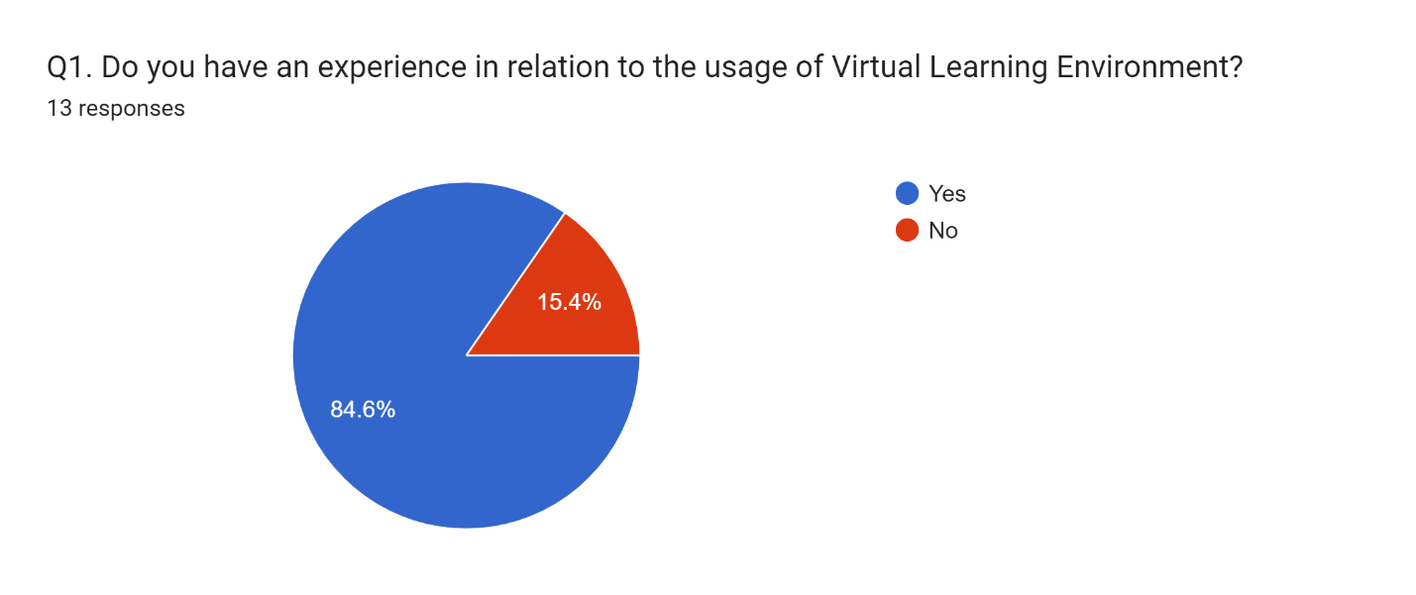
Figure 1 Virtual Learning Environment creates the option for inclusive learning practices for the students
The figure represents that 13 of the respondents have agreed that Virtual Learning Environment creates the option for inclusive learning practices for the students. 84.6% of the respondents have respond yes and 15.4% of them disagreed with the fact. VLE represents the inclusive learning environment where the students can make the decision for learning and lesson planning.

2. Students are way more engaged with VLE in the educational system.
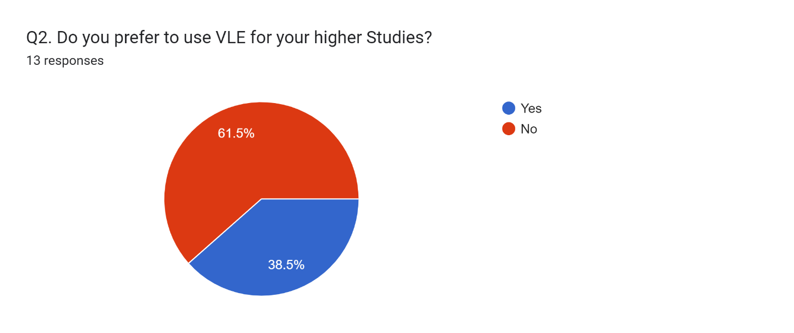
Figure 2 Students are way more engaged with VLE in the educational system
The figure represents that 38.5% of the respondents have agreed that students are way more engaged with VLE in the educational system. 61.5% of the respondents have been of them disagreed with the fact. As VLE helps in lesson planning and decision-making of the students, they are not supported for distance and fast learning in the educational system.

3. Personalised learning is the effective benefit of VLE for student satisfaction.
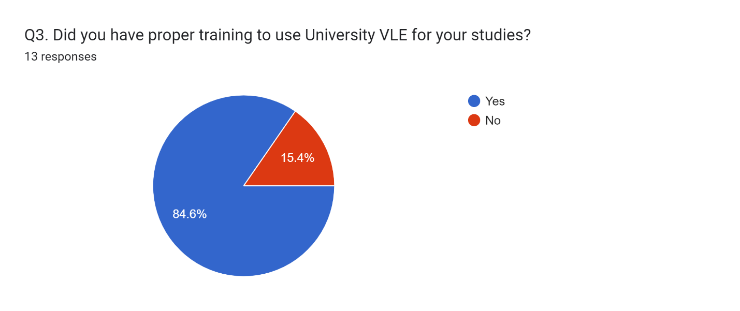
Figure 3 Personalised learning is the effective benefit of VLE for student satisfaction
The figure represents that 84.6% of the respondents have been prepared. 15.4% of the respondents have been marked not prepared. VLE has helped the teachers to develop inclusive and personalised course planning and learning for student satisfaction and learning progress.

4. VLE can create more isolation for the student under poor human-to-human contact.
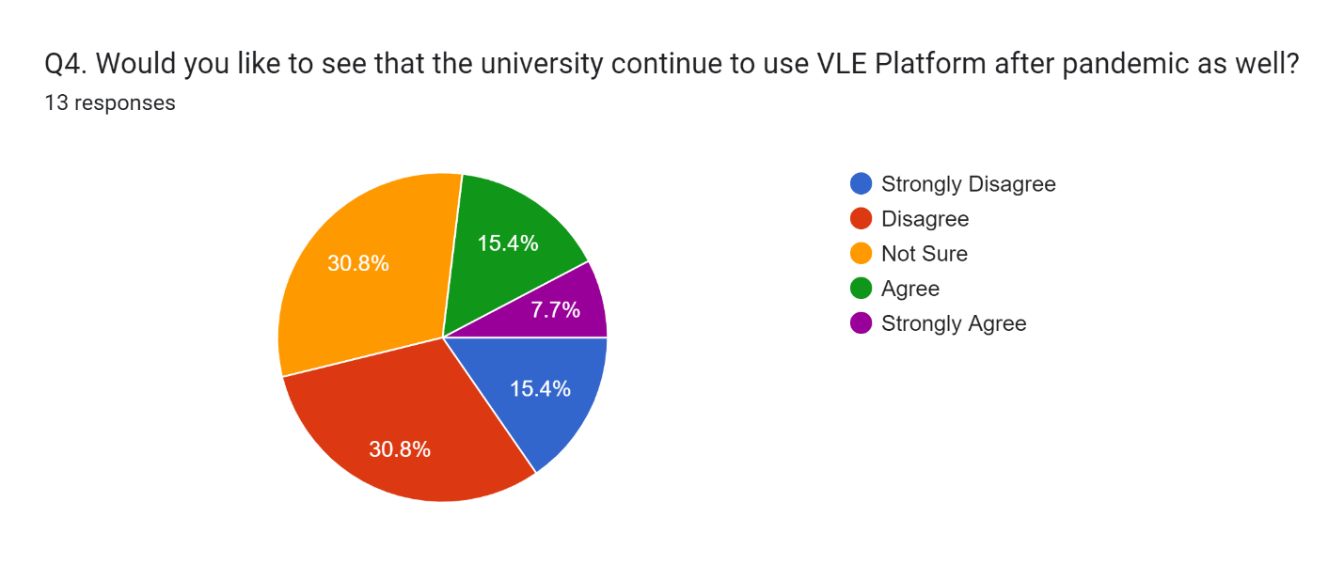
Figure 4 VLE can create more isolation for the student under poor human-to-human contact
The figure represents that 15.4% of the respondents agreed that VLE can create more isolation for the student under poor human-to-human contact. 30.8% of the respondents has been not sure and 30.8% of them disagreed with the fact. The students are isolated and concentrated on own matters which can affect their social learning and mind-set in the long run.

5. Virtual Learning Environment lowered the final grade of students.
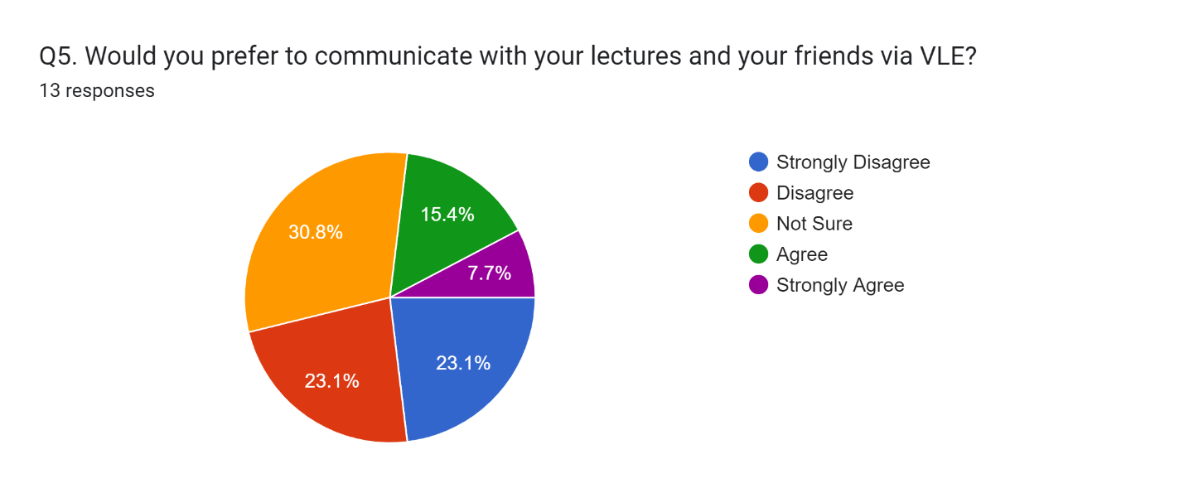
Figure 5 Virtual Learning Environment lowered the final grade of students
The figure represents that 30.8% of the respondents have agreed that Virtual Learning Environment lowered the final grade of students. 7.7% of the respondents have been not sure and 23.1% of them disagreed with the fact. The application of VLE has clear effects on the grade of the students. Students are having less grade while participating in VLE.

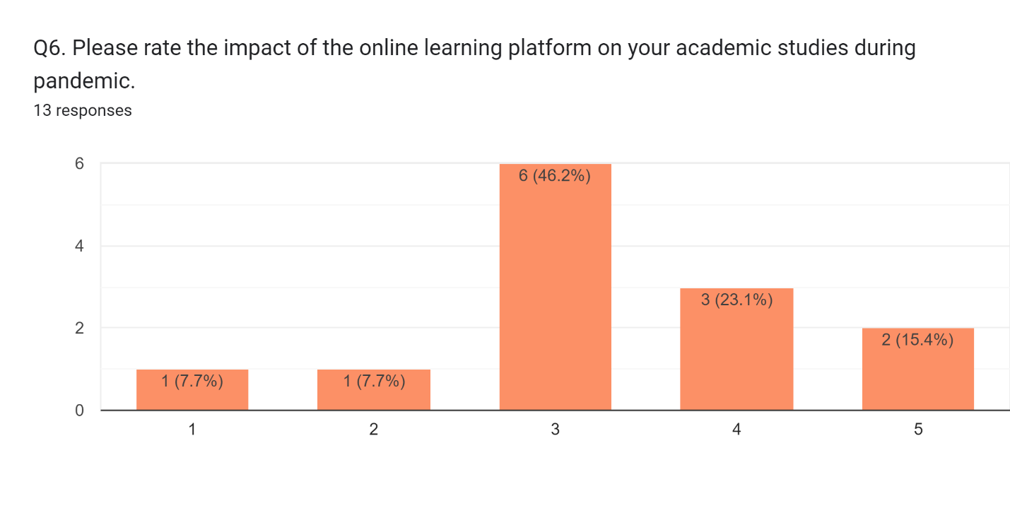
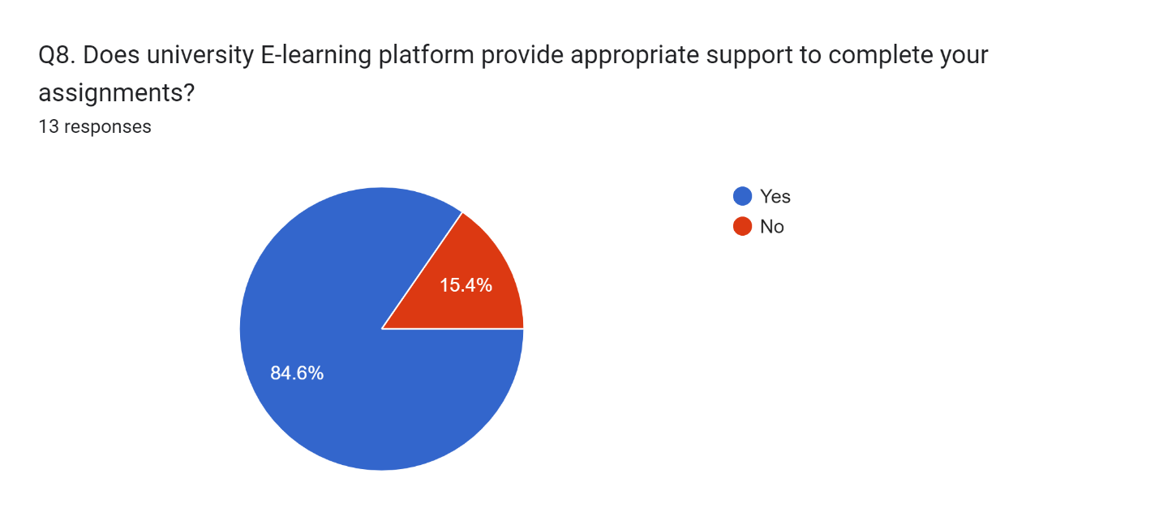

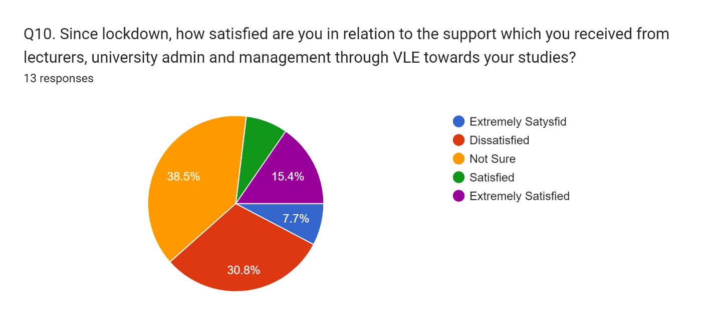

7. Secondary data analysis
The modern technologies and the internet have higher impacts on improving the educational system and learning planning for the students (Frosch and Goldstein, 2021). Even different resources are available in technologies where studies are relying on technologies almost in every area. In this situation, different software and tools are used for implementing and managing a virtual learning environment for the students. During the pandemic, the usages of these tools have been higher as students had to go through VLE. In the meantime, the usages of VLE have higher impacts on both student’s experiences and learning progress in the educational system. Studies showed that a virtual learning environment has great effects on the engagement of the students and inclusive practices for the student (Yuhanis Omar, 2021). These can contribute to the learning of the students in a challenging environment.
However, the virtual learning environment has already affected student’s experience and learning progress in negative ways. The grades are comparatively lowers for the students who prefer to learn in a virtual learning environment compared to the students who prefer to learn in the traditional way (Nowfeek and Rupasinghe, 2022). In this situation, the lacking and limitation of resources for managing virtual learning environments in the educational system have been responsible. The virtual learning environment can be effective in nature if the management/teacher is able to use modern technologies effectively.

8. Conclusion and Recommendation
The 1st research objective was to analyse the concept and factors related to Virtual Learning Environment or Moodle Software for students in (UWTSD). Based on the findings, a virtual learning environment has been adopted for its benefits towards fast and distance learning with more approaches to inclusive practices. The 2nd research objective was to investigate the factors contributing to the learning experiences of the students in (UWTSD). The learners can easily progress in learning with the supports and resources from the educational organisation. The 3rd research objective was to analyse the impacts of VLE on the learning experiences of the students in (UWTSD). The virtual learning environment has both positive and negative impacts on the learner’s learning experience. In some cases, the students can gain fast learning in a supportive environment. Also, the learners can lose some of their grades with poor planning of a virtual learning environment.
The 4th research objective was to recommend effective strategies for managing factors and aspects related to VLE for student’s learning experiences and activities in (UWTSD). Based on the findings, the educational systems have to focus on more modern emerging technologies and internet system to clear the concept of the virtual learning environment. Also, the students need to be more serious while taking part in the virtual learning environment.

Reference
Ajami, K. and Haidar, O., 2018. APPLYING STUDENT EVALUATION OF TEACHING (SET) IN VIRTUAL LEARNING ENVIRONMENT (CASE STUDY: SYRIAN VIRTUAL LEARNING). International Journal of Teaching &amp; Education, VI(2).
Bryman, A. and Bell, E., 2011. Business research methods. Oxford: Oxford Univ. Press.
Frosch, E. and Goldstein, M., 2021. Using a learning community model for virtual medical student support during the COVID19 pandemic. International Journal of Medical Education, 12, pp.136-139.
Hwang, J. and Wao, F., 2021. College Student Satisfaction Typology and Its Relationship With Engagement Patterns. Journal of College Student Development, 62(1), pp.118-124.
Kilcoyne, M. and Habig, W., 2016. Online Learning – Learning Styles in a Virtual World Addressing student learning styles in a virtual class focusing on the ability to enhance the learning experience for students in the online learning environment. International Journal for Innovation Education and Research, 4(12), pp.144-153.
NASHAAT, N., ABD EL AZIZ, R. and ABDEL AZEEM, M., 2021. The Mediating Role of Student Satisfaction in the Relationship between Determinants of Online Student Satisfaction and Student Commitment. Journal of e-Learning and Higher Education, pp.1-13.
Nowfeek, M. and Rupasinghe, D., 2022. Development of a Virtual Learning Environment (VLE) During the COVID -19 Pandemic: A Study with special reference to Advanced Technological Institute. International Journal of Latest Technology in Engineering, Management &amp; Applied Science, 11(01), pp.32-46.
O’Connor, K. and Larkin, L., 2019. Making a Better Student Learning Experience for Virtual Learning Environment Users. International Journal for Digital Society, 10(2), pp.1489-1496.
Schindler, P., 2022. Business research methods. New York: McGraw-Hill.
Yuhanis Omar, A., 2021. Enhancing Student Engagement in VLE Platform: Student Perceptions Towards Programming Course Learning Resources. Psychology and Education Journal, 58(1), pp.5607-

Questionnaire
Yes/No Option:
Likert Scale


