Effective Teamwork and Communication
Assessment

Student Name: Aleksandar Mihaylov
Student ID:2029754
Submission Date: 05/01/2022
Table of Contents
Introduction 3
Models of Communication 3
Communication skills discussed in class 7
Case Studies of empirical reference to the communication skills 8
Poor Communication in workplace 9
Improvement plan of poor communication 10
Conclusion 10
References 11

Introduction
Effective communication comprehensively affects teamwork in both positive and negative manner, as the quality and quantity of the overall concept of communication working within a team and leadership significantly impacts team dynamics. A team is said to work effectively and efficiently together through good patterns of communication and interaction. Poor communication and interaction between the team members tend to bring in unnecessary chaos and hurdles in performing tasks within a workplace (Thompson, 2018). This has therefore been one of the most significant rationales behind businesses encouraging their employees to pay attention to clear communication with the teammates and executives of the organisations at large (Greenaway et al., 2015). The report here, attempts to cover the communication models and skills that have been discussed in the class, to elucidate on the facts of communication and interaction periphery. Moreover, the report also highlights case studies and real instances, experienced within workplaces, in order to provide reference to the communications skills at large. Furthermore, to this context, the report also produces an idea of poor communication in the workplace and boasted about the improvement plan to retain success in the workplace.

Models of Communication
The communication models are widely used within the management of a workplace, in order to depict and decipher an idea, thought, concept etc. The models of communication collectively help the employees and the employers to comprehend any sort of concepts, ideas in order to gain a clear vision of the competencies of the employees in general (McQuail and Windahl, 2015). Therefore, 5 models have been considered and identified to be useful and essential for regular reference of the employers to successfully understand the employee performance and interaction, maintaining team dynamics.
Belbin’s model of communication
The model eventually identifies with eight roles which eventually contributes to the distinctive functioning of the team. Yet it has been observed that each has their own areas of weakness on considering with the eventual blind spot. The Voice point identifies with the necessary voices which are eventually regarded to be the mode of expression. Each of them eventually serves with eventual function, techniques, useful in potential conversation. The overused point is eventually considered to be quite insensitive and eventually it has been observed that the participants are continuous in maintaining necessary interaction through voices (Lynch, et al., 2018). This are considered to be more appropriate and eventually more productive way of attaining with necessary approaches of communication.
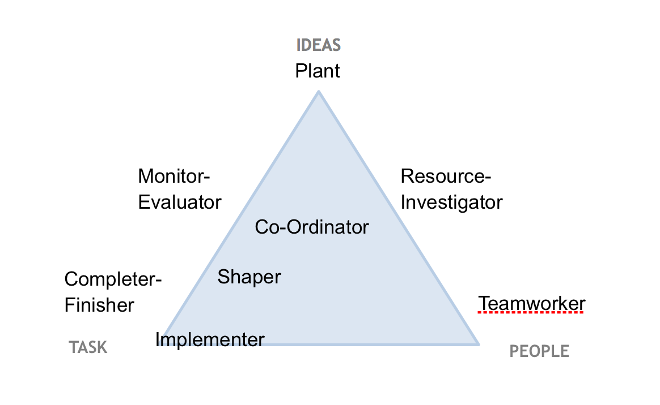
Fig 1: Belbin’s Model of Communication
Source ((Lynch, et al., 2018)

Berlo’s SMCR Model of Communication
This model technically focuses on the encoding and decoding concept, which usually occurs before the sender sends the message and prior to the receiver receiving the message respectively. Berlo’s model of communication usually procures four components and elements that describe the communication process between two or more individuals namely, Sender, Message, Channel and Receiver. The Sender here is said to be the source of the message generated in a communication process or the person originating the message, who is responsible to send the message to the receiver to further provide scope of interpretation (Muyanga and Phiri, 2020). The element of Message in this model or process of communication is the news or content that has been prepared to be sent by the sender to the receiver. This might be in the form of voice, audio, text, video or other media in general. The element of Channel on the other hand, is regarded to be medium that is used in order to send the message. In this context, mass communication and other forms of communication channels, technical machines are seen to be used as channels like telephone, internet etc. The Receiver in this model is the person, for whom the message has been generated and sent throughout the process. In this regard, the message might not possess the same effect as intended to send if the receiver and sender are not similar (Farivar and Wang, 2021).

Figure 2: Berlo’s Model of Communication
(Source: Muyanga and Phiri, 2020)
Shannon and Weaver Model of Communication
This model is usually designed to develop effective communication between the sender and receiver in general. Adding to this, this model at large finds factors from the theory, which affects the communication process called “Noise”. This model further deals with multiple concepts like information source, encoder, channel (noise), decider and destination. The sender is regarded as the information source for the originator of the message, who desires the message to be communicated. The Encoder is the transmitter in this context, which converts the message into signals or Binary data. The Decoder is the reception place of the signal, which further converts the signals into a clear message (Mishra, 2017). Finally, the Receiver is the person or the destination of the message from the sender.

Figure 3: Shannon and Weaver Model of Communication
(Source: Mishra, 2017)

Tuckman’s stages of group development
The Tuckman’s theory of communication has been divided into five stages which would be discussed. This has been regarded to be one of the best featured group communication theory ever to be existed.
- Forming Stage: This is the stage where the group of employees discuss on their primary and life goals. This is the stage where the employees eventually clear the uncomfortableness within themselves (Solomon, 2020). This is the second stage where the employees provide everyone to speak and do not cross examine among each other.

- Storming Stage: This is stage where the employees talk among themselves and discuss about the work and eventually develop with necessary binding during the project.

- Cooperation Stage: This is the stage where the employees work together as a team and eventually discuss about the eventual work force and also discuss on the necessary aspects regarding the work.

- Performing Stage: This is the stage where the employees communicate among each other and eventually adopt with the working culture and the situation.

- Adjourning Stage: This is the stage where the employees develop a good relationship among themselves and eventually try to achieve with the necessary common goal.
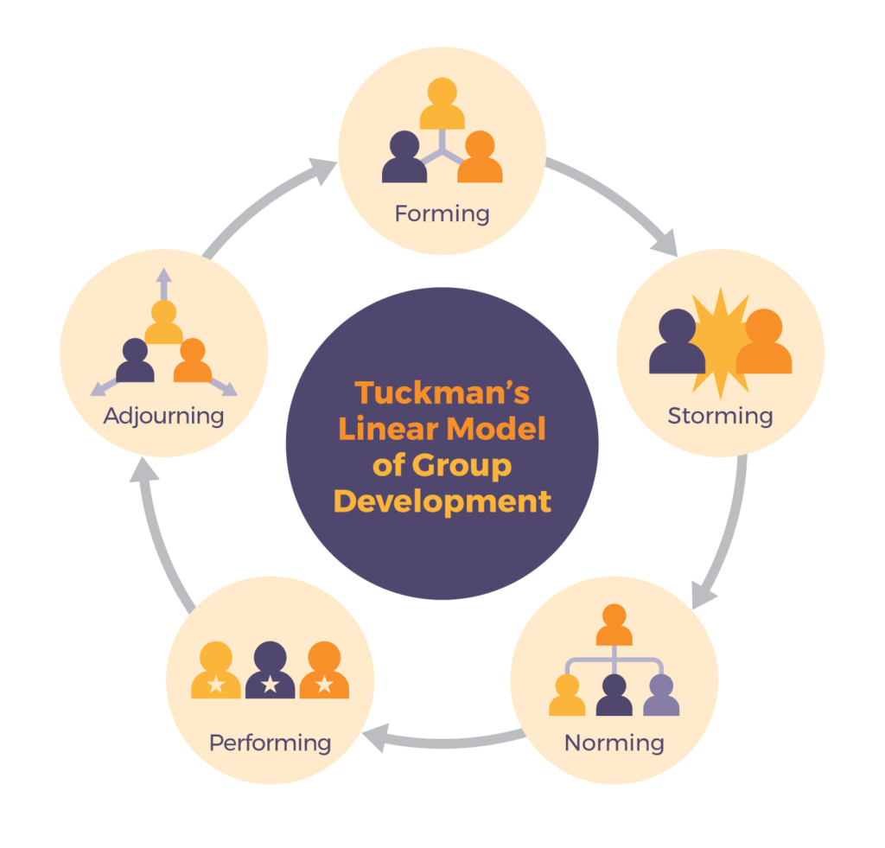
Fig 2: Tuckman’s Model
Source ((Solomon, 2020))

Communication skills discussed in class
Listening: Good listening skills and being an effective listener are said to be the best and required attributes in communication. Ineffective listening makes the communication process hard to interpret for the receiver as well as the sender. Active listening in a two-way communication refers to the context of paying close attention to minute details of the message that has been provided by the communicator (Hargie et al., 2017).
Non-verbal Communication: Effective communication process is usually seen to happen through non-verbal cues and communication skills such as body language, facial expressions, eye contact etc. The process of interaction in terms of two-way communication needs to have innate attention and concentration in order to decide the meaning and interpret the clarity of the message, being received or sent. This can further be done through providing a meaningful body language and facial expression, which successfully conveys most of the message without the need of any words (Buluş et al., 2017).
Confidence: People within workplaces, are more likely to respond to ideas and thoughts, which are presented with utter confidence. Providing vivid eye contact can portray confidence within people, while addressing someone with a certain amount of message (Motschnig and Ryback, 2016). Adding to this, posture, behaviour, communication pattern etc., collectively and profoundly impacts the self-confidence, which is showcased through communication and interaction. This further helps individuals to successfully survive job interviews and presentations in front of clients within a corporate fraternity (Ahmad, 2016).
Empathy: The communication skill of empathy is required to be eligible to work within a corporate world. This communication skill has been said to be important to work in both a team context and one-on-one workplace setting. The element empathy reflects the emotions and way of response of an individual while communicating, which helps the communicators to acknowledge and diffuse their feelings along with supporting the ideas and projects (Ahmad, 2016).
Respect: Respect is demarcated as a key aspect of communication skills, which refers to the knowledge of initiating a particular communication and response at large. This skill of communication and interaction is required in a team-based workplace setting, which allows the individuals to speak without interruption and provide respect to every individual and communication in the team or workforce (Hargie et al., 2017).
Feedback: A strong sense and skill of communication can potentially possess the power of accepting critical feedback as well as provide constructive input to others. The individuals are required to have the innate capability of producing feedback, which are viable to answer the issues identified, provide solutions, and help to strengthen the project at large (Koprowska, 2020).

Case Studies of empirical reference to the communication skills
I have been able to comprehend these mentioned and identified communication skills, as I have been through several cases and experiences, which have struck the ideas of improving and catering to advanced levels of communication skills. Continuing professional development is an important aspect for gaining success in career by addressing personal weaknesses and aiming to strengthen the same, for being able to function under every circumstances (Genoni and Walton, 2005). Referring to a presentation case, occurred within my academic career, I can reflect on the fact that I have gathered and been taught about listening skills and confidence skills through my presentation rounds, which have further helped me in my corporate life as well. Focusing on the presentation case study, I have gained the knowledge that I require to be utterly confident on whatever aspects I am ought to represent in front of my fellow classmates. I have also acquired the knowledge and skill of being an active listener, patient and confident. Moreover, stating and referring to an event or case of client meeting within my corporate career, I have learnt and gathered the communication skill of empathy and respect through client meetings. Therefore, referring to the case study of this, I have been able to gain the understanding of having the verbal and non-verbal communication skills along with providing a sense of empathy and respect while interacting with superior members in a workplace setting (Turaga, 2016).

Poor Communication in workplace
Poor communication usually develops a tense and chaotic environment, which portrays demotivated people within a workplace environment. People with poor communication skill at large, are usually not productive in nature and have no inspiration to collaborate with others in a performative and successful manner (Gordon et al., 2014). In this context, my experience of faulty leadership within an event management programme in my workplace can be considered as a plausible example of poor communication (Tripathy, 2018). In this case, the managers of the workplace had been assigned with the tasks of organising the event for a business program and monitoring the performance and credibility of the employees. The managers in this context portrayed a lack of vigilance and communication with the employees about their individual tasks to perform in the event programme. This catered to a poor communication, which brought about a gap in the overall interaction within the event management and developed a communication restrain between leaders and the employees, resulting in limited and restricted communication and success (Gamil and Rahman, 2017).

Improvement plan of poor communication
Throughout the analysis of the communication skills that have been identified earlier, the poor communication of faulty leadership in the event management programme could be improved through the skill of active listening and verbal communication. The leaders and managers effectively communicating with the employees in this context, would help them to establish a successful planning of the event along with developing leadership skills within them in general (Alert, 2017). Therefore, it can be stated that, through the vivid application and incorporation of patience, communication and most importantly feedback, this context of poor communication could be resolved and improved to a successful event management.

Conclusion
It has been stated from the above findings that, eligibility and need of effective communication with the superiors, colleagues, and staff and team members is essential in a workplace, irrespective of the industry type. Therefore, it has been deduced from the report that, listening, presentation, verbal, non-verbal, clarity and concision, friendliness, confidence, empathy, open mindedness, respect feedback etc., are collectively stated to be certain communication skills that are required to be inherited by individuals, engaged within a workplace. Furthermore, it has been inferred from the findings that, the ineffective manner of approaching colleagues and team members and interacting with the superiors and executives in the workplace, bring in challenging chaos and issues within the employees and overall workforce. It has therefore, been deduced from the conducted research of the report that, types of communication that have been elucidated from the illustrated models and the communication skills are essential in catering to and securing a skilful performance along with successful teamwork. Henceforth, the communication skills like feedback, verbal and non-verbal communication, confidence etc., have been regarded to be certain aspects and attributes of communication, which are required in ample by the employees to work rigorously and successfully within a workplace.

References
Ahmad, S.R., (2016). Importance of English communication skills. International Journal of Applied Research, 2(3), pp.478-480.
Alert, S.E., (2017). Inadequate hand-off communication. Sentinel Event Alert, 58, pp.1-6.
Brouwers, M.H., Bor, H., Laan, R., van Weel, C. and van Weel-Baumgarten, E., (2018). Students’ experiences with a longitudinal skills training program on breaking bad news: A follow-up study. Patient education and counseling, 101(9), pp.1639-1644.
Buluş, M., Atan, A. and Sarıkaya, H.E., (2017). Effective Communication Skills: A New Conceptual Framework and Scale Development Study. International Online Journal of Educational Sciences, 9(2).
Farivar, S. and Wang, F., (2021), June. Influencer Marketing: Current Knowledge and Research Agenda. In Digital Marketing & eCommerce Conference (pp. 201-208). Springer, Cham.
Gamil, Y. and Rahman, I.A., (2017). Identification of causes and effects of poor communication in construction industry: A theoretical review. Emerging Science Journal, 1(4), pp.239-247.
Genoni, P. and Walton, G. (2005) Continuing professional development-- preparing for new roles in libraries a voyage of discovery: Sixth World Conference on Continuing Professional Development and Workplace Learning for the Library and Information Professions. München: K.G. Saur.

Gordon, Feldman, D. L., and Leonard, M. (2014). Collaborative caring: stories and reflections on teamwork in health care. ILR Press.
Greenaway, K.H., Wright, R.G., Willingham, J., Reynolds, K.J. and Haslam, S.A., (2015). Shared identity is key to effective communication. Personality and Social Psychology Bulletin, 41(2), pp.171-182.
Hargie, O., Dickson, D. and Tourish, D., (2017). Communication skills for effective management. Macmillan International Higher Education.
Hargie, O., Dickson, D. and Tourish, D., (2017). Communication skills for effective management. Macmillan International Higher Education.
Koprowska, J., (2020). Communication and interpersonal skills in social work. Sage.
McQuail, D. and Windahl, S., (2015). Communication models: For the study of mass communications. Routledge.
Mishra, S., (2017). Shannon and Weaver model of communication.
Motschnig, R. and Ryback, D. (2016) Transforming Communication in Leadership and Teamwork Person-Centered Innovations. 1st ed. 2016. Cham: Springer International Publishing. doi:10.1007/978-3-319-45486-3.
Muyanga, C.C. and Phiri, J., (2020). Assessment of Effective Communication in International Schools in Developing Countries Based on the Berlo’s SMCR Model. Open Journal of Business and Management, 9(1), pp.448-459.
Thompson, N., (2018). Effective communication: A guide for the people professions. Macmillan International Higher Education.
Tripathy, M., (2018). Role of creative thinking as an imperative tool in communication at workplace. Journal of Organizational Culture, Communications and Conflict, 22(2), pp.1-7.
Turaga, R., (2016). Organizational models of effective communication. IUP Journal of Soft Skills, 10(2), p.56.
Solomon, D., 2020. The Worth of Steady Digital Team Formation Strategy A Case Study of Bruce Tuckman's Model in Software Industry.
Lynch, D.S., Lynch, M.J. and Clemens, C.M., 2018. Belbin Team Roles. The Handbook of Communication Training: A Best Practices Framework for Assessing and Developing Competence.

