University Of Wales Trinity Saint David’s
School of Engineering


Engine Dynamometer
Testing
Vehicle / Motorsport Technology ACHA4012

James Evans
2104143
28/03/2022

Contents
1 Introduction 2
1.1 Aims of investigation 2
2 Experimental Procedure 3
2.1 Testing Equipment 3
2.2 Method 7
3 Results 8
3.1 Data 8
3.2 Calculations 10
3.3 Graphs and Plots 11
3.3.1 SFC Heat Map 11
3.3.2 Power and Torque 12
3.3.3 BMEP and Thermal Efficiency 13
3.3.4 Measured Pressure 3D Plot 14
4 Analysis 15
4.1 Method Analysis 15
4.2 Engine Performance upgrades 15
5 Reference List 16

Introduction

Aims of investigation
To measure different variables such as Engine Speed, rotational force, and fuel flow rate at increasing engine speeds and strain.
To use results to calculate torque, Horsepower/Corrected power, Break Mean Effective Pressure, specific fuel consumption and Break Thermal Efficiency.
Observe full results and suggest engine upgrades

Experimental Procedure
The following equipment information and method was provided by Andrew Noble (2022)

Testing Equipment

Dyno cell
A Dynamometer cell refers to the complete equipment setup described bellow

Engine
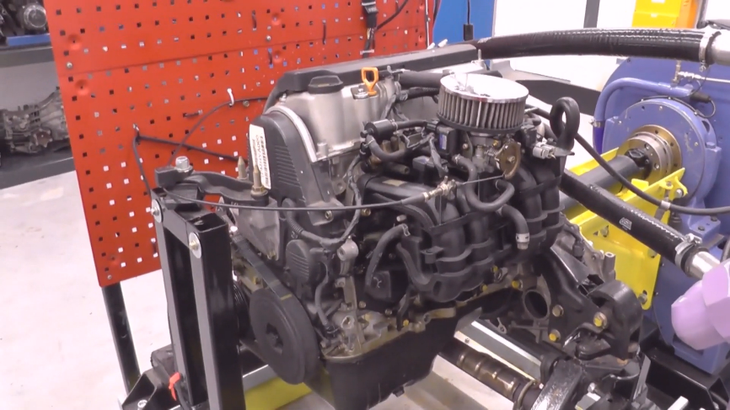
The engine tested was a Honda 1.6vtech 2000 d16 with a custom air filter its built-in sensors include: Coolant temperature, flow meter and a lambda sensor

Throttle Actuator Box
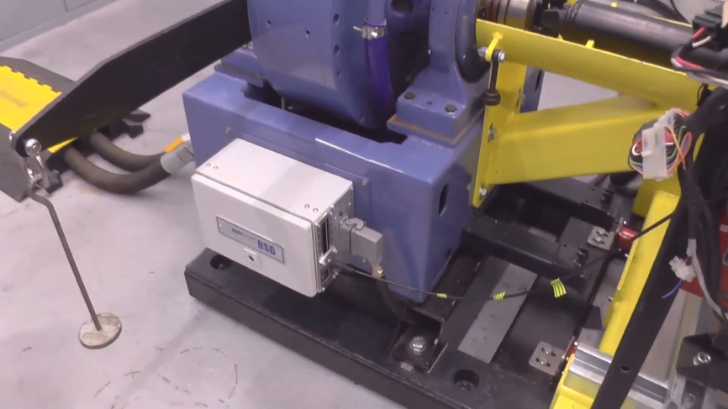
Throttle is controlled by a throttle actuator box attached to the side of the dynamometer as shown.

Dynamometer
The Dynamometer used was an eddy current dyno limited to 10,000 rpm with a max appliable electric load of 230Kw. The Dyno was attached to engine by a drive shaft bolted onto crankshaft.
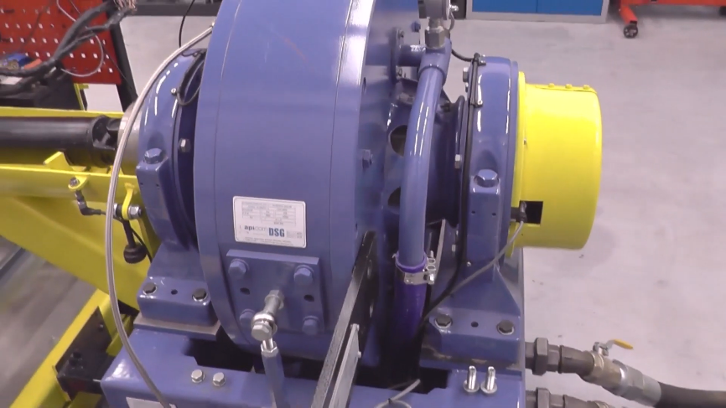
Figure 1. SHENCK WS230 dynamometer
As shown above the dyno consists of an inner core of that spins freely with the engine, the outer core is fed an electric current. electromagnetism is used to apply a resistant force to the inner core which in turn puts a load on the engine. The outer casing attempts to turn due to the electromagnetic reaction forces but is held in place by a strength gauge which sends a signal between 0 and 10 volts to the computer system. volt equivalent in engine load is decided by the two calibration arms, each calibration arm’s length is marked on it by manufacturers. a mass is hung from one of the calibration arms, causing the outer casing to try and rotate. the torque is resisted by a strain gauge and using the equation for torque, the corresponding value obtained from the strain gauge was observed for multiple weights to get an accurate equivalent value of Nm from volts for results. The dyno is cooled by inlet and outlet coolant pipes.

Sensor modules
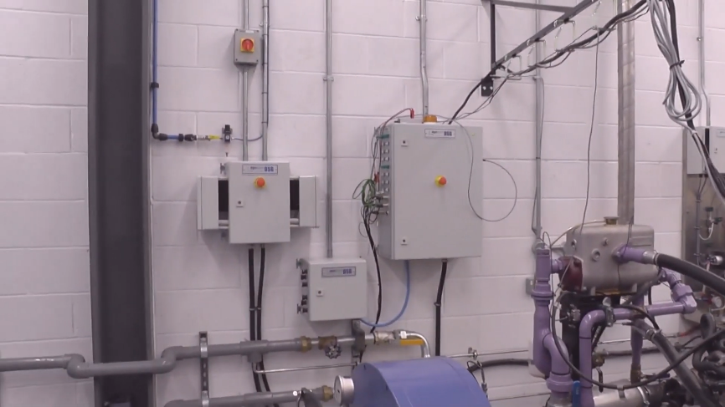
Sensor recorder modules attached to the wall next to dyno to feed info to computers
all data is passed from the engine to the computer and vice versa through them.
exhaust extraction system
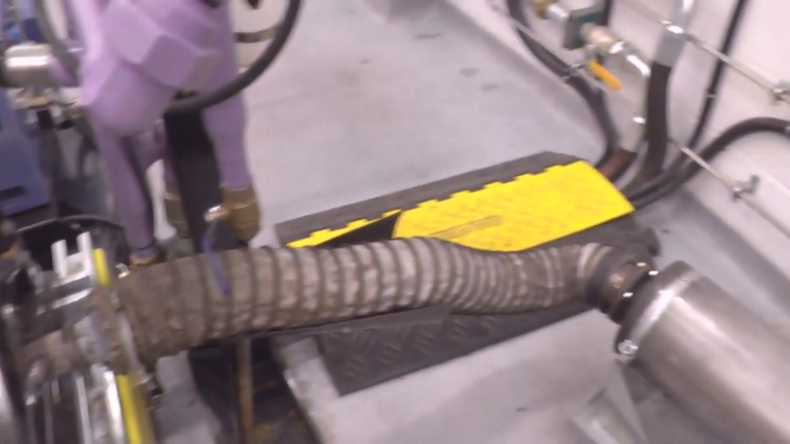
The extraction pipe was attached to engine exhaust without a silencer as shown above.
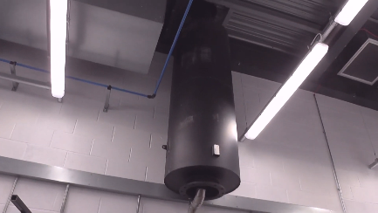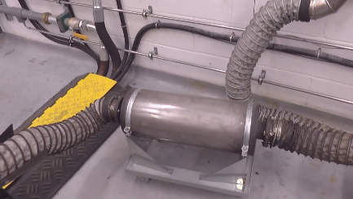
The Pipe then goes via an auxiliary alternate silencer before connecting to the fume tank.

fuel safe
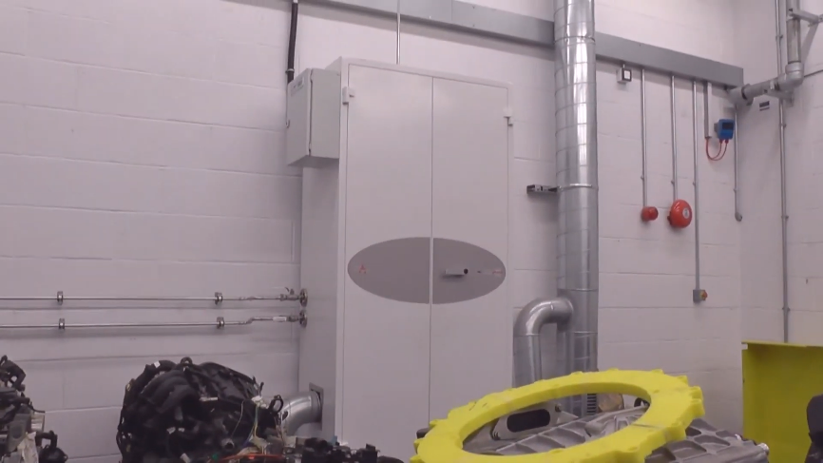
A strong metal cabinet with a tank inside. made to safely store fuel in the place of a cars Fuel tank.

Fuel supply board
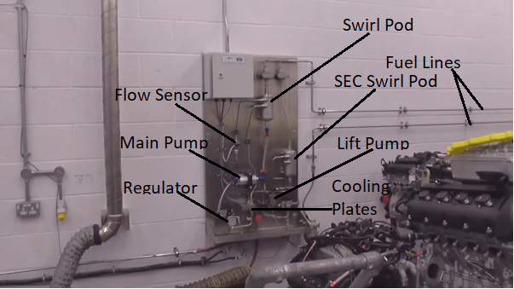
fuel is pumped via a lift pump from the main tank in the fuel safe it is filtered and passes through a flow sensor along the way to a swirl pod. the pod feeds the main fuel pump which goes through a regulator to feed the engine (the regulator allows fuel injected and non-fuel injected engines to be tested) the return line from the regulator goes through a cooling plate before re-joining the secondary swirl pod

Control Centre
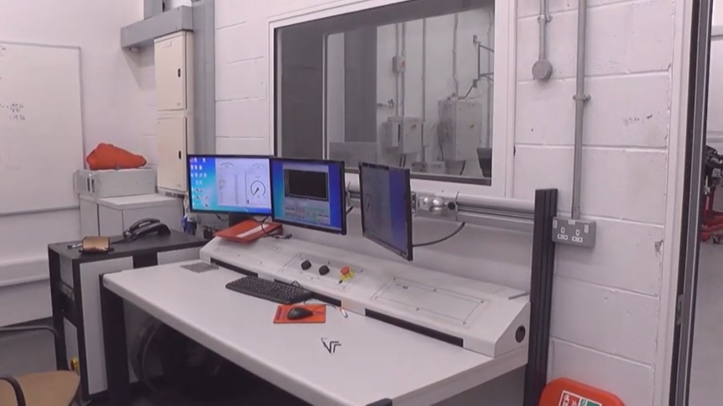
two dials: one to control the throttle and one to control the Load applied by the dyno.
Screens showing the software used to record data sent by the sensors and run the testing programs. the screens also show real time data readings.

Method
The three methods of testing available included manual, step testing and sweep testing. Sweep testing was chosen for its accuracy over manual and reduced stress on the engine as opposed to step.
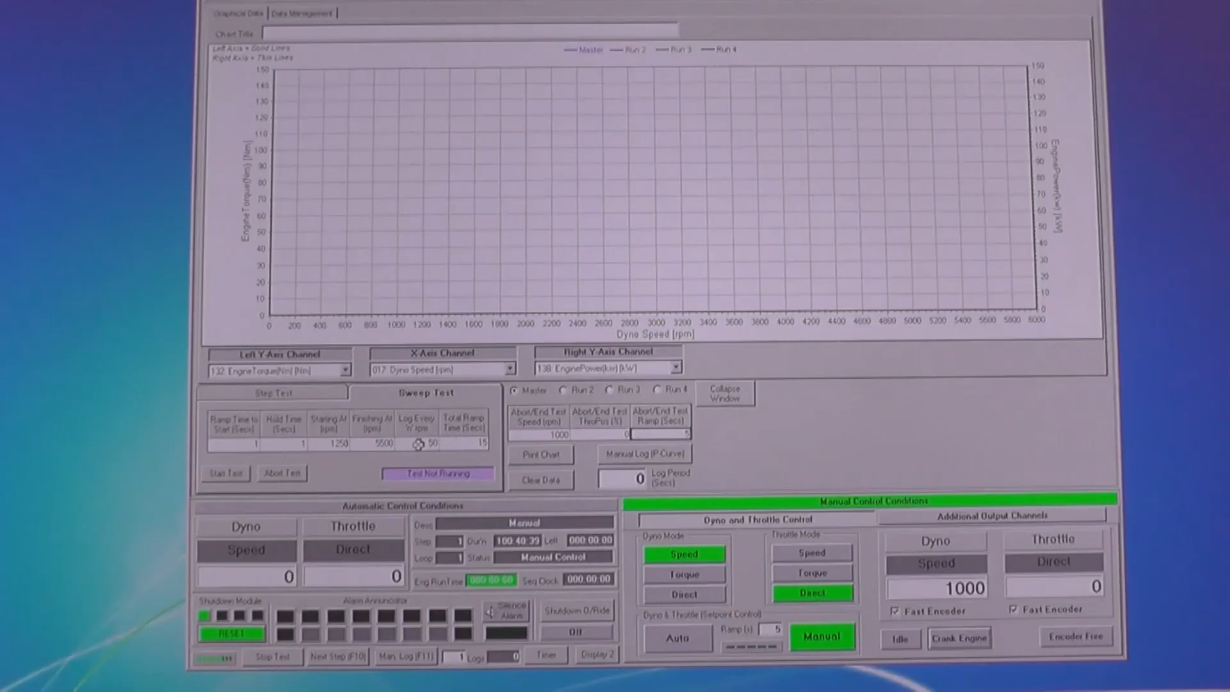
Figure () shows the software setup of the sweep test used. The test raised engine speed to 1250 rpm and held it there for 1 second each. After the initial second the engine speed was raised to 5500rpm in 15 seconds with a reading being taken by each sensor every 50RPM gained. Finally, throttle was fully released over 5 seconds bringing rpm to 0.

Results

Data
Test data measured to support results is stated bellow.
Four Data matrices were generated by testing. Three of these were plotted against engine speed (RPM) on the x axis and throttle (%) on the y:
showing The Load (N) measured by the dyno.
The speed of the Dyno (RPM) vs the engine speed and throttle.
Fuel use in Litres per 45 s.

The final matrix produced plots the combustion chamber pressure vs engine speed and the crankshafts angle in relation to the start. The pressure matrix was omitted from this report due to its size.

Calculations
The Results were extrapolated using MATLAB, a matrix based language software.

A Torque matrix was created by multiplying the Force matrix (W) by the dyno radius in m (R)
$$T=W ×R$$
Power was calculated using:
$$\frac{ 2πNT}{60}$$
Power needs to be adjusted for Ambient: Temperature in K (Ta) and pressure in Bar (Pa) to get Corrected Power (Ps).
$$Ps =\frac{\frac{1.01325}{Pa} × √\frac{Ta}{293}}{P}$$
Piston area was Calculated using bore in m (d) and piston area in m² (A)
.$A= \frac{πd^{2}}{4}$
Break Mean Effective Pressure in Pa (BMEP) was then calculated using stroke in m (L), Area, number of cylinders (n), Engine speed in RPM (N) and corrected power.
$$BMEP=\frac{Ps×(60×2)}{L×A×n×N}$$
Specific fuel consumption (SFC) was calculated with volume of flow in CC (V), time in s (t), Specific gravity of fuel (SG) and corrected power:
$$SFC= \frac{V×SG×3600}{t×1000×Ps}$$
Break thermal efficiency in % (ηT) is found using the calorific value of the fuel used in J/Kg (CV) and the SFC
$$η_{T}=\frac{3600×1000}{SFC×CV}$$

Graphs and Plots

SFC Heat Map
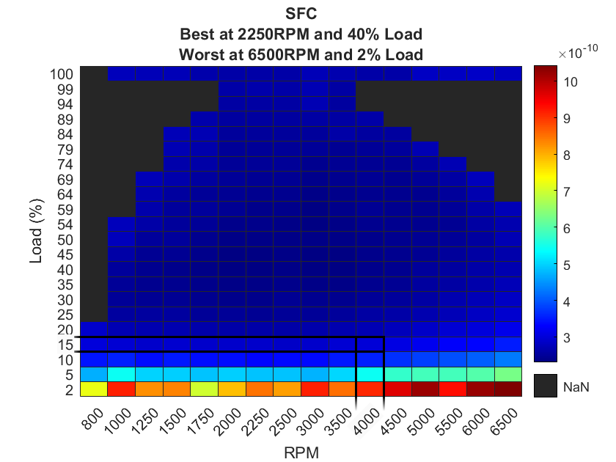
Figure 2. SFC Heat map
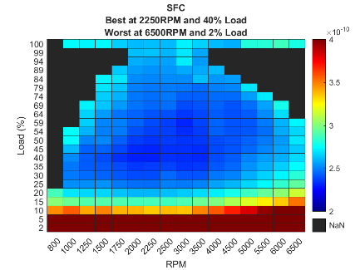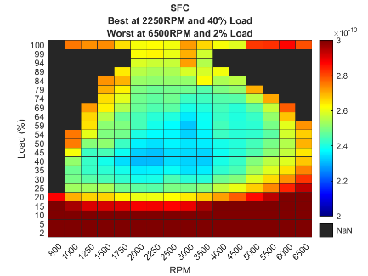
Suggest reasons why the SFC varies as it does with engine speed and load.
As shown in figures () SFC is at its optimum
To change the speed of the vehicle, its engine must expend some energy corresponding to the inertia work required to overcome the inertia resistance

Specific Fuel Consumption is a parameter that reflects the efficiency of a combustion engine in burning fuel and producing rotational power. (Stark 2017). In automotive applications, BSFC is used to evaluate the efficiency of the internal combustion engines (ICE). The keyword “brake” is related to the use of a dynamometer (electrical brake) to measure the engine parameters’(Stark 2017)
SFC = fuel flow rate/ engine speed * Torque meaning as engine speed increases the specific fuel consumption decreases however

Power and Torque
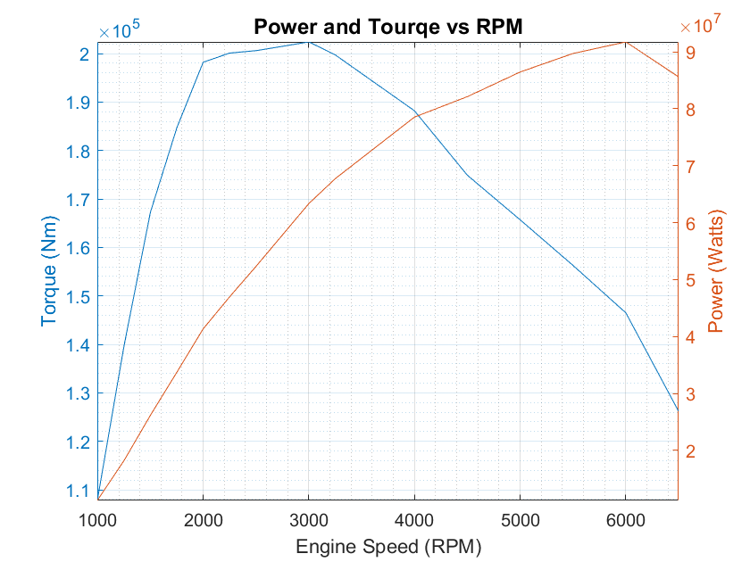

Initially Torque rises rapidly before slowing its accent and peaking. The increase is understood by applying Newtons second law, which states acceleration of an object is dependent upon the force acting upon the object and the mass of the object (The Physics Classroom n.d.). As the mass (Cm) is constant, torque raises proportionally with Engine Speed $T=\frac{N}{Cm}$. once reaching an RPM of around 3000 the engine began to experience a slowly increasing decline in: volumetric efficiency due to insufficient airflow to the engine and mechanical efficiency due to friction. The drop in efficiency Caused torque to drop,
Power increased at a gradually declining rate with RPM and continued to do so after torques peak. The reason it did not peak with torque is that the decrease in torque was initially lower in relation to the increase in speed. As speed increased to around 6000rpm the power peaks and begins to fall due reaching the peak of the RPM range.

BMEP and Thermal Efficiency
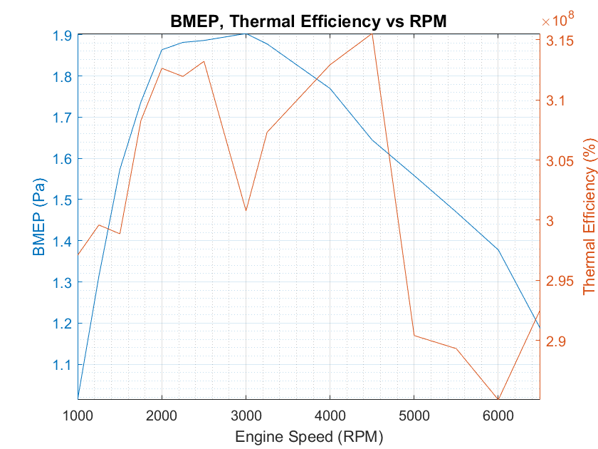
Suggest reasons why Thermal Efficiency (BTE) and BMEP vary as they do with engine speed.

BMEP is “the average (mean) pressure which, IF imposed on the pistons uniformly from the top to the bottom of each power stroke, would produce the measured (brake) power output.” (epi-eng 2019)
BMEP increases with the rise in compression rate until it peaks at and peaks at 3000 rpm around the same at torque which is to be expected as they rise together. It then begins to fall due to decreased airflow to the pistons at higher engine speeds.
<https://scialert.net/fulltext/?doi=tasr.2009.188.199#:~:text=The%20obtained%20results%20seen%20that,the%20brake%20specific%20fuel%20consumption.>

Measured Pressure 3D Plot
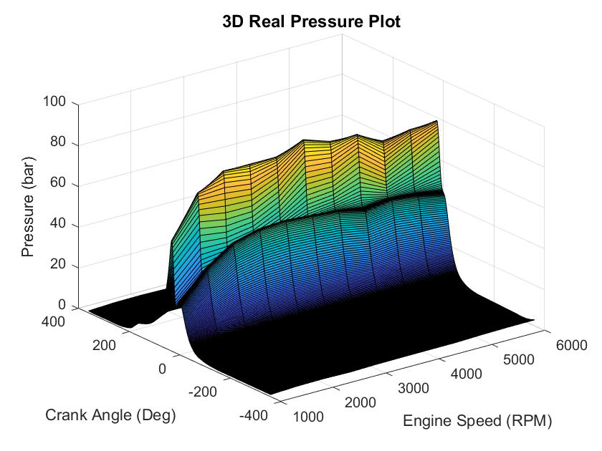
Discuss the differences and importance of values found in the different engine operating strokes.
Special spark plugs with pressure sensors were used to take accurate readings from inside the combustion chamber the mean data is plotted above against crank angle and engine speed it shows a clear increase in pressure with Engine Speed at a given crank angle, at 360 Degree crank (its starting point) pressure is 0 this is because it is at bottom dead centre (BDC) at the end of its intake stroke. The compression stroke occurs When the crank angle is between 360 and 180 degrees. at 180 the piston is at top dead centre and at the end of its combustion stroke having compressed the fuel air mixture, this is the point of most pressure throughout the cycle. As the piston moves through its power stroke from 180 to 0 degrees pressure drops due to being transferred to the crankshaft as torque. Although reaching BDC the pressure does not reach a minimum as the combustion chamber contains biproducts from the reaction. From 0 to –180 the exhaust stroke is observed in which the remaining pressure drops due to combustion chamber being purged. At – 180 the intake stroke starts.

Analysis

Method Analysis
Of the three methods of testing available: Manual, Step and Sweep testing the later was selected. Sweep testing is the most appropriate method. One reason was a much higher degree of accuracy than manual by eliminating the risk of human error. Another benefit included not running the risk of overheating the engine as step testing would over large rpm range. However, sweep testing has the potential for inaccuracy compared to step due to the speed at which results were collected. If a specific small range of RPMS required observance step would be used. (lecturer)

Engine Performance upgrades
Based of test results it was decided that the most significant performance gains would arise from upgrading the airflow of the engine. To increase airflow multiple upgrades can be made.
Turbocharger
The purpose of turbocharging an engine is to increase its power output by harnessing exhaust gasses and forcing them into the cylinders with a compressor run by a pully connected to the crankshaft. Since more fuel will be burned max cylinder pressure and mechanical stress will be increased. ( N. WATSON 1988)
The Plenum feeds the intake manifold from the various regular sources of airflow, Upgrading the plenum will improve fuel efficiency .Larger cylinder head valves will increase torque and allow other torque upgrades to be more effective(TorqueCars n.d.)

Fuel injector
A fuel injector directly sprays highly pressured atomised fuel directly into the combustion chamber, it is timed electronically by the ECU. Adding fuel injection will increase power while also improving fuel efficiency (Ariens 2017)
Cam Shaft upgrades
Although significant gains can be made on most cars from camshaft upgrades. Altering the camshaft profile is unnecessary as the engine already has VTEC which can

Reference List
Ariens, 2017, The Benefits of Electronic Fuel Injection, Blog, viewed 26 March 2022,<https://www.ariens.com/en-us/company/blog/108/the-benefits-of-electronic-fuel-injection>.

(epi-eng, 2019, Brake Mean Effective Pressure, viewed 24 March 2022, <http://www.epi-eng.com/piston_engine_technology/bmep_performance_yardstick.htm>.

Evans, J 2022, ‘annotated fuel supply board’, Engine Dynamometer Testing, University Of Wales Trinity St David’s, Swansea.

Torque Cars, n.d., Guide to performance tuning the D17 engine from Honda, viewed 20 March 2022, <https://www.torquecars.com/honda/d17-tuning.php>.

Noble, A 2022, Lecture 3: Dynamometer Testing, lecture notes, ACHA4012, University Of Wales Trinity St David’s, 3 February 2022.

Stark, A 2017, Brake Specific Fuel Consumption, x-engineer, viewed 23 March 2022, < https://x-engineer.org/brake-specific-fuel-consumption-bsfc/> .

The Physics Classroom Newton's Second Law – Revisited, viewed 24 March 2022, <https://www.physicsclassroom.com/class/circles/Lesson-2/Newton-s-Second-Law-Revisited#:~:text=Newton's%20second%20law%20states%20that,the%20mass%20of%20the%20object>.

WATSON, N 1988, ‘Turbocharged Engines’, Internal Combustion Engines, viewed 23 March 2022.

