

Modern and traditional methods of construction
Assignment 1 - UWTSD
18.12.2022
Sam Davies
2115596

Table of contents
  - ….Introduction

  - …. Analysing and discussing the foundation requirements of the building giving due consideration to the location. Estimate the excavation works required based on the information given, and any other reliable sources of information, for example the ground conditions in the local area.

2.1…. Analyse and discuss the choice of materials for the super-structure, giving consideration to design, structural strength, stability, fire safety, aesthetics and environmental impact and sustainability.

2.2…. Conclusion

2.3….References

1.1
In this assignment I will be discussing the foundation requirements to the Carbon neutral Laboratory for sustainable chemistry, University of Nottingham. Moreover, I will be investigating the ground conditions in the area to give myself an idea on what type of foundation would be suitable for the building. I will also be analysing the choice of materials that have been used throughout the build. Giving consideration to overall design, this including stability, fire safety, structural strength etc.
1.2 Analyse and discuss the foundation requirements of the building giving due consideration to the location. Estimate the excavation works required based on the information given, and any other reliable sources of information, for example the ground conditions in the local area.
The building is located in Nottingham. Location plan is shown below. It is owned by the university of Nottingham.
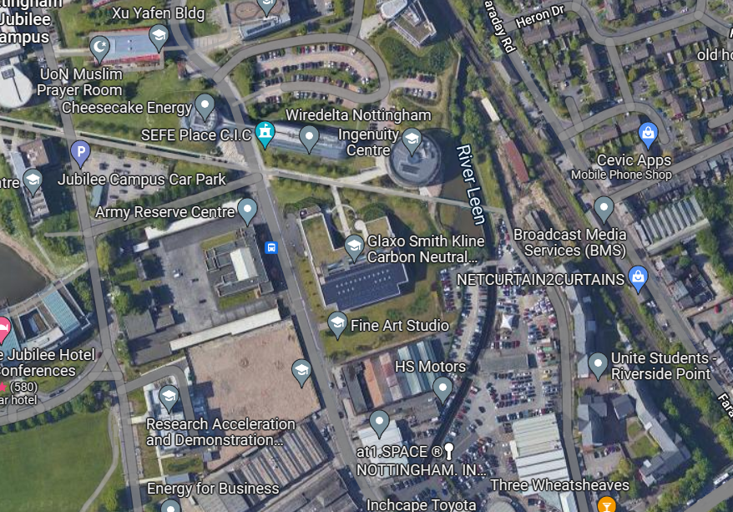

This building aimed to achieve full carbon neutral status. The building has a strong focus on sustainability and obtained a BREEAM excellent rating.
I believe the greatest risk lies in the type of ground being constructed on. The ground is subject to voids, fine sand and clay which are very poor ground conditions. Boreholes right on the area could not be accessed for my use so I would suggest having one carried out on site before construction starts. There are no mines in the ground so I am not concerned however I am still concerned about voids in the ground as the area is subject to water sources so erosion and voids have to be considered in the process of construction. No investigating is needed to say that the location of the site is right on the coast so it will be heavily prone to weathering over time. A contamination risk assessment or contamination report is now needed under local planning authority rules. These would be carried out initially at desktop study stage and then later done physically on site to depending on the history of the site. Cable detection can be done with a CAT and genny, an underground utility survey will have to be done as previous buildings have been on the land is possible. In addition to this there are things like street lights and other buildings are close so any type of excavation to the ground must not be carried out until a full survey is completed as cable strikes are a risk. Other utilities such as water mains, gas mains etc. will need to be carried out by professionals.
The best foundation choice for the proposed building would be a pile foundation. The reason for chosen this is based on the strata of the site. As we are building on fine sand for the top layer of ground and then clay/boulders further down into the ground. I feel this would be most effective and need less remedial work in the future. The piles could be driven down into more stable ground such as the clay between 7 and 8m deep. Bored piles would be used due to their popularity in urban areas as they are un affected by vibration. These are also used when building next to other buildings which we are. One of my drawings in this report shows that if you pile down to approximately 7-8m you will get clay and boulders this is compacted ground so the piles would not sink.
The foundation type used would be determined under multiple factors. After viewing the BGS maps, this footprint of the building is on bedrock formation. The superficial deposits of the ground are made up of clay, silt, sand and gravel. Due to the instability of the ground in this area, the consideration of a foundation would be either a pile foundation or a raft foundation. We can also see that there is a river next to the footprint along with other embodiments of water in the surrounding area. With deep foundations being effective against high water tables, a pile foundation would be my favoured option.
Excavation works would be minimal due to piles being driven into the ground. Where excavation works are required however, they would need to be battered back or have adequate shoring due to the instability of the ground and the risk of the trenches collapsing. Assuming the pile foundations are driven piles then excavations would need to be done for the pile caps. This would consist of 600mm-1200mm deep trenches. The pile foundation would easily take the direct load from the timber frame building as well which would be a big advantage and cause minimal problems.
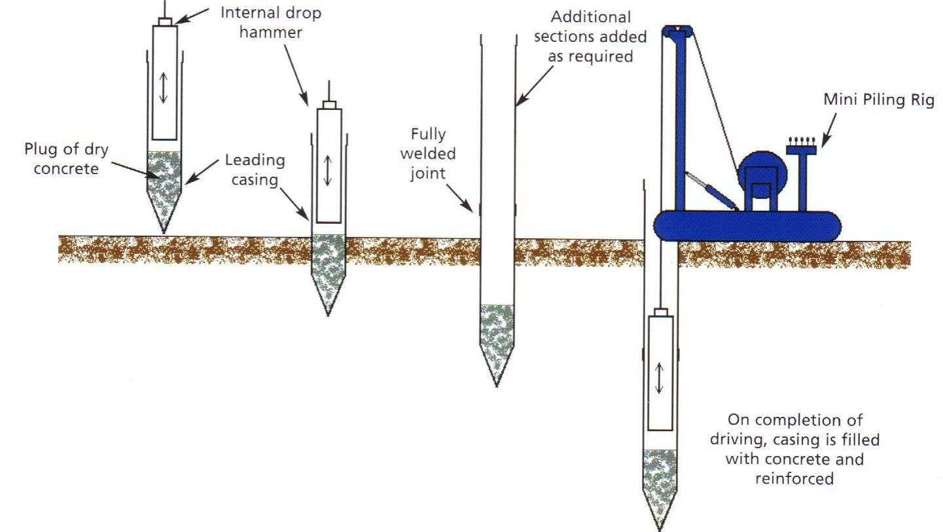
A raft foundation could also be used on this type of ground makeup (Although it would not be my preferred option). A raft foundation would allow the building to move more freely under- ground settlement issues. They are constructed by reinforced concrete slabs of a uniform thickness (typically 150 mm to 300 mm) that cover a wide area, often the entire footprint of a building. A Raft foundation isn’t usually effective at taking high direct loads however due to the main bulk of the building’s superstructure being made from timber, this would suit a Raft foundation.
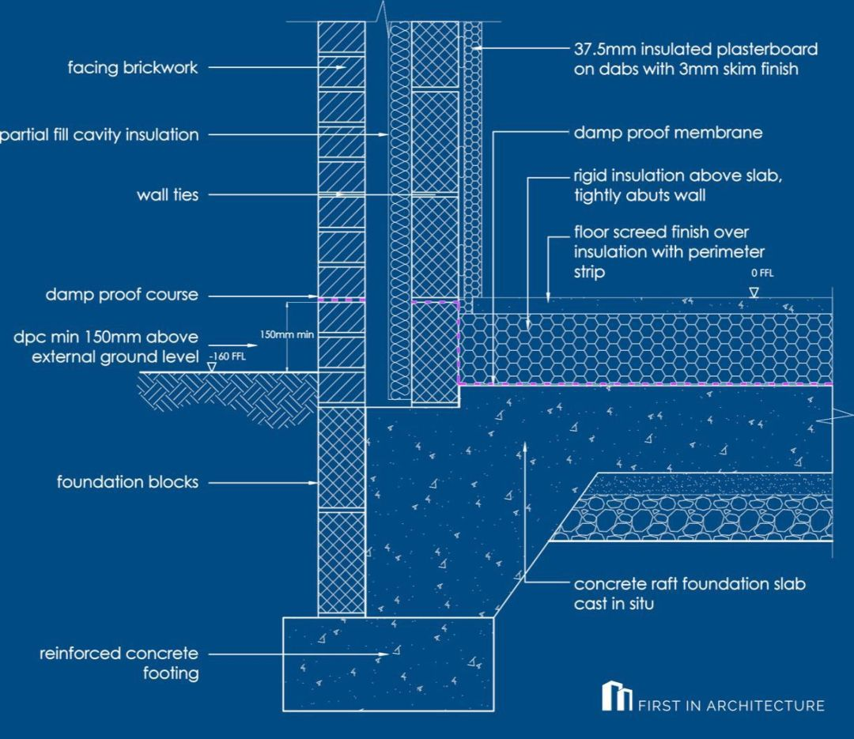
Using other foundations like strip on this type of ground would require significant amounts of excavation, thus resulting in high cost for the foundations. The possibility of remedial works on a strip foundation used on clay would be high. The possibility of a failed foundation would also be high, this would result in large cost implications possibly early into the buildings lifespan.
The foundations and ground floor would also need gas membrane and damp-proofing due to the high-water table in the area.
I cannot find any evidence of this land being previously used for mining so excavations shouldn’t be in issue. Once again, the only issue that may arise from excavating is that there is a potential for high water tables. Further to this I cannot find any evidence of boreholes that show data of water tables near the area.
2.1 Analyse and discuss the choice of materials for the super-structure, giving consideration to design, structural strength, stability, fire safety, aesthetics and environmental impact and sustainability.
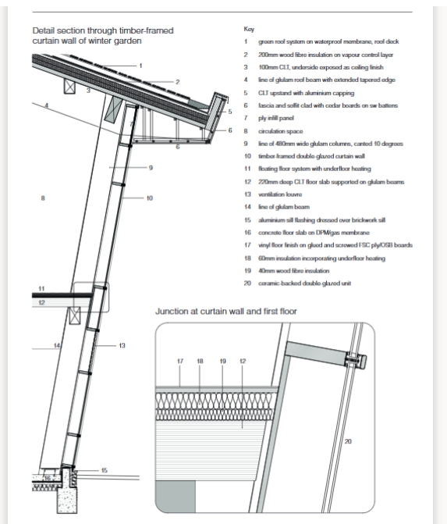
The building materials are designed to incorporate fire safety, stability, sustainability and structural strength all in one. The majority material used throughout the building is timber. This has been incorporated in different methods. You can see from the below detail that the building has incorporated sustainable materials into the build.
The design has been thought out to create natural heat sources where possible. For example, there is a large area of glass around the building to provide natural lighting and natural heat. Obviously, this method wouldn’t be fully effective all of the time. Other methods of sustainability include, photovoltaic panels, a green roof and a ventilation tower. These design features have been incorporated/designed to provide energy saving features as well as making the building environmentally friendly.
The building is not really around any other buildings it seems to be closer to a forest as the pictures shown throughout the report/previously. This is would be another reason for using green features, so the building would blend in with the surrounding area.
The building uses large amounts of Timber to make up the bulk of superstructure material. The building was constructed using pre-fabricated items of Timber which reduced cost of the building. The flexibility of wood allows the building to be changed fairly easily under any future demands/changes. “The timber frame contains almost 1,600 tonnes of carbon extracted from the atmosphere through the process of sequestration and tree growth and should make the building carbon neutral over its 25-year life.” The building uses different timber design techniques such as Glulam and CLT.
The glulam timber is rectangular large cross sections. It is very flexible under design. Multiple cross sections would make up different curved shapes and a variety of cross sections. Glulam is easy to manufacture and readily available for use. This would lead to sustainable construction as it is easy to construct on site and is manufactured in a more environmentally friendly manner.
The stability and structural strength are thought of in the design by using CLT (Cross laminate timber). This method involves, three to seven layers of timber being merged together. The result of the merging results in strong structural strength. As the laboratory is quite large and the building does not use any steel or concrete this technique is perfect for the building. CLT is also known for its fantastic fire resistance. The timber from CLT is great sustainable practice as the wood comes from sustainably managed forests.
The heavily implemented design of off-site construction can have many advantages on the building. The benefits to offsite construction are that it can be more productive and efficient when opposed to constructing on site. As the construction industry is trying to be more sustainable offsite construction is proving to be more eco efficient when being compared to other methods of construction. This can be because of reduced costs and time spent on site as well as materials being moved around less. (kier.co.uk)
The use of technology and quick installation times mean labour time/cost is reduced on almost every build done. The short times of installation can also make programme times a lot shorter which can be appealing to clients in tender stages. Delays in regards to weather can also be delayed due to the fact that offsite construction is usually carried out in factories.
Health and safety are greatly increased as work is usually carried out at bench level. The risk that comes from manual handling will also be reduced as there will not be much labour required.
On the other hand, offsite construction can make design changes more difficult or without any success due to the limitations on the structural design. Moreover, not every site is compatible with off-site construction, there could be a variety of issues that would stop this taking place. Projects can fail if co-ordination between the design team and contractors is not also taken seriously as there is a large amount of planning needed before a modular building can be constructed. Appearance of the building may also be affected by the limitation of design put on the building, for example, modular buildings may look blockier in design as the shape of the building cannot be casted like a concrete building etc. Clients may also not be certain on the fact that it’s made at a lower cost, there could be issues with return on investment if these buildings are to be sold further down the line. Principal contractors may be susceptible to off-site methods as payments would usually be larger and subject to a single sub-contractor, problems could occur if a given sub-contractor was in a difficult financial situation and they were accountable with large amounts of money.
Further to this they can often be subject to a lot of maintenance if not manufactured to the highest quality. There have been common incidents of leaks occurring in prefabricated buildings.
The roof of the building is a green roof system. This type of roof comes with many advantages in a variety of aspects. These can be broken down into cost advantages, structural advantages, environmental advantages and even aesthetic advantages. It provides a rainwater buffer and purifies the rainwater. This also allows water to evaporate through the plants. There is less risk of flooding involved in this as the water is filtrated through the ground, there is much less chance of an overflow of water as the ground can soak it up when comparing it to a metal sheet roof with a gutter system for example. The roof would provide noise insulation making inside the lab sound ambient. This is extremely beneficial as it’s a university building and exams, lectures and experiments would be carried out in this building. The lifespan of a roof is also drastically increased when a green roof is used. Sources indicate that the lifespan can be doubled or even tripled. The value of the building will also increase, in this instance I imagine it will always be owned by the university but it is still applicable. As the green roof will naturally hold moisture the fire resistance of the roof is great. The risk of fire would also be prevented from spreading around the building. Green roofs also require minimal upkeep and maintenance, this would also be cost effective.
Moreover, the building also has photovoltaic panels. This further encourages the sustainability of the building. The use of these further produces environmental qualities. The advantages to using this can include, zero fuel consumption for energy, low noise pollution, low maintenance costs, and high reliability under harsh conditions.
2.2
After reviewing all these points, we can clearly see that the building has been designed to have many environmentally friendly features. The use of materials of the building also indicates it’s flexible and is cost effective. Certain clever design features also account for the fact that the building is a laboratory that comes with its own advantages. We can also see from the ground makeup that the ground isn’t very stable due to the formation of clay, gravel and silt. As I have previously explained there are a few viable options.
2.3
References
GmbH (https://www.klokantech.com/), K.T. (n.d.). SK53 - OS 1:25,000 Provisional Series Map. [online] www.oldmapsonline.org. Available at: https://www.oldmapsonline.org/map/nls/91794519 [Accessed 9 Jan. 2023].
The Carbon Neutral Laboratory - The University of Nottingham
Raft foundation - Designing Buildings
Glaxo Smith Kline Carbon Neutral Laboratory for Sustainable Chemistry - Google Maps
Advantages and disadvantages of photovoltaic systems - Sungzu
British Geological Survey 1998 - 2017 (c)NERC mailto:www-bgs@bgs.ac.uk (2019). British Geological Survey (BGS) | A world-leading geoscience centre. [online] Bgs.ac.uk. Available at: https://www.bgs.ac.uk/.

