Performance Management Analysis of

Haidilao Hot-Pot Company



Assignment 1
of
BMMB7007

MODULE NAME : Human Resource Management

NAME : Keke Zhao

STUDENT NUMBER : 2204274

LECTUER: James Moore

DATE： March 25, 2023

Executive summary
Haidilao is a well-known listed Chinese hotpot company. As of 2022, Haidilao operates in 11 countries around the world. With its unique innovative and thoughtful service, it has won the love of customers and become the leader of many hot pot brands. For a catering enterprise that attracts more attention by providing high-quality service, the service staff working in the front line is the core productivity of the enterprise, the communicator of brand concept and the spokesperson of brand image. Therefore, the human resource management of Haidilao company is a very key link in the enterprise management. And performance management has become a priority area in human resource management. This report analyzes the performance management of Haidilao enterprises by referring to an ideal performance management model provided by Armstrong. After referring to the SMART goals setting rules, some unreasonable factors are found existing in the methods of evaluation indicators setting. For service enterprises, personnel management is the key to achieve organizational goals, so Haidilao organization needs to make changes and overcome these defects, so as to enable employees and the company to achieve more long-term development. some recommendations are made as below:
- Improve the relevance and rationality of the company's performance management indicators;
- Improve the skills and personal qualities of employees through more staff training, standardize their behaviors, and make them establish personal development goals consistent with the company's strategic goals.
- Enrich the diversity of organizational performance evaluators to make the evaluation results more credible, such as peer assessment, 360 degree feedback and external assessment.
4. Establish and perfect feedback channels to facilitate smooth communication between employees and leaders, so as to increase the fairness of evaluation and enhance employees' work enthusiasm.

Table of Contents

1.0 Introduction 1
2.0 Organizational Overview 1
3.0 Performance Management of Haidilao 2
3.1 PM system review 2
3.2 The existing problems of Haidilao 5
3.3 Necessities of Improving Performance Management. 7
4.0 Conclusion 8
5.0 Recommendations 8
Reference 11

1.0 Introduction
The development of an enterprise is inseparable from the management of talents. Performance management is crucial to the service industry and its practitioners (SHMR, 2017). This report introduces one of the most famous Chinese catering organization Haidilao Hot Pot, and its unprecedented considerate service generated by the “customer-centered” business strategy; reviews its prior area of performance management system with a ideal model, and existing problems of over depending on rigid appraisal index, unhealthy competitions among employees caused by pursuing bonus-oriented assessment results, as well as some impartial elements relates to appraisers in the process, which has some negative impacts on company’s profitability, satisfactory of the customers and employees’ relationship. In recent three years, Haidilao has met with something of difficult time caused by Covid-19 pandemic, so the problems relate to performance management has also hindered the further development of the whole organization. Rational and practical recommendations are made to these identified issues in order to develop a new insight of organizational performance management of Haidilao. At meantime, the risks and disadvantages of the improvement in performance management area are also mentioned at the end.

2.0 Organizational Overview
Haidilao International Holdings Co., Ltd. is a hot pot catering company established in Sichuan Province, China in 1994 (Haidilao, 2023). It is the largest chain of hot pot restaurants in China. As of March 2023 Haidilao has a market cap of $14.98 Billion (Companiesmarketcap, 2023). According to the company's official website, as of June 2022, there were over 1,435 Haidilao restaurants worldwide, 103 of which were located in 11 other countries, with a total of employees over 101041 (He, 2022).
Haidilao strictly adheres to the customer-centric and hard-working values. Chiu (2018) mentioned before, the reason why Haidilao can develop rapidly is not because of its superb and inimitable cooking skills, but the concept of customer first and advanced service methods, which captures people's eyes. So the first-line employees who directly serve customers have become the key point of the success. Before the Haidilao, there has never been a restaurant that can provide manicure, facial care, shoe shine, etc., which do not seem to belong to the scope of catering services (Chen and Wee, 2018). Even cosmetics such as face creams and perfumes are accessible in the bathroom for customers to use. They really follow the principe that “customer is God”. All these fully demonstrate that the service providers are the direct representative of the corporate image and the vital factor for the good name of the corporate. Therefore, HRM plays a very important role in Haidilao company and performance management could be viewed as the prior area to deliver the best service. In terms of management, Haidilao advocates the value of changing fate through hard work, creates a fair and just working environment for employees, implements a humanized and affectionate management model, and enhances the value of employees.

3.0 Performance Management of Haidilao

3.1 PM system review
Performance management is an ongoing process of managing a business and improve its performance. By setting individual or team goals that are consistent with the strategic goals of the organization, including make plans to achieve the goals, review and evaluate the results, improve the knowledge and skills of employees, etc. (Armstrong, 2018). And reinforce each other with other key human resource activities, especially human capital management, talent management and so on. A good performance management system can improve employee engagement effectively.
An ideal performance management system model should run as:
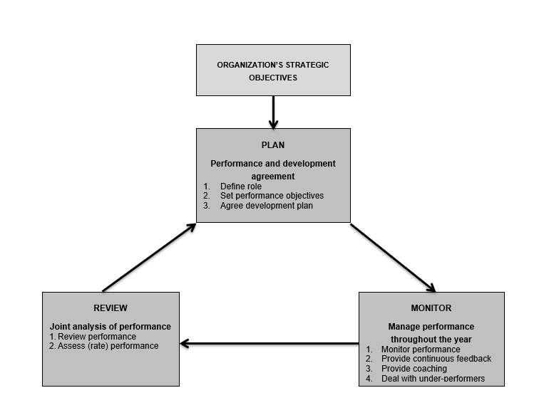（Armstrong, 2018）
The model consists of a series of logical PM activities, each of which is a necessary process to improve performance. Armstrong (2018) mentioned there is no problem with the logic of the process. But each stage of the process needs to be executed correctly if it want a success. In practice, it’s difficult to meet the ideal model’s need, which puts forward higher requirements for all performance management participants.
Haidilao has a performance management system with its original philosophy, this model can be applied to review the effectiveness of Haidilao’s PM.

●Plan
The overall pursuit of PM is to develop individuals and teams so as to improve the performance of the organization by correcting bad and staying in good ones continuously. In details, defining responsibilities and objectives, assigning tasks and establishing reasonable evaluation criteria, to ensure the organization has objective information and data to refer to.
Haidilao conveys corporate vision in performance management and regularly conducts performance appraisals for employees, usually once a year or every six months. These appraisals are used to assess employee performance and identify areas for improvement. It has formulated specific KPIs for each employees and stores such as table turnover rate and service ordering rate. These KPIs are designed to measure employee performance of providing the best service to their customers and meet the selling goals.
In order to improve the employee efforts, Haidilao provides incentives such as performance-related bonuses or promotions to everyone who meets or exceeds settled targets. The founders of Haidilao Zhang yong came from grass-roots, so he always insists that every ordinary person can fulfill personal value through hard work. Except for the CFO and engineering director, all the leaders, managers of Haidilao are grown up from the first-line waiters (Liu and Wan). Employees of a store are divided into junior, intermediate and senior positions. The wages of different levels are progressively priced on a piece-by-piece basis, and their qualification of promotion are determined by the store manager directly.

●Monitor
Once the the goal settled, all parts should develop towards the set goals and be supervised in the process to achieve continuous improvement. Haidilao provides regular and fair training and development opportunities to help employees improve their skills and position (Jiao, 2019). Its apprenticeship system is helpful scheme. The new employee will guided and taught by an experienced old employee. Apprenticeships enable new recruits to meet the company's expectations of qualified employees through training, and at the same time, they can improve themselves well (CIPD, 2022).
Haidilao chain stores have three ratings: A, B, and C (Minnaar, 2022). Managers will give priority to selecting employees of A-level stores as new store managers. Besides, his master can get part of the bonus of the new store (Zhihu, 2019). This master-apprentice system gives great priority to those store manager's apprentices. B-level stores need to improve themselves by learning from A-level stores, while C-level stores need to attend training. Store managers who have been rated C twice in a row will be fired, and their masters will also be affected.

●Review
The final step is to review the effectiveness of the whole process and identify the problems then make new plan to improve further.
Although Haidilao has unprecedented innovation in service, it stays relatively traditional in performance management appraisal. In practice, the senior managers found that the profits of stores in different regions are not uniform due to regional differences, so the KPI assessment which directly related to store profits was cancelled. Performance goals set by the organization are important, however, the realization of rigid indicators for everyone is challenging in practice (CIPD, 2022). Hence, the higher level leaders made only “customer satisfaction” and “employee effort” the main content of assessment. In order to improve these two index, some new problems gradually emerged. Therefore, the rules of target-performance setting need to be reviewed.

3.2 The existing problems of Haidilao
The SMART goal is a good way to consider the goal setting method in the PM.
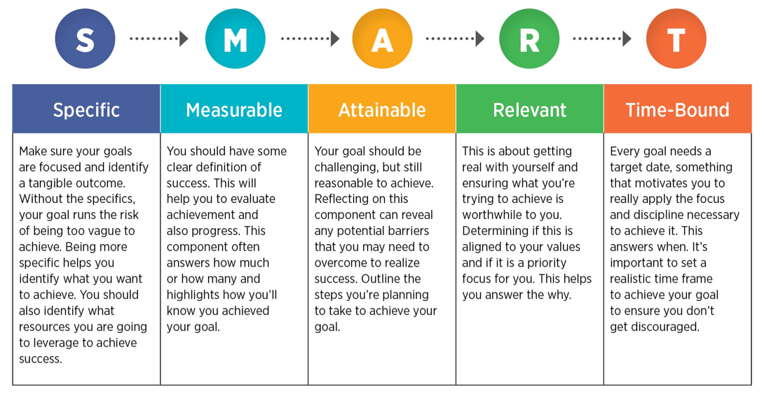
(ISTE, 2022)
In the review process, Haidilao has some unattainable and irrelevant appraisal standards in its PM based on this method:

● Unnecessary Check. Some of the index lacks scientific rationality, and cannot correctly observe the professional skills acquired by the employees. Sometimes, actual situation and the appraisal requirement are out of touch, which seriously reduces the effect of results. For instance, dining in Haidilao, when customers are seated, waiters will provide small gifts such as rubber bands, glasses cloths and mobile phone cases, if one did not guide customers to use these things will be deducted points, besides, if the customer said he appreciated the service, more gifts should be given to the costumers before he leaves, otherwise the waiter would lose points too. Such performance appraisal has no direct relationship with the working ability of employees to

●Table Turnover Rate is an important indicator of branch store assessment. Haidilao believes that there is a positive correlation between the "rate" and profit, for it can reflect customer satisfaction and loyalty to the store (LI, 2022). Usually, during dining hours, it is necessary to queue up to reserve a seat in advance. However, if the customer is late for a few minutes, the waiter will immediately cancel the reserved seat and assign it to others on the spot. It has a negative impact on the brand image and also loses some guests who were likely to love it.

●Service Ordering Rate (the number of times customers designated a certain serving person) has caused vicious competition among waiters. The higher the service rate means the higher the bonus. Technically, it has a certain incentive effect on the waiters in that they can maintain a higher level of service quality in the working process and further improve customer satisfaction. However, many waiters will use extra gifts in exchange for a higher order rate, which drives a unhealthy competition among them, increases the cost of the branch and reduce the profit margin of the store.

●Lack of appraisers. The ratings of store employees are directly completed by the store manager which will lead to some false judgments due to human factors, and is not conducive to a fair competition among employees. A manager may be biased if he personally likes a specific employee. Much higher ratings tend to be given to some “considerate individuals”. It benefits the employees who are good at flattering and maintaining a good relationship with the managers to increase their ratings (CIPD, 2022). Although the company arranges mysterious customers to visit from time to time, the store manager still has the power over the assessment of store employees. For evaluators, the scoring process is also embarrassing, too low evaluation results may harm the harmonious working atmosphere. Thus the manager's evaluation is more or less emotional, especially for Chinese companies.

3.3 Necessities of Improving Performance Management.
Human resource is the key resource as the core of HRM, performance appraisal is an essential tool to improve the performance of employees and the whole enterprises (Murphy and Cleveland, 1991).
In the past three years, under the great pressure of the COVID-19 epidemic, China’s economic development has slowed down. According to Savanevičienė (2022), especially lockdown policy has posed a variety of new challenges for the catering service sector. Haidilao has also suffered losses due to its irrational rapid expansion during the pandemic period, with over 300 stores closure or suspension of operation in 2021. It saw the declining profits and high employee turnover (Flannery, 2022). The problems that arise in performance management also need to focus on when making integrate adjustments. Thus, it is absolutely imperative to address these issues. Readjusting overly stringent indicators such as an excessively high table turnover rate will help improve customers' trust in Haidilao, retain old customers while attract more new ones because reputation is also a significant intangible asset for an organization (Mao, 2010). Regulating employees' improper behaviors caused by excessive pursuit of indicators will not only maintain a harmonious working atmosphere among colleagues, but also strengthen the individual ability to collaborate, it will also reduce the unnecessary cost sacrificed by employees’ personal performance goals. In addition, enthusiasm that employees bring to their work is directly influenced by their satisfaction of performance appraisal, which in turn impacts the enterprise's overall effectiveness (Sageer, Rafat and Agarwal, 2012, p.32). Therefore, improving the fairness of performance evaluation is beneficial to employee retention and motivating them to work harder for sake of getting a longer-term development in the big family of Haidilao. Whether it is for individual employees, companies, or shareholders, strengthening performance management is a necessary way to deliver better service and create more income in the further.

4.0 Conclusion
With its unprecedented elaborate customer service and diversified customer experience, Haidilao became the first listed company among many hot pot brands, and also became the first hot pot brand well-known at home and abroad, making it expand rapidly just in two decades. However, Haidilao have some deficiencies after checking by the PM model. Although its performance appraisal methods motivates employees to a certain extent and provides a relatively fair development platform for a large number of people with limited education and no advantages in background, too much reliance on evaluations index has led to some unfair assessment results, decreased customer satisfaction, vicious competition and decrease in company profitability eventually. These phenomenons are not conducive to the healthy development of the company. Therefore, In order to minimize the impact of these unfavorable factors, it is of great significance to reconsider the scientific and rationality of performance evaluation standards for meeting the organizational strategic targets.

5.0 Recommendations
1. Haidilao’s performance measurement should be trustworthy as well as relevant. An ideally assessment scheme should minimize the non-quantifiable factors (Boella, 2017, p.101). In the process of implementing performance appraisal in Haidilao, it is necessary to clarify the evaluation criteria but should not rely too much on hard or redundant index. Appropriately reducing the weight of non-essential indicators in salary to make employee performance appraisal closer to job responsibilities.

2. Persist in conveying corporate culture through strengthening employee training so as to create common values shared by the whole organization and all employees. Because many of them do not have a high level of knowledge. Professional and cultural training could make them understand that personal development is inseparable from the overall improvement of the enterprise. Aguinis (2009) mentioned "Performance management requires that managers ensure that employees' activities and outputs are congruent with the organization's goals and, consequently, help the organization gain a competitive advantage”. Personal goals of Haidilao’s staffs should be consistent with organizational strategic goals, so as to create greater value.

- Performance management should be a continuous healthy cycle and multi-departmental collaborative work (Enthoven, 2023). It is an ongoing procedure that consists of various elements, in that it should not limited to a once-a-year occurrence (Armstrong and Baron, 2000, p.53). Many companies have used performance appraisal as a direct daily dialogue between employees and managers, rather than a rigid evaluation index form. To strengthen dialogue, which is most important for employees to give correct feedback to the evaluation and actively practice it (Michael, 2017). In addition, Haidilao can boldly use some innovative achievements in employee evaluation, such as peer assessment, 360 degree feedback and external assessment.

- Create a smoother information feedback channels. In order to make the results of performance appraisal fairer and more satisfactory, employees can leapfrog responses in the face of unfair competitions (Dauda and Luki, 2021), complaint channels could be built to understand the opinions and suggestions of employees or appraisers on the assessment. If the problems reported by the employees can be dealt with in a timely and effective manner, the loyalty and trusts of the employees to the company will be enhanced. They will be more proactive in participating in performance appraisals, and psychologically increase their sense of belonging to the company at the same time.

However, according to SHRM (2017), changes in performance management are complex at the organizational level, with potential costs and risks, for instance, spending a lot of money on employee training that does not bring expected results. To whom chasing more performance bonuses, this change may not be desirable, as it may result in a relative reduction in high incomes. Thereby, the enthusiasm and initiative in personal work will be greatly reduced; Establish a smooth information feedback system to reduce the interference of human factors as much as possible. It must also face the investment in technical support and the increase in labor costs of whom spend more time on individuals’ appraisal process. However, there is no guarantee that refined employee performance will directly lead to bottom-line improvements in organizational results. For Haidilao, only by strictly estimating the costs and the risks when making changes can they reap positive achievements.

Reference

Aguinis, H. (2009) Performance management. Upper Saddle River, NJ: Pearson Prentice Hall.

Armstrong, M. and Baron, A. (2000) Performance management. Kogan Page Limited.
Boella, M.J.(2017) Human resource management in the hotel and catering industry. Essex: Taylor & Francis.

Bournemouth University (2012) An Emerging Service Paradigm for Catering Industry in China: A Case Study of Hai Di Lao. Available at: https://eprints.bournemouth.ac.uk/29753/4/Hai%20Di%20Lao%20Case%20Study%20Content%20Journal%20of%20China%20Tourism%20Research%20revised.pdf Available at:https://zhuanlan.zhihu.com/p/94427562 (Accessed: 17 March 2023)

Chen, E and Wee, S.L. (2018) Offering Manicures With Your Hot Pot, Chinese Haidilao Plans a Global Push. Available at: https://www.nytimes.com/2018/09/25/business/haidilao-china-hotpot-ipo.html (Accessed:17 March 2023)

Chen, H. and Zeng, Y. (2018) Analysis on Employee Motivation Management of Haidilao from the Perspective of Confucianism Wulun. Chinese Business Review, 17(11), pp.542-546. Available at: http://www.davidpublisher.com/Public/uploads/Contribute/5ceba8f55b8d8.pdf (Accessed: 17 March 2023)

Chiu, J. (2018). “Hong Kong’s Hot-Pot IPO: A Chinese chain serving pig brains and giving manicures”. Wall Street Journal. 10th, September. Available at: https://www.wsj.com/articles/hot-pot-ipo-a-chinese-chain-serving-pig-brains-and-giving-manicures-1536581024 (Accessed: 17 March 2023)

CIPD (2022) Apprenticeship. Available at: https://www.cipd.co.uk/knowledge/fundamentals/people/routes-work/apprenticeships-factsheet (Accessed: 17 March 2023)

CIPD (2022) Performance Reviews. Available at: https://www.cipd.co.uk/knowledge/fundamentals/people/performance/appraisals-factsheet (Accessed: 17 March 2023)

Companiesmarketcap (2023) Market capitalization of Hai Di Lao Hot Pot (6862.HK). Available at:https://companiesmarketcap.com/hai-di-lao-hot-pot/marketcap/(Accessed: 17 March 2023)

Dauda, Y. Luki, B.N. (2021) ‘Perspectives on Performance Appraisal Practices in Organization’. Global Scientific Journal , 9 (5), pp.931-950.

Enthoven, D. (2023) How Big Data Will Reinvent Performance Management.Available at: https://www.inc.com/daniel-enthoven/how-big-data-will-reinvent-performance-management.html (Accessed: 17 March 2023)

Flannery, R. (2022) More Restaurant Industry Woes In China: Haidilao Sees Up To $710 Mln Loss. Available at: https://www.forbes.com/sites/russellflannery/2022/02/20/more-restaurant-industry-woes-in-china-haidilao-sees-up-to-710-mln-loss/?sh=1e181e567a43 (Accessed: 17 March 2023)

Haidilao official (2023) About Haidilao Available at: https://www.haidilao.com/about/brand (Accessed: 17 March 2023)

ISTE (2022) Goal setting | Is Your Goal SMART? | 3-5, 6-8, 9-10, 11-12. Available at:https://iste.web.unc.edu/activity/is-your-goal-smart-3-12/(Accessed: 17 March 2023)
Jiao, W. (2019) Factors positively affecting loyalty of Haidilao hot pot’s consumers in Chang Zhou city in China. Available at:http://dspace.bu.ac.th/handle/123456789/4314 (Accessed: 17 March 2023)

Li, J. (2022) The selection and analysis of the performance appraisal index of Haidilao. Available at: https://wk.baidu.com/view/52abf704f4ec4afe04a1b0717fd5360cba1a8de9 (Accessed: 17 March 2023)

Liu, Z. and Wan, X. (2019) Employee Potential Development: Haidilao High Growth Enlightenment. Open Journal of Business and Management, 7(3), pp.1173-1182.

Mao, J.(2010) Customer brand loyalty. International journal of business and management, 5 (7), p.213.

Michael, A. (2017) How can we fix performance management? Available at: https://www.peoplemanagement.co.uk/article/1746081/fix-performance-management (Accessed: 17 March 2023)

Minnaar, J. (2022) HaiDiLao Hot Pot: Entrepreneurship at Scale. Available at:https://www.corporate-rebels.com/blog/haidilao-hot-pot-entrepreneurial-at-scale (Accessed: 17 March 2023)

Murphy, KR and Cleveland, JN. (1991) Performance appraisal: An organizational perspective. Allyn & Bacon.

Sageer, A., Rafat, S. and Agarwal, P. (2012) Identification of variables affecting employee satisfaction and their impact on the organization. IOSR Journal of business and management, 5 (1), pp.32-39.

Savanevičienė, A. et al. (2022) Ensuring sustainable human resource management during the COVID-19 pandemic: the case of Lithuanian catering organisations. Economics and sociology, 15(3), pp.121-142.

SHRM (2017) PERFORMANCE MANAGEMENT THAT MAKES A DIFFERENCE: AN EVIDENCE-BASED APPROACH. Available at: https://www.shrm.org/hr-today/trends-and-forecasting/special-reports-and-expert-views/documents/performance%20management.pdf (Accessed: 17 March 2023)

Zhihu (2019) Why are the employees of Haidilao dedicated and enthusiastic? Zhang Yong: The monthly salary of the store manager is 35,000. Available at:https://zhuanlan.zhihu.com/p/94427562 (Accessed: 17 March 2023)

