Advanced Cyber Security
Model Code: ACCA6000 | Lecturer: Carlene Campbell
Assignment

[1]

Shannon Boulting (1903281)
4th May 2020

Contents
Contents 1
List of Tables 2
List of Figures 2
Introduction 4
Part 1: Research and Analysis of Lab Exercises 5
1. Research 5
1.1 Cloud-based services security issues 5
1.1.1 Overview 5
1.1.2 Security Challenges 7
1.1.3 Summary 8
1.2 Internet of Things and Smart City security issues 9
1.2.1 Overview 9
1.2.2 Security Challenges 10
1.2.3 Summary 11
2. Analysis of Lab Exercises 12
2.1. Lab 1 12
2.1.1 Purpose 12
2.1.2 Exercise 12
2.1.3 Preventative measures against threats or attacks 13
3.1. Lab 2 14
3.1.1 Purpose 14
3.1.2 Exercise 14
3.1.3 Security Implications 15
3.2 Lab 3 17
3.2.1 Purpose 17
3.2.2 Exercise 17
3.2.3 Security Implications 18
3.3 Lab 4 19
3.3.1 Purpose 19
3.3.2 Exercise 19
3.3.3 Security Implications 20
Part 2: Synthesise a solution to a potential real-life scenario 22
1. Introduction 22
2. Simulation Network 22
3. Possible threats and vulnerabilities 26
4. Security features implemented 26
4.1.1 DNS/DHCP 27
4.1.2 Firewall 29
4.1.3 Encryption 30
4.1.4 IPS 31
4.1.5 Wi-Fi Password 32
5. Conclusion 33
6. References 34

List of Tables
Table 1: Overview of Threats & Solutions [8] 7
Table 2: Components of Smart Campus 23
Table 3: Components of smart garden 24
Table 4: Components of smart parking 25

List of Figures
Figure 1: Benefits of Cloud Computing [5] 5
Figure 2: Smart City Components [14] 9
Figure 3: TunnelBear 12
Figure 4: Switching IP address location 12
Figure 5: Hide IP address 12
Figure 6: Phishing Email 14
Figure 7: Phishing Facebook Page 14
Figure 8: Personal information retrieved 14
Figure 9: Phishing Example [30] 15
Figure 10: Malware software scanning phone 17
Figure 11: Issues encountered 17
Figure 12: Review of system settings 17
Figure 13:Applying encryption 19
Figure 14: Encrypting message 19
Figure 15: Decrypted message 19
Figure 16: Smart Campus 23
Figure 17: Smart garden 24
Figure 18: Smart parking 25
Figure 19: Registration server for IoT devices 27
Figure 20: Creating the server account 27
Figure 21: Registration of devices in server 27
Figure 22: Monitor the devices in server 27
Figure 23: Device status 28
Figure 24: Adding DNS 28
Figure 25: Webpage status 28
Figure 26: Laptop desktop 28
Figure 27: Adding rules 29
Figure 28: Transmitting message to server 29
Figure 29: Message undelivered 29
Figure 30: No password encryption 30
Figure 31: Password encrypted 30
Figure 32: Password encryption set 30
Figure 33: Password decrypted 30
Figure 34: IPS Implemented 31
Figure 35: Wi-Fi Configured 32

Introduction
The aim of this paper is to firstly investigate key research areas in the field of security and current technology and then apply this in order to analyse various lab exercises. Secondly, utilising knowledge gained from the first part of the paper, various security measures will be designed and simulated in order to protect the resources and services of an organisation.

Part 1: Research and Analysis of Lab Exercises

Research

1.1 Cloud-based services security issues

1.1.1 Overview
Cloud computing is a collaboration of Information Technology (IT) services which provide customers with a service over a network (“the cloud”) [2]. Cloud computing is currently having a substantial impact on the IT industry; well-known global companies such as Amazon Web Services (AWS) (provides data storage), Google Cloud Platform (provides data analysis, storage and machine learning) and Microsoft Azure (for application development, testing and deployment) have moved to cloud platforms whilst other companies seeking to alter their business models to the same paradigm because of its benefits (figure 1) [3]. Cloud computing services tend to be provided by a third-party organisation who own the infrastructure. Moreover, this provides advantages such as flexibility, scalability and efficiency. Cloud computing can be used for big data analytics, file storage, back-up and data recovery [4]. Companies are often slow to implement cloud computing as it is associated with many challenges, including security issues [2].
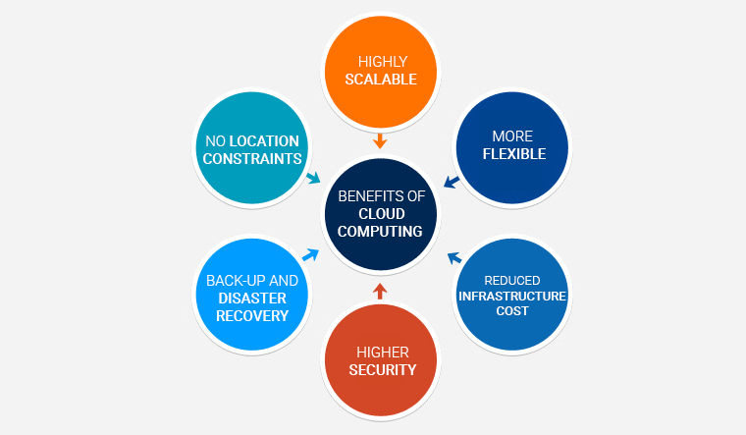
Figure 1: Benefits of Cloud Computing [5]
Cloud computing can be characterised by the following features:
- Consumers can access computing services through the cloud with no requirement to interact with the service provider [3].
- Cloud computing is available via the network through the users devices for example desktop, mobile phone, tablet [3].
- Resource pooling is utilised to deliver computing services. Storage, network bandwidth, processing and memory require pooling and are assigned based on demand to their various consumers [3].
- Services are measured and metered to track usage and costs based on demand for resources [3].
- Elasticity is necessary for resource allocation to be efficient; as they need to be assigned quickly and accurately to support increases and decrease in demand with minimal impact on performance [3].
There are three types of clouds available:
- Public cloud which can be accessible by all with an internet connection and is provided by third parties, an example being Microsoft Azur. The user account can be managed through a web browser whereas the software, hardware and infrastructure is managed by the cloud provider [6] [7].
- Private cloud is mainly used by an individual business or organisation and can be located in their organisations data centre onsite [7].
- Hybrid cloud which is a combination of the above where both the data and applications can be shared providing optimisation of a business due to their flexibility [6].
Furthermore, there are four types of cloud providers available:
- Software as a Service (SaaS): for installing applications where the cloud provider manages the applications and infrastructure as well as upgrades and patching [7].
- Platform as a Service (PaaS): gives the user access to an environment to develop, deliver, test and manage applications [7].
- Infrastructure as a Service (IaaS): where the user fully outsources its storage and resources, for example both hardware and software [6].
- Serverless computing, overlapping with PaaS, where the cloud provider manages the setup with its focus on developing the app functionality but with no requirement of managing the infrastructure or server [7].
The types of cloud services available are dependent on an individual’s needs and differ on access control levels. Therefore, choice of cloud type and provider is primarily based on the user requirements. Each therefore have their own security challenges and while security can be a benefit of cloud computing, there are also many risks associated with it.

1.1.2 Security Challenges
Cloud computing usage is growing every day as various organisations are adopting cloud technology. Organisations opt for secure infrastructures where the data will be transmitted to remote locations [8]. Cloud computing poses a risk as the consumer has no control or knowledge of what is happening to their data. The concerns are heightened when personal and sensitive data is stored [9].
A computer security threat is known as something which can cause serious harm to computer systems. Table 1 outlines the most common threats and solutions associated with cloud computing.
Threats | Solutions
Malicious insiders, whereby an organisations resources are penetrated resulting in a decrease of productivity and asset damage which severely impacts the operation of an organisation. | Implement agreement reporting and ensuring security management processes are transparent and documented.
Abusive use of cloud computing which can lead to fraud and loss of validation. | This can be prevented through observation of the network status and providing robust authentication and registration methods.
Data loss and leakage such as sensitive data being corrupted, modified or deleted. | Data should be backed-up and appropriate data storage provided.
Service/account hijacking, for example compromising the security of the services through stolen user account credentials. | Implementation of security policies and strong authentication methods.
Identify theft. | This can be prevented through strong use of strong multitier passwords or authentication methods.
Table 1: Overview of Threats & Solutions [8]
Additional security concerns and features include:
- Data security: cloud computing services are achieved through the communication protocol HTTP (Hypertext Transfer Protocol). Data is secured and data integrity maintained through HTTTPS (Hyper Transfer Protocol Secure) and SSH (Secure Shell). In addition, strong encryption methods are applied as well as access control [9].
- Data location: where users have no knowledge of the location of the data centres. Various cloud providers have data centres located all around the world which can be an issue due to data privacy laws. For instance, EU data is not allowed to leave the country due to its sensitive information. Furthermore, there is also the issues of adhering to local laws and knowing which jurisdiction the data come under if an investigation were to be undertaken [9]. This needs to be clear and well researched to avoid infringement.
- Data privacy: which is one of the key concerns of cloud computing. There are requirements for organisations to meet the data privacy pressures of its consumers and regulators. A privacy committee is recommended to be set up to support data privacy decision making [9].
- Data integrity can be achieved by following ‘ACID’ (atomicity, consistency, isolation and durability) transactions. The majority of data gathered is stored within the cloud and therefore users can lose control, resulting in reliance on cloud operators to enforce access control [9].
- Security and compliance policy ensures compliance with security audits to ensure customer trust and confidence is maintained. Organisations are required to adhere to various regulations and standards such as ISO (International Standards Organisation which sets out rules and standards which products are required to adhere to) and PCI. (Payment Card Industry) Organisations are required to provide evidence of adherence with security standards [9].
- Network security which have various classification types such as public, private, shared or non-shared, each of which hold their own unique security threats. They can become vulnerable to attacks such as DNS (Domain Name Server) or Sniffer. DNS translates domain names to IP addresses and traffic can be directed away from original servers to an alternative destination. Sniffer attackers which capture packets being transmitted across a network which may not be encrypted and consequently intercepted and read [9].
- Data transmission is where encryption techniques are required to be applied to further protect the data, so it is not intercepted on transmission and not modified. Furthermore, to ensure confidentiality and integrity access controls are implemented requiring authorisation/ authentication. This is to prevent man-in-the-middle attacks which is when an attacker is situated between the user and service provider attempting to interrupt data transmission [9].
Lastly and something which is often overlooked in the literature, physical security is vital as data centres require control access, alarms, fire protections, monitoring for critical parameters, and power supplies which cannot be interrupted. As well as up-to-date security policies and an incident response plan if a breach were to occur [10].

1.1.3 Summary
Whilst companies adopt cloud-based services they should carefully evaluate and consider the benefits and risks. Security risks involve the technology itself, users, legal aspects of the data and services. The pool of confidential and sensitive data being stored alongside the large volume of resources attract attackers. Therefore, it is important that cloud-based service defensives are scalable and robust. They need to be continually updated to keep up with the evolving technology and knowledge hackers and attackers utilise. To decrease the risk of threat, appropriate security measures, like those discussed, should be implemented to ensure data is kept securely and private throughout the cloud computing lifecycle. This is vital within cloud-based services as cloud architectures require various roles such as cloud administrators, auditors and security personnel [11].

1.2 Internet of Things and Smart City security issues

1.2.1 Overview
A smart city has been defined as the future, an improved version of an existing, traditional city with enhanced and more efficient tangible (transport infrastructures, natural resources and energy distribution networks) and intangible resources (human and intellectual capital of businesses etc). Advanced and sustainable systems are implemented to manage energy, transportation, healthcare and education, water and traffic (Figure 2) [12]. An example of a real-life smarty city is Singapore, which has implementation of smart grid technologies, Wi-Fi access points, mobile device penetration and intelligent lighting. Other smart cities include Barcelona, London and San Francisco [13].
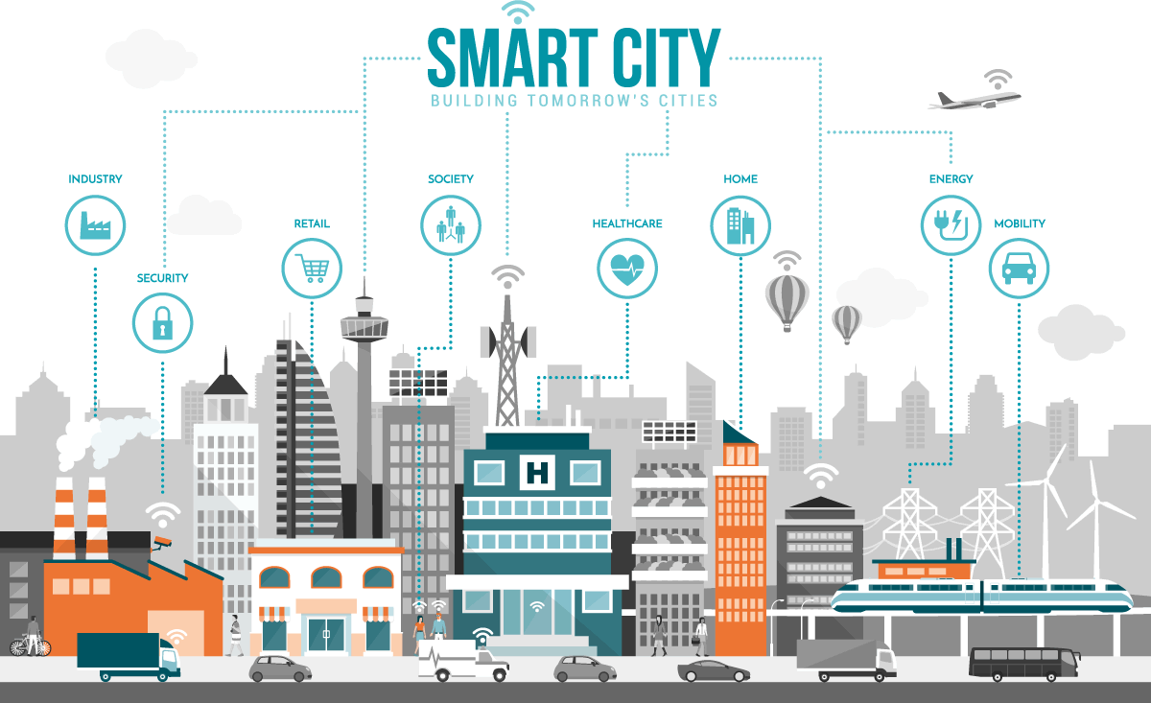
Figure 2: Smart City Components [14]
Whilst the emergence and definition of smart cities is continually evolving, individuals are now already interconnected through their smart phones and devices. Furthermore, cars, public venues and homes are now transforming to the Internet of Things (IoT) which are improving lives. In addition, city infrastructures are also benefiting from interconnectivity of systems to monitor and control or automate. Transport will have access to data via GPS for weather and traffic updates [15]. Smart cities interlink with IoT as IoT helps make up the elements of a smart city.
Internet of Things (IoT) is physical devices which connect to additional physical or virtual devices via wireless communication and offer the appropriate services. RFID (radio frequency identification) is the basis of the development alongside other incorporating technologies like sensors, GPS, Wi-Fi and short range (NFC, Bluetooth and Wi-Fi) communications [16].
One of the key challenges for IoT and smart cities is guaranteeing supply reliability and security which is dependent on applications being confidential, available, robust, flexible and ensuring integrity [16]. Security breaches at a city level have the potential to be devastating so it is key that this is addressed.

1.2.2 Security Challenges
Smart cities are constantly expanding and therefore the risk increases as the attack surface is also expanding, which must be secured. Smart cities have major benefits such as efficiency, as it optimises operations based on data available, but it is also vulnerable to attack. They can be manipulated, misconfigured or have malicious intentions if misused [17]. A successful cyberattack could result in disruption of vital city services and infrastructure within health case, law enforcement, residential, transportation and power and utilities. The result can be catastrophic as it can result in loss of life and the breakdown of social and economic systems [18].
Smart cities have a physical level of vulnerabilities: sensors. This can be the weakest link as it is often neglected or overlooked as it is constantly changing, and system developers can be overwhelmed as a result. An example is a smart home product being hijacked through exploitation of its hardware vulnerabilities where a DHCP server (which can result in man-in-the-middle or sniffing attacks) is established to compromise the other devices on the home Wi-Fi network. A solution is cryptography to ensure all data is encrypted [17].
Furthermore, communication security within smart cities and IoT has been researched in-depth. IoT wireless networks are vulnerable to jamming, message injection and eavesdropping. Wi-Fi is at risk to man-in-the-middle attacks. To counteract this attacks, it is imperative that encryption is implemented to validate authenticity, detect spoofing and assess integrity [17].
Smartphones can compromise a smart cities security through a malicious application, spyware, botnets, social networks, Bluetooth or Wi-Fi. They form part of the IoT infrastructure and provide access to different services and applications. An attacker can upload a malicious application to an individual’s phone which can infect the device and gain access to the smart city. If access is gained to various smartphones, a botnet can be initiated resulting in simultaneous attacks within a smart network. Moreover, an individual’s privacy and security can be exploited through the GPS feature on a smartphone. Spyware can be utilised to eavesdrop on conversations and consequently gain access to sensitive information. These attacks can be accomplished through unsecured Wi-Fi or Bluetooth connections. Furthermore, social media networks contain an individual’s personal information increasing their risk of an attack [19].
Another security issue is RFID (radio frequency identification) tags. These are utilised in various sectors with the aim of improving real-time information traceability and visibility. However, this system is at high risk of attacks and threats. For example, unauthorised access requests which aim to exploit sensitive data, breaching confidentiality and privacy. RFID can be breached if they are intercepted through an RFID read which provides the correct EPC (Electronic Product Code). If the attacker has gained access to RFID readers or EPC it can read the confidential tags. The interception can be achieved through jamming, eavesdropping, denial of service attacks (DoS) or tag cloning/killing [19].
Smart city security issues are not just technological as economic pressures can interfere with security efforts. If a system requires patching, this is a costly process to undertake and therefore, security investments may be concentrated on preventative measures which increase levels of security across an entire system. Security teams may also focus on attacks which can cause mass disruption to a smart city network. DoS attacks can disrupt or shut down an entire smart city therefore concentration is focused on widespread devastation prevention [19]. The smart city system is only secure if it is managed and updated appropriately.

A solution to cyber-attacks is to implement a security model, such as the 3-layer onion model:
- Data protection application for the server: consists of reviewing data which is transmitted between servers and the network to capture malicious information which can cause corruption [19].
- Data scrutiny: involves protecting servers from direct communication with a smart network. Therefore, it essentially functions like a firewall [19].
- Secure smart software for devices consists of preventing malicious software from gaining access to a smart network. It ensures devices are not infectious [19].
This approach aims to provide various layers of security for both the network and server whilst adhering to privacy and security laws. These are preventative, rather than reactive, measures to security risks.

1.2.3 Summary
To conclude, smart cities are more sustainable and bring better quality of life to its citizens. This is achieved through interconnectivity of systems and devices, which results in increased productivity and accessibility within cities. However, consequently there are security challenges and issues such as eavesdropping, jamming, DoS and man-in-the-middle attacks which can be accomplished through compromising an individual’s smartphone device or RFID devices. It is vital that security measures are implemented to prevent these attacks as they can have serious consequences on a smart network and cause mass disruption to its users. Security measures such as the 3-layer approach can be implemented to provide protection to both the network and server, or encryption can be implemented to protect user’s data when it is being transmitted between devices.

Analysis of Lab Exercises
The purpose of this section is to analyse and document the results of a series of lab exercises. These will investigate the targets security set-up and expose any vulnerabilities in order to better understand how to prevent and detect weaknesses, threats and potential attacks.

Lab 1

2.1.1 Purpose
The purpose of the lab is understanding the importance of anonymous browsing and the various software available allowing users to access blocked or censored content, for example VPN’s can protect the user against public Wi-Fi insecurities/threats. More importantly. Businesses use VPN’s to connect all their employees on a virtual network with the ability to share applications, data and files. Only those with access to the VPN can gain access to the network [20].
The software utilised for this lab was TunnelBear (Figure 3). The exercise undertaken is demonstrated below:

2.1.2 Exercise
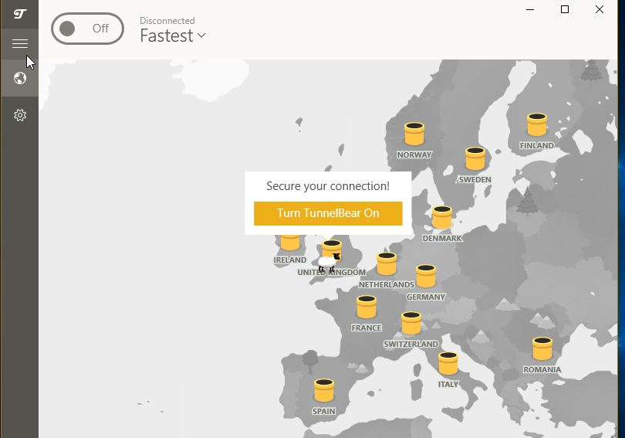  Figure 3: TunnelBear | 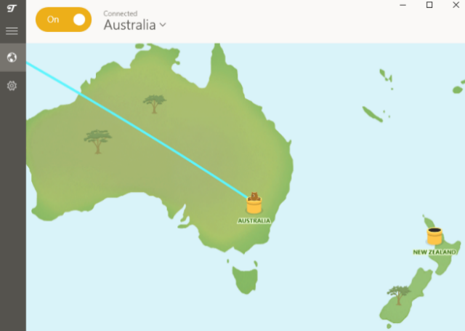  Figure 4: Switching IP address location
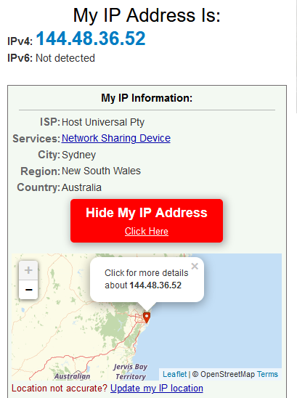
Figure 5: Hide IP address

TunnelBear (Figure 3) protects online privacy and allows its users to surf anonymously whilst accessing blocked or censored content. It keeps the user’s personal information private as physical location and browsing activity is not visible to hackers or advertisers. Users can modify their device location (Figure 4 & 5) to access restricted content which is blocked within their country [21].
Anonymous browsing allows users to protect their personal information from being exposed. Each machine connected to the internet has a unique IP address. The ISP links to the IP address along with your name, home and email address, phone number and at times credit card information. Cookies are an alternative way of tracking a user’s web surfing habits. Cookies can contain login information, user preferences or other identifiers. Cookies personalise and tailor the users web experience. Cookies and IP address can start to build a picture of the user’s profile but combined with search history it can disclose the user’s identity to hackers and make them vulnerable to malicious activity. Furthermore, search engines store search queries and if a hacker examines many search queries from one IP address, they can determine the user’s identity especially if they map searches to their home address [22].
Each time a URL is searched for in the user’s web browser and in response sends back the web page, it requires knowledge of your IP address. This can be avoided by utilising a proxy server; this is a machine which lies between the user and the internet. Every page request must go through the proxy server first. A proxy server can erase the users IP address from page requests and substitute it for an alternative [22].

2.1.3 Preventative measures against threats or attacks
Due to the risk of personal information leakage and malicious use of this information, anonymity on the internet helps to protect the user’s privacy from being exploited. The following are ways in which users can remain anonymous on the internet:
- Anonymity via the internet browser as these have a built-in anonymous mode known as ‘private browsing’ or ‘incognito’ mode. However, research has shown anonymous surfing solely cleans cookies once the browser has been closed and therefore tools such as Wireshark can still capture the cookies which can then be utilised in real-time attacks [23].
- As mentioned previously, proxy’s can be used to mask IP addresses and prevent information being logged on the server side. However, the data still needs to be transferred via the ISP, but the IP address will be masked by the client, but the ISP will still be able to see the IP address. Therefore, packets can be captured on the way to ISP through traffic analysis tools [23].
- VPN (Virtual Private Network) is similar to a web proxy but keeps information encrypted sent through alternative servers. It keeps browsing as well as file sharing and messaging anonymous. Furthermore, the web browsers private mode can be applied to prevent web pages which an individual visited being tracked [24].
Web browsing leaves the users information exposed to the website owner, ISP, Government and other parties who have access. It can support browsing in countries with restrictive web policies and prevent internet habits being tracked and logged for advertising purposes [24].

Lab 2

3.1.1 Purpose
Lab 2 examines the use of social engineering as a way of utilising psychological manipulation to reveal confidential information. It is estimated that 98% of attacks are based on social engineering techniques [25].

3.1.2 Exercise
Figures 6 and 7 are examples of a social engineering attack known as phishing. Social engineering attacks are popular and used day-to-day in order to compromise companies. Social Engineering Toolkit (SET) is popular among hackers as it is free and can be used for spear-phishing attacks to name one. It allows hackers to draft emails or attach malicious files to reveal personal information (Figure 8), as seen in the example below.
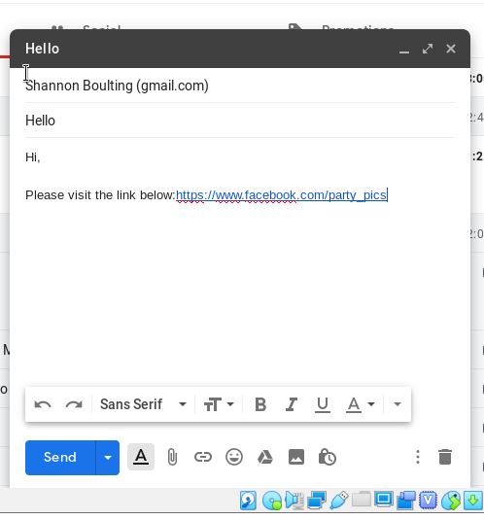  Figure 6: Phishing Email | 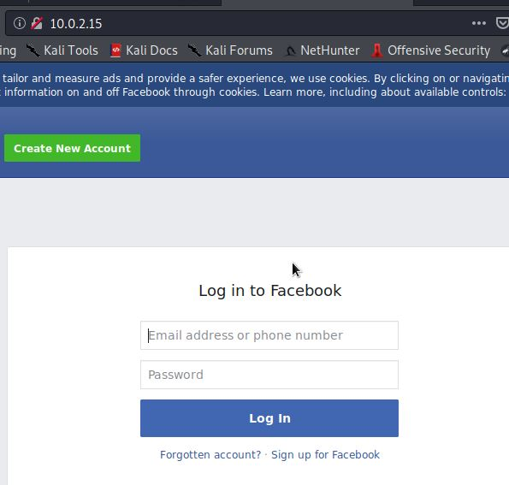  Figure 7: Phishing Facebook Page
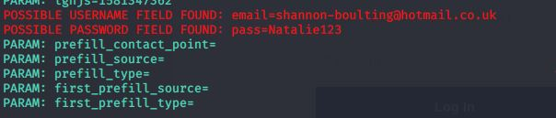
Figure 8: Personal information retrieved

Alternatively, SET can be used for ‘penetration testing’ to check for vulnerabilities which could be exploited. It is Python-driven and can be used to perform attacks against humans through exploiting their behaviour.
It is important to undertake regular and extensive testing of systems as this process identifies any weaknesses within the infrastructure or applications. It ensures that controls implemented are effective and can be used to tests applications to reveal any bugs within the software and perform patching or updates when necessary. Patching and software updates can minimise vulnerabilities but also create new ones. [26].
Social engineering can also be used to test the human elements for vulnerabilities. They are tested through phishing or impersonation where a pen tester will mimic attacks which a social engineer would utilise to breach a system. Phishing can be utilised for 3 purposes:
- Controlled compromise of an organisations network to expose vulnerabilities which if reported in detail can be used to strengthen the network
- A security awareness programme which educates users on phishing.
- Tests to assess individuals on their knowledge of phishing attacks and if they are any gaps in knowledge further training is required to be implemented [27].

3.1.3 Security Implications
Identifying threats within information systems is imperative in developing efficient defence mechanisms. As organisations implement robust security technologies, attackers are increasingly concentrating on the weakest link to exploit: end users [28].
Social engineering is the easiest way to gain access to confidential data as it requires less effort than hacking. For social engineering attacks to be effective it requires the end user to activate the malware so it can successfully run on their system with no interruptions [28]. Phishing is the most successful technique as it is personalised and tailored to the targeted user. SET allows for phishing attacks to be performed. It provides the attacker with the relevant tools to perform the attack (Figures 6 -8) [29]. As hackers develop their techniques end users are finding it increasingly difficult to distinguish legitimate emails from non-legitimate emails (Figure 9) [28].
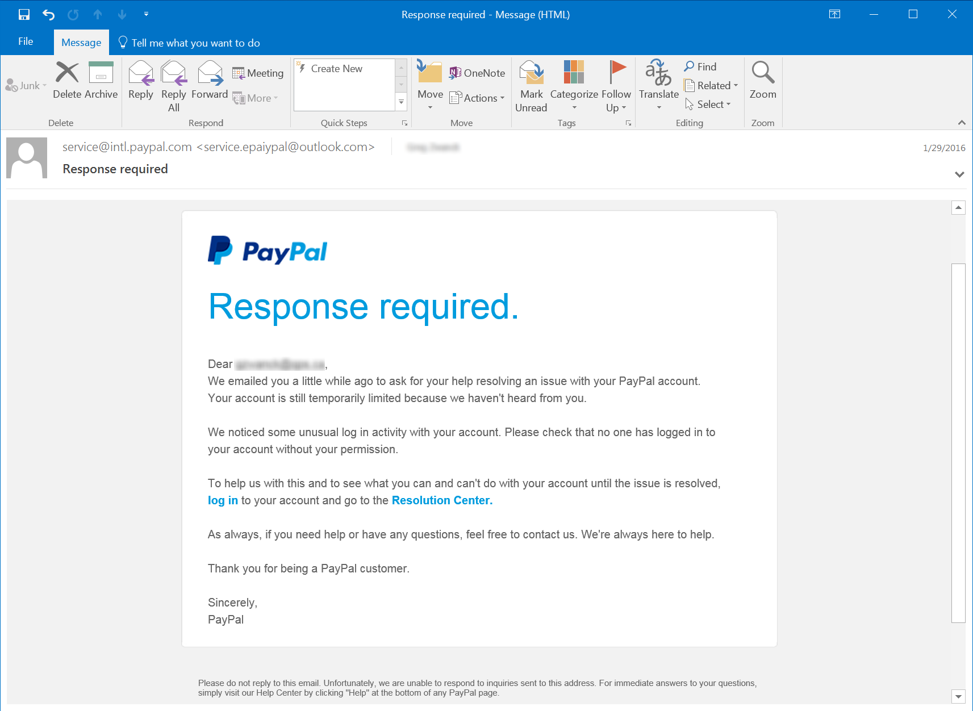
Figure 9: Phishing Example [30]
Attackers can perform attacks by text message, telephone or social networks by creating fake identities with the aim of getting the end user to reveal their sensitive information to them Figure 9). Moreover, Waterholing attacks (where a popular website is infected with malware) are carried out alongside phishing to gather confidential information [31].
However, these attacks can be prevented if end users understand the different types of social engineering techniques. Security awareness training should be implemented in organisations so employees are made aware of phishing techniques and the impacts it can have on an organisation.

Lab 3

3.2.1 Purpose
This lab provides further information on additional security measures which can be implemented to secure mobile phones devices, as they are one of the most popular methods of communications. Individuals are often aware of security requirements for computers but not so much for mobile devices [32]. A real-life example is whereby a UK lawyer’s phone was exploited via a WhatsApp vulnerability. The hacker continuously attempted to install Pegasus on his phone, which allows data to be extracted such as text messages, contacts, email, browser history and GPS location. The lawyer was involved in a civil case against an Israeli surveillance company called NSO Group. The Pegasus malware has previously been used against Mexican journalists [33]. The aim of the attack was to spy on the lawyer. This could have serious consequences as the attacker could retrieve extremely sensitive information about the lawsuit which can also damage the company’s reputation.

3.2.2 Exercise
Figures 10-12 are examples of Malwarebytes Security application in use. The application is capable of providing protection for Android devices through scanning applications for ransomware, phishing URLs and undertakes privacy audits regarding access privileges for all applications installed [34].
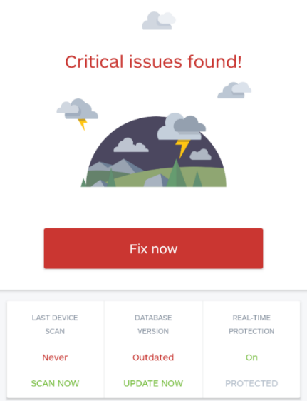  Figure 10: Malware software scanning phone | 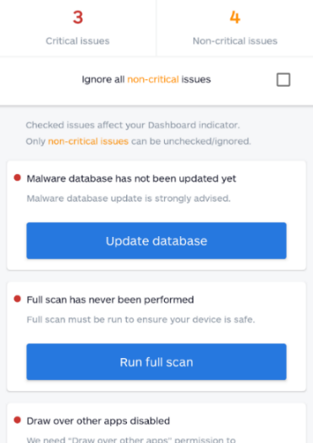  Figure 11: Issues encountered
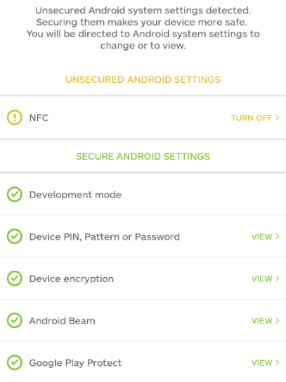
Figure 12: Review of system settings

3.2.3 Security Implications
Mobile devices have multiple uses such as sending and receiving emails, calls, social media and financial transactions. This results in a large mobile application portfolio to support all these actions. However, the increase in mobile usage brings an increase in malware applications [35].
It is vital that mobile devices implement access controls such as fingerprint or PIN so that only authorised individuals have access to its contents. The device owner is responsible for the security and protection of the device, as devices can be comprised and perform attacks such as DoS (Denial of Service) [36].
As mentioned, due to the rise in mobile phone usage has resulted to the rise in security threats. There are three types of threats:
- Malware such as virus, worm, trojan or spyware. Malware is a malicious software which can causes disruption to the end user, comprising its information and/or documents. In the case of application based threats, such as spyware, their core obligation is to gather information without the user’s consent [37]. Malware can listen to phone calls, read texts and capture both email and call logs, view the end users GPS location and forward email correspondences to an alternative inbox [36].
- Vulnerabilities in software or hardware where weaknesses are identified within a system and become exploited. Weaknesses can be found within the design, applications or internal controls [37]. It is vital that wireless networks are secured as they transmit sensitive and confidential information. If sensitive data is compromised in can affect an organisations reputation and result in legal action. Wireless communications can transmit malware and install it on the receiver’s device which can result in data corruption and leakage [36].
- Attacks: can be software, hardware or user-based through phishing technique as explained earlier. Furthermore, QR Code attacks where users are directed to malicious URLs or SSL Proxy attacks. These can be on either the SSL (Secure Sockets Layer) or TLS (Transport Security Layer). These provide encryption to data. However, if it is neglected and not reviewed settings can be altered and data can be comprised [37].
To conclude it is important that mobile phones are protected with access control such as password, PIN, touch ID or pattern. The mobile phone operating system must be kept up to date, especially in terms of security fixes which protects confidential data from hackers. Prior to downloading applications from the app store, it is important to check user reviews and to scan the apps for malware once downloaded.

Lab 4

3.3.1 Purpose
Applications, whether on mobile phone devices or on the web, have a vital role in our day to day lives. Various attacks occur which can comprise sensitive data therefore it is important that application data is kept secure. Confidential information can be kept secure via encryption [38]. An example can be seen in WhatsApp’s end-to-end encryption, which ensures the intended recipient can read the messages sent ensuring confidentiality and integrity of the data sent [39].

3.3.2 Exercise
CrypTool (Figure 13-15) is an example of a freeware programme enabling the application and analysis of cryptographic mechanisms.
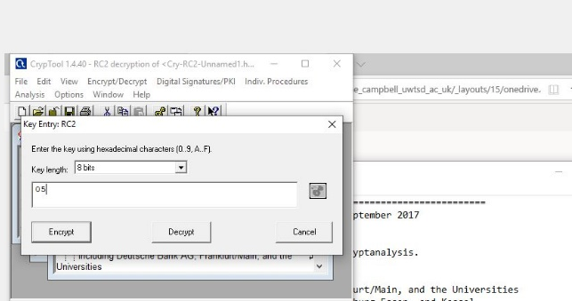  Figure 13:Applying encryption | 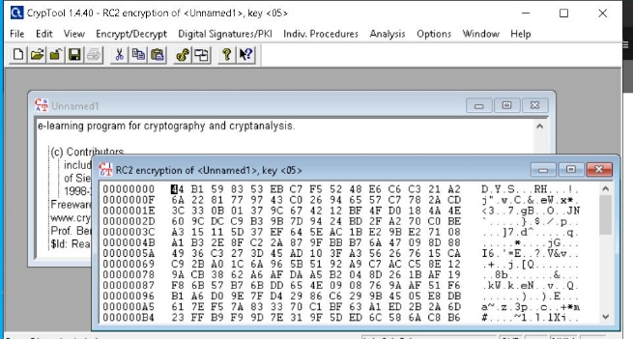  Figure 14: Encrypting message
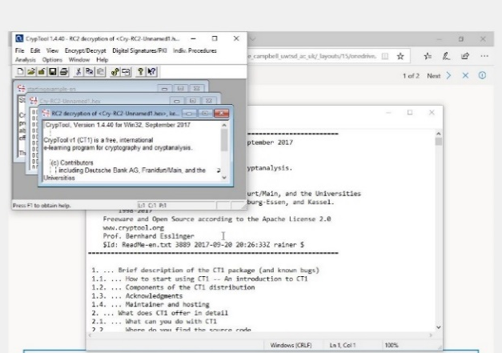
Figure 15: Decrypted message
To ensure maximum network security it is imperative to use strong encryption (Figure 14). Attacks normally focus on targets which are easy to compromise. If an attacker wants to breach an encrypted network, they are required to use decryption initially to access the network (Figure 15), usually resulting in the hacker searching for an alternative target to breach due to amount of effort and time required to attempt this. Encryption and decryption are vital in security. Encryption converts information into unreadable formats increasing levels of security and only those who have authorisation can access it [40].
Cryptography has been described as the art and science of hiding sensitive information from being comprised by unauthorised individuals. It is used to safeguard and protect information as it allows for the transfer of sensitive data across the internet securely [40].
Cryptography is linked to information security such as confidentiality, message authentication, data integrity and entity authentication. Confidentiality ensure sensitive information remains secure from those unauthorised to access it. Data integrity does not allow for alterations to made to the sensitive data. Message authentication validates the source of the information whilst entity authentication verifies the entity identity [41].
The information is disguised in plain text which is known as encryption or enciphering. The encrypted messaged is known as the ciphertext. This process is required to be reversible so that the intended recipient can obtain the text. This is known as decryption or deciphering. It requires a deciphering key. In other terms, if the recipient receives the correct message it can only be decrypted with the correct key [41].
The following are types of cryptographic keys:
- Symmetric keys, also known as shared-secret keys, which is exchanged between two routers and a VPN. Both the sender and receive are required to share a secret key which is 80 to 256 bits. An example is AES (Advanced Encryption Standard) or DES (Data Encryption Standard) [42].
- Asymmetric keys, also known as public key algorithms, utilised to secure HTTPS applications. They are 512 to 4,096 bits and the receiver and sender do not share a key. An example are RSA (Rivest Shamir Adleman is an encryption and authentication system) and DH (Diffie-Hellman where data exchanged is encrypted using SSL or TLS on the internet) [42]. Public key algorithms use two different keys: private (only known by its owner) and public (known to everyone). The key utilised for encryption is different to the key utilised for decryption [42].
- Digital signatures utilised to connect to secure websites, ensuring data has not been altered when it was signed. It is used to authentic a source and provide evidence the part has seen and signed the data [42].
- Hash keys which is utilised in symmetric, asymmetric keys and digital signatures. It calculates a fixed-size bit string hash value which is unique, known as a message digest [42].

3.3.3 Security Implications
Cryptography attacks occur assuming the attacker has access to encrypted information. The following are types of cryptography attacks:
- Ciphertext-only where the attacker aims to recover the encryption key via the ciphertext.
- Chosen-key like a chosen-text attack [42].
- Known-plaintext where the attacker has some knowledge of the plain text which is used to develop ciphertext to decipher other messages [42].
- Adaptive chosen-plaintext where the attacker carries out queries to select plaintexts which are based on prior encryptions [42].
- Chosen-plaintext where the attacker creates their own plaintext which is fed into the cipher which analyses the ciphertext [42].
- Timing consists of measuring exact execution times repeatedly of exponentiation operations [42].
- Chosen-ciphertext consists of gathering plaintexts which relate to a subjective set of ciphertexts [42].
- Rubber hose consists of extracting cryptographic secures such as encrypted files and passwords [42].
In addition, there are also code breaking methodologies such as using social engineering techniques to reveal cryptography keys. Brute-force can be utilised by applying all combinations possible to reveal the keys. One-time pad can be applied which contains non-repeating groups of letters or numbers chosen randomly to discover the keys. Moreover, attackers may undertake a study to determine the frequency of letters within a ciphertext. This is based on the evidence that within a written language, specific letters/combination of letters occur with differing frequencies [42].
To conclude, encryption converts data into a scrambled code sent across either a private or public network with the intent that only the intended receiver can decrypt it. This process is vital as it ensures data remains confidential, authenticated and integrity is applied. Cryptography can be implemented to protect confidential information such as emails, web transactions, person data and chat sessions.

Part 2: Synthesise a solution to a potential real-life scenario

Introduction
This section combines both the understanding and knowledge from Part 1 to implement and design a simulation of a University’s network if it were a ‘Smart Campus’. To design and simulate a Smart Campus, Smart Garden and Smart Car Park, Cisco packet tracer was utilised which includes smart objects allowing campus automation.

Simulation Network
A network simulation has been undertaken of the “Smart Campus” IQ Building at the University of Wales Trinity Saint David (UWTSD). IoT plays a significant role within the campus which supports the network to enhance the quality and performance of the university’s services. An example of a smart campus can be seen at Glasgow University; which utilises smart technology such as sensor technology for monitoring Co2 levels within lecture theatres and adjusting ventilation when necessary as well as sensors to alert users on the number of empty spaces at quiet study areas [43]. This data allows the system to be utilised more efficiently and allows users to make ‘smarter’ decisions e.g. students not having to waste resources looking for space in a full library.
The IoT consist of various devices which are incorporated together by the internet as well as interacting with it by means of monitoring, tracking and sensing objects within their environment. These devices can be sensors, remote devices or smart products which can relay information to data warehouses and/or business systems [44]. They provide the system with valuable data which it can learn and adapt from, creating a more sustainable process.
A Smart Campus can be seen as an environment which interconnects applications, devices and individuals enabling new services and experiences with the aim of improving operations efficiency [45]. A Smart Campus (Figure 16) requires wireless connectivity both indoors and outdoors as well as a common technology infrastructure to support the individuals, applications and devices allowing for interaction amongst one another [44].
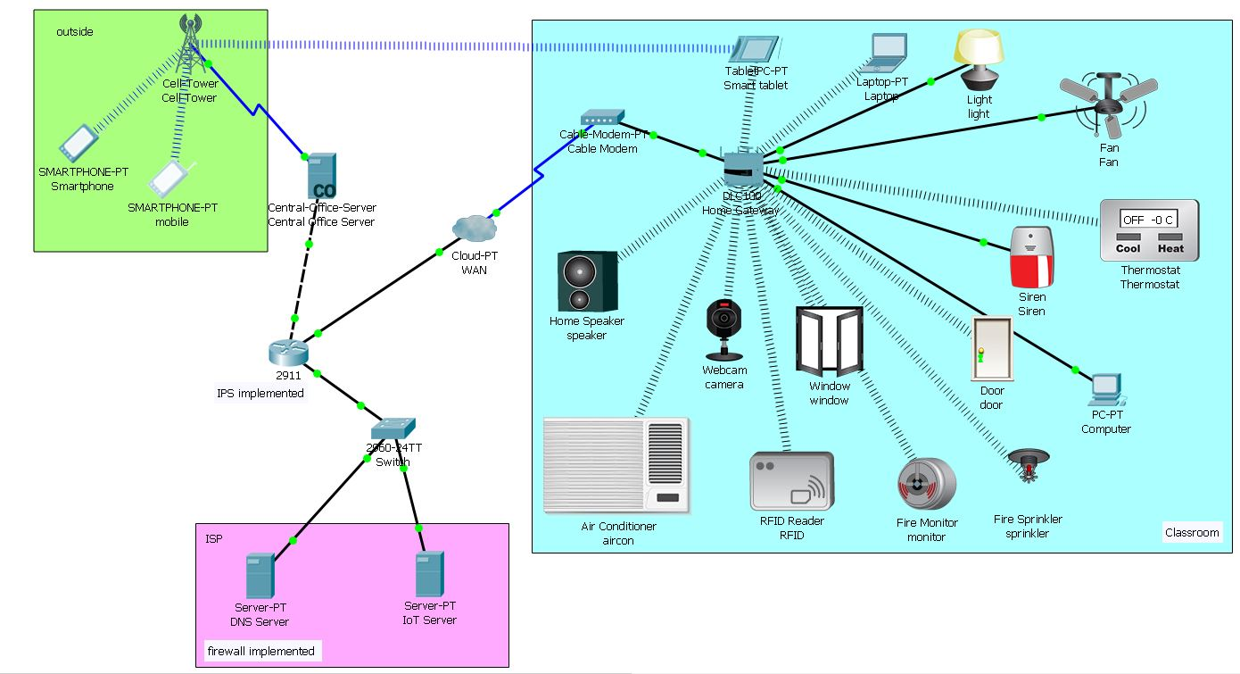
Figure 16: Smart Campus
Table 2 provides an overview of the devices and their purpose which forms part of the Smart Campus.
Device | Purpose
Server (control office) | Connects the cell tower to the router and router to the cell tower to transfer information
Cell tower | Allows for campus services to be controlled and accessed remotely
IPS router | Connects the cellular network and campus together
IoT server | Controls the IoT devices registered
Cable modem | Connects the gateway and cloud together
Home gateway | Registers and assigns an IP address to the smart devices
Light | Provides light for the campus
Fan | Ventilates the campus
Thermostat | Control the temperature of the campus
Siren | To alert any unauthorised access when campus is closed
Door | Connects to the home gateway and can be locked or unlocked via a smart phone
Window | Can be controlled remotely with a smart phone
Fire sprinkler | To put out a fire
Fire monitor | To alert if a fire occurs
RFID | Authorised access to the campus via student card
Webcam | Monitor campus activities
Air conditioner | To provide cold air if campus is too warm
Speaker | Provides audio output
Table 2: Components of Smart Campus
The devices in a smart campus can be controlled via a smart phone. The servers (IoT and DNS) (Figure 16) store the data and the smart devices can be controlled via smartphone, tablet, laptop or computer. The smart devices are connected to the IoT server and access to the data stored can be via the IoT server via the web on a laptop, tablet or smartphone. The same process is applied for the smart garden and smart car park however, there is only the one server for the smart devices.

A Smart Garden is an innovative garden which can take care of itself (Figure 17) [46] and can be controlled by smart devices. Sensors can provide the system with valuable data on how it can adjust the instructions sent to associated devices in order to behave more efficiently. For example, in this smart garden the water level monitor will tell the server data regarding the level of water in the system, the server can apply intelligence to this (logarithms or conditions pre-set by the user) to determine if the water level is too low and therefore can send an instruction to the sprinkler to turn on. Once the water level monitor sends data indicating that the water level is sufficient, then the server can send another instruction to the sprinkler to turn off. This smart garden could be extended to include a smart green house where food could be grown using temperature and water controls.
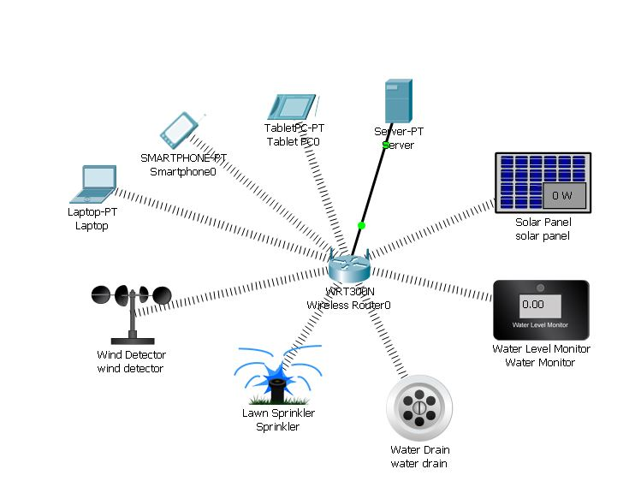
Figure 17: Smart garden
Table 3 is an overview of the devices and their purpose which form the Smart Garden.
Device | Purpose
Server | Controls the IoT devices registered
Mobile/ laptop & tablet | Can view the smart devices registered and edit their conditions
Wind detector | Detects the wind speed
Lawn sprinkler | Waters the lawn
Water drain | Collect surface/ground water
Water monitor | Monitors the water levels
Solar panel | Generate electricity
Table 3: Components of smart garden
Smart Parking uses a network of sensors and IoT components which supports drivers with guidance, analytics and payment processes (Figure 18). In addition, smart car parks can alert drivers how many spaces are available within car parks. This improves efficiency as drivers waste less time looking for spaces which also lowers carbon footprint in the long-term. Other efficiencies can be gained through smart lighting activated only when users are present. Smart payment can reduce the requirement for car-park staff and allow carparks to operate 24/7.
An example of smart parking is in Longbridge Railway Station car park where sensors are utilised to provide real-time information on spaces which is feedback to Transport for West Midlands to provide data analytics and live activity within the carpark. The data collected can be utilised for data analysis to reveal patterns within the data such as peak times to support future planning and help align supply and demand [47].
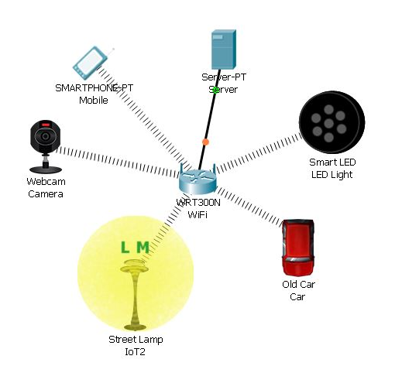
Figure 18: Smart parking
Device | Purpose
Smartphone | Can view the smart devices registered and edit their conditions
Server | Controls the IoT devices registered
Smart LED light | Advises if a car park space is available or not
Streetlamp | Provides light for the car park
Webcam | Monitor car park activities
Table 4: Components of smart parking

Possible threats and vulnerabilities
The following are challenges IT administrators are faced against for securing a smart campus, garden and carpark network:
- Maintaining the security and availability of applications whilst still allowing access to unrestricted learning environments [48].
- Enforcement of security policies despite the numerous endpoints connecting to the network. It is required to promote appropriate behaviour amongst the users as well as the ability for administrators to identify which endpoints are secure/unsecure.
- Overcoming bandwidth issues as the increase of peer-to-peer traffic requires extensive tools/resources [48].
- There is increasing difficult to identify malicious activity as there are numerous of active users [48].
- Attackers are continuously adopting new attack methodologies as their skills improve, and tools become increasingly accessible. Viruses and worms are aimed to target higher bandwidth environments as they can spread quicker [48].
- If a network is compromised consequently numerous users records too are at risk. This can be costly and lead to reputational damage. Furthermore, damage to both the student and faculty productivity can occur [48].
Furthermore, threats to a campus network can either be internal or external. Internal threats breaches confidentiality as one of the main risks is unauthorised access to the network, as it can result in data leakage and tampering. External threats can be viruses which can be a result of students downloading software or sharing resources which can increases the risk [49].
Campuses are targeted for three main reasons: espionage, notoriety and identity theft. Therefore, it is vital that mobile phones and other connected devices are required to be secured to protect them against BYOD (bring your own device) security threats [50].
Identify theft poses a risk in terms of their inexperience which increases their vulnerability. If they are utilising mobile phone banking applications and access their accounts via unsecure devices, they are at risk of exposing their financial data. Due to the lack of transaction history it makes it increasingly difficult for attacks to be identified. It is evidenced that students are more at risk of losing money as a result of fraud than adults [50].
In 2017, a smart university campus was under attack from its very own vending machine incorporated into the network. The IoT devices on the smart campus network was used against the campus to perform a botnet attack on itself. Later analysis of the network revealed that 5,000 devices (light sensors and vending machines) were creating hundreds of DNS lookups every 15 seconds. This was a consequence of weak passwords and no encryption implemented. The attack could have disrupted the entire university and shut it down leaving students with no access and perhaps even exposed sensitive data [51]. This provides real life evidence of how crucial it is to protect smart networks; they are only as justifiable as the security put in place to protect them.

Security features implemented
As a first point of protocol to reduce cyber security threats, it is imperative that students are educated on cyber security threats. This does not resolve the issue but it does provide knowledge on best practice. Information could include not clicking on links provided from unknown email sources and to not connect to Wi-Fi accounts unknown as devices can be penetrated by hackers [50]. This security guidance should be continually updated and distributed to staff and students.
Universities could enforce a policy where students and faculties are required to register their device on campus so it can be mapped to its own [50]. Additionally, physical security is vital such as intruder alarm, control systems such as card systems or biometrics and CCTV systems [52].
Implementing a robust campus network requires security risk analysis to be carried out to inform and develop an action response plan. Network configuration should include firewall, encryption, DHCP/DNS and IPS [53].

4.1.1 DNS/DHCP
Dynamic Host Configuration Protocol (DHCP) allows users to be assigned a reusable IP address. DNS (Domain Name Server) here host names or names of objects are mapped into IP numbers [54]. Within the smart campus the DNS server allows the hosted website on the IoT server access solely if a username and password is entered. Therefore, only those users with authorisation can gain access to the data stored within the IoT server.
The IoT device registration process is outlined in Figures 19-26 below.
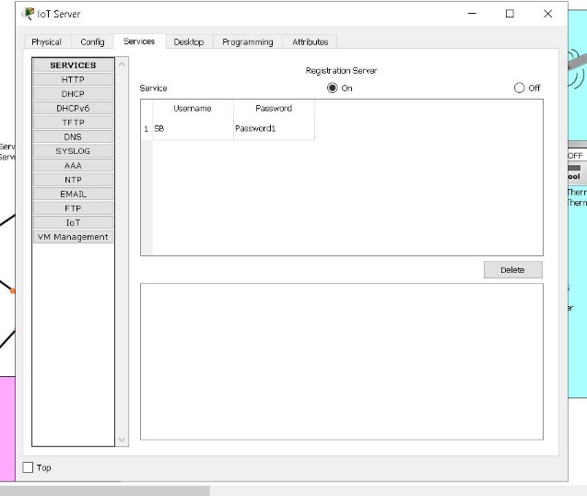  Figure 19: Registration server for IoT devices | 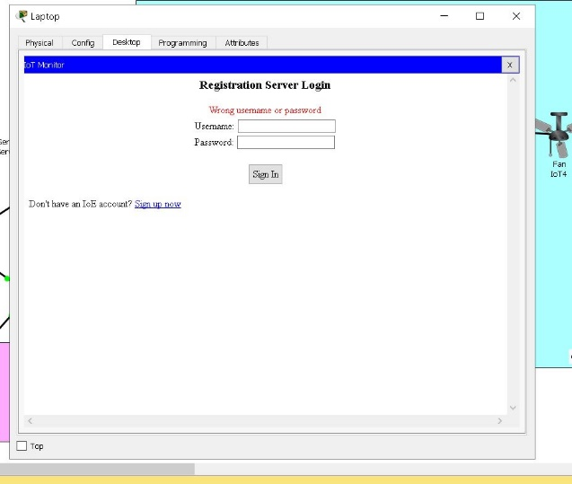  Figure 20: Creating the server account
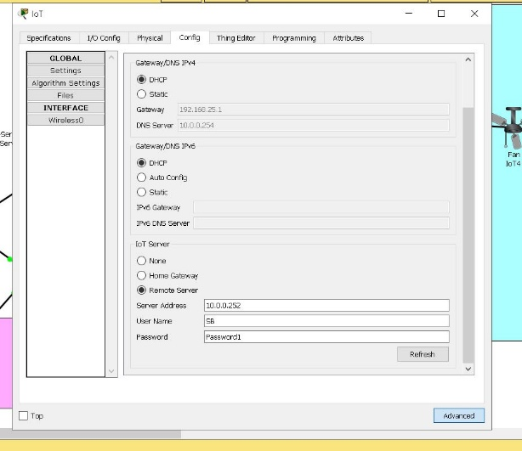  Figure 21: Registration of devices in server | 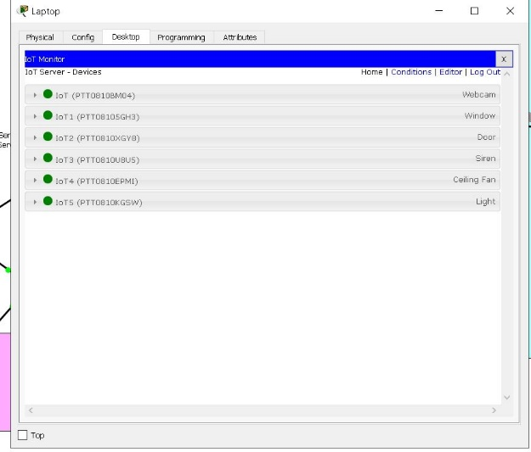  Figure 22: Monitor the devices in server

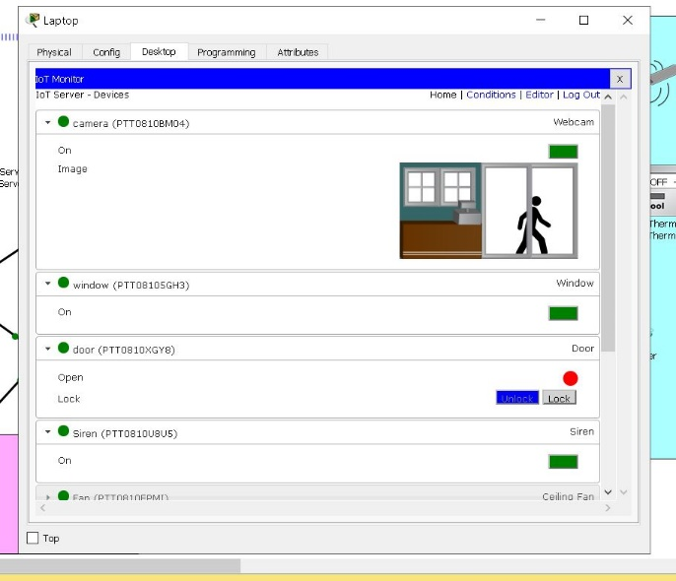  Figure 23: Device status | 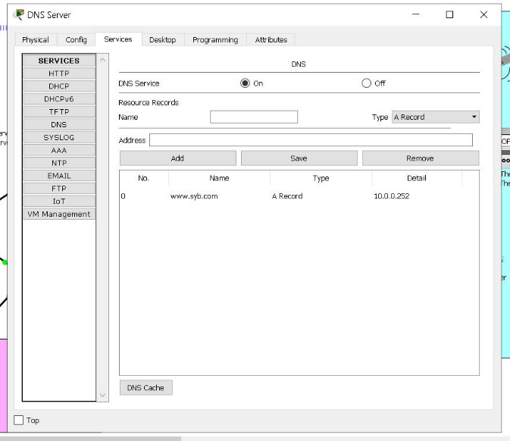  Figure 24: Adding DNS
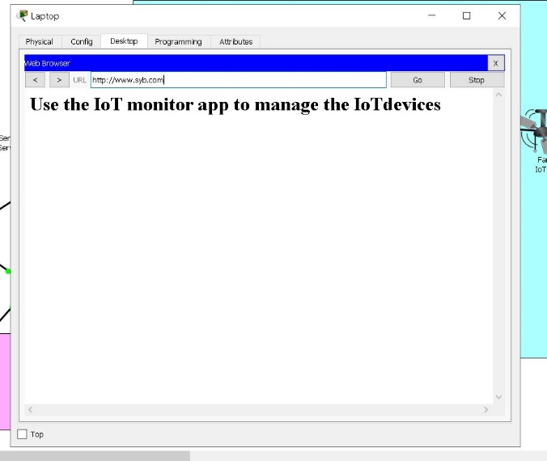  Figure 25: Webpage status | 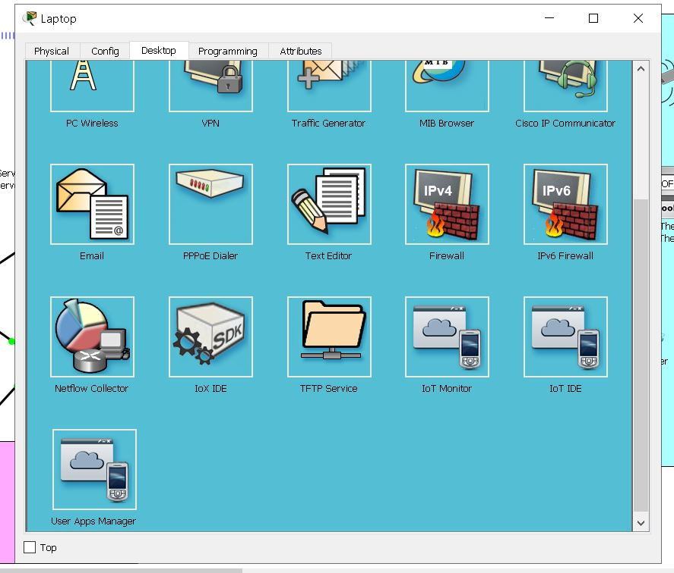  Figure 26: Laptop desktop

From the laptop desktop (Figure 26), the IoT monitor devices can be accessed which displays all the devices connected to the home gateway (Figure 22). The device status can be altered, for example turning the webcam on and off (Figure 23).
To gain access to the server requires a username and password, therefore an account needs to be created (for first use) (Figure 20). The username and password can be seen in the IoT server (Figure 19). All smart devices are remotely connected to the IoT server via the same username and password (Figure 21). The same process was applied to both the smart garden and car park to help keep all smart networks protected from unauthorised outsiders.

4.1.2 Firewall
Firewall provides network security which checks the incoming and outgoing traffic and determines whether specific traffic should be allowed or blocked. The decision is based on the set of security rules implemented [55].
In the example below rules have been defined within the DNS server (Figure 27). The rules implemented was to block ICMP (Internet Control Message Protocol) these contain error messages from routers to indicate where there was success or failure upon communicating with other IP addresses. A test was undertaken to determine whether the rules implemented worked accordingly. Figure 28 is transmitting a message from the computer to the DNS Server. Figure 29 provides evidence that the packet was not delivered successfully.
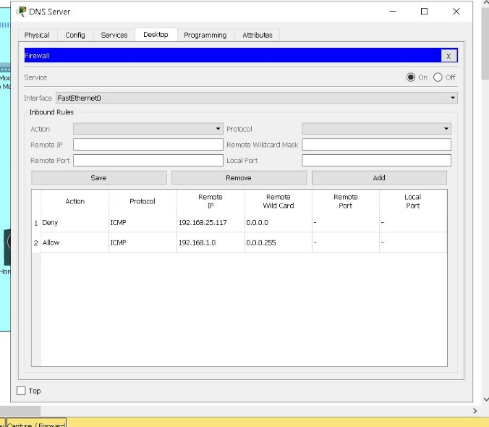Figure 27: Adding rules | 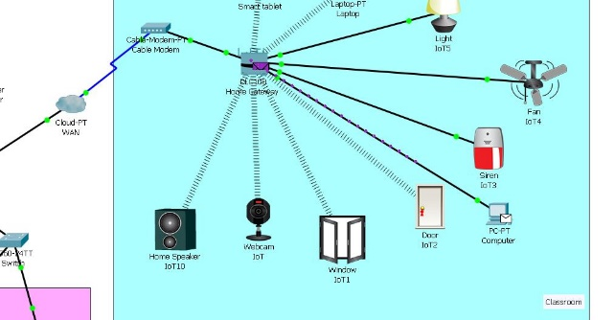  Figure 28: Transmitting message to server
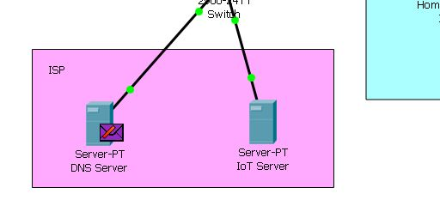
Figure 29: Message undelivered

4.1.3 Encryption
Passwords on routers can be utilised to restrict access to a router. Passwords allow for authorised persons to access the router. The passwords can be encrypted which is vital for securing confidential information as mentioned in Part 1 above. If the password is not encrypted, it is readable within the configuration file making it unsecure. Within the smart campus primarily the ISP router had no password encryption implemented (Figure 30).
The command password-encryption configuration statement was implemented to enable a strong encryption password (Figure 31 & 32). However, the password can be decrypted using Cisco Password Cracker (Figure 33).
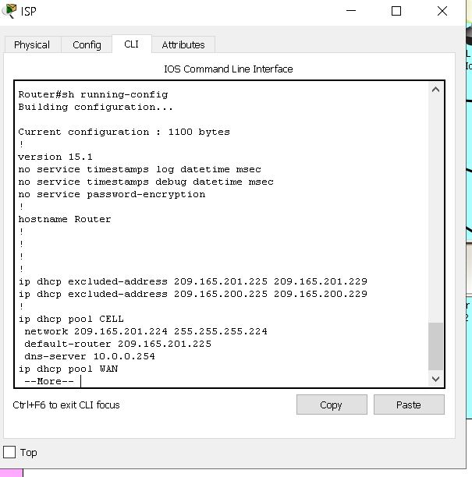  Figure 30: No password encryption | 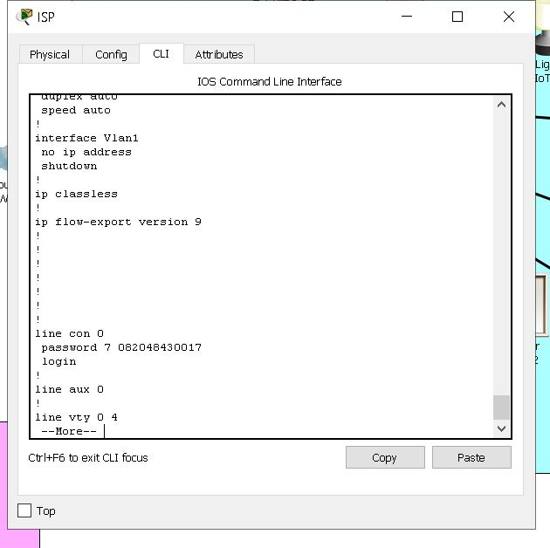  Figure 31: Password encrypted
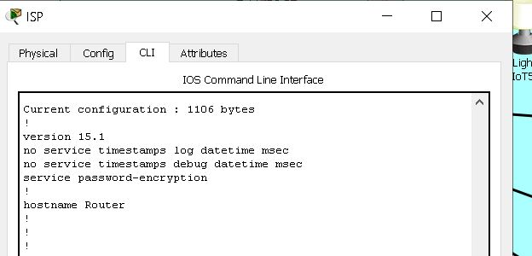  Figure 32: Password encryption set | 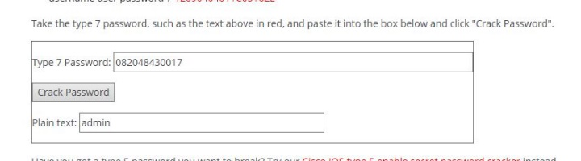  Figure 33: Password decrypted

4.1.4 IPS
IPS is an Intrusion Prevention System which examines the network traffic flow. It can identify and counteract any weaknesses within the network. This is vital within a smart campus as it can prevent any attacks on point of entry. Signature-based detection is active (Figure 34) which is based on a dictionary of patterns which can be used to identify any exploits within a code. If an exploit is identified the signature (code) is stored within a dictionary.
The IPS was configured utilising the command line interface. The IPS was implemented within the ISP router to scan all incoming traffic. Primarily an active security package was implemented: securityk9. A directory was created: ipsdir. The IPS signature storage location was also configured to be directory created: ipsdir. An IPS rule was created called iosips. The IPS signature category was retired. The interface was configured to implement the IPS rule to scan all incoming traffic.
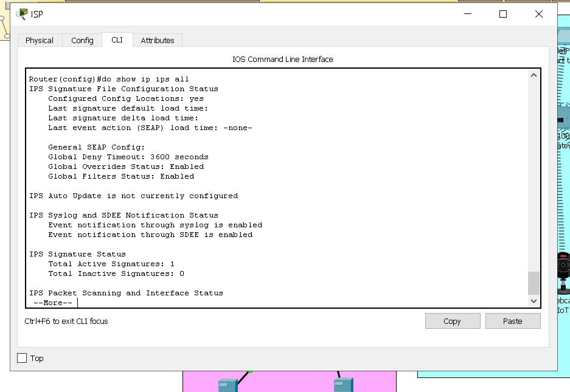
Figure 34: IPS Implemented

4.1.5 Wi-Fi Password
Wi-Fi passwords secure the smart campus network from unauthorised users. The Wi-Fi implemented within the campus has been secured with a password (Figure 35). If a Wi-Fi password is not implemented, it will put the both the campus and its users at risk of exposing their confidential information. Wi-Fi passwords prevent the campus from ransomware, malware and phishing [56].
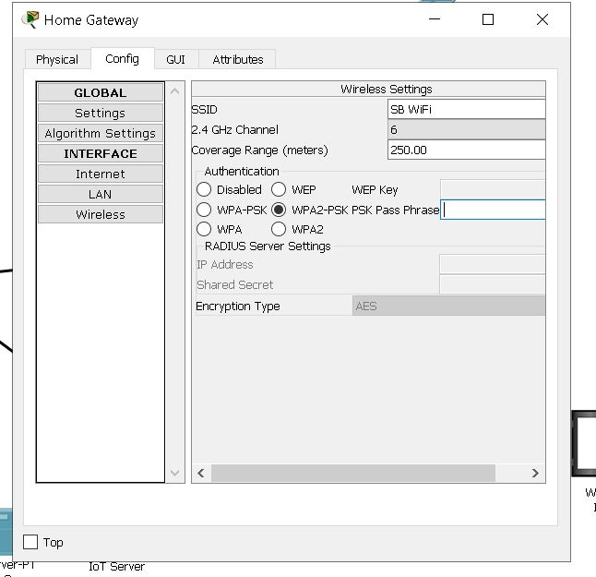
Figure 35: Wi-Fi Configured

Conclusion
To conclude, smart networks provide huge advantages over traditional systems; they’re more efficient and sustainable and also pass these benefits on to users. However, if a smart network (a smart campus, garden and carpark in this case) is not secured from attack then the consequences can be catastrophic to the network and users. Unauthorised and malicious access to a smart network can result in breach of sensitive data as well as total shut down of the system, making it unusable.
It is therefore vital to ensure a campus network, including its related elements like the car park and garden, is secure as there are thousands of users, numerous endpoints and applications running at a given time which each hold sensitive personal data and each provide an essential purpose. Often security is overlooked but it is just as important, if not more important, to ensure effective security as it is to ensure usability and functionality when creating a smart campus. If the security is breached and the system goes down then the usability and functionality are essentially void. The following are critical security measures which should be implemented to help protect the system:
- Security awareness training, as it can fill any gaps in knowledge and raise awareness surrounding cyberattacks such as phishing. Users can therefore act as a line of defence against attacks.
- Scheduled software updates on smart devices are required as they include security updates and patches for any vulnerabilities within a system or device. If these aren’t kept up-to-date then devices and processes are vulnerable and expose the system to attack.
- Encryption should be implemented as it ensures confidentiality and integrity of personal data. Moreover, it requires more time and effort for hackers to breach the network as decryption is required.
- Firewall can be utilised to monitor traffic and block any suspicious traffic from entering a network.

6. References

[1] | B. Baker, “A year in cybersecurity with the UK National Cyber Security Centre,” Army Technology, 5 September 2019. [Online]. Available: https://www.army-technology.com/comment/a-year-in-cybersecurity-with-the-uk-national-cyber-security-centre/. [Accessed 14 April 2020].
[2] | S. Kuyoro, F. Ibikunle and O. Awodele, “Cloud Computing Security Issues and Challenges,” International Journal of Computer Networks , vol. 3, no. 5, 2011.
[3] | A. Verma and S. Kaushal, “Cloud Computing Security Issues and Challenges: A Survey,” Communications in Computer and Information Science, vol. 193, pp. 445-454, 2011.
[4] | M. Ferkoun, “Top 7 most common uses of cloud computing,” IBM, 6 February 2014. [Online]. Available: https://www.ibm.com/blogs/cloud-computing/2014/02/06/top-7-most-common-uses-of-cloud-computing/. [Accessed 2 May 2020].
[5] | K. Technologies, “Benefits of Cloud Computing,” Medium, May 12 2016. [Online]. Available: https://medium.com/@KNOWARTH/benefits-of-cloud-computing-8f6eee9a28e. [Accessed 2 May 2020].
[6] | A. Huth and J. Cebula, “The Basics of Cloud Computing,” Carmegie Mellon University, 2011.
[7] | M. Azure, “What is cloud computing,” Microsoft Azure, 2020. [Online]. Available: https://azure.microsoft.com/en-gb/overview/what-is-cloud-computing/#cloud-computing-models. [Accessed 2 April 2020].
[8] | A. Singh and K. Chatterjee, “Cloud security issues and challenges: A survey,” Journal of Network and Computer Applications, vol. 79, pp. 88-115, 2017.
[9] | R. P. Padhy, M. R. Patra and S. C. Satapathy, “Cloud Computing: Security Issues and Research Challenges,” International Journal of Computer Science and Information Technology & Security, vol. 1, no. 2, 2011.
[10] | T. Aslan, “Cloud physical security considerations,” IBM, 12 February 2012. [Online]. Available: https://www.ibm.com/blogs/cloud-computing/2012/02/22/cloud-physical-security-considerations/. [Accessed 2 May 2020].
[11] | F. Ogigau-Neamtiu, “CLOUD COMPUTING SECURITY ISSUES,” The Regional Department of Defense Resources Management Studies, Brasov, Romania, vol. 3, no. 2, 2012.
[12] | D. Popescul, L. D. Radu and A. I. Cuza, “Data Security in Smart Cities: Challenges and Solutions,” Informatica Economica, vol. 1, 2016.
[13] | B. Buntz, “The World’s 5 Smartest Cities,” IoT World Today, 18 May 2016. [Online]. Available: https://www.iotworldtoday.com/2016/05/18/world-s-5-smartest-cities/. [Accessed 2 May 2020].
[14] | A. A. Group, “Smart Cities and Buildings,” ARC Advisory Group, 2020. [Online]. Available: https://www.arcweb.com/industries/smart-cities. [Accessed 2 May 2020].
[15] | A. S. Elmaghraby and M. M. Losavio, “Cyber security challenges in Smart Cities: Safety, security and privacy,” Journal of Avanced Research, vol. 5, no. 4, pp. 491-497, 2014.
[16] | M. Georgescu and D. Popescul, “The Importance of Internet of Things Security for Smart Cities,” Intechopen, 2016.
[17] | H. Habibzadeh, B. H. Nussbaum, F. Anjomshoa, B. Kantarci and T. Soyata, “A survey on cybersecurity, data privacy, and policy issues in cyber-physical system deployments in smart cities,” Sustainable Cities and Society, vol. 50, 2019.
[18] | D. Close, “Futurizing IoT Security for Smart Cities,” Security Magazine, 23 August 2019. [Online]. Available: https://www.securitymagazine.com/articles/90775-futurizing-iot-security-for-smart-cities. [Accessed February 2020].
[19] | T. Braun, B. C. Fung, F. Iqbal and B. Shah, “Security and privacy challenges in smart cities,” Sustainable Cities and Society, vol. 39, pp. 499-507, 2018.
[20] | BT, “A guide to VPN for businesses,” BT, 2020. [Online]. Available: https://business.bt.com/help/guides/vpn-for-business/. [Accessed 5 May 2020].
[21] | T. Bear, “Take back your online privacy with TunnelBear VPN,” TunnelBear, 2020. [Online]. Available: https://www.tunnelbear.com/b/vpn/?utm_source=google&utm_medium=cpc&utm_campaign=2020%20-%20UK%20-%20Search%20-%20Brand%20-%20Others&campaignid=9106823986&feeditemid=&adgroupid=93226768460&keyword=tunnel%20vpn&matchtype=e&creative=414551951719&adposition=&. [Accessed February 2020].
[22] | D. Roos, “How to Surf the Web Anonymously,” How Stuff Works, 2020. [Online]. Available: https://electronics.howstuffworks.com/how-to-tech/how-to-surf-the-web-anonymously4.htm. [Accessed April 2020].
[23] | N. P. Hoang and D. Pishva, “Anonymous Communication and its Importance in Social Networking,” Advanced Communication Technology , 2014.
[24] | T. Fisher, “How to Browse the Web Anonymously,” Lifewire, 13 December 2019. [Online]. Available: https://www.lifewire.com/anonymous-web-basic-3482839. [Accessed April 2020].
[25] | Purplesec, “The Ultimate List Of Cyber Security Statistics For 2019,” Purplesec, 2019. [Online]. Available: https://purplesec.us/resources/cyber-security-statistics/. [Accessed April 2020].
[26] | I. Governance, “Why is penetration testing necessary?,” IT Governance, 04 September 2013. [Online]. Available: https://www.itgovernance.co.uk/media/press-releases/why-is-penetration-testing-necessary. [Accessed 12 April 2020].
[27] | S. T. Education, “Penetration Testers,” Security Through Education, 2020. [Online]. Available: https://www.social-engineer.org/framework/general-discussion/categories-social-engineers/penetration-testers/. [Accessed 12 April 2020].
[28] | S. Abraham and I. S. Chengalur-Smith, “An overview of social engineering malware: Trends, tactics, and implications,” Technology in Society, vol. 32, no. 3, pp. 183-196, 2010.
[29] | D. Shackleford, “Social engineering penetration testing: Four effective techniques,” Search Security, 2015.
[30] | Phishing, “Phishing Examples,” Phishing, 2020. [Online]. Available: https://www.phishing.org/phishing-examples. [Accessed 2 May 2020].
[31] | K. Krombholz, H. Hobel, M. Huber and E. Weippl, “Advanced social engineering attacks,” Journal of Information Security and Applications, vol. 22, pp. 113-122, 2015.
[32] | L. P. Shing, L. H. Shing, C.-C. Shing, M. C. Chiang and C. W. Yang, “Smartphone Security Risks: Android,” International Journal of Electronics and Electrical Engineering, vol. 4, no. 4, 2016.
[33] | N. Hopkins and D. Sabbagh, “WhatsApp spyware attack was attempt to hack human rights data, says lawyer,” The Guardian, 14 Mat 2019. [Online]. Available: https://www.theguardian.com/technology/2019/may/14/whatsapp-spyware-vulnerability-targeted-lawyer-says-attempt-was-desperate. [Accessed 2 May 2020].
[34] | Malwarebytes, “Malwarebytes for Android,” Malwarebytes for Android, 2020. [Online]. Available: https://www.malwarebytes.com/android/. [Accessed April 2020].
[35] | M. Koyuncu and T. Pusatli, “Security Awareness Level of Smartphone Users: An Exploratory Case Study,” Hindawi, 2019.
[36] | L. Wlosinski, “Mobile Computing Device Threats, Vulnerabilities and Risk Are Ubiquitous,” Isaca Journal, 2016.
[37] | M. Yesilyurt and Y. Yalman, “Security Threats on Mobile Devices and their Effects: Estimations for the Future,” International Journal of Security and its Applications, pp. 13-26, 2016.
[38] | V. P. Srinivas Avireddy, “Random4: An Application Specific Randomized Encryption Algorithm to Prevent SQL Injection,” Security and Privacy in Computing and Communications, pp. 1327-1333, 2012.
[39] | WhatsApp, “WhatsApp Encryption Overview,” 2019.
[40] | M. T. Gençoğlu, “Importance of Cryptography in Information Security,” Journal of Computer Engineering, vol. 21, no. 1, pp. 65-68, 2019.
[41] | F. Piper, “Cryptography,” Encyclopedia of Software Engineering, 2002.
[42] | D. C. Campbell, “Cryptography,” University of Wales Trinity Saint David, Swansea, 2019.
[43] | U. o. Glasgow, “How the Internet of Things will help enable the “Smart Campus”,” Glasgow University , 27 November 2017. [Online]. Available: https://www.gla.ac.uk/myglasgow/news/campus/2017/headline_561658_en.html. [Accessed 5 May 2020].
[44] | A. Abdi, “Designing Smart Campus Using Internet of Thing,” Internation Journal of Computer Science Trends and Technology, vol. 6, no. 3, 2018.
[45] | I. Global, “What is Smart Campus,” IGI Gloval Plublisher of Timely Knowwledge, 2020. [Online]. Available: https://www.igi-global.com/dictionary/design-and-prototyping-of-a-smart-university-campus/75800. [Accessed 29 April 2020].
[46] | C. a. Grow, “The Smart Garden 3,” Click and Grow, 2020. [Online]. Available: https://eu.clickandgrow.com/products/the-smart-garden-3. [Accessed 2 May 2020].
[47] | S. Parking, “SmartPark System,” Smart Parking , 2020. [Online]. Available: https://www.smartparking.com/smartpark-system. [Accessed 2 May 2020].
[48] | C. Solutions, “Cisco Campus Secure,” 2006.
[49] | M. Tao, W. Shaoqian, L. Minglian and W. Baozhu, “The Research on Strategy of Building Campus Network Security Based on University Management,” International Conference on Mechanical and Electronic Engineering, vol. 3, pp. 142-147, 2012.
[50] | E. Levine, “What Universities Can Do to Limit the Cybersecurity Risk of Personal Devices on Campus,” EdTech, 05 March 2019. [Online]. Available: https://edtechmagazine.com/higher/article/2019/03/what-universities-can-do-limit-cybersecurity-risk-personal-devices-campus. [Accessed 30 April 2020].
[51] | J. Murdock, “University hacked by its own vending machines: How IoT almost took entire campus offline,” International Business Times, 15 February 2017. [Online]. Available: https://www.ibtimes.co.uk/verizon-cybercrime-sleuth-reveals-how-iot-almost-took-entire-university-offline-1605941. [Accessed 4 May 2020].
[52] | G. University, “PHYSICAL SECURITY POLICY (AMENDED 2018),” Glasgow University, 2018. [Online]. Available: https://www.gla.ac.uk/myglasgow/central/trafficandsecurity/physicalsecuritypolicy2018/. [Accessed 5 May 2020].
[53] | L. Kumari, S. Debbarma and R. Shyam, “Security Problems in Campus Network and its Solutions,” Department of Computer Science, 2011.
[54] | Cisco, “Dynamic Host Control Protocol (DHCP)/Domain Name System (DNS),” Cisco , 2020. [Online]. Available: https://www.cisco.com/c/en/us/products/ios-nx-os-software/dynamic-host-control-protocol-dhcp-domain-name-system-dns/index.html. [Accessed 3 May 2020].
[55] | Cisco, “What Is a Firewall?,” Cisco, 2020. [Online]. Available: https://www.cisco.com/c/en_uk/products/security/firewalls/what-is-a-firewall-c.html?adobe_mc_sdid=SDID%3D2C215309D4D37AF8-19793CB3BC4BD38E%7CMCORGID%3DB8D07FF4520E94C10A490D4C%40AdobeOrg%7CTS%3D1588504443&adobe_mc_ref=https%3A%2F%2Fwww.google.com%2F. [Accessed 3 May 2020].
[56] | B. Mitchell, “Why You Should Change the Default Password on a Wi-Fi Router,” Lifewire, 6 January 2020. [Online]. Available: https://www.lifewire.com/changing-default-password-on-wifi-network-816567. [Accessed 3 May 2020].
[57] | T. A. Butt and M. Afzaal, “Security and Privacy in Smart Cities: Issues and Current Solutions,” Research Gate, 2017.
[58] | Rishabhreddy, “IMPORTANCE OF CRYPTOGRAPHY AND ITS APPLICATIONS,” Medium, 8 November 2018. [Online]. Available: https://medium.com/@rishabhreddy18/importance-of-cryptography-and-its-applications-83ed8ae38e3d. [Accessed 13 April 2020].
[59] | D. Courses, “OSPF encrypted authentication - Packet Tracer,” YouTube, 13 April 2012. [Online]. Available: https://www.youtube.com/watch?v=rqIAgmK_RW4. [Accessed 1 May 2020].
[60] | N. A. Rakhmawati, “[Cisco Packet Tracer ] HTTP, FTP, Firewall (AccessList),” YouTube, 22 June 2015. [Online]. Available: https://www.youtube.com/watch?v=yW3qIYkQ8C0. [Accessed 1 May 2020].
[61] | C. P. T. Labs, “[CCNA Security] Configuring access control list on Cisco router,” YouTube, 1 August 2018. [Online]. Available: https://www.youtube.com/watch?v=15Rg_bgbYcA. [Accessed 1 May 2020].
[62] | C. P. T. Labs, “CCNA Security Lab 5.4.1.2: Configure IOS Intrusion Prevention System (IPS) Using CLI,” YouTube, 29 December 2016. [Online]. Available: https://www.youtube.com/watch?v=KBELcaBveNI. [Accessed 1 May 2020].

marking criteria and Student FEEDBACK

This section details the assessment criteria. The extent to which these are demonstrated by you determines your mark. The marks available for each criterion are shown. Lecturers will use the space provided to comment on the achievement of the task(s), including those areas in which you have performed well and areas that would benefit from development/improvement.

Common Assessment Criteria Applied (Assignment 1) | Marks available | Marks  awarded
1. Engagement with Literature Skills
Extent of research and/or own reading, selection of credible sources, application of appropriate referencing conventions.
Diversity of appropriate sources used with key concepts discusses. The appropriate referencing used (Grade mark: 88.89%) | 45 | 40
2. Knowledge and Understanding Skills
Extent of knowledge and understanding of concepts and underlying principles associated with the discipline.
3. Cognitive and Intellectual Skills
Analysis, evaluation and synthesis; logic, argument and judgement; analytical reflection; organisation of ideas and evidence
Your introduction need to be improved, see more comments within your report. You have demonstrated excellent research knowledge in the research aspects. You have discussed the lab exercises very well and include analysis after each lab discussions (very good) and how they could aid an organisation. (Grade mark: 91.11%) | 45 | 41
4. Practical Application Skills
Deployment of methods, materials, tools and techniques; application of concepts; formulation of innovative and creative solutions to solve problems.
5. Transferable Skills for Life and Professional Practice
Attributes in professional practice: individual and collaborative working; deployment of appropriate media; presentation and organisation.
Your report flow very well. You could align justify it to enhance it more professionally. Try to avoid contraction grammar for academic writing. (Grade mark: 80.00%) | 10 | 8

Assignment Mark (Assessment marks are subject to ratification at the Exam Board. These comments and marks are to give feedback on module work and are for guidance only until they are confirmed. ) | Late Submission Penalties (tick if appropriate) |  | 89%
 | Up to four weeks late |  | 89%
 | First Attempt? |  | 89%

marking criteria and Student FEEDBACK

This section details the assessment criteria. The extent to which these are demonstrated by you determines your mark. The marks available for each criterion are shown. Lecturers will use the space provided to comment on the achievement of the task(s), including those areas in which you have performed well and areas that would benefit from development/improvement.

Common Assessment Criteria Applied (Assignment 2) | Marks available | Marks  awarded
1. Engagement with Literature Skills
Extent of research and/or own reading, selection of credible sources, application of appropriate referencing conventions.
2. Knowledge and Understanding Skills
Extent of knowledge and understanding of concepts and underlying principles associated with the discipline.
You have demonstrated coherent knowledge and understanding of the subject area. You did not following the IEEE report format. (Grade mark: 80.00%) | 20 | 16
3. Cognitive and Intellectual Skills
Analysis, evaluation and synthesis; logic, argument and judgement; analytical reflection; organisation of ideas and evidence
The design discussion was excellently done with a table overview of the devices and their purposes. You also included a detailed discussion on challenges IT admin will face from possible threats and vulnerabilities. (Grade mark: 95.00%) | 20 | 19
4. Practical Application Skills
Deployment of methods, materials, tools and techniques; application of concepts; formulation of innovative and creative solutions to solve problems.
Your practical design considered no redundancy in the core. Relevant security measures in place. When tested, most pings were successful and all within the LANs. (Grade mark: 75.00%) | 60 | 45
5. Transferable Skills for Life and Professional Practice
Attributes in professional practice: individual and collaborative working; deployment of appropriate media; presentation and organisation.

Assignment Mark (Assessment marks are subject to ratification at the Exam Board. These comments and marks are to give feedback on module work and are for guidance only until they are confirmed. ) | Late Submission Penalties (tick if appropriate) |  | 80%
 | Up to four weeks late |  | 80%
 | First Attempt? |  | 80%

