Module Name: Hotel Placement Research Project
Module Code: BMIH6008
Title: “Assessing the Role of Front Office Executive in Delivering Personalised Experiences to the guest in the hospitality industry, a case study of Mercure Milton Keynes Hotel”
Student Name: Cristiana Andreea Staicu
Student ID: 2026517
Institution and Department Name: Mercure Milton Keynes /Front office

Generative AI Declaration
I have used Grammarly within this assignment to improve the spelling and grammar that are being used in it to facilitate a high standard of understanding regarding this assignment.

Acknowledgement
I would like to express my sincere gratitude to all those who have supported me throughout the course of this research. I am also effectively grateful to all the institutional members for providing them with the resources and facilities for conducting this research. A special then goes to the library manager, who assists with obtaining essential materials and research tools.

Glossaries
The unique word I have used
- Spatial: Occupying Space
- Proximity: Relationship
- Compliance: Regulations
Abstract
The hotel front office, in the context of the hospitality industry, is far more than a reception desk. The front office executive effectively ensures that every interaction with the guest is seamless from the moment a guest makes a reservation. According to several reports in the hospitality industry, it can be stated that the hospitality industry recognises the important role of the front office. This role is based on a strategic driver of guest satisfaction and hotel revenue. This particular research appears to have been developed mainly based on the several challenges faced by the UK’s hospitality industry. The front office executives, as well as organisations such as Mercure Milton Keynes Hotel, face effective or significant challenges in designing personalised guest experiences. This is primarily driven by severe labour shortage, high staff turnover, the pressure to adopt new technologies and more. There are several hotel organisations that effectively rely on the legacy property management system. This cannot store the detailed guest references. This effectively makes it difficult to provide personalised touches. The key aim of the research study was to analyse the effectiveness of the front office executive in delivering a personalised experience to the customer in the UK’s Hospitality industry-a case study of Mercure Milton Keynes Hotel. This study has been mainly developed as there is a diverse range of hotels that struggle to deliver this approach consistently. The front office staff, as the primary point of contact, is effectively critical for delivering this personalisation. Meanwhile, the corporation sometimes face significant challenges. This mainly includes high staff turnover, pressure to automate processes for efficiency and a lack of adequate training. This research has mentioned developing a detailed methodological approach in Chapter Three. This is based on primary quantitative and secondary qualitative data. This methodology also followed the Saunders onion research methodology. The secondary data has been collected from several preexisting articles through Google Scholar. Additionally, the primary data has been collected from conducting a survey with 30 participants that belonged to the hotel guests. An effective descriptive analysis has been conducted in this research paper to analyse the primary data. These ultimate findings stated that this front office executive of the mentioned hotel is effectively providing personalised guest experiences for enhancing their satisfaction.

Table of Contents
Chapter 1. Introduction 9
1.1. Background and Context 9
1.2. Problem Statement 9
1.3. Research Aim and Objectives 10
1.4. Research Questions 10
1.5. Rationale 10
1.6 Summary 11
Chapter 2. Literature Review 12
2.1 Introduction to Literature Review 12
2.2 Evaluation of Literature and Theories 12
2.2.1 Identification of the front office executive's role in delivering personalised experiences to customers in the UK’s hospitality industry 13
2.2.2 Examination of the specific techniques used by Front Office executives to tailor effective guest experiences in the UK’s hospitality industry 14
2.2.3The relationships between personalised front office service and overall guest satisfaction, positive reviews and loyalty 15
2.2.4 Recommend innovative strategies that can be used by the Front Office Executive in delivering effective and personalised guest service. 17
Chapter 3. Methodology 18
3.1. Introduction to the Chapter 18
3.2. Saunders’ Onion Research method 18
3.3. Ethical consideration 20
3.4. Chapter Summary 20
Chapter 4. Findings 21
4.1. Introduction to the Chapter 21
4.2 Evaluation of Results 21
4.3 Evaluation of Thematic Analysis 35
4.4 Discussion 38
4.4.1 Analysis of research findings in relation to existing literature by addressing the research topic, objectives and questions 38
4.4.2 Implication of the research findings 41
4.4.3 Limitations 42
4.4.4 Valuable areas critical to the placement of hotel operations 42
4.5 Chapter Summary 43
Chapter 5. Conclusion and Recommendations 44
5.1 Conclusion 44
5.2 Recommendation 47
References 50
Appendix 60

Chapter 1. Introduction

1.1. Background and Context
The front office executive is one of the essential roles in the hospitality industry that plays a critical role in delivering personalised experiences in the UK hospitality industry. The front office executive mainly acts as the primary, high-touch point of contact. In the context of a competitive market. 71% of UK customers expect individualised experiences (inspiredthinking, 2026). The effectiveness of the front office executive effectively encourages the ability to transform from traditional administrative tasks to proactive guest engagement. As per several reports. 88% of UK consumers are more likely to recommend the Mercure Milton Keynes Hotel, which effectively offers tailored services.

1.2. Problem Statement
The UK hospitality industry is effectively facing issues regarding personalised guest drive. In this industry, personalised guest service has effectively become a primary driver of customer loyalty and satisfaction (thehotelmagazine, 2025). There is a diverse range of hotels that struggle to deliver this approach consistently. The front office staff, as the primary point of contact, is effectively critical for delivering this personalisation. Meanwhile, they sometimes face significant challenges. This mainly includes high staff turnover, pressure to automate processes for efficiency and a lack of adequate training. In the context of Mercure Milton Keynes Hotel, the management of the hotel has aimed to provide high-standard guest experiences (mercuremiltonkeynes, 2026). Though it effectively faces possible gaps in delivering personalised attention, especially at a time when they are trying to balance the standardised operational procedure with individual audience references.

1.3. Research Aim and Objectives
Aim: The key aim of the report is to analyse the effectiveness of the front office executive in delivering a personalised experience to the customer in the UK’s Hospitality industry-a case study of Mercure Milton Keynes Hotel.
Objective 1: To identify the role of the front office executive in delivering personalised experiences to customers in the UK’s hospitality industry.
Objective 2: To examine the specific techniques used by Front Office executives to tailor effective guest experiences in the UK’s hospitality industry
Objective 3: To determine the relationships between personalised front office service and overall guest satisfaction, positive reviews and loyalty.
Objective 4: To recommend innovative strategies that can be used by the Front Office Executive in delivering effective and personalised guest service.

1.4. Research Questions
Question 1: What is the role of a front office executive in delivering personalised experiences?
Question 2: What are the specific techniques used by Front Office executives to tailor effective guest experiences?
Question 3: What are the innovative strategies that can be used by the Front Office Executive in delivering effective and personalised guest service?

1.5. Rationale
The rationale of the research appears to be very effective for the UK hospitality industry. This particular research topic provides the opportunity to shift towards an experience economy in that ace tailored service is essential and the primary differentiator in a competitive market. As the UK consumers prefer more individualised attention, the front office executive effectively provides an essential human link. It effectively converts data into memorable guest experiences. In the context of the UK tourism and hospitality industry, tourists effectively preferred a comfortable room.

1.6 Summary
This particular chapter has effectively covered the background and context of the case study or placement hotel that significantly faces issues related to delivering effective guest experiences from the front office staff. This chapter has also covered the problem and the rationale of the present topic in an effective way.

Chapter 2. Literature Review

2.1 Introduction to Literature Review
The literature review will discuss the role of the front office executive in delivering personalised experiences to customers in the UK hospitality industry. It will examine some specific techniques and provide recommendations about effective and personalised guest services.

2.2 Evaluation of Literature and Theories
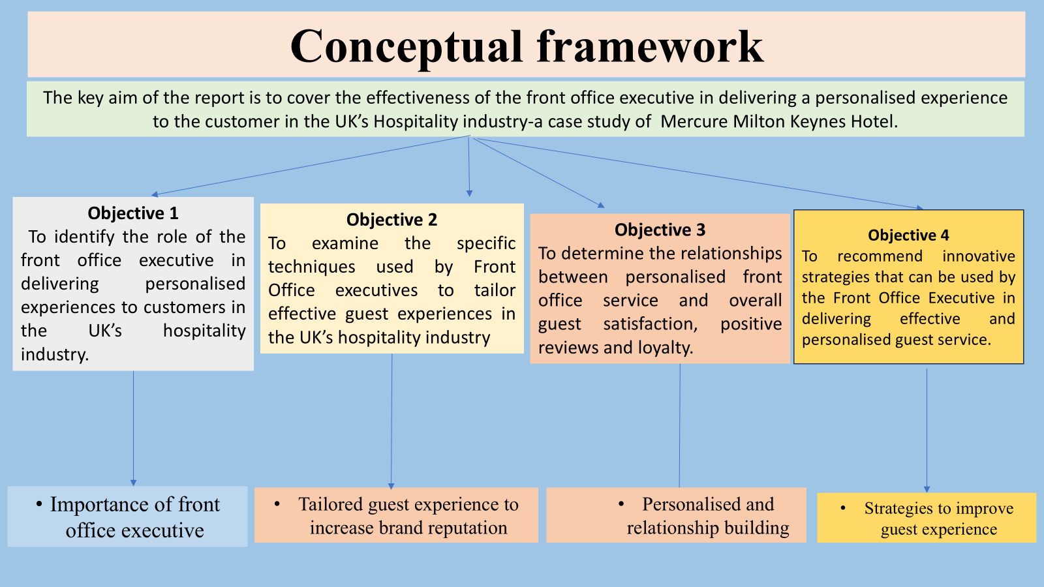
Figure- Conceptual framework
Source- Self-made
According to the authors Delbosc and Shafi (2023, p.914) Conceptual framework is a visual diagram that highlights the key variables, constructs and factors in a research paper. This study aims to develop a conceptual framework of the role of the front office executive using a literature review of existing studies.

2.2.1 Identification of the front office executive's role in delivering personalised experiences to customers in the UK’s hospitality industry
According to the author, Collins (2023, p. 12), office executives in the hospitality industry play a crucial role in delivering personalised experiences to customers. They deliver personalisation through managing guest profiles according to their needs, providing recommendations and solving their problems properly. According to Stoyanova-Bozhkova et al (2022, pp.359), using strong personal skills to create a welcoming, professional and memorable environment in the hospitality industry. This helps to deliver a personalised experience to customers. These actions make sure that the front office is not just an administrative sector; it is a strategic centre that enhances guest experience.
As per the author, Fowler et al. (2024, p.334), implementing knowledge management provides benefits in the hospitality industry. It focuses on its impact on customers' and guests’ experience and satisfaction. This strategy enables staff to access detailed guest and customer profiles such as their dietary preferences, room preferences and many more. It allows for a tailored experience that enhances their satisfaction and increases brand loyalty. According to Cuozzo et al. (2025, pp.2080) Effective knowledge management provides real-time data that helps the office executives to proactively identify the problems. It also helps to outpace their decision-making in the hospitality industry to enhance customer experience. According to Ferreira et al. (2023, p.100076) The front office executive often uses CRM tools to identify guests’ preferences and feedback to personalise check-in and throughout the stay in the hotels. They also use multiple digital tools, such as digital check-ins through mobile, in-room assistants, to improve future services. As per Forman and Udvaros (2023, pp.2673), they fill the gap between technology and human interaction by applying behavioural knowledge to make sure guests feel valued.
Social Exchange Theory
According to the author Liang et al. (2025, p. 202), social exchange theory is a framework that suggests social behaviour is the outcome of a cost-benefit analysis. As per Stafford and Kuiper (2021, pp. 379), Individuals could evaluate relationships based on increasing rewards and minimising the cost. This theory suggests that human interaction depends on corresponding exchanges of resources, both in tangible and intangible ways (de Meireles Cunha, 2024, pp. 57). As per the author, Evans-Howe (2025, p. 289), it transforms routine interaction into memorable experiences that boost customer loyalty and operational revenue.

2.2.2 Examination of the specific techniques used by Front Office executives to tailor effective guest experiences in the UK’s hospitality industry
As per the author, Wilson (2025, p.72), front office executives ensure operational efficiency and sustain competitive advantage in the hospitality industry. Techniques that increase guest experience in the UK hospitality sector that front office executives use, such as property management systems, Artificial Intelligence and many others. According to Radović et al. (2025, p.134), the UK hospitality industry mainly focuses on the human-digital balance. They use technology for handling routine tasks and free up staff to offer personalised service to guests. As per Papademetriou et al (2023, p.8251), through implementing technology, human resource practices, technological innovation and sustainability influence both organisational performance and customer satisfaction. As per the authors, Kandampully and Solnet (2024, p.344), front office executives demonstrate the way the hospitality sector could utilise technology to enhance customer satisfaction for other staff and employers. They see hospitals and tourism as essential services that need a holistic, cross-functional approach to satisfy customer needs.

Technology Acceptance Model
According to the authors, Marikyan and Papagiannidis (2024, p.3), the technology acceptance model shows the acceptance of information systems by individuals. This theory highlights that the acceptance of modern technology is predicted through the user's behavioural intention. That is, in turn, driven by the perception of technology's usefulness in performing tasks.
As per the author, Davis et al. (2024, p.109), the technology acceptance model functions as an effective guiding concept, smoothing the way to achieve specific goals of the hospitality industry.
It helps to explore the technology acceptance approaches for a wide range of technological solutions. According to the author, Najafi (2024, p.15) Through the technology acceptance model, front office executives in hotels could see the technology as beneficial. According to Mois et al (2024, p.105373), the executives are technology-based hosts; they ensure that new technologies are useful and easy to use for everyone.

2.2.3The relationships between personalised front office service and overall guest satisfaction, positive reviews and loyalty
According to the author, Bardukova (2023, p.88), the hospitality industry is undergoing rapid transformation. It is driven by technological innovation, changing customer preferences and global events. According to Stringam and Gerdes. (2021, p.6), This industry has implemented technology for increasing guest experience, with trends such as easy check-in through their mobiles, keyless entry and smart room control. According to Mandić et al. (2023, p. 174), Personalised front office services perform as a primary driver of guest and customer satisfaction. It remarkably influences the generation with positive feedback and creates long-term guest loyalty in the hospitality industry.
As per the author, Eckert et al. (2022, p.569), customer and guest satisfaction management is increasing day by day, and it is important within the hospitality industry. Defining the guest-oriented strategy and implementing digital applications based on technologies ranks among the most strategic challenges. According to Brochado and Mendes (2025, pp. 301), as guest expectation increases, the advancement of high-touch services with high-tech solutions has become an analytical strategic discriminator. According to Wilson (2025, pp.72), the relationship between a personalised front office executive has several components, such as guest satisfaction, positive reviews, loyalty and retention.
Relationship Marketing Theory
According to the author Chatzi et al. (2024, p. 272), Relationship marketing theory highlights that building a long-term and trusting connections with customers to increase loyalty and deepen business. According to Geissdoerfer et al. (2023, pp.3830), it enhances personal interaction, high-quality services and consumer retention. Keeping customers loyal is extremely crucial in hospitality businesses. According to Gurler (2025, pp.920), Customer satisfaction mediates the linkage between two cognitive constructs of perceived quality, price and brand loyalty. Emotional value affects the relationship between satisfaction and brand loyalty.
According to the author, George (2025, p.385), that personalised front office service is an analytic driver of hotel performance; it directly influences guest satisfaction, brand reputation and long-term loyalty. According to the author, Osadare et al. (2024, p.553), there are several techniques to enhance customer satisfaction in the hospitality industry. According to Rooney (2021, pp.42), through the framework of relational marketing theory, it prioritises long-term and emotionally engaging interaction over transactional, personalised service. According to Prentice et .al (2022, p.102788), this helps to transform a hotel stay into a memorable experience and build an emotional bond between the guest and the organisation.

2.2.4 Recommend innovative strategies that can be used by the Front Office Executive in delivering effective and personalised guest service.
According to the authors, Bilgihan and Ricci (2024, p.123), there are several technologies the hospitality industry could use to enhance customer experience.
According to Mueller‐Saegebrecht and Walter (2025, pp.420), the importance of fundamental marketing practices such as customer-friendly websites, mobile-friendly websites, social media engagement, content marketing and data-driven revenue management. As per the author, Mogaji (2025p. 33), with the help of modern technology, front office executives could track marketing performance, customer personalisation and many other things that enhance guests’ experience.
Herzberg’s Two-Factor Theory
According to the authors, Peramatzis and Galanakis (2022, p.971), Herzberg’s theory is applied because it provides information on the task of motivation through drawing attention to the job factors that are sometimes overlooked. As per the authors, Koncar et al (2022, p.1), Herzberg's two-factor theory is a strategic way of understanding the influential aspects for employee and customer satisfaction. According to the author (Iugova, 2025, p.8), Herzberg's two-factor theory suggests that to deliver effective and personalised guest and customer experience, a front office executive could eliminate dissatisfaction to reach a neutral state.

Chapter 3. Methodology

3.1. Introduction to the Chapter
Research methodology is one of the common sections in the dissertation (ijoear, 2025). This is a systematic approach that is used by a researcher to conduct and develop a study paper (Saunders et al., 2012). Methodology in the research paper includes diverse types, including mixed methods, quantitative and qualitative (Zarei, 2025). Methodology mainly helps to understand the research topic and ensures the accurate and reliable methods of the results (vt, 2025). This particular research paper was mainly developed by following the mixed method. This includes primary quantitative and secondary qualitative. This methodology also follows the Saunders onion research methodology.

3.2. Saunders’ Onion Research method
Saunders’ onion Research Method is one of the common research methodological approaches that is mainly known as the research process onion or methodological onion (jfsdigital, 2026). This particular methodological approach was founded by Mark Saunders and colleagues (Morrison, E.A. and Saunders, M.N., 2025, pp. 136). This methodology especially helps researchers to offer a systematic plan for their research topic (aesanetwork, 2024). This is mainly based on broad philosophical outer layers to spatial practical inner layers (getitdoneex, 2025).
3.2.1. Research philosophy
Research philosophy is the first stage of Saunders' onion research methodology (thecontentcreek, 2026). This has three types, including positivist, interpretivist and pragmatist (Lawler and Waldner, 2023, pp. 232). This particular research approach has followed the pragmatist research philosophy. This is appropriate as it serves as the philosophical foundation for mixed methods (Elgeddawy and Abouraia, 2024, pp. 73). It allows for the integration of both qualitative and quantitative approaches to answer the research question (Ormerod, 2021, pp. 800).
3.2.2. Research approach
The research approach is the second stage of this methodology (Mulisa, 2022, pp 120). This particular research has followed both an inductive and deductive approach (Taherdoost, 2022, pp. 57). The deductive approach is appropriate for primary research and inductive for secondary (Collis & Hussey, 2014). This combination effectively allows for structured confirmation of hypotheses with in depth understanding (Yuwono and Rachmawati, 2023, pp. 5).
3.2.3. Research Strategy
Research strategy is the third stage of the methodology (Dzwigol, 2022, pp. 86). The particular research mainly follows two types of research strategies, including case study analysis and survey. This research strategy may be an explanatory sequential strategy (Warren, 2025). This is appropriate as it provides explanatory power and provides a complete picture in which the numerical trends and authentic data are explained by contextual narratives (Finkelstein et al., 2024, p. 23).
3.2.4. Research choice
This is the fifth stage of research on onion methodology (Nazirova and Tursunov, 2023, pp. 22). This particular research paper will follow the mixed method as the methodological choice (Cottrell, 2014). This is appropriate as it effectively provides informed and quality data through secondary qualitative research and numerical, authentic data from the primary quantitative analysis.
3.2.5. Time Horizon
Longitudinal was followed in this particular research paper. This particular time frame is appropriate as the research paper was finished over multiple months across the months.
3.2.6 Data Collection and Analysis
The secondary data has been collected from several preexisting articles through Google Scholar. Additionally, the primary data has been collected from conducting a survey with 30 participants that belonged to the hotel guests. The primary data has been analysed through a descriptive table using Excel, and the secondary data has been analysed through thematic approaches.

3.3. Ethical consideration
The ethical research in the UK effectively demands strict adherence to GDPR (General Data Protection Regulation) and data protection laws. This effectively ensures their informed consent, participation safety and confidentiality. This particular research has followed this consideration in a significant manner (Veal, 2006).

3.4. Chapter Summary
The research paper has effectively conducted the methodological approaches of this particular study paper that aims to analyse the effectiveness of the front office executive in delivering a personalised experience. The mixed method has been followed in this particular chapter to develop this methodology.

Chapter 4. Findings

4.1. Introduction to the Chapter
The chapter will evaluate the insights about the role of front officer executives in delivering personalised experiences to the customers. The full analysis has been done based on the hospitality industry. The evaluation will do primary quantitative and secondary qualitative research by collecting direct and numerical data. This will help to provide measurable and valid insights about the effectiveness of front office executives to deliver personalised customer experience in the UK's hospitality industry.

4.2 Evaluation of Results
Primary Quantitative Research
Result 1
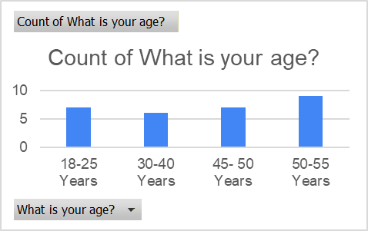
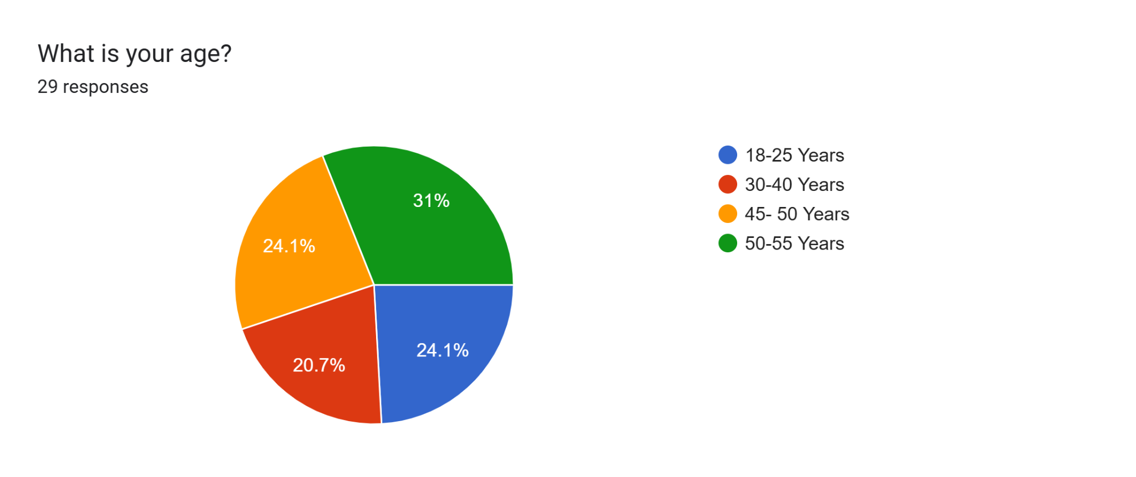
The survey has been done with 29 individual customers from the hospitality industry in the UK. The results have highlighted that 31% participants who participated were mostly 50 to 55 years old. Almost 24.1% participants were 18 to 25 and 45 to 50 years old.
Result 2
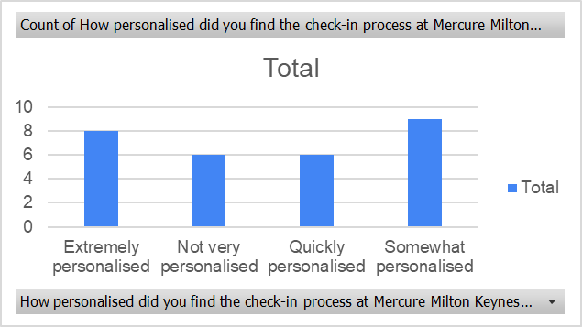
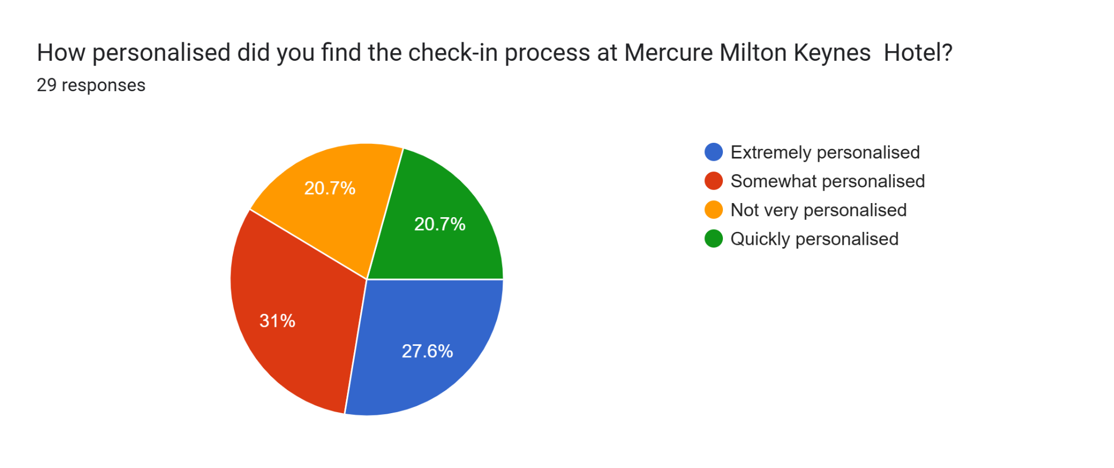
This particular analysis stated that almost 31% of individuals have found the check-in process somewhat personalised at Mercure Milton Keynes Hotel. On the other hand, 27.6% of individuals have found their check-in process extremely personalised, and they are totally satisfied with it.
Result 3
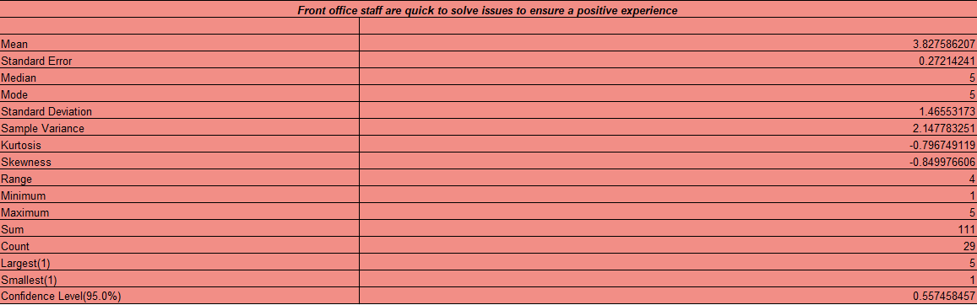
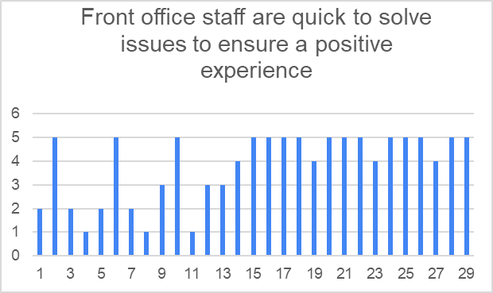
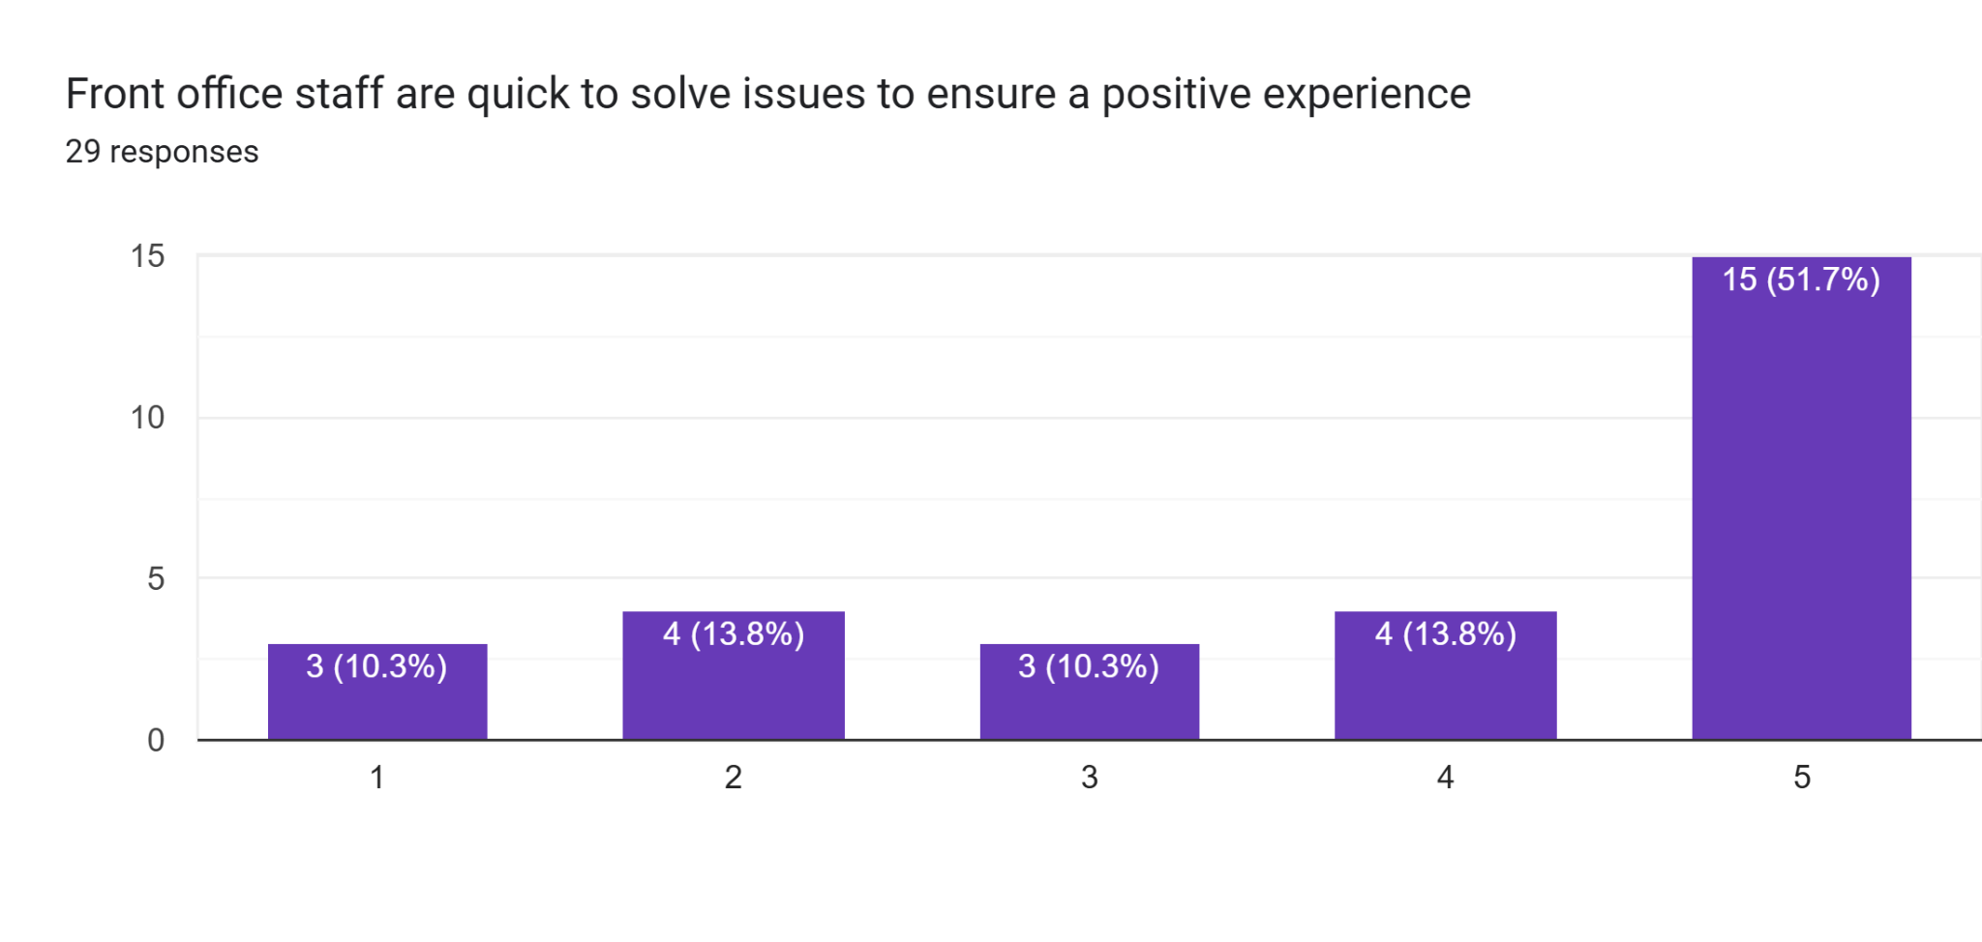
Based on the analysis, it has been found that the mean value is 3.82758620689655, and the median and mode values are 5. According to the analysis, most individuals think that front office staff effectively help to solve any kind of issues very quickly to provide a positive experience. Almost 51.7% of individuals have agreed with these decisions. Most of the responses are in the middle of 4 to 5. Very little repose has been given on the negative side. This means the customers are satisfied with the efficiency and service quality of the front office staff.
Result 4
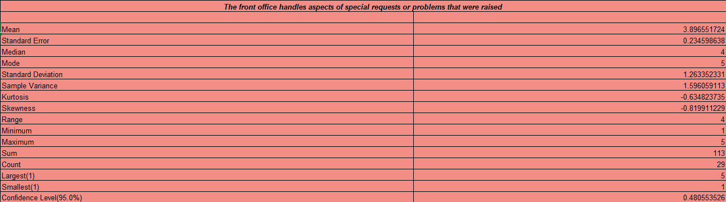
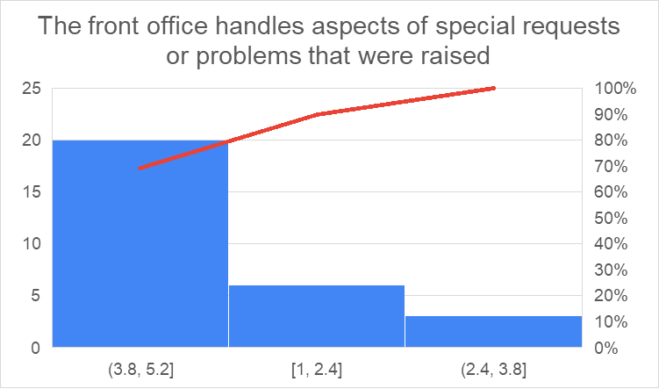
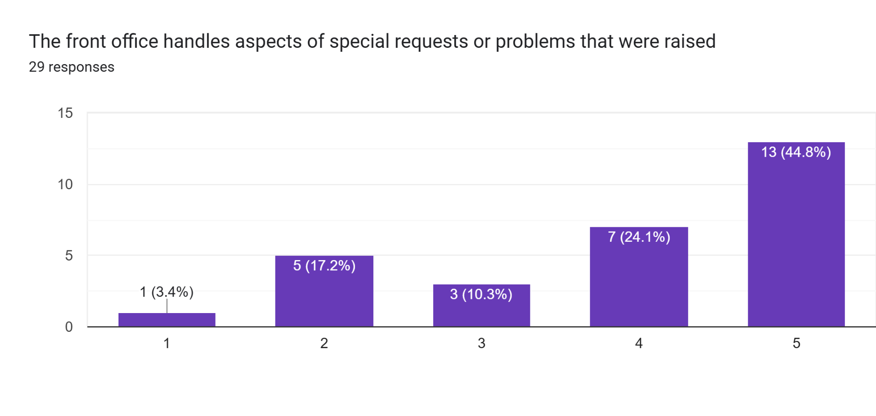
As per the analysis, the mean value of the fourth question is 3.89655172413793, and the median and mode value is 4 and 5. The analysis has confirmed that 44.8% of individuals think that the front office handles aspects of social requests or any kind of problem that was raised in the hotel. According to them, the effectiveness of the front office in handling problems is quite impressive, as they are quick to solve them. The majority of the respondents have stated the rating between 3.8 and 5.2 as they agree with the question.
Result 5
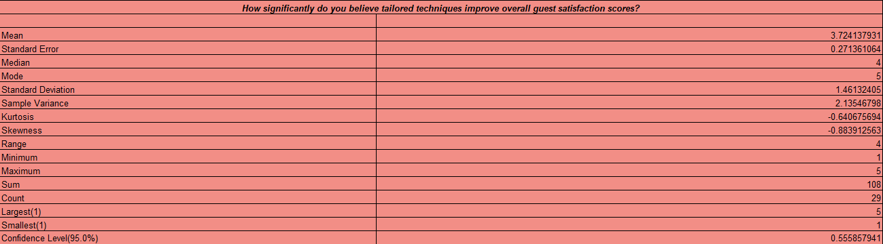
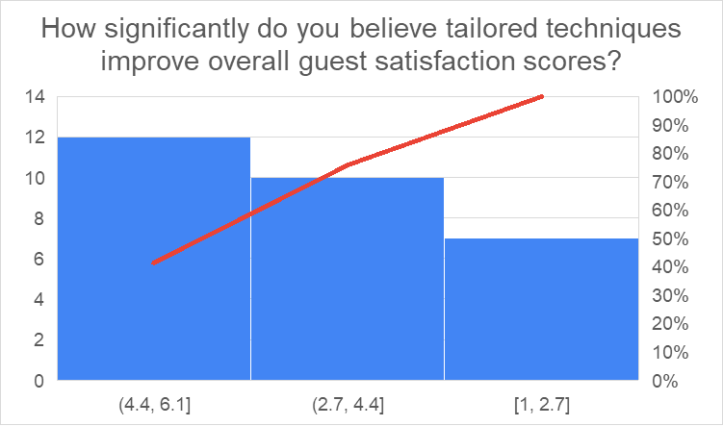
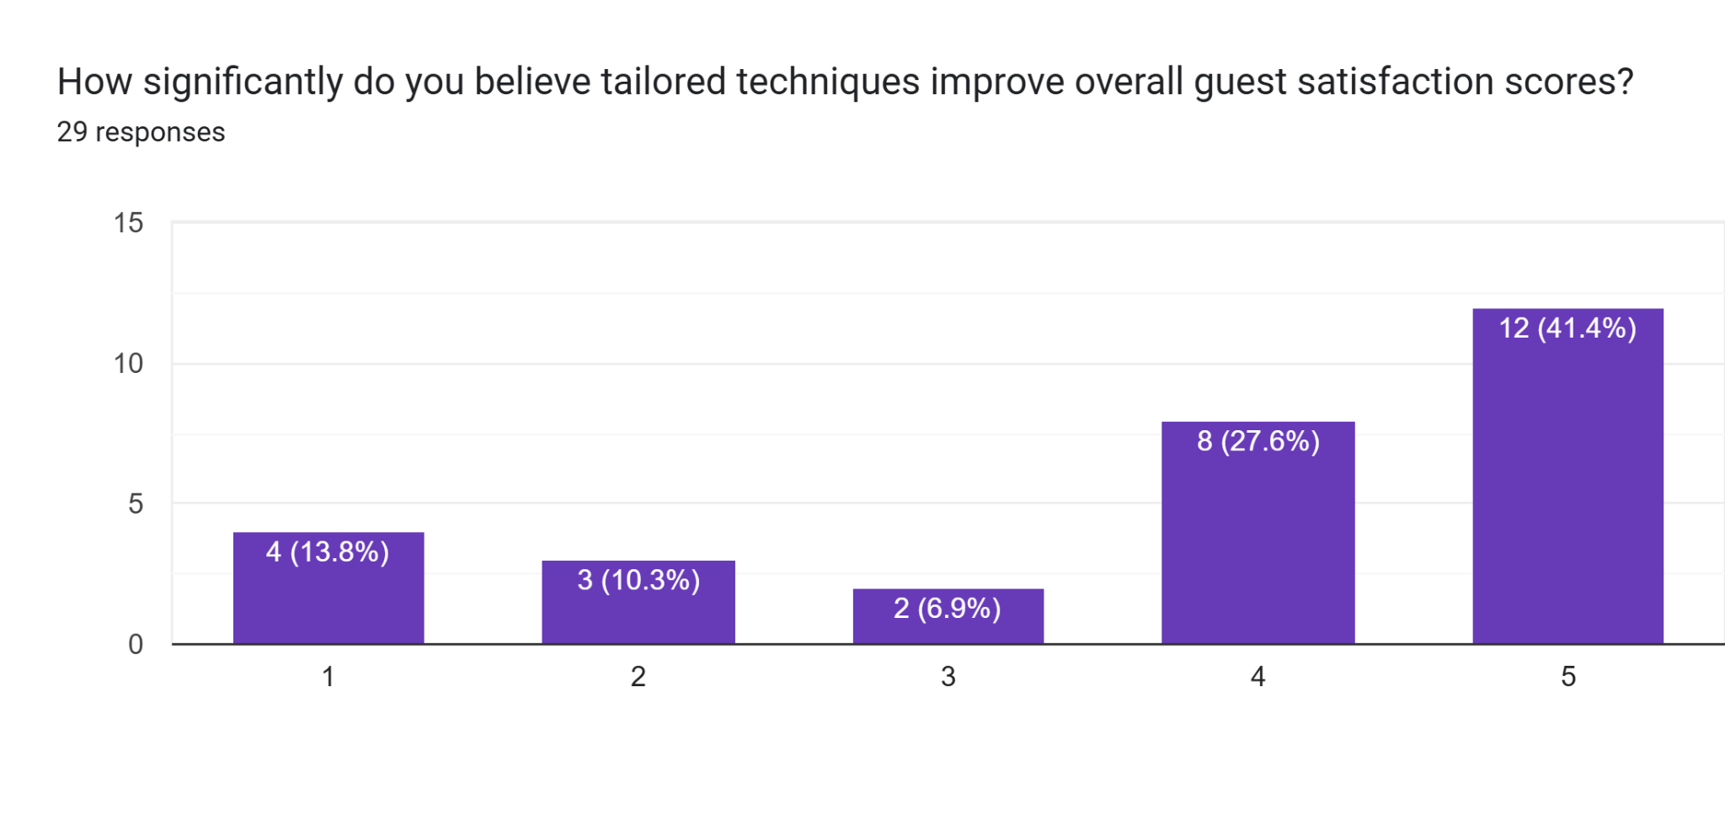
According to the descriptive table, it has been found that the standard deviation value is 1.46132405040619, and it shows the moderate variability of the respondents. Minimum 1 and a maximum of 5 respondents have provided a full rating scale. The Pareto chart has analysed that 80% of the respondents have rated it between 4.4 and 6.1. On the other hand, 70% participants have rated it 2.7 to 4.4. Almost 41.4 % of individuals have highly agreed with the third question about tailored techniques in improving overall guest satisfaction scores.
Result 6
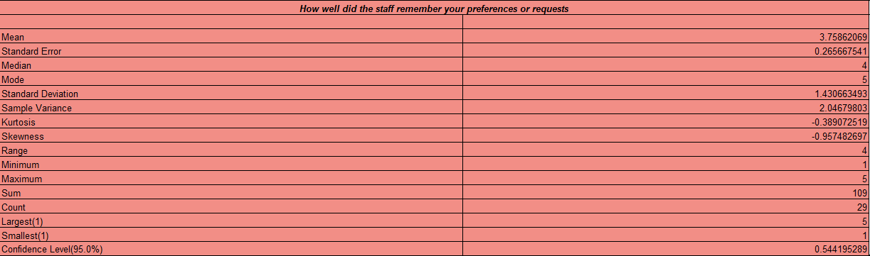
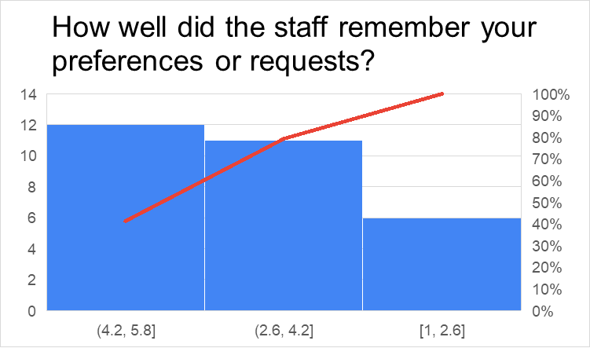
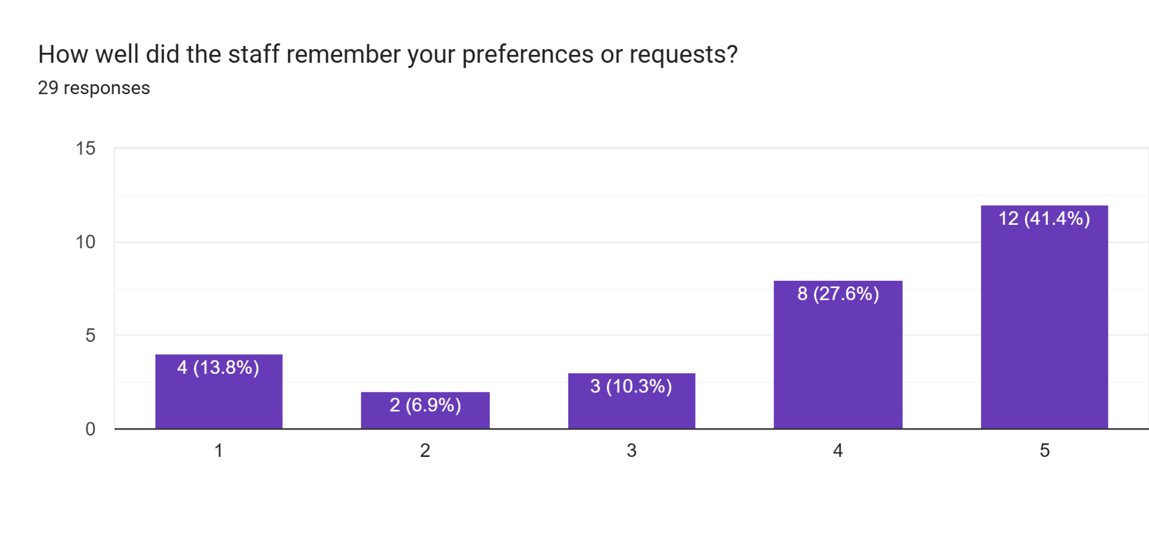
According to 41.4% of individuals, the staff member did very well in remembering individual customer’ preferences in the Mercure Milton Keynes Hotel. Based on the descriptive table, it can be stated that of the 29 respondents, 5 respondents provided the rating on the full scale as they had been treated well and got what they preferred from the staff member of the hotel. The mean value of the sixth question is 3.75862068965517, and the median and mode values are 4 and 5. This value indicates that the staff of the hotel are doing well.
Result 7
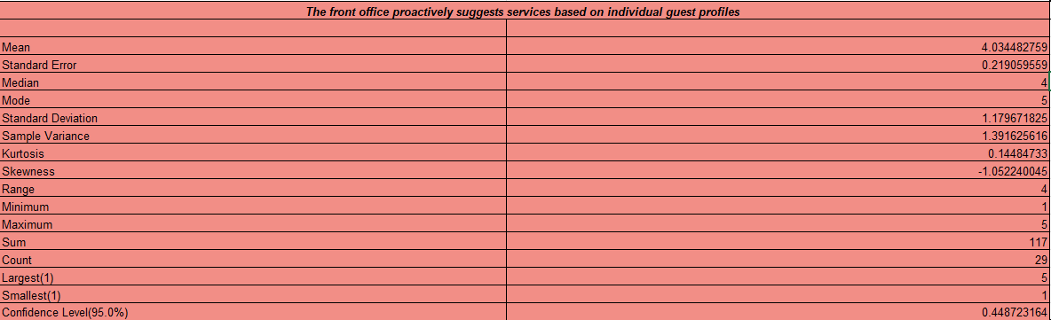
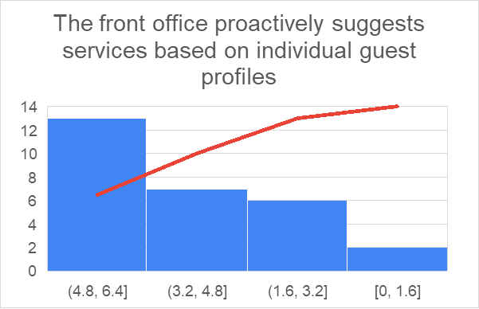
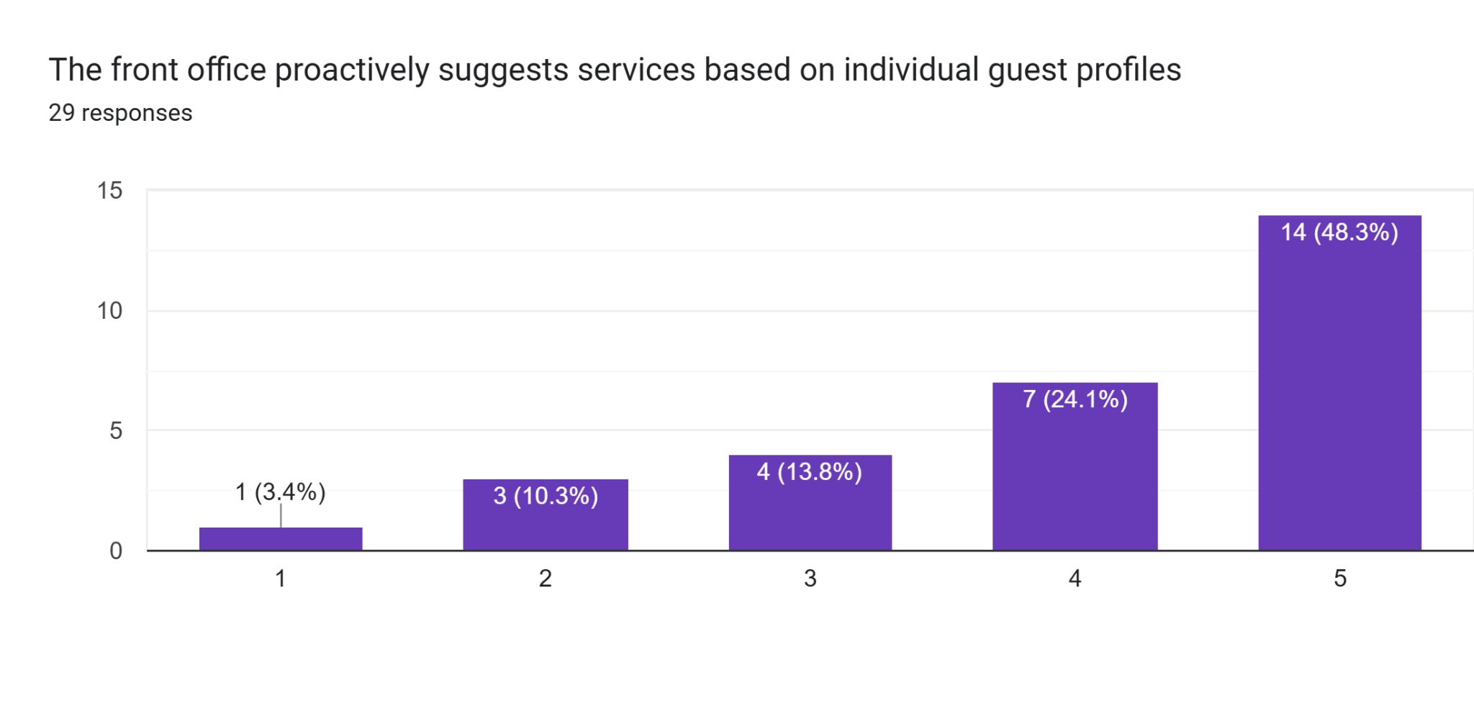
According to the Pareto chart, it has been identified that more than 12 respondents have rated the seventh question 4.8 and 6.4. It could be seen from the survey that 48.3% of individuals have highly agreed with the question about the suggestion of the front office about service based on the individual guest. The descriptive table has analysed the mean value of the question, which is 4.03448275862069. As the median value is lower than the mode, there might be lower scores that suggest inconsistency in the guest’s experience.
Result 8
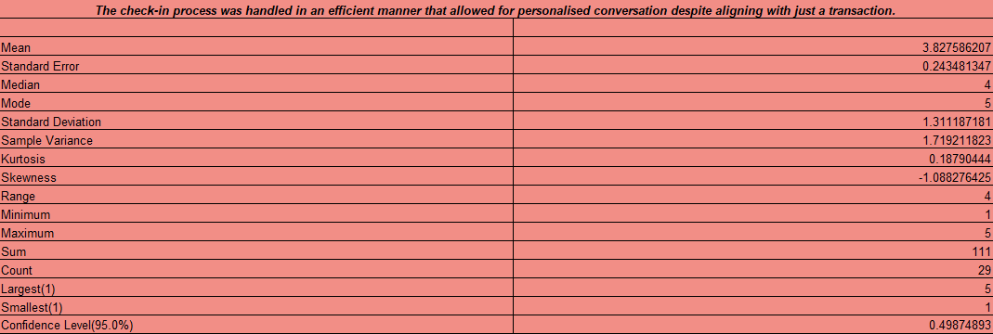
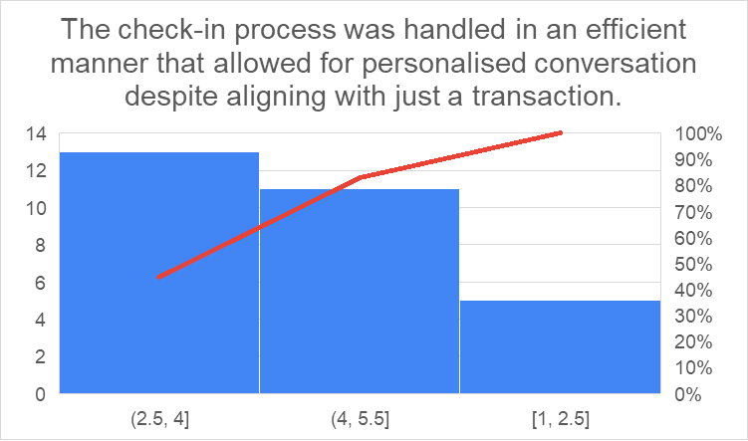
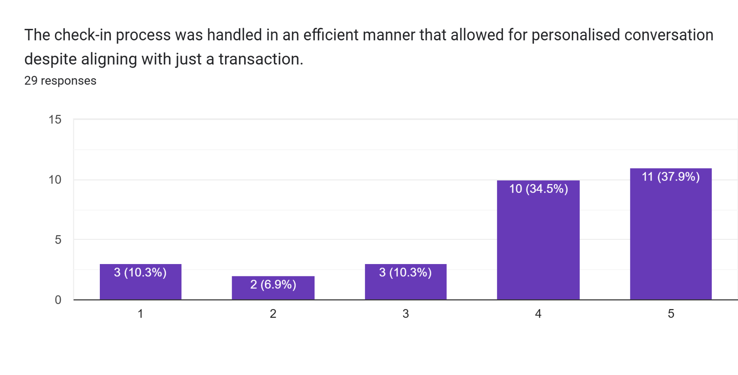
Based on the descriptive table, the mean value of 3.82758620689655 indicates a generally positive and above-average customer experience for the eight questions. According to the survey,37.9% respondent stated that the transactional part of the check in possess is likely working well with low effort required from customers. According to the Pareto chart, 80% of individuals rated this 4 and 5.5. This means the team should focus on making the interaction feel less like a welcoming experience.
Result 9
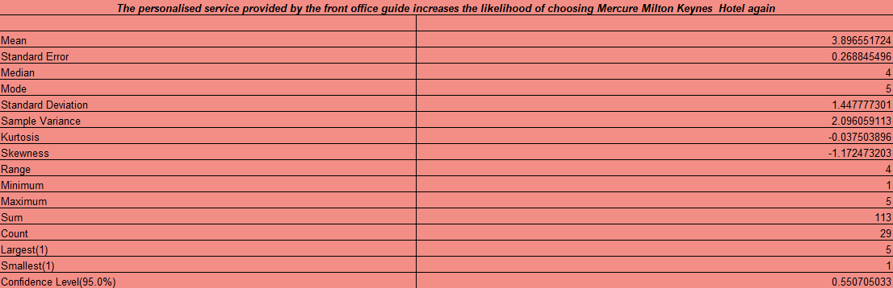
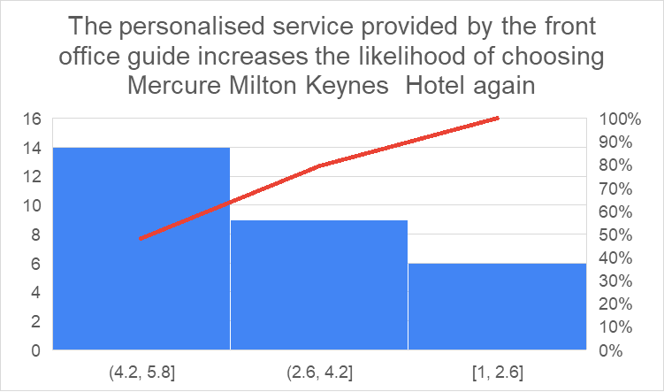
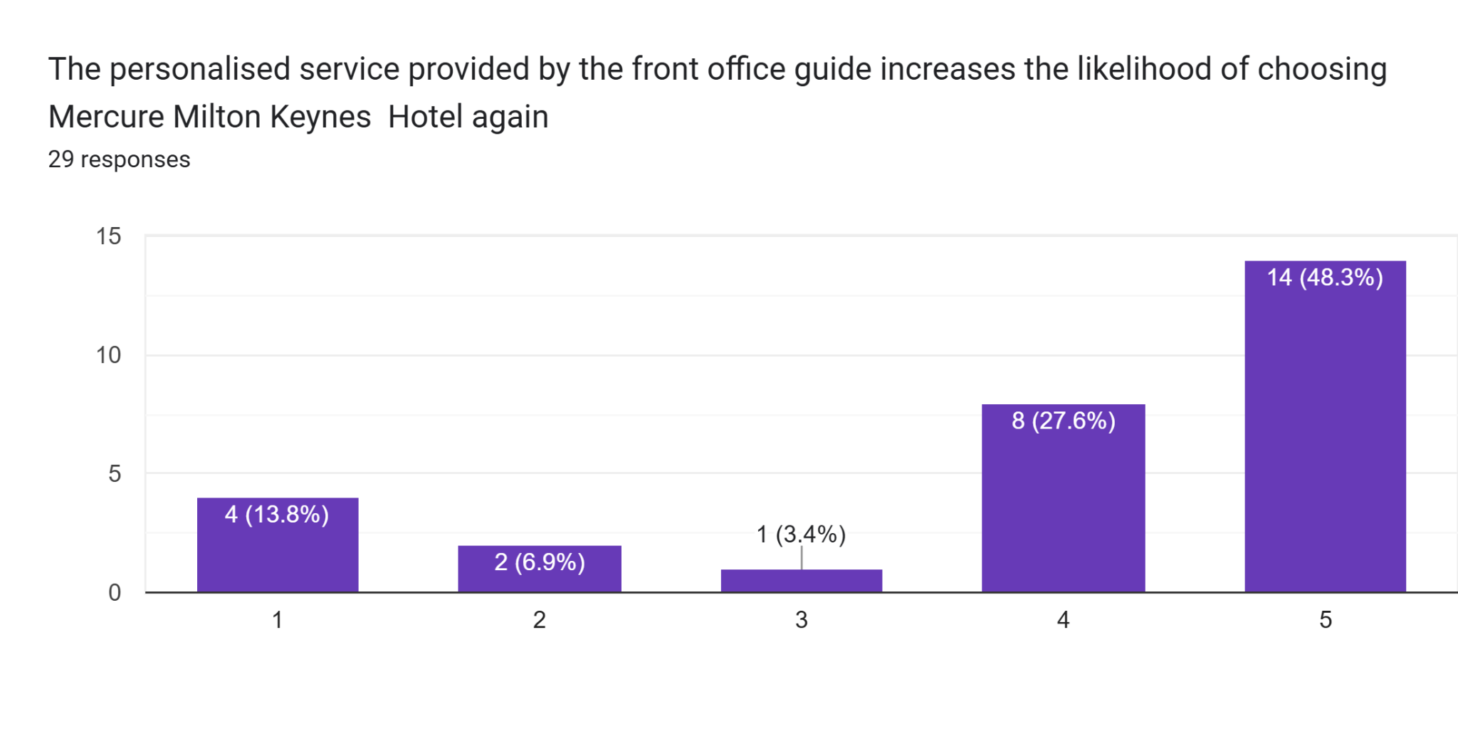
Based on the analysis, 48.3% highly agreed on the ninth question of the survey. According to 90% respondent, the main reason for choosing the Mercure Milton Keynes Hotel is due to its personalised service that is provided by the front office guide. The descriptive table showed the mean value is 3.89655172413793, and the median and mode value is 1 and 5. The analysis showed that more than 8 participants have rated this question at 2.6 and 4.2. The rating indicates that customers strongly value the front office service.
Result 10
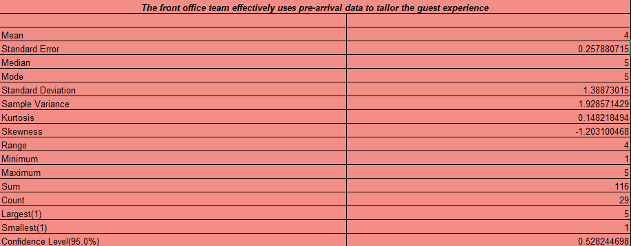
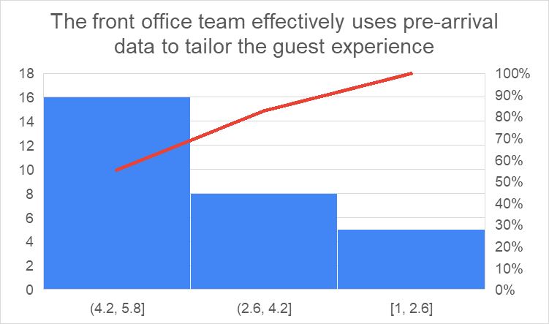
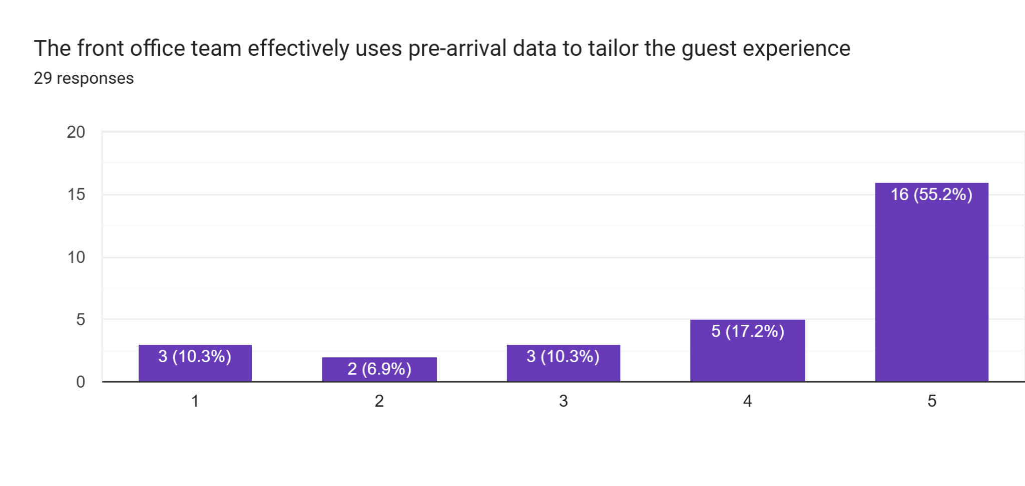
The mean value came to 4 in the descriptive analysis of the tenth question. This signifies that the front office teams actively analyse the pre-arrival data as it helps to provide personalised services to the customers. As per the Pareto chart, 16 respondents have rated the survey question 4.2 and 5.8. The median and mode values of the analysis area 5 indicate a highly positive response from the respondents. This means guests selected strongly agree more than any other single option. The standard deviation value is 1.38873014965883. This indicates that the front office team is exceptionally effective in using re arrival data in customising guest experiences.

4.3 Evaluation of Thematic Analysis
Secondary Qualitative Research Analysis
In this research, thematic analysis has helped to evaluate four themes and sub-themes that facilitate resemblance within the hospitality industry. These themes guided the evaluation of the integration of professional greetings to help to establish a sense of value among guests.

Theme 1: Strategic role of the front office executive in enhancing guest experience
Thematic analysis highlighted the role of the front office executive in enhancing guest experience as a sense of organised aspects are developed within them. Bookings and guests are handled by the front office executive that guides to prevent issues of overbooking. Coordination with other departments is established for addressing problems within a small-time frame. The privacy and confidentiality of guests are maintained, which helps to establish a link with new technologies (Calderon-Monge and Ribeiro-Soriano, 2024, pp.449). The front office executive is responsible for inventory management, as room availability is monitored long-term.
Theme 2: Impact of personalisation techniques and data utilisation on guest experience
Personalisation techniques and data utilisation guide to enhance guest experience, as it helps to enhance the satisfaction level. Hyper customisation is facilitated by a guide to help to align with a tailored experience (Bigwanto et al., 2024, pp.151). Operational efficiency is facilitated, and wait times are reduced within a small-time frame. Personalisation guide to reduce the margin of operational costs and increase return on investment through it.
Theme 3: Impact of tailored service on loyalty and reputation
Tailored service affects the loyalty of consumers, and the reputation of the hospitality industry is affected as well. Personalised service is provided that guides to establish a link with a memorable experience. Expectations are addressed within a limited time frame that helps to establish a link with brand loyalty (Jenneboer et al., 2022, pp.212). Consumer expectations are addressed to help to reduce the likelihood of switching towards the competitors. It affects brand reputation as it guides them to establish consistency within their approach.

Theme 4: Role of innovative technological integration in establishing personalised experience
Integration of innovative technologies helped to establish a personalised experience in the hospitality industry, as browsing and purchase history are analysed through it. Real-time adaptation is facilitated through it, and website content is changed through it. Integration of omnichannel in a seamless manner is facilitated through it, which helps to ensure a personalised experience (Kiyani, 2023, pp.73). Chatbots and virtual assistants are integrated to provide tailored support, and customised virtual tours are provided through them. It helps to align with hospitality content, and retention rates are improved through it.

4.4 Discussion

4.4.1 Analysis of research findings in relation to existing literature by addressing the research topic, objectives and questions
The evaluation of existing literature by addressing aspects of the research topic in relation to the objective and questions states that memorable experiences are created in the long term. As per Collins (2023, p. 12), guest experience is enhanced through the integration of diversified aspects that help to establish engagement on a large scale. Fowler et al. (2024, p.334) stated that high margins of benefits are provided through knowledge management that is aligned with guest satisfaction. Tailored experiences are facilitated through the integration of strategies to obtain real-time insights within a small-time frame. Multiple digital tools are integrated for establishing a personalised experience, and behavioural knowledge is facilitated for establishing a sense of value.
Social exchange theory guides the evaluation of relationships with consumers that aim to reduce the cost margin. This theory suggests that tangible aspects help to manage the circumstances of a hotel. Evans-Howe (2025, p. 289) stated that customer loyalty and operational revenue are maintained for establishing interaction in real-time. From the findings, it is evaluated that the research topic has focused on evaluating the role of the Front Office Executive in providing a personalised experience to their customers in the hospitality industry through the case study of Mercure Milton Keynes Hotel.
This evaluation focused on ensuring operational efficiency and competitive advantage are sustained within the hospitality industry. Front office executives are responsible for integrating strategies that help them establish the position of their hotels in a sustainable manner. Chatzi et al. (2024, p. 272) stated that the Relationship marketing theory guides the establishment of a fair connection with consumers that helps to increase loyalty and personal interaction is enhanced through it. Personalised offers are provided by a front office executive to enhance their hotel's image within the highly competitive hospitality industry of the UK. Quality is measured through the integration of personalised techniques that help to establish emotional engagement with consumers. An emotional bond with guests is established through the integration of digital technologies that help to enhance their engagement on long-term. From the analysis, it is evaluated that 31% individuals have felt somewhat personalised through the integration of the check-in process within the hospitality industry, while 27.6% stated that they have felt extremely personalised through the utilisation of the check-in process.
Based on the analysis, it is evaluated that the mean value for the aspects of front office staff to solve the issue for ensuring a positive experience is 3.82758620689655, and the mode value is 5. Research objectives and questions focused on the evaluation of the role of the front office executive in providing a personalised experience in the long term. High-standard techniques are integrated for providing an effective guest experience that guide to establish brand positioning regularly. While evaluating aspects of special requests and problems that were raised, it became difficult to align with diversified circumstances. From the evaluation, it was analysed that Peramatzis and Galanakis (2022, p.971) stated that the integration of Herzberg’s Two-Factor Theory helps to analyse tourists’ motivation and customer satisfaction in an effective manner.
Diverse circumstances are evaluated, and the level of dissatisfaction is addressed within the hospitality industry. Guest loyalty in the hospitality industry is enhanced through the integration of customer feedback. Customer and guest satisfaction are responsible for managing diverse circumstances within the industry. From the survey, it was evaluated that 27.6% of individuals stated that extremely personalised check-in processes are facilitated by them, which helps to enhance their guest satisfaction in the long term. Based on the analysis, it is evaluated that positive experience is sought by consumers while aligning with the hospitality industry and links with diversified aspects are established for establishing diversification. Moreover, 51.7% of individuals agreed with the aspects that front office executives focus on addressing consumer queries that help to develop a positive experience within diverse circumstances. From the evaluation, it was found that the integration of tailored techniques helps to enhance guest satisfaction scores that guide the establishment of engagement with their changing preferences. 70% participants stated that they have rated the hotel between 2.7 and 4.4, that highlights a medium positive experience that they gained. From the evaluation, insights were gained that Osadare et al. (2024, p.553) focused on evaluating techniques that are integrated for enhancing guest experience and brand reputation within the hospitality industry.
Service quality is enhanced through the integration of digital technologies within the hospitality industry, as emotional engagement is facilitated. Personalised technologies are integrated to help to develop an emotional bond between guests and hospitality organisations. Based on descriptive statistics evaluation, it was found that 48.3% individuals highly agreed with the personalised service that was provided by Mercure Milton Keynes Hotel for establishing a seamless integration with diversified circumstances. Moreover, Interaction with diversified aspects was facilitated, that helped to establish engagement in a significant manner. 48.3% individuals stated that the personalised service that is provided by the front office guide helps to increase the likelihood of choosing this hotel properly. From the evaluation, it was analysed that personalised service is provided by the office team members to their consumers, that help to customise their guest experience.

4.4.2 Implication of the research findings
The research findings imply that they guided the management and leadership of Mercure Milton Keynes hotel to integrate an experiential approach for performing tasks that guide the meeting of hospitality standards. Strategic differentiation is fostered, that guide to diversify their proposition in comparison to their competitors. Data-driven decisions are made to guide the integration of CRM tools to empower guests (Kiyani, 2023, pp.80). High investment is made in training for improving aspects of soft skills that guide the building of emotional connection. High authority was facilitated by front desk executives that focused on solving issues within a limited time frame (Geissdoerfer et al., 2023, pp.3814-3832). This research focused on tracking aspects of employee engagement, and internal marketing strategies are integrated to enhance the link with changing circumstances. Internal marketing strategies are integrated to help to establish a link with a seamless user experience, and brand alignment is facilitated (Bailey et al., 2022, pp.10).
From this research, it was evaluated that the link with customisation is fostered, that helps to align with changing preferences. Furthermore, this research focuses on obtaining insights into the role of smart room customisation on the basis of past preferences (Colovic, 2022, pp.102083). Special requests are handled to align with consumer preferences that help to streamline the process, and unique requests are delivered on a long-term basis (Shibata, 2022, pp.1560). Research findings have highlighted that a real-time feedback loop is integrated through the utilisation of digital tools that guide the resolution of issues in a significant manner (Aguinis et al., 2024, p.101029). Issues are addressed in relation to aspects of engagement, and personalised recommendations are provided for enhancing areas for improvement. Moreover, an emotional connection is established with consumers that helps to align with high guest retention, and requirements are anticipated regularly.

4.4.3 Limitations
Limitations of this research are that limited generalisability is facilitated in the evaluation of the issues associated with the research topic. The effectiveness of changing consumer experience in relation to delivering personalised experience to consumers is not evaluated in a detailed manner in this research. This research has not evaluated specific areas within which consumers lack engagement despite integrating personalised experience. This research has not evaluated aspects of subjective customer feedback in integrating personalised experience.

4.4.4 Valuable areas critical to the placement of hotel operations
The valuable areas that are critical to the placement of hotel operations are aligning with personalised greetings that help to establish a link with a memorable stay. Special requests are facilitated to help to track guest preferences. Instant problem resolution is facilitated through the integration of digital technologies, as negative reviews are addressed in a significant manner (Jorzik et al., 2024, p.114764). Guest loyalty program management was facilitated by a guide to align with personalised offerings (Andrieux et al., 2024, p.101032). Integration of digital technologies helps to streamline the check-in and check-out process that helps to establish an emotional connection in the long-term. Professionalism and grooming are maintained through the integration of diversified aspects that help to establish consistency within the service (Mancuso et al., 2023, p.103457). Confidential data is handled appropriately, and cross-departmental communication is ensured to help to align with consistency in relation to multiple aspects. Compliance with brand standards is maintained, which helps to maintain brand consistency (Andreini et al., 2022, pp.1105). Secure guest experience is maintained, that helps to enhance engagement.

4.5 Chapter Summary
This chapter highlighted that the integration of innovative technologies helped to enhance guest experience as links with diversified aspects are established. Integration of virtual tours has facilitated aligning with a customised journey, and the tailored support was provided on a long-term basis. This chapter evaluated aspects of personalised amenities that guided the alignment with seamless booking. Multilingual support was provided that helped to create a warm atmosphere in diverse circumstances. Compliant handling was facilitated through the integration of digital technologies, as coordination with guest transfer was established.

Chapter 5. Conclusion and Recommendations

5.1 Conclusion
The research paper evaluated the role of the front office executive in delivering a personalised experience to customers in the hospitality industry. The front office executive plays a crucial role in delivering personalised experiences to the customer. The research paper has recommended the Mercure Milton Keynes hotel, which effectively offered tailored services. Types of problems that the hospitality industry in the UK faced regarding personalised customers experienced has been discussed thoroughly. The front office primarily delivered the personalisation service. Sometimes they face several problems, such as a lack of customer data, insufficient information, high work pressure, high staff turnover, training gaps, technology failures and many others.
The research paper highlighted the importance of the office executive roles of creating an enabling environment that fosters innovation, collaboration and responsible digitisation practices in the hospitality industry. Office executives utilise guest history and preferences that are stored in property management systems to personalise and customise their stays in the hotel. The rationale of the research paper highlights that this research topic provides the opportunity to shift towards an experience economy in the tailored service. These are the essential and primary differentiators in this competitive market. Moreover, the literature review in this research paper provided the key findings from the research and evaluated the gaps in the literature to justify the research. This review confirmed that front office executives played a critical part to deliver personalised experiences in the UK hospitality industry. With the help of social exchange theory, the research paper discussed that human interactions are dependent on corresponding exchanges of resources, both in tangible and intangible ways. Moreover, it suggests that the way front office executives could transform routine interaction into a memorable experience helps to enhance customer loyalty and operational revenue. The literature review examined several techniques that front office executives used to tailor effective guest experience in the hospitality sector. This hospitality sector uses several technologies such as property management systems, Artificial intelligence and many others. Through the technology acceptance model, this research paper presented a concept that smooths out the way to achieve specific goals of the hospitality industry. The relationship between personalised front office service and overall guest satisfaction, positive review and loyalty has been discussed in this paper. The key finding from this highlighted that front office executives directly boost satisfaction with the help of recognised, effective interaction and catering to specific preferences.
Moreover, this remarkably influenced the satisfaction values of the guests. The relationship marketing theory and Herzberg’s two-factor theory have been discussed thoroughly to analyse these strategies that could be used by the front office executive to develop effective and personalised guest services. The methodology section in this research paper has been described with the help of Saunders’ onion research model. Methodology in this paper contained a diverse range of types, such as mixed methods, quantitative and qualitative. The Saunders’ onion research model was founded by Mark Saunders and his colleagues. This method helps the researcher to get the information from the inner layers. The research highlighted that this model addressed each layer systemically and thus enhanced the academic defensibility of the study. Saunders onion research model guided step-by-step, structured research that ensured all methodological decisions were aligned with logic. Furthermore, findings from this research paper have been analysed primarily quantitatively and secondary qualitative though the collected data from the survey. This survey has happened on the guests in the Mercure Milton Keynes hotel. The primary quantitative research highlighted that the survey was conducted among 29 individual guests. The results showed that most of the participants are about 50 to 55 years old. About 31% of guests found out that the check-in process in this particular hotel was personalised, and they are satisfied with it. The analysis has confirmed that approximately 44% of people think that the front office handles aspects of social requests or any kind of problems that happen in the hotel.
Furthermore, the findings from the thematic analysis helped the research paper to evaluate for themes and sub-themes that connect within the hospitality industry. The first theme is the strategic role of the front office executive in enhanced guest experience. This analysis highlights the role of the front office executive to enhance guest experience as a sense of organised aspects are developed within them. Impact of personalisation techniques and data utilisation, loyalty and reputation, role of innovation, and technological integration have also been analysed in this thematic analysis. The analysis from these findings highlighted literature through addressing the research topic, objective and several questions. Ultimately, some strategic recommendations for the Mercure Milton Keynes Hotel have been identified in this research paper. They should take some initiative to improve customer satisfaction and experience. These recommendations include leveraging location and market position, adopting technology for efficiency, operational and revenue management and enhancing customer experience and many others. Finally, the hotel should implement an eco-friendly initiative for today's customers. These customers mainly focus on sustainable services. Through these strategies, the hotel could increase customer satisfaction, which boosts brand loyalty.

5.2 Recommendation
Based on the analysis and the research, it has been identified that Mercure Milton Keynes Hotel should take some initiatives to improve its performance further. They should focus on some key areas such as digital marketing, contemporary atmosphere and improving guest experience. The hotel could better align its operational capabilities with market demand. This could help to improve occupancy and guest satisfaction by focusing on these areas.
Recommendations to enhance Mercure Milton Keynes Hotel’s performance and operation:
Leverage Location and Market Position: There are a lot of hotels with 3 and 4-star ratings where Mercure Milton Keynes Hotel is located. This kind of environment requires high focus on competitive differentiation. Mercure Milton Keynes Hotel should utilise relationships with major demand generators and the central shopping. This would help the hotel to target the market effectively. The hotel should position the property as a peaceful place and should leverage its location as a country club. The hotel should provide on-site EV chargers that would help to attract eco-conscious customers.
Adopt Technology for Efficiency: Mercure Milton Keynes Hotel should implement an automated system, as this would help to pre-authorise cards and digital checkout. This would help to improve efficiency and minimise front desk workload among the workers. Mercure Milton Keynes Hotel should use a property management system (PMS) data as this would help to track key performance indicators. This would effectively help to identify the operating profit for each available room and housekeeping turnaround times. These KIPs methods would help to minimise operational bottlenecks. The hotel should continuously maintain high-speed internet and modern in-room technology, as this would help to improve guest experience. Moreover, the hotel should use contactless checkouts, as this would help to improve efficiency and reduce wait times.
Operational and Revenue Management: Mercure Milton Keynes Hotel should implement dynamic pricing strategies, as this would help to adjust room rates daily. This should be based on real-time market demand and supply fluctuations. The brand should implement targeted energy-saving measures as this would help them to improve efficiency. The hotel should prioritise high performing platforms such as Google Ads, as this would help to increase direct bookings. The hotel should segment its target audiences, as this would help to tailor marketing. The brand should align operational departments to directly support revenue goals. This would help to reduce overbooking risks and improve efficiency.
Enhance Customer Experience and Service: Mercure Milton Keynes Hotel should actively manage and respond to online reviews, as this would help to improve brand reputation. They should focus on the negative reviews as well to know the places they need to improve. This would make the guest feel more valued and engaged. The hotel should provide 24-hour room service, as this would be for late-night travellers. The hotel should maintain its casual and contemporary atmosphere, as most of the guests like this type of environment. They should also invest in staff training by focusing on communication, technology and customer service. This strategy would help to enhance operational quality.
Enhance Sustainability: Mercure Milton Keynes Hotel should implement eco-friendly practices by aligning with guest preferences for sustainable travel. The hotel should aim to cut its carbon emissions by 30% in 2030. Mercure Milton Keynes hotel should develop comprehensive methodologies, as this would help to assist hotels to achieve net zero commitments in reducing carbon footprints. The hotel should encourage its guests to participate in sustainability efforts positively. The hotel should integrate eco-friendly initiatives such as solar panels, LED lighting and a filtered water system to reduce single-use plastics.
Targeted Digital Marketing: Mercure Milton Keynes Hotel should utilise platforms such as Facebook and Instagram to target specific demographics. It should include younger, eco-conscious travellers and families. The hotel should implement strong local SEO strategies, as this would help to ensure visibility for those who are searching for accommodation. The hotel should focus on B2B digital marketing as this would help to emphasise efficiency and ROI. This strategy would help to attract business travellers and corporate events.

References
aesanetwork. (2024) Blog 132-Research Onion: A Systematic Approach to Designing Research Methodology. [Online] Available at: https://aesanetwork.org/research-onion-a-systematic-approach-to-designing-research-methodology/#:~:text=The%20research%20onion%20also%20considers%20three%20types,realism%20*%20Interpretivism%20*%20Postmodernism%20*%20Pragmatism [Accessed 17 02 2026].
Aguinis, H., Beltran, J.R. and Cope, A. (2024) How to use generative AI as a human resource management assistant. Organizational Dynamics, 53(1), p.101029.
Andreini, D., Bettinelli, C., Foss, N.J. and Mismetti, M. (2022) Business model innovation: a review of the process-based literature. Journal of Management and Governance, 26(4), pp.1089-1121.
Andrieux, P., Johnson, R.D., Sarabadani, J. and Van Slyke, C. (2024) Ethical considerations of generative AI-enabled human resource management. Organizational Dynamics, 53(1), p.101032.
Bailey, D.E., Faraj, S., Hinds, P.J., Leonardi, P.M. and Von Krogh, G. (2022) We are all theorists of technology now: A relational perspective on emerging technology and organizing. Organization Science, 33(1), pp.1-18.
Bardukova, L. (2023) Navigating the hospitality horizon: current trends and strategies for customer attraction and retention in the hotel industry. Economics and computer science, 2(1), pp.88-103.
Bigwanto, R., Prasetyo, I.J. and Maella, N.F.S. (2024) Communicative Hospitality: Acts Of Service Among Front Desk Hotelier. Jurnal Ekonomi, 13(03), pp.151-159.
Bilgihan, A. and Ricci, P. (2024) The new era of hotel marketing: integrating cutting-edge technologies with core marketing principles. Journal of Hospitality and Tourism Technology, 15(1), pp.123-137.
Bocken, N.M. (2024) Circular business model innovation: New avenues and game changers. In Business model innovation: Game changers and contemporary issues (pp. 193-225). Cham: Springer International Publishing.
Brochado, A. and Mendes, A.V.D.B.N. (2025) Smart Luxury: Exploring Portuguese Guests’ Technology Preferences in High-End Hotels. In The Evolution of Luxury Brands, Volume II: Society, Technology, and Context (pp. 301-327). Cham: Springer Nature Switzerland.
Calderon-Monge, E. and Ribeiro-Soriano, D. (2024) The role of digitalization in business and management: a systematic literature review. Review of managerial science, 18(2), pp.449-491.
Chatzi, S., Peitzika, E. and Konsolaki, G. (2024) Enhancing brand loyalty: A relationship marketing perspective within the context of contractual services. Journal of Relationship Marketing, 23(4), pp.272-304.
Collins. (2023) Impact of digitalization on customer experience management in the hospitality industry. Hospitality and Tourism Journal, 1(1), pp.12-23.
Collis, J & Hussey, R (2014), Business Research, A Practical Guide for Undergraduate and Post Graduate Students, Palgrave, London.
Colovic, A. (2022) Leadership and business model innovation in late internationalizing SMEs. Long range planning, 55(1), p.102083.
Cottrell, S. (2014) Dissertations and project reports: a step-by-step guide. New York: Palgrave.
Cuozzo, B., Russo, G., Pascucci, F. and Fella, S. (2025) Knowledge management in a dynamic context in the digital era. European journal of innovation management, 28(5), pp.2080-2100.
Davis, F.D., Granić, A. and Marangunić, N. (2024) The technology acceptance model: 30 years of TAM (pp. 20-54). Switzerland: Springer International Publishing AG.
de Meireles Cunha, A.C. (2024) Diversity and Cultural Acceptance in the Leisure Industry in the USA: Case Study: Palm Beach Country Club, Florida (Master's thesis, Universidade de Aveiro (Portugal)).
Delbosc, A. and Shafi, R. (2023) What do we know about immigrants’ travel behaviour? A systematic literature review and proposed conceptual framework. Transport reviews, 43(5), pp.914-934.
Dzwigol, H. (2022) Research methodology in management science: Triangulation. Virtual Economics, 5(1), pp.78-93.
Eckert, C., Neunsinger, C. and Osterrieder. (2022) Managing customer satisfaction: digital applications for insurance companies. The Geneva Papers on Risk and Insurance-Issues and Practice, 47(3), pp.569-602.
Elgeddawy, M. and Abouraia, M. (2024), July Pragmatism as a research paradigm. In European Conference on Research Methodology for Business and Management Studies (pp. 71-74). Academic Conferences International Limited.
Evans-Howe, S. (2025) Managing Temporality in Customer Experience. In The Role of Temporality in Customer Experience: Why Time Matters to Customers (pp. 289-306). Cham: Springer Nature Switzerland.
Ferreira, M.S., Antão, J., Pereira, R., Bianchi, I.S., Tovma, N. and Shurenov, N. (2023) Improving real estate CRM user experience and satisfaction: A user-centered design approach. Journal of Open Innovation: Technology, Market, and Complexity, 9(2), p.100076.
Finkelstein, I., Soffer-Vital, S. and Lieblich, A. (2024) Contextual narrative interpretation model (CNI): Rethinking qualitative analysis. International Journal of Qualitative Methods, 23, p.16094069241296983.
Forman, N. and Udvaros, J. (2023) Digital innovation in hospitality: Bridging the gap between concierge services and hotel guests. Journal of Environmental Management & Tourism, 14(6), pp.2673-2684.
Fowler, D.S., Zinn, D. and Musgrave, J. (2024) Knowledge management's impact on customer experience and consumer satisfaction in the hospitality sector: a literature meta-analysis to identify common qualitative themes. International Journal of Knowledge Management in Tourism and Hospitality, 3(4), pp.334-346.
Geissdoerfer, M., Santa‐Maria, T., Kirchherr, J. and Pelzeter, C. (2023) Drivers and barriers for circular business model innovation. Business Strategy and the Environment, 32(6), pp.3814-3832.
Geissdoerfer, M., Santa‐Maria, T., Kirchherr, J. and Pelzeter, C. (2023) Drivers and barriers for circular business model innovation. Business Strategy and the Environment, 32(6), pp.3814-3832.
George, R. (2025) Quality Service Experiences Through Internal and Relationship Marketing. In Marketing Tourism and Hospitality: Concepts and Cases (pp. 385-413). Cham: Springer Nature Switzerland.
getitdoneex. (2025) The Research Onion Explained: Layers, Methodology, and Application. [Online] Available at: https://getitdoneex.com/the-research-onion-explained-layers-methodology-and-application/#:~:text=A%20Layered%20Guide%20to%20Research%20Methodology&text=The%20process%20of%20designing%20a,foundation%20for%20their%20empirical%20investigations. [Accessed 18 02 2026].
Gurler, H.E. (2025) How does service quality predict loyalty? The serial mediation effects of perceived value and consumer brand identification. International Journal of Quality & Reliability Management, 42(3), pp.920-940.
ijoear. (2025) What is Research Methodology? Types, Importance, and Examples. [Online] Available at: https://ijoear.com/what-is-research-methodology-types-importance-and-examples [Accessed 17 02 2026].
inspiredthinking. (2026) When 71% of consumers expect personalization, how are brands responding?. [Online] Available at: https://inspiredthinking.group/when-71-of-consumers-expect-personalization-how-are-brands-responding/#:~:text=are%20brands%20responding?-,When%2071%25%20of%20consumers%20expect%20personalization%2C%20how%20are%20brands%20responding,risk%20and%20unlock%20s [Accessed 14 02 2026].
Iugova, I. (2025) Employee Motivation and Its Influence on Customer Satisfaction.
Jenneboer, L., Herrando, C. and Constantinides, E. (2022) The impact of chatbots on customer loyalty: A systematic literature review. Journal of theoretical and applied electronic commerce research, 17(1), pp.212-229.
jfsdigital. (2026) Towards an Explicit Research Methodology: Adapting Research Onion Model for Futures Studies. [Online] Available at: https://jfsdigital.org/articles-and-essays/2018-2/towards-an-explicit-research-methodology-adapting-research-onion-model-for-futures-studies/ [Accessed 17 02 2026].
Jorzik, P., Klein, S.P., Kanbach, D.K. and Kraus, S. (2024) AI-driven business model innovation: A systematic review and research agenda. Journal of business research, 182, p.114764.
Kandampully, J. and Solnet, D. (2024) Service management principles for hospitality & tourism in the age of digital technology.
Koncar, P., Santos, T., Strohmaier, M. and Helic, D. (2022) On the application of the Two-Factor Theory to online employer reviews. Journal of Data, Information and Management, 4(1), pp.1-23.
Lawler, J. and Waldner, D. (2023) Interpretivism versus positivism in an age of causal inference. Oxford handbook of philosophy of political Science, pp.221-242.
Liang, S., Li, J. and Xu, S. (2025) Residents’ perceptions of impacts and support for sports events: A meta-analysis based on social exchange theory and triple bottom line. Journal of Leisure Research, pp.1-28.
Mancuso, I., Petruzzelli, A.M. and Panniello, U. (2023) Digital business model innovation in metaverse: How to approach virtual economy opportunities. Information Processing & Management, 60(5), p.103457.
Mandić, D., Panić, A. and Šain, M.Č. (2023), December Automated service delivery in hotels: balancing efficiency and human interaction for optimal guest satisfaction. In International Scientific Conference on Economics, Management and Information Technologies (Vol. 1, No. 1, pp. 167-174).
Marikyan, D. and Papagiannidis, S. (2024) Technology acceptance model: A review. TheoryHub book.
mercuremiltonkeynes. (2026) Love Is in the Details. [Online] Available at: https://www.mercuremiltonkeynes.com/ [Accessed 14 02 2026].
Mogaji, E. (2025) Market and Customer Insights. In Strategic Marketing Management: Principles and Practice (pp. 33-63). Cham: Springer Nature Switzerland.
Mois, G., Lydon, E.A., Mathias, V.F., Jones, S.E., Mudar, R.A. and Rogers, W.A. (2024) Best practices for implementing a technology-based intervention protocol: Participant and researcher considerations. Archives of Gerontology and Geriatrics, 122, p.105373.
Morrison, E.A. and Saunders, M.N. (2025) Researching trust in public governance: methodological considerations and approaches. In Handbook on Trust in Public Governance (pp. 136-151). Edward Elgar Publishing.
Mueller‐Saegebrecht, S. and Walter, A.T. (2025) Strategic agility—an urgent capability for successful business model innovation? A conceptual process model and theoretical framework. Strategic Change, 34(3), pp.407-428.
Mulisa, F. (2022) When does a researcher choose a quantitative, qualitative, or mixed research approach?. Interchange, 53(1), pp.113-131.
Najafi, V. (2024) Exploring Front Desk Employees' Perceptions of Technology in Hotel Information Systems: An Integration of Technology Acceptance and Self-Efficacy Models.
Nazirova, E.S. and Tursunov, J.A. (2023) Analysis of scientific research methodology. Oriental renaissance: Innovative, educational, natural and social sciences, 3(8), pp.17-24.
Ormerod, R.J. (2021) Pragmatism in professional practice. Systems Research and Behavioral Science, 38(6), pp.797-816.
Osadare, O.O., Akande, O.N., Soladoye, A.A. and Sobowale, P. (2024) Smart Hospitality: Leveraging Technological Advances to Enhance Customer Satisfaction. FUOYE Journal of Engineering and Technology, 9(3), pp.553-557.
Papademetriou, C., Anastasiadou, S. and Papalexandris, S. (2023) The effect of sustainable human resource management practices on customer satisfaction, service quality, and institutional performance in hotel businesses. Sustainability, 15(10), p.8251.
Peramatzis, G. and Galanakis, M. (2022) Herzberg’s motivation theory in the workplace. Psychology, 12(12), pp.971-978.
Pirro, D.N. (2024) Responsive Resonance Theory (RRT)-The Art of Fast, Authentic Connections & Trust. A Modern Framework for Building Trust-Based Client Relationships in Fast-Paced Markets. A Modern Framework for Building Trust-Based Client Relationships in Fast-Paced Markets (November 02, 2024). DOI, 10.
Prentice, C., Dominique-Ferreira, S., Ferreira, A. and Wang, X.A. (2022) The role of memorable experience and emotional intelligence in senior customer loyalty to geriatric hotels. Journal of Retailing and Consumer Services, 64, p.102788.
Radović, N., Vujko, A., Stanišić, N., Ljubisavljević, T. and Lunić, D. (2025) Digital Hospitality as a Socio-Technical System: Aligning Technology and HR to Drive Guest Perceptions and Workforce Dynamics. World, 6(4), p.134.
Rooney, T., Krolikowska, E. and Bruce, H.L. (2021) Rethinking relationship marketing as consumer led and technology driven: propositions for research and practice. Journal of Relationship Marketing, 20(1), pp.42-61.
Saunders, M., Lewis, P. and Thornhill, A. (2012) Research Methods for Business Students, FT/Prentice Hall: Harlow.
Shibata, S. (2022) Digitalization or flexibilization? The changing role of technology in the political economy of Japan. Review of International Political Economy, 29(5), pp.1549-1576.
Stafford, L. and Kuiper, K. (2021) Social exchange theories: Calculating the rewards and costs of personal relationships. In Engaging theories in interpersonal communication (pp. 379-390). Routledge.
Stoyanova-Bozhkova, S., Paskova, T. and Buhalis, D. (2022) Emotional intelligence: a competitive advantage for tourism and hospitality managers. Tourism Recreation Research, 47(4), pp.359-371.
Stringam, B.B. and Gerdes, J.H. (2021) Hotel and guest room technology. University of South Florida (USF) M3 Publishing, 17(9781732127593), p.6.
Taherdoost, H. (2022) What are different research approaches? Comprehensive review of qualitative, quantitative, and mixed method research, their applications, types, and limitations. Journal of management science & engineering research, 5(1), pp.53-63.
thecontentcreek. (2026) Unveiling the Research Onion: Understanding Saunders’ Methodology. [Online] Available at: https://thecontentcreek.com/unveiling-the-research-onion-understanding-saundersmethodology/#:~:text=Research%20methodologies%20are%20the%20backbone,contribute%20to%20robust%20research%20endeavors. [Accessed 18 02 2026].
thehotelmagazine. (2025) The Evolution of Personalisation in Hotels: Enhancing Guest Experiences Through Technology. [Online] Available at: https://thehotelmagazine.co.uk/the-evolution-of-personalisation-in-hotels-enhancing-guest-experiences-through-technology/#:~:text=As%20personalisation%20becomes%20a%20central,UK%20and%20European%20hospitality%20sectors. [Accessed 14 02 2026].
Treptow, I.C., Kneipp, J.M., Gomes, C.M., Kruglianskas, I., Favarin, R.R. and Fernandez-Jardón, C.M. (2022) Business model innovation for sustainable value creation in construction companies. Sustainability, 14(16), p.10101.
Veal, A J (2006), Research Methods for Leisure and Tourism, 3rd Ed, Financial Times/ Prentice Hall.
vt. (2025) Research Methods Guide. [Online] Available at: https://guides.lib.vt.edu/researchmethods/design-method [Accessed 17 02 2026].
Warren, D. J. a. K. (2025) What Is Research Methodology?. [Online] Available at: https://gradcoach.com/what-is-research-methodology/ [Accessed 17 02 2026].
Wilson, O. (2025) Enhancing Operational Efficiency and Guest Satisfaction in Hotel Management: A Strategic Approach. OTS Canadian Journal, 4(5), pp.72-81.
Wilson, O. (2025) Enhancing Operational Efficiency and Guest Satisfaction in Hotel Management: A Strategic Approach. OTS Canadian Journal, 4(5), pp.72-81.
Yuwono, M.A. and Rachmawati, D. (2023) Combined methods. Can this solve the differences between deductive and inductive methods in qualitative research?. Moroccan Journal of Quantitative and Qualitative Research, 5(3).
Zare, J. and Persaud, A. (2025) Digital transformation and business model innovation: a bibliometric analysis of existing research and future perspectives. Management Review Quarterly, 75(3), pp.1999-2032.
Zarei, M. (2025) Research Methods: The Ultimate Guide for Academic and Professional Success. [Online] Available at: https://www.litmaps.com/articles/types-of-research-methods [Accessed 17 02 2026].

Appendix
Thematic Analysis
Description | Sub-Theme | Theme
The front office executive focuses on enhancing the guest experience as a link with personalised service is established. | Role of the front office executive, Enhancing guest experience | Strategic role of the front office executive in enhancing guest experience
Personalisation techniques and data utilisation help to enhance guest experience as they help to create a memorable experience. | Impact of personalisation techniques, Impact of data utilisation on guest experience | Impact of personalisation techniques and data utilisation on guest experience
Tailored service impacts customer loyalty and organisational reputation as it helps to increase retention and develop an emotional connection. | Impact of tailored service, Aspects of loyalty and reputation | Impact of tailored service on loyalty and reputation
Integration of innovative technologies helps to establish a personalised experience as guest satisfaction levels are analysed through AI algorithms. | Role of innovative technological integration, Technological aspects in establishing personalised experience | Role of innovative technological integration in establishing personalised experience

