Academic Employability skills

Kibibi Birau 1915171

(BMSW4001_LON)
TIMOTHY HOPKINS

Contents

Introduction Pg. 1
Skills Pg.1

Employability skills Pg.1
Hard skills Pg.1
Soft skills Pg.2
- Communication Pg.2
- The ability to understand and give instruction Pg. 3
- Working with a team Pg.3
- Time management Pg. 3

SWOT analysis introduction Pg.3
The process Pg.4
Conclusion Pg.4
PDP (Personal development plan) Pg.4
Research and note taking Pg.5
Referencing and the avoidance of plagiarism Pg.5
Paraphrasing and summarising Pg.6
Conclusion Pg.6
Recommendation pg. 6
Appendix Pg.7
References Pg.7

Introduction
The report is to enable the reader to understand my skills based on my current life lessons I have developed and to further my own knowledge to enable success in which ever given chosen career. Drawing reference from in class activities and published literature to compile my report.

Skills
Defining the meaning of skills on the Cambridge English dictionary, “an ability to do an activity or job well, especially because you have practised it” to execute a skill would be to straight talk, non-verbal communication, emotion control, stress management and finally listening to be one of the most fundamental aspects of communication.

Employability skills
To have these top 10 essential transferable skills for a work force can enhance an individual’s employability, problem solving is one moving onto oral communication, collaboration, resource management another key one is organizational skills, adaptability written and to conclude with technology use.

Hard skills
Hard skills can be learnt, which makes it easier for any person to apply this for self-improvement in a working environment. They are normally obtained through repetition and education. Some key elements of hard skills are to attain a degree, professional experience, industry specific skills, language ability but this can dependent on the industry in which you desire to work. Another prime example is computer skills, internship experience and certificates. Although you may have a degree some test could be required in some countries the person could have to take a certificate test.
To advance in your career, you need to grow and push yourself. This means constantly learning new things, evolving as a person and developing both soft and hard skills. (valley, january 4, 2019)

Soft skills
Soft skills is the total opposite to what is written in hard skills as an individual is generally self-motivated with normally no training is required to increase them. Being able to have soft skills is generally a quality that maybe specific to a job or industry. List of examples of 10 top ten important soft skills are Communication, self-motivation, leadership, responsibility, problem solving, decisiveness ability to work under pressure, time management flexibility, negotiation and conflict resolution.
These skills can be learnt but are not easily attainable they are not like passing an exam they can however be developed and improved over time. If you wish to improve here are some self-help tips practice self-refection, look for online training, observe others and mainly practice.

Communication
The evolution of communication verbal and non-verbal communication are explained in the pyramid below:
Figure 1. Pyramid of communication
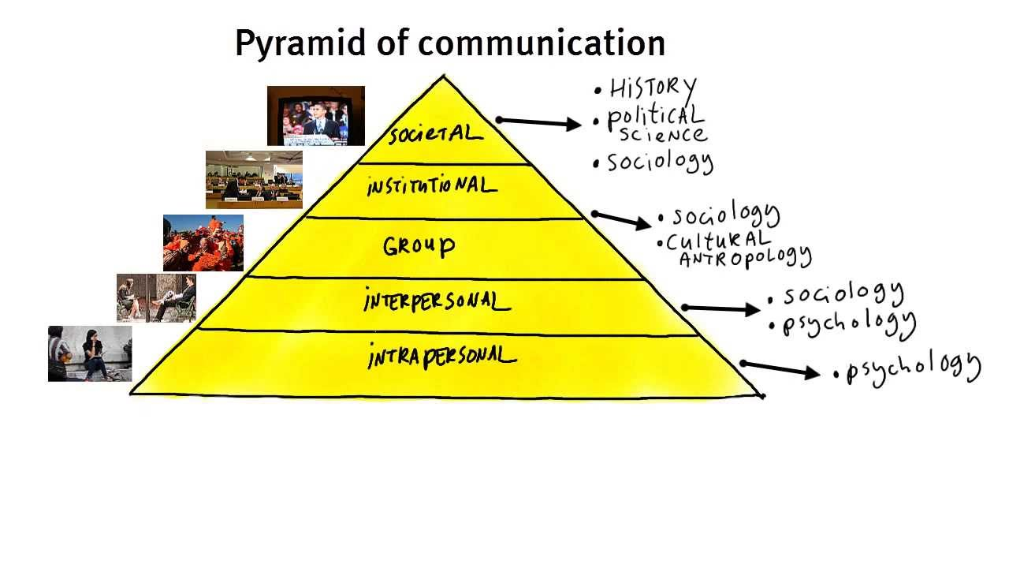
Over the year’s scientist have shared theories and methods the pyramid show a purpose in its simplest forms but yet affective way. The forms of models of communication in the pyramid are to reflect how we really communicate. The Pyramid Principle is not just valuable for communicating with a head person, but really it’s effective to communicate with anyone who wishes to persuade with argument. As a care worker, the tool could be what you use to communicate with prospective clients or doctors.

The ability to understand and give instruction
Another true quality when talking on different levels being able to convey a message without giving multiple mixed messages is a raw talent one not to be taken lightly as this sounds easy but in fact is actually complex. Don’t assume they know what you mean, be clear and specific, give time frames, give examples, give alternatives, set boundaries, get clarification these are some factors that you can apply.
Working with a team
Teamwork is a huge factor across all industries teamwork has an astounding ability in creating a healthy work force – following sense of security, trust and loyalty within employees and employers. Without teamwork one could say that morale is lowered. When this takes place you will then find that productivity could be lowered. When companies identify this fact you will then find that they will implement programmes of activates to gain back or maintain a high level of team work.
Time management
“Time management” the ability to use ones time effectively or productively, especially at work. Time management is the key to efficient working. (Taken from the oxford dictionary)
Looking through this process of organizing and planning how to divide your time between specific activities good time management enables you to work smarter not harder so that you can get more done in less time, even when your time is tight and pressures are high. Falling to manage your time damages your effectiveness and causes stress.

SWOT ANALYSIS
Figure 1. SWOT analysis
 | Helpful to achieving the objective | Harmful to achieving the objective
Internal origin | STRENGTHS  Very hard working  Make sure things are done 100%  Very creative  Caring, open hearted  Experience  knowledge | WEAKNESS  Very kind hearted is sometimes the cause of people taking me for granted  Gaps in my qualification
External origin | OPPORTUNITIES  Knowledge  Empowerment  Discovery | THREATS  Training and education obstacles  Right now I live pay check to check  Not a good public speaker
Source created be lecture filled in by author
SWOT analysis review conclusion
The above SWOT analysis, show visible strengths, weakness and threats, doing this exercise I was able to gain a new perspective at my weakness and manage them to improve or eliminate threats that could however hurt my ability to move forward and separate yourself from your peers, and specialise those talents you need to progress in my chosen career and to obtain my own personal goals.
Following the SWOT we then went into depth of future plans, which shows in my PDP (personal development Plan)

Personal Development Plan

Figure 2 personal development plan (PDP)
Personal development plan
 | Short-Term Time Frame  What do I want to accomplish in the next three to six months? | Mid-Term Time Frame  What do I want to accomplish in the next six months to two years? | Long-Term Time Frame  What do I want to accomplish in the next two to three years?
Section 1 - My Goals  What are my overall goals that I want to accomplish in this time period?  Example: become a  Student Affairs Officer;  learn computer graphics | Confident enough to speak in large crowds. | To be more articulate with my vocal presentation | To change a policy for immigrants on the NHS, or human rights and to maybe help disabled, mental health or terminally ill patients
Section 2 - Skills and  Knowledge to be  Learned  What specifically do I need to learn? What project do I need to work on?  Example: Student advising; Banner; Dreamweaver; develop a procedures manual | Stand up in the class and just jump in at the deep end to help build my conversation technique.  Maybe become a student councillor. | To read more books so I can gain more knowledge and understanding
Section 3 - Next Steps  How am I going to acquire the skills and knowledge? How am I going to do this project?  Example: take  Dreamweaver class; do an informational interview; set up a project outline | Maybe go and watch more live stand-up comedians, go to Hyde park and listen to people air their view. (Speeches corner) | Knowledge more on law, around human rights.
Adapted from: http://www.hr.ucdavis.edu/sdps/forms/IDP%20Final%2010.14.11.pdf

 | Short-Term Time Frame  What do I want to accomplish in the next three to six months? | Mid-Term Time Frame  What do I want to accomplish in the next six months to two years? | Long-Term Time Frame  What do I want to accomplish in the next two to three years?
Section 4 - Resources

What resources do I need?

Example: free time; funding

Section 5 - Time Schedule  What is my time schedule? | Current |  | future
When will I start? | Current
When do I expect to finish? | On going |  | On going
Source created be lecture filled in by author

Research and note taking
Note taking is a very useful tool and can easily be neglected there are tricks to taking notes whether it is notes from a lecture or just simply from reading. A note taker is encouraged to make notes brief but can be as much as you want to be, adding visuals to your notes will boost the power and clarity of that note.

Referencing and the avoidance of plagiarism
A subject which covers so many avenues from a universe full of many human beings giving quotes and methods on sometimes the same subject matter. It can be classed as very offensive and very thoughtless for a person to plagiaries freely and is considered a serious academic offence, without giving proper citing and documenting in a report or essay with the original source being mentioned.
Some steps on how to avoid plagiarism are to manage time and plan the work, allow enough time to check your material, save all files, notes and anything regarding to work until you get your final mark. When plagiarising be sure to use own words (Wilson Mizner 1941)
“If you steal from one author it’s plagiarism; if you steal from many it's research.” This quote defies all the odds it can be seen as inspirational, and gives great detail on how research it can be used in the purpose of referencing how to avoid, at whatever the cost.

Paraphrasing and summarising
Paraphrasing and summarising are 2 key components of the most significant structure to skills for human existence applying this in the educational domain or work place. The ability to use paraphrasing would encourage an ability to process a skill and in my judgement of leadership, for to be a leader you need to have ability to.
Summarising happens in everyday life whether it be at work or just evaluating a current life experience i.e. to learn from and gain knowledge summarising to be more productive with either working in a team or by one’s self.

Conclusion
The report consist of many different aspect of skillsets needed in current times from my perspective. After carefully looking into the set class activities
Listening and attending in class lectures are by far one of the most important aspects
Widening ones self-awareness involves allowing more doors to open as an individual, making future discovery and development have an impact when you let this open then future success and achievement will take place.
I have learnt from my report a great deal regarding my weakness and how I am to move forward and to empower myself through self-discovery and gain future success in my goals going forward.

Recommendations
The in class exercises have given me greater understanding on my weak points and shown me how I can improve my academic skill set and the importance this will be in my carrier path.

Appendix
3 articles relating to community care work
https://www.skillsforcare.org.uk/Careers-in-care/Job-roles/Roles/Care-worker.aspx
https://www.theguardian.com/society/care-workers
https://www.communitycare.co.uk/2020/04/05/community-care-supporting-covid-19-pandemic/

In class chart of Eisenhower

Eisenhower figure 1.

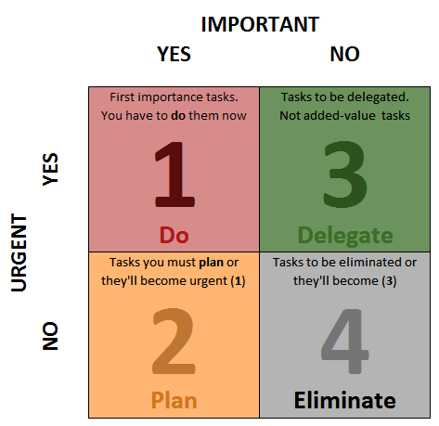

References

Az quotes. (1949) Wilson mizner https://www.azquotes.com/author/10228-

Employability Skills: The Skills You Need to Get a Job (no year) Avaailable at:

https://www.skillsyouneed.com/general/employability-skills.html (Accessed 2020)

Morgan, P. (2016). The Business Student’s Guide to Study and Employability. Sage Publications

valley, m. (january 4, 2019). the top 5 hard skills needed to excel in your career.(Accessed 2020)

https://i.ytimg.com/vi/S7CN9Trw43w/maxresdefault.jpg

