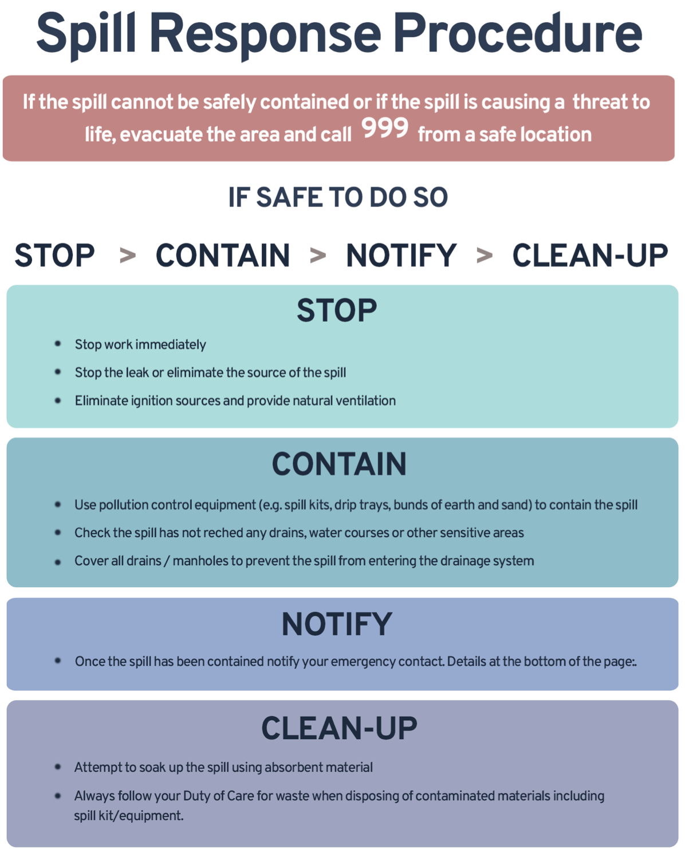
EMERGENCY CONTACT DETAILS

NAME TELEPHONE NEAREST SPILL KIT

WELFARE UNIT

