Student Learning Log
Housekeeping and Back-office (Event Department)

Sorin Ionut Boata, 2014248
Managing Guest Services Operations, BMIH6003
Lecture’s: Dr Jayne Griffith-Parry
Robyn Griffiths

Table of Contents

Introduction 2
Housekeeping Department: issue and solutions 3
Event department: issue and solutions 4
Conclusion 7
References 8

Introduction

The learning journal is primarily concerned with displaying my professional, intellectual, and personal growth. It has enabled me to reflect on my development and assess the job I've done.
It has been created to help me critically reflect on my educational experiences as I evaluate my progress in hotel management.
Vocational development has shown to be useful in my growth as a professional as well as personally concentrating on my hospitality abilities (QAA, 2018). I receive the work experience that provided the groundwork for my future employment. It has allowed me to bring my skills and the greatest degree of competence in hospitality. I got offered a chance to be trained at the Mercure Atlantic Tower hotel in Liverpool.
Whilst I had the opportunity to make my placement at the Mercure Atlantic Tower hotel in Liverpool, I took advantage of each chance that may help me grasp what is important at a hotel to know in terms of potential concerns in the management and operational sectors.

Housekeeping Department: issue and solutions

The Housekeeping Department is where I assist the team with their responsibilities after gaining knowledge and experience in the Food and Beverage department. There are a few concerns with the rooms because they look outdated, so this major issue could affect the hotel's prestige because it will reflect in guests' level of satisfaction, which could be preceded by a negative review on TripAdvisor.
The manager must always have a strategy in place to be able to recognise and properly solve housekeeping difficulties in advance. He must thus learn to adjust to new circumstances.
The management must evaluate the funds allotted to create a comprehensive plan and begin repainting and renovating the hotel rooms.
The Wi-Fi and air conditioner in most of the rooms appear to have problems, which is another issue that needs to be addressed by the maintenance team and to fix them before the guests are arriving in the rooms. Above is where the majority of complaints from guests arise. The recommendation is obviously for the housekeeper to make sure the amenities in the room are operational before marking the room as inspected and granting visitors access to it. To be corrected and sold in excellent shape, any issues discovered by housekeeping must be communicated to and reported to the maintenance staff as soon as possible.
As a result, it is critical to apply development inside the rooms in creating and delivering value to their guests by incorporating modern technology that will allow the guests to feel comfortable by controlling the lighting, air conditioner, and temperature utilising an iPad provided by the hotel in each room (Brody, 2016).
According to Rosemberg and Li (2018), if the supervisor or manager encourages and facilitates worker contact, the housekeeping staff will become more efficient in the workplace and hence more effective at performing tasks.
While it may appear obvious, the hotel may suffer if housekeeping and other hotel departments fail to communicate with each other. As a consequence of the engagement, the workforce will become more linked, ensuring that a high degree of service and strategy is delivered for anything from basic questions to specialised scheduling requests and revisions (Paskins, 2015).
As a result, communication in this area is critical to the success of the business and the retention of visitors to their hotel (Hochsmann,2018).
As compared to other departments in the hotel, the housekeeping department has the highest workforce of personnel (Casado, 2012). Due to the number of rooms, it is important to have four housekeepers on each level of the hotel to manage time and completed it in time to clean the rooms for the visitors. The hotel displays 250 rooms for sale to guests, with around 20 rooms on each level separated into twin, single, double, suite, and privilege rooms (Mercure,2023).

Event department: issue and solutions

Another milestone in my placement adventure was being allowed to join the events department and research and study their responsibilities in event planning.
I was privileged to have seen the wedding fair event prepared and organised at the hotel because this has been a good opportunity to see in what consists of the goal of this event which has the scope to sell the property space for a special event that would bring profit to the hotel (Jamie, 2022).
Before the occasion, I was allowed to assist with the preparation of the restaurant by dressing the table and chairs, folding the napkins, and setting the plates and cutlery on top of the table. To be honest, I found it simple since I had excellent help from Tenishia, the event manager, who provided me with vital information regarding organising an event.
This event was primarily organised by the event management to attract couples interested in holding their wedding reception at a hotel restaurant that has been presented by the hotel as an all-inclusive event with appealing specials and packages.
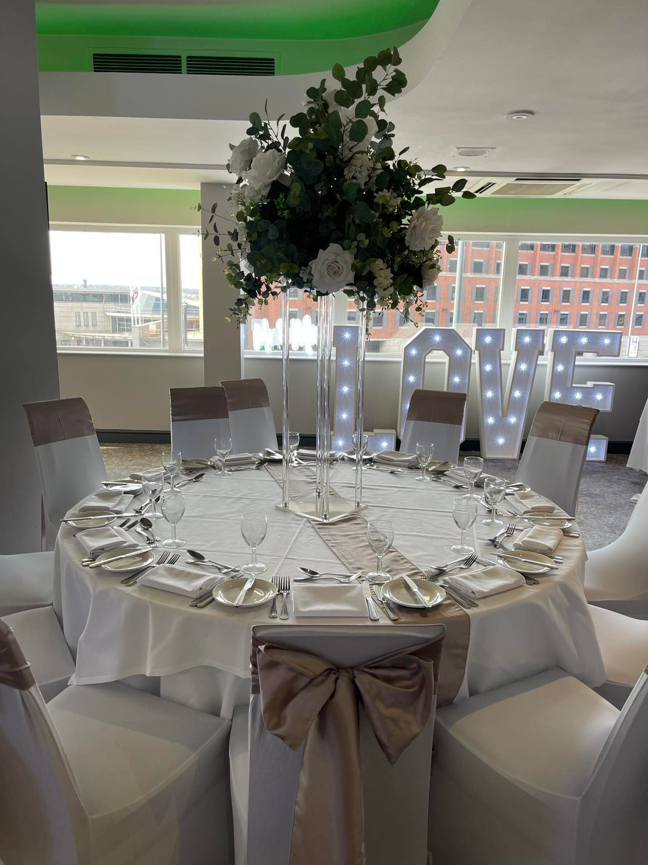
(self-creation)
Honestly, I was expecting a busy day because of the confirmations they had received from audiences. Nevertheless, just a few people showed up there, which I regarded as a big issue because I thought the event had been adequately publicised on social media.
As a result, the answer to this problem is to make the event known and promoted it on social media a few weeks in advance, to begin gathering information about possible visitors interested in this type of event.
The purpose of advertising is to enhance attendance by increasing event awareness through various promotional tactics.
It is critical to understand how to market the event, since this may effectively attract participants and serve as a critical selling point. The manager must be aware of the crucial role that events play in promoting, developing, and achieving goals (Preston, 2015).
It's an excellent way for event planners to stay current with industry trends and increase participation at their events. It's also a great tool for event managers to use to ensure that their venue stands out from the crowd by collecting appealing photographs and building a smart content strategy (Evans,
2020).
I was able to strengthen my capabilities in terms of guest services while working in the Housekeeping and Events departments because I was able to see difficulties that may affect the visitor's expectations and therefore the business reputation from the back office.
The biggest challenges in these two sectors are connected to communication, which might be improved with good training and significant involvement in marketing an event on social media. I was able to accomplish my aims of gaining experience working in numerous areas at the Mercure Atlantic Tower and increasing my awareness. Additionally, the practice has been far beyond my expectations.
It was also extremely fascinating to meet with people who possessed a wide range of knowledge and talents. They were knowledgeable and helpful. This is useful for gaining a better understanding of the field and thinking about potential career options.
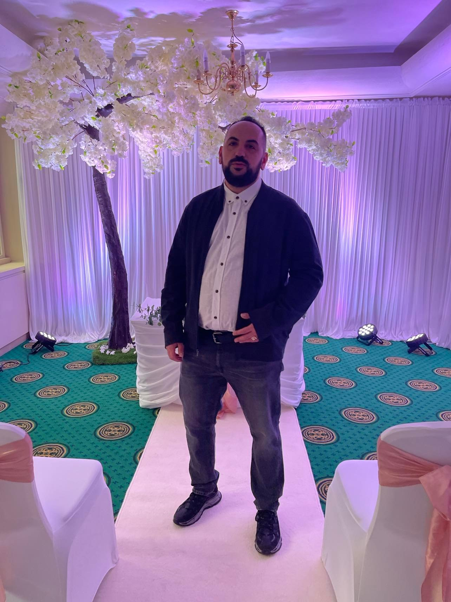
(self-creation)
Knowledge gained throughout the internship.
During my shifts made in the housekeeping and event departments, I was able to gain practical knowledge and take initiative in learning to adapt myself to new responsibilities, while observing the issues from these departments which could be rectified by having the right solution, to avoid damage the business brand and the guests' satisfaction. I do think that I become flexible and open to any circumstance that allows me to accept and deal with potential issues at any moment. As inflexibility prevents both one's progress and that of one's followers, I do think that a leader's efficacy is both constrained and restricted in the absence of change adaptation (Sihombing, 2021).

Conclusion

I feel pleased and open to my future profession because of the experience and new abilities I learned whilst working in the back office, which in my case was represented by the staff from the housekeeping and event departments.

References

ANTHONISZ, A., (2014) Assessing the future of housekeeping operations in Dubai's five-star hotel industry - room for innovation? Worldwide Hospitality and Tourism Themes, 6(4), pp. 352-361.
Brody, D., (2016) Housekeeping by design: Hotels and Labor. Chicago: The University of Chicago Press.
Casado, M., (2012). Housekeeping Management, Wiley, London.
Evans, N., (2020) Strategic management for tourism, hospitality, and events. New York: Routledge.
Höchsmann F., (2018) Housekeeping Management Manual for Successful Housekeeping &amp; Cleaning. Norderstedt: Books on Demand.
Jaime, (2022) Event planning: Defining event goals and Objectives, The Events Calendar. Available at: https://theeventscalendar.com/blog/event-management/defining-event-goals-and-objectives/ (Accessed: March 3, 2023).
Mercure Liverpool Atlantic Tower Hotel, (2023) all.accor.com. Available at: https://all.accor.com/hotel (Accessed: March 5, 2023).
Paskins, P., (2015) Hospitality supervision and leadership level 3. London: Hodder Education.
Preston, C.A., (2015) Event marketing: How to successfully promote events, festivals, conventions, and expositions. Hoboken: Wiley.
QAA, (2018). UK Quality Code, Advice and Guidance: Work-based Learning, QAA, London.
Rosemberg, & Li, Y., (2018). Effort-Reward Imbalance and Work Productivity Among Hotel Housekeeping Employees: A Pilot Study. Workplace Health & Safety, 66(11), 516–521
Sihombing, (2021). The Influence of Individual Factors on Hospitality Students’ Internship Satisfaction: The Mediation Role of Perceived Importance. Global Business and Finance Review, 26(1), 9–21.

