

Student Name: Juma Akter
Student ID: 2425483

Programme: Master of Business Administration
Module & Code: International Marketing: Principles and Practices (LCMB7026)

Company Name: Coca-Cola
Country: UK & INDIA

Word: 5264

Lecturer: Tushara Balendran
Submission Deadline: 19/12/2025

Table of Contents
1. Introduction 1
2. Brand Overview 2
The Global Operations at Coca-Cola 2
Coca-Cola in the United Kingdom 3
Coca-Cola in India 3
3. Comparison of the Socio-Cultural / Macro-Environment (PESTLE Analysis) 4
Political Factors 4
Economic Factors 5
Social / Cultural Factors 6
Technological Factors 9
Legal Factors 9
Environmental Factors 10
4. Comparison of STP Strategies (Segmentation, Targeting, and Positioning) 11
4.1 Segmentation 11
4.2 Targeting 13
4.3 Positioning 14
5. Comparison of Marketing Mix (7Ps) Strategies 17
5.1 Product 17
5.2 Price 19
5.3 Place (Distribution) 20
5.4 Promotion 21
5.5 People 22
5.6 Process 23
5.7 Physical Evidence 23
6. Evaluation of Marketing Strategy Performance 24
6.1 Market Share and Sales Performance 24
6.2 Brand Recognition and Consumer Affair 25
6.3 Marketing Effectiveness 26
7. Evaluation of Marketing Ethics Practices 27
7.1 Ethical concerns in the United Kingdom (UK) 27
8. Conclusion 29
9. References 30

1. Introduction
Coca-Cola is a large recognised consumer brand within the non-alcoholic beverage sector in all parts of the world. Coca-Cola is an example of a multinational enterprise that has developed since its founding in 1886 to become an enterprise that manages to operate in more than 200 countries (The Coca-Cola Company, 2024a). This hybrid organisational structure, a unification of a global ownership of brand, enables Coca-Cola to ensure its brand is constant with varied marketing and products that suit the local tastes (HCCB, 2024). Such a twin approach has been the reason why Coca-Cola is one of the richest and strongest brands globally claiming the place in the top ten global brands regularly (Kantar, 2023).
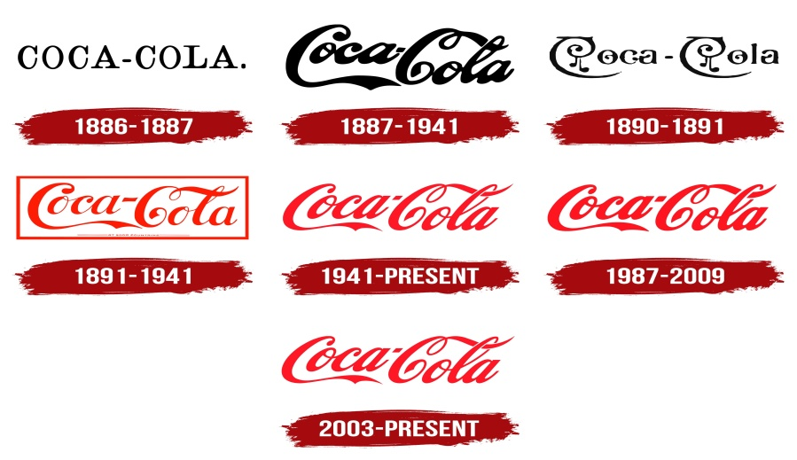
Source: (The Coca-Cola Company, 2024a)
The present report discusses the international marketing techniques of Coca-Cola as it was applied in two opposite settings, the United Kingdom and India. UK is a highly regulated mature, health-conscious, and highly-regulated market with consumers growing more worried about the consumption of sugar and sustainability (Coca-Cola Great Britain, 2025). India, in contrast, is a young, culturally relevant, and price-sensitive, and fast-growing market where affordability, availability, and localised cultural relevance are the main success factors (HCCB, 2024). These two opposing environments are helpful sources of comparison of the way Coca-Cola balances the global standardisation and the local adaptation.
The analysis will take a documentary and analytical tone based on the recent corporate reports, market studies, and scholarly sources that were written in 2025. Performance measurement is measured in market data like annual sales, market share and brand rankings (Expert Market Research, 2024). The PESTLE framework can be used as a key analytical lens to investigate the differences in terms of macro-environment, STP (Segmentation, Targeting, and Positioning) can be used to investigate the audience strategies, and the 7Ps marketing mix can be used to analyse the tactical implementation in the two countries.

2. Brand Overview
The Coca-Cola Company is one of the largest beverage companies in the world. The company established itself in Atlanta, Georgia in 1886 and since then, selling more than 200 brands sold in more than 200 countries (The Coca-Cola Company, 2024a). The product page of Coca-Cola has changed significantly since the introduction of the classic cola and now has a variety of drinks that include Diet Coke, Coca-Cola Zero Sugar, Sprite, Fanta, Dasani, Minute Maid, and Smartwater (The Coca-Cola Company, 2024b). In 2024, the business recorded net operating revenues of USD 45.8 billion, which is a consistent growth despite economic changes (The Coca-Cola Company, 2024c).

The Global Operations at Coca-Cola
Coca-Cola is a franchise bottling system: the assisting company is concentrated on the brand management, marketing, and concentrate production; the manufacturing, packaging, and distribution is done by local bottlers. The system allows the system to be responsive to the needs of the locality, economical, and aligned to the sustainability process with the priorities of the community (The Coca-Cola Company, 2024a). The global sustainability agenda of the firm is through its mission, to refresh the world and make a difference, which has goals of a net zero emission by 2050 and a 100 percent recyclable packaging by 2030 (Coca-Cola Great Britain, 2025).

Coca-Cola in the United Kingdom
Coca-Cola was first introduced in UK in 1900 and today it has Coca-Cola Europacific Partners (CCEP) that bottles and distributes their drinks throughout the region. The market in the UK is competitive, mature, and highly regulated, in particular, concerning the content of sugar and environmental sustainability (Expert Market Research, 2024). To cope with these pressures, coca-cola has also resorted to innovation and diversification such as the successful launch of Coca-Cola Zero Sugar, Diet Coke, and low-calorie beverages to comply with government-led health drives and the UK Sugar Tax that was enforced in 2018 (Coca-Cola Great Britain, 2025).
Sustainability and the use of the circular economy is also a focus in the UK activities of the company. CCEP has undertaken to switch to 100 percent recycled PET bottle, cut down carbon emissions in the supply chain, and invest in other programmes such as the inclusion of the world without waste (Coca-Cola Great Britain, 2025). The brand indulges in national sports sponsorships, including those with the English Football League that continue to instill brand nostalgia and emotional attachment amongst consumers (Grocery Trader, 2025).

Coca-Cola in India
India Economic liberalisation saw Coca-Cola re-enter the market in 1993, 16 years after it had left. It currently works under Hindustan Coca-Cola Beverages Pvt. Ltd. (HCCB) and a system of franchise bottlers. India is also one of the fastest-growing markets of Coca-Cola, as the population is young and the disposable incomes are increasing (HCCB, 2024). The Indian portfolio of Coca-Cola is significantly localised and has Thums Up, Limca, Maaza, and Minute Maid Pulpy, which meet regional tastes and preferences (Economic Times, 2024).
To target the rural markets of India, Coca-Cola has introduced cost-effectiveness pricing (e.g., ₹10 bottle), and new Hub and Spoke distribution systems to ensure the product is available in the remote locations (HCCB, 2024).
In Conclusion, the success of Coca-Cola in both markets is based on the fact that it can adapt: in the UK it fits the priorities of health and environmental consistency whereas in India it appeals to the affordability, accessibility, and cultural relevance of the brand and thus the brand has a dynamic global and local balance (Kantar, 2023).

3. Comparison of the Socio-Cultural / Macro-Environment (PESTLE Analysis)

Political Factors
United Kingdom (UK):
UK is a sound democratic nation with properly set laws regarding food and beverages. The Soft Drinks Industry Levy (sugar tax) is one of them, as it influences the formula and marketing and pricing of drinks of such companies as Coca-Cola (CCEP, 2024).
Overall political factor: Unfavourable due to strict regulations, although stability is favourable.
India:
The political environment in India is typified by a fast rate of regulatory changes, liberalisation, digitisation and infrastructure growth. Rural electrification and the digital payment system (UPI) are some of the initiatives that have boosted rural access to beverages (Statista, 2024).
Overall political factor: Moderately favourable, but complicated due to frequent regulatory shifts.
Comparison:
The climates of the two countries are predictable to foreign companies. UK is concerned in long-term stability, regulation and sustainability where India is concerned with fast development, investment and dynamic changes in regulations and hence political environment is more complex in India.

Economic Factors
United Kingdom (UK):
The UK has a saturated and high-per capita income beverage market, and it is a developed economy. In 2020, carbonated soft drinks market reached USD 8.3 million, and the CAGR is expected to reach 4.4% until 2028 (Statista, 2024).
Economic factor: Partly favourable (high income) but partly unfavourable (market saturation & high costs).
India:
India is a high growth beverage market. Volume growth occurs due to rural expansion, increased disposable incomes, and low base consumption, but rural growth is growing about 3% higher than urban (Economic Times, 2024). Economic factor: Favourable (growth potential), but inflation and price sensitivity remain challenges.
Comparison:
The UK plans are based on efficiency and maximisation of margin whereas the India plans demand volume increase, sensitivity at prices and extensive distribution. Coca-Cola is forced to tailor-made economic approaches to every market.
Favorable and Unfavorable Economic Factors
Economic Factors | United Kingdom | India
Favorable | High GDP per capita; stable economy; advanced supply chain infrastructure | Rapid economic growth; expanding middle class; urbanisation and government support for investment
Unfavorable | Post-Brexit economic uncertainty; high operational costs; inflation pressure | Income disparity; inflation and currency risks; competitive low-cost local options
Source: Statista (2024)

Social / Cultural Factors
UK:
Consumers are becoming health-conscious and environmentally conscious such that products that contain low/no sugar will be demanded, which a product will be formulated, marketed, and packaged.
India:
India is a multicultural nation, and it possesses several languages, local preferences, and social/festive events. Coca-Cola is a product that markets very well in the rural markets during festivals. The increasing middle-income and younger generations promote the need to have easy-to-carry packaged drinks, but price elasticity is still very low (Economic Times, 2024).
Comparison:
The cultural trends in UK, are aimed at health, sustainability, convenience and in India, the cultural trends are centred on affordability, availability, local relevance and adapting to tastes and preferences.
Hofstede 6 Cultural Dimensions
Hofstede’s framework helps understand cultural differences affecting consumer behaviour and marketing strategies.
Dimension | United Kingdom (Score) | India (Score) | Implications for Coca-Cola Marketing
Power Distance | 35 | 77 | UK consumers value equality; India accepts hierarchy, so marketing may leverage celebrity endorsements or aspirational branding
Individualism vs Collectivism | 89 | 48 | UK messaging can focus on personal choice; India emphasizes family, festivals, and social occasions
Masculinity vs Femininity | 66 | 56 | UK favors achievement and performance; India balances aspiration with social harmony
Uncertainty Avoidance | 35 | 40 | Both markets tolerate ambiguity; India prefers clear guidance in campaigns
Long-Term vs Short-Term Orientation | 51 | 61 | UK focuses on trends and immediate gratification; India values brand loyalty and heritage
Indulgence vs Restraint | 69 | 26 | UK receptive to enjoyment-oriented marketing; India emphasizes affordability and portion control
Source: Hofstede Insights (2024)
Cultural Comparison:
Significant differences exist in Individualism, Power Distance, and Indulgence, requiring different marketing tactics. The UK is highly individualistic and indulgent, while India is collectivist and restrained, with a stronger acceptance of hierarchy. The comparison of the United Kingdom (UK) and India across Hofstede's 6 Cultural Dimensions reveals significant cultural contrasts, which are crucial for global marketing strategies. The most pronounced differences exist in three key areas: Individualism, Indulgence, and Power Distance.
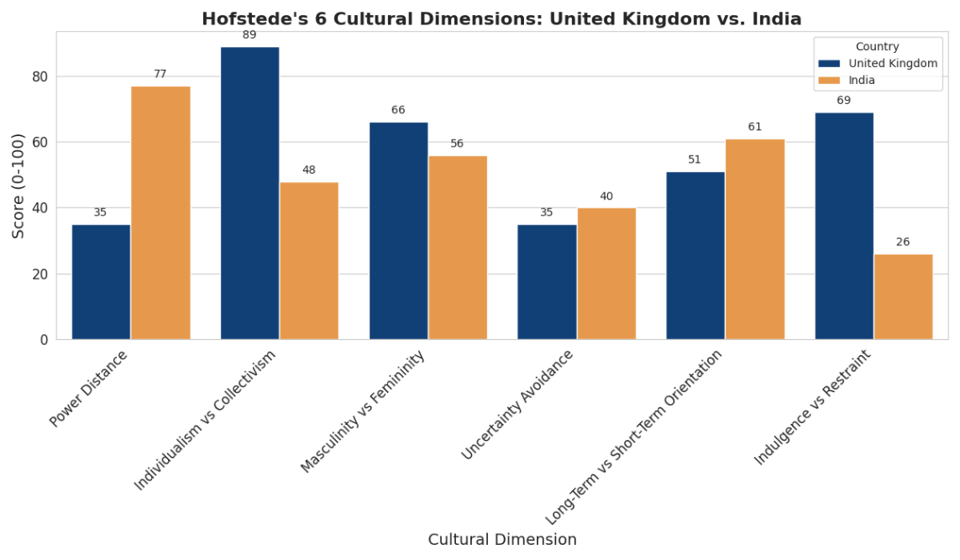
Source: Hofstede Insights (2024)
The UK (89) scores very high on Individualism, meaning its culture values personal choice, freedom, and goals, whereas India (48) is moderately collectivist, prioritizing family and community relationships. Similarly, the UK (69) is an indulgent society, being more receptive to marketing centered on enjoyment and personal gratification, while India (26) is highly restrained, emphasizing social norms, prudence, and affordability. Furthermore, India (77) shows a high score for Power Distance, indicating a greater acceptance of hierarchical structures, while the UK (35) values equality and a low Power Distance.
Advantages and Disadvantages of Hofstede’s Model
Advantages
- Helps understand cultural behaviours that impact marketing and consumer preferences.
- Provides a structured and quantifiable way to compare countries.
- Useful for designing culturally appropriate advertisements, branding, and product positioning.

Disadvantages
Based on outdated and generalised data; may not reflect modern cultural changes.
- Assumes national culture is uniform—ignores regional differences (very relevant for India).
- Does not account for individual differences within a culture.
- May oversimplify complex cultural behaviours.

Technological Factors
UK:
High-level supply chains, digital marketing, and e-commerce, as well as intelligent packaging are supported with advanced technology (Statista, 2024). Advanced supply chains, e-commerce, and digital marketing improve efficiency and customer experience, making technology favourable for Coca-Cola.
India:
The fast implementation of digital payments (UPI), mobile internet, and distribution facilitated by technology increases coverage of rural markets. There are still logistic issues (Statista, 2024). Rapid digital adoption (UPI, mobile internet) helps expand market reach, but logistical challenges limit effectiveness, making technology moderately favourable.
Comparison:
UK concentrates on efficiency and higher consumer experience and India on scale, reach and access.

Legal Factors
UK:
Food safety, labelling, sugar content, packaging waste and advertising are regulated strictly especially to the children. This is compulsory (Statista, 2024). Unfavourable due to regulatory strictness.
India:
Legal environment is changing, such as food safety, state regulations, licencing and distribution in rural areas. Flexibility is important (Statista, 2024). Moderately unfavourable due to inconsistency.
Comparison:
UK has the risk of strict compliance, India has the compliance with the various and changing regulatory standards.

Environmental Factors
UK:
Sustainability of the environment is desirable. Coca-Cola is under pressure in terms of recycling, decreasing plastic waste, and using water (Statista, 2024). Moderately unfavourable (high expectations).
India:
Water shortage, plastic recycling, recycling restrictions, and climatic vulnerability (monsoons, heat) are some of the challenges. Firms are currently concerned with the efficiency of water, sustainable packaging and energy conservation. Unfavourable due to environmental risks and infrastructure gaps.
Comparison:
The two markets drive Coca-cola towards sustainability. Consumer expectations and established regulations are prevailing in the UK, whereas in India, infrastructures and rapidly evolving regulations are the most important issues.

Overall Similarities and Differences in PESTLE (UK vs India)
Similarities
- Both require compliance with food safety and environmental regulations.
- Both push Coca-Cola towards healthier and sustainable products.
- Technological adoption (digital payments, e-commerce) growing in both.
Differences
- UK = stable, mature, highly regulated, health-focused.
- India = dynamic, high-growth, price-sensitive, culturally diverse.
- UK legal and environmental regulations are stricter; India’s are diverse and evolving.
- Technology in the UK improves efficiency; in India it expands market reach.
Conclusion: PESTEL and Hofstede analysis prove that Coca-Cola has different external pressures in the UK and India. As the UK is concerned with health, sustainability, and efficiency, India is concerned with volume growth, affordability and cultural adaptation. Such factors present country-specific marketing strategies in order to succeed.

4. Comparison of STP Strategies (Segmentation, Targeting, and Positioning)
Key to the differences between the socio-cultural, economic, and consumer behaviour is the fact that Coca-Cola customises its Segmentation, Targeting, and Positioning (STP) strategies to suit the UK and India. Knowledge on STP will give an insight into how the brand will customise marketing campaigns, products, and communication plans to maximise the market share in different settings.

4.1 Segmentation
United Kingdom (UK)
In the UK, Coca-Cola mainly uses demographic, lifestyle, and psychographic segmentation. Key segmentation criteria include:
- Age: The primary consumers of carbonated soft drinks are young adults (16–34 years). Older adults tend to prefer diet or low-sugar variants.
- Lifestyle & Health Consciousness: With growing emphasis on healthy living, Coca-Cola targets health-conscious consumers through low-calorie, sugar-free, and functional beverages (Coca-Cola Great Britain, 2025).
- Income and Affluence: Premium variants such as Coca-Cola Signature Mixers are targeted at higher-income consumers seeking quality and unique beverage experiences.
India
In India, segmentation is influenced by income, geography, culture, and occasion-based consumption. Major segments include:
- Income: Small pack sizes and low-priced options are offered for lower-income consumers, while standard and premium products target middle- and upper-middle-class groups.
- Urban and Semi-Urban Consumers: Modern retail stores, online delivery, and organised trade dominate in urban and semi-urban markets, whereas rural markets are served through small pack sizes and direct distribution networks.
- Cultural/Occasion-Based: Products like Maaza and Thums Up are heavily promoted during festivals, cricket matches, and social events, highlighting group and festive consumption (HCCB, 2024).
Comparison Table – Segmentation
While UK segmentation prioritises health, lifestyle, and individual preferences, India requires multi-dimensional segmentation shaped by income levels, geography, and cultural occasions.

Segmentation Basis | United Kingdom | India
Demographics | Age, income, lifestyle | Age, income, geography, occasions
Psychographics | Health-conscious, indulgent lifestyle | Cultural relevance, family-oriented consumption
Geographic | National, urban-focused | Urban, semi-urban, rural
Behavioural | Limited occasion-based consumption (daily, casual drinking) | Festivals, social gatherings, family sharing
Source: HCCB (2024)
Note: VALS personality types are connected to psychographics because they classify consumers based on lifestyle, motivations, and personality traits.

4.2 Targeting
United Kingdom (UK):
In the UK, Coca-Cola uses differentiated targeting, and targets various segments with product lines tailored:
- Young adult and students: Classic Coca-Cola and Coca-Cola Zero Sugar.
- Adults who are health conscious: Diet Coke and Coca-Cola Zero Sugar.
- Premium customers: Coca-Cola Signature Mixers and limited editions.
The media-based targeting is intended to reach young people who are tech-savvy and operate on the digital platform (Instagram, Tik Tok, and YouTube) (Kantar, 2023).
India:
Another approach that India employs is also differentiated targeting and focuses on mass-market penetration and regional adaptation:
- City and middle-income customer: Coca-Cola Classic, Diet, and Coca-Cola Freestyle machines in contemporary stores.
- Simple packs (₹10/20 bottles), domestic brands such as Thums up and Limca: Rural users and price sensitive markets.
- Cultural and occasion-based targeting: During festivals, cricket tournaments, school events, and so on, advertising to families and groups (HCCB, 2024).
Comparison Table – Targeting
UK targeting emphasises personal lifestyle and health preferences, while India focuses on volume, accessibility, and culturally relevant messaging to capture diverse market segments.
Targeting Strategy | United Kingdom | India
Approach | Differentiated, lifestyle-oriented | Differentiated, mass-market + regional adaptation
Key Segments | Young adults, health-conscious, premium | Urban middle-class, rural low-income, festival/occasion-based
Media Channels | Digital, social media, influencer marketing | Traditional media, digital, outdoor, event sponsorship
Source: (HCCB, 2024)

4.3 Positioning
United Kingdom (UK):
Coca-Cola presents itself as a luxurious, pleasant, and responsible brand, balancing between luxury and health/sustainability programmes. Messaging highlights:
Status and pleasure: Happy days, social, and emotional campaigns (e.g., “Open Happiness”).
Health and sustainability: Sugary variants, recycled packaging, and a reduction in carbon footprint (Coca-Cola Great Britain, 2025).
India:
Coca-Cola markets its brand as cheap, convenient, and integrated into the culture and still has a premium aspirational target to urban consumers. Messaging highlights:
Cultural relevance: Festival specific advertising and sponsorship of cricket (Thums Up campaigns).
Availability: Low-price, small packages to the low-income or rural market.
Emotional involvement: Brand relates to the family, the community, and common experiences (HCCB, 2024).
Comparison Table – Positioning
Coca-Cola’s UK positioning focuses on individual indulgence and sustainability, while India positions the brand around community, affordability, and local relevance, adapting to cultural expectations.
Positioning Aspect | United Kingdom | India
Core Message | Premium, enjoyment, ethical & sustainable | Affordable, culturally relevant, aspirational
Emotional Appeal | Personal enjoyment, lifestyle, happiness | Family, community, celebration
Product Differentiation | Sugar-free, low-calorie, limited editions | Regional flavors, small pack sizes, local brands
Source: (HCCB, 2024)

Perceptual Map (India Example):
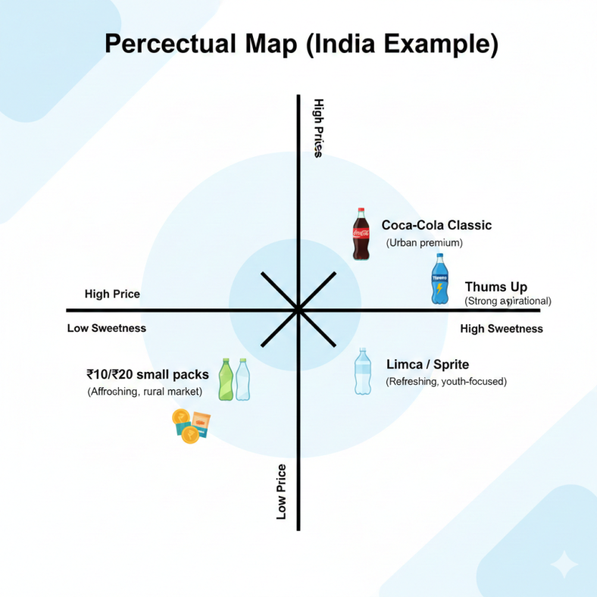
Figure: Perceptual Map (India)
Source: (HCCB, 2024)
Brief Explanation of Perceptual Map
- This perceptual map shows how Coca-Cola products in India are positioned based on price and sweetness intensity.
- Thums Up and Coca-Cola Classic are positioned as higher-priced, strong-flavoured, aspirational beverages for urban consumers.
- Limca and Sprite occupy the moderate-price, refreshing segment.
- Small affordable packs (₹10/₹20 bottles) are positioned as low-price, high-accessibility products for rural and price-sensitive consumers.
Similarities and Differences in STP (UK vs India)
Similarities
- Both markets use differentiated targeting.
- Coca-Cola maintains core global brand identity (happiness, refreshment).
- Digital marketing is used in both countries.
Differences
- UK focuses on health, lifestyle, sustainability; India focuses on affordability and cultural relevance.
- UK segments mainly using age and health consciousness; India uses income, region, culture, and festivals.
- Positioning differs: UK = premium & responsible; India = affordable & community-oriented.
- Distribution intensity is higher in India due to rural markets.
By tailoring segmentation, targeting, and positioning, Coca-Cola successfully maintains global brand consistency while adapting to local preferences, enhancing competitiveness in both markets.

5. Comparison of Marketing Mix (7Ps) Strategies
Coca-Cola’s 7Ps strategy in the UK and India reflects a thoughtful balance between global consistency and local adaptation. In the UK, the brand focuses on health consciousness, sustainability, and premium value, while in India, the emphasis lies on affordability, cultural connection, and market accessibility. Despite these differences, Coca-Cola successfully maintains its global brand image through a shared message of happiness and refreshment. This ability to adapt marketing strategies while staying true to its core identity is what continues to make Coca-Cola one of the world’s most recognisable and trusted brands.

5.1 Product
Coca-Cola adjusts product depth and width differently across the UK and India, supported by distinct branding approaches.
United Kingdom (UK)
In the UK, Coca-Cola offers a diverse product portfolio catering to health-conscious, indulgent, and premium consumers. Key offerings include:
- Coca-Cola Classic
- Coca-Cola Zero Sugar
- Diet Coke
- Coca-Cola Signature Mixers (premium, limited edition)
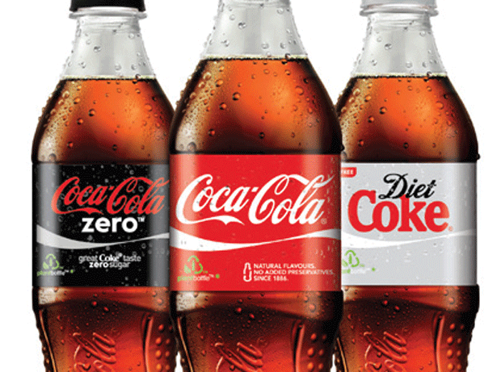
Figure: UK Coca-Cola products
Seasonal and special-edition launches appeal to consumers seeking novelty and exclusivity (Coca-Cola Great Britain, 2025). Branding focuses on premium quality, sustainability, wellness, and lifestyle alignment.
India
In India, the company provides a broader and more affordability-oriented portfolio, including:
- Coca-Cola Classic
- Coca-Cola Zero Sugar
- Diet Coke
- Local favourites: Thums Up, Limca, Maaza
- Small, low-cost packs (₹10–₹20) for rural markets
- Family-size bottles for urban households
Branding emphasises local culture, family consumption, affordability, and refreshing taste, tailored to diverse regional preferences (HCCB, 2024).
Comparison
- UK: premiumisation, health focus, sustainable packaging
- India: affordability, localisation, small packs for accessibility

5.2 Price
UK:
The pricing is high-end based on high purchasing power, quality of product and sustainability efforts. There are limited promotions, reward programmes and discount pricing strategies (HCCB, 2024).
India:
The consumers are price-sensitive and this makes the pricing very competitive. Small pack prices enable the rural and semi-urban markets to be affordable and urban markets to offer normal and premium prices.

Comparison Table – Product & Price
Element | United Kingdom | India | Key Insight
Product | Classic, Diet, Zero Sugar, Premium mixers; recyclable packaging | Classic, Diet, Zero Sugar, Thums Up, Maaza; small packs for affordability | UK: focus on premium and sustainability; India: affordability & local relevance
Price | Premium pricing, seasonal promotions | Competitive, low-cost small packs; price-sensitive | India pricing is volume-driven; UK pricing is quality- and lifestyle-driven
Source: (HCCB, 2024)

5.3 Place (Distribution)
UK:
Supermarkets, convenience shops, vending machines, online retail outlets and hospitality avenues are some of the outlets that Coca-Cola products are sold. High-tech logistics guarantee freshness and availability throughout the country.
India:
In India, Coca-Cola operates a highly extensive and multi-tiered distribution network designed to reach both urban and rural consumers. The system covers urban modern trade channels such as cafés, restaurants, and supermarkets, while also extending to rural markets through small retailers, kiosks, and direct delivery systems. The company continues to invest in cold-chain infrastructure to maintain product quality, particularly in rural and high-temperature regions (HCCB, 2024).
Market Entry Methods
United Kingdom
Coca-Cola entered the UK through direct exporting and later established full foreign direct investment (FDI) via bottling plants.
Why chosen:
- Stable, high-income market
- Favourable business environment
- Strong retail infrastructure
Advantages:
- Full control over operations
- Strong brand consistency
Disadvantages:
- High operating and labour costs
India
Coca-Cola re-entered India in 1993 using acquisition + franchising. It acquired local brands (Thums Up, Limca, Maaza) and partnered with local bottlers.
Why chosen:
- Large, diverse market
- Local brands already popular
- Need for rapid distribution expansion
Advantages:
- Fast market penetration
- Local knowledge and established networks
Disadvantages:
- Reduced operational control compared to fully owned bottling
Comparison
- UK: FDI with centralised control
- India: Franchising + acquisition for rapid coverage and cultural relevance

5.4 Promotion
UK:
The promotion plan of Coca-Cola emphasises on digital marketing, social media campaign, partnership with influential people, sustainability campaign and experience event. Focus on lifestyle, health-consciousness, and happiness advertising.
India:
The promotion combines both the old media (TV, radio, billboards, etc.) and the online marketing. The most important is the cultural relevance and this can be achieved through festival campaigns, sponsorship of cricket and community events. The urban young people are the target of influence marketing and the rural promotional are usually based on the local festivals (HCCB, 2024).
Comparison Table – Place & Promotion
Element | United Kingdom | India | Key Insight
Place | Supermarkets, convenience stores, vending machines, online, hospitality | Urban: modern trade; Rural: small retailers, kiosks, direct delivery | India: multi-tiered distribution required; UK: efficiency-focused
Promotion | Digital, social media, influencers, sustainability campaigns | TV, radio, billboards, festivals, cricket sponsorships, social media | India: culturally adaptive campaigns; UK: lifestyle & sustainability-focused
Source: (HCCB, 2024)

5.5 People
Coca-Cola employs around 22,000 people in the UK across production, distribution, sales, and marketing, while in India, Hindustan Coca-Cola Beverages has over 5,000 staff, and the parent company employs an estimated 25,000 people (Coca-Cola, 2024; HCCB, 2024). Employees are trained to enhance customer experience, support sustainability, and adapt marketing campaigns to local preferences.
UK:
Employees are educated to improve customer experience, sustainability awareness, and online interaction. Emotional connexion is enhanced by the use of brand ambassadors and influencers (Statista, 2024).
India:
Employees are equipped to work distribution to the mass-market, in the rural areas and with the promotion to events/festivals. Local brand ambassadors are used to reach out to cultural differences (Statista, 2024).

5.6 Process
UK:
High quality products and adherence to sustainability standards are met with the efficient processes such as automated production, digital order processing, and eco-friendly logistics (Statista, 2024).
India:
Processes are concerned with flexibility and scalability, whereby production is flexible to a variety of variants and packs are small, and regional logistical problems are handled.

5.7 Physical Evidence
UK:
The tangible assets at Coca-Cola are branded packages, vending machines, retail shelves, and sustainable store materials. Visual branding is used in campaigns to support premium, ethical and lifestyle messaging (Statista, 2024).
India:
The physical evidence consists of minor cost-effective packs, holiday-themed wrappings, point-of-sale displays, and branding of events. Packaging conveys low cost, domestic taste, and cultural appropriateness.
Summary of 7Ps Analysis
Coca-Cola tailors its marketing mix to fit each market. In the UK, it focuses on health, sustainability, and premium quality, offering low-sugar products, eco-friendly packaging, and digital promotions. In India, the strategy centres on affordability, localisation, and wide reach, with local brands, small pack sizes, and culturally driven promotions. Overall, Coca-Cola’s glocal approach balances global brand identity with local consumer needs, ensuring success in both mature and emerging markets.

6. Evaluation of Marketing Strategy Performance
The marketing strategies that Coca-Cola uses in the UK and India can be analysed based on market share, brand recognition, sales, social media and consumer perception. This part is a critical insight on whether or not the 7Ps strategies and the STP are working in both countries.

6.1 Market Share and Sales Performance
United Kingdom (UK):
Coca-Cola has a dominant share in the market of carbonated soft drinks (CSD) with the percentage of about 45 in the UK market (Statista, 2024).
In UK, the sales of the Coca-Cola products amounted to approximately 2.3 billion pounds annually (2023), and the diet and zero-sugar versions are increasing at a higher rate than the traditional ones because of the trend of healthiness.
The brand uses the luxury and exclusive products to keep the consumer interested in a mature and very competitive market (CCEP, 2024).
India:
Coca-Cola also has a strong market share in India non-alcoholic beverage market, with the closest competitors being local brands (Thums Up, which is a company subsidiary), and Parle Agro.
The company of soft drinks has about 40 market share in India, rural penetration is increasing more than urban (HCCB, 2024).
In India, the total revenue is more than ₹6,500 crore (~ USD 800 million), which is a great progress due to the popularity of small packs and festival promotions (Economic Times, 2024).
Comparison Table – Market Share & Sales
Metric | United Kingdom | India | Key Insight
Market Share | 45% (CSD market) | 40% (soft drinks market) | Coca-Cola is market leader in both countries
Annual Revenue | £2.3 billion (2023) | ₹6,500 crore (~USD 800m) | UK: mature market, steady growth; India: high-growth, volume-driven
Growth Trends | Diet/Zero Sugar growing | Rural & festival segments driving growth | UK: product innovation; India: distribution & cultural adaptation
Source: (Economic Times, 2024).

6.2 Brand Recognition and Consumer Affair
United Kingdom (UK):
Coca-Cola has good brand recognition (>90%), and good awareness of diet and zero-sugar products (Kantar, 2023).
The digital presence is strong, which takes advantage of social media (Instagram, Tik Tok, YouTube) to reach young adults and lifestyle-oriented consumers.
Sustainability campaigns and promotions increase brand image and loyalty.
India:
The brand awareness is also high (>85%), classic Coca-Cola, Thums Up, Limca and Maaza are highly recognised.
The promotional activities will focus on festivals, cricket sponsorship, and rural outreach to guarantee emotional connexion and presence.
The coverage with multi-segments is maintained with the use of social media campaigns aimed at urban youth and traditional TV and outdoor advertising (HCCB, 2024).
Comparison Table – Brand Awareness & Engagement
Metric | United Kingdom | India | Key Insight
Brand Awareness | >90% | >85% | High in both countries
Social Media Engagement | Strong, lifestyle & sustainability campaigns | Strong, festival & sports campaigns | UK: lifestyle-focused; India: culturally adaptive
Consumer Loyalty | High, premium & zero-sugar consumers | High, culturally & price-adapted | Strategies resonate with local consumer expectations
Source: (HCCB, 2024)

6.3 Marketing Effectiveness
United Kingdom (UK):
Marketing is efficient in causing brand equity and in sustaining premium positioning. Growth of diet and zero-sugar versions: means in line with the health-crazed trends.
Consumer engagement and repeat buying power are enhanced by the use of digital campaigns, influencer relationships and experiential marketing.
India:
Marketing the effectiveness of marketing is exhibited through the rapid rural growth, the development of promotions based on fests, and the growth of sales depending on volume. Affordability of small packs, domestic brands (Thums Up, Maaza) and cultural relevance will see the product penetrate several segments well.
Coca-Cola successfully strikes the balance between the accessibility of its products in the mass market and the aspirational products that are sold in the urban market.

7. Evaluation of Marketing Ethics Practices
Marketing ethics examines the moral principles and social responsibilities that guide a company’s marketing practices. Coca-Cola, as a global brand, faces ethical challenges in both the UK and India due to health concerns, environmental impact, and advertising practices (HCCB, 2024).

7.1 Ethical concerns in the United Kingdom (UK)
The marketing activities of Coca-Cola in the United Kingdom have a number of ethical considerations especially concerning health, advertisements as well as environmental sustainability. Among the most popular ethical challenges is the problem of sugar content and the health of the population. The popularity of the Soft Drinks Industry Levy (SDIL), which was introduced in the year 2018, is indicative of an increased public awareness about obesity and sugar-related diseases. Coca-Cola has, in turn, reformulated a great deal of its products, reducing sugar content, introducing low- and no-sugar products like Coca-Cola Zero Sugar, and being more transparent due to clear nutritional labeling (CCEP, 2024).
The other ethical aspect is the advertisement to such vulnerable groups, especially children. The UK advertising laws do not allow the marketing of high sugar drinks to anyone below the age of 16. Coca-Cola needs to then be especially careful about the fact that their campaigns, sponsorships, and social media posts do not present to underage people in an indirect manner (UK Government, 2024). The importance of ethical responsibility in the advertisement process is very significant in ensuring social legitimacy of the company.
Summary Table – Ethical Aspects in the UK
Ethical Aspect | Approach in the UK | Key Insight
Sugar & Health | Reformulation, low/no-sugar products, SDIL compliance | Regulation-driven sugar reduction
Marketing to Children | Restricted advertising to under 16 | High ethical vigilance required
Environmental Responsibility | Recycling, reduced water usage, carbon footprint management | Compliance with regulations ensures sustainability
Transparency & Labelling | Clear nutritional information | Supports informed consumer choices
Coca-Cola in the UK demonstrates high ethical standards, adhering to regulations and addressing health, environmental, and advertising concerns. This structured approach ensures consumer trust while maintaining the company’s global brand reputation.

Recommendations for Coca-Cola’s International Marketing
1. Product & Pricing:
- UK: Concentrate on low/zero-sugar and high-end versions.
- India: Grow small packs and culturally oriented flavours, which are affordable.
2. Distribution & Promotion:
- UK: Capitalise on digital platform, modern store, and e-commerce.
- India: Bolster the rural distribution, festival promotions, and multi-channel marketing.
3. Ethics & Sustainability:
- Keep the markets transparently labelled, responsible, and sustainable in packaging.
4. Digital/Consumer Engagement:
- Make it personal with data-driven marketing and social media campaigns to get more engagement.

8. Conclusion
Finally, Coca-Cola has shown high capability in balancing international and local brand consistency in both the UK and India. The brand has succeeded in an environment that is mature, health-aware, and regulation-oriented in the UK through the application of high-quality product deliverables, online marketing, and sustainability programmes. In India, Coca-Cola, on the contrary, is successful due to cultural adaptation, low-pricing packages and rural retailing, as well as festival-oriented advertising as it utilises a rapidly expanding and diversified consumer population. The comparative analysis of PESTLE, cultural dimensions introduced by Hofstede, STP, and 7Ps marketing mix reveal that country-specific strategies are inevitable in order to cope with the economic situation, culture, and regulating environment. Moral conducts of marketing within both markets, including nutritional, environmental sustainability, and so on, strengthen the brand image even further. On the whole, the strategic emphasis on innovation, cultural relevance, and ethical responsibility can help Coca-Cola to continue increasing its growth and competitive power both in developed and emerging markets in the long run.

9. References
- CCEP (Coca-Cola Europacific Partners) (2024) Soft Drinks Industry Levy and Market Overview – UK. Available at: https://www.cokeccep.com (Accessed: 13 November 2025).
- Coca-Cola Great Britain (2025) Coca-Cola GB – About & Campaigns. Available at: https://www.coca-cola.com/gb/en (Accessed: 13 November 2025).
- Coca-Cola Great Britain (2025) Coca-Cola GB – About & Sustainability Initiatives. Available at: https://www.coca-cola.com/gb/en (Accessed: 13 November 2025).
- Coca-Cola Great Britain (2025) Marketing & Brand Strategy Overview. Available at: https://www.coca-cola.com/gb/en (Accessed: 13 November 2025).
- Down to Earth (2023) Coca-Cola’s water use and sustainability response in India. Available at: https://www.downtoearth.org.in/ (Accessed: 13 November 2025).
- Economic Times (2024) ‘Coca-Cola rural market growth in India,’ The Economic Times, 12 March. Available at: https://economictimes.indiatimes.com (Accessed: 13 November 2025).
- Economic Times (2024) Coca-Cola India Rural & Festival Marketing. Available at: https://economictimes.indiatimes.com (Accessed: 13 November 2025).
- Expert Market Research (2024) United Kingdom Soft Drinks Market Report 2024–2034. Available at: https://www.expertmarketresearch.com/reports/united-kingdom-soft-drinks-market (Accessed: 13 November 2025).
- Grocery Trader (2025) Expanding category: Both the traditional and emerging segments within soft drinks are in growth. Available at: https://grocerytrader.co.uk/ (Accessed: 13 November 2025).
- Hindustan Coca-Cola Beverages (HCCB) (2024) Brand Portfolio and Marketing Insights. Available at: https://www.hccb.in (Accessed: 13 November 2025).
- Hindustan Coca-Cola Beverages (HCCB) (2024) Brand Portfolio and Marketing Insights. Available at: https://www.hccb.in (Accessed: 13 November 2025).
- Hindustan Coca-Cola Beverages (HCCB) (2024) Company Overview and Sustainability Report. Available at: https://www.hccb.in/ (Accessed: 13 November 2025).
- Hofstede Insights (2024) Country Comparison – United Kingdom and India. Available at: https://www.hofstede-insights.com/country-comparison/ (Accessed: 13 November 2025).
- Kantar (2023) BrandZ Top 100 Global Brands Report. Available at: https://www.kantar.com (Accessed: 13 November 2025).
- Statista (2024) Beverage Market Data – UK and India. Available at: https://www.statista.com (Accessed: 13 November 2025).
- The Coca-Cola Company (2024a) Annual Report 2024. Available at: https://investors.coca-colacompany.com/financial-information (Accessed: 13 November 2025).
- The Coca-Cola Company (2024a) Annual Report 2024. Available at: https://investors.coca-colacompany.com/financial-information (Accessed: 13 November 2025).
- The Coca-Cola Company (2024b) Fourth Quarter and Full Year 2024 Results. Available at: https://investors.coca-colacompany.com/news-events (Accessed: 13 November 2025).
- The Coca-Cola Company (2024b) Sustainability and Beverage Portfolio Overview. Available at: https://www.coca-colacompany.com/sustainability (Accessed: 13 November 2025).
- The Coca-Cola Company (2024c) Fourth Quarter and Full Year 2024 Results. Available at: https://investors.coca-colacompany.com/news-events (Accessed: 13 November 2025).
- UK Government (2024) Soft Drinks Industry Levy (SDIL) Report. Available at: https://www.gov.uk (Accessed: 13 November 2025).

