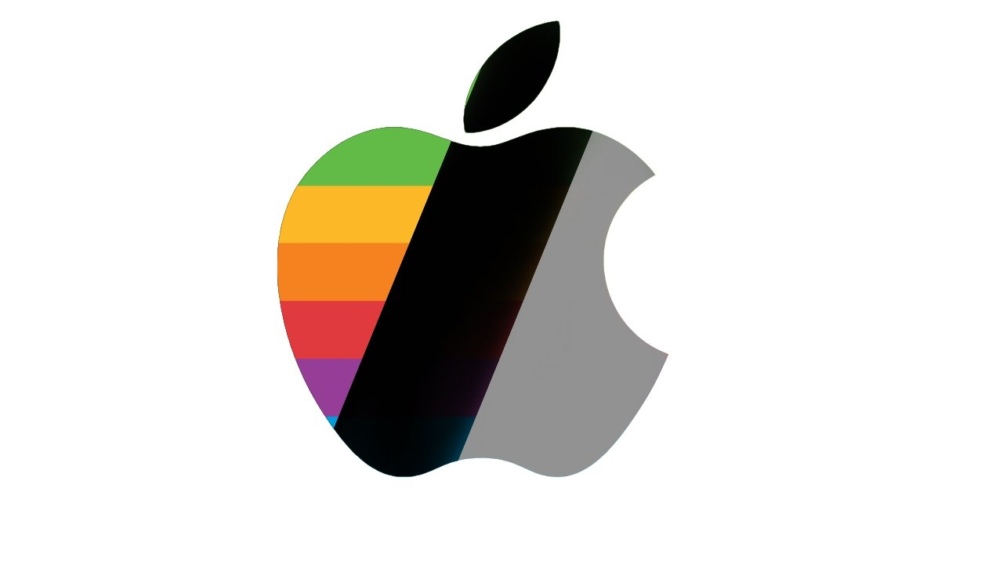  Assignment one  BMSP6006 – Strategies for Resilience and Prosperity | Sarah Carr (2107448)  December 2023

Table of Contents
Introduction 2
Company Overview 2
Company Strategy 3
What are Strategic Management Tools 4
SWOT Analysis 4
PESTLE Analysis 6
Stakeholder Analysis 8
Conclusion 9

Introduction

The following report will contain an analysis of the internal and external environment which demonstrates aspects of sustainability and resilience of the technology company Apple. In this report I will give a brief history of the company Apple, research their current company strategy, and using strategic management tools such as Porters five forces, SWOT, PESTLE, and Stakeholder analysis to assess Apple’s strategy.

Having a business strategy is a crucial part of any company. Creating a plan with distinctive steps allows any business to reach their goals and create future success. A strategy sets out how a business or organisation uses their resources, implements their skills and knowledge, who they tend to employ and their financial commitments to achieve their over goal.

Michael Porter takes a competitive approach and defines strategy as “the companies distinctive approach to competing and the competitive advantages on which it will be based”, (Harvard Business School, 2022). Having a competitive business strategy, a company can position themselves strategically within their industries to achieve a competitive advantage over their competition.

Henry Mintzberg tells us that strategy in business is emergent. Businesses and organisations are learning what works for their company while in practice, emergent strategy is a set of actions, or behaviour that “develops over time as a business balances its goals with the changing circumstances, strategies emerge as businesses carries out actions repeatedly to develop a pattern of its habits” (Indeed, 2022).

Company Overview

Apple Inc was established in 1977 and is an American computer and consumer electronics company based in California. The company was founded by Steve Jobs and Steve Wozniak. From its humble beginnings in Jobs’ garage, it has grown into the largest information technology company and the second largest mobile phone manufacture in the world (Apple, 2023).
The companies first success came in the late 70’s when the success of the AppleⅡ propelled them into spotlight and they became the leading computer manufacturer in America. Throughout the years conflict with the company caused Wozniak to leave his position while Jobs was removed from all duties by the board of directors and eventually left the company in 1985. Upon leaving Jobs created another computer company NeXT.
Due to the increase in competition from companies such as Microsoft-Windows, and many changes at higher management Apple was losing focus and began experiencing flops in the market. In 1996 Apple made the decision to acquire Jobs’ new company NeXT, (Apple, 2023) which also brought Steve Jobs back into the Apple universe, allowing him to take Apple back to their core focus and avoid bankruptcy.
In 1998, Apple launched the iMac and named Jobs as the new CEO. They continued to innovate and create under Jobs, with their next big success in 2001 with the release of the iPod, followed by the one of the first popular smartphones, the iPhone in 2007 and the iPad in 2010 (Apple, 2023).
Sadly, Steve Jobs died of pancreatic cancer in 2011. However, Apple continued in his footsteps by releasing new products and expanding their services by launching their streaming services Apple Music in 2015 and Apple TV+ in 2019 (Apple, 2023). Their innovation shows no bounds, with rumours circulating in the technology environment of Apple working on a virtual reality headset and stepping into another new industry with self-driving automobiles.

Company Strategy

Apples business strategy is “classified as product differentiation, the multinational technological company differentiates its products and services on the basis of simple, yet attractive design and advanced functionality” (Dudovskiy, 2023). He continues to break down the business strategy of apple into four elements,

Focus on design and functionality of products.
Apple has always been a leader with regard to innovation and creativity and this remains one of its key focuses going forward. Since the early 2000s Apple continues to improve on the model that come before they are leading innovators for computers and have been labelled a ‘first mover’ in the field. However, it may be challenging to keep that competitive advantages as new competitors are continually introduced new innovative products into the market.

Enhancing the customer experience.
Customer experience is one of the Apple’s core pillars of it strategy. Consumers are so excited with their new products that they post on their excitement on social media platforms offering a new form of advertising for the company at no cost. Apple products are easy to use as soon as they are unboxed, as “there is no need to download or install anything” (Dudovskiy, 2023). Apple offer many ways in which customers can contact them with questions via their online chat systems or to try products before they buy in a number of stores in location across the world.

Strengthening the Apple ecosystem.
Apple devises all sync easily and work well together. A business can run their programmes on multiple devices at different locations thanks to their operating systems. However, the products do not pair with non Apple devices.

Decreasing the dependence of the sales of iPhone.
In the past Apple business strategy has been focused and prioritizing the sales of iPhone over anything else. High profile changes withing the top-ranking officers at Apple have quickly changed their target and they are now focused on services and other businesses divisions such as artificial intelligence, show that they are trying to decrease their dependence on the sale of iPhones.

What are Strategic Management Tools

Business and organisations create plans to assess and direct their next steps. When making these plans, they may use different strategic management tools to help assess their resources and create objectives. These tools show the businesses their current financial obligations and lay out their long-term goals and how they can implement plans to achieve the goals.
There are many benefits of using strategic management tools. Being able to review their short- and long-term goals, outlining their priorities with time bound goals, allocating resources, improving communication, and highlighting opportunities with employees and higher management.

There are many different strategic management tools in this report I will be using a SWOT analysis, PESTLE analysis, Porters five forces and stakeholder analysis.

SWOT Analysis

A SWOT analysis is a strategic management tool used to assess the internal factors of a business. SWOT stands for strengths, weaknesses, opportunities, and threats. It is used to assess what a business is doing successful now, what opportunities it will have in the future, but also where they need to improve and how they need to protect themselves from possible threats.

SWOT Analysis of Apple.

STRENGTHS | WEAKNESSES
- Strong brand recognition  - Loyal customer base  - High quality, design and performance of products and services  - Financial strength and profitability  - Leader in technology | - Expensive products and services  - Dependence on iPhone sales  - Lack of innovation in face of growing competition  - Limited customisation options  - Different operating systems not compatible with other products
OPPORTUNITIES | THREATS
- Using brand name to enter new markets.  - Green technology  - Increased focus on content for streaming services  - Artificial intelligence  - Forming strategic partnerships | - Increasing threats within all industries  - Counterfeit products  - Reduction in demand due to economic downturn  - Continued impact from Coronavirus

Below is a brief description of each point in the SWOT analysis.

Strengths
Apple is a brand that has strong recognition with the public, it has a loyal customer base with many purchasing more than one apple product. The innovative technology, high quality, attractive design, and high performance of their products make them appealing to people all over the world, and because of this in return Apple has gained financial strength and become a market leader.

Weaknesses
Apple products and services are very expensive, with new competitors emerging daily. Apple products are limited to Apple own operating systems which limits the customers options unlike other brands such as Microsoft and Samsung. Apple places a large dependence on the sales generated from the iPhone and with lack of innovation with the latest models could become a problem with new competition.

Opportunities
Apple has many opportunities from Artificial intelligence to green technology, using their strong brand name and forming strategic partnerships with other possibly highly innovative companies they can enter many new markets.

Threats
The threat of counterfeit products is an increasing problem for Apple. With the cost of their products becoming higher some consumers are looking for cheaper alternatives that look and act like their latest product. Many big technology companies are now competing to be the best and major competitors like Samsung are battling it out with Apple to continuously innovate and create new products.

PESTLE Analysis

A PESTLE analysis assesses the external factors that have an effect on a business or organisation including the political, economic, social, technological, legal, and environmental.

PESTLE analysis of Apple

P (political) | - Higher corporate taxation.  - Dependent on manufacturing in China.  - Global political issues.
E (Economic) | - Currency exchange rate.  - Cost of labour.  - Cost of living crisis.
S (Social) | - Ethical concerns of China manufacturing.  - The rise in remote working and studying.  - Population demographics.
T (Technological) | - Competitors ability to duplicate products and services.  - Growing use of smartphones and tablets versus desktop computers.  - Increased concerns of cyber attacks.  - Artificial intelligence.
L (Legal) | - Apple Pay – financial sector.  - Apple Music – intellectual property laws.  - Automobile industry – highly regulated.
E (Environmental) | - Disposal of used/ damaged devices.  - Climate Change issues.  - Rise in energy costs.

The following is a brief description of the PESTLE analysis.
Political
The political factors effecting Apple are similar to many other companies. Currently in America there are calls for companies with Apples income to pay higher taxes. Apples manufacturing is dependent on the low cost workers in China, at this time of political unrest in China this could cause a delay in receiving goods and eventually cause costs to rise. There has also been calls for America to restrict Chinese imports to help boost the American manufacturing economy.

Economic
The rising cost of labour worldwide could have a serious effect on Apples cost advantages by sending manufacturing overseas. The current exchange rate fluctuation globally can influence the overall profit. As well as the cost of living crisis facing many of Apples consumers, some may feel the high costs of Apple products and services may be an non essential or luxury item they can no longer afford.

Social
The ethical concerns of China manufacturing could limit their products appeal to many consumers are becoming more concerned about where their products are made/ come from. However, the rise in remote working and or studying can be a positive factor for Apple, as consumers may need to upgrade or purchase equipment to use from home.

Technological
Apples competitors and counterfeiters have the ability to duplicate their products and services making them a cheaper option for consumers who are looking to save money in tough times. The rise in innovation of smart phones and tablets can also lower the demand for desktop and laptop computers. Finally, the rise in artificial intelligence being integrated into a number of new technologies companies no longer have a choice and need to incorporate into new products.

Legal
With Apple moving into new sectors such as financial and music also sees a move into more highly regulated fields, new laws that need to be followed, government oversight and litigation.

Environmental
As the world is becoming more concerned on their environmental impact, companies need to be held accountable for their actions to. Their overseas shipping, manufacturing and supply chain can be negatively affecting the environment. The disposal of used and or damaged products, especially the disposal of the batteries in their products. Finally, the increase dependence on electricity and the internet can increase the energy use of Apple.

Stakeholder Analysis

A stakeholder analysis allows a business to identify their stakeholders which is a key component to success. Once the stakeholders are identified they can be visually identified through a stakeholder matrix. With creating a matrix, a business can allocate where each stakeholder fits within a variable of high or low with regards to their influence or power and interest in the project. (Indeed, 2023)

The matrix below shows how a stakeholder analysis of Apple may look like. Each stakeholder is identified and placed inside the matrix assessing which method and level of communication is needed.

High power, low interest | - Stakeholders to keep satisfied.  - May not be directly involved but position has a lot of influence.  - Example – CEO.
Low power, low interest | - Stakeholder that needs monitoring.  - Contributing to a task or administrative capacity.  - Example – Employee.
High power, high interest | - Stakeholders that need managing closely.  - Overseeing the project and has an interest in its success.  - Example – Head of Department.
Low power, high interest | - Stakeholder that needs to be kept informed.  - Involved heavily in the project but have little control over it.  - Example – Senior Employee.

However, there are negative points to using this method. This method of analysis can be subjective to the person creating it and also, it doesn’t show if the stakeholders interest in the project is a positive or negative one.
By creating this stakeholder analysis matrix businesses can create a visual accessible point of reference when needed to inform others of your analysis making it easier to understand. As well as being quick to create it also allows businesses to change, remove or add stakeholders when they review.

Stakeholder Analysis Matrix of Apple

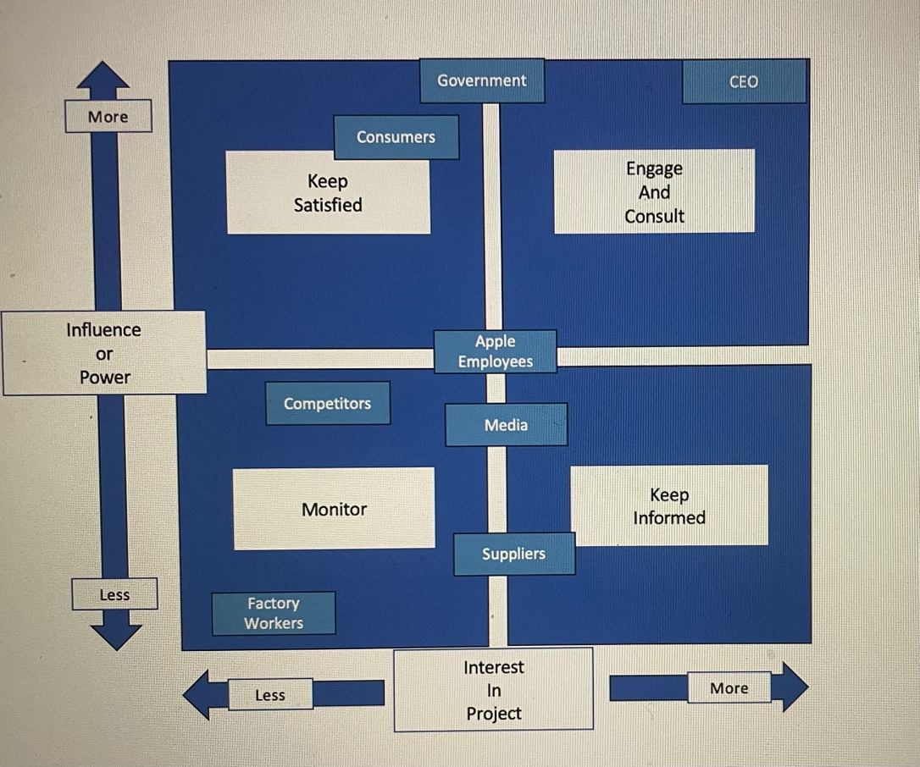

Conclusion

Apple should be able to thrive even with all of the uncertainties due to their ability to adapt to the changing environment. The capabilities of their research and development department gives them an advantage over many other companies to grow for decades to come.

Bibliography
Apple. (2023). About Apple. Retrieved November 28, 2023 , from Apple: https://www.apple.com/uk/legal/
Dudovskiy, J. (2023, July 3). Apple Business Strategy: a brief overview. Retrieved December 1, 2023, from Business Research Methodology: https://research-methodology.net/apple-business-strategy/#
Harvard Business School. (2022). Strategy Explained. Retrieved December 1, 2023, from Harvard Business School: https://www.isc.hbs.edu/strategy/Pages/strategy-explained.aspx#:~:text=Michael%20Porter%27s%20frameworks%20help%20explain,which%20it%20will%20be%20based.
Heracleous , L. (2015, November 10). The Secret Behind Apple's Strategy - Quantrum Stratergy. Retrieved December 2, 2023, from Warwick Business School: https://www.wbs.ac.uk/news/the-secret-behind-apple-s-strategy-quantum-strategy/
Indeed. (2022, June 25). What is emergent strategy? Retrieved December 1, 2023, from Indeed: https://www.indeed.com/career-advice/career-development/emergent-strategy-definition#:~:text=Emergent%20strategy%20is%20an%20action,a%20pattern%20in%20its%20habits.
Indeed. (2023, July 28). What is a Stakholder Matrix? Retrieved December 4, 2023, from Indeed: https://www.indeed.com/career-advice/career-development/stakeholder-matrix
Khalid, M. A., & Vida, V. (2023). Strategic Marketing Plan for Apple Inc. Network Intelligence Studies, 61 - 74.
Linzmayer, O. W. (2004). Apple Confidential - The Definitive History of the Worlds Most Colourful Company. USA: William Pollock.
Mind Tools. (2023). SWOT Analysis. Retrieved November 30, 2023, from Mind Tools: https://www.mindtools.com/amtbj63/swot-analysis
Moore, K. (2011, November). The Emergent Way: How to achieve meaningful growth in an era of flat growth. Retrieved November 29, 2023, from Ivey business journal: https://iveybusinessjournal.com/publication/the-emergent-way-how-to-achieve-meaningful-growth-in-an-era-of-flat-growth/#:~:text=According%20to%20Henry%20Mintzberg%2C%20emergent,learning%20what%20works%20in%20practice.
Ogedengbe, B. (2021, November 29). A Strategic Analysis of Apple Inc. Retrieved December 2, 2023, from LinkedIn: https://www.linkedin.com/pulse/strategic-analysis-apple-inc-bidemi-ogedengbe/
On Strategy. (2022, December 2). What is PESTLE Analysis? A Complete Guide. Retrieved December 4, 2023, from On Strategy: https://onstrategyhq.com/resources/pestle-analysis/
Podolny , J. M., & Hansen , M. T. (2020, November). How Apple is Organized for Innovation. Retrieved December 2, 2023, from Harvard Business Review: https://hbr.org/2020/11/how-apple-is-organized-for-innovation
Porter, M. E. (1985 ). Technology and competitive advantage. The journal of business strategy , 60-78.
Richardson, A. (2008, April). The Founding of Apple Computer, Inc. Retrieved November 27, 2023, from Library of Congrerss: https://guides.loc.gov/this-month-in-business-history/april/apple-computer-founded
Simic, N., & Jovicic, T. (2023, May 19). Fundamental Analysis of the Apple Compnay. International Scientific Conference on Economic and Social Development, pp. 97 - 106.
Smith, J. (2023, August 5). Apple Inc. History, Impacts and Facts. Retrieved December 2, 2023, from Study.com: https://study.com/academy/lesson/apple-inc-history-products-facts-company.html
Wright, G. (2023, June). Apple. Retrieved November 27, 2023, from Tech Target: https://www.techtarget.com/whatis/definition/Apple

