Word Count – 4269

Report

Introduction
This report is prepared for the senior management team to provide details and examples of how evidence-based practice and the ability to think critically can contribute to the success of our organisation. ‘The goal is to make better, more effective decisions to help organisations achieve their goals’ (CIPD, 2023). It will also include methods and best practice examples. Additionally, the report will include analysis of example people data and make relevant recommendations.
Evidence Based Practice (AC 1.1)
“The faster you make a decision the worse it is going to be. It’s that simple.” (Briner, 2015). This statement by Rob Briner, a leading professor in both psychology and HR suggests that every organisational decision should be made by using evidence-based practice such as the Six A’s. Following such practice can contribute to well informed decisions, making “conscientious, explicit, and judicious use of different sources of information” to make correct choices. (HR Magazine, 2015).
The 6 steps of evidence-based practice include- asking, acquiring, appraising, aggregating, applying and assessing. There is evidence to suggest that critical thinking can be achieved by practicing these 6 steps.
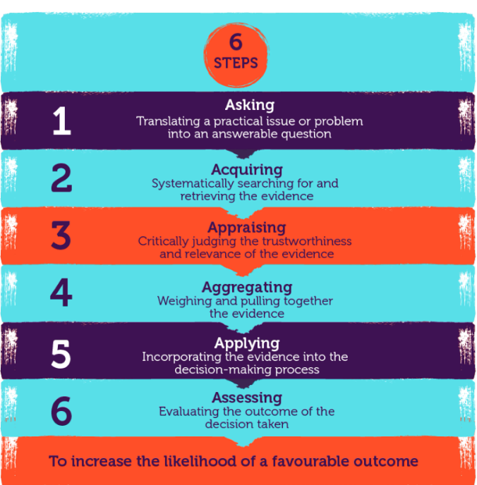
Figure: The Six Steps to evidence-based practice (CIPD 2023)
It’s important for decision makers to challenge and probe the information in front of them using the 6 As for the evidence to be the best available. Ensuring the evidence is as good as possible ensures the right decision can be made.
Evidence based practice simply sets out to reduce reliance on wisdom and experiences. It challenges professionals to think critically, critiquing and questioning the information available to come to the best answer and solution. It’s not always about reaching the perfect conclusion but to satisfy the business that the best and better informed decision has been reached through the act of evidence based practice.
The four sources of evidence for people professionals are Professional expertise, Scientific literature organisational data and stakeholder views. By considering these 4 categories of information then following the 6 steps, there is a likely chance of reaching a credible and effective decision. (CIPD, 2023).
That’s not to say that people practitioners need to become skilled researchers – for many challenges that need an answer, collaboration is key. Group thinking has great advantages and can ensure unconscious biases and preconceived ideas don’t sneak into the decision-making process. Collaboration and involving other can also ensure that we test arguments and conclusions before making the final decision. Onboarding a data specialist or a researcher to work alongside stakeholders and HR managers can be beneficial when exploring how to correctly dissect and solve a business problem.
The implications of not using evidence-based practice to drive decisions can be costly, both in terms of people cost e.g. poor morale, loss of confidence in management, wellbeing but also financially as people actions almost always affect business results (or the bottom line). If the problem is very important to the business, it’s always worth investing time to develop a better understanding of what’s happening and what we can do about it (Briner, 2023)

Analysis Tools and Methods (AC1.2)
There are many analysis tools available to professionals that are proven to assist with recognising and diagnosing issues such as PESTLE, DESTEP, Porter’s Five Forces, SWOT analysis and fishbone analysis. All are universally recognised and whilst they are used widely and have many advantages, they are not without their limitations.

The pestle tool is a simple framework that facilitates an understanding of the wider business environment (CIPD, nd). PESTEL is an acronym for Political, Economic, Social, Technological, Legal, and Environment. It addresses six environmental influences and helps organisations understand how these may impact their business performance, thus allowing them to react and strategise effectively to avoid or exploit opportunity. The disadvantages of a pestle include the potential risk of capturing too much data or using insufficient data. It is also very much a snapshot in time which means to be effective, it needs to be repeated on a regular basis. Doing a PESTLE analysis regularly can help spot trends early and give the organisation a chance to stay ahead of competitors.

The six environmental sections are illustrated below
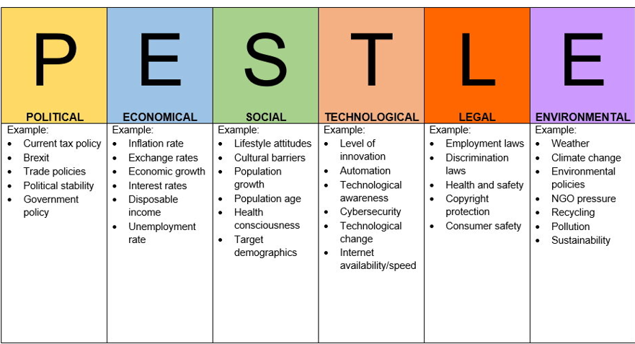
Diagram: (Impact Innovation, 2022)

The CIPD factsheet outlines useful tips on how to conduct a successful PESTLE, these include the need to collaborate, utilise expertise and resource within the organisation, consider using PESTLE alongside another analysis tool, incorporating the PESTLE info an ongoing process to monitor changes in the business environment and avoid jumping to conclusions. It is also important to assess all six of the factors and avoid moving forward from one quickly. Once the assessment is complete, best practice includes writing a paper for stakeholders for discussion and determine what action needs to be taken or trend monitored etc.

On top of analysis tools, people practitioners can use various methods to diagnose issues, challenges and opportunities. Examples of analysis methods include interviews, observations, job analysis, questionnaires, surveys and work sampling. People analytics is also a popular and highly effective analysis method when solving business problems. People data can be data from HR systems, IT systems, salary data or surveys for example. Businesses use the insight from people data to drive operational change (CIPD, 2022). People analytics are important as it enables organisations to drive change not only to enhance wellbeing, DEI and performance for example but also understand financial and social returns of any change initiative that may have been made. People analytics should align to both the business and people strategy. When done well the strategy should connect people data with business data to inform leaders and facilitate decision making, enable the implementation of people practices and measure their effectiveness in delivering against its people objectives (CIPD, 2022).

Critical Thinking (AC1.3)
Critical thinking has many definitions, but at its core it’s the ability to think well and appraise individual and group ideas, opinions and arguments so that we solve problems successfully, make better decisions and create more value, together. (www.linkedin.com, n.d.)

Critical thinking is a skill required of people professionals so that they can carefully evaluate and analyse the information given to them. It’s the ability to differentiate between fact and fiction or opinion, critiquing the evidence and information and ensuring that no biases or assumptions are influencing the decisions we make. It’s about asking who wrote the evidence? Who commissioned it? Are there conflicts of interest? We should never just take evidence on trust even if it’s from a seasoned professional, an academic expert, a management guru, a well-established consultancy firm, or a leading management journal. Likewise we should not dismiss evidence if it contradicts or challenges our existing beliefs. (Briner, HR Magazine, 2015)

Warren Howlett outlines three key parts to critical thinking in his CIPD Podcast (2019), he defines critical thinking as the ability to think well and to critically reflect on the ideas, opinions and arguments of others. He explains the need to critique, to construct arguments and opinions and communicate these well and thirdly, to understand when others are using critical thinking techniques. Identifying when others are thinking critically can ensure that you’re on a level playing field and ensure that the conversation is not distracted or that common errors are being made.

Critical thinking doesn’t come naturally to all; it takes practice. The ability to evaluate and question evidence for biases or inaccuracies, awareness of personal agendas, moving past personal experiences or an attitude of ‘its worked before, so why not again’ etc. It demands the use of other cognitive acts such as imagination, creativity, and insights. Critical thinking means looking at both sides and testing the ideas.

CIPD’s article on How to Write a Critical Review (CIPD, 2016) concludes that ‘A critical review evaluates the strengths and weaknesses of an item’s ideas and content. It provides description, analysis and interpretation that assess the item’s value. It’s an exercise that can be carried out on many different types of writing, but is most often carried out on a report, a book or a journal article.’ This is what critical thinking aims to achieve.

Aristole said ‘It is the mark of an educated mind to be able to entertain a thought without accepting it. (www.goodreads.com, n.d.).

Decision Making Processes (AC1.4)
Making effective decisions as a manager is one of the biggest challenges in a fast-moving world (CMI, 2020). CMI also outlines 10 steps that form a decision-making checklist that includes scoping the decision appropriately, consider the impact, decide who needs to be involved, define the issue, account for uncertainty, gather contributions, use decision making tools, watch out for biases, communicate effectively, and monitor the outcomes.

On top of this useful checklist, there are numerous decision-making processes that can assist with coming to the right decision and solution.

De Bono’s ‘Six thinking hats’ encourages the investigating of an issue from six perspectives or ‘hats’. This tried and tested approach (first published in 1985) ensures that six perspectives are considered. It encourages the team to move away from instinctive or biased decisions without having to argue their case or make a snap decision. The Six Thinking Hats technique looks at a problem in six different ways. It takes the team beyond any instinctive positions, so that they explore a range of perspectives. That way, careful consideration of each one can be achieved….. (Mindtools, 2022). The idea of this process is that by the end of the activity, you have a ‘rich insight’ of perspectives. By being this thorough, it promotes curiosity and ensures that every angle has been considered.
Another effective decision-making process is Action learning. The idea behind Action Learning Sets is that adults learn best when they can talk with one-another, reflect, and plan Tell me and I forget. Teach me and I remember. Involve me and I learn. – Benjamin Franklin, American statesman and inventor. (Mindtools 2023). Action learning brings together a group of people to think about a problem, try out solutions and discuss and question the results. The role of facilitator is assigned to a group member. The action learning process encourages dialogue, collaboration and teamwork. (CFI, 2022).

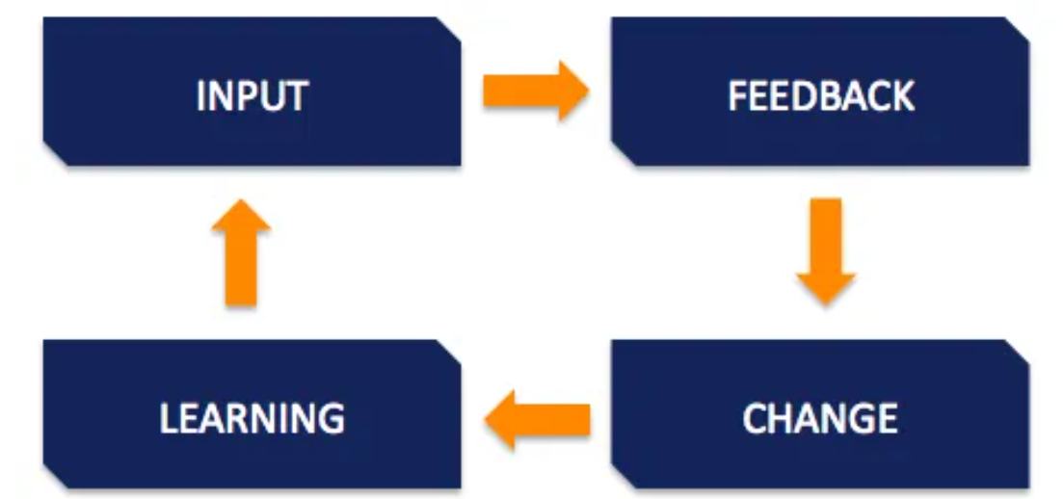
Diagram: (CFI, 2022).

The Problem Outcome Frame is a framework based on the idea that resolving workplace problems requires a systematic approach to understand the root cause, gather relevant information, and identify the best possible solution. (Anon, nd). There is a fixed structure with a view of ensuring the concluding solution is effective and sustainable. This is done in 4 steps and the intention is that the colleagues involved identify the underlying issues before determining next steps.

Ethical Perspective (AC 1.5)
Having an awareness of the various ethical perspectives can help decision makers day to day and ensure that their decisions aren’t influenced by personal beliefs and moral standards. Everyday people issues such as recruitment and selection and performance management demand decision making and it’s important to remember that everyone has an ethical perspective, whether they realise it or not. The ethical perspective is often referred to as the ‘lens’ used to view a problem. Ethics can impact on management styles and decisions and consequently the organisation’s culture and strategy.
An organisation that can demonstrate sound ethical practice can expect to benefit from improved morale (due to the open culture promoted through ethics), good relationships with customers which leads to a positive reputation and outperform their competitors financially (CIPD, 2022).
Below are three different ethical theories:
Deontological - focus on rules and obligations and the deontologists in the workplace will emphasise the morale rule or their duty to help whatever the situation.
Consequential – focuses on consequences of actions. Consequentialists will point to the good consequences that arises for everyone when helping one another.
Virtue – focuses on how our behaviour will make us feel and how we should aspire to be the best people.
The CIPD report in 2015 introduced eight lenses or possible ways of thinking that should be applied to workplace dilemmas. These lenses shouldn’t be considered right or wrong but essentially offer different perspective on any workplace dilemma.
- The Fairness Lens – everyone should be able to agree to it
- The Merit Lens – Jobs and reward should track talent and hard work
- The Markets Lens – Jobs and Rewards should follow from voluntary market exchanges
- The Democracy Lens- Everyone should have a say
- The Well-being Lens- Work should be good for us
- The Rights and Duties lens- everyone has a right to do some things and be free of some things. Everyone has a duty not to violate others rights.
- The Character Lens- everyone should work to develop the best ethical character for our roles
- The Handing Down Lens – the responsibility of maintaining the small parts we are responsible for and passing it undamaged to our descendants.
Understanding the different ethical perspectives that exists and demonstrating a sensitivity towards them when navigating an organisation’s problems should result in the right decision and culture being achieved. All HR professionals should be familiar with the CIPD code of conduct – this address ethical standards and integrity which should be abided.

Measuring Financial and Non-Financial Performance (AC3.1)
When understanding the performance of an organisation, it’s important to review both financial and non-financial measures to really understand the organisations strengths and weaknesses and direction of travel.
Understanding the numbers can help the business with making better decisions. A people professional with an understanding of financial accounting can take steps to provide additional value (Stobierski, 2020). A popular financial measure is the KPIs (Key performance indicators). A set of metrics that track, measure and analyse the financial performance of a company. These KPIs can be personalised and can be shared amongst management on a regular basis by way of emails or dashboards. A big advantage of financial measures is that they are accurate and can be monitored and updated with ease. Departments can also tailor their objectives and TOMs around these recognised KPIs. The biggest disadvantage with any set of numbers is that they are short –term in nature, they’re sometimes without external context and are not effective for implementing into a long term strategy.
Non-financial measures can fill the gaps that financial measures leave. Together, they provide a fuller picture. A tried and tested example of non-financial performance measures for many businesses is customer feedback. Retaining customers in an indicator that the business is performing well. Loyal (retained) customers are as valuable as new business. Customer feedback can be gathered in many ways such as surveys, email feedback links immediately following a service aswell as activities such as contacting customers directly following an expression of dissatisfaction etc. The advantages are clear; customer feedback can ‘empower positive change in any business — even (and especially) when it’s negative.’ (Help Scout, 2019). Other advantages include the ability to conduct a deep dive into the feedback and really understand any issues- this is often missing when reviewing financial measures. The disadvantage to such activities is that often they are considered time consuming and costly in terms of resource.
Colleague feedback is also golden when understanding the company’s performance. Low attrition and absence rates can be positive indicators (quantitative measures) but feedback from surveys and focus groups can help create a culture of open communication, where employees are comfortable sharing their opinions and ideas (Culture Monkey, 2023). Colleagues who feel heard will enjoy their work more ‘People who like what they do, do it better’ (Pyke, 2016). It’s important to act on feedback; Failure to do so will result in a loss of faith and have a knock-on effect on the company culture which in turn can lead to a lack of engagement, amongst other things.

People Practices and their Value (AC 3.2)

People practices are the processes and approaches that we use across the employee lifecycle. Learning needs analysis, creating talent pools, developing people policies, analysing people data, managing grievances, recruiting people: all these are examples of people practices (CIPD, 2023). The impact of getting these practices wrong can be catastrophic to morale, wellbeing, productivity and attritions for example, which can affect the company’s financial performance (profit and loss accounts).
It is important to measure the success of our people initiatives. Not only to ensure objectives are met but to justify any financial spend, identify further gaps or issues and to generally continually improve the people picture. There are many ways the impact of people practices can be measured.
Methods – Evaluation tools e.g. staff satisfaction surveys. In recent years, topics such as hybrid working has attracted great interest and there’s a genuine need for businesses to get it right. People practices are integral to the success of a hybrid working policy. The people department act as the intermediary between management and workers, they are also responsible for making sure both parties feel heard and understood. Complaints and concerns can be passed through HR to ensure that the best outcome is found, and heightened emotions don’t interfere with business decisions (Hurst, 2021). A successful hybrid working people practice would result in a motivated workforce that felt supported regardless of their place of work. Colleagues would feel confidence in their company, be enthusiastic and feel listened to. With increased job satisfaction comes other benefits such as attracting further talent and a reduction in leavers. These are all indicators of a great company culture.
Another method for measuring the impact of a people practice would be a cost benefit analysis. For example, determining whether increasing headcount and hiring new staff was a success. This can be done by revisiting the issue or challenge that prompted the decision to hire more staff. Was the customer satisfaction rate too low resulting in customers leaving? Was the call answer rate a concern resulting in dissatisfaction, an increase in complaints and compensation payments? Understanding the investment made versus the financial savings made would give you a simple calculation of the ROI in financial terms. There would however also be non-financial benefits to an initiative like this for example, an increase in staff wellbeing, a rejuvenated staff morale and energised workforce.
People practices are vitally important to the success of an organisation; ‘as HR professionals and managers, we are making decisions that impact on people’s lives. When we make a major decision, we should make it to the best of our ability. (Jacobs 2015)

Analysing Data, Identifying trends and making recommendations
In this section, you will see both quantitative (numerical) and qualitative (narrative feedback) data being reviewed. I have utilised Microsoft Excel to analyse Equality, Diversity, Inclusion and Salary data. I have used various diagrams (graphs) to present the data in an appropriate. For both data sets, I have provided commentary and recommendations. Research suggests that using both methods is considered a useful exercise when understanding a question that needs answering. It provides a more ‘in depth’ finding. This approach is called a mixed methods approach (GOV.UK 2020). (AC 2.1)
(AC 2.2)

Graph 1. Illustrates % of each Gender by type. It establishes that whilst most staff identify as Male (53.85%), there is only a few % difference between male and female (45.38%). Non-binary (0.77%) colleagues make up less than 1% of the population so are therefore severely underrepresented.

Graph 2. Shows total ethnicity as a % by team. Despite 8 categories being listed, the data shows that most colleagues identify as White British.

Graph 3. Summarises the number of colleagues who are disabled as a % and split by teams. The IT team have the most disabled colleagues at 22.2%. 7 of 18 Teams are noted to have no disabled members.

Graph 4. Shows that only 8.08% of the workplace are classed as disabled.

Graph 5. Depicts average FTE salary by Team. It is not a surprise to see the Directors Team with the highest average salary. The Green Spaces teams earn the lowest average salary.

Graph 6. This scatter diagram shows salary difference across genders. This type of diagram is useful to demonstrate non-linear patterns.
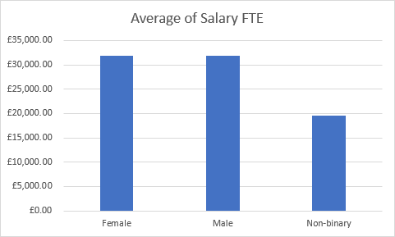
Graph 7: Illustrates average salary based on Gender type. The average salary for both male and females are similar.
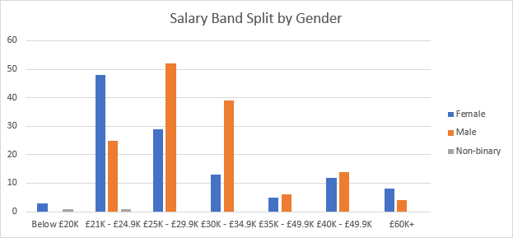
Graph 8: Groups together salary bandings showing how each Gender type is represented within the bands. It shows most Females earn between £21-£24.9k whilst Males sit in the £25-£29.9k band. The Nonbinary colleagues sit in the £20- £24.9k bandings.
Recommendations (AC 2.3)
There should be a regular review of the company’s DEI (diversity, equality, and inclusion) policy – we must ensure the culture is one where colleagues can be open and honest about their health and disabilities. Not only is it important for people managers to be familiar with People Policies, they should also be aware of their legal obligations under the Equality Act 2010. This act provides legal protection for nine protected characteristics. A robust EDI strategy will add value to an organisation, contribute to the wellbeing and equality of outcomes and impact on all employees (CIPD 2022). CIPD research suggests that having a diverse workforce can aid decision making, innovation and solving problems as colleagues tap into their varied experiences and backgrounds on offer. A culture where colleagues feel safe and empowered is important. Feedback from employees with disabilities and long-term conditions is useful in developing an open and inclusive workplace culture (CIPD 2023). Failure to achieve this can result in reputational damage and a loss of talent as those who don’t feel heard exit the business. A high attrition rate can result in high recruitment costs etc.
The data analysed suggests that there is a distinct lack of diversity in respect of ethnicity in certain teams. Articles such as those written by Nadia Nagamootoo, founder and CEO of Avenir consulting services provides useful tips and advice around creating a supportive environment for ethnic minorities which included developing senior leaders, sending them on inclusive leadership programmes, educating all staff on racism even in its subtlest forms and creating an employee resource group for people to come together and share and signposting a curiosity for learning more (CIPD People Magazine 2023).
The data in relation to salary suggests that there is a Gender pay gap in many areas of the business. A gender pay gap report is recommended on an annual basis and a strategy created to tackle any issue. Discriminating can not only sour a company culture and limit its achievements, it can also result in costs (legal, compensation, settlements) when claims of discrimination are made against the company (CIPD 2022).
This qualitative data depicts results from a hybrid working practice survey conducted in a sample of 300 employees. Caution should be applied when taking these results at face value as there appears to be some potential errors in the table data e.g question 10 with 301 responses.
On face value, the strongly disagree response was most popular over the question set of 14 questions. However, these survey results are a little conflicting and could be summarised that there appears to be some potential people issues with the hybrid pattern that’s currently being used with the data responses suggesting that working from home affects functional communication and collaboration and can cause causing colleagues to struggle with meeting targets.
There are also some wellbeing concerns raised in these survey results with colleagues suggesting they struggle with accessing resource and don’t feel sully supported when working from home. I would suggest that all people managers are provided training on how to manage in a hybrid world. The organisation must enable and empower managers to support in all environments. Training such as emotional intelligence training will help managers with understanding potential issues betrayed by body language etc. The cost associated with this does not have to be high; training can include real case scenarios and can be online, reducing time and cost involved. Failure to roll out such training could result in the organisation’s culture coming under threat, along with consequences such as a dip in morale and productivity (because colleagues feel unsupported or unimportant) and absence or attrition increases which are undoubtedly costly for any business. Doing this well will benefit the organisation and employees alike. The organisation’s wellbeing strategy should be reviewed to ensure that its accessible to all, from the office and from the home office. Failure to create a holistic and accessible wellbeing strategy can be catastrophic to the business. The business has a responsibility to their staff, regardless of where their place of work is. “You bring your whole self to work. Now that everything is intertwined, it’s connected you even more with your employer. Organisations have a responsibility to take care of their employees further than just providing a safe workplace and ensuring your desk is at the right height” (HRD, 2022).
Consideration should also be given to the potential of analysing People data reports to review such as absence data, KPIs or attrition data would be useful, to establish whether the quantitative data in Table 2 reflects the same potential trends.
I would recommend that management consider management use alternative information gathering methods such as focus groups or interviews are used in order to learn more and to drill down into understand the real story behind the survey responses. In future surveys, thought should be given to providing a free text box for colleagues to leave specific feedback.
There are clear advantages of offering hybrid working which include attracting and retaining talent, reducing estate and facilities cost, enabling wellbeing, and supporting inclusion and diversity (CIPD 2023) therefore it’s important that more consideration and research is given to this topic to better improve the current hybrid working policies.
Summary
This report outlines the importance of critical thinking and how evidence-based decisions can benefit business strategy and people practices. In CIPD’s Podcast, Tim Coburn (CIPD 2019) summarised that People professionals should have the ability to think well, think clearly, and have diverse considerations to reach conclusions that take people with you. This is the objective that every people practitioner aims to achieve in their critical thinking and quest for evidence-based decisions.

Reference List
Anon, (n.d.). Discuss Problem Outcome Frame HR. [online] Available at: https://cipdforum.co.uk/forums/topic/discuss-problem-outcome-frame-hr/#:~:text=The%20problem%20outcome%20frame%20is.

Barends, E., Rousseau, D.M., & Briner, R.B. (2014). Evidence Based Management: The Basic Principles. Amsterdam: Centre for Evidence- based management.
Briner, R. (2023). Aligning HR with the business through the evidence-based HR process. [online] HRD. Available at: https://www.hrdconnect.com/2023/10/03/aligning-hr-with-the-business-through-the-evidence-based-hr-process/.

CFI (2022). Action Learning. [online] Corporate Finance Institute. Available at: https://corporatefinanceinstitute.com/resources/elearning/action-learning/.

CIPD. (2022). CIPD | On this page. [online] Available at: https://www.cipd.org/uk/knowledge/factsheets/ethics-role-hr-factsheet/#why-is-ethical-practice-important.

CIPD (2019). CIPD | Critical thinking | Podcast. [online] CIPD. Available at: https://www.cipd.org/uk/knowledge/podcasts/critical-thinking/.

CIPD. (n.d.). CIPD | Equality, diversity and inclusion in the Workplace | Factsheets. [online] Available at: https://www.cipd.org/uk/knowledge/factsheets/diversity-factsheet/#:~:text=As%20well%20as%20designing%20appropriate [Accessed 23 Nov. 2023].

CIPD (2015). Ethical decision-making: Eight Perspectives on Workplace Dilemmas. [online] Available at: https://www.cipd.org/globalassets/media/comms/the-people-profession/profession-map-pdfs/ethical-decision-making-2015-eight-perspectives-on-workplace-dilemmas_tcm29-9564.pdf.

CIPD (2023). CIPD | Evidence-based HR: Make better decisions and step up your influence. [online] CIPD. Available at: https://www.cipd.org/uk/knowledge/guides/evidence-based-profession/.

‌ CIPD. (2022). CIPD | Explore our related content. [online] Available at: https://www.cipd.org/uk/knowledge/guides/planning-hybrid-working/.

CIPD. (2021). CIPD | Getting started with people analytics. [online] Available at: https://www.cipd.org/uk/knowledge/guides/analytics-practitioner-guide/.

CIPD (2022). CIPD | Pay Fairness & Pay Reporting | Factsheets. [online] CIPD. Available at: https://www.cipd.org/uk/knowledge/factsheets/pay-fairness-reporting-factsheet/.

‌ CIPD. (2022). CIPD | People Analytics | Factsheets. [online] Available at: https://www.cipd.org/uk/knowledge/factsheets/analytics-factsheet/#three.

CIPD. (n.d.). CIPD | PESTLE Analysis. [online] Available at: https://www.cipd.org/uk/knowledge/factsheets/pestle-analysis-factsheet/#:~:text=A%20PESTLE%20analysis%20can%20help.

CIPD (2023). CIPD | The Profession Map / Core knowledge / People practice. [online] CIPD. Available at: https://www.cipd.org/uk/the-people-profession/the-profession-map/explore-the-profession-map/core-knowledge/people-practice/#:~:text=People%20practices%20are%20the%20processes.
‌CMI (2020). Decision Making. [online] CMI. Available at: https://www.managers.org.uk/knowledge-and-insights/resource/decision-making/.
CultureMonkey. (2023). How to gather employee feedback in 2023. [online] Available at: https://www.culturemonkey.io/employee-engagement/how-to-gather-employee-feedback/#:~:text=This%20can%20help%20to%20create [Accessed 24 Nov. 2023].

Elder, S.R. and October 2023, M.N. 31 (n.d.). Considering the application and relevance of evidence-based HR. [online] www.peoplemanagement.co.uk. Available at: https://www.peoplemanagement.co.uk/article/1845833/considering-application-relevance-evidence-based-hr.

‌GOV.UK (2020). Mixed methods study. [online] GOV.UK. Available at: https://www.gov.uk/guidance/mixed-methods-study#:~:text=A%20mixed%20methods%20study%20combines.

HRD. (2022). Wellbeing in the hybrid workplace: how to successfully drive engagement. [online] Available at: https://www.hrdconnect.com/2022/01/20/wellbeing-in-the-hybrid-workplace-how-to-successfully-drive-engagement/.
‌‌Help Scout (2019). Customer Feedback: Why It’s Important + 7 Ways to Collect It - Help Scout. [online] Helpscout.com. Available at: https://www.helpscout.com/blog/customer-feedback/#:~:text=Customer%20feedback%20is%20the%20information.

HR Magazine. (2015). HR Magazine - What’s the evidence for... Evidence-based HR? [online] Available at: https://www.hrmagazine.co.uk/content/features/whats-the-evidence-for-evidence-based-hr/#:~:text=There%20are%20four%3A%20professional%20experience [Accessed 26 Nov. 2023].

HR Magazine. (2015). HR Magazine - Rob Briner: Spend longer on evidence-based decision-making. [online] Available at: https://www.hrmagazine.co.uk/content/features/rob-briner-spend-longer-on-evidence-based-decision-making/#:~:text=Briner%20broke%20down%20evidence%2Dbased [Accessed 26 Nov. 2023].

Hurst, J. (2021). How does HR add value? [online] Real Business. Available at: https://realbusiness.co.uk/hr-add-value.

‌Impact Innovation (2022). PESTLE Analysis. [online] Impact Innovation & Growth Services Ltd. Business Management Consultants in Wales. Tel: 01633 215545. Available at: https://www.impact-innovation.co.uk/pestle-analysis.

‌Jacobs, K. (2015). HR Magazine - Evidence-based HR in practice. [online] HR Magazine. Available at: https://www.hrmagazine.co.uk/content/features/evidence-based-hr-in-practice.

www.linkedin.com. (n.d.). How Critical is Your HR Thinking? [online] Available at: https://www.linkedin.com/pulse/how-critical-your-hr-thinking-warren-howlett/.
‌Miller, J. (2022). CIPD | Disability & Employment | Factsheets. [online] CIPD. Available at: https://www.cipd.org/uk/knowledge/factsheets/disability-discrimination-factsheet/.
MindTools (2022). Six Thinking Hats . [online] www.mindtools.com. Available at: https://www.mindtools.com/ajlpp1e/six-thinking-hats.

Mindtools (2023). MindTools | Home. [online] www.mindtools.com. Available at: https://www.mindtools.com/anbk5zv/action-learning-sets.

Nagamootoo, N. (2023). Dear Problem Solvers. PM People Management, Nov., p58.

Pyke, C. (2016). The Henry-isms that helped Admiral become so successful. [online] WalesOnline. Available at: https://www.walesonline.co.uk/business/business-news/22-henry-isms-helped-admiral-11321989.

‌ Stobierski, T. (2020). 13 Financial Performance Measures Managers Should Monitor | HBS Online. [online] Harvard Business School Online. Available at: https://online.hbs.edu/blog/post/financial-performance-measures.
www.goodreads.com. (n.d.). A quote from Metaphysics. [online] Available at: https://www.goodreads.com/quotes/1629-it-is-the-mark-of-an-educated-mind-to-be#:~:text=Sign%20Up%20Now- [Accessed 25 Nov. 2023].

