

Digital Skills for Personal and Professional Growth
BMSW4008

Evidence of Learning (E-Portfolio)

Prepared by: Salsabeel Ali Islam
2330870

Contents
Task 1 - Questionnaire Analysis 4
Introduction 4
Importance of Supporting Charitable Businesses 4
Choosing a Business Based on Charitable Contributions 5
Ideal Percentage of Revenue for Charitable Contributions 5
Willingness to Pay More for a Charitable Cause 6
Conclusion 7
Task 2 - Design of the Website and Marketing Materials. 8
Introduction 8
Segmentation 8
Ethically Conscious Consumers 8
Neutral Consumers 9
SEO Optimization 9
Keyword Integration 9
Content Relevance 10
User Experience 10
Conclusion 10
Task 3 - Financial Projection at Microsoft Excel and Essay 11
Task 4 – Paragraph for Video 13
References 14
Task - 1 14
Task - 2 14
Task - 3 15
Task - 4 16
Appendix 17
Task 1 – Questionnaire 17
Task 2 – Design of the Website and Marketing Materials. 21
Website Images 21
Marketing Materials 22
Task 3 - Financial Projection at Microsoft Excel and Essay 24
Financial Projections 24
Bar Chart 25
Task 4 - Video of the brand 25

Task 1 - Questionnaire Analysis

Introduction
The survey data was being collected from 24 respondents which offers important information about their perceptions and behaviors regarding businesses that donate a portion of their revenue for treatment of spinal cord injuries as a charity in UK. The most significant findings based on the responses are the answers to four key question which are considered to be as follows:

Importance of Supporting Charitable Businesses
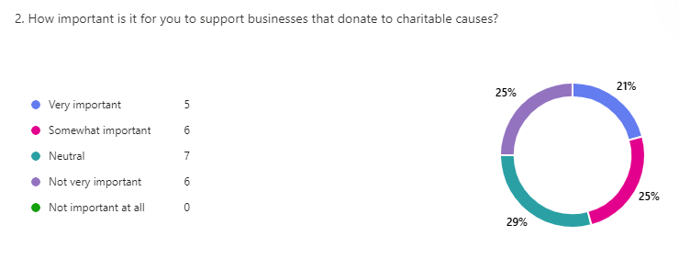
Figure 1.1: responses to question 2 of the questionnaire
Survey results show a varied consumer perspective on supporting businesses that contribute to charitable causes. A bigger chunk of the of respondents thinks that it is important or somewhat important whereas 29% are neutral and 25% believe it is not very important. In particular, none of the respondents stated that charitable contributions were of no importance at all. Accordingly, this implies that while philanthropy is considered a good thing, it is not a driving force behind consumer decision making. Bardos et al. (2020) also supports this finding, which shows that consumers value CSR, but they usually focus on product quality, affordability and brand trust (Bello et al., 2021). Social Responsibility can elevate the brand image and customer loyalty as being stated by Carroll and Shabana (2010) however it is certainly no argument for giving up on key core business values. It has also been found by Chang and Chen (2019) that customers prefer flexibility in charitable giving over a mandatory price increase. Hence while charitable donations differentiate a brand, they should be part of a larger marketing and operations strategy that focuses on prioritizing customers’ preferences and the sustainability of the business.

Choosing a Business Based on Charitable Contributions
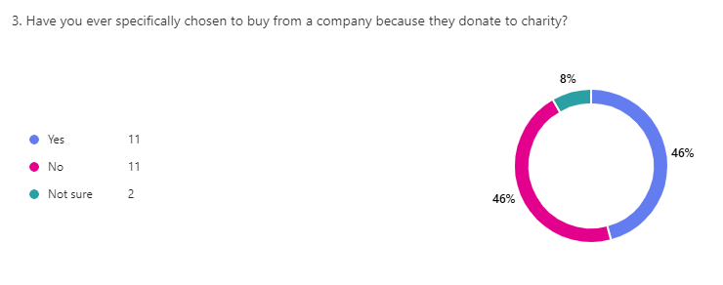
Figure 1.2: responses to question 3 of the questionnaire
Consumers are nearly split in half according to the survey when it comes to whether or not they have specifically chosen to buy from a company because it donates to charity. Respondents are equally distributed among such a decision however 8% were unsure. This said, charitable giving should not be used as a primary marketing tool, but rather as a supplementary one. Accordingly, those CSR initiatives that are most effective are integrated with some other compelling value propositions, like superior product offerings and strong brand identity (Sharma, 2019).

Ideal Percentage of Revenue for Charitable Contributions
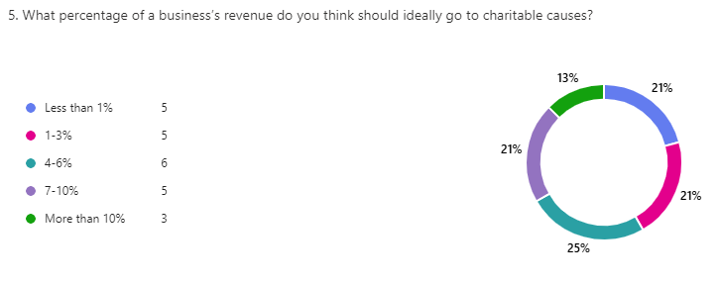
Figure 1.3: responses to question 5 of the questionnaire
The responses to the survey are varied in this context as 67% of respondents felt that businesses should contribute between 1 and 6 percent, with 25 percent of respondents in the 4-6 percent range. At the same time, another group of 34% considering that more than 7-10% or more than that should be contributed. The findings from this data imply that consumers value the corporate philanthropy, but also do not expect businesses to donate to the extent that it threatens the business’s financial sustainability. In line with this research on corporate social responsibility (CSR), it is found that moderate and well communicated charitable contributions can strengthen the brand with loyalty and consumer trust while not harming profitability (Cho et al., 2019). Furthermore, consumers tend to be suspicious of too much donations because they doubt whether such donations are genuine or just a marketing gimmick (Chakraborty and Jha, 2019). For businesses that want to incorporate charity into their business model, the 1-6% range of contribution appears strategically and financially sustainable.

Willingness to Pay More for a Charitable Cause
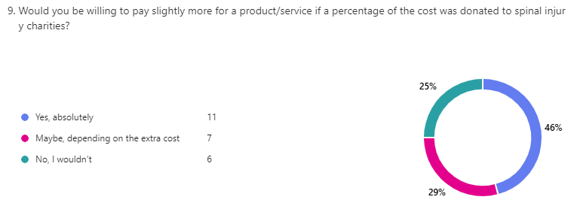
Figure 1.4: responses to question 9 of the questionnaire
The survey results show that a good proportion of respondents are willing to pay a bit more for a product or service if a certain percentage of the cost is donated for treating spinal cord injuries as a charity. More specifically, 46% said they would be absolutely willing to pay more whereas 29% said they might pay. Nevertheless, 25% were not willing to pay any extra amount. These findings are in line with previous research that consumers typically support businesses which give charitable contributions, provided that the perceived value is above a comfortable price point (Saiia and Schwartz, 2022). The mixed response shows that companies should be very careful to strike the right pricing balance while promoting their charitable work.

Conclusion
This analysis demonstrates that while charitable giving influences consumer behavior, it is not the sole factor driving purchases. Businesses should integrate charity strategically while maintaining a strong focus on product quality, pricing, and transparency. By offering donation options, enhancing communication about impact, and collaborating with trusted charities, businesses can appeal to ethically conscious consumers without alienating those who prioritize other purchasing factors.

Task 2 - Design of the Website and Marketing Materials.

Introduction
The report deals with providing details about SPICORD which is a newly formed charitable institution dealing in helping people with spinal cord injuries. The website and marketing materials are designed after extracting and gathering insights from analysing the data of the questionnaire which was very instrumental in shaping the design and content of the website and marketing materials. Valuable information was gathered from the survey which allowed understanding the preferences and perceptions of the consumers along with their behaviour with regards to contributing towards charitable institution and supporting business that donate some percentage of their earnings to charitable institutions which are more likely to be dealing with spinal cord injuries. This summary explains how the questionnaire data was used and analysed in order to create the website and marketing materials with a focus towards understanding the target segments of the audience along with learning what key words were important for SEO optimization and developing the overall content strategy.

Segmentation
Distinct segments of the target audience were revealed through the analysis of the questionnaire out of which two segments were considered to be important and understanding these segments was important towards developing a tailored approach in both the website and marketing materials.

Ethically Conscious Consumers
A significant portion of respondents was found willing to pay more for products or services if a percentage of its cost was donated to charities dealing with treatment of spinal injuries. These 46% of the respondent’s valued transparency therefore the major aim of SPICORD is to target these consumers and marketing materials are also themed around encouraging this group to make donations and take part in charitable activities to help people with spinal cord injuries. The website highlights the services we provide and also include a call to action to encourage people to make donations. The marketing materials emphasize the positive outcomes of donations by highlighting what spinal cord injuries are and how we can make lives of such people better to build trust and credibility (Bardos et al., 2020; Cho et al., 2019).

Neutral Consumers
The analysis of the questionnaire also revealed that 29% of respondents were neutral about supporting businesses that donate to charity and that gives an idea that such a segment is not aware of the impact of spinal cord injuries which is why our marketing materials highlight what spinal cord injury is so that people learn the impact of such injuries and therefore develop a sense of responsibility to make contributions towards charitable institutions. Since this segment can be influenced by clear communication and ease of access to information therefore the website is designed to be user-friendly with easy navigation links and clear call to action buttons. The information provided through the website and the marketing materials is straightforward therefore it will make it easy for this segment to understand the value of supporting the business (Kumar et al., 2021).

SEO Optimization
Search engine optimization (SEO) is one of the critical considerations in designing a website and marketing materials due to the fact that people use keywords at google search engines or any other search engines in order to find any goods and services or anything they would like to learn about (Erdmann et al., 2022). The questionnaire data provided insights into the useful keywords and phrases that resonate with the target audience and therefore such information was utilised in order to incorporate these keywords and phrases in the website and marketing materials to improve search engine rankings and visibility.

Keyword Integration
The survey highlighted that there were three terms that were most useful for the target audience and for SEO optimisation. These three terms were "spinal cord injury charity," "corporate social responsibility," and "charitable contributions" which were also analysed through the use of google keyword planner in order to understand their search volume and competition. These keywords were strategically integrated into the content of the website. The keywords are not only used in the home page of the website which is visible for the people but has also been used in the background as meta descriptions and alt text for images. Marketing materials also incorporated these keywords to enhance their online discoverability. Hence such a SEO strategy would allow competitive way of increasing search visibility and discoverability online (Ahmad et al., 2024).

Content Relevance
The questionnaire data also revealed that transparency is very important for the consumers as 25% of the respondents were of the opinion that they would like businesses to be transparent about where and how are they channelising the charities and the impact of those charity amounts. To address this, the website includes a dedicated section on how their donations can create an impact for the affectees with our trained professionals and readily available staff to discuss their issue and help them at their convenience. This not only builds trust but also improves SEO by providing fresh and relevant content that search engines favour (Lopes and Casais, 2022).

User Experience
It has been found by Sauer et al. (2020) that ease of navigation and access to information are one of the important factors which should be incorporated in to the websites as audience are more inclined towards scanning the useful information from the landing page. Hence keeping this view in mind, the website was designed with a clean and intuitive layout in order to ensure that users can easily find the information they need. This positive user experience would contribute towards lower bounce rates and higher engagement, both of which are favourable for SEO. Hence all the important information and call to action buttons are provided on the landing page which is also the home page of the website so that people can easily find all the necessary information on the homepage to grab their attention.

Conclusion
The questionnaire data was very useful to design and creating the content for the website and marketing materials. The business effectively communicates its value proposition and charitable initiatives by segmenting the audience and tailoring the content to address specific preferences and concerns of the audience. Finally, the integration of survey insights into the website and marketing materials helps the business to be able to reach and connect with their target audience while also generating sales and support for the charitable mission of the business.

Task 3 - Financial Projection at Microsoft Excel and Essay

Importance of Excel in the Digital Era

It has been stated by Alcaraz-Martinez et al. (2024) that the current era of digital age demands businesses and individuals to treat data as one of their essential organizational assets due to the fact that critical insights can be revealed with the help of information available which will then help in devising strategies or future plans. Considering the importance of digital era, Microsoft Excel is one of the leading data management programs that is able to deliver robust capabilities in a user-friendly way in this digital age for the purpose of analysing and representing information visually which then helps organizations to become more efficient through its use. Excel not only enables business and individuals to perform financial projections with the use of sophisticated formulas but also allows them to execute inventory management tasks and complex statistical modelling which otherwise is done through other statistical programs. Hence Microsoft excel provides broad functionality together with its easy accessibility that makes it vital for financial institutions as well as every other type of organizations (Oike et al., 2019).
One of the most important functionalities of Microsoft excel is that it provides users with a system to arrange large datasets in an organised manner that remains easily accessible. There are businesses that use Excel to organize and manage the information of their employees and manage records of their customers as well. Apart from this, records of financial data are also being maintained and so are their control operations with respect to their inventory (Guerrero et al., 2019). Users can speed up their data handling operations through the combination of tools that are being provided by the software such as that of sorting data or filtering functions and providing conditional formatting capabilities. The financial records of data are maintained in a way that not only provides a snapshot of the previous years but also allows complex forecasting to understand how the business can perform over the foreseeable years. This is also performed together with budgeting as these are the most basic functions of excel. Other basic uses of excel include preparing the financial statements of the organizations which are performed through basic financial calculation formula like SUM, AVERAGE, VLOOKUP and IF statement functions. The financial spreadsheet also shows businesses how to monitor yearly revenue alongside expenses and profits which supports their strategic planning (Kaligis et al., 2023).
Apart from the basic use of excel, it also provides businesses with pivot tables and data visualization charts which enables them to make better decisions as such charts and tables simplify big dataset and provide summary of the large chunk of datasets. The charts not only include basic bar graphs or pie charts but also provides complex line graphs. Hence businesses benefit from these essential tools for their day-to-day activities and presentations which not only makes them efficient with taking their critical decisions but also gets informed of the trends and patterns in their datasets which is crucial for any business to survive.
Microsoft excel also provide automation capabilities of which include both macros as well as VBA (Visual Basic for Applications). A self-running software system enables enterprises to decrease human mistakes while saving operational hours through automation of recurring operations including data entry processes and report production and document page arrangement (Kaligis et al., 2023). The automation delivers the most benefit to large businesses which execute complex workflow systems and extensive data processing operations. Apart from this, Excel provides complete integration with different software programs through its ability to work with QuickBooks accounting applications while also supporting Salesforce CRM systems and Power BI business intelligence tools to name a few. The seamless software connectivity improves workplace operations because it enables data movement between platforms and allows users to create professional-level reports (Becker and Gould, 2019). The use of Microsoft excel is not limited to business but is also a valuable tool for academic institutions as well due to the fact that researchers depend on Excel for conducting statistical analysis and data modelling. The analytical functions including regression analysis and hypothesis testing and correlation calculations enable researchers to evaluate survey findings and experimental data as well as academic reports (Divisi et al., 2017).
Hence Microsoft excel is a well-rounded software which not only supports businesses but academics as well which highlights the great capabilities of the software therefore Microsoft excel is an essential digital tool because it provides flexible functionality together with powerful analytics features and user-friendly operation (Held et al., 2019).

Task 4 – Paragraph for Video
Storytelling telling technique on a real-life situation has been used in the video in order to engage the viewers with SPICORD which would be helpful to inspire action as storytelling is the most powerful way to put ideas forward as being stated by Mckee (1997) and Gupta and Jha (2022). A clear narrative arc is being followed in the video in order to ensure an emotional and logical flow. The problem is established in the beginning of the video highlighting that the business deals with spinal cord injuries and therefore introduces SPICORD as a solution. I appear at the start to create a personal connection in order to build credibility and engagement which was fostered through this personal presence. The middle section of the video builds an emotional connection by presenting real-life-inspired case with respect to spinal cord injury suffered by Sarah. The disruption and recognition narrative were used to highlight the transformation of the affected individual which then showed how SPICORD helped in providing the medical support and rehabilitation for Sarah. Visual storytelling is used through the footage of Sarah to reinforce authenticity (Catala et al., 2017). The resolution narrative drives the call to action urging viewers to support SPICORD in the end. The brand also remains visible throughout in order ensure strong brand association.

Link for the video: https://youtu.be/w4k30z8TT3k?si=GKjdOpF4FC4_tqRQ

References

Task - 1
Bardos, K.S., Ertugrul, M. and Gao, L.S., 2020. Corporate social responsibility, product market perception, and firm value. Journal of Corporate Finance, 62, p.101588.
Bello, K.B., Jusoh, A. and Md Nor, K., 2021. Relationships and impacts of perceived CSR, service quality, customer satisfaction and consumer rights awareness. Social responsibility journal, 17(8), pp.1116-1130.
Chakraborty, A. and Jha, A., 2019. Corporate social responsibility in marketing: a review of the state-of-the-art literature. Journal of social marketing, 9(4), pp.418-446.
Chang, C.C. and Chen, P.Y., 2019. Which maximizes donations: Charitable giving as an incentive or incentives for charitable giving?. Journal of Business Research, 97, pp.65-75.
Cho, S.J., Chung, C.Y. and Young, J., 2019. Study on the Relationship between CSR and Financial Performance. Sustainability, 11(2), p.343.
Saiia, D. and Schwartz, M.S., 2022. The continuum of strategic philanthropy: Rationalizing the context for philanthropy in business and society. Business and Society Review, 127(1), pp.3-22.
Sharma, E., 2019. A review of corporate social responsibility in developed and developing nations. Corporate Social Responsibility and Environmental Management, 26(4), pp.712-720.

Task - 2
Ahmad, U.F., Mahdee, J. and Bakar, N.A., 2024. Search engine optimisation (SEO) strategy as determinants to enhance the online brand positioning. F1000Research, 11, p.714.
Bardos, K.S., Ertugrul, M. and Gao, L.S., 2020. Corporate social responsibility, product market perception, and firm value. Journal of Corporate Finance, 62, p.101588.
Cho, S.J., Chung, C.Y. and Young, J., 2019. Study on the Relationship between CSR and Financial Performance. Sustainability, 11(2), p.343.
Erdmann, A., Arilla, R. and Ponzoa, J.M., 2022. Search engine optimization: The long-term strategy of keyword choice. Journal of Business Research, 144, pp.650-662.
Kumar, V., Ramachandran, D. and Kumar, B., 2021. Influence of new-age technologies on marketing: A research agenda. Journal of Business Research, 125, pp.864-877.
Lopes, A.R. and Casais, B., 2022. Digital content marketing: Conceptual review and recommendations for practitioners. Academy of Strategic Management Journal, 21(2), pp.1-17.
Sauer, J., Sonderegger, A. and Schmutz, S., 2020. Usability, user experience and accessibility: towards an integrative model. Ergonomics, 63(10), pp.1207-1220.

Task - 3
Alcaraz-Martinez, R., Ribera, M., Roig Marcelino, J. and Pascual-Almenara, A., 2024, June. Can we create accessible charts with Microsoft Excel?: a review of possibilities and limits, with a special focus to users with low vision. In Proceedings of the XXIV International Conference on Human Computer Interaction (pp. 1-13).
Becker, L.T. and Gould, E.M., 2019. Microsoft power BI: extending excel to manipulate, analyze, and visualize diverse data. Serials Review, 45(3), pp.184-188.
Divisi, D., Di Leonardo, G., Zaccagna, G. and Crisci, R., 2017. Basic statistics with Microsoft Excel: a review. Journal of thoracic disease, 9(6), p.1734.
Guerrero, H., Guerrero, R. and Rauscher, 2019. Excel data analysis. Springer International Publishing.
Held, B., Moriarty, B. and Richardson, T., 2019. Microsoft Excel Functions and Formulas with Excel 2019/Office 365. Mercury Learning and Information.
Kaligis, S., Walukow, I. and Rengku, J., 2023. Development of Computer Accounting Applications with Microsoft Excel VBA (Macro) in The Preparation of Financial Statements of Micro, Small and Medium Enterprises (MSMES) Coconut Wood Furniture. Journal Research of Social Science, Economics, and Management, 2(07), pp.1302-1324.
Oike, H., Ogawa, Y. and Oishi, K., 2019. Simple and quick visualization of periodical data using microsoft excel. Methods and protocols, 2(4), p.81.

Task - 4
Catala, A., Theune, M., Gijlers, H. and Heylen, D., 2017, June. Storytelling as a creative activity in the classroom. In Proceedings of the 2017 ACM SIGCHI Conference on Creativity and Cognition (pp. 237-242).
Gupta, R. and Jha, M., 2022. The psychological power of storytelling. The International Journal of Indian Psychology, 10(3), pp.606-614.
McKee, R., 1997. Substance, structure, style, and the principles of screenwriting. Alba Editorial.

Appendix

Task 1 – Questionnaire

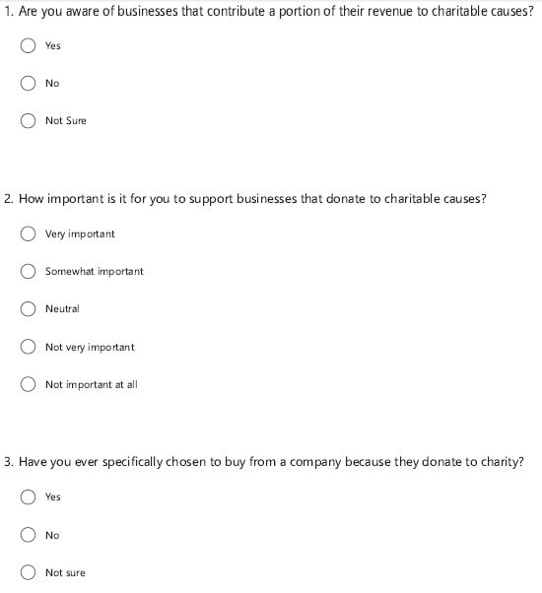
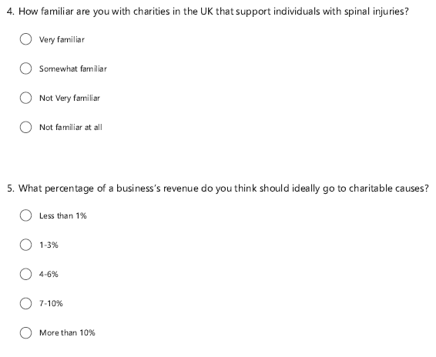
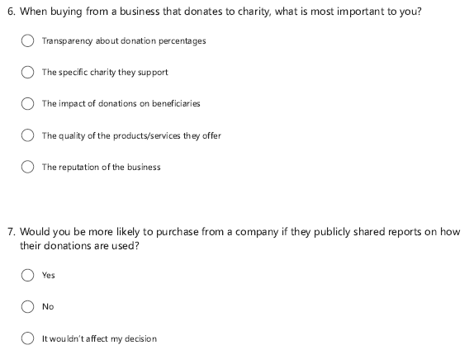
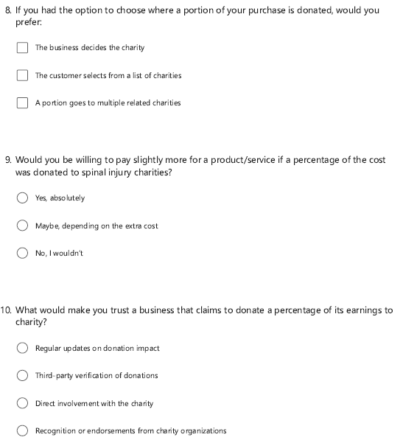

Task 2 – Design of the Website and Marketing Materials.

Website Images
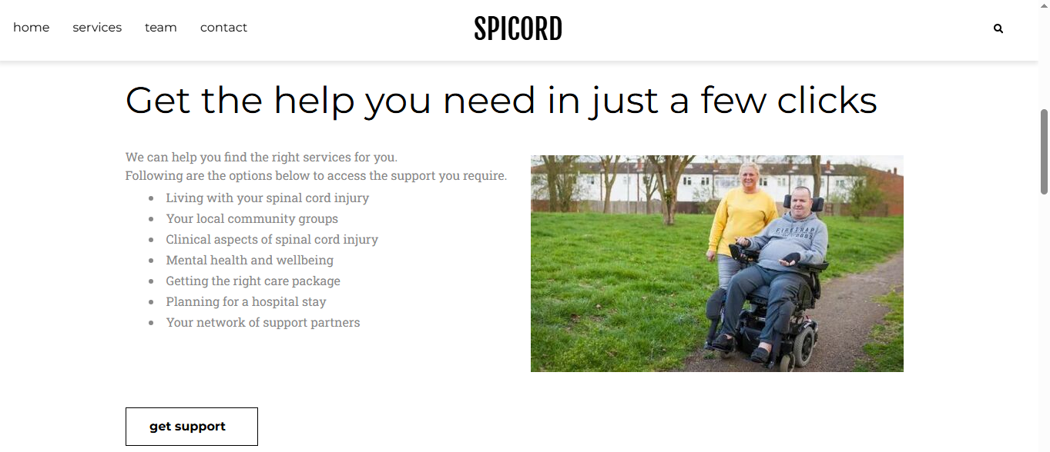
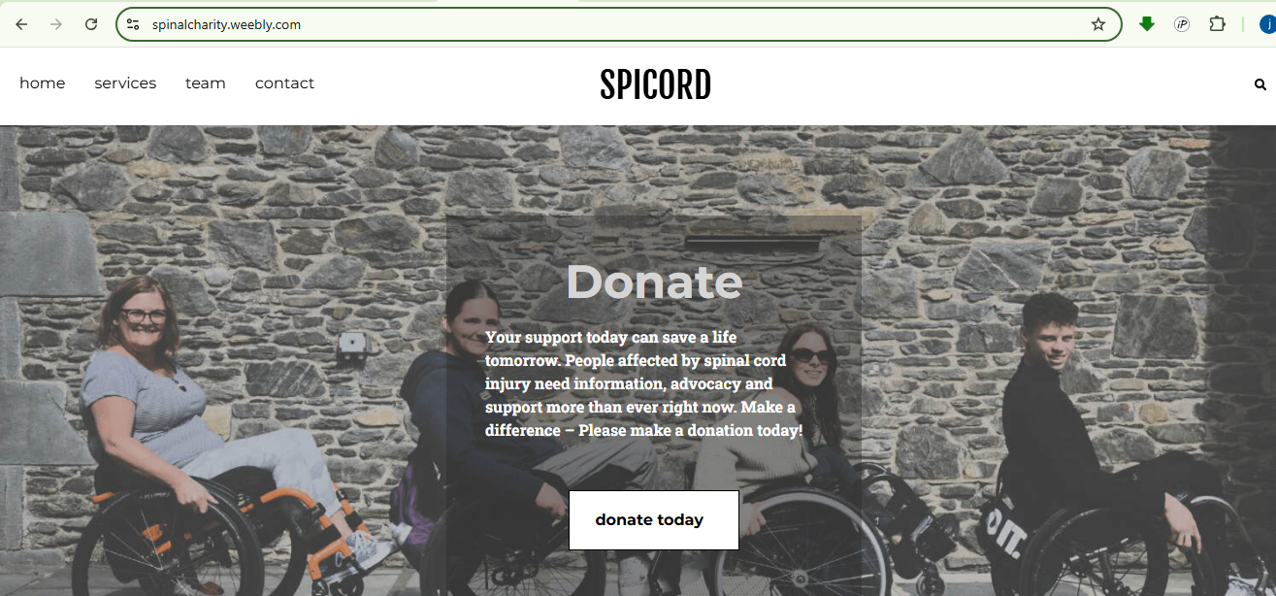
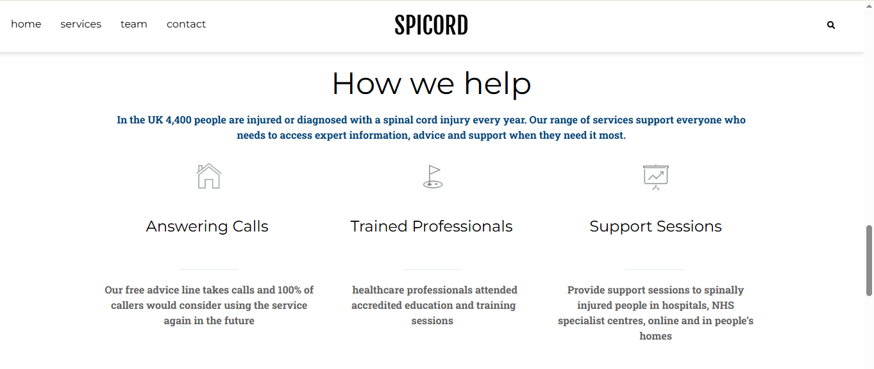

Marketing Materials
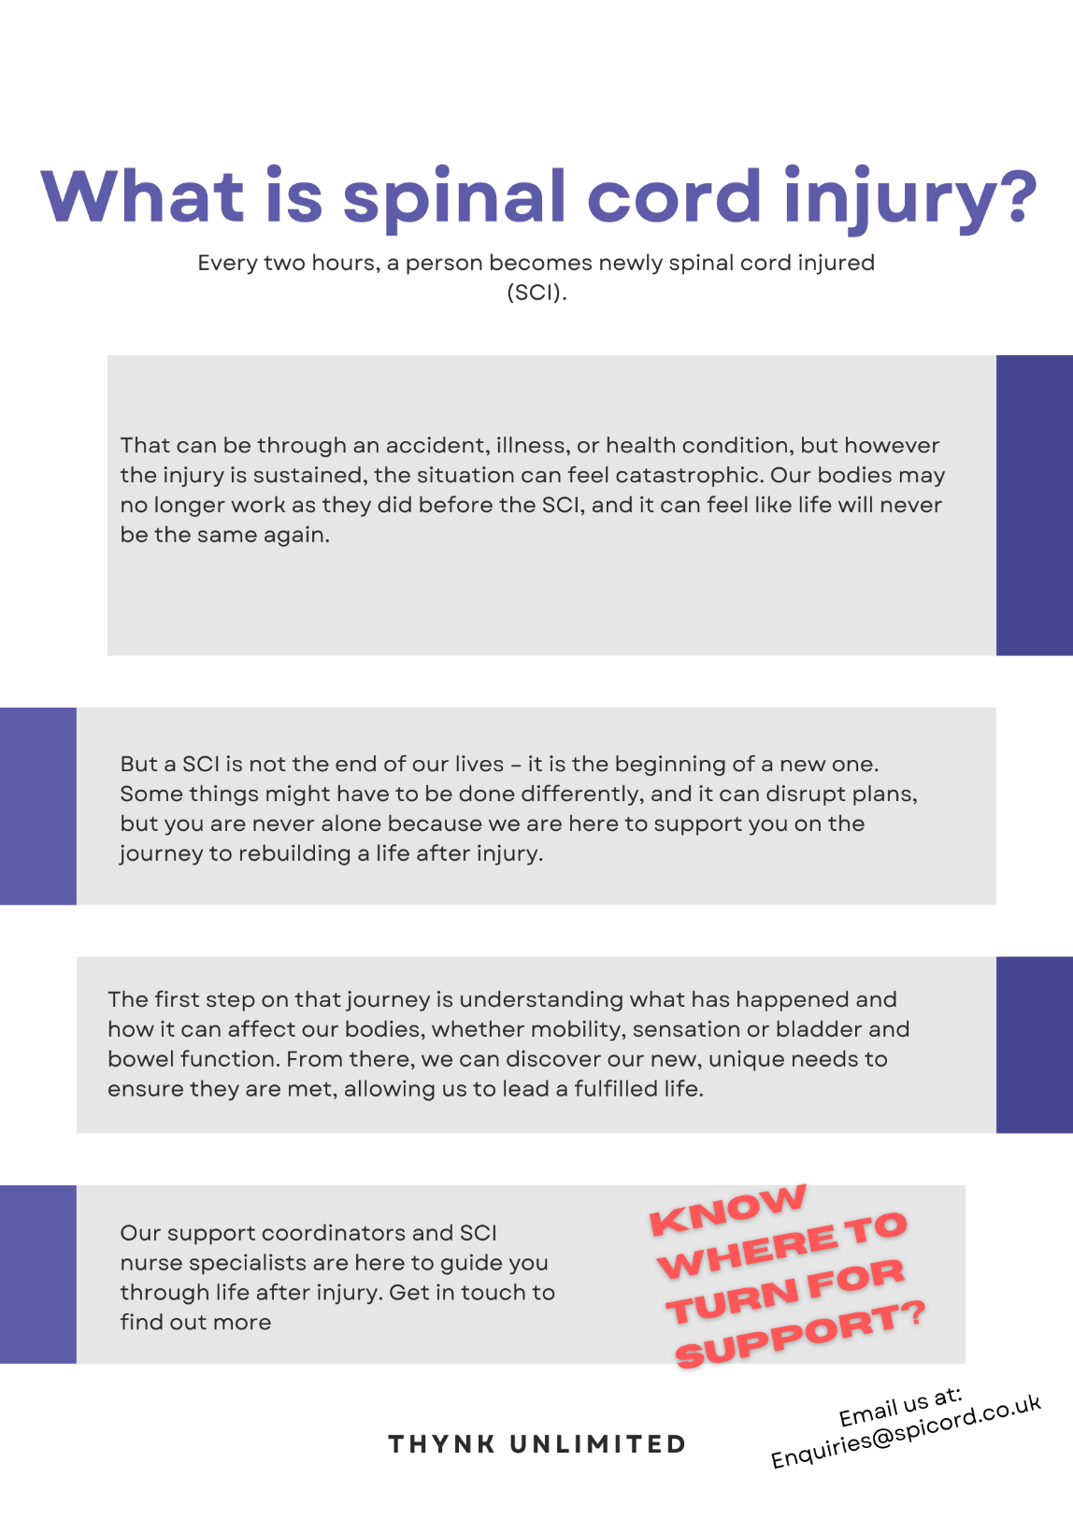



Task 3 - Financial Projection at Microsoft Excel and Essay

Financial Projections
 | Jan | Feb | Mar | Apr | May | June | July | Aug | Sept | Oct | Nov | Dec | Annual  Total
Revenue: Product Sales | $ 5,000 | $ 5,000 | $ 5,000 | $ 5,000 | $ 5,000 | $ 5,000 | $ 5,000 | $ 5,000 | $ 5,000 | $ 5,000 | $ 5,000 | $ 5,000 | $ 60,000
Revenue: Service Fees | $ 2,000 | $ 2,000 | $ 2,000 | $ 2,000 | $ 2,000 | $ 2,000 | $ 2,000 | $ 2,000 | $ 2,000 | $ 2,000 | $ 2,000 | $ 2,000 | $ 24,000
Revenue: Other Income | $ 1,000 | $ 1,000 | $ 1,000 | $ 1,000 | $ 1,000 | $ 1,000 | $ 1,000 | $ 1,000 | $ 1,000 | $ 1,000 | $ 1,000 | $ 1,000 | $ 12,000
Total Revenue | $ 8,000 | $ 8,000 | $ 8,000 | $ 8,000 | $ 8,000 | $ 8,000 | $ 8,000 | $ 8,000 | $ 8,000 | $ 8,000 | $ 8,000 | $ 8,000 | $ 96,000
Expenses: Marketing | $ 1,000 | $ 1,000 | $ 1,000 | $ 1,000 | $ 1,000 | $ 1,000 | $ 1,000 | $ 1,000 | $ 1,000 | $ 1,000 | $ 1,000 | $ 1,000 | $ 12,000
Expenses: Website Maintenance | $ 200 | $ 200 | $ 200 | $ 200 | $ 200 | $ 200 | $ 200 | $ 200 | $ 200 | $ 200 | $ 200 | $ 200 | $ 2,400
Expenses: Software Subscription | $ 300 | $ 300 | $ 300 | $ 300 | $ 300 | $ 300 | $ 300 | $ 300 | $ 300 | $ 300 | $ 300 | $ 300 | $ 3,600
Expenses: Operational Costs | $ 1,500 | $ 1,500 | $ 1,500 | $ 1,500 | $ 1,500 | $ 1,500 | $ 1,500 | $ 1,500 | $ 1,500 | $ 1,500 | $ 1,500 | $ 1,500 | $ 18,000
Expenses: Miscellaneous | $ 500 | $ 500 | $ 500 | $ 500 | $ 500 | $ 500 | $ 500 | $ 500 | $ 500 | $ 500 | $ 500 | $ 500 | $ 6,000
Total Expenses | $ 3,500 | $ 3,500 | $ 3,500 | $ 3,500 | $ 3,500 | $ 3,500 | $ 3,500 | $ 3,500 | $ 3,500 | $ 3,500 | $ 3,500 | $ 3,500 | $ 42,000
Profit | $ 4,500 | $ 4,500 | $ 4,500 | $ 4,500 | $ 4,500 | $ 4,500 | $ 4,500 | $ 4,500 | $ 4,500 | $ 4,500 | $ 4,500 | $ 4,500 | $ 54,000

Bar Chart

Task 4 - Video of the brand
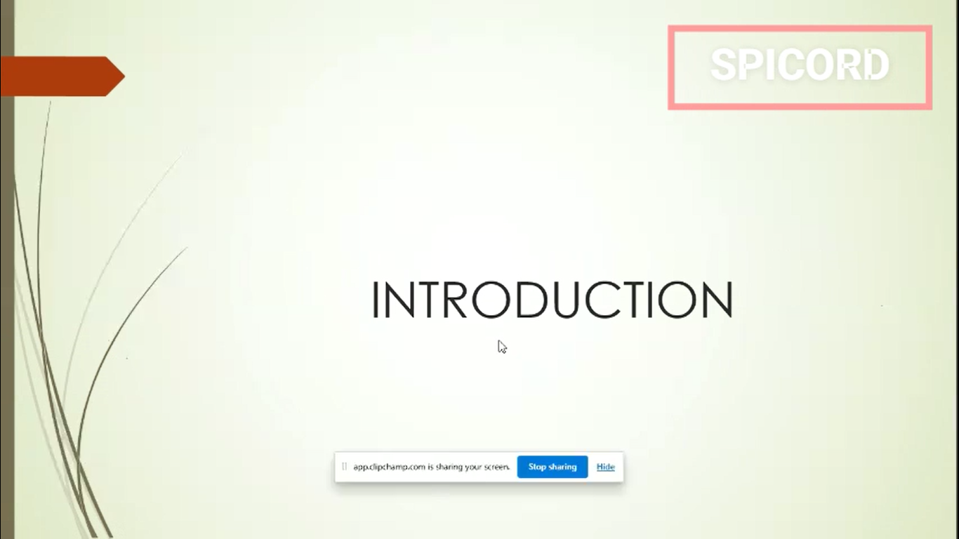

Link to the video: https://youtu.be/w4k30z8TT3k?si=GKjdOpF4FC4_tqRQ

