University of Wales Trinity Saint David.
School of Engineering.

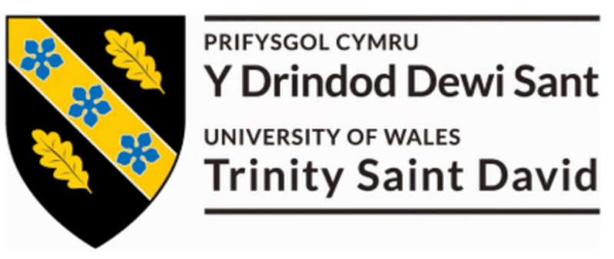

Subject: Group Project.

Title: System Automation through SQL Code.

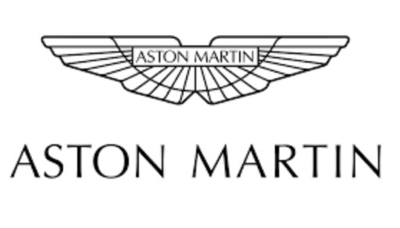

Name: George Griffiths (0901007).

Date: 5th February 2021.

Contents page:

Introduction. ~ Page 3.

How Aston Martin Incorporate DC Tools ~ Page 4.

Gantt chart of project plan. ~ Page 6.

Automation of DC Tooling. ~ Page 8.

Summary of DC Tooling within Power BI – Utilizing the SQL Code. ~ Page 10.

Introduction to VCATS. ~ Page 13.

Automation of VCATS process. ~ Page 13.

Summary of VCATS within Power BI – Utilizing the SQL Code. ~ Page 15.

Improvements Based on Project. ~ Page 16.

Project Analysis. ~ Page 17.

References. ~ Page 18.

1.0 Introduction
During the first year of the apprenticeship scheme at Aston Martin working in the current car manufacturing engineering team around Aston Martins DBX, there was a clear focus on system automation and driving continuous improvements across the production line. The team believed striving for industry 4.0 would allow the business to strive for continuous improvement in both quality and delivery. Due to this, it became apparent that maximizing our current systems too drive automation through SQL code can return conditioned data too automate systems too highlight failure rates across the production line, “SQL, Structured Query Language, is a programming language designed to manage data stored in relational databases. SQL operates through simple, declarative statements. This keeps data accurate and secure, and it helps maintain the integrity of databases, regardless of size” (CodeAcademy, 2021). Across Aston martin as a business multiple system are utilized to record legislative data to ensure each vehicle has sufficient quality prior too dealership distribution. The fault with many of the current system being utilized is to gain access to this data it is a manual process the user must complete, thus making data driven decisions based on failure rates hard to achieve. An example of this would be too view the station where a part is assembled on the production line – currently to do this the user must complete a full BOM (Bill of materials) download into Excel, then filter by model, model variant and part number to gain access to this data. From a lean manufacturing perspective, the team believes that this data should be automatically accessible, excluding the manual process currently partaken by the user.

To increase efficiency – it became apparent that writing SQL (structured query language) code as a business intelligence tool could provide a deeper analysis to drive improvement across Aston Martin as a business.

This process included generating SQL queries against the back-end of Aston Martins data systems, where data is inputted sporadically across hundreds of data tables, of which it is possible to join and filter to generate the correct conditions of which the user would like to view. The back end of the data set is the raw form of what the user will view using the systems interface, “The back end of a website consists of a server, an application, and a database. A back-end developer builds and maintains the technology that powers those components which, together, enable the user-facing side of the website to even exist in the first place” (Wales, 2020).

In the examples below, it has been demonstrated how using SQL code improvements have been made to our DC Tooling and VCATS system. DC Tooling, a Dessouter technology is utilized to record legislative mechanical data throughout the whole build process of DBX from tubs/body in white through to off tracks testing, predominately recording torque/angle of joints which are secured.

VCATS is the control of all electrical components across the production line. VCATS testing essentially pings a vehicles ECU to ensure a sufficient output is achieved prior too continuation of process, a example of this being technician is asked through VCATS test to lower passenger side window, technician presses window down button but window doesn’t lower – this would indicate a VCATS failure highlighting a ECU failure. All ECUS are tested throughout our Trim and Final stage of the assembly process.

2.0 How Aston Martin Incorporate DC Tools?
In St Athan the home of the Aston Martin DBX, to comply with legislation and to ensure all vehicles are assembled safely and efficiently, the business utilizes a Dessouter system called DC Tooling to control all safety critical and performance critical joints are secured to specified parameters across the production line. The parameters, which include Torque (Will have a lower, nominal and higher tolerance) beginning angle, final angle and abort angle – need to be met to ensure a joint is secured sufficiently on the production line.

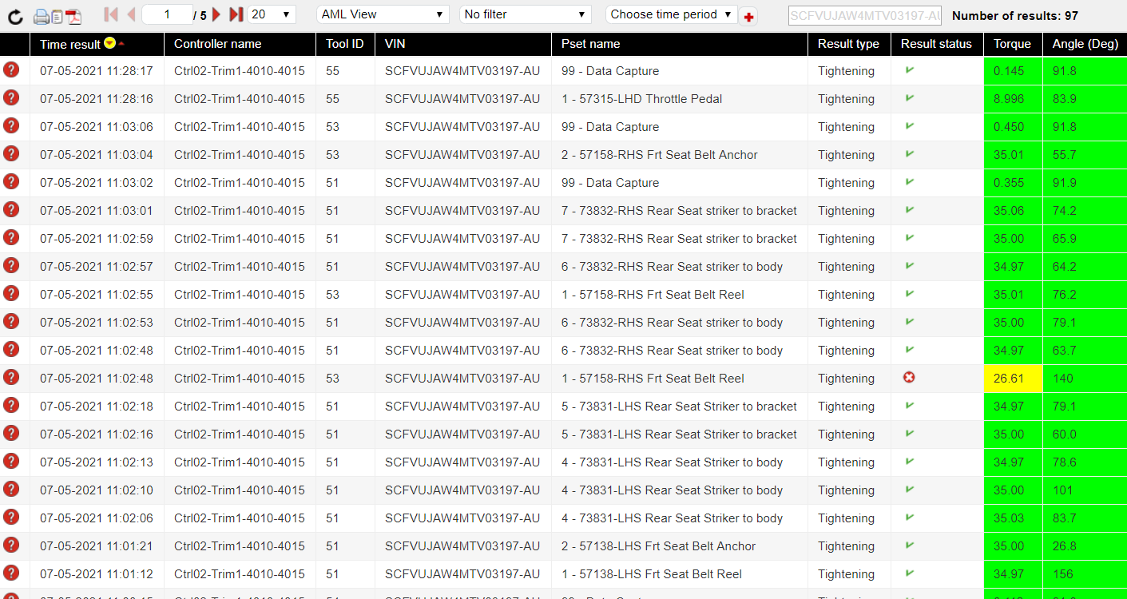
DC Tools are connected to a lineside controller which allocates the DC Tooling process (Called PSETS from a DC Tooling Perspective) when a new VIN number arrives in the respected station. As DC tooling is a legislative requirement, all DC tooling is interlocked to the production line, meaning all processes must be completed prior to the vehicle progressing through its assembly process. Thus meaning, all DC tooling connects to a lineside controller via WIFI, which then connects too the line sides PLC’s network switch via prophinet cable which will allow the line to progress post completion of all PSETS on each individual tool. All Bolts secured utilizing a DC Tool are recorded for legislative purposes if a vehicle fails under consumer use, traditionally prior to this improvement project the business would utilize a software called CVI Net Web to view tightening results as seen in image 1.

(Image 1 – Current System for Recording Legislative Data
Reference, CVI Net Web 2021).

When considering CVI Netweb, the system fundamentally provides us its primary function – allowing the technician to search by VIN number to ensure all OK PSETS have been accounted for. A PSET is a description of a tightening process, (for example : Operation 57315 LHD Throttle pedal secure). As a improvement project, the business’ looking to create a report which will provide us with a overall status on DC Tooling by area, to highlight the highest failing PSETs to drive quality to DBX from a mechanical perspective which currently is not possible utilizing the above system.

A PSET are parameters set to a specific tightening process, based upon torque and angle parameters as seen in Image 2. When these parameters are met, the DC Tool will provide a green light to the user which indicates the bolt has been tightened sufficiently.
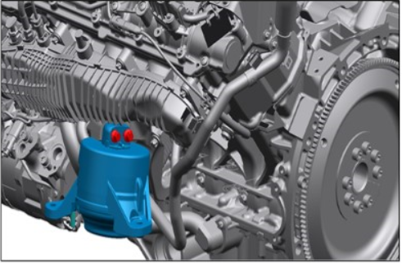

(Image 2 – Engine Mount Assembly Process on the Aston Martin DBX
Reference – Siemens NX, 2021).

When considering the physical assembly process of this operation as seen in image 2, there are two fixings for the engine mount, thus meaning there will be 2 PSETS assigned to this operation in the assembly process, both of which with the same parameters (Assuming fixings used are of correlating pitch/length). Aston Martins current process only records angle from the point of the bolt reaching minimum torque, thus meaning the business currently does not have a robust incorrect fixing identification procedure. A failure on a DC Tool when securing could be due to cross threading, damaged part of fitment, damaged thread on bolt when securing, contamination in housing of bolt (Potentially from painting process), incorrect part being fitted by technician (Technician not following standard process), incorrect PSET being utilized (Technician error where incorrectly fastened bolt) or most commonly during prototype incorrect parameters being utilized on the bolt.

The primary function of DC Tooling is to comply with the confirmative of legislation laws which exist within the automotive industry, “Conformity of Production (CoP) is a means of evidencing the ability to produce a series of products that exactly match the specification, performance and marking requirements outlined in the type approval documentation. Whether you are a manufacturer, or the agent applying for approvals on behalf of a manufacturer, and whatever your product is, suitable CoP arrangements must be made.” (GOV, 2020). Therefore, to comply with legislation, Aston Martin must record all legislative fixings within DBX to ensure the mechanical qualities of the vehicle are sufficient under consumer use. To ensure Aston Martin are compliant with this legislation external auditors will audit the legislative systems where “test records and production records must be available to the visiting inspector” (GOV, 2020). Therefore, utilizing Desoutters DC Tooling system acts as a control plan which allows Aston Martin to comply with COP legislation to ensure manufacturing is possible.

The conformity of production legislation also protects Aston Martin when an incident surrounding a vehicle happens in field under consumer use. In the incident of a consumers vehicle failing, to prevent legal consequences brought upon the company it is possible to present DC Tooling in the court of law as a efficient control plan for all components on the potentially defected unit.

3.0 Gantt Chart of Project Plan
To ensure the project is completed within the three-month period, prior to beginning the team generated a Gantt chart of how the business intended to implement the system improvement and too ensure that time management targets are met.

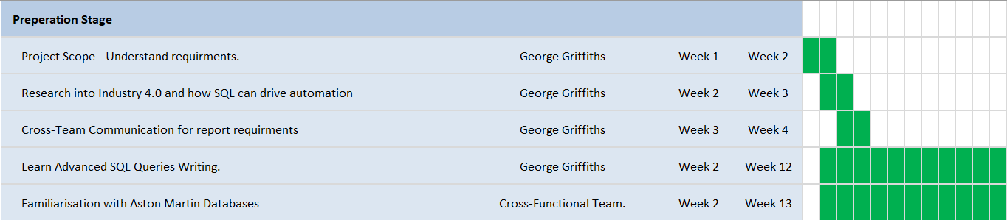
Stage 1 – The Preparation stage
(Image 3 - Preparation Stage of Project
Reference – Microsoft Excel, 2021).

The preparation stage of the project as seen in image 3, is predominantly focused upon understanding the consumers’ requirements and understanding industry 4.0 and system automation. It was during this stage of preparation it became apparent SQL was the most efficient way of communicating with our systems servers to generate conditioned codes to export data. Post this being determined, the team began to have tutoring on how to manufacture and interpolate SQL via a engineer in Gaydon which provided exposure to a deeper analysis of Aston Martins databases and systems. Aston Martin have 141 actively live databases which are populated live based upon manufacturing data of which the team are able to communicate with utilizing SQL code.

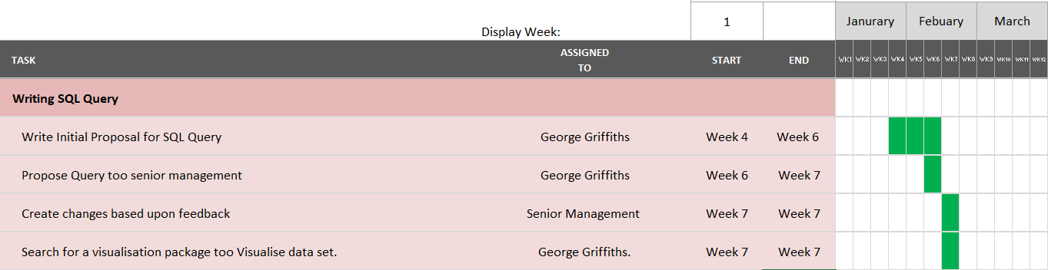
Stage 2 – Initial SQL Code Proposal.

(Image 4, Initial SQL Query
Reference – Microsoft Excel, 2021).

The second stage of the project as seen in image 4, is focused around completing the SQL query to ensure it is sufficient for the wider team to analysis to drive improvement. During week 6 a commonly discussed agenda was how the team could drive improvements to ensure the report is tailored for all aspects of the business. During this stage, the wider team decided that utilizing Microsoft Power BI was the visualization package the business would integrate our query with too visualize the data set, of which the the team would present to the business.

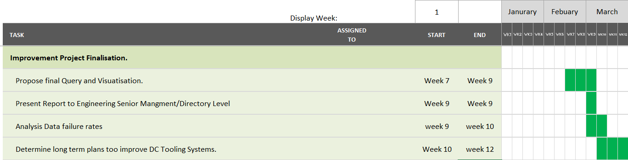
Stage 3 – Finalization of Improvement project

(Image 5 - Project Finalization
Reference – Microsoft Excel, 2021).

The final segment of the report as seen in image has a clear emphasis on presenting the improvement to a wider team and to conclude on how improvements could potentially be utilized to increase quality across the production line. This can be completed by highlighting the consistent discussion with senior management/directory level of how improvements based on the highlighted failures can be addressed to improve the quality of DBX from a mechanical perspective.

4.0 Automation of DC Tooling.
With regards to DC Tooling, the project brief was to create a automated report live from production which highlights our highest consistent failing PSETS across a three month period. Aston Martins current process for this entails a technician manually searching a vehicle by VIN to ensure all PSETS are accounted for prior too vehicle testing.

To decrease the manual investigation via the technician, a distinct count of failure rates would provide the user with instant results with regards too if a vehicle is able to progress to the next stage of its process. This also drives the faults seen at the end of line back to their point of fitment which will prevent faults on the vehicle being continued throughout the production line.

Post completion of the SQL query, when visualizing the data in a pareto chart it is possible to monitor failure rates over a specific time period to emphasize the improvements which have been made to increase process repeatability and improve mechanical quality.
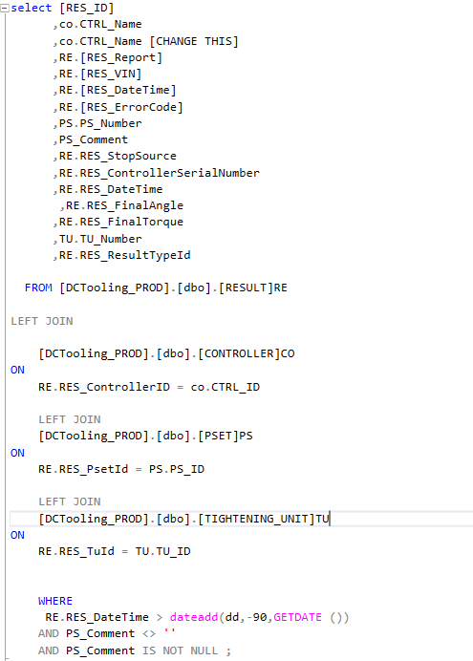

(Image 6 - SQL Query for DC Tooling Report
Reference – Microsoft SQL Server Management Studio)

When analyzing code created in image 6, – It can be interpolated into three dimensions.

- “SELECT” clause – During this segment of the code it is have specified what columns of data the user would like to include in the report. Here the coder has included data surrounding the Controller name, Report Status (OK/NOK hit), VIN number, Date/Time, Error code, PSET number, PSET comment (This data field included the PSET name, which allowed us to identify the exact process of failure), Stop Source and Controller Serial number. The Controller name allows us to identify where in the production process a DC Tool has failed, VIN number as it demonstrates that all data against every VIN is collected and if there is an issue the technician is able to identify potentially defective vehicles and comment/Number as each PSET will have a unique identifier – thus meaning the user is are able to identify the exact job the technician is failing upon. Date/time is also of significant use to the user – thus allowing them to see clearly when a failure clause has occurred.
- LEFT JOIN Clause – Here as previously mentioned, the data had been sporadically imputed into the database across multiple tables, by adding a join clause the coder is able to combine datasets from multiple tables into a newly existing query. To do this, the coder must ensure all columns joined must be joined through a common delimiter. As seen in the code above the “Controller” table has been added to the query through the controller ID – Where the user may see RE.RES ControllerID = CO.CTRL_ID (The terms CO and RE are Aelius given to each line of code which refers to what table the data is being activated from). Post completion of this process, it is now possible to select any column from the controller table and add it to my select clause – thus meaning it is possible to expand my data set through joining tables in SQL.
- WHERE clause – The where clause is our filtering process of the code. Here, it is specified that 90 days’ worth of data is too be considered from the current date/time (“RE.RES_DateTime > dateadd(dd,-90,GETDATE ())) which allows the data analyzer to trend data too see improvements that made to decrease bad joints being secured.

Post running the code, as seen in image 7, it is possible to view the raw data table of which obliges to the conditions stated in our code, of which contains 1.4 million rows of data.

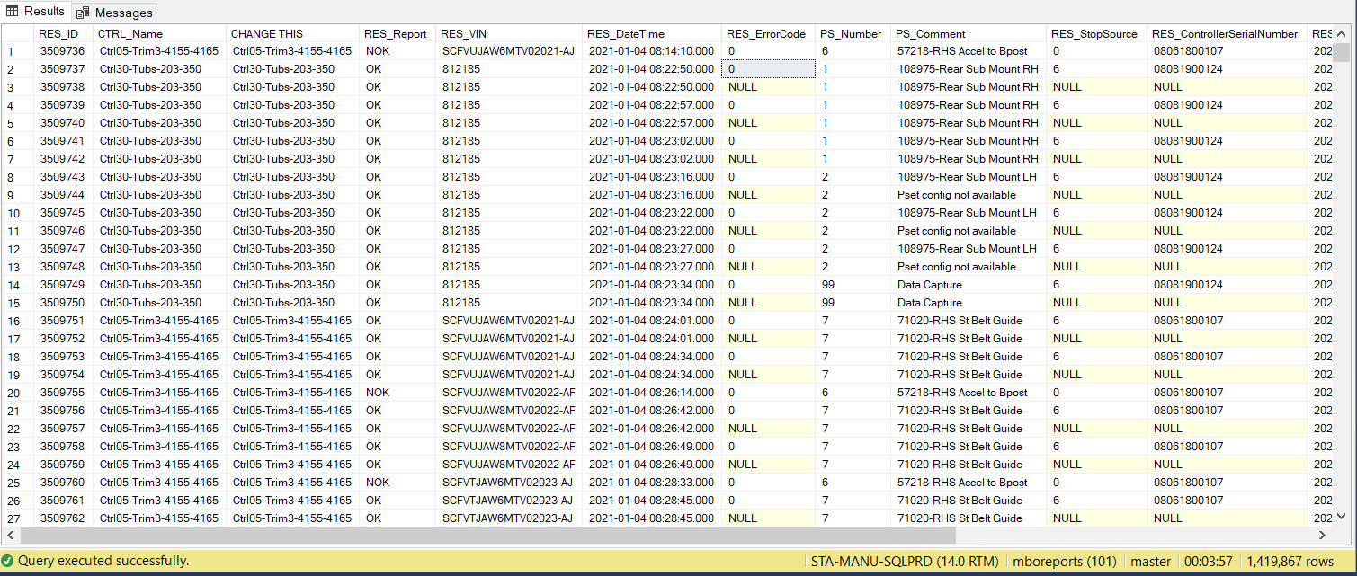
(Image 7 - SQL Query for DC Tooling Report
Reference – Microsoft SQL Server Management Studio)

Visualizing this Data Set
Post gaining the relevant data in its raw-form, the team is now able to utilize Microsoft’s power BI software to visualize data to emphasizes failure rates across the production line, “Power BI is a business analytics service by Microsoft. It aims to provide interactive visualizations and business intelligence capabilities with an interface simple enough for end users to create their own reports and dashboards.^{[1]} It is part of the Microsoft Power Platform” (Wikipedia, 11). As Power Bi demonstrates a basic structure and allows the user to create their own customized reports the business believes this is the best software to utilize – as it effectively displays data with no training to upskill to effectively use.

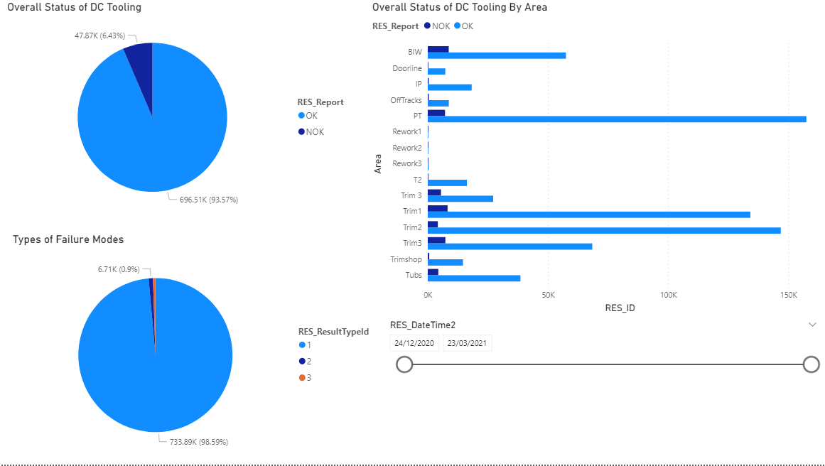
5.0 Summary of DC Tooling within Power BI – Utilizing the SQL Code.

(Image 8 - SQL Query imported into Microsoft Power BI
Reference – Microsoft Power BI.)

Using the code generated in image 6, Microsoft Power BI visualization package allows data to be summarized to provide us with an in-depth analysis of its performance across all areas of the business. By Visualizing the data, in the top left of the workbook the user is able too determine an overall status for OK/NOK hits, which provides a high level statistic as too if the business is achieving good quality from a DC Tooling perspective. In the bottom left of the report the data analyzer is able to see our failure types we are receiving in the 6% failure mode, 1 being a standard tightening failure (This potentially could be due too incorrect parameters on the DC Tool or technician error), 2 being where the technician has loosened a bolt using a DC Tool during process, and 3 being a batch increment. A batch Increment is where a production group leader allows a build technician too essentially skip a process including a DC Tool – leaving this joint un-fastened. This operation Is then escalated to the end of line quality team, who will complete the appropriate re-work which is flagged in our quality systems. Batch increments are only organizationally deemed acceptable when a known parts shortage is highlighted via the supply chain team.

This segment of the report also demonstrates by area a distinct statistic of failure rates via area, to emphasize in what areas of the production line are experiencing failure rates, a feature not possible whilst utilizing CVI Netweb.

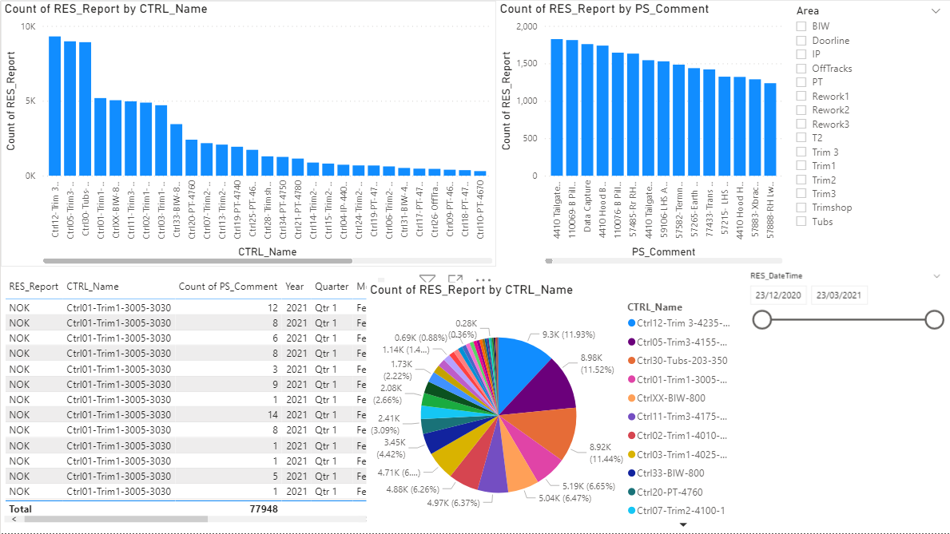
(Image 9 - SQL Query imported into Microsoft Power BI
Reference – Microsoft Power BI.)

To follow from image 8, to understand our 6.43% failure mode (Number of NOK results), the team generated a report when filtered by controller (Which allows the user to identify where on the production line the failure occurred), a pareto chart of the biggest failing DC Tooling Operations. It is important to note all DC Tools are programmed to received 3 NOK hits per PSET prior to the tool becoming locked, which requires a engineer to unlock to allow the technician to re try to achieve a OK hit. Thus meaning, it was possible, prior to the generation of this report, for a technician to receive 2 NOK hits per PSET on every vehicle which previously would not have been identified.

As this report is generated by SQL code, the report updates live as the technicians complete they’re processes – thus meaning it is possible to see a count of failing PSETS live throughout a single production day or throughout a 3 month period, a capability which CVI net web currently does not have.

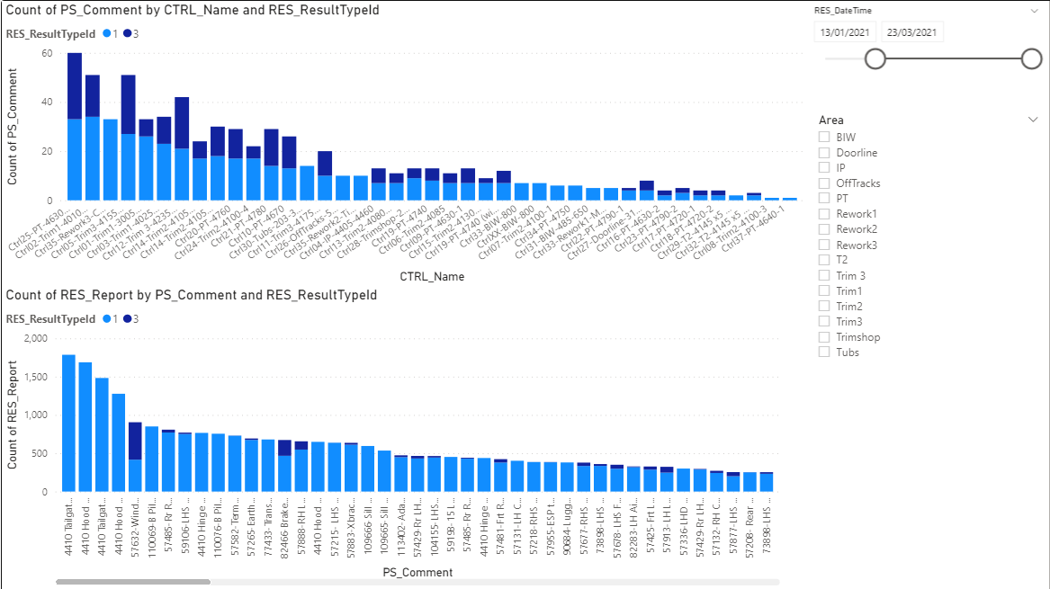
(Image 10 - SQL Query imported into Microsoft Power BI
Reference – Microsoft Power BI.)

As seen in image 10, during this workbook it was possible to demonstrate to the user based on the previous workbooks highest effected failing PSETS, the failure mode on each individual process – allowing the engineer to find route cause of the issue based on if the failure cause. This data is imperative from a Engineering perspective as it allows us to determine route cause of the issue. Where the user may see a Result Id type 3, it is possible to share this report with the wider team as this is only permissible when there are no lineside parts for that part. This data could potentially be of use for Aston martins supply chain, who control part inter-operations and lineside deliveries to demonstrate failure points during process. When considering failures due to Result Type Id 1, Aston Martins engineering team can do to directly decrease this failure mode by reviewing parameters of the tool in question or altering the assembly process to ensure repeatability is possible.

6.0 Introduction to VCATS
VCATS is a Bosch system which is utilized in Aston martin globally across all models to ensure all electrical components are sufficient prior to continuing the assembly process. This process includes all electrical ECU’s within the vehicles provide sufficient output prior to dealership distribution.

7.0 Automation of VCATS Process.
Whilst considering the business’ current structure of recording electrical data, similarly to CVI net web when considering Dc Tooling, Q bay provides results based on Vin Number. When considering a warranty issue surrounding wheel alignment, the business required a report which would visually display to us the Camber, caster and Toe measurements against each individual VIN number to ensure good quality is being produced from our onsite WAHA rig (Wheel alignment headlight adjustment). This process would improve the current system, as it would essentially visually highlight to us a discrepancy within our process if the user is able to spot trends in the data set.

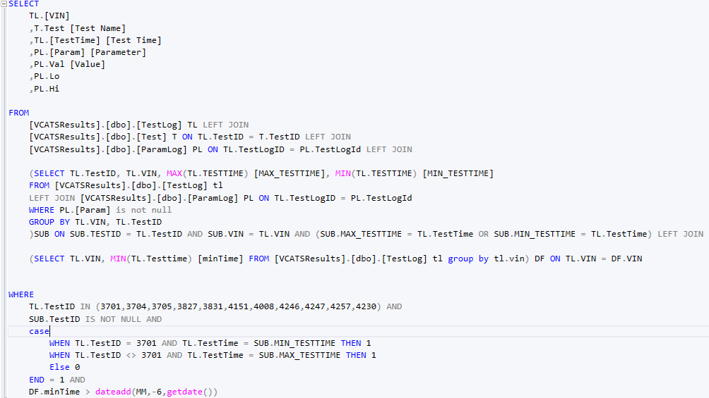
As previously discussed, the above is possible through communicating with Q bays database, where the data is sporadically inputted to a server across 90 tables. The data collected was in raw form – thus meaning there was no context to the data and was imputed sporadically into the server as data is collected live from the production line. Through communicating with the database through SQL code, it became apparent it was possible too modify/manipulate the data to suit our desires as seen in image 11.
(Image 11 - SQL Query for VCATS Wheel alignment Report
Reference – Microsoft SQL Server Management Studio .)

When analyzing the above code in image 11 – It can be interpolated into four dimensions:

- Select clause – Here the user is able too see the specified columns the coder would like to include in the results column, here the VIN number, Test time, parameter (This is the part of the test the user is considering), value achieved, lower and higher parameter. These columns will allow the user to identify, by VIN Number, if here has been a value out of specification achieved at a specific date/time.
- FROM clause – This area states what tables the values in the SELECT clause are sourced from. This area of the code allows the coder to retrace his steps if alteration to the codes are required. The Aelius assigned to each line of code correlates directly to the database of where the column has come from (Aelius T = to all columns being considered from the Test Id table).
- Sub query – The area within the code between brackets is assigned as a “Sub query”. As data is recorded for the camber, caster, and Toe value inbound from trim and final (Prior to being processed to a specific parameter) and post processing into final testing, it is important to consider two-time stamps against each Vin and Test ID. Here the user can see by test ID (This is an individual test identifier for a specific VCATS test), here it became apparent that a min test time (being the first test) and max test time (being the final test time) must be considered. This allows the user to determine by TestID whether the user would like to see the parameter of the Toe, Camber or Caster prior too processing or post processing (The quality the customer will receive). The team integrated this into the code to consider the pre vs post condition of the toe, camber and caster set to prove sufficient quality is being achieved on WAHA.
- Where Clause – Here, in the beginning of the clause the coder states state the test identification (TestID = unique identifier for each individual test) the user would like to include within the SELECT clause of the code. The where clause here has allowed the coder to refine too display 11 tests out of a dataset of 1,000. When considering the case statement, it became apparent when the test time = 3701 (test being 00800 Read Wheel alignment values Pre) to consider the minimum test time. Thus meaning, when considering the value of both Camber and Toe immediately from production, processing times on WAHA may be decreased if consistent inaccurate readings are provided (If quality from production line improves the processing time could potentially be reduced). Contrary to the above, the alternating where clause states to only consider the remainder of the tests when the maximum test time is achieved which will allow the analyzer to consider quality achieved prior too dealership distribution. The final line within the code states that the last 6 months of data will be considered.
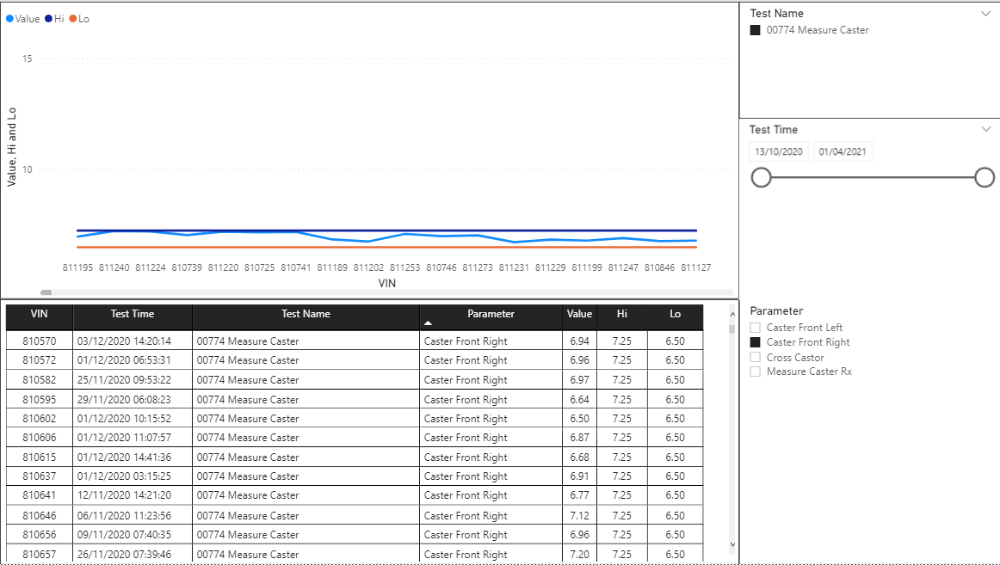
8.0 Summary of VCATS within Power BI – Utilizing the SQL Code.
(Image 12 – VCATS Wheel Alignment Status
Reference – Microsoft Power BI.)

Post implementing the SQL code into power Bi the business is now able to see how the report is now directly providing us with a visualization as too if quality within specification is being achieved or not. The slicer in the top right of the report allows the user to select what test they would like to consider, and the parameter within the test they would like to consider from that test. In the above example, the user is considering the test 00774 measure caster test specifically the front right caster parameter. The table at the bottom of the workspace includes all columns included into the SELECT clause of the SQL code. The visualization at the top of the screen simply displays, by VIN number (X axis), the higher and lower parameters set by the corresponding engineer and the value achieved via individual Build Number. The benefit of the above report demonstrates how a system can be automated to consider a segment of a vast database to drive data driven improvements within a manufacturing facility. The report is now used when outstanding warranty issues are raised against steering alignment , of which can be found easily and visualized through SQL code to determine a good/bad status within seconds of loading the report, thus excluding the manual process of searching through Q bay to ensure sufficient which increases our efficiency as a team.

9.0 Improvements Based on Project
Post creation of the reports, it became apparent where our biggest failure modes where when considering legislative data from a Mechanical and Electrical perspective within St Athan.

Post implementation of the Power Bi report, it became apparent from Directory level that further improvements were required to decrease failure rates across the production line. As a short-term containment, to increase repeatability the business altered all DC Tooling angle parameters to standard 3 sigma. This was possible by downloading all results for a Specific PSET into Microsoft excel, and generating a Power query report which will return the standard deviation to 3 sigma for both the final angle and abort angle of each individual PSET – thus guaranteeing better accuracy results are recorded mechanically.

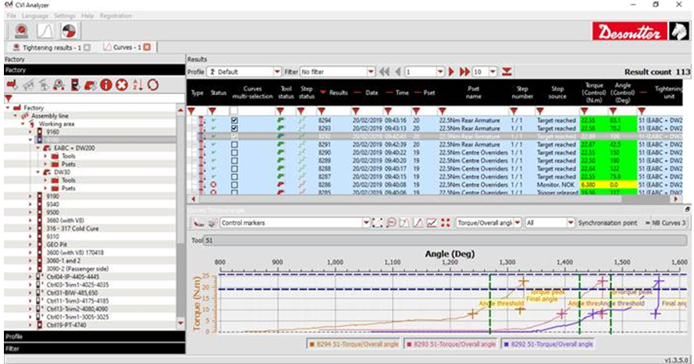
With regards to long term improvements to our current system, Aston Martin decided to invest in a further software, CVI Analyzer, which demonstrates “Extensive tightening results analysis” this will allow the user too “Import controllers data and run full analysis of collected results with customized filters and reports” (Desoutter, 2021). Previously, to determine run down parameters on DC Tooling the user would consider each individual bolt in terms of the bolts pitch, then by utilizing the report made by the team made make changes in due course to reduce failure rates. As previously discussed, this method is a single run-down angle parameter, which allows the user to monitor bolt rotation post alignment with the minimum torque assigned to that PSET. To enhance this process, CVI Analyzer allows the team, as seen in image 13, to upgrade all PSETS too a two-stage run down to prevent incorrect fixings being utilized on the production line.

(Image 13 – CVI Analyzer License
Reference – Desoutter, 2021.)

10.0 Project Analysis
Post successful completion of the project, whilst considering the effect the reports made on the business it became apparent it significantly improved our current DC Tooling status and drove significant funding too improve further developments into the system too decrease failure rates. These developments (Specifically the installation of CVI Analyzer and socket trays to the production line) are being driven by myself and providing they’re successful in St Athan, will also be implemented into Aston Martins world headquarters in Gaydon, home of the Vantage, DB11 and DBS Supperlegera. Also, on the 01/05/2021 I was notified due to the implementation of SQL coding into St Athan, I was awarded the Aston Martin Apprentice of the year award by both AML and the worshipful Welsh livery company. Due to the implementation of this automated system, Aston have arranged a visit too Toyota Deeside to broaden my knowledge on industry 4.0 too strive towards further automation. With regards to further implementation of further SQL reporting, AML have also arranged a visit to Silverstone too discuss how improvements to Aston Martins F1 team could be implemented to drive further improvements ahead of the upcoming season whilst considering build quality to enhance performance.

When considering the VCATS report created, this was too aid a investigation into a warranty issue surrounding wheel alignment. This report was utilized at directory level to prove over a 200-car data set (Which is incorporated into the SQL code) that Aston Martin were providing sufficient quality into field for consumer use.

With regards to disadvantages of the project, initially many engineers within the business were not familiar with using Microsoft Power BI, which led to a cross functional team including too up-skill the wider team too successfully integrate the report into our daily reporting scheme. Post the brief training required – the reports utilizing SQL were provided to both the production team and engineering team to begin the continuous drive for improved quality.

11.0 References.

CodeAcademy. (2021, January 01). CodeAcademy. (CodeAcademy, Editor, CodeAcademy, Producer, & CodeAcademy) Retrieved April 02, 2021, from CodeAcademy: https://www.codecademy.com/articles/sql-commands
Davis, M. (n.d.). What is Potential energy? Retrieved from https://www.livescience.com/65548-potential-energy.html
Desoutter. (2021, 01 01). Desoutter Industrial. (Desoutter, Editor) Retrieved 04 07, 2021, from Desoutter Industrial: https://www.desouttertools.com/tools/2/electric-assembly-systems/21/cvi3-range/219/cvi3-software/p/6159276960/cvi-analyzer-1-user
GOV. (2020, 05 11). Conformity of Production (CoP). (GOV, Editor, GOV, Producer, & GOV) Retrieved 05 10, 2021, from Conformity of Production (CoP): https://www.vehicle-certification-agency.gov.uk/conformity-of-production/
Ltd, T. (2012). Engineering Science Guidance Notes - Potential and Kinetic Energy.
Wales, M. (2020, 12 08). UDACITY. (M. Wales, Editor, M. Wales, Producer, & UDACITY) Retrieved 05 13, 2021, from Front-End vs Back-End vs Full Stack: https://www.udacity.com/blog/2020/12/front-end-vs-back-end-vs-full-stack-web-developers.html
Wikipedia. (11, 07 2011). Microsoft Power BI. (Wikipedia, Editor, Wikipedia, Producer, & Wikipedia) Retrieved 05 01, 2021, from Microsoft Power BI: https://en.wikipedia.org/wiki/Microsoft_Power_BI

