

Data Handling and Business Intelligence
LCBB5014

Student Name: Ionel Costea
Student Number: 2422706

Table of Contents

INTRODUCTION 3
DATA CLEANING & PREPARATION 4
DESCRIPTIVE STATISTICS AND SUMMARY 7
TREND ANALYSIS & VISUALISATION 9
STATISTICAL ANALYSIS (SPSS) 15
Independent Samples T-Test 15
Correlation Analysis 16
Regression Analysis 17
INSIGHTS & RECOMMENDATIONS 19
REFERENCES 20

INTRODUCTION
The growth in data analytics in the entertainment and streaming sector has revolutionised the way organisations gain insight into audience preferences and enhance their content strategies (Sai et al., 2025). The use of digital film databases and streaming services has resulted in the collection of large volumes of user data, allowing the use of business intelligence (BI) tools to guide data-driven decision-making (Emma, 2024). Through the analysis of ratings, engagement, and viewing patterns, companies can optimise content recommendations, increase viewer satisfaction, and improve business outcomes (Ahmed and Abdulkareem, 2023).

This report examines the Letterbox Movie Classification dataset, which includes data on 10,000 movies, including variables such as average rating, film length, watches, likes, fans, genres and language. The data set offers the chance to examine the impact of various film characteristics on audience responses. Microsoft Excel is used for data cleaning, preparation and visualisation, while IBM SPSS is used for statistical analyses such as hypothesis testing, correlation and regression (Attwal and Singh, 2024). This report has three main objectives. First, to clean and standardise the data to facilitate accurate data analysis. Second, to extract insights and patterns in audience ratings and participation for various film characteristics. Third, to use statistical tools to investigate the relationship between variables and identify predictors of film ratings. Finally, the outcomes will showcase the use of data in informing the media and entertainment industry.

DATA CLEANING & PREPARATION
Pre-processing of data was done in Microsoft Excel to clean and prepare the data for analysis. Data exploration revealed a number of data quality problems. The Genres variable was in a nested format, with multiple values in one cell, preventing meaningful categorisation and comparison. To resolve this, the data was normalised by identifying a dominant genre for each movie, allowing for more effective classification and comparison (this may overlook the complexity of multi-genre films).
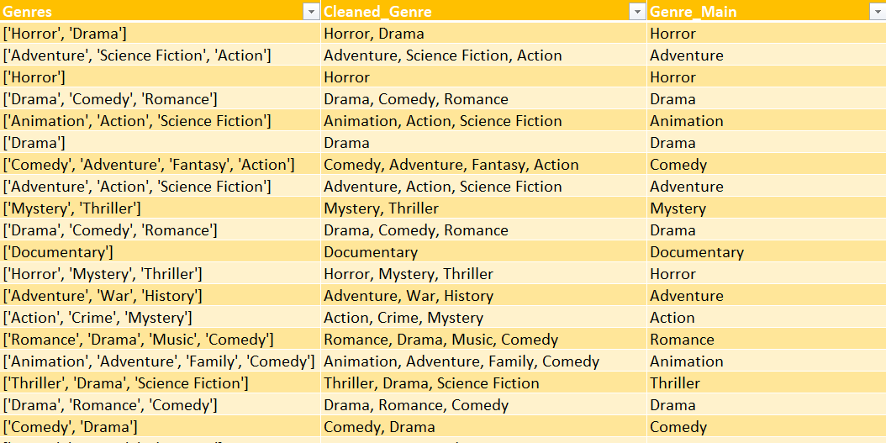
Fig 1: Genre cleaning (before vs after)

To facilitate analysis, the Language variable was also standardised by adding a new variable, Language_Numerical, in which films were categorised as 1 (English) and 2 (Non-English). This was essential to conduct statistical analyses, like t-tests, in SPSS. Another new variable, Engagement Ratio, was also constructed to reflect user interaction in relation to engagement. This variable better represents engagement than raw variables such as watches or likes.
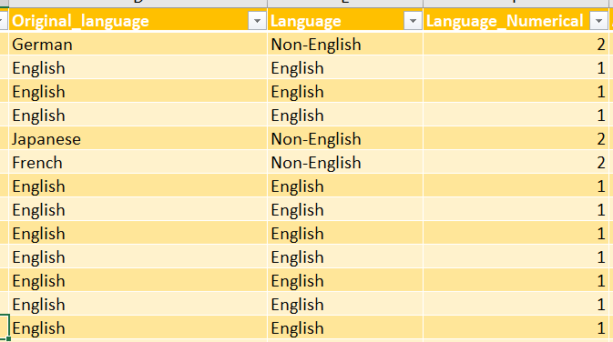
Fig 2: Language_Numerical column

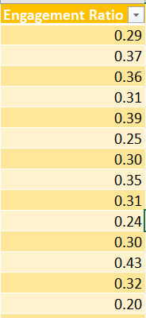
Fig 3: Engagement Ratio formula in Excel

Numerical variables such as average rating, length, watches, likes and fans were verified for data type and format. There were no major missing values, but data cleaning procedures were undertaken to guard against any inconsistencies and outlier effects. Data cleaning affects the nature of statistical inference and business decisions. While simplifications (such as genre classification) enhance the interpretability of the data, they also create concessions by losing complexity. Thus, it was important to prepare the data correctly to gain trustworthy insights while being aware of the trade-offs introduced by the data cleaning process (Brown and Anderson, 2023).

DESCRIPTIVE STATISTICS AND SUMMARY
Descriptive statistics were calculated using Excel and SPSS to understand the main features of the dataset, setting the stage for deeper exploration. The sample comprises 10,000 films with an average rating of 3.27 (min = 1.08, max = 4.71) and a low standard deviation. This suggests the ratings of films are concentrated around the middle, with the majority of films having moderate ratings and minimal variance in the dataset.
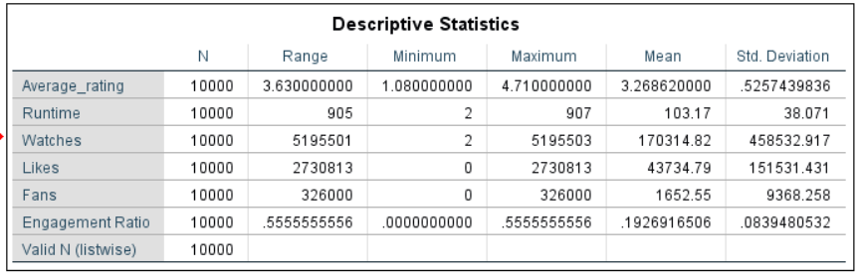
Fig 4: Descriptive statistics table (SPSS output)

By contrast, engagement measures show significant variability. The variable number of watches, likes, and fans has very large ranges and standard deviations compared to their means, suggesting that a few films are receiving a disproportionate amount of attention, while the rest are relatively less popular. For example, watches vary from very low to millions, underscoring the highly skewed pattern of audience engagement with films. Likewise, the Engagement Ratio, with a mean of around 0.19, shows variance in the effectiveness of films in translating visibility to interaction.
This distribution is a long tail, where a small number of highly popular films attract disproportionate interaction, while a majority of films attract relatively less interaction. This pattern is typical of digital media ecologies, where computer algorithms and network effects drive the visibility of popular films. Consequently, engagement variables are highly skewed, while ratings are less so.
The film ratings histogram shows a grouping around the mean, confirming their normal or slightly skewed distribution with no noticeable outliers. Conversely, boxplots of engagement variables show outliers, reinforcing the view of skewness and inequality in audience engagement. This demonstrates that audience popularity and quality perception follow distinct statistical distributions, with ratings exhibiting stable user assessment and engagement exhibiting exposure-based distribution.
Skewness is essential for entertainment businesses. The high degree of skewness in the distribution of engagement suggests that using raw metrics (views, likes) as the sole basis for decision making may result in a skew towards popular content, with under-representation of niche, yet potentially high-quality content (Ren and Chandra, 2025). Consequently, using balanced metrics such as the engagement ratio and distribution analysis allows better business intelligence practices to be implemented, which can enhance recommendation engines and ensure an eclectic content portfolio in line with industry trends in algorithm-driven content strategy (Deloitte, 2025).

TREND ANALYSIS & VISUALISATION
Trend analysis was performed using Excel to examine relationships between ratings and engagement for various film attributes, complemented with visualisations to detect dependencies and correlations in the data.
Genre-based ratings analysis shows audience ratings vary significantly. Documentary, history, and war genres have higher average ratings, while action, science fiction and horror genres have lower average ratings. This implies a differentiation between quality and commercial value, where content linked to realism, storytelling or educational content may be more highly rated, whereas commercialised content may focus on entertainment and popular appeal rather than critical assessment (Ren and Chandra, 2025). But this explanation must be taken with a grain of salt, since genre categorisation has been simplified during data processing and may have diminished the complexity of films.
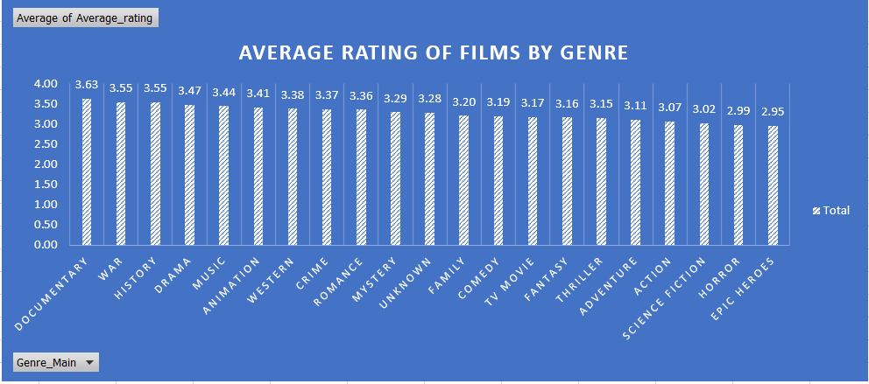
Fig 5: Bar chart: Average Rating by Genre

Additionally, the analysis by language reveals a consistent pattern, with non-English films garnering higher average ratings than English films. This could be driven by demand for culturally different or unique content, but it might also be affected by sample bias, with only quality non-English films being made available to global audiences. Consequently, the difference observed may not apply to all non-English films, but to a selected segment.
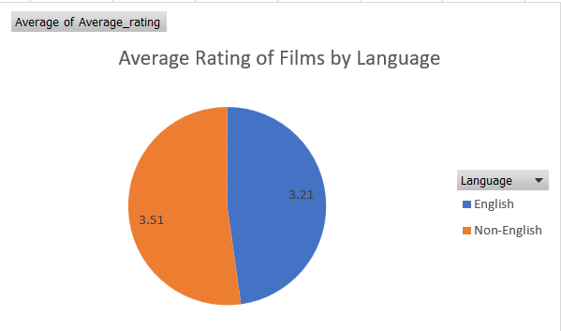
Fig 6: Bar chart: Ratings by Language

Scatter plots shed more light on relationships among engagement metrics. Watches and likes are positively correlated in a linear fashion, with more views leading to more engagement. This finding confirms the idea of "exposure-driven engagement", where content with higher visibility has a greater chance of receiving user interaction regardless of its quality. However, the correlation between runtime and rating is low, meaning that film duration has little impact on viewer perceptions.
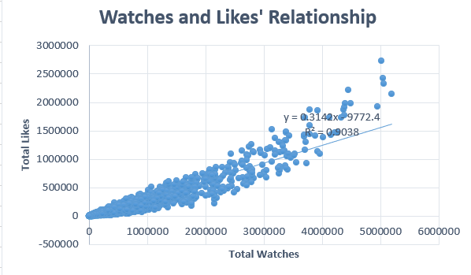
Fig 7: Scatter: Watches vs Likes
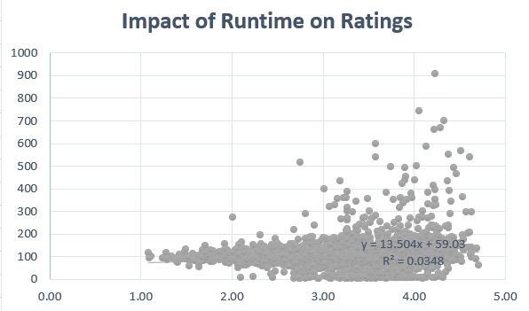
Fig 8: Scatter: Runtime vs Rating

Likewise, there is a weak correlation between fans and rating, suggesting that metrics of popularity do not translate into perceived quality.
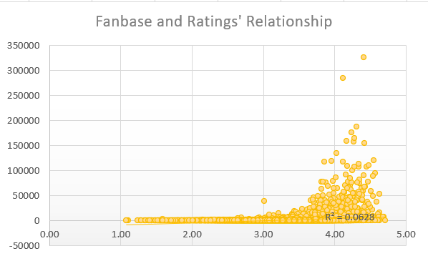
Fig 9: Scatter: Fanbase vs Rating

This analysis also sheds more light on audience engagement patterns across genres. Genres like music, documentary, and animation have relatively higher engagement ratios, which may reflect the genres' ability to engage the audience better. On the other hand, genres like epic heroes and TV movies have relatively lower engagement ratios, implying less audience interaction. But the variations between genres are not drastic, and most engagement ratios fall within a relatively small range (around 0.16 to 0.23). This implies that genre is just one of several factors that affect engagement. Rather, engagement is likely a product of a mix of content, audience and visibility factors. In summary, the chart supports the notion that engagement levels differ across genres but are relatively equal, and that it is important to examine several factors to assess content performance.
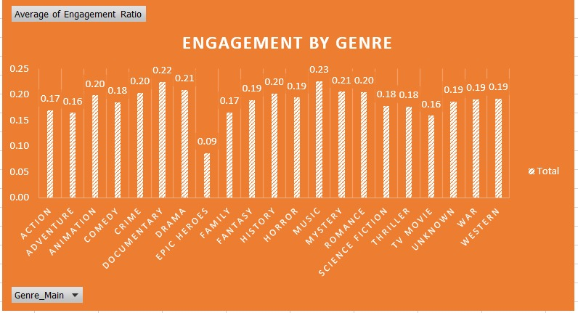
Fig 10: Engagement by Genre

In terms of the relationship between likes and ratings, the chart in Fig 11 reveals the existence of a positive but fairly weak correlation. Although there is an overall upward trend that implies higher-rated films attract more likes, the scatter of the data points suggests that this trend is weak and not highly predictive. The stated R² value of around 0.084 also confirms that only a small part of likes can be explained by ratings. This suggests that while higher-rated films may receive more likes, there are other factors - such as high visibility, marketing, and the site's algorithm - which play a significant role in determining likes. The presence of multiple high-like outliers at comparable ratings also suggests that engagement is not uniformly spread and not exclusively based on quality ratings.

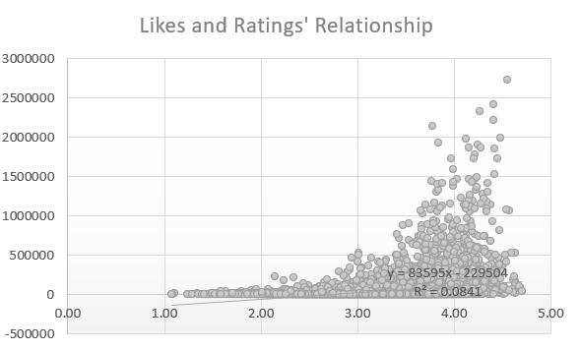
Fig 11: Likes and Ratings

STATISTICAL ANALYSIS (SPSS)

Independent Samples T-Test
Using SPSS, an independent samples t-test was performed to test whether the difference in the mean ratings of English and non-English films is statistically significant. The analysis shows that the average rating for non-English films (≈3.51) is greater than the average rating for English films (≈3.21). The p-value (p = 0.000) is less than the 0.05 significance level, indicating that the difference between the two means is statistically significant and not due to chance.
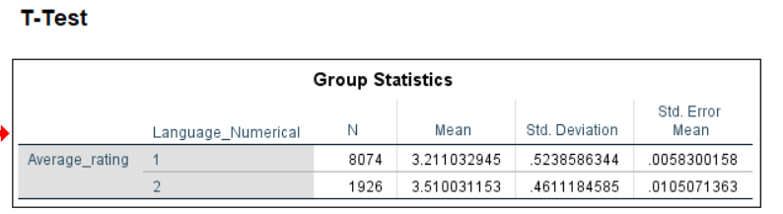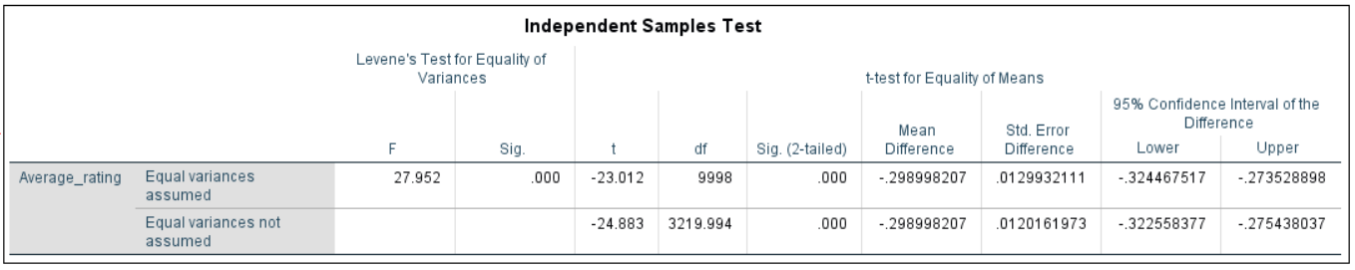
Fig 12: T-Test table (Group Statistics + Significance)

The result implies that language is a significant factor in the audience's assessment. This is significant for international streaming and media companies from a business intelligence standpoint. Media organisations and streaming services may want to consider investing in international and non-English film content, which may lead to greater audience satisfaction (Esser and Steemers, 2026). But this finding must be taken with a grain of salt, as it could be a case of selection bias; only good-quality non-English films will be promoted internationally.

Correlation Analysis
Pearson correlation tests were conducted to explore the relationships between the variables. We found a very strong correlation between watches and likes (r = 0.951), suggesting that popularity leads to greater audience engagement. Likes also correlate positively and highly with fans (r = 0.799), suggesting that engagement leads to audience loyalty (Hollebeek et al., 2019).
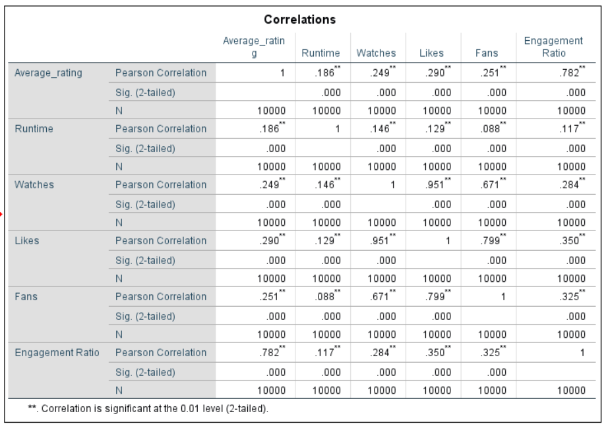
Fig 13: Correlation matrix

But the relationship between average rating and engagement variables is rather weak (r ≈ 0.25-0.29), suggesting that popularity is not a reflection of quality. This supports the idea that popularity attracts engagement but not necessarily satisfaction.
A new variable that has been added is the strong positive correlation between Engagement Ratio and average rating (r ≈ 0.78). This indicates that films that successfully translate exposure into engagement are more likely to be highly rated. However, this finding needs to be treated with caution, since the engagement ratio is a derived measure. Thus, some of the strengths could be due to mathematical relationships rather than just behavioural interactions.

Regression Analysis
A multiple linear regression was performed to determine the degree to which film duration, number of watches, likes and fans are associated with average film ratings. The model is significant (p = 0.000), meaning that the predictors as a group are related to ratings. The model only accounts for 11.7% of the variance (R² = 0.117), indicating its low explanatory power of explanation.
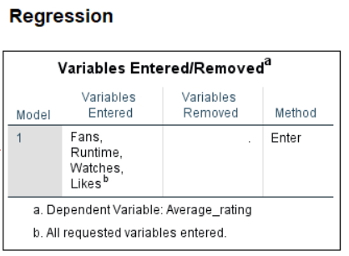
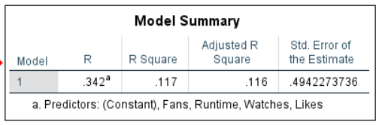
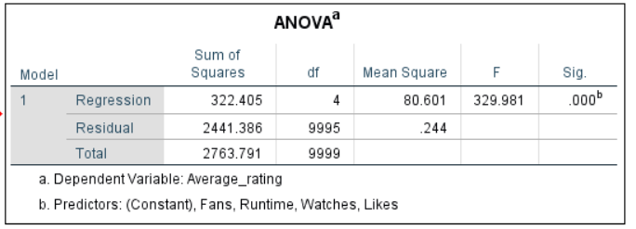
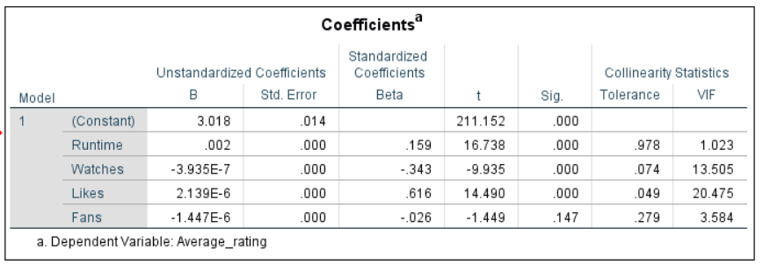
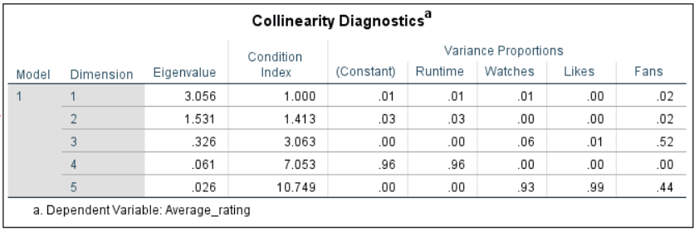
Fig 14: Regression output (Model Summary + Coefficients)

Likes emerge as the most significant predictor with a positive association, followed by a less significant positive association with runtime. On the other hand, watches have a negative coefficient, suggesting that popular films are not necessarily the best rated. Fans are not significant, suggesting the number of fans is not a good predictor of ratings when other factors are taken into account.
A major concern with the model is the presence of multicollinearity between watches and likes, as these are strongly correlated. This is evident from the low tolerance scores, showing they are measuring similar engagement. Multicollinearity weakens the interpretability of regression coefficient estimates and reduces the confidence in conclusions made with this model (Kyriazos and Poga, 2023).
In sum, the model is statistically significant but has low predictive power. This implies that other factors affecting film ratings are missing from the data, including budget, actor talent, marketing and reviews. As a result, although engagement metrics offer partial information, they are not enough to predict audience ratings.

INSIGHTS & RECOMMENDATIONS

Key Insights
The findings bring to light a number of insights into audience engagement and film success. First, there is a distinction between popularity and quality, with variables such as watches, likes and fans showing a strong correlation with each other, but only a weak correlation with ratings. This suggests that popularity is more a function of exposure than satisfaction. Second, the average ratings of non-English films are higher, indicating higher audience satisfaction, albeit possibly due to sample bias. Third, different film genres have a notable impact: documentary and history are rated higher than commercial genres like action and science fiction. Finally, the advent of the Engagement Ratio shows that films that are able to transform viewers' viewing experiences into engagement activities are more likely to score higher ratings, making it a better predictor of success than traditional engagement metrics.

Business Recommendations
From a business intelligence point of view, these results indicate that streaming services and media companies should stop focusing solely on engagement metrics. Rather, platforms should consider using engagement quality metrics such as engagement ratios to better understand audience satisfaction. What's more, there is a clear need to support high-quality niche content, especially in genres that achieve higher ratings, to enhance content variety and customer satisfaction.
From a strategic perspective, companies should prioritise investment in non-English and international films, capitalising on their superior audience ratings to reach global audiences and target different user groups. Also, recommendation services should be optimised to achieve a balance between reach and quality, so highly rated but less visible content is not dominated by mainstream content.

Limitations
However, there are limitations to these findings. The regression model exhibits low explanatory power, suggesting that variables such as budget, cast, promotion and newspaper reviews are not considered. Finally, potential biases in the data set or film selection may affect the analysis, especially for non-English films. As such, future research should include more variables to increase prediction accuracy and inform decision-making.

REFERENCES

Ahmed, A. and Abdulkareem, A.M., 2023. Big data analytics in the entertainment industry: audience behaviour analysis, content recommendation, and revenue maximisation. Reviews of Contemporary Business Analytics, 6(1), pp.88-102.

Attwal, K. and Singh, A., 2024. Exploring SPSS statistics for data mining and statistical modeling. International Journal of Statistics and Applied Mathematics, 9(3), pp.09-16.

Brown, P.A. and Anderson, R.A., 2023. A methodology for preprocessing structured big data in the behavioral sciences. Behavior research methods, 55(4), pp.1818-1838.

Deloitte, 2025. Media and entertainment industry outlook. Deloitte Insights. Available at: https://www.deloitte.com/us/en/insights/industry/technology/technology-media-telecom-outlooks/2025-media-entertainment-outlook.html (Accessed: 1 May 2026).

Emma, L., 2024. Data-driven decision-making and business intelligence in modern organizations. Ladoke Akintola University of Technology.

Esser, A. and Steemers, J., 2026. Global platforms, new media generations and Anglo-American hegemony: An exploration of young audience viewing and language preferences in four European countries. Critical Studies in Television, 21(1), pp.16-37.

Hollebeek, L.D., Srivastava, R.K. and Chen, T., 2019. S-D logic–informed customer engagement: Integrative framework, revised fundamental propositions, and application to CRM. Journal of the Academy of Marketing Science, 47(1), pp.161–185.

Kyriazos, T. and Poga, M., 2023. Dealing with multicollinearity in factor analysis: the problem, detections, and solutions. Open Journal of Statistics, 13(3), pp.404-424.

Ren, G. and Chandra, R., 2025. Analysis of IMDb movie reviews and ratings using a language model framework. IEEE Access, 13, pp.192655-192673.
Sai, V.S., Nair, G.P. and Krishnan, G., 2025, May. Beyond the Spotlight: AI-Driven Data Mining and Business Intelligence in Entertainment–A Review. In World Conference on Artificial Intelligence: Advances and Applications (pp. 99-109). Cham: Springer Nature Switzerland.

