

Student Name: Shajna Azad

Student ID: 2232143

Module Name: Social Epidemiology and Public

Health Development

Module Code: LCHS7000

Assignment Title: Component 2, Analytical Report

Lecturer: Dr Hamdi Hussain

Contents
Introduction 3
Type 2 Diabetes 4
Cardiovascular Disease 4
Maternal and Perinatal Health 5
Poverty and Socioeconomic Deprivation 5
Overcrowded and Insecure Housing 6
Barriers to Healthcare Access and Cultural Competence 6
National Response to Reduce Health Inequality 6
Organisation Supporting South Asian Communities 7
Conclusion 7
Epidemiological Analysis: Type 2 Diabetes Among South Asian Adults in Inner-City Birmingham (Aston, Newtown, Lozells, Bordesley Green) 8
Introduction 8
Public Health Measures: Using the 3 P’s 9
Prevention 9
Protection 9
Promotion 9
Key Determinants and Risk Factors 10
Biomedical Risk 10
Structural Determinants 10
Healthcare Determinants 10
Health Needs Assessment and Identification of At-Risk Groups 10
Monitoring and Surveillance Systems 11
Public Health Impact 12
Proposed Programme 13
Healthy Steps Birmingham: South Asian Community Diabetes Support Programme 13
Aim 13
Objectives 13
Key Activities 13
Evaluation of the Intervention 14
Recommendations 15
Bibliography 16

Health Inequality in South Asian Communities: A Social Epidemiological Analysis

Introduction
South Asian communities in England defined in the UK Census as individuals identifying as Indian, Pakistani and Bangladeshi, constitute one of the largest ethnic minority groups nationally. Despite improvements in population health, persistent ethnic health inequality affects these groups, with substantially higher burdens of Type 2 diabetes, cardiovascular disease and adverse maternal health outcomes than among White British people. Evidence indicates that people from Pakistani and Bangladeshi backgrounds have some of the highest rates of chronic disease in England, including diabetes and cardiovascular disease, compared with other ethnic groups (The Health Foundation, 2025).
These disparities are not explained solely by biological susceptibility; social epidemiology emphasises that health is shaped by structural determinants such as socioeconomic deprivation, housing, occupational conditions, and unequal access to culturally responsive healthcare services. Furthermore, the risk of Type 2 diabetes among South Asian people increases from around age 25, substantially earlier than in White populations where risk typically rises after age 40 (England, 2023). From a life-course perspective, cumulative exposure to disadvantage increases vulnerability to chronic disease and entrenches inequality gradients.
This report examines three major disease burdens and three key social determinants affecting South Asian communities, then evaluates national responses and the role of voluntary sector organisations in addressing health inequality.

Type 2 Diabetes
South Asian populations in England experience considerably higher prevalence of Type 2 diabetes than White British populations, with estimates suggesting up to three to six times greater risk in South Asians compared with White people (Commission on Race and Ethnic Disparities, 2021). Diabetes also develops at a younger age and often with greater severity and risk of complications. Structural factors such as socioeconomic deprivation, limited access to healthy food environments, and occupational constraints, interact with biological predisposition to elevate risk. For example, South Asian individuals are more likely to develop insulin resistance at a lower BMI, a recognised risk mechanism for diabetes (NHS, 2022).
Addressing this inequality requires early screening, culturally adapted intervention programmes, and community-engaged health promotion. Programmes such as the NHS Diabetes Prevention Programme aim to reduce incidence, but evidence suggests that uptake may be lower in ethnic minority communities without culturally tailored delivery.

Cardiovascular Disease
Cardiovascular disease (CVD) risk is also higher in South Asian populations. Compared with White Europeans, South Asians have elevated risk of coronary heart disease and stroke, including evidence of nearly twice the likelihood of developing coronary heart disease in some studies (Mehta, 2024). South Asian groups also exhibit higher prevalence of elevated blood pressure, blood sugar and abnormal cholesterol profiles, all of which are established CVD risk factors (Commission on Race and Ethnic Disparities, 2021). Chronic stress associated with deprivation and discrimination may further amplify risk pathways, while unequal uptake of preventive services such as NHS Health Checks may delay early detection and treatment.
Reducing inequality in CVD requires improved access to preventive screening, systematic management of hypertension and lipid control, and culturally appropriate lifestyle support that accounts for dietary and social norms.
Maternal and Perinatal Health
South Asian women have higher prevalence of gestational diabetes and experience disproportionate maternal and perinatal health risks compared with the White British population. Although national maternity data by ethnicity can be patchy, evidence from health inequalities analysis shows that ethnic minority women have elevated diabetes-linked risk factors contributing to poorer maternal outcomes (Raleigh, 2025). Contributing factors include delayed engagement with antenatal care, language barriers, and cultural mismatch in service provision.
Promoting equitable maternal health outcomes requires continuity of midwifery care, effective interpreter services, and targeted outreach to ensure early booking and culturally safe care pathways.

Poverty and Socioeconomic Deprivation
Socioeconomic deprivation is a key driver of ethnic health inequality. South Asian households, particularly Pakistani and Bangladeshi, are disproportionately represented in the most deprived neighbourhoods in England, with higher child poverty and lower household income levels compared with national averages (Cook, Sachs and Weiskopf, 2021). This material disadvantage constrains access to healthy foods, safe environments for physical activity, and opportunities for stable employment, contributing to chronic disease risk. Social epidemiology posits that structural inequalities shape exposure to multiple health risk factors over time, reinforcing poorer health outcomes (Au-Yeung et al., 2024).
Policy approaches that integrate income support, employment protections, and embedded welfare advice within healthcare settings are critical to address upstream determinants of health inequality.

Overcrowded and Insecure Housing
South Asian households are more likely to experience overcrowding and suboptimal housing conditions than the White British population. Overcrowding is associated with elevated stress, poorer mental health, and increased transmission of communicable conditions. Poor housing quality may also limit opportunities for health-promoting activities and compound chronic disease risk (Cook, Sachs and Weiskopf, 2021).
Public health action should include enforcement of housing standards, targeted local authority improvement programmes, and cross-sector collaboration between health and housing services.

Barriers to Healthcare Access and Cultural Competence
Language barriers, limited health literacy, and culturally mismatched services can reduce engagement with preventative healthcare among South Asian people (The Kings Fund, 2023). Lower uptake of screening and diabetes self-management services has been observed in some areas, while structural issues, such as inadequate interpreter provision and limited workforce cultural competence training, continue to reinforce disparities. Systematic equity audits and investment in community health workers who bridge cultural and linguistic gaps can improve access and outcomes (The Kings Fund, 2023).

National Response to Reduce Health Inequality
National strategies have increasingly recognised ethnic health inequality. The NHS Core20PLUS5 framework identifies ethnic minority groups as priority populations for targeted healthcare intervention, aiming to reduce care variation and improve outcomes (NHS England, 2021). Additionally, the NHS Long Term Plan emphasises prevention and reducing avoidable health disparities in long-term conditions such as diabetes and cardiovascular disease. However, implementation challenges remain; evidence indicates that without culturally tailored delivery and community engagement, these initiatives may not fully reach South Asian communities.

Organisation Supporting South Asian Communities
Diabetes UK plays a significant role in addressing diabetes-related inequality. The charity funds research on ethnic disparities, advocates for equitable care standards, and produces culturally adapted educational resources. Through community outreach initiatives and partnerships with local health providers, Diabetes UK helps raise awareness of elevated diabetes risk in South Asian populations and supports early detection and lifestyle management.
While voluntary sector organisations contribute valuable advocacy and engagement, sustainable reduction in inequality requires coordinated policy action and systemic changes in service design and resource allocation.

Conclusion
South Asian communities in England experience persistent health inequalities characterised by elevated burden of Type 2 diabetes, cardiovascular disease, and adverse maternal health risks. These disparities are socially patterned, shaped by structural determinants such as socioeconomic deprivation, housing inequality, and barriers to culturally competent healthcare. Although national frameworks such as Core20PLUS5 and the NHS Long Term Plan acknowledge inequality, meaningful reduction requires culturally responsive implementation and cross-sector collaboration. A social epidemiological perspective demonstrates that ethnic health inequality is produced through modifiable social structures and is therefore amenable to systemic intervention.

Analysis: Type 2 Diabetes Among South Asian Adults in Inner-City Birmingham (Aston, Newtown, Lozells, Bordesley Green)

Introduction
Type 2 diabetes (T2D) is a chronic metabolic disorder characterised by insulin resistance and progressive pancreatic β-cell dysfunction, leading to sustained hyperglycaemia and long-term vascular complications (Forouhi and Wareham, 2019). If inadequately controlled, T2D increases the risk of coronary heart disease, stroke, chronic kidney disease, neuropathy and retinopathy (World Health Organization, 2016). Common clinical manifestations include polyuria, polydipsia, persistent fatigue, blurred vision, slow wound healing and recurrent infections. Because symptoms often develop gradually, diagnosis may be delayed, increasing the likelihood of long-term complications (NHS, 2025).
Globally, diabetes affects approximately 537 million adults and remains a leading cause of premature mortality (World Health Organization, 2023). In the United Kingdom, approximately 4.3–4.9 million individuals are living with diabetes, with around 90% diagnosed with Type 2 diabetes (Diabetes UK, 2023). Public Health Fingertips data indicate that Birmingham Local Authority reports diabetes prevalence above the England average. Inner-city wards such as Aston, Lozells, Newtown and Bordesley Green are characterised by high deprivation and substantial South Asian populations (Birmingham.gov.uk, 2025).
Epidemiological analysis indicates that diabetes prevalence in Birmingham increased from 6.6% in 2009–2010 to 9.1% in 2021–2022, consistently exceeding the national prevalence in England (Au-Yeung et al., 2024). Regional data also show that the West Midlands has one of the highest diabetes prevalence rates in England, affecting approximately 8.6% of adults (Office for Health Improvement & Disparities, 2025). Local ward-level data highlight the concentration of disease burden in deprived areas, with prevalence approaching 9–10% in wards such as Bordesley Green and Balsall Heath (Diabetes UK, 2023).
This report aims to analyse the epidemiology of Type 2 diabetes among South Asian adults living in deprived inner-city wards of Birmingham and to evaluate the public health strategies used to monitor, prevent and reduce disease burden within this defined population.

Public Health Measures: Using the 3 P’s

Prevention
Primary prevention strategies in England include structured lifestyle interventions and referral to the NHS Diabetes Prevention Programme (NHS England, 2023b). The programme aims to reduce progression from non-diabetic hyperglycaemia to T2D through dietary modification and increased physical activity. For South Asian communities in deprived Birmingham wards, culturally adapted delivery is particularly important due to earlier disease onset and higher baseline risk.
Secondary prevention through NHS Health Checks seeks to identify high-risk individuals aged 40–74, although earlier screening is recommended for South Asian populations due to earlier onset risk (The King’s Fund, 2015). Proactive risk stratification within general practice in Aston and Lozells is therefore epidemiologically justified.

Protection
Protection measures aim to prevent complications among those already diagnosed. The Quality and Outcomes Framework (QOF) enables routine monitoring of diabetes prevalence and management indicators, including HbA1c control and blood pressure regulation (NHS England, 2023b). The National Diabetes Audit further evaluates care processes and outcomes across England (NHS England, 2023b).
Diabetic eye screening programmes and structured annual reviews aim to reduce microvascular complications (NHS England, 2023). However, attendance disparities have been observed in deprived urban populations, potentially reinforcing inequalities if not actively addressed (Marmot et al., 2020).

Promotion
Health promotion strategies in Birmingham include community engagement initiatives and social prescribing schemes delivered through Primary Care Networks. Evidence suggests that culturally adapted interventions, such as bilingual health educators and faith-based outreach, improve engagement in South Asian communities (Diabetes UK, 2025). Promotion must therefore integrate behavioural change messaging with structural support to address socioeconomic barriers affecting health behaviours.

Key Determinants and Risk Factors

Biomedical Risk
South Asian populations exhibit elevated insulin resistance and central adiposity at lower BMI thresholds compared with White populations. Health Survey for England analysis demonstrates higher rates of impaired glucose regulation among South Asian adults (NHS England, 2022). Earlier onset increases cumulative glycaemic exposure and complication risk across the life course.

Structural Determinants
Epidemiological evidence suggests that the elevated burden of diabetes within South Asian communities cannot be explained by ethnicity alone. Attributable fraction analysis estimates that approximately 64% of diabetes cases and 44% of pre-diabetes cases are attributable to socioeconomic deprivation, highlighting the importance of structural determinants (Au-Yeung et al., 2024; Diabetes UK, 2022). Prevalence odds ratios further demonstrate a strong association between Asian ethnicity and diabetes (POR = 5.43, p < 0.001), with risk increasing substantially when ethnicity interacts with deprivation (Au-Yeung et al., 2024; D James et al., 2012).
However, these estimates should be interpreted with caution, as measures such as attributable fractions and odds ratios derived from observational studies indicate statistical association rather than causation and may be affected by residual confounding or limitations in the measurement of socioeconomic factors (Cook, Sachs and Weiskopf, 2021).

Healthcare Determinants
Barriers including language differences, health literacy gaps and cultural mismatch in service delivery may reduce preventive service uptake (The King’s Fund, 2023). Incomplete ethnicity coding within primary care datasets can also obscure true prevalence patterns (NHS, 2023a).

Health Needs Assessment and Identification of At-Risk Groups
A local health needs assessment integrates epidemiological, comparative and expressed need (D James et al., 2012). Public Health Fingertips data indicate that Birmingham’s diabetes prevalence exceeds the England average. Hospital Episode Statistics data show elevated admission rates for diabetes-related complications in deprived urban populations (Winkley et al, 2013).
Comparative analysis indicates significantly higher incidence among South Asian populations relative to White groups (Winkley et al., 2013). Expressed need can be assessed through NHS Health Check uptake rates and Diabetes Prevention Programme engagement (NHS England, 2021). Limitations include underdiagnosis and ecological bias when interpreting ward-level deprivation data (D James et al., 2012).

Monitoring and Surveillance Systems
Diabetes monitoring in England relies on a combination of passive, sentinel and active surveillance systems that allow public health authorities to track incidence and disease patterns.
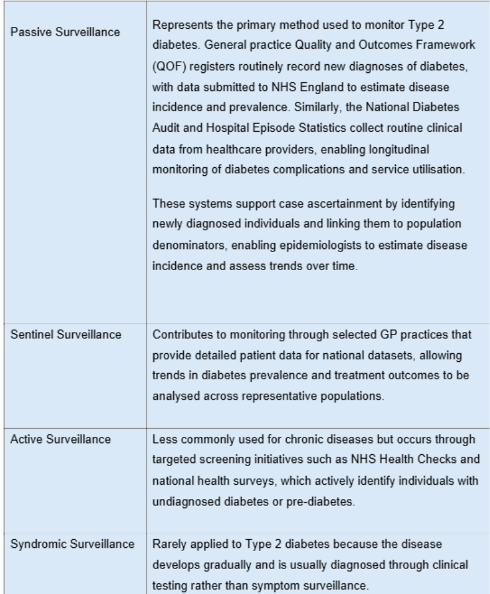

Public Health Impact
Type 2 diabetes has substantial short- and long-term public health consequences among South Asian populations living in deprived urban areas of Birmingham.
In the short term, diabetes increases healthcare utilisation, including greater demand for GP consultations, medication prescribing and hospital admissions for acute complications such as hyperglycaemia and cardiovascular events (NHS, 2023). Epidemiological data show that diabetes prevalence in Birmingham increased from 6.6% in 2009–2010 to 9.1% in 2021–2022, demonstrating the growing burden of disease within the city (Au-Yeung et al., 2024).
Over the long term, Type 2 diabetes significantly increases the risk of major chronic complications. Longitudinal evidence from the UK Prospective Diabetes Study demonstrated that sustained hyperglycaemia significantly increases the risk of long-term complications, including cardiovascular disease, nephropathy and retinopathy. The study showed that each 1% reduction in HbA1c was associated with a 21% reduction in diabetes-related complications (Stratton et al., 2000; (Rao Kondapally Seshasai et al., 2011).
In addition, diabetic retinopathy remains a leading cause of preventable blindness among working-age adults (Rao Kondapally Seshasai et al., 2011), while peripheral neuropathy may result in diabetic foot ulcers and lower-limb amputations. Population studies further estimate that Type 2 diabetes can reduce life expectancy by up to six years, particularly when diagnosed earlier in life Stratton et al., 2000). Earlier onset among South Asian populations therefore increases the lifetime burden of disease and risk of long-term complications.

Proposed Programme

Healthy Steps Birmingham: South Asian Community Diabetes Support Programme
Healthy Steps Birmingham would be a community-based lifestyle and diabetes self-management programme designed for South Asian adults living in deprived inner-city wards such as Aston, Newtown, Lozells and Bordesley Green. The programme would aim to improve physical activity, health knowledge and diabetes self-management by delivering culturally appropriate health promotion activities within trusted community settings.

Aim
To improve lifestyle behaviours and diabetes management among South Asian adults in inner-city Birmingham in order to reduce the progression and complications of Type 2 diabetes using the theoretical framework of the health belief model (Abraham and Sheeran, 2005).

Objectives
- Increase participation in regular physical activity among South Asian adults within 12 months.
- Improve knowledge and attitudes regarding healthy diet, physical activity and diabetes management.
- Increase engagement with primary care services, including diabetes screening and annual reviews.

Key Activities
Walk and Talk Sessions
Community walking groups organised after school drop-off times would encourage regular physical activity while providing opportunities for social interaction and peer support. These sessions would be facilitated by trained community health workers and would include short discussions on healthy lifestyle behaviours.
Paint and Talk Community Sessions
Creative group sessions held in community centres or faith-based venues would provide a relaxed environment where women can discuss health concerns while participating in social activities such as art or crafts. These sessions would incorporate culturally tailored diabetes education and peer discussion.
Culturally Tailored Health Education
Educational sessions delivered by bilingual community health workers would provide information on diet, physical activity and diabetes management in relevant languages.

Evaluation of the Intervention
Evaluation would be integrated into the programme using several approaches:
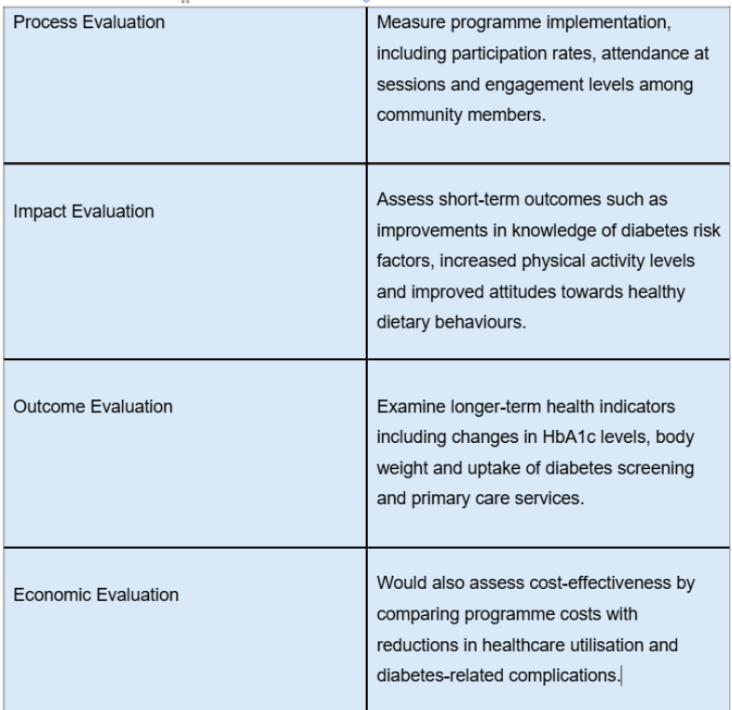
Through culturally sensitive community engagement and systematic evaluation, the programme aims to improve lifestyle behaviours and reduce the burden of Type 2 diabetes in this high-risk population

Recommendations
Type 2 diabetes remains a significant public health challenge within South Asian communities living in deprived inner-city areas of Birmingham. Epidemiological evidence demonstrates that the burden of disease is shaped by the interaction of biological susceptibility, socioeconomic deprivation and barriers to culturally appropriate healthcare. Addressing this inequality requires targeted public health interventions that are sensitive to cultural context and community needs.
It is recommended that local health authorities expand culturally tailored lifestyle programmes delivered through community settings, including initiatives that promote physical activity and social support such as community walking groups and culturally appropriate health education sessions. In addition, earlier diabetes screening for South Asian populations should be prioritised within primary care to support earlier diagnosis and intervention. Improving ethnicity recording within surveillance systems and strengthening community health worker programmes may further support engagement with high-risk population. Implementing these measures could contribute to improved diabetes management and reduced health inequalities within Birmingham’s South Asian communities.

Bibliography
Abraham, C. and Sheeran, P. (2005) ‘The Health belief model’ in Conner, M. and Norman, P. (editors), Predicting health behaviour, Berkshire, England: Open University Press.
Au-Yeung, C.H., Ellis, D., Dallaway, A., Riley, J., Varney, J. and Howell-Jones, R. (2024). Socioeconomic and ethnic inequalities increase the risk of type 2 diabetes: an analysis of NHS health check attendees in Birmingham. Frontiers in Public Health, 12. doi:https://doi.org/10.3389/fpubh.2024.1477418.
Birmingham City Council (2019). Joint Strategic Needs Assessment (JSNA) | Birmingham City Council. www.birmingham.gov.uk. Available at: https://www.birmingham.gov.uk/info/50268/joint_strategic_needs_assessment_jsna. (Accessed: 1 March. 2026).
Birmingham.gov.uk. (2025). IMD - Indices of Deprivation 2025 - WMCA Wards (2024). Available at: https://cityobservatory.birmingham.gov.uk/explore/dataset/imd-indices-of-deprivation-2025-wmca-wards-2024/insight/?disjunctive.local_authority_code_2024&disjunctive.local_authority_name_2024&disjunctive.ward_code_2024&disjunctive.ward_name_2024&refine.local_authority_name_2024=Birmingham. (Accessed: 5 March. 2026).
Birmingham.gov.uk. (2026). Diabetes: QOF prevalence - Birmingham Wards. Available at: https://www.cityobservatory.birmingham.gov.uk/explore/dataset/diabetes-qof-prevalence-birmingham-wards/insight/?disjunctive.area_name. (Accessed: 15 February. 2026).
Commission on Race and Ethnic Disparities (2021). Ethnic disparities in the major causes of mortality and their risk factors – a rapid review. GOV.UK. Available at: https://www.gov.uk/government/publications/the-report-of-the-commission-on-race-and-ethnic-disparities-supporting-research/ethnic-disparities-in-the-major-causes-of-mortality-and-their-risk-factors-by-dr-raghib-ali-et-al. (Accessed: 10 March. 2026).
Cook, L.A., Sachs, J. and Weiskopf, N.G. (2021). The quality of social determinants data in the electronic health record: a systematic review. Journal of the American Medical Informatics Association. doi:https://doi.org/10.1093/jamia/ocab199.
D James, G., Baker, P., Badrick, E., Mathur, R., Hull, S. and Robson, J. (2012). Ethnic and social disparity in glycaemic control in type 2 diabetes; cohort study in general practice 2004–9. Journal of the Royal Society of Medicine, 105(7), pp.300–308. doi:https://doi.org/10.1258/jrsm.2012.110289.
Diabetes UK (2022). Risk of Type 2 Diabetes in the South Asian Community. Diabetes UK. Available at: https://www.diabetes.org.uk/node/12895. (Accessed: 1 March. 2026).
Diabetes UK (2023). How Many People in the UK Have diabetes? Diabetes UK. Available at: https://www.diabetes.org.uk/about-us/about-the-charity/our-strategy/statistics. (Accessed: 7 March. 2026).
Diabetes UK. (2025). Tackling Inequity. Available at: https://www.diabetes.org.uk/about-us/our-impact/tackling-inequity. (Accessed: 10 March. 2026).
Editor (n.d.). Diabetes rate highest in Birmingham. Diabetes. Available at: https://www.diabetes.co.uk/news/2013/aug/diabetes-rate-highest-in-birmingham-92031930.html. (Accessed: 1 March. 2026).
England, N. (2023a). NHS England — Midlands» Black and South Asian people in the East Midlands urged to act now to prevent or delay Type 2 diabetes. England.nhs.uk. Available at: https://www.england.nhs.uk/midlands/2023/01/25/black-and-south-asian-people-in-the-east-midlands-urged-to-act-now-to-prevent-or-delay-type-2-diabetes. (Accessed: 29 February. 2026).
Ethnicity, deprivation and diabetes inequality Position Statement: June 2022 Key points. (n.d.). Available at: https://www.diabetes.org.uk/sites/default/files/2022-06/Inequalities%20position%20statement%20-%20Final%20June.pdf. (Accessed: 10 March. 2026).
Forouhi, N.G. and Wareham, N.J. (2019). Epidemiology of diabetes. Medicine, (online) 47(1), pp.22–27. doi:https://doi.org/10.1016/j.mpmed.2018.10.004.
Health (2026). Local Authority Health Profiles - Data | Fingertips | Department of Health and Social Care. Phe.org.uk. Available at: https://fingertips.phe.org.uk/profile/health-profiles/data#page/3/gid/1938132695/pat/6/par/E12000005/ati/302/are/E08000025/iid/93347/age/187/sex/4/cat/-1/ctp/-1/yrr/1/cid/4/tbm/1. (Accessed: 4 March. 2026).
Health inequalities in Birmingham Barriers encountered in underserved wards in East and West Birmingham. (n.d.). Available at: https://www.aston.ac.uk/sites/default/files/2024-01/Health%20inequalities%202023%20Report%20sp.pdf. (Accessed: 10 March. 2026).
Live.com. (2019). Available at: https://view.officeapps.live.com/op/view.aspx?src=https%3A%2F%2Fassets.publishing.service.gov.uk%2Fmedia%2F5d8b3abded915d0373d3540f%2FFile_1_-_IMD2019_Index_of_Multiple_Deprivation.xlsx&wdOrigin=BROWSELINK. (Accessed: 29 February. 2026).
Marmot, M. (2015). The health gap : the challenge of an unequal world. London, England: Bloomsbury Press, An Imprint Of Bloomsbury Publishing Plc.
Marmot, M., Allen, J., Boyce, T., Goldblatt, P. and Morrison, J. (2020). HEALTH EQUITY IN ENGLAND: THE MARMOT REVIEW 10 YEARS ON. Available at: https://www.health.org.uk/sites/default/files/upload/publications/2020/Health%20Equity%20in%20England_The%20Marmot%20Review%2010%20Years%20On_full%20report.pdf. (Accessed: 5 March. 2026).
Marmot, M. and Wilkinson, R. (2003). The solid facts : Social determinants of health. 2nd ed. Copenhagen: Centre for Urban Health, World Health Organization.
Mehta, K. (2024). South Asians almost twice as likely to develop coronary heart disease than White Europeans. www.bhf.org.uk. Available at: https://www.bhf.org.uk/what-we-do/news-from-the-bhf/news-archive/2024/june/south-asians-almost-twice-as-likely-to-develop-coronary-heart-disease-than-white-europeans. (Accessed: 5 March. 2026).
Montgomery Peterson Publishing (2019). Weekly Planner 2020.
National Health Service (2025). Symptoms - type 2 diabetes. NHS. Available at: https://www.nhs.uk/conditions/type-2-diabetes/symptoms/. (Accessed: 29 February. 2026).
NHS (2022). Diabetes. NDRS. Available at: https://digital.nhs.uk/data-and-information/publications/statistical/health-survey-england-additional-analyses/ethnicity-and-health-2011-2019-experimental-statistics/diabetes. (Accessed: 29 February. 2026).
NHS (2025). What is type 2 diabetes? NHS. Available at: https://www.nhs.uk/conditions/type-2-diabetes/what-is-type-2-diabetes/. (Accessed: 29 February. 2026).
NHS England (2021). Core20PLUS5 an Approach to Reducing Health Inequalities. www.england.nhs.uk. Available at: https://www.england.nhs.uk/about/equality/equality-hub/national-healthcare-inequalities-improvement-programme/core20plus5/. (Accessed: 1 March. 2026).
NHS England (2023b). NHS Diabetes Prevention Programme (NHS DPP). NHS England. Available at: https://www.england.nhs.uk/diabetes/diabetes-prevention/. (Accessed: 10 March. 2026).
Office for Health Improvement & Disparities (2025). Diabetes profile: Statistical commentary, March 2025. GOV.UK. Available at: https://www.gov.uk/government/statistics/diabetes-profile-update-march-2025/diabetes-profile-statistical-commentary-march-2025. (Accessed: 7 March. 2026).
Pham, T.M., Carpenter, J.R., Morris, T.P., Sharma, M. and Petersen, I. (2019). Ethnic Differences in the Prevalence of Type 2 Diabetes Diagnoses in the UK: Cross-Sectional Analysis of the Health Improvement Network Primary Care Database. Clinical Epidemiology, (online) Volume 11(11), pp.1081–1088. doi:https://doi.org/10.2147/CLEP.S227621.
Raleigh, V. (2025). The Health of Women From Ethnic Minority Groups In England. The King’s Fund. Available at: https://www.kingsfund.org.uk/insight-and-analysis/long-reads/the-health-of-women-from-ethnic-minority-groups-england. (Accessed: 3 March. 2026).
Rao Kondapally Seshasai, S., Kaptoge, S., Thompson, A., Di Angelantonio, E., Gao, P., Sarwar, N., Whincup, P.H., Mukamal, K.J., Gillum, R.F., Holme, I., Njølstad, I., Fletcher, A., Nilsson, P., Lewington, S., Collins, R., Gudnason, V., Thompson, S.G., Sattar, N., Selvin, E. and Hu, F.B. (2011). Diabetes mellitus, fasting glucose, and risk of cause-specific death. The New England journal of medicine, 364(9), pp.829–841. doi:https://doi.org/10.1056/NEJMoa1008862.
Rosenstock, I. M., Stretcher, V. J. and Becker, M. H. (1988) Social Learning theory and the health belief model, Health Education Quarterly, 15, pp.175-183.
Sheikh, A. (2017). How You Vote Can Kill YouHealth Divides: Where You Live Can Kill You By Bambra Clare Bristol (UK) : Policy Press , 2016 256 pp., $22.00. Health Affairs, 36(2), pp.380–381. doi:https://doi.org/10.1377/hlthaff.2016.1505.
South, Britain:, G. and British Heart Foundation (2006). Prevention, Treatment and Rehabilitation of Cardiovascular Disease in South Asians. The Stationery Office.
Stratton, I.M., Adler, A.I., Neil, H.A.W., Matthews, D.R., Manley, S.E., Cull, C.A., Hadden, D., Turner, R.C. and Holman, R.R. (2000) Association of glycaemia with macrovascular and microvascular complications of type 2 diabetes (UKPDS 35). BMJ, 321(7258), pp.405–412.
The Health Foundation (2023). Inequalities in diagnosed health conditions by ethnicity. The Health Foundation. Available at: https://www.health.org.uk/evidence-hub/health-inequalities/inequalities-in-diagnosed-health-conditions-by-ethnicity. (Accessed: 1 March. 2026).
The King’s Fund. (2015). Implementing the NHS five year forward view: aligning policies with the plan. Available at: https://www.kingsfund.org.uk/insight-and-analysis/reports/implementing-nhs-five-year-forward-view?gad_source=1&gad_campaignid=178464699&gclid=EAIaIQobChMIqfy19b2HkwMVL5lQBh1LzQBwEAAYASAAEgJ0dPD_BwE. (Accessed: 5 March. 2026).
ukhsa.blog.gov.uk. (n.d.). A new approach to tackling Type 2 diabetes is a step forward for prevention - UK Health Security Agency. Available at: https://ukhsa.blog.gov.uk/2016/03/22/a-new-approach-to-tackling-type-2-diabetes-is-a-step-forward-for-prevention/. (Accessed: 5 March. 2026).
Winkley, K., Thomas, S.M., Sivaprasad, S., Chamley, M., Stahl, D., Ismail, K. and Amiel, S.A. (2013). The clinical characteristics at diagnosis of type 2 diabetes in a multi-ethnic population: the South London Diabetes cohort (SOUL-D). Diabetologia, 56(6), pp.1272–1281. doi:https://doi.org/10.1007/s00125-013-2873-5.
Wood-Ritsatakis, A., Péter Makara, Farrington, J.L., Geneau, R., Bosse Pettersson and World Health Organization. Regional Office For Europe (2009). Gaining health : analysis of policy development in European countries for tackling noncommunicable diseases. Copenhagen: Who Regional Office For Europe.
World Health Organization (2016). Global Report on Diabetes. www.who.int. Available at: https://www.who.int/publications/i/item/9789241565257. (Accessed: 1 March. 2026).
www.birminghamsolihull.icb.nhs.uk. (n.d.). NHS Birmingham and Solihull pledges to support health and race equality :: NHS Birmingham and Solihull. Available at: https://www.birminghamsolihull.icb.nhs.uk/news-and-events/news/nhs-birmingham-and-solihull-pledges-support-health-and-race-equality. (Accessed: 10 March. 2026).

