Cluedo Part 2
  - Module ACCB6017 Assignment
by
  - John Dunkley-Williams
1903715

Contents

- Introduction
- Storyboards
  - Wireframe
  - Usability Testing
  - Updated Wireframe
- Data Collection and Future Planning
- Design Summary
- References
- Appendices

Introduction
Cluedo is a murder-mystery game invented by a retired solicitor, Anthony E. Pratt in 1944. After years of refinement and delays from wartime supply lines, the game was published in 1949 by Waddingtons. [1] Cluedo is a game that, like Monopoly, has many licensed versions. A popular and well-known boardgame, quick to set up and play on a Sunday afternoon. That being the case, the task of producing a UWTSD version of the game is a simple enough premise, with some recognisable locations from the University and some setting appropriate characters, the task of creating this game can begin.
The game will be designed as a mobile phone application for up to 8 players. I am keen to include a range of representation in my characters beyond the usual “Mr” and “Mrs”, while not assigning gender to any particular job role. The latest publication of the game (2023) claims to have been “refreshed” with more meaningful backstories and motives for the characters to “reflect the diversity of its players” [2] – But I intend to go a step further than making “Solicitor Peacock” female. [3]

Storyboards

2.1 Wireframe
Using free software; Balsamiq, basic wireframes were drawn up for the UWTSD Cluedo application.
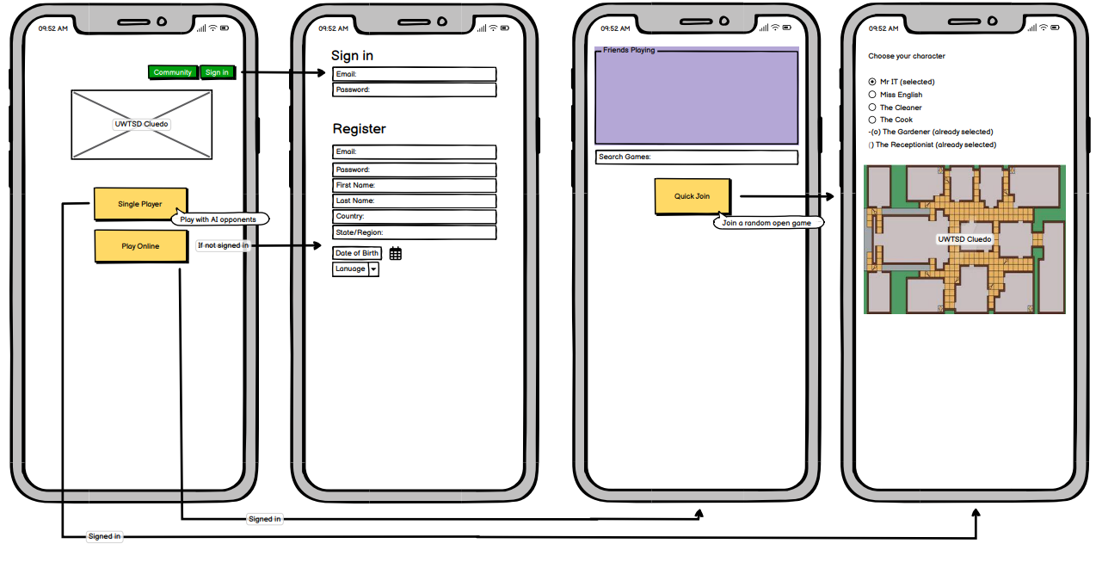
The game starts with a sign in or sign up requirement to create a unique player ID, but this collects a minimal amount of data used only to create that ID and create groupings to match with other players. There is a single player option to play offline against AI. The play online screen allows the player to either manually search games, see at a glance what games registered friends are in, or quick join the first open game.
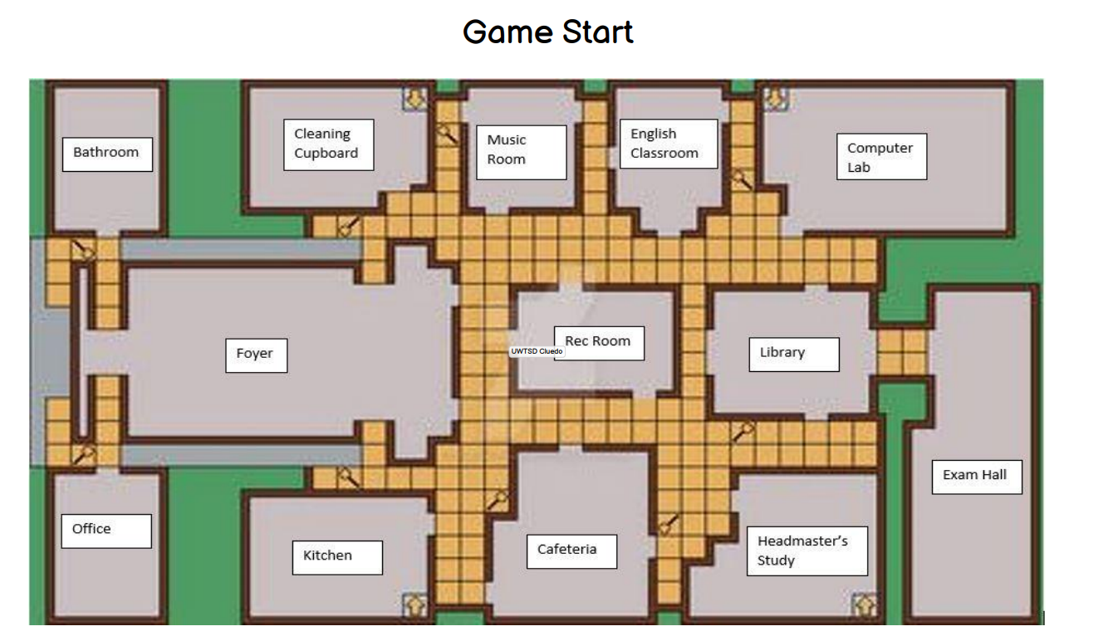
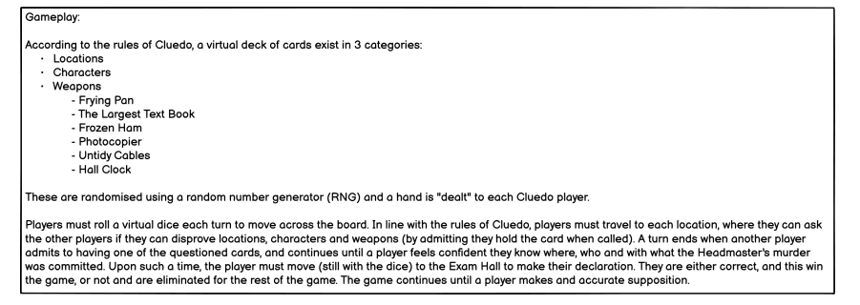
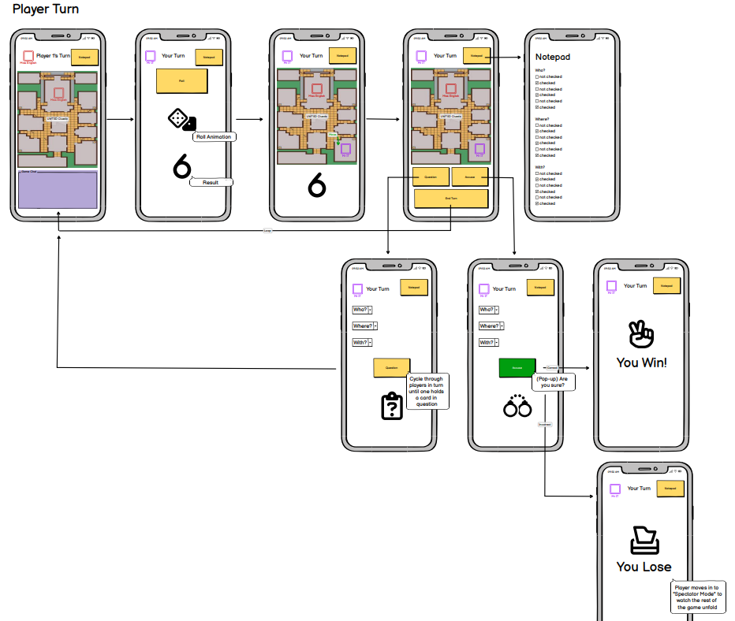
The gameplay is a basic loop, inactive players will watch other players move on the game board before getting the opportunity to roll, move, question or accuse and end turn. There is a persistent option to view and edit a notepad to log progress obtained through questioning and watching the game unfold. The question feature cycles through players as one would playing the physical board game until one answer is received, then the game returns to the start of the loop. When the time comes to accuse, the player either correctly guesses and wins, or else is eliminated and moves to spectator mode.
See appendix a. for Pdf version.

2.2 Usability Testing
With the basic application planned out, the next step would be usability testing. Usability testing is the practice of testing a product with representative users, to make sure it works as intended by someone who isn’t on the development team. [4] Design decisions can be informed by the intended users to work best for them, often yielding benefits in the profitability of a product [5] and beyond intended users, products can be tested on those who have no experience with a product to ensure anyone could pick up and use the product, even having never heard of it before.
Best practice for designing, be it apps, websites, or even non-digital products, is to focus on the user, not the product. Usability testing is how this is achieved. Users will find ways to use products that might be completely out of alignment with how it was designed, but it will make sense to them. A well-designed product will account for this and deliver a positive user experience regardless. [6]
There is no one-size-fits-all for usability testing. It all depends on the product and the target audience. Some tests are best conducted in a controlled environment, where others with a completely uninformed user-group. [7] For the purpose of this test, the target will be a middle ground, with an even distribution of experts and non-expert users.
The larger a user group tested, the more data that can obviously be collected. This naturally gives an increased chance to spot deficiencies in the product, but a moderated usability test can also reduce the margin of error in terms of getting the product right ahead of production. [8] However, Krug [9] makes the point that testing one user is 100% better than testing none, and testing one user earlier in a project, as with this usability test, is better than testing 50 near the end.
A range of users were asked for feedback directly, with links placed openly on social media in addition to collect views from players who had and had not played the game before. The wireframe was shared along with a Microsoft Forms survey to ascertain numerous data points from each user, as well as take feedback on ideas for improvements, missing features, or areas where improvements would be required to improve understanding of the game.
The feedback results were as follows:
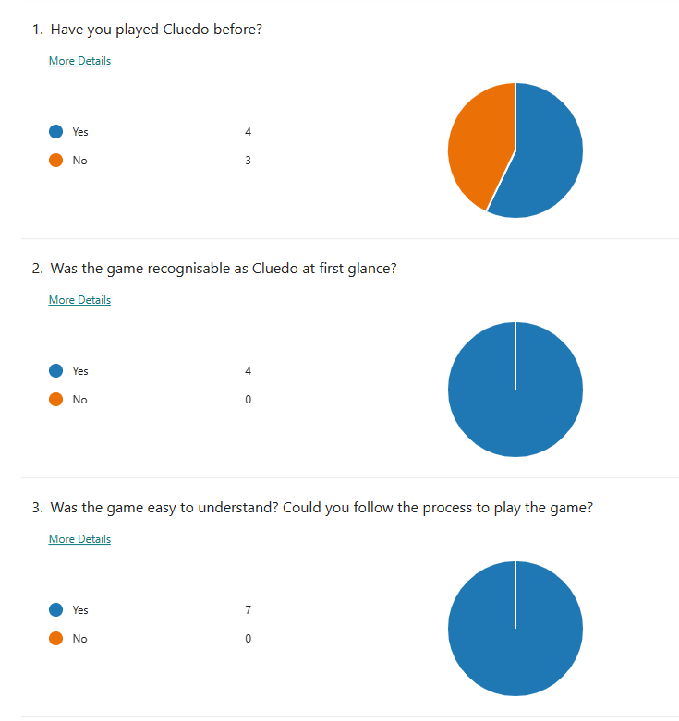
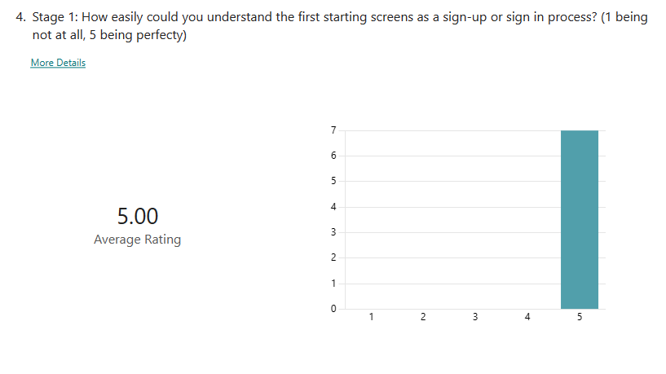
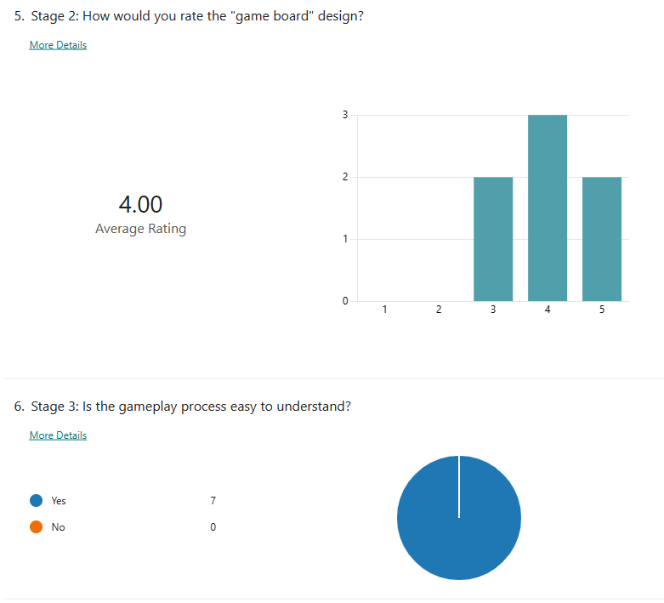
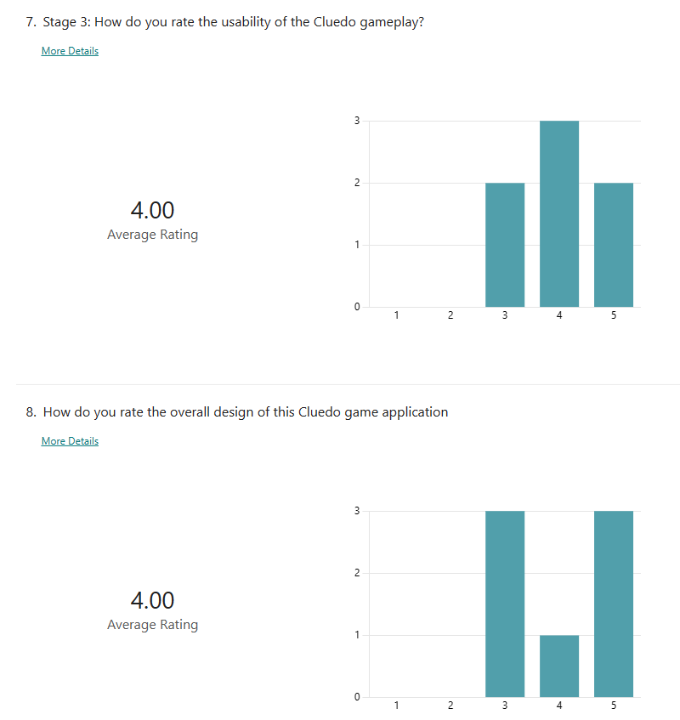
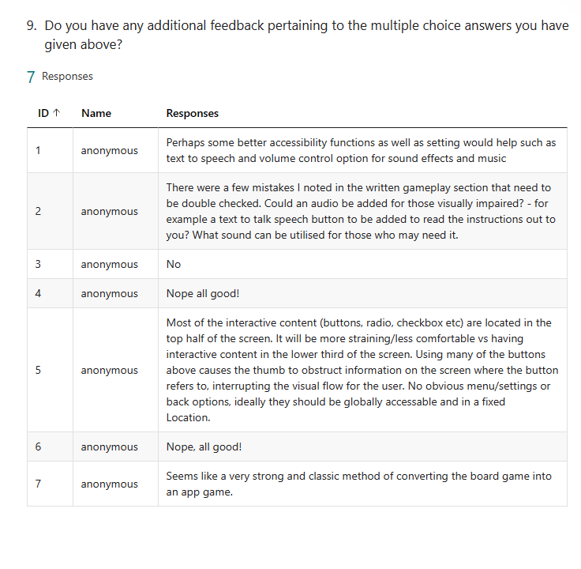
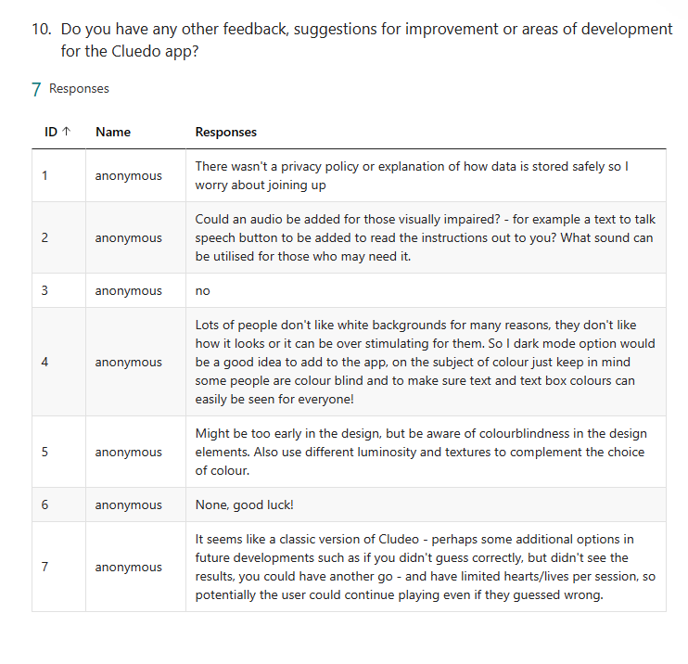
With an even split of players that had and had not played Cluedo before, the feedback data meets the hoped-for criteria. To those that had played, the game was recognisable at first glance, and all players found it easy to follow the process to play the game. The sign-in or sign-up process was understood by 100% of players, and despite the simple game board design, it was rated on average 4/5 stars. 100% of players understood how to play, and the gameplay usability and design also received an average 4/5 stars.
The first suggestion for revision, which was a repeated one, was for the inclusion of accessibility options, including clear volume controls and text to speech functionality. Also, a dark mode and colour-blind option setting for the visually impaired, or those playing in low light or simply with that alternate preference.
Another good observation was that the buttons are set towards the tops of pages (in line with good practice for web design), but indeed for a mobile game this should be inverted based on the way a phone is held.
The next suggestion was for a fixed menu button throughout the game. Also a privacy policy, and this persistent menu would be the perfect place to include this.
The final suggestion was for some interactive element for players that lose the game before completion.

2.3 Updated Wireframes
Following feedback from the usability tests, the following updates were made to the wireframe:
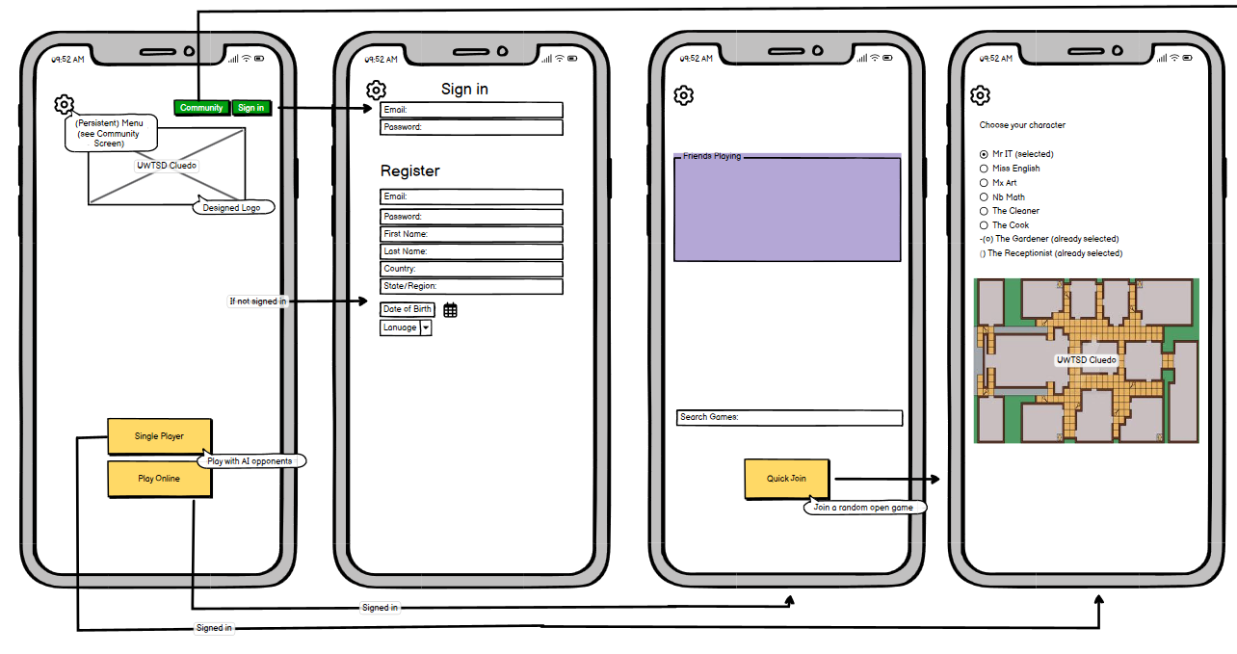
- All buttons were moved to the lower hemisphere for their respective displays to make the game easier to play based on how the average user holds their mobile phone
- A persistent menu was added
- Additional characters were added to accommodate the 8 players in the specification (over the regular Cluedo 6) with non-binary gender identifiers
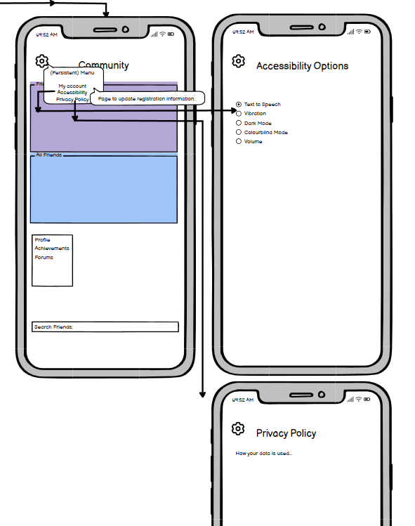
- The Community page design was added
- The persistent menu includes the ability to update registration details, to access a Privacy Policy and to access Accessibility options
  - Accessibility options include all those suggested; Dark mode, colourblind mode, text-to-speech, volume, and also vibration options
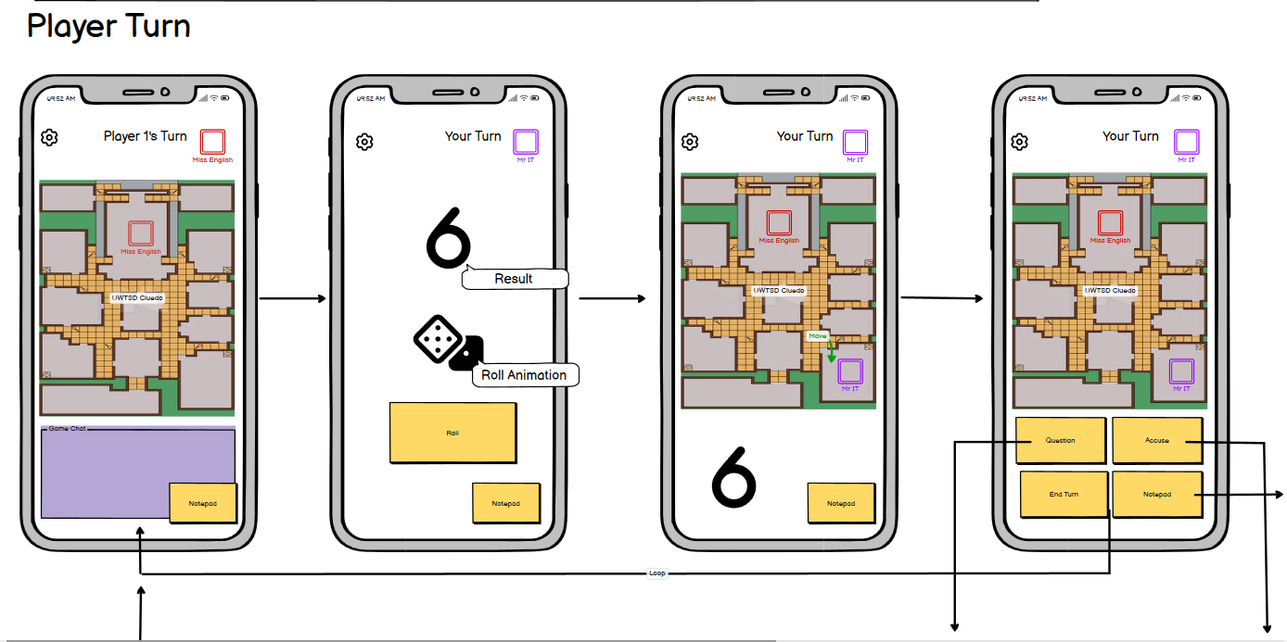
Button placement inversions continue along with the inclusion of the persistent menu button.
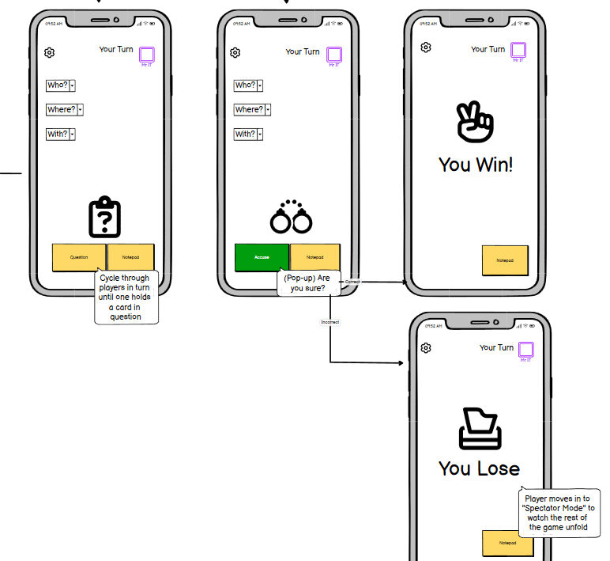
See appendix b. for updated Pdf.
Currently, players can continue in spectator mode after losing the game. Considerations have been considered to ways in which the spectator could continue to interact, such as being able to drop objects (images) on the game board, or perhaps have some persisting influence over the game as a “ghost” player – but steps would have to be considered to ensure these features could not be used to bias the game for the remaining players.

Data Collection and Future Planning
Once the game is in full deployment data can continue to be gathered to make continuous improvements to the game. There would be data collection with regards to the basic identifiable information; name, email address, that will allow users to be individually distinguished, to find and be found by friends, save personalisation settings on the application, and to track individual achievements in the game. Beyond this, data can be continuously collected, within the boundaries of the law, to continue to improve game functionality. Continuous data collection allows a developer to continue to improve services, understand consumer needs and grow and retain a user base. [10]
The most common types of data collected by videogames are
- Behavioural – Generally, this would be responses to the game, how a player navigates, the time they spend playing, or on a specific game menu. [11] For the purposes of Cluedo, this data could look like the average time it takes to complete a game, the time it takes to find a game, time spend in menus. If the resulting data showed that players took too long to find a game, or that games ended too quickly, steps could be taken to address those issues to improve the overall game experience.
- Social [11] – This would track how users interact with each other; do they search for multiple friends using the available forums? Do they generally keep a small or non-existent friend list, and tracking the difference changes made to the game impact on this data.
- Location [11] – While location data isn’t essential, it would allow, should the users opt-in to sharing it, the tracking of where in the world the game is popular. This would inform more targeted regional marketing, or if the game is being used exclusively online, is there a way, or features that could be added to stimulate local play.
There are several strategies with regards to collecting and using this data, developed over generations of gaming advances, recording the length of games and broader player retention, to building “funnels” to analyse user journeys. [12] The biggest payoff in the videogame industry is of course financial. Either players spending money on a game directly, or else generating revenue through advertising, while data such as playtimes form the KPI for screentime of each advert and so-forth.
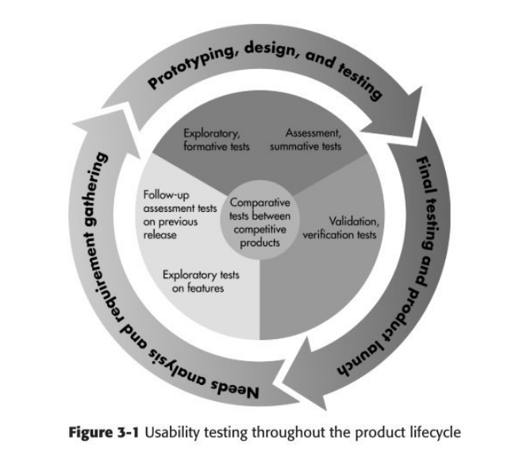 [5]
This diagram from Rubin’s 2008 publication captures the data cycle effectively. To maintain an audience beyond the release of a game, the design would need to keep evolving, keep presenting players with new elements of interaction. At the same time, it needs to stand out against the competition to ensure it is this game being played over others.
Ideas for refinement could be a reduction in menu options, or an introduction of sub menus to prioritise what users need most to simply play the game. If games are ending too quickly, finding elements of gameplay that might slow the pace of the game. If players are getting bored and not returning, what additional content could be drip fed to keep the game fresh? New characters, new maps/boards, new music, thematic events that tie in with seasons or thriller books, games and movies elsewhere in the entertainment market.

Design Summary
The game design was based on a large already available board template. With the accommodation of an additional 2 players compared to the regular board game, it would need a bigger playing field. The size of the board is also going to impact the length of the game, and thus this is a large consideration in future game developments as the development seeks to lengthen or shorten games, or even put those options in the players hands by including multiple game boards.
Hasbro made some very slight attempts at inclusion with their 2023 release of the game [2], but this design wanted to push that inclusivity to where it should be in 2023, with gender-neutral roles and non-binary titles within lecturer names among character choices. Again, this can continue to be expanded in the ongoing development.
The usability testing targeted known people within the IT field that would be familiar with the game, as well as a wider, more random audience by the publication of the survey on open social media. The data collected showed a very even range, as used documented in use by similar usability studies to ensure a diverse range of testers for a wider dimension, and higher quality of feedback. [13]
The feedback brought some great ideas for development, and all of those changes are reflected within the updated design. Further usability testing could be conducted ahead of release to see that users feel the points are sufficiently addressed, but changes can continue to be made over the lifespan of the game also.

References

[1] | Hasbro, “The History Of Clue,” Hasbro, 2008. [Online]. Available: https://web.archive.org/web/20090929021146/http://www.hasbro.com/clue/default.cfm?page=History&src=endeca. [Accessed 2 May 2023].
[2] | B. Abbott, “Clue board game reboot "more accurately reflects the diversity of its players",” GamesRadar, 4 January 2023. [Online]. Available: https://www.gamesradar.com/new-clue-revealed-price-and-features/. [Accessed 2 May 2023].
[3] | Amazon, “Amazon,” Amazon, 2023. [Online]. Available: https://www.amazon.co.uk/Hasbro-Gaming-Reimagined-Players-Detective/dp/B0BSLFD2RC/ref=sr_1_1?crid=1027MCM06SVXN&keywords=2023+cluedo&qid=1683010128&sprefix=2023+cluedo%2Caps%2C113&sr=8-1. [Accessed 2 May 2023].
[4] | usability.gov, “Usability Testing,” usability.gov, 2 May 2023. [Online]. Available: https://www.usability.gov/how-to-and-tools/methods/usability-testing.html. [Accessed 2 May 2023].
[5] | J. Rubin, “Usability Testing: An Overview,” in Handbook of usability testing: how to plan, design, and conduct effective tests, Wiley-Blackwell, 2008.
[6] | C. Barnum, Usability Testing Essentials, Cambridge: Elsevier, 2021.
[7] | J. Redish, “Expanding Usability Testing to Evaluate Complex Systems,” Journal of Usability Studies, vol. 2, no. 3, pp. 102-111, May 2007.
[8] | User Interviews, “Usability Test Best Practices,” User Interviews, 17 March 2023. [Online]. Available: https://www.userinterviews.com/blog/usability-testing-best-practices. [Accessed 2 May 2023].
[9] | S. Krug, Don't make me think, revisited: a common sense aproach to usability testing, New Riders, 2013.
[10] | Emeritus, “What is Data Collection? Why is it Important for Your Business?,” Emeritus, 25 November 2022. [Online]. Available: https://emeritus.org/blog/data-analytics-what-data-collection/#:~:text=Data%20collection%20can%20help%20improve,other%20businesses%20at%20a%20profit.. [Accessed 3 May 2023].
[11] | J. Kearsley-Ho, “How do Video Games Collect and Use Data?,” eSports Lawyers, 2023. [Online]. Available: https://www.google.com/search?q=what+data+should+a+mobile+game+collect+and+why%3F&oq=what+data+should+a+mobile+game+collect+and+why%3F&aqs=edge..69i57.6974j0j4&sourceid=chrome&ie=UTF-8. [Accessed 2 May 2023].
[12] | O. Synak, “Mobile game analytics: 6 essential metrics & how to track them,” Smartlook, 16 February 2023. [Online]. Available: https://www.smartlook.com/blog/mobile-game-analytics/. [Accessed 2 May 2023].
[13] | M. N. H. e. a. Al-Kinani, “Usability Testing of Mobile Flipboard Application on both Non-Users and Novice Users,” Universiti Utara Malaysia, Kedah, 2020.
[14] | A. Kumar, “Taking String input with space in C (3 Different Methods),” GeeksforGeeks, [Online]. Available: https://www.geeksforgeeks.org/taking-string-input-space-c-3-different-methods/. [Accessed 16 March 2020].
[15] | N. Kanralkar, “Scansets in C,” GeeksforGeeks, [Online]. Available: https://www.geeksforgeeks.org/scansets-in-c/. [Accessed 16 March 2020].

Appendices

- - UWTSD Cluedo Wireframe 1
- - UWTSD Cluedo Wireframe 2 – Usability Test revisions

