

Strategic Management
Case: Tesla’s entry into the U.S Auto Industry

Student Name: Leanne Lawrence
Student ID: 1711795
Module Code: LCMB7003
Module Name: Strategic Management
Sub topic : Tesla’s Entry into the U.S Auto Industry
Tutor: Gladuius Kulothungan

Table of Contents
Executive Summary 4
Introduction 5
Analysis of U.S Automotive Industry 6
Sales of U.S automotive industry 9
Composition of U.S Automotive industry 10
Key Trends of U.S Automotive Industry 11
Key Success Factors of Tesla Inc. 13
Impact of Covid-19 pandemic on Tesla Inc. 13
Internal Analysis of Tesla Inc. 14
Value analysis using VRIO framework 15
Planning and evaluation 15
The Resources, Competencies, and Distinctive Capabilities of Tesla Inc. 16
External Analysis of Tesla Inc. 17
SWOT analysis 17
PESTLE Analysis 18
Evaluation of Market Attractiveness for Tesla Inc. 19
The linkage between Stakeholder Expectation and Organisational Purpose 21
Mendelow’s Stakeholder Analysis 21
Ethical issues, sustainability, corporate social responsibility and their impact on strategic development of Tesla Inc. 23
Organiational culture, structure and leadership and their impact on strategic implementation of Tesla Inc. 24
Strategies of Tesla Inc. to Sustain the Competitive Advantages 25
Ansoff Matrix 25
Deliberate Strategy: Plan for Market Expansion 25
Emergent Strategy: Recruiting skilled manpower to expand into international market 26
Eco-Friendly Strategy 27
Strategic Clock 28
Choice of Best-fit strategy and the implementation 28
Recommendations 29
Conclusion 29
References 31

Executive Summary
The term strategic management refers to optimised utilisation of resources by regular planning, direction and implementation that makes a company more competitive. Strategic management helps business with there organisations to gain the best competitive advantage within the business environment as well as to exploit opportunities within the best way. To undertake strategic management, a company needs to analyse its external and internal core competencies. The competitiveness of an organisation could be understood much more easily from its value chain analysis, resource analysis, competency evaluation and distinctive capabilities within the company. Porter's five forces model is an effective tool that helps within the evaluation of marketing competition and identify the competitive advantages. To be sustainable, within a business organisation they need to be able to conduct an SWOT analysis and PESTLE analysis that is effectively helpful within understanding the market environment for developing strategic management plans. Further, for deep insights, companies undertake analytical tools like deliberate and emergent strategies. These two strategies are especially tailored within understanding the core competencies of an organisation, which are crucial if a company has plans to tap new markets within neighbouring or new countries. While doing these, various ethical issues and CSR are to be considered to have an environmentally sustainable management structure. Finally, after such a critical evaluation, it’s very important that a company hires experts and skilled employees who can work towards planning the strategic management within the company and make the company more sustainable within the long run. This report focuses on these particular issues based on the context of a case study- Tesla’s entry into the U.S auto industry.

Introduction
The U.S automotive industry has seen constant growth within the last few decades having a significant amount of foreign direct invest within this sector. It’s been originated that since 1982, there has been more than $75 billion investment within the U.S. The automotive companies within the uk to support more than 400,000 jobs for the U.S, which makes it the second largest auto industry within the world (Bindra, 2019). Tesla was founded in 2003 as one of the leading pioneer of the U.S electric vehicle companies. Since its inception, the picture within the U.S was nearly similar to the picture that experts fore-said that how people would thought about and used cars. However, when Tesla was attempting to build a Model 3 electric cars, they faced significant difficulties and challenges. To better understand and evaluate the strategic management of Tesla, to better understand the case study of Tesla’s Model 3 production failure has been chosen. Tesla uses sophisticated technology and artificial intelligence tools to produce its cars, which has been their biggest strength within the company. The company has been extensively investing within the R&D but complete automation of the production line for the Model 3 brought big failures for the company. The company hires skilled employees who could match up with its production line. Yet the company has been successful within many cases using its extensive research capabilities, skilled workforce and efficient use of artificial intelligence within its Workplace. The CEO of Tesla, Elon Musk has been questioned about the failure of Model 3 production and the time it has taken. Elon Musk ( said that there have experience some mistakes regarding the complete autonomous production line. Tesla has been effectively successful within utilising its core competencies in order for them to have a competitive advantage over the traditional automakers such as Toyota, GM, Ford and others (Wang, 2020). Within strategic management of Tesla, CSR is quite an important part since it is the vision for the company to enable them to build a world with sustainable energy. The impact of CSR and various ethical issues on the strategic development within the company is also significant. Tesla also makes the right use of deliberate and emergent strategies so that the new markets could be tapped with efficient management.

Analysis of U.S Automotive Industry
The new passenger car market within the U.S has equalled to $270 million within 2016 at the retail level of the U.S auto industry. Upon seeing the slow market growth of they industry within 2016, it was expected that the sales would remain flat until 2021. Most People within the U.S continued with the buying of big cars whose average price was $35,500. Within 2016, 60% of the 7 million cars sold within that time were pickups and SUV's (Makadok, 2018). Nevertheless, the experts predict that by 2023, the demand for small cars would comprise from 20% of the total car demand within the US. In a additional to this , it was predicted that by 2025, almost 60% of all the vehicles within the U.S would be EVs, hybrids and fuel cell cars. The following figures represents the facts more precisely:
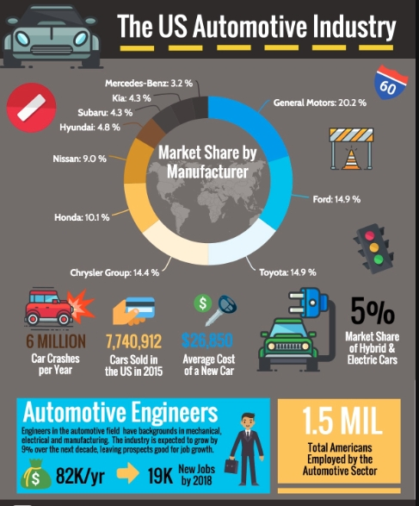

Figure 1: U.S Automotive Industry Analysis (Hitt, 2017).

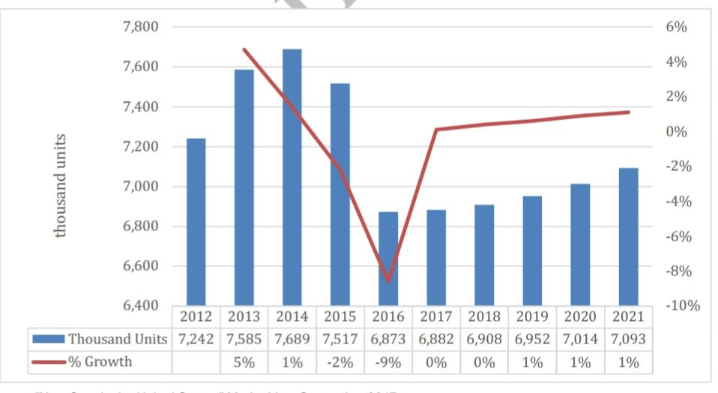
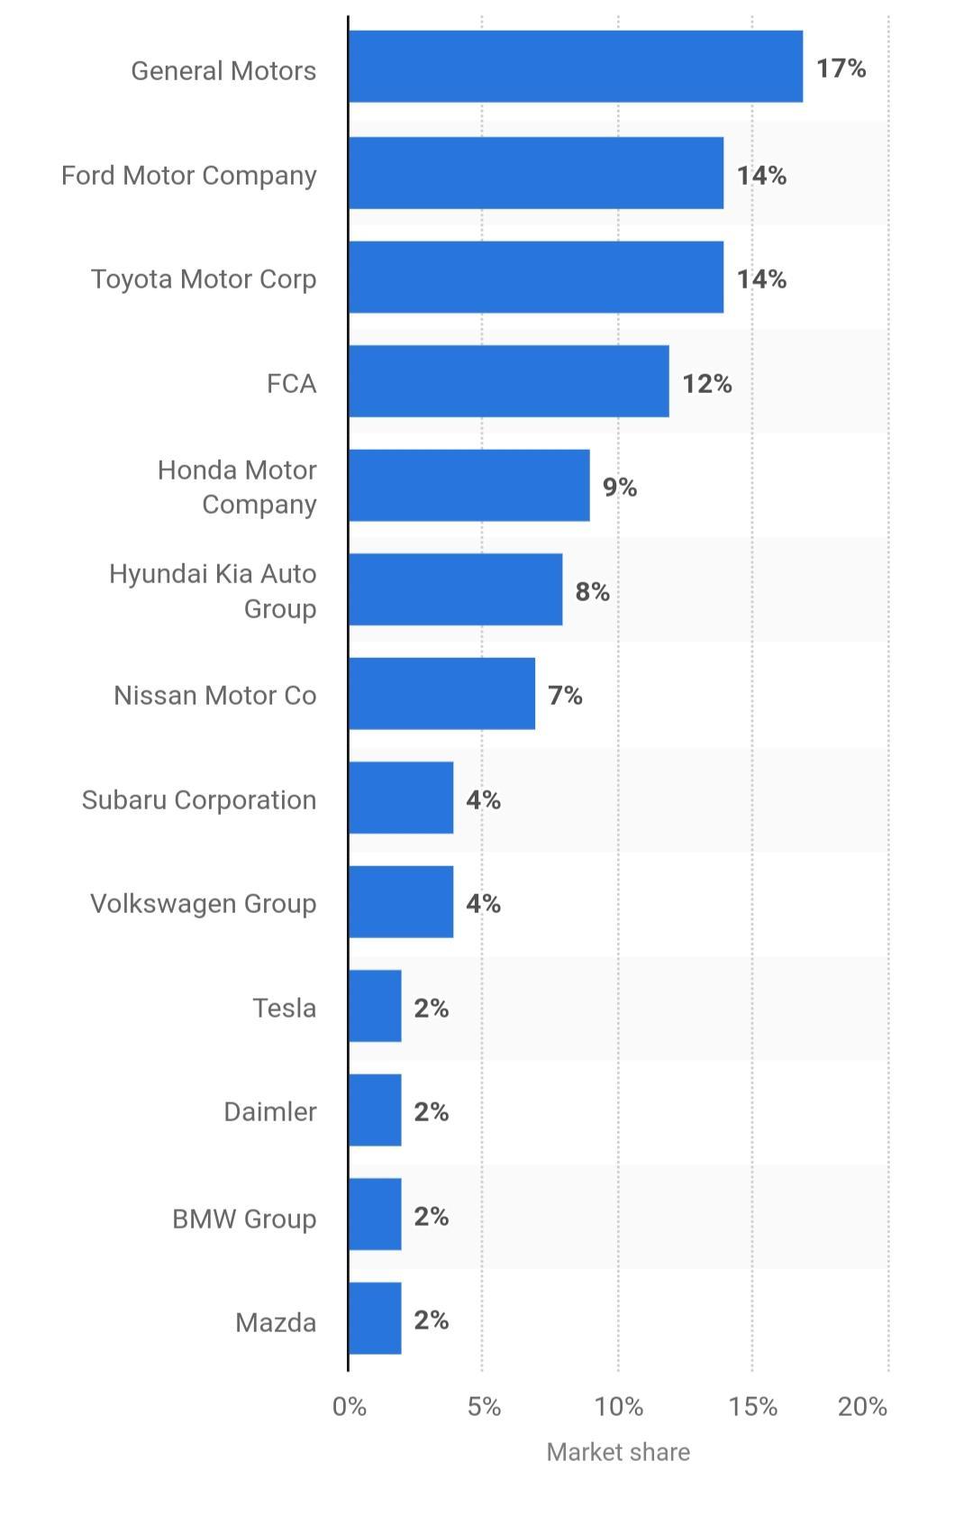
Figure 2: Market share of U.S Automotive Industry (Wang, 2020).
Figure 3: U.S Car market by value (Nunes, 2021).

Sales of U.S automotive industry
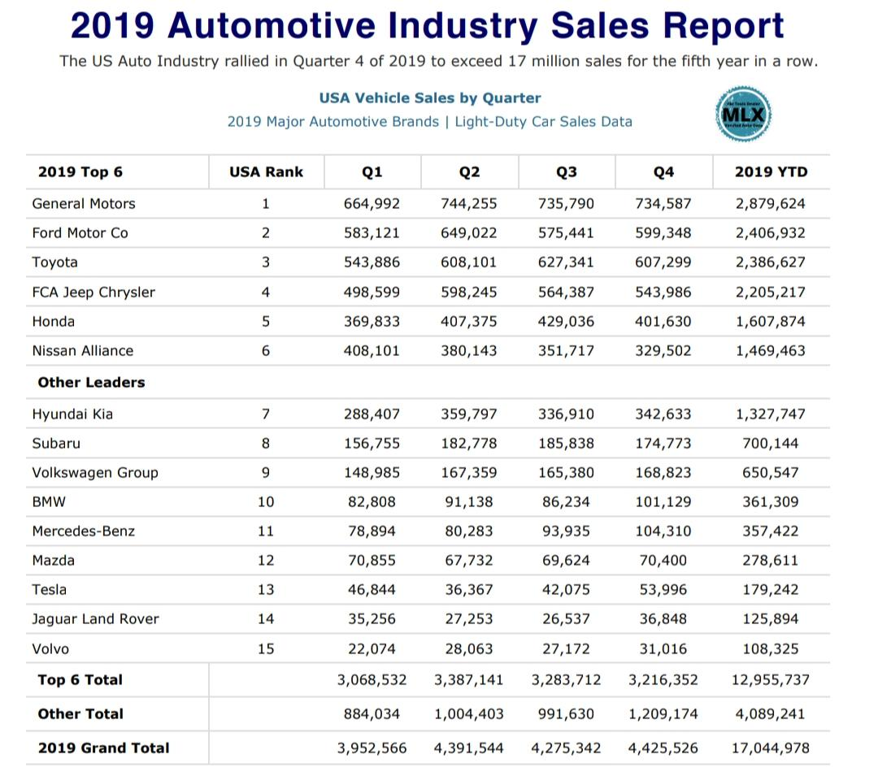
The sales revenue of the U.S automotive industry has seen constant growth over the years. The industry is known to be the second largest auto industry within the world (Bryson, 2020). In 2018, the total sales of vehicles reached to 17.2 million within the U.S. The U.S vehicle industry. It has supported more than 600,000 direct jobs for the U.S people within all of it’s sector composition (Fuertes, 2020). In 2019, General motors was within the leading position of sales shorty after they were followed by Ford and Toyota. The total sales of the top 15 automaker companies was 17,044,978 units. The sales have increased specially within the light vehicles sector over the years. However, the Covid-19 pandemic has created a big adverse effects within the industry.

Figure 4: Sales of U.S Auto Industry for 2019 (Bryson, 2020).

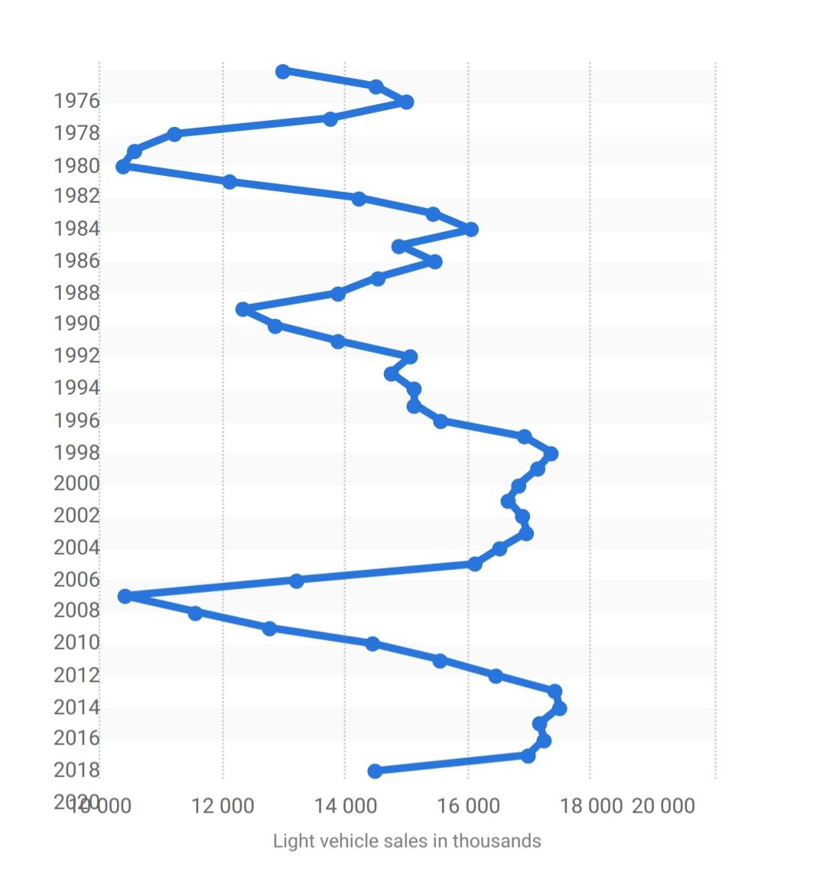
Figure 5: Sales of light vehicles in U.S Auto Industry (Nunes, 2021).

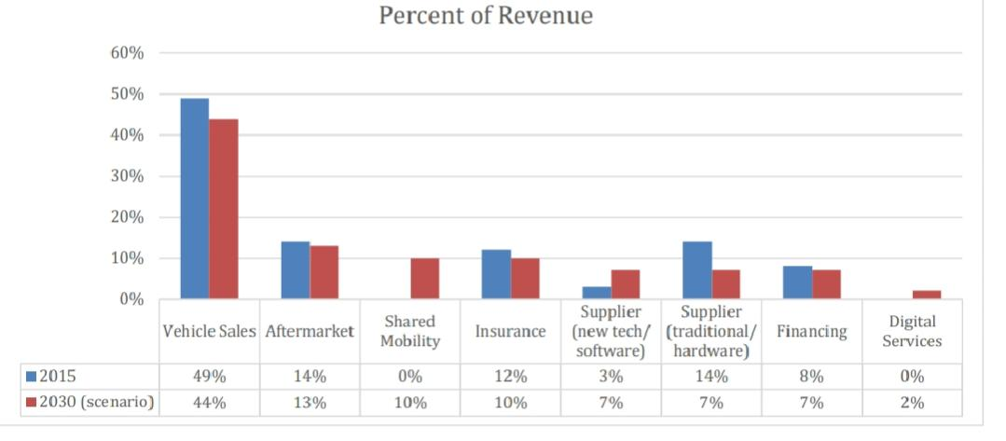
Composition of U.S Automotive industry
Figure 6: Percent revenue of sectors of U.S Auto Industry (Makadok, 2018).
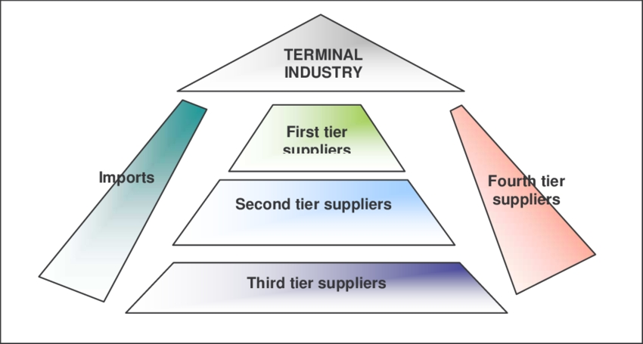
U.S automotive industry has many different sectors within it. Most of they revenue comes from they suppliers and the different parts for assembling the vehicles. From the above figure, we can find that aftermarket, shared mobility, suppliers of new tech or software, suppliers of traditional hardware, financing and digital service sectors are included within the whole automotive industry.

Figure 7: Supply chain composition of U.S Auto Industry (Grant, 2018).
The suppliers are segregated into different levels from suppliers of the raw materials to the supplier who maintain the important parts of a one vehicle like the engines (Fuertes, 2020). The suppliers of various materials are connected directly or indirectly to the automakers, dealers and importers, which consists the final part of the automotive industry.

Key Trends of U.S Automotive Industry
The U.S auto industry is undergoing several changes along with trends within the advancement of its technology. Electrification like Electric vehicles produced by Tesla, that has shared their mobility like Uber and the use of artificial intelligence are the recent trends of utilisation of vehicles within the U S. For the construction of vehicles, The big data analytics, have been using human machine interface, blockchain and 3D printing technologies are being used (Hitt, 2017).

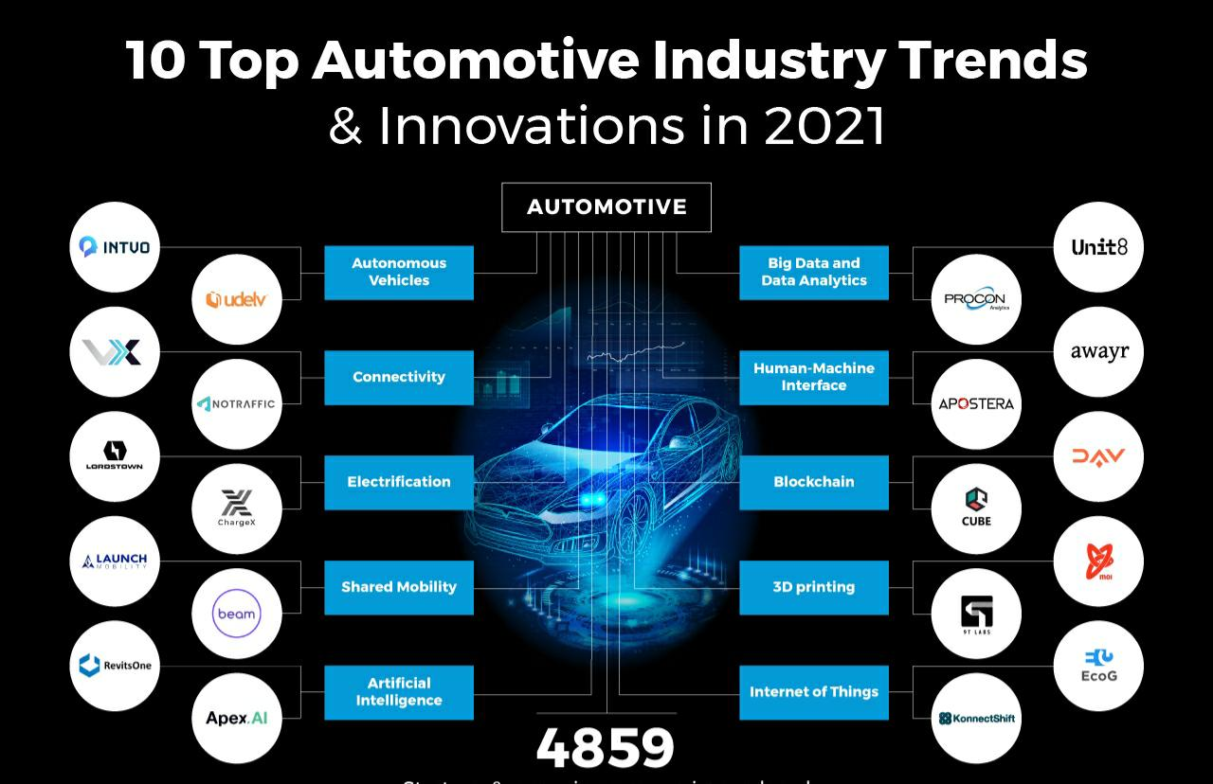
Figure 8: Key Trends of U.S Auto Industry (Fuertes, 2020).
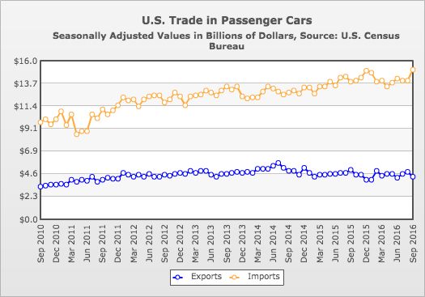
Besides, the exports and imports of the US passenger vehicles are shown within this figure below:

Figure 9: Exports and imports of U.S Auto Industry (Bindra, 2019).

Key Success Factors of Tesla Inc.
The key success factors within the automotive industry would be the capital, government support, battery technology, customer education and charging infrastructure. The key factors are the drivers for providing an competitive edge to the company where they customers are able to get a better value from the company than other companies within the market. The key success factors for Tesla have been divided into four categories: Disruptive Technology, Customer Experience, Superchargers and Consistent brand image (Grant, 2018). Tesla has been using disruptive technology within the construction of its vehicles using robots and advance AI software. Customer experience within the case of Tesla's cars are quite satisfying because people like the advanced services and automation that Tesla provides. Tesla has more than 25000 superchargers within many states of the U.S making it the largest and fastest charging network within the world. Finally, the brand image is the most important key success factor that Tesla has gained over the years. Owing to its large capital, production automation and foresightedness within its management body, the company has also build a strong image within the the U.S auto market.

Impact of Covid-19 pandemic on Tesla Inc.
It was expected that the activities of Tesla would slow down due to the hit within the Covid-19 wave around the world. The first two quarters of the year 2020, is the year when corona virus hit the country, this is were it has became somewhat a loss situation for the company. The company was still delivering cars to to suit its customers need and the sales rose by 54% within the third quarter rising the company's profit to $8.7 billion (Nunes, 2021). The company’s share value also quadrupled within the same quarter. The main reason of Tesla's ability to face the situation is that Tesla directly delivers cars to best suit its customers. So, in spite of the dealers shops were closed down within the C-19 pandemic , the customers were able to still order from the website get information and updates and also receive they deliveries.

Internal Analysis of Tesla Inc.
Value Chain Analysis
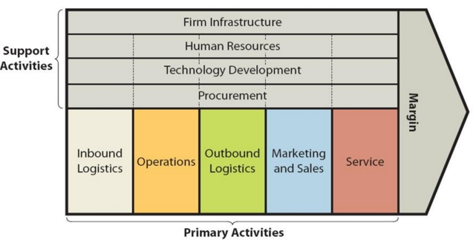
The following figure represents the value chain analysis of Tesla Inc.:
Figure 10: Value chain analysis of Tesla Inc. (Veselovsky, 2019).
For Tesla, the value chain is made up of inbound logistics, operations, outbound logistics, marketing, sales, and service. Tesla’s inbound logistics including receiving raw materials for its EV's and solar energy systems. Tesla's operations includes activities like designing, constructing and storing automobiles as well as energy generation and storage. The main reason for Tesla's value creation is the high integration of robots within the production line (Jabbar, 2017). The outbound logistics of Tesla includes distributing and warehousing electric vehicles and solar panels. Tesla directly sells to the end users rather then depending on dealers or suppliers. The marketing and sakes of Tesla is ‘zero dollar’ strategy where word of mouth is practiced widely. Tesla's customer services has improved greatly within the years and the automaker now provides their customers with the opportunity to directly complaining to a company executive (Jabbar, 2017).

Value analysis using VRIO framework
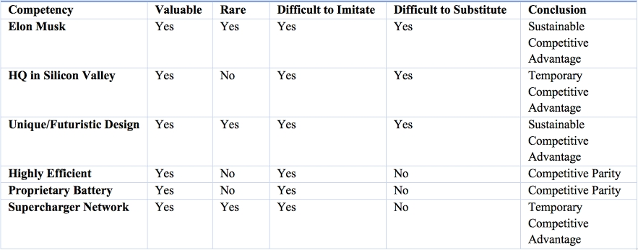
The creation of Model 3 electric cars were delayed extensively by Tesla due to several problems. The production had to stopped for a number of days and it was said that Elon Musk underestimated the capacity of human beings. Almost ninety five percent of the production line was autonomous and so the possibility of missing minor error increased production complexity (Veselovsky, 2019). However, after the 2nd quarter, the company started to produce 5000 cars where they could not even produce half of this within the first 2 quarters. The value here is created when the CEO of the company realised the mistake and were again able to employee humans within the many work process instead of using robots.

Figure 11: Value chain analysis of Tesla Inc. using VRIO Framework (Desai, 2019).
The above VRIO framework determines the value of Tesla through four categories- value, rare, imitability and substitutability.

Planning and evaluation
The company has plans to undertake strategic steps to create more value within the market. Tesla is thinking of producing more affordable cars within the range of $25000 within the U.S driving a number country towards sustainable energy (Desai, 2019). The company is also planning to establish 100 more service centres within addition to its 150 centres it already has. Tesla made extensive evaluation of current market situation and considered targeting persons that are somewhat far from.the high end.

The Resources, Competencies, and Distinctive Capabilities of Tesla Inc.
Resources: Resources are the assets of a business organisation, which are incorporated into the activities, and processes of the organisation. A company might have internal and external resources. Internal resources for Tesla the skilled workforce, efficient utilisation of AI and strategic management plans (Barney, 2018). However, suppliers of various materials, investors and external funding are external resources for the company. Overall, every tangible and intangible resources like advanced research and development, engineer team, competitive business model and the management structure works as resources within the company that helps to get competitive advantage within the U.S auto market.
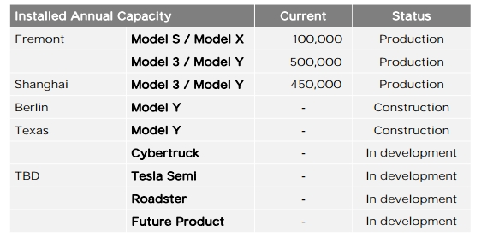
Competences: Competences are unique characteristics and features that makes one organisation different from another’s. Competences are very important for every company to gain a competitive edge within the ever-changing market. The competences of on function must work within collaboration with another function in order to be effective for an organisation. For Tesla, the big data analytics and usage of robotics is one of the core competences. Installation of CAD software and the ability of the Engineering department to use those it also is a competence for Tesla (Bondarenko, 2017). The capacity for company’s management team to use disruptive technology as a core competence of the company. The ability of Tesla within producing cars is shown below:

Figure 12: Annual capacity of Tesla Inc. to produce cars (Desai, 2019).
Distinctive Capabilities: Distinctive qualities are characteristics that are unique to an organisation and other organisations cannot imitate those. Distinctive capabilities may convert to sustainable qualities when proved to have long-term advantage for the company. Within the case of Tesla, a strong and consistent brand image is one of the distinctive capabilities. Within addition, to this being able to have the ability to turn a production line entirely autonomous is also a distinctive quality of the company, which has actually helped it to gaining the advantage of innovation within the market (Makadok, 2018).

External Analysis of Tesla Inc.

SWOT analysis
SWOT analysis tool is a framework that helps an organisation to identify the internal strengths and weaknesses as well as external threats and opportunities. The SWOT analysis for Tesla Inc. is presented within the following table:
Strengths | Weaknesses
- Power of using innovation efficiently.  - Strong brand image and brand value helps the company to attract investors in spite of its regular losses (Barney, 2018).  - Effective marketing power and marketing strategy.  - Unique car design and customer experience.  - Strong partnerships with eco-companies. | - High debt to equity ratio making it a financially weak company.  - Severe manufacturing problems due to autonomous production lines.  - The market focus is consolidating rather being diverse and spreading.  - The batteries used within EV's are not secure options instead of gasoline vehicles.
Opportunities | Threats
- Huge growth opportunities outside of Europe are being used unlike for those within Asia and China.  - The ability to deal with mid-market products.  - Can install own battery production house to solve battery issues.  - Can tap U.S market extensively with installation of large number of charging points. | - Intense competition from the U.S large automakers as a huge investment is being done within electric vehicles (Velikorossov, 2020).  - China is developing its own domestic electric car brands.  - New substitutes can be launched to manage air pollution and problems with gasoline.

Table 1: SWOT analysis of Tesla Inc.

PESTLE Analysis
The PESTLE framework is a wonderful tool to analyse the external macro environment of a business organisation. The PESTLE analysis for Tesla is represented within the following table:
Political Analysis | The U.S has recently taken a program of investment of $8 billion to advance the vehicle technology that is useful for the production of their cars for Tesla. Additionally, the government has investment more than $5 billion for accelerating growth within the auto industry.
Economic Analysis | The tax and inflation rates are working in favor of Tesla. The government has decided to install charging stations within the U.S into reduce the battery park costs by 70% (Berisha Qehaja, 2017). Though the growth rates they have been moving slow within the U.S, yet the people are not deterred and yet still they are buying their cars on credit.
Social Analysis | In this arena, the U.S citizens applaud the initiatives of using sustainable energy to produce sustainable products. Many large companies have failed to implement their sustainable models yet the people within the U.S are optimistic about new companies adopting sustainable resources.
Technological Analysis | Since the U.S is a technologically advanced country, Tesla has exploited the opportunity well. Tesla started with experience employees from they car industry as well as those having technological innovation knowledge (Berisha Qehaja, 2017). This has yet to show the company how it can attract the attention of consumers as well as their investors.
Legal Analysis | Tesla prefers to sell products directly to their end consumers. The U.S legislation has passed many laws against such actions that restricts Tesla to work according to its plan.
Environmental Analysis | Various electric automakers are using coals o produce fuel and batteries. However, Tesla is one of the contrary that is on the verge of innovating battery packs that could be used within conjunction for solar panels and making the company truly eco-friendly (Bondarenko, 2017).

Table 2: PESTLE Analysis of Tesla Inc.

Evaluation of Market Attractiveness for Tesla Inc.
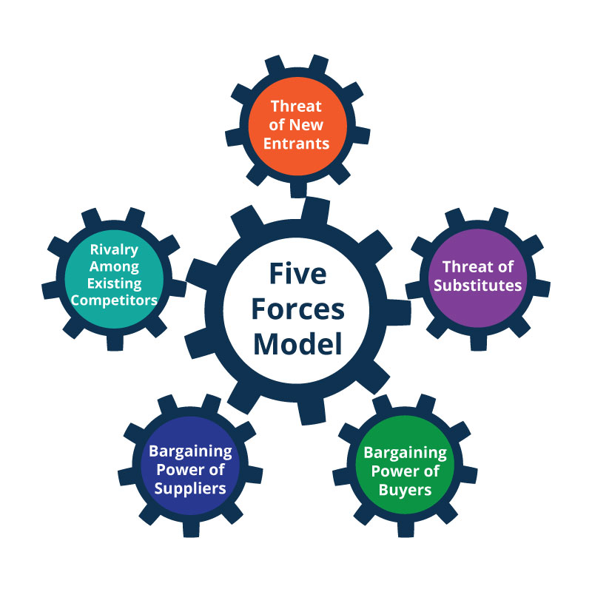
To understand the level ot competition and market attractiveness of a company, Porter's five forces model is generally used that depicts the impact of five larger forces on the company. The analysis for Tesla Inc is shown below:

Figure 13: Porter’s five forces model (Bondarenko, 2017).
- Industry competition: The competition for Tesla within the U.S automotive industry is very strong withinspite of the fact that there is a small number of automakers within the country. This is the reason that these companies are very aggressive within investing and developing electric vehicles. Various large automobile companies have aggressive marketing campaigns compared to Tesla that makes competition level strong for the company (Bondarenko, 2017).
- Threats of new entrants: This force of the Porter’s five forces is on a weak level due to several reasons. The automotive industry needs high capital and investment. The industry requires high costing for brand building that are not feasible for any new comer because not every business has huge capital (Makadok, 2018). Moreover, the companies within this industry has to have high economies of scale, which makes it less attractive for new entrants to enter the market. So, Tesla has the lowest threat of entrants as these three important factors limit the impact of the threat on Tesla.
- Bargaining power of suppliers: Tesla needs numerable suppliers to continue its production process. However, the impact of this force on Tesla is limited by the fact that the suppliers have a very low influence on the distribution and sales level for the company. Again, the size of the suppliers of Tesla is also moderate that makes moderate influence on the company. Hence, the bargaining power of suppliers is moderate for Tesla and the forward integration of suppliers is a plus point for the company.
- Bargaining power of buyers: The customers are the primary focus for Tesla. The customers of Tesla have low switching options that poses a threat to the company. However, the threat is limited by the fact that there are no easily available substitutes for the customers to switch in. Again, it’s also a fact that customers buy their cars in a less numbers because they cannot buy frequently. So, the bargaining power of customers for Tesla is also a moderate force for the company.
- Threats of substitutes: Customers shifts to competitive companies when they find that the value for the competitor provides is greater than the value provide by a particular company (Bondarenko, 2017). There are many companies within the U.S, which are heavily investing within the electric vehicles and sustainable resources. However, most of them are lagging behind Tesla due to extra mileage opportunity, heavy automation and faster production process. However, if people finds well, that they can shift to low mileage vehicles. So, the threat of substitutes for Tesla is also moderate.

The linkage between Stakeholder Expectation and Organisational Purpose
Stakeholder’s expectation is directly linked with organisational purposes. Therefore, a company should plan its activities to develop products or services within a way that the plans comply with the stakeholders expectations from the company (Berisha Qehaja, 2017). Mendelow’s stakeholder analysis is a very widely used framework for this purpose.

Mendelow’s Stakeholder Analysis
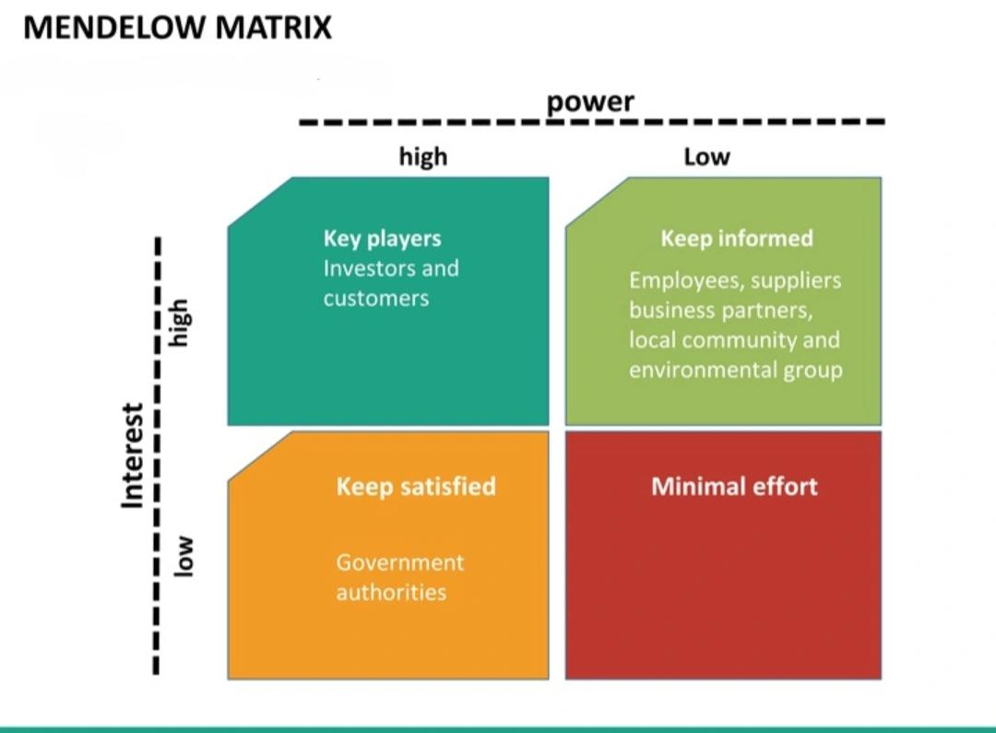
Mendelow has developed a matrix that helps a business organisation to understand and analyse the influence of stakeholders on an organisation. The matrix identifies the influence through two metrics- power and interest of stakeholders. These two metrics are again divided intro four submatrices. For Tesla, the Mendelow’s matrix has been analysed below:

Figure 14: Mendelow’s Stakeholder Analysis (Jabbar, 2017).
- High power, high interest: Stakeholders of this kind exerts huge influence on the organisational decision-making process and they tend to act as the key players for the company (Grant, 2018). These stakeholders are given power of decision and policy formation. Customers and investors have a high power and a high interest within the company. For example, within the case study of Tesla it is seen that, in spite to making wrong decision during production of Model 3 cars, Elon Musk was still given the power to make further decisions due to him having huge investments within the company.
- High power, low interest: The stakeholders having high influence and low interest needs to be kept satisfied. From the case study of Tesla, it’s been seen that various law and regulations are influencing the company's sales to its end customers. Government do not have much interest within the company, but the Covid-19 restrictions and laws are exerting huge pressure on the company (Bryson, 2020).
- Low power, high interest: Some stakeholders possess low power and high interest within the company meaning that they do not have much impact on company's operations but clearly possess interest on what is happening within the company. If we analyse the given case, it is found that when Elon Musk made the decision of making the production line autonomous, employees had no say within it because of him having low power (Jabbar, 2017).
- Low power, low interest: Low power, low interest groups need minimal efforts from the company. These stakeholders are negligible and the company do not need to develop very high strategic plans to tackle them. These groups show less interest within what is going on within the company. These are people who do have knowledge particularly about the company and the products it offers like Tesla's Electric vehicles.

Ethical issues, sustainability, corporate social responsibility and their impact on strategic development of Tesla Inc.
Ethical issues, sustainability and corporate social responsibility has an significant impact on the strategic development of a company. A company that has a sustainable vision like Tesla needs to emphasise on these topics to ensure strategic development through competitive advantage. However, Tesla has ethical policies and conducts that are followed within the organisation. Sustainable plans are the core competencies of Tesla as the company is focused on using sustainable resources. As a part of its CSR, Tesla has taken initiatives to ensure employee safety and health at the workplace. Tesla’s workforce contains 60% of underrepresented community people that made it the best company to employ diversity by Forbes in 2019 (Bindra, 2019). Furthermore, Tesla has been operating recycling process for many metals and maintaining a lower carbon emission strategy for the production of its cars.

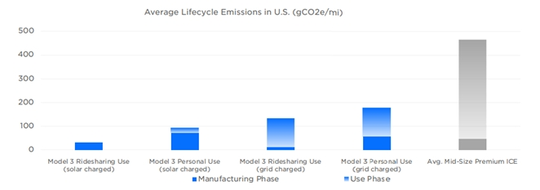
Figure 15: Average lifecycle emissions by Tesla cars in U.S (Grant, 2018).
These issues have significantly helped with the maintain of the brand image for Tesla within the years. In spite of the fact that Tesla have had many failures during its production and distribution phases (Berisha Qehaja, 2017). Ethical policies and CSR thus helps a company to gain competitive advantage for strategic development of a company.

Organisational culture, structure and leadership and their impact on strategic implementation of Tesla Inc.
Organisational culture is the shared beliefs, views and culture of a company whereas organisational structure is the process through which the activities of an organisation are run (Bindra, 2019). Employees through their combined efforts develop organisational culture and the company through its BOD decides the organisational structure. Strong organisational culture and structure like Tesla’s have significant impact within the implementation of strategic plans of the company. These two things have help to run the business activities smoothly and innovatively which within turn to this it helps an organisation to be strategic. Within, both the cases, strong leadership is necessary since leaders are the persons who helps employees to realise vision and mission of a company. Tesla's CEO Elon Musk is such a leader who has done exemplary activities to direct the employees towards a shared purpose of attaining a sustainable environment (Bindra, 2019). Efficient organisational structure, culture and leadership paves the way to formulation of strategies and decide upon smooth ways of strategic implementation.

Strategies of Tesla Inc. to Sustain the Competitive Advantages
Strategic Choice Development

Ansoff Matrix
Ansoff Matrix is a useful tool for every business organisation to identify sustainable market entry strategies. The matrix is applied for Tesla in the following table:
Market Penetration | Market Development
Tesla has a market share within China. However, since China has been working on developing its own EV brand, Tesla needs to focus on South Asia and other European countries to expand its market. Tesla has been producing distinguished cars of unique design at affordable rates (Bryson, 2020). Tesla can grab a huge market share within untapped markets by adopting a good marketing strategy. | Tesla has to develop strategies to enter new markets beyond borders. It has to conduct market research on various developing markets and adopt pricing strategy according to that. Tesla has been considering entering South Asian market through supply of energy storage systems and EV's.
Product Development | Diversification
Tesla has always been the market leader within terms of the new products like ie new solar panels and new electric cars. However, since various other automakers are also adopting same strategies, Tesla has to find a permanent solution of own battery system to produce innovative cars that would be sustainable at the same time. | Product diversification is not a good option for Tesla since Tesla has two successful production lines of energy systems and electric vehicles. Entering diversified production lines could hugely affect the production of existing products and the company can become bankrupt within the process (Fuertes, 2020).
Table 3: Application of Ansoff’s matrix for Tesla Inc.

Deliberate Strategy: Plan for Market Expansion
For Tesla, the deliberate strategy to undertake market expansion is presented within the following table using SMART tool:
Specific | Tesla Inc. has the plan of expansion to Asian market (Fuertes, 2020). However, recently Tesla has established a factory at Germany and thus established a strong base at Germany to expand current market share.
Measurable | Tesla’s operations can be measured through successful production and distribution of electric cars within the target market (Fuertes, 2020).
Achievable | Tesla has the required intellectual as well as financial capabilities to go international.
Realistic | To improve the present dangling situation and increase profits, Tesla needs to go international to survive the competition within the U.S market.
Time frame | Tesla needs 3 years of time to implement the strategy.

Table 4: Deliberate Strategy through SMART analysis.

Emergent Strategy: Recruiting skilled manpower to expand into international market
For successful implementation of the deliberate strategy, Tesla requires skilled workforce. For this purpose, the emergent strategy using SMART tool has been described within the following table:
Specific | Tesla has to recruit diverse, innovative and skilled workforce to maintain the production and management of its products for new markets (Velikorossov, 2020).
Measurable | The strategy will be a success when the company is able to meet production needs and creativity level up to the mark.
Achievable | Tesla has enough financial capacity to recruit skilled workforce that would bring profits for the company.
Realistic | It is obvious that along with robots, Tesla needs to have a skilled workforce that can adapt to changing needs in order to produce the best product / services and to make instant decisions (Velikorossov, 2020).
Time frame | Tesla can implement the strategy within a 2-month span of time.

Table 5: Application of emergent strategy through SMART analysis.

Eco-Friendly Strategy
Almost all the organisations within the world are. Now moving towards development of eco-friendly business strategies due to environmental concerns. Eco-friendly strategies not only to help meet the environmental regulations but also to help within creating a different brand value for their customers that is an excellent way of gaining competitive advantage (Desai, 2019). Tesla is already committed to producing electric cars using sustainable resources and thus driving the world towards sustainable energy consumption. Tesla has adopted several eco-friendly measures such as commitment to low carbon emission, recycling of necessary metals and using sustainable batteries. The green strategies adopted by the company has been successful within many terms. But the usage of sustainable batteries still remains a questionable fact because the company is using fuel cell batteries to drive its cars. However, it is said by the company that, research and development has been going on in issue and soon the company will be able to find a way to use sustainable batteries (Hitt, 2017).

Strategic Clock
Bowman's strategic clock helps to determine the perfect strategy that a company can adopt to position itself within the target market. The clock has eight different segments each having different meanings. Tesla has been adopting ‘focused differentiation' technique for market positioning both within the domestic and international market (Hitt, 2017). The company first intended to target high end users and then started focusing on middle-range car users to increase their sales. The customers can so easily enjoy the features and services provided by Tesla cars and energy systems.
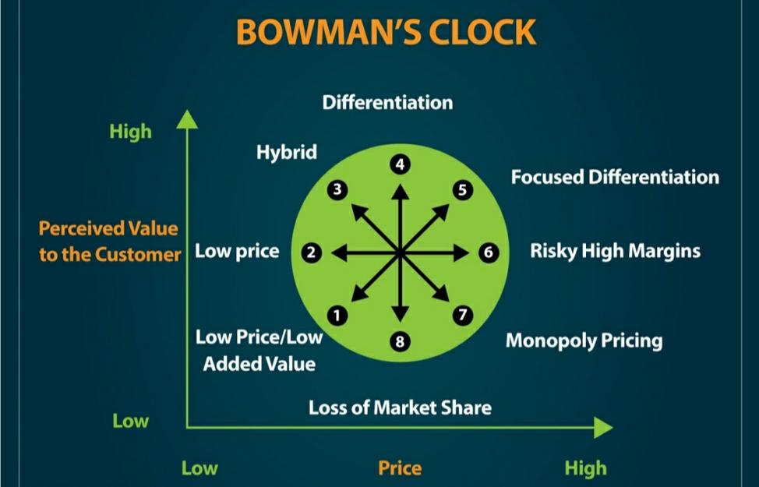
Figure 16: Strategic Clock (Desai, 2019).

Choice of Best-fit strategy and the implementation
An organisation should be strategic and evaluative while choosing the best solution and decision for the company. Choosing the best-fit strategy is one of the most difficult tasks to do because humans can only predict future therefore uncertainty remains. Tesla has selected the best strategy to meet the production failures due to complete autonomous lines. Elon Musk himself has overseen the production process by spending more than 120 hours a week within the factory and days after days (Barney, 2018). The employees have been supportive enough to revive again and produce 5000 model 3 vehicles within a week. The deliberate strategy of Tesla to expand its market is a right fit strategy to survive intense competition it is facing within the domestic market. The emergent strategy to meet the requirements of the deliberate strategy is also a best-fit strategy for the company to cope up with the situation. The implementation of these strategies are very crucial to the company (Barney, 2018).

Recommendations
For efficient strategic management, Tesla Inc. needs to work on some of its weakness and strengths. Recommendations for the company are:
- The company should keep up its innovative technique of providing cars for the customers, as innovation is the main reason for which the company remains in focus.
- Tesla Inc. needs to rely its faith on human employees rather than just depending on robots and artificial intelligence.
- Tesla should adopt some marketing strategies to expand its market within the international arena because other similar competitors are exerting aggressive pressure of marketing within the company.
- Tesla can adopt surprising techniques to introduce its new products. Apple has been the most successful company within this respect to offer products to customers as a surprise and they have boosted their sales by this technique.
- The company has to work the ‘taste makers' meaning that as it has been continuing its ‘PR-centric' approach for it car reviews, it should consider establishing retail stores within various taste making areas of U.S.

Conclusion
Strategic management is the method of planning and making decisions by which the management body of a company is able to develop effective strategies to meet the goals and objectives of the company. In other words, strategic management is that tool for a company without which a company will not be able to gain competitive advantage and will vanish from the market quickly. Tesla has been a company, which from its inception has been using strategic management to differentiate itself from other electric vehicle producers within the U.S market. The given case study explains a situation when the company was unable to utilise its resources for efficient production of model 3 cars and could not sell the product as per target. But through the strategic analysis of the case study throughout this report, there have emerged several strengths and weaknesses of the company which could be utilised to rebuild the image of the company in the global market. The company has been found to be capable enough to face the challenges cropped due to production failures and deal with the challenges with efficient strategic management.

References
Barney, J.B. and Mackey, A., 2018. Monopoly profits, efficiency profits, and teaching strategic management. Academy of Management Learning & Education, 17(3), pp.359-373.
Berisha Qehaja, A., Kutllovci, E. and Shiroka Pula, J., 2017. Strategic management tools and techniques usage: a qualitative review. Acta Universitatis Agriculturae et Silviculturae Mendelianae Brunensis, 65(2).
Bindra, S., Parameswar, N. and Dhir, S., 2019. Strategic management: The evolution of the field. Strategic Change, 28(6), pp.469-478.
Bondarenko, T.G., Isaeva, E.A., Orekhov, S.A. and Soltakhanov, A.U., 2017. Optimization of the company strategic management system in the context of economic instability.
Bryson, J. and George, B., 2020. Strategic management in public administration. In Oxford Research Encyclopedia of Politics.
Desai, C., 2019. Strategy and strategic management. In Management for Scientists. Emerald Publishing Limited.
Fuertes, G., Alfaro, M., Vargas, M., Gutierrez, S., Ternero, R. and Sabattin, J., 2020. Conceptual framework for the strategic management: a literature review—descriptive. Journal of Engineering, 2020.
Grant, R.M. and Baden-Fuller, C., 2018. How to develop strategic management competency: Reconsidering the learning goals and knowledge requirements of the core strategy course. Academy of Management Learning & Education, 17(3), pp.322-338.
Hitt, M. and Duane Ireland, R., 2017. The intersection of entrepreneurship and strategic management research. The Blackwell handbook of entrepreneurship, pp.45-63.
Jabbar, A.A. and Hussein, A.M., 2017. The role of leadership in strategic management. International Journal of Research-Granthaalayah, 5(5), pp.99-106.
Makadok, R., Burton, R. and Barney, J., 2018. A practical guide for making theory contributions in strategic management.
Nunes, B.C., Pimentel, J., Malheiro, J., Ferreira, M.R. and Proença, J.F., 2021. Life in a Bag: Sustainability, Green Economy, and Business Strategy–A Case Study. In Handbook of Research on Nascent Entrepreneurship and Creating New Ventures (pp. 335-350). IGI Global.
Velikorossov, V.V., Genkin, E.V., Balakhanova, D.K., Sidorov, M.N., Maksimov, M.I., Sulimova, E.A. and Loshkov, B.D., 2020. Strategic management.
Veselovsky, M.Y., Izmailova, M.A., Lobacheva, E.N., Pilipenko, P.P. and Rybina, G.A., 2019. Strategic management of innovation development: insights into a role of economic policy. Entrepreneurship and Sustainability Issues, 7(2), p.1296.
Wang, Z., Wang, Y., Liu, Z., Cheng, J. and Chen, X., 2020. Strategic management of product recovery and its environmental impact. International Journal of Production Research, pp.1-21.

