
Master of Business Administration
International Business pathway

Module name: Business Development Proposal
Module code: LCMB7037
Superviosr: MR.JIA Miao
Student name: Vivekananda Reddy Singireddy
Student ID:2529561
Word count: 2000

Topic
Developing a Verified E Waste Collection Network: A Business Development Proposal for Improving Formal Electronic Waste Collection and Recycling in the UK

Table of Content
1. Introduction 3
1.1 Business problem and context 3
1.2 Proposed business opportunity 3
1.3 Aim and objectives 3
2. Literature Review 4
2.1 Circular Economy 4
2.2 PESTLE 4
2.3 Jobs to Be Done 4
2.4 Value proposition canvas and Business model canvas 4
3. Methodology 4
3.1 Research Approach 4
3.2 Primary Research 5
3.3 Analysis and Ethics 5
4. Initial market opportunity analysis 5
4.1 Market need and opportunity 5
4.2 PESTLE analysis 6
4.3 Customer need and JTBD analysis 7
4.4 Value proposition and competitive differentiation 8
4.5 Business model and revenue potential 9
5. Limitations 9
6. Timeframe 10
7. Conclusion 10
References 11

1. Introduction

1.1 Business problem and context
The disposal of electronic waste is becoming a huge environmental and business problem (Jain et al., 2023). The amount of e-waste produced in the world has increased to 62 million tonnes in 2022, of which only 22.3% was formally collected and recycled; by 2030, it is expected to be 82 million tonnes (WHO, 2024). While there was a higher reported recycling rate in Europe (42.8%), there is still a significant amount of material that is unrecovered (Liu and Crebier, 2026). The Environment Agency (EA) keeps track of electrical equipment that is placed on the market in the UK, as well as the WEEE collected, emphasising the ongoing importance of formal systems (Gov.uk, 2023).

1.2 Proposed business opportunity
The concept of the business opportunity is that of an established network to collect e-waste from households and organisations to accredited recycling partners. The service would make disposal easier through scheduled collections, certifying to the recycler, tracking and notification of recycling. The value proposition is quick and easy, with trust and regulatory certainty, especially for companies that need proof of disposal and documentation. Incorporating an asset-light model, revenue would be achieved by contracting for collection for companies, individual collection and recycling partnership, and growth across UK markets could be achieved.

1.3 Aim and objectives
Aim: The aim of this research is to evaluate the commercial feasibility of establishing a verified e-waste collection network in the UK that connects households and organisations with accredited recycling partners through a convenient, traceable and compliance-focused service.
Objectives:
- To assess the scale, market conditions and demand drivers influencing formal e-waste collection and recycling in the UK.
- To identify the key disposal challenges, service expectations and unmet needs of household and organisational customers.
- To develop and evaluate a viable value proposition and business model based on verified recycling partnerships, collection services and traceability.

2. Literature Review

2.1 Circular Economy
The principles of the circular economy aim to keep products, materials and resources in use for as long as possible by reusing, repairing, refurbishing and recycling (Kirchherr et al., 2023). This structure can enable e-waste collection and resource recovery, as well as minimize reliance on waste disposal in the proposed network (Arruda et al., 2021).

2.2 PESTLE
PESTLE is a structured framework which allows you to evaluate the political, economic, social, technological, legal and environmental aspects of a business opportunity (Olayiwola et al., 2025; Per Dannemand, 2026). The proposed e-waste network is adequate since regulatory requirements, sustainability pressures, consumer attitudes, technological innovation and operating costs can have a significant impact on market attractiveness, feasibility and commercial development over time.

2.3 Jobs to Be Done
Jobs to be Done (JTBD) is a technique that puts the emphasis on the underlying work that customers want to do instead of the features of the product (Monaco Neto and Gray, 2026; Deshpande and Prentice, 2026). It is relevant to the proposed e-waste network, as it provides inputs into the identification of the functional, emotional and practical needs that will influence the design of the services, for the benefit of households and organisations.

2.4 Value proposition canvas and Business model canvas
Value Proposition Canvas helps to put e waste service on the road by identifying customer jobs, pains and expected gains and aligning the service to the real needs of the service user (Shamsuzzoha et al., 2023). The Business Model Canvas takes this analysis a step further, by establishing customer segments, partners, activities, costs and revenue streams, enabling the creation of a viable and scalable business model (Bachmann et al., 2025).

3. Methodology

3.1 Research Approach
This study will use a deductive quantitative research methodology to test assumptions that have been formulated in advance about the demand for verified e waste collection services by customers (Barroga et al., 2023). Primary data will be gathered by structured questionnaires which will be based on closed ended questions. This numerical data will then allow the systematic measurement of the preferences of the customers, their disposal behaviour and willingness to use the proposed service.

3.2 Primary Research
The primary research will be done using a structured online questionnaire which will be sent to potential users of the household and organisational level in the UK (Lin et al., 2024). Closed ended questions will be used to get quantitative data to analyze the current e waste disposal habits, service preferences, trust in recyclers, willingness to utilize verified e waste collection services and willingness to pay for services.

3.3 Analysis and Ethics
Data will be analysed quantitatively using frequency analysis in the MS Excel software, which will enable patterns in customer preference and trend of disposal behaviour to be identified. Ethical procedures comprise informed consent, voluntary participation, anonymity, confidentiality, secure data storage and withdrawal rights. Handling data will follow the UK Data Protection Act 2018 and privacy requirements.

4. Initial market opportunity analysis

4.1 Market need and opportunity
There is a significant market need as the total global e-waste in 2022 is estimated at 62 million tonnes, which constitutes just 22.3% of formal collection and recycling, with a loss of approximately US$ 62 billion in recoverable resources (UNITAR, 2024). By 2030, ITU estimates will show that 82 million tonnes of e-waste will be generated. In England, the amount of WEEE and other types of scrap metals collected for household recycling rose by 6.2%, from 491,000 tonnes in 2023 to 522,000 tonnes in 2024 (ITU, 2024). These trends suggest an increase in waste, and continued need for effective formal collection and recycling systems.

4.2 PESTLE analysis
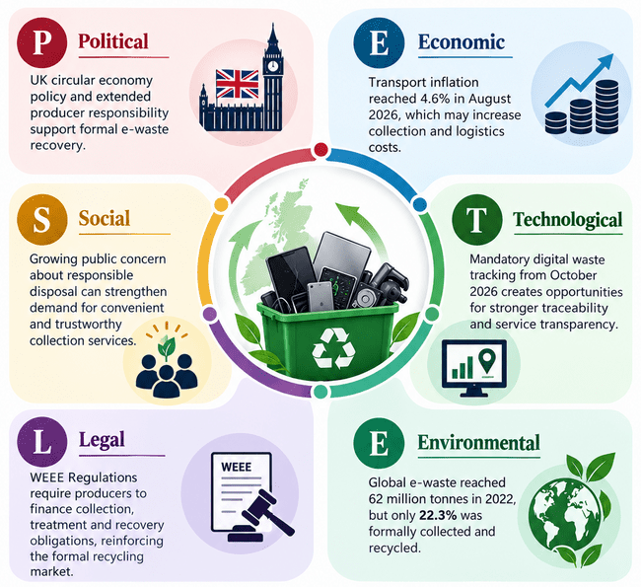
Figure 1: PESTLE analysis
(Self-developed)
The UK has established a circular economy policy that encourages E Waste recovery with the help of EPR. On the economic front, transport inflation stood at 6.6% in September 2026, which could lead to higher collection costs (Ons.gov.uk, 2026). Socially, people are becoming more concerned about responsible disposal and this can help increase the demand for convenient services. From October 2026, tracking of digital waste made mandatory, creating more opportunities for traceability in terms of technology (Gov.uk, 2026). The WEEE Regulations make collectors financially liable for producers' obligations for collecting, treating and recovering WEEE. Electronic waste (e waste) is created around the world at a rate of 62 million tonnes of e waste in 2022, of which only 22.3% was formally recycled (Gov.uk, 2023). The opportunity is supported by these factors of regulation, digitalisation and sustainability, while the logistics costs and compliance requirements could limit profitability during early market development phases.

4.3 Customer need and JTBD analysis
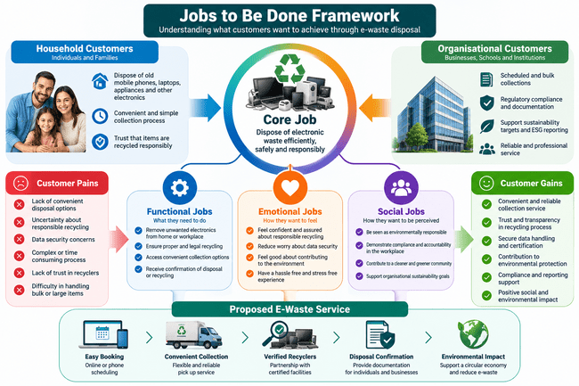
Figure 2: Jobs to be Done framework
(Self-developed)
The Jobs to Be Done framework shows that customers are looking for more than simple e waste disposal. The households need an easy-to-use, reliable and transparent way to dispose of unwanted electronics without fear of responsible recycling issues. Organisational customers also require regular pick-ups, compliance assurance, traceability and reliable documentation for compliance and sustainability reporting (Hariyani et al., 2025). The primary functional job they have is therefore to dispose of the e-waste in an efficient manner, and the emotional (social) jobs concerned in their case are of confidence, accountability, and environmental responsibility. The suggested network meets these needs by providing integrated verified recyclers and collection coordination and disposal confirmation, which minimize inconvenience, ambiguity, and perceived risk for customers.

4.4 Value proposition and competitive differentiation
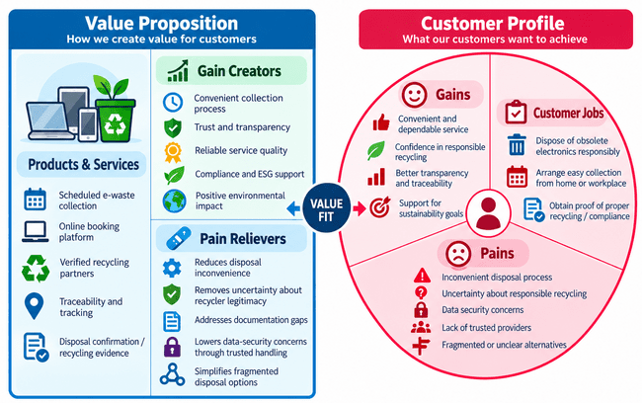
Figure 3: Value proposition canvas
(Self-developed)
The proposed network will stand out for its convenience, in addition to having verified recycling partners, traceability and confirmation of the disposal within the same service. The platform will offer regular pickups and demonstrate responsible recycling, unlike recycling centres, take back schemes and traditional waste collectors, which are broken up. There will be added value for organisation customers in documentation, reliability and compliance support. This all-encompassing offer will be based on trust, transparency and service quality, not price.

4.5 Business model and revenue potential
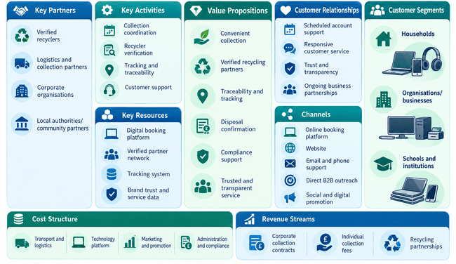
Figure 4: Business model canvas
(Self-developed)
The Business Model Canvas places households and organisations as core segments of the recycling market and verified recyclers and logisticians as support. Some of the core activities are collection coordination, customer support, tracking and recycler verification. Revenue will be generated through corporate collection contracts, single collection fees and recycling programs. An asset light partnership model can help lower capital needs, and facilitate scalable growth and ongoing commercial revenue.

5. Limitations
The proposal may have a relatively small primary research sample which may affect the generalisability of findings throughout the UK market. Express interest in using or paying for the service doesn't necessarily translate into actual use. Market estimates may be limited due to lack of access to commercial recycling data and informal e waste flows, so transparent assumptions and triangulation will be used.

6. Timeframe
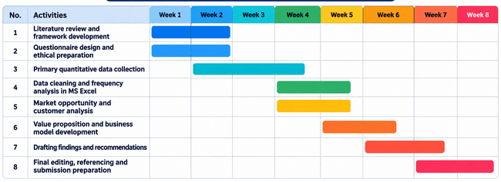
Figure 5: Proposed timeframe
(Self-developed)

7. Conclusion
The opportunity offered by the proposal is a viable e waste collection network that is both convenient and trusted, while also filling the void of formal recycling. There is commercial potential based on market evidence and customer needs, as well as the proposed asset light model. Additional primary research will be necessary to confirm demand, willingness to pay and feasibility.

References
Arruda, E.H., Melatto, R.A.P.B., Neto, W.L.B. da S. and Conti, D. de M. (2021). Circular economy: A brief literature review (2015-2020). Sustainable Operations and Computers, [online] 2(2), pp.79–86. doi:https://doi.org/10.1016/j.susoc.2021.05.001.
Bachmann, N., Thienemann, A.-K., Tüzün, A., Brunner, M., Tripathi, S., Pöchtrager, S. and Jodlbauer, H. (2025). The evolution of the business model canvas for digital sustainability. 6th International Conference on Industry 4.0 and Smart Manufacturing, [online] 253, pp.1012–1023. doi:https://doi.org/10.1016/j.procs.2025.01.163.
Barroga, E., Matanguihan, G.J., Furuta, A., Arima, M., Tsuchiya, S., Kawahara, C., Takamiya, Y. and Izumi, M. (2023). Conducting and writing quantitative and qualitative research. Journal of Korean Medical Science, 38(37), pp.1–16. doi:10.3346/jkms.2023.38.e291.
Deshpande, R.Y. and Prentice, C. (2026). Jobs-to-be-done meets mobile banking: What makes customers recommend. Cogent Business & Management, 13(1). doi:https://doi.org/10.1080/23311975.2026.2616110.
Gov.uk (2023). Electrical and electronic equipment (EEE) covered by the WEEE regulations. [online] GOV.UK. Available at: https://www.gov.uk/government/publications/electrical-and-electronic-equipment-eee-covered-by-the-weee-regulations/electrical-and-electronic-equipment-eee-covered-by-the-weee-regulations [Accessed 22 Oct. 2026].
Gov.uk (2026). Digital waste tracking goes live: A major step forward in stopping waste crime – creating a better place. [online] Blog.gov.uk. Available at: https://environmentagency.blog.gov.uk/2026/04/30/digital-waste-tracking-goes-live-a-major-step-forward-in-stopping-waste-crime/ [Accessed 22 Oct. 2026].
Hariyani, D., Hariyani, P., Mishra, S. and Sharma, M.K. (2025). A review of the structured framework for sustainability audits in manufacturing organizations. Green Technologies and Sustainability, 3(3), p.100170. doi:https://doi.org/10.1016/j.grets.2025.100170.
ITU (2024). Press release. [online] ITU. Available at: https://www.itu.int/en/mediacentre/Pages/PR-2024-03-20-e-waste-recycling.aspx [Accessed 22 Oct. 2026].
Jain, M., Kumar, D., Chaudhary, J., Kumar, S., Sharma, S. and Verma, A.S. (2023). Review on e-waste management and its impact on the environment and society. Waste Management Bulletin, [online] 1(3), pp.34–44. doi:https://doi.org/10.1016/j.wmb.2023.06.004.
Kirchherr, J., Yang, N.-H.N., Schulze-Spüntrup, F., Heerink, M.J. and Hartley, K. (2023). Conceptualizing the circular economy (revisited): An analysis of 221 definitions. Resources, Conservation and Recycling, 194(1), p.107001. doi:http://doi.org/10.1016/j.resconrec.2023.107001.
Lin, Z., Gu, H., Gillani, K.Z. and Fahlevi, M. (2024). Impact of green work–life balance and green human resource management practices on corporate sustainability performance and employee retention: Mediation of green innovation and organisational culture. Sustainability, 16(15), pp.6621–6621. doi:10.3390/su16156621.
Liu, J. and Crebier, J.-C. (2026). A parametric life cycle inventory framework and decision-support tool for power module recycling. Sustainability, 18(16), p.8426. doi:https://doi.org/10.3390/su18168426.
Monaco Neto, L.C. and Gray, A.W. (2026). A jobs-to-be-done framework for mapping digital innovation opportunities in climate-smart agrifood systems. Sustainability, [online] 18(9), p.4487. doi:https://doi.org/10.3390/su18094487.
Olayiwola, K., Perera, S., Kagioglou, M., Jin, X. and Sharafi, P. (2025). A PESTEL analysis of problems associated with the adoption of offsite construction: A systematic literature review. Buildings, [online] 15(13), pp.2146–2146. doi:https://doi.org/10.3390/buildings15132146.
Ons.gov.uk (2026). Consumer price inflation, UK. [online] Ons.gov.uk. Available at: https://www.ons.gov.uk/economy/inflationandpriceindices/bulletins/consumerpriceinflation/september2026 [Accessed 22 Oct. 2026].
Per Dannemand, A. (2026). The PESTEL framework and its variants for analysing the strategic environment: Evolution, limitations and adoption in energy policy research. Futures, [online] 184, p.103914. doi:https://doi.org/10.1016/j.futures.2026.103914.
Shamsuzzoha, A., Suihkonen, A.-M., Wahlberg, C., Jovanovski, B. and Sujan Piya (2023). Development of value proposition to promote green innovation for sustainable organizational development. Cleaner engineering and technology, 15, pp.100668–100668. doi:https://doi.org/10.1016/j.clet.2023.100668.
UNITAR (2024). Global e-Waste monitor 2024: Electronic waste rising five times faster than documented e-waste recycling. [online] United Nations Institute for Training and Research. Available at: https://unitar.org/about/news-stories/press/global-e-waste-monitor-2024-electronic-waste-rising-five-times-faster-documented-e-waste-recycling [Accessed 22 Oct. 2026].
WHO (2024). Electronic waste (e-waste). [online] World Health Organization. Available at: https://www.who.int/news-room/fact-sheets/detail/electronic-waste-(e-waste) [Accessed 22 Oct. 2026].

