Research Report
Student Name:Andreea Dascalu
Student Number: 2130822
Lecturer Name: Dale Clarke
LCHS4002_BIRM
Digital Skills and Research Methods

Acknowledgement
This research has been executed by me solely and nobody has any influence on this research. I would like to convey my gratitude to my university instructors who have motivated me a lot while carrying out the research. I would also give my warm gratitude to my family members who have always supported me and trusted me. I would also like to appreciate my friends who have helped me a lot during the execution of the research. The sources that I have used in this research are all authentic. There is no scope for plagiarism and this writing piece is unique and done by me completely.
Abstract
This research has been based on the uses of digital technology in the working sector. The strategies of digital technology that help to increase the efficiency of the workplace have been added in this research. The challenges and the problems of digital technology have been studied here. The solution method to the problems that the employees have faced with digital technology in the workplace has been investigated in the report. For this research, the researcher has chosen Iceland food PLC. This company has sold packaged food items, for this reason, the company has started to use digital technology in Iceland food PLC to increase the working capacity of the worker. In order apply the digital technology in the working sector of Iceland food PLC has had a positive impact. On the other hand, the employees of the company face some problems with digital technology. For solving their problems and managing the workplace culture research has taken an important role.

Table of Contents
Introduction 5
Introduction 5
Background of the research 5
Research aims and objectives 5
Research rationale 6
Research Design 7
Research questions 7
Methodology 7
Ethical consideration 8
Results 9
Discussion 14
Conclusion 16
References 17
List of figures
Figure 1 10
Figure 2 10
Figure 3 11
Figure 4 12
Figure 5 13
Figure 6 13

Introduction

Introduction
This research will be based on incorporating digital technology into an organisation. This section will discuss the background of the chosen topic of digital transformation. Along with this, a brief understanding of the chosen organisation will be showcased in this research. The suitable aim and objectives will be highlighted in this section to solve the research problem properly. Moreover, this section will highlight the research rationale to justify the research topic properly.

Background of the research
This research will discuss the importance of digital technology in an organisation. The incorporation of digital technology in an organisation helps to meet the demand of the customers properly. The business operation will be smoother by incorporating digital technology into an organisation (Dienlin, and Johannes, 2022). Iceland Foods Ltd is a supermarket in the United Kingdom that was founded in 1970. This organisation was founded by Sir Malcolm Walker and this organisation has generated £4 billion in 2021 (iceland, 2022). This research will help this organisation to understand the need for digital transformation to improve working efficiency (Altadonna, 2022).

Research aims and objectives
Aim
To analyse the impact of digital technology in improving the efficiency of the workplace and the employability of Iceland PLC.
Objectives
1. To determine the significance of digital technology in increasing the workplace efficiency of Iceland Foods Ltd.
2. To determine the challenges of incorporating digital technology in the workplace of Iceland Foods Ltd.
3. To determine the strategies implemented by Iceland Foods Ltd to mitigate the challenges of digital technology.

Research rationale
This research will help to understand the importance of incorporating digital technology in an organisation to smoothen work efficiency (Pratt, 2022). This research will help to understand the challenges regarding incorporating digital technology. Besides this, this research will help to understand the proper strategies to implement and overcome the challenges (Dao, 2020).

Research Design

Research questions
1) What is the significance of digital technology in increasing the workplace efficiency of Iceland PLC?
2)What are the challenges of incorporating digital technology in the workplace of Iceland PLC?
3) What are the strategies implemented by Iceland PLC to mitigate the challenges of digital technology?

Methodology
This section has highly focused on the research methods of the research. The researcher has chosen the descriptive research design for this researcher. Using the descriptive research design the researcher has included the survey and the questioners in this research topic (Dodds and Hess, 2020). The researcher has chosen the descriptive research design for extracting the positive result from this research. The researcher has used the research to complete the research statistically. Every step of the research has been included in the research onion (Zangirolami, 2018, pp.356-360). For doing the research the researcher has to start the research from the outer side to the inner side of the research onion. Saunder implemented this research onion in the year 2007 to do the research in a statistical and planned way (Babii, 2020). The next step of the research onion us the research philosophy. The research philosophy of the personal viewpoint of the researcher. Through this part, the researcher has sharpened the way of the research. For this research, the researcher has chosen positivism to conclude the result positively (Newman, 2020, pp.3-22). Using positivism as a research philosophy the researcher has avoided the negative data from this research. Using the deductive research approach the researcher has logically completed the research. This part has taken a useful role in the research cause the researcher can make the next plan for the research through this part (Melnikovas, 2018). The research was based on the survey method for this reason the researcher has chosen the survey method as the research strategy. Using a survey method for this research the researcher has to make some open-end questions for this research. Research choice is another important part of the research, selecting the research choice the researcher has chosen the next step of the research. For the research topic, the researcher has chosen the mono method. Using the mono method the researcher has completed the research with a particular resource of the research. The main important part of the research is the data collection and sampling method for this particular research. The researcher has chosen the primary resources for the research. The researcher only collected the data from the survey of 20 samples. The samples of the survey were collected from the employees of Iceland food limited. Using their reviews the researcher has included the real data in the research. Including real data in the research, the researcher has extracted the truth and positive results from the research that has related to the aims and objective of the research. The samples are collected through questionnaires and survey methods. The researcher has chosen the cross-sectional time horizon for this research.

Ethical consideration
The samples of the research have been protected by the data protection act 2018. The researcher has uploaded the research report on the internet site and is protected by the ID and password. Only a few people can edit this report of the research with the correct ID, password and the approval of the researcher (Abutabenjeh and Jaradat, 2018). On the other hand, the researcher has uploaded the PDF file of the research to avoid copyright issues. The used samples have been collected by the researcher from the employees of the Iceland food company as per their permission. No person is influenced by another person to take part in the research (Davidavičienė, 2018, pp. 1-23).

Results
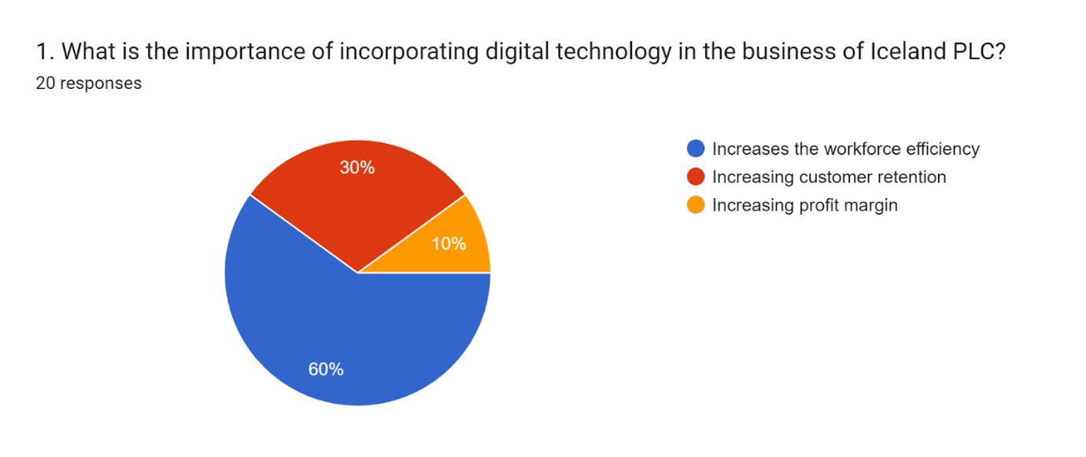
Figure 1
Source- (google, 2022)
Analysis
The survey result is showing the importance of incorporating digital technology into the business. From the above survey result, it can be seen that, according to 60% of the respondents, digital technology has increased the workforce efficiency of Iceland Foods Ltd. On the other hand, according to 30% of the responders, the customer retention rate has also increased. According to the rest 10% of the respondents, the profit margin of the organisation has also increased.

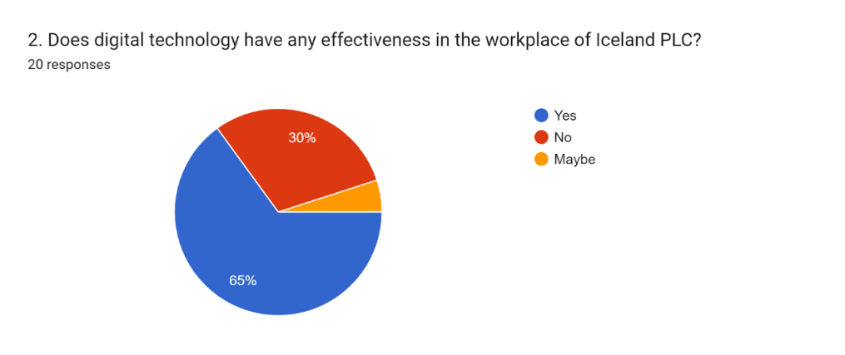
Figure 2
Source- (google, 2022)

Analysis
The above survey result is showing the efficiency of digital technology in the business. According to 65% of the respondents, digital technology has been effective in the business operations of Iceland Foods Ltd. On the other hand, according to 30% of the respondents, it does not create any effectiveness in the workplace of Iceland Foods Ltd. The rest of the respondents have no idea about the same.
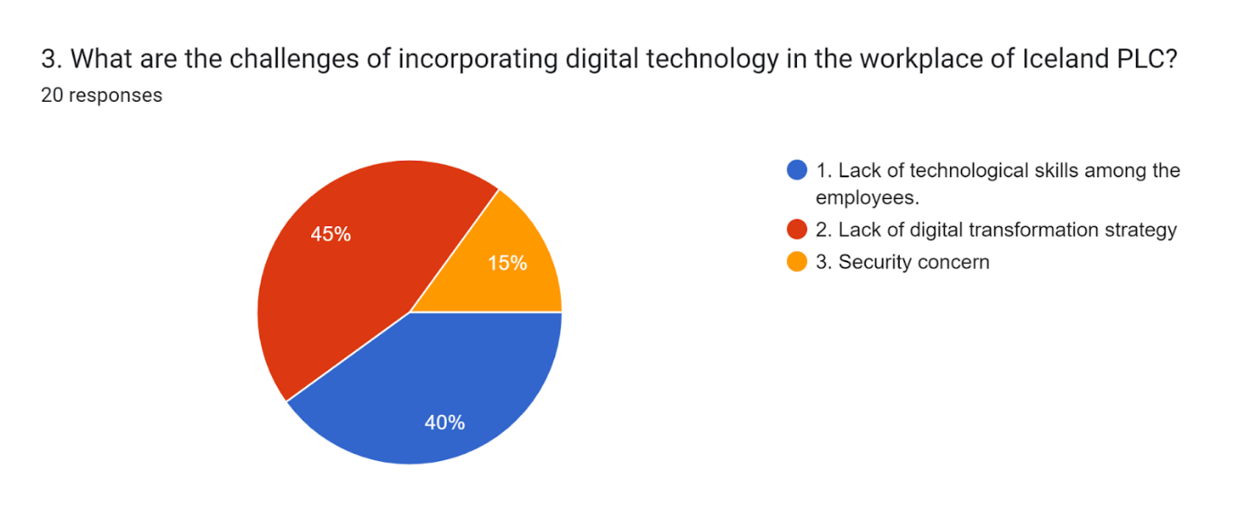
Figure 3
Source- (google, 2022)
Analysis
From the above survey result, it can be seen, according to 40% of the respondents, that the major challenge of digital technology is the lack of technological skills among the employees. On the other hand, according to 45% of the respondents, lack of digital transformation strategy is another concern. According to the rest 15% of the respondents, security is another major issue.
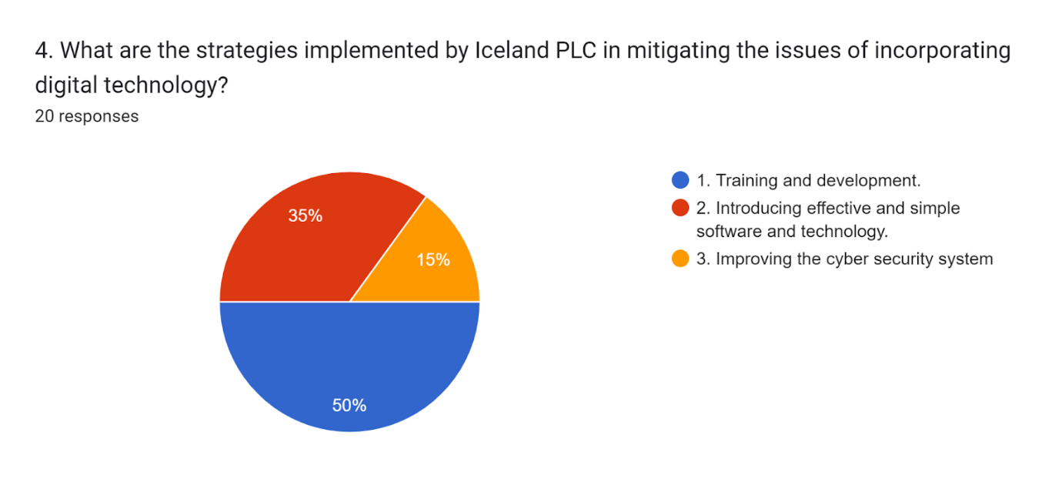
Figure 4
Source- (google, 2022)
Analysis
From the above survey result, it can be seen that, according to 50% of the respondents, providing training to the employee on technological skills is an important strategy for mitigating the issues. According to 35% of the respondents, introducing not-so-complex software and technology to the employees is another strategy. On the other hand, improving the cyber security system is another important strategy.
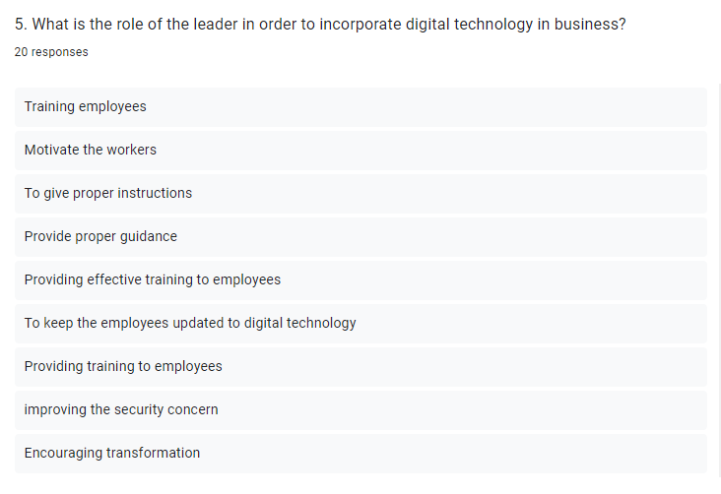
Figure 5
Source- (google, 2022)
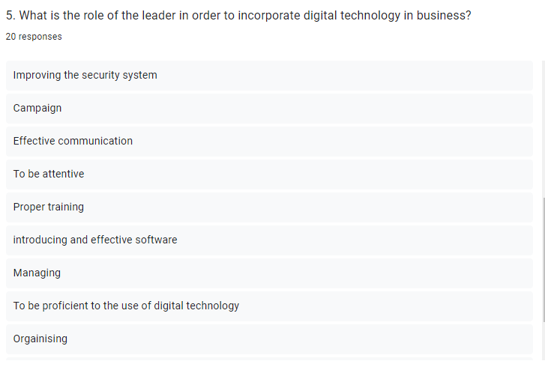
Figure 6
Source- (google, 2022)

Analysis
The above survey result is showing the role of leaders in incorporating digital technology. Among them, the most significant ones are providing training, providing guidance, and improving the digital security system are the others.

Discussion
From the above analysis, it has been seen that the importance of digital technology in an organisation plays a vital part. It genuinely increases the efficiency of the workforce. Besides this, the incorporation of digital technology helps to make a strong customer base that will make a positive impact on the revenue of an organisation. The technology in an organisation helps to increase the operational efficiency of the business process, services and products. It will help to maintain the data flow. It allows management of the records of the employees. Besides this, it has been found from the above analysis that the effectiveness of digital technology is immense. Most business organisations collect numerous pieces of data and the proper data analysis leads an organisation towards future growth. The incorporation of digital technology also gathers the information and the business resources that are most appropriate for an organisation. The increased efficiency in a business organisation will also help to save time as well as money. This is one of the reasons why an organisation can achieve their goals within less time. Communication within the business operation will be more effective. Technology helps to boost the wider, faster as well as a more efficient way of communication. The implementation of digital technology also builds some challenges in an organisation. The challenges such as lack of technological skills among the employees. Some employees exhibit resistance to learning the new technological skills and some employees do not feel comfortable working effectively with the new implementation of digital technology. Regular productivity in the workplace decreases due to a lack of technological skills among the employees. The other challenge faced by an organisation is the lack of digital transformation. The right set of implementations of the right tools helps to get the best results. The organisational culture is the one of biggest digital transformation challenges in an organisation. The main reality of digital transformation is not only about implementing the technologies. It also depends on the organisation’s ability to adopt the changes positively. The ineffective communication also hinders digital transformation. The lack of challenge management strategy also leads to failure of the new project in an organisation. Besides this, complex technology and software are also large challenges in an organisation. The lack of proper IT skills also hinders cyber security in an organisation as well. The analysis has also found the strategies implemented by organisations to handle the issues that have emerged from the incorporation of digital technology in business. Training and development are the major strategies that have been practised by organisations. Management arranges training regarding the various technical skills that are used in the organisations. It helps the employees to acquire the necessary skills. Along with that, it also increases the motivation among the employees. The skills that are being trained for employees are software integration, data security, data analytics and data handling.

Conclusion
The research has exhibited the importance of digital technology in the business process of an organisation. It has followed the quantitative methodology in executing the research. The research methodology chosen by the researcher was successful to address the objectives and research questions of the research. It has conducted an online survey with a quantitative questionnaire. The survey was conducted on the employees of Iceland Foods Ltd. It has been investigated that digital technology has been able to improve workforce efficiency. Though it has faced some drawbacks such as a lack of proper IT skills among the employees, and the absence of a proper digital transformation strategy. It has also identified the strategies that can help to mitigate these issues. Providing training to the employees is one of the major strategies implemented by the organisation. Along with that, it has been also identified that improving the cyber security system will also help to mitigate the issues. Complex technology and software also develop challenges among the employees. This issue creates problems in data analytics and data integration. For mitigating this issue, the management of an organisation should consider this matter and should introduce friendly software and technology for the employees. At the initial stage of digital transformation, management should consider this issue. On the other hand, poor digital security systems are a major issue in organisations regarding digital technology. For this reason, management should take care of cyber security from the beginning. Weakness in cyber security is a very alarming issue. Management needs to implement a proper digital security system in their organisation.

References
Abutabenjeh, S. and Jaradat, R., (2018). Clarification of research design, research methods, and research methodology: A guide for public administration researchers and practitioners. Teaching Public Administration, 36(3), pp.237-258.
Altadonna, N., (2022). Digital Transformation: How Technology is Changing Business. [Online] Available at: https://www.apty.io/blog/digital-transformation-how-technology-is-changing-business
Babii, A., (2020). Important aspects of the experimental research methodology. Вісник Тернопільського національного технічного університету, 97(1), pp.77-87.
Dao, D. Q., (2020). 3 Benefits of Digital Technology in Business. [Online] Available at: https://www.techfunnel.com/information-technology/3-benefits-of-digital-technology-in-business/
Davidavičienė, V., (2018). Research Methodology: An Introduction. In Modernizing the Academic Teaching and Research Environment (pp. 1-23). Springer, Cham.
Dienlin, T. and Johannes, N., (2022). The impact of digital technology use on adolescent well-being. Dialogues in clinical neuroscience.
Dodds, S. and Hess, A.C., (2020). Adapting research methodology during COVID-19: lessons for transformative service research. Journal of Service Management, 32(2), pp.203-217.
iceland, (2022). Everyday Essentials. [Online] Available at: https://www.iceland.co.uk/everyday-essentials
Melnikovas, A., (2018). Towards an explicit research methodology: Adapting research onion model for futures studies. Journal of Futures Studies, 23(2), pp.29-44.
Newman, M. and Gough, D., (2020). Systematic reviews in educational research: Methodology, perspectives and application. Systematic reviews in educational research, pp.3-22.
Pratt, M. K., (2022). 10 digital transformation benefits for business. [Online] Available at: https://www.techtarget.com/searchcio/tip/Top-10-digital-transformation-benefits-for-business
Zangirolami-Raimundo, J., Echeimberg, J.D.O. and Leone, C., (2018). Research methodology topics: Cross-sectional studies. Journal of Human Growth and Development, 28(3), pp.356-360.

