

EXAMINATION PAPER
MARKS AND COMMENTS SHEET

PROGRAMME | OME Degree Apprenticeship
LEVEL | 4
MODULE | ACDB4011 Chemistry
STUDENT I.D. | 2413109
EXAMINER | Ewa Kazimierska | INTERNAL VERIFIER
Once completed marks only should be transferred onto the front of the examination paper (no comments other than ticks or crosses on the examination paper)

Question  Number | Comments | Marks available | Marks awarded | 2nd marker (sample) | 3rd marker (where necessary)
1 | 7/10 True/False correct. Good understanding of molecular interactions and energetics; minor errors in atomic structure. | 15 | 10.5
2 | All parts correct and well-presented, though part d lacked discussion of N≡N bond’s relevance to explosive performance. | 11 | 10.5
3 | All equations and calculations performed correctly in part a, but incorrect energy units used. Part b lacked unpaired electron count; part c confused terminology. | 10 | 7.5
4 | Balanced equation provided. Errors in mole ratios and unit mismatch affected final calculations. Final volume calculation had formula errors. | 15 | 10
5 | Good overall understanding of oxygen balance and its significance. Minor calculation mistakes in OB but strong application in following parts. | 16 | 12
6 | Diagram presented without calculated values for activation energy or enthalpy. No answer for part b. | 7 | 1.5
7 | Some elements of the phase diagram interpreted correctly. Heat curve lacked labels, triple point name omitted, and explanation in c) was brief. | 11 | 8
8 | Molarity equation was incorrect; ionic equation was not attempted. | 5 | 1.5
9 | Good understanding of calorimetry. Correct use of the equation and calculations. | 5 | 5
10 | Incorrect oxidation number assignments. Redox agents not clearly identified and second part was not answered. | 5 | 0
 |  |  | 66.5

1st Marker Name | Ewa Kazimierska | 1st Marker Signature | 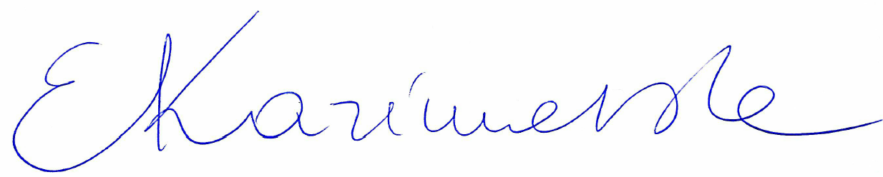
2nd Marker Name |  | 2nd Marker Signature
3rd Marker Name |  | 3rd Marker Signature
Reasons for awarding the final mark where there is more than one marker
Notes:
- The 3rd marker may be used where there is more than a 10 percentage point difference (in the TOTAL mark) between markers 1 and 2 OR when it is not possible to get agreement between markers 1 and 2. Reasons must be given where an agreed mark is given.
- This form is for internal use only and is NOT to be returned to the student. The final agreed marks must be transferred to the student feedback sheet in the assignment specification.
- The external examiner MUST be shown this form.

