

Managing Hotel Administration

Student Name: Baby Lima

Student ID:2133582
Lecturer Name : Jessica Newport
Date of Submission: 06.03.25

Table of Contents
Introduction 3
Learning Objectives for HR Placement: 3
Reflection on Experience and Personal Development 4
Critical Analysis of Work-Based Skills and Technical Knowledge in Hotel Administration 6
Reflection on Organisational Issue in Hotel Administration 7
Conclusion 8
Action Plan 8
References 10

Introduction
Ibis London Stratford has an administrative structure, which makes their guest service, financial, and human resource activities more organised (Ibis, 2025). Centre on service quality is when the Department of Human Resources (HR) is concerned about recruitment, extraneous relations with employees, training and compliance with industry regulations.

Learning Objectives for HR Placement:
- Understanding the recruitment and hiring processes effectively.
- Obtaining and developing knowledge of employee onboarding and training.
- Learning policies and responsibilities of HR, labour laws, and compliance.
- Enhancing communication and conflict resolution skills.
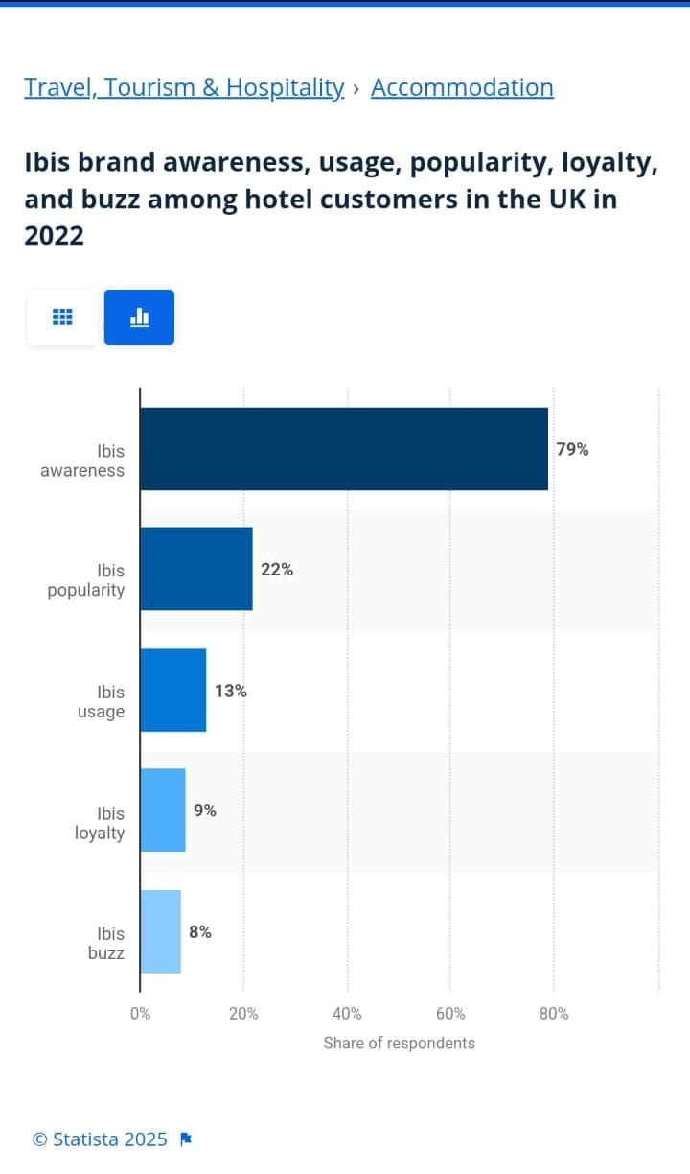
Figure 1: Ibis brand awareness
(Source: Statista, 2025)

Reflection on Experience and Personal Development
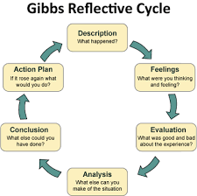
Figure 2: Gibbs Refection Model
(Source: Hashim et al., 2023)
Description
I got the opportunity to shadow a supervisor in hotel administration during my placement at Ibis London Stratford. Taking placement in something improves several skills (ASET, 2017). It was a responsible role where I observed daily operations like facility coordination, guest relations and real-time problem-solving. I learned how to deal with guests' complaints, how to make reservations and how to manage the efficiency of the staff. I was also involved in team briefings and had an opportunity to go through the SOPs of the hotel administration. Practical exposure to a supervisory position in the hospitality sector was a great experience.
Feelings
I was both excited and suspicious at first while stepping into this dynamic hotel environment. I wanted to learn about hotel operations and was not sure if my fast pace would translate into this profession. By that time I became more confident with the role and appreciated the opportunity to have such experiences. At the end of the placement, I felt completely satisfied, and confident in using the theory that I learnt to solve real-life problems.
Evaluation
The experience was so important in aiding the understanding of how work-based skills were important in the hotel administration. I learn about guest service standards, staff management and problem-solving techniques. What I also liked was that the supervisor showed very good communication and leadership skills. But also I found it to be difficult to work with a team, handling tricky guests or operational problems. A hotel supervisor must be able to balance how efficiency meets guest satisfaction.
Analysis
This placement reinforced my understanding of the technical knowledge required to maintain high guest service standards. Developing communication skills helps in career growth (Bardi, 2010). It also enhanced my ability to communicate effectively, work as part of a team, and manage tasks efficiently. I also recognised the impact of personal skills such as patience, adaptability, and problem-solving on delivering quality service. Placement bridges the gap between academic learning and real-world application (Johnston, Clark and Shulver, 2012). It allows me to see how theoretical concepts, such as customer relationship management and operational efficiency, function in practice.
Conclusion
It was a transformative experience shadowing a supervisor in hotel administration. It is important to analyse which place is right for placement to develop the required skills (Hagg, 2013). It made me realize how necessary good hotel leaders are for the operations of maintaining service standards. There were areas of personal development I could progress in, for instance, increasing my tolerance to stress and hastening up my decisions. The experience also made me want to continue pursuing a career in the hospitality industry as my career aspiration.
Action Plan
In the future, I intend to strengthen my leadership abilities by continuing my education in hotel management and customer service. Time management is another important skill in housekeeping management (Casado, 2012). I will also try to improve my time management as well as conflict resolution skills in order to prepare myself for forthcoming supervisory assignments. I will further engage in industry placements as well as in academic studies in order to enhance my understanding of hotel administration.

Critical Analysis of Work-Based Skills and Technical Knowledge in Hotel Administration
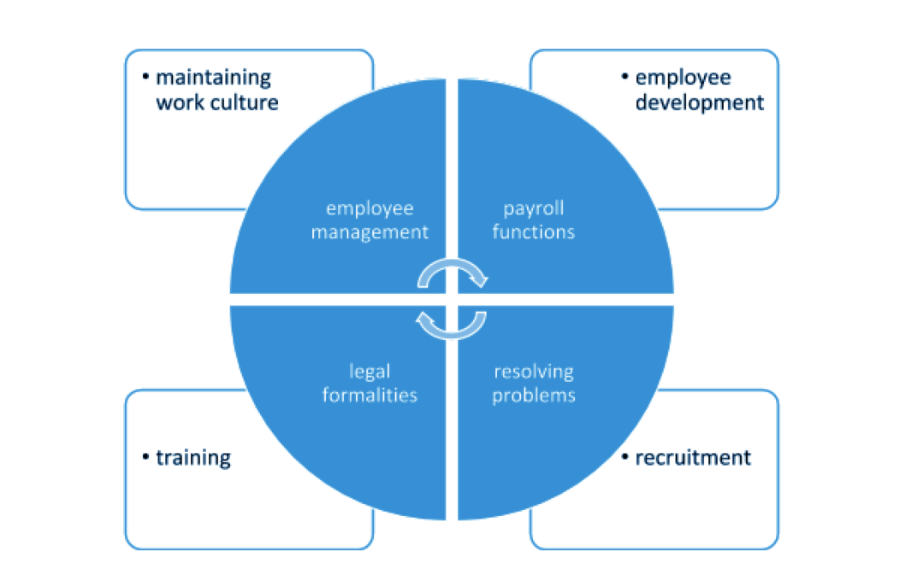
Figure 3: Role of HR
(Source: Ochieng, 2023)

The ability to manage administration in the hotel is dependent upon work-based skills and technical knowledge (Vallen and Vallen, 2014). To coordinate staff, communicate with guests, and maintain smooth operations one must possess strong communication and leadership skills. As an example, in one of the shadowing experiences I had, I witnessed how the supervisor conducted a daily briefing to keep people together to achieve operational activities, which explained the value of the conversation in service quality.
It is equally important that the person has technical experience, meaning one is competent with hotel reservation systems, financial reporting, and adhering to health and safety policies. With Access HRIS employee engagement can be fostered (The Access Group, 2025). A property management system was used by the supervisor to track occupancy rates and allocate rooms and guest preferences effectively. Furthermore, together with procedural knowledge, and problem-solving skills were necessary to resolve guest complaints and yet ensure customer satisfaction by adhering to the company policies.
These experiences increased the need for the hotel administration to be able to adapt, multitask, and make correct and effective decisions. It is essential to shift to continuous professional development in these areas to ensure keeping abreast with industry advancements and high service standards (Susskind and Susskind, 2022). Second, a combination of being able to work on skills and being able to be technically competent in the industry is key to attaining operational efficiency.

Reflection on Organisational Issues in Hotel Administration
Placement learning is an effective process to develop skills (QAA, 2018). In my shadowing experience in the hotel’s administrative department, I noticed a problem with the badly scheduled staff of the hotel. The hotel had a strict scheduling system which would not account for the changes in the amount of demand of the guests, resulting in situations of gross understaffing and gross overstaffing. This all negatively affected operational efficiency, employee morale, as well as the level of guest service quality. For instance, long check-in lines generated guest dissatisfaction at peak times and at low times overstaffing caused waste labour expenditure.
Thus, the issue is in line with Herzberg’s Two Factor theory where poor conditions at work such as inconsistent workloads affect employee motivation. Implementing self-scheduling options to handle multiple roles could also improve adaptability. Additional adaptability could be provided by instigating the use of self-scheduling options, or cross-training employees to do multiple roles. If the hotel cannot address this issue, it can decrease operational efficiency, improve staff satisfaction, as well as enhance guest experience, and thus, improve service quality and cost-effectiveness.

Conclusion
The work experience at Ibis London Stratford had the particularity of allowing me to discover what it means to manage the hotel administration, that is, the complexity of a management post skeleton of a hotel, highlighting the need for work-based skills, technical knowledge and operational efficiency. Observing a supervisor’s interaction with the staff, guest service and problem-solving processes reminded me of the role of leadership, multitasking and making decisions under such pressure even in a complicated environment.
I have understood the challenges of administrative work and am interested in improving my knowledge of workforce management strategies. It will be important for future roles in the hotel industry to develop competencies in hotel software, conflict resolution, and guest relations.
I intend to further develop my leadership faculties and further develop my technical expertise.

Action Plan
Skills | Resources | Activities | Timeline
Enhance leadership skills | Online courses, books, attending business events | Attend hospitality leadership workshops and seek mentorship opportunities | 8-9 months
Enhance communication skills | Books, Online courses, writing on different topics | Engaging with teamwork, attending more events, taking online courses | 3-4 months
Improve teamwork skills | Team projects, group discussions, professional team leader | Participating in team projects, taking part in group discussions and appreciating others' decisions. | 5-6 months
Develop conflict-resolution skills | Case study analysis, Hospitality management textbooks, Customer service workshops | Participate in customer service training and role-playing exercises | 7-8 months
Develop technological skills | Online courses, Books, Youtube tutorials | Taking online courses, Reading books on the use of different technology, Watching YouTube tutorials and also taking courses from professionals | 10-12 months

References
ASET (2017) Good Practice Guide for Workbased and Placement Learning in Higher Education. Sheffield: ASET.
Bardi, J. (2010) Hotel Front Office Management. London: Wiley.
Casado, M. (2012) Housekeeping Management. London: Wiley.
Hagg, E. (2013) Internship Guide: Work Placements Step by Step. 5th ed. The Hague: Eleven International Publishing.
Hashim, S.N.A., Yaacob, A., Suryani, I., Asraf, R.M., Bahador, Z. and Supian, N. (2023) ‘Exploring the use of Gibbs’ reflective model in enhancing in-service ESL teachers’ reflective writing’, Arab World English Journal, 14(2).
Ibis (2025) Hotel info [Online]. Available at: https://ibis-london-stratford.h-rez.com/?lbl=ggl-uk-rsp&gad_source=1&gclid=CjwKCAiAn9a9BhBtEiwAbKg6fpaY4Fg7Y3rtuJhVqF8wBZkNhgMF5nGHrSBQraSB7YYie8UzDbZVrxoCQ5cQAvD_BwE (Accessed: 19 February 2025).
Johnston, R., Clark, G. and Shulver, M. (2012) Service Operations Management: Improving Service Delivery. 5th ed. London: Pearson.
Ochieng, E.M. (2023) ‘A study of the history functions, roles and challenges of human resources management’, Journal of Enterprise and Business Intelligence, 3(1), pp. 54–64.
QAA (2018) UK Quality Code, Advice and Guidance: Work-based Learning. London: QAA.
Statista (2025) Ibis brand awareness, usage, popularity, loyalty, and buzz among hotel customers in the UK in 2022 [Online]. Available at: https://www.statista.com/forecasts/1335566/ibis-hotels-brand-profile-in-the-uk (Accessed: 19 February 2025).
The Access Group (2025) [Online]. Available at: www.theaccessgroup.com (Accessed: 19 February 2025).
Vallen, G.K. and Valen, J.J. (2014) Check-In Check-Out: Managing Hotel Operations. 9th ed. Harlow: Pearson Education Limited.

