Mohammed Abdul Farhan
Civil Engineering
Construction Management
Programme Control
Assignment 1 of 2


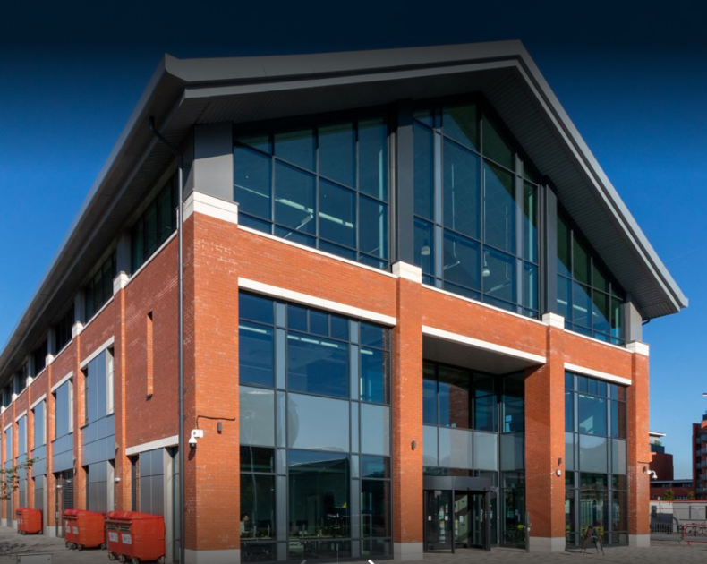

Contents

1.0 - Abstract………………………………………………………………………..2
1.1 - Introduction…………………………………………………………………...3
Figure 1………………………………………………………………………….4
1.2 - Productivity…………………………………………………………………...5
1.3 - Cost…………………………………………………………………………...6
1.4 - Concrete columns + Prefabrication….…………………………………….7
1.5 - Safety training and measures……………………………………………...8
1.6 - Incentives…………………………………………………………………….9
1.7 - Advise the client on contract conditions on delay and disruption……..10
1.8 - Sketch up Drawing.………………………………………………………...11
1.9 - Spreadsheet of project……………………………………………………..13

1.0 - Abstract

This report will outline what stages are undertaken for the build of the new UWTSD SA1 library (Y Fforwm). The initial work will begin on the 6th of May 2020. The Gantt chart provides the information on how long each task will take to complete along with starting other tasks at the same time, this is due to saving labour time and will give a quicker end finish. Of course will all the builds, the contract set out will have to be thoroughly read and ensures that if there are any changes what actions and what route to go down if anything does occur within this build timescale. The contract set out will explain, how to deal with the client if any delays or disruptions take place, and what incentives will be placed in order to keep our client satisfied.

Author - Mohammed Abdul Farhan
University Of Wales Trinity St David (Swansea)
11/05/2020
  - - Introduction

The purpose for a works project schedule (Gantt Chart) is to enable and give a representation of what the actual time it will take to complete the project from start to finish. The build programme duration for the UWTSD library will give an understanding as to where to start, how long each activity build will take along with starting another activity. For example, building the site area and installing the temporary services can both be started on the same date, which is the 06/05/20 and finish date for both will be 08/05/20, the is no conjunction and no delays for this, is time saving and also cost effective in the long run. This will be done for the various activities and the task which are set out in the excel sheet for the build. The main advantage of using the Gantt chart for this work is that it is easy to read and follow each task, the representation of the time frames give a clear indication of exactly how long should be given to each stage of the build, it is easy to add dependencies and predecessors which will then show the project plans. Of course the library build is nothing of a straight forward task, there will be problems and occurrences which will be discussed further along. The project programme includes the following basics and can be amended with for information and timescale;
- A critical path
- Float shows the delays that do not affect the critical path
- Materials and services
- The task, time and start/finish dates
- Once a task has been completed it allows another task to start without any clash
- The task which can be done together
- What happens if there is a delay and how it can impact financially (once there is data for the financial cost, such as materials, labour and equipment, the calculations can be done. Spon’s book have the updated prices and labouring cost per day and for materials etc).

The UWTSD library is located just outside the SA1 not far from the city centre, in fact less than 5 minutes to walk. The specifications of the library floor area is 3552m2 and a flexi floor area with 7666m2, this space is generously big due to different work areas for students to quietly work in, there are lecture rooms located on the ground floor along with offices for staff on all 3 levels, ground, first and second floor. The third floor includes a library book storage for students to be able to access books, articles and other resources needed. Of course the foundation will be made to specification and also the concrete columns will be placed in the areas which will not obstruct the students nor the staff and visitors, this will be meet with the British standards and regulations for the work of build 2010. The library building is going to be situated by The River Tawe, in two parts by the barrage at Trafalgar Bridge which is the marina and close to the river sea. The East edge of the site is defined by the access road into the British ports - APB Langdon Road. Of course there are new projects which are ongoing in the area, such as the proposed plan of the Tidal Lagoon, city centre renovation and taking old bridge out on Oystermouth road also opposite the technium building. The main access for the SA1 campus and to get into the SA1 waterfront area will be via Fabian Way which has two access points on either side of the road. Figure 1 shows a map of the different developments within the SA1 area and city centre.

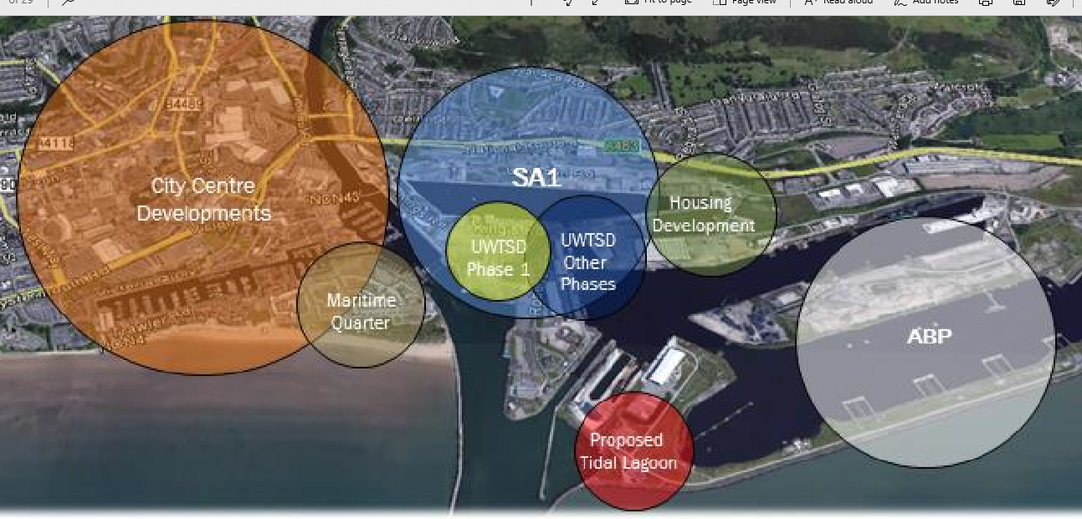
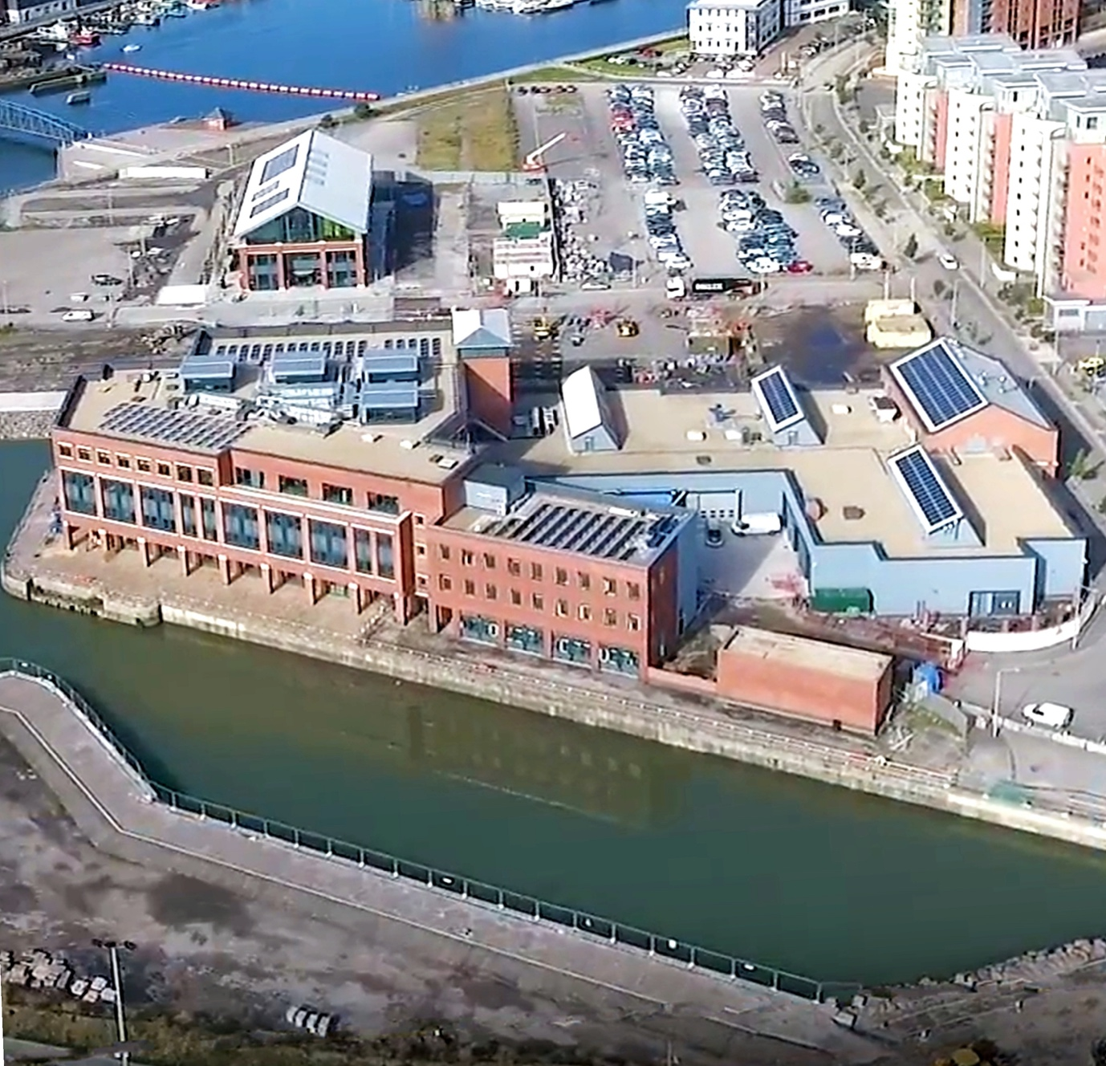
Figure 1. The developments within the SA1 and city centre area. The IQ building and the Library.
1.2 - Productivity

There are many ways to deal with performance issues and the lack of work that being put into a project. Including a plan of action would be a start in order to see improvements where necessary and whether the work force are able to adapt to change and if they can meet deadlines for their measurable improvements, but to go even further before reaching this stage, there will be an effective performance evaluation process in place and regular inspections will be taken in place to ensure that quality and safety is met up to the clientele’s expectations.
The stability of the surrounding structures is a prime consideration due to being near waterfront, the soil will be wet and cohesive. The method of piling used may well be influenced by this and the foundations for the build will have to be solid and form correct once set. Of course the underground will need to be thoroughly inspected and ensure there are no water courses or major water below as this can be a really hazardous danger for the build if not consulted and checked, the client will have all rights and a lot of time and money will be wasted if not done correct. All Site engineers will be trained on the particular method statement which will be used for the project. Such as, lifting appliances, cranes, the lifting gears will all need to have the right test certificate proving that the examination has been undertaken and this must be in hand whilst operating the machinery. Equipment will need to be taken care of and made sure that they are left on firm base level and for the cranes mats. The site engineers will all have had the proper training and the experience needed to undertake this project, they will be working in accordance to the regulations of safety work and ensuring the general public are in safe hands without possibly going down an accident route. PPE is substantial important, any person working on a machinery with noise and vibration must ensure that ear plugs, eye protection hard glasses and hard hats to be worn at all times, if not worn they will be dis missed of due to not working safe and not complying with rules and regulations. In addition, when necessary if workers are in a crane which is raising and lowering, the crane should be fitted tight and with a dead man’s handle, the lowering will be done with low power to stability and from preventing the crane from tipping and spinning, it is vital that the crane is constructed with a cage for this.

1.3 - Cost

Cost reporting is a process used to inform a client (or other party) about the magnitude of a construction project’s predicted, or actual cost. This can be expressed either in absolute terms or as a variance compared to the project budget.

A cost report will generally include all the costs incurred by the date of the report, where they are known, a forecast of the costs likely to be incurred during the rest of the project, in so far as these can be foreseen and estimated, and risk allowances for the possibility of unforeseeable costs. Contingencies to cover these risks are often expressed in terms of percentages. The percentages applied are at their greatest in the early stages of the project when there are the greatest number of possible risks, but they can then be reduced as better particulars about the project become available and some risks have passed or been overcome.

It is important to be clear what costs will be included in cost reports. For example, the client may have costs that, whilst they are directly related to the project, they would prefer to account for them themselves. This might include; land acquisition costs, specialist plant or equipment, furniture, construction contracts outside of the main contract and so on.

Other than initial cost appraisals, these all relate to the construction cost of the project.
Contingencies will tend to be highest in the early stages of the project when there are the greatest number of possible risks, but can generally be reduced as better particulars about the project become available and some risks have passed or been overcome. (Design WIKI).

1.4 - Concrete columns + Prefabrication
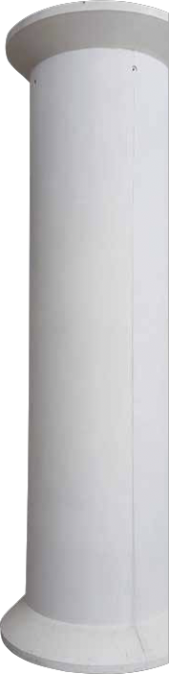
Benefits of using precast concrete

Increases speed of construction between levels.
Helps reduce margins of error.
High compressive strength.
Eliminates complex pours on-site.
Reduces Health and Safety risks on-site. Health and Safety statistics indicate that fatal accidents are five times more likely on-site than in a factory controlled environment.
Detailed and manufactured to your specification incorporating additional features and fittings if needed.
Precast columns can be circular, square, rectangular or oval. A range of standard columns are available.
Precast concrete columns may be single or double storey height.
Connections may be made via a base plate to the column or by reinforcing bars projecting from the cast, or set into a preformed hole in a foundation block and grouted into position.

Benefits of using stairs and landings

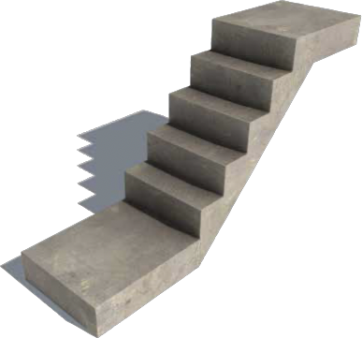
Self-compacting concrete provides a high quality finish.
Cast on edge or flat, depending on finish requirements.
A range of casting options are available for integral or separate landings.
Can be provided on a supply-only or supply-and-fit basis.
Ideal for both precast frame and steel frame structures.
Works with our lift shaft cores.
A comprehensive range of adjustable standard and bespoke moulds for stairs and landing configurations, all of which comply with building regulations.
Manufactured to a custom-made design and specific project requirements.

1.5 - Safety training and measures

Building and project delays occur majority of the time by accidents in the workplace which then leads to the budget of the project exceeding and this leaves a bad impression towards our client, therefore it is vital that safety measures are in place, and each staff and site engineer is familiarised with the health and safety guidance given by the HSE authority. Regular safety training and meetings should be taken in accordance for all site engineers and also the project managers. The construction manager will need to make awareness for all employees of the risk hazards associated with each task and activity for the project of the UWTSD SA1 library. For example, at the stage of excavation and pilling the engineers will need to work in a safe method and ensure that the materials and waste are being disposed and removed correctly without causing any danger to nearby public, and also the engineers who are also working on the site. Some other examples include, Health hazards such as contact with contaminated risings or groundwater and contact with hazardous materials or dusts. Noise, vibration. Contact with plant or machinery during lifting, slewing and pitching of piling elements. the movement of piling rigs etc.

- Plant instability caused by gradients, variable ground conditions, and/or inadequate bearing capacity
- Hazards of buried or overhead services
- Collapse of excavations, nearby structures etc.
Safety training will always need to be updated to the correct date, if they are old and conduct the outdated safety practices this will not be in anyway in assistance to the project and to the build, it is always vital to get inspections done regularly and making sure that the code of safety is updated and recorded for the safety for the project site engineers and also the visitors and inspectors who will be coming to do their checks and making sure everything is in place following the guidelines. The legislations which are currently used in the construction industry requires the following compulsory laws to be attributed into the project safety, this is mainly for the purpose of protect the members of public, our workers/labourers and the hierarchy, the following are in compliance with the construction industry;

- Risk Assessments
- Notifying of an injury or problem
- The Gantt Chart and programme of works.
- Recording all injuries, regardless of how minor it is, it will all need to be written down to prevent it happening again.
- Method statement and schedule of works
- Inspection reports from the council and client whichever it maybe.
- Dangerous occurrences

Effective communication is very important to achieving a successful construction completion also communicating within a team can benefit and add onto team working skills, lead to positive collaboration and results in a optimist project journey for our client. On site everyone does get affected by productivity, once the team has managed to exchange ideas clearly and the vision is there, it makes the programme and build run smoother and ensures the project is done on the set completion date. Along with this workers will develop as they go on they will be able to give improvements.
1.6 - Incentives
Deliver value for money by the following:
- Making an agreement on cost from all parties and drawing up a contract.
- Increasing efficiency.
- Focusing on value for money for the client and all parties.
- Encouraging the supply chain to exceed the project objectives.
- Supporting the common objectives of the client and the supply chain.
- Promote better networks for communication and of similar information
- Increase supply chain profit
- Minimise risk by promoting proactive management and sharing of project risks throughout the supply chain
Improve allocation of resources for training
Accordingly, incentive and shared saving arrangements will have to display the following characteristics:
- Link profit level and performance at project level
- Relate to each party’s business objectives, therefore offering worthwhile benefits
- Be based on the principle of sharing both gains and losses
- Link sharing of risks/rewards to “capacity to influence”
- Focus on collective performance
- Be subject to formal agreement and rules that make clear commercial arrangements and risk ownership
- Involve the key members of the supply chain
- Be based on equality of information and access to data (open books)
- Be understandable, easy to apply and administer
- Be based on performance indicators agreed by all parties
- Be able to be adjusted when major changes occur regularly

1.7 - The paving around the building is Granite being delivered from China. Due to travel restrictions the ship is delayed by two weeks. Advise the client on contract conditions on delay and disruption.

The construction contract, the term used disruption means a loss of productivity due to an interruption of the progress on the construction works which then losses the work rate. There are both sides as to who can be blamed for a disruption, if it caused by the employer the contractor could have leeway to get compensation, only under some circumstances. Disruption and also claims are normally to recoup losses incurred from it especially large complex builds. The main difference between the two (disruption and delay) is the fact that the latter relates to lateness instead of productivity but can sometimes can be related. Disruptions can cause delays and vice versa too, but require a completely different approach when analysing claims.
Of course with delay and disruptions there are many ways to deal with a situation as it arises, it all depends on how serious it is, and how the contractor will deal with it in accordance with the contractual programme. The JCT contract notifies that under the JCT 2011 and 2016 contract the work must have an extension time for delays and disruptions. The client in this instance will have to understand there will be disruptions but extension time can be put in place to avoid disappointment and escalating the problem even further than what it needs to be. Neutral events also can get an extension on the time to complete it only if the parties are happy the client.

For instance the following:
Exceptionally horrific weather conditions.
Civil threats, terrorism.
National strikes.
Changes in statutory requirement

However, is there is a delay which has an impact on the completion date is caused by the contractor, the contractor will be reasonable and liable to pay liquidated and ascertained damages towards the client.
NEC contract deal with a vast majority these types of problems under the heading compensation events. They treat the compensation event more like a blame instead of a risk. Any type of risk that is not identified by the client is borne by the contractor and he will be the person that the HSE and governing bodies meaning the project manager will deal with.

When it becomes more clear there is a delay or a delay that can get an extension of time, the contractor in this instance by law must in writing notice to the contract administrator what exactly had caused the effect of this delay. On the NEC contract it is both parties which need to give the early warning of anything which they know for certain will delay the project and the build. Once this has been done they need to discuss how to prevent and mitigate this from happening again in the project.

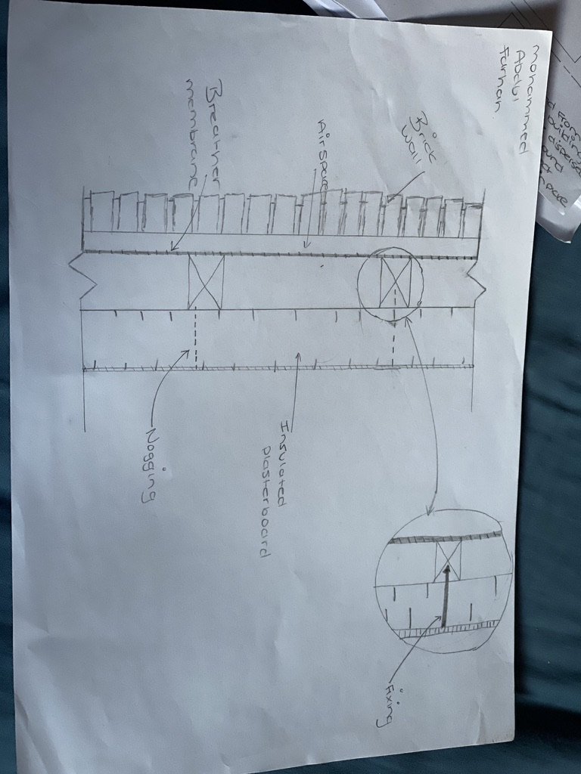
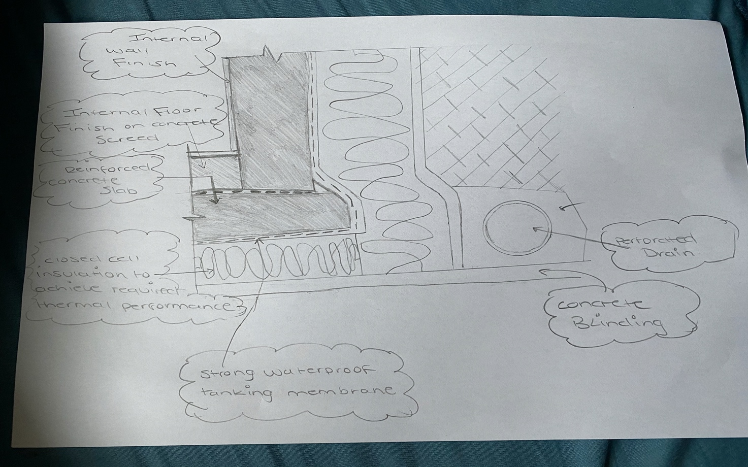
1.8 - Sketch up drawing

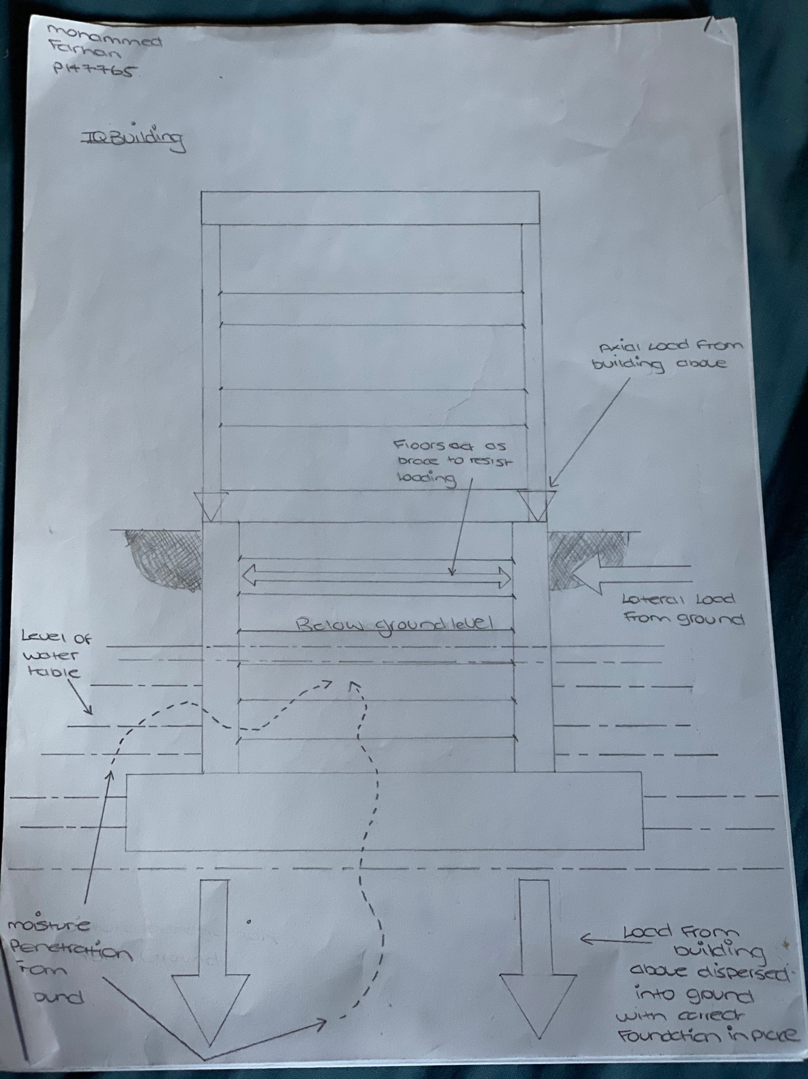

1.9 - Spreadsheet of project



