University of Wales Trinity Saint David
School of Engineering



Electronic Circuits Testing and Applications

Electrical Control Systems and ACHA4010

Daniel George Hannis
2102864
31/03/2023

Contents
1.0 Task 1 – Question Sheet 1
Question Sheet 1
1.1 A) 1
1.2 B) 1
1.3 C) 1
1.4 ii. 1
1.5 iii. 1
1.6 iv. 1
1.7 D) 2
1.8 D) 2
2.0 Task 2 – Full Bridge Rectifier 3
2.1 Scope Time Division Calculations 3
2.2 Function Generator Output: 3
2.3 Rectifier Without Capacitor Before the Resistor: 3
2.4 Rectifier with Capacitor Before the Resistor: 4
2.5 Drop in Voltage Question 4
2.6 Rectifiers use in Automotive Applications. 4
2.7 Question Probing 5
3.0 Task 3 – Identify Capacitors 6
3.1 Scope Time Division and Resistor Calculations 6
3.2 Function Generator Output 6
3.3 Scope Wave Across Capacitor Output with Capacitor Charge and Discharge Wave Marked at Correct Points 6
3.4 Basic Capacitor Calculations 7
3.5 Capacitor Discharge Table 7
3.6 Gradient Plot and Calculations 7
3.7 Inaccuracies Question 8
4.0 References 9

1.0 Task 1 – Question Sheet

Question Sheet

1.1 A)
The resistance of E is done using ohms law:
V = IR
V = 12 – 4Emf
4Emf = 4Ir = 2
Emf = (Ir + 0.5)V
V = 12 -4 (Ir + 0.5)V
V = 3V
R = V/I = 3V / 0.5A = 6 ohms
Resistance of E = 6 ohms.

1.2 B)
0.3A = IB + IC
IB = IC = 0.30A/2 = 0.15A
Direct current passing B and C is 0.15A each.

1.3 C)

i.
P = IV = I^2R
R = P/I^2
R = 0.9J/s / (0.3A) ^2 = 10 ohms.
Resistance of A = 10 ohms.

1.4 ii.
Being resistors B and C are the same; B and C are parallel to A, giving the result of the same answer of 10 ohms; this is from parallel to one another. This can also be assigned of potential difference in being 4V.

1.5 iii.
All of the resistors between A, B and C are 5V which can be seen on the diagram; positioned similarly and previously calculated, they are all parallel to each other, creating the same voltage.

1.6 iv.
The resistance of D is the potential difference of D divided by the current passing through D.
The potential across D is calculated to 7V (volts/voltage).
The resistance of D = 7V /0.3A = 23.3 ohms.

1.7 D)
In a circuit diagram, the lost volt is a parallel arrangement of differencing, one cell = E – 2V.
The E total = E – 2V + E – 2V + E – 2V +E – 2V.
This results in 4E – 8V.
This difference is the same as the difference across a combination of cells.
4E – 8V = 4Er/(4r) + 12V
This, in total, gives:
R = (4E -20V)/(4I). I is the current flowing in the circuit.
R is parallel = r/4

1.8 D)
12V – 2V = 10V
The circuit consists of a 12V cell.
12V – 3 (10V) – 2V = 0
12V – 30V = -2V
-18V = -2V
The total voltage drop from this in precise cell results in 18/3 = 6V.
6V = r * 0.3A
r = 20 ohms

This results in the combination in all four cells as all four are parallel to total resistance r/4 = 5 ohms.

2.0 Task 2 – Full Bridge Rectifier

2.1 Scope Time Division Calculations
For the time division calculation of a 10Hz sine wave, to calculate 1 full period on the screen is the following working:
A time period is 1/frequency.
For 10Hz = 1/10 = 0.1s (seconds).
A full time period of a 10Hz sine wave is 0.1 seconds.

2.2 Function Generator Output:
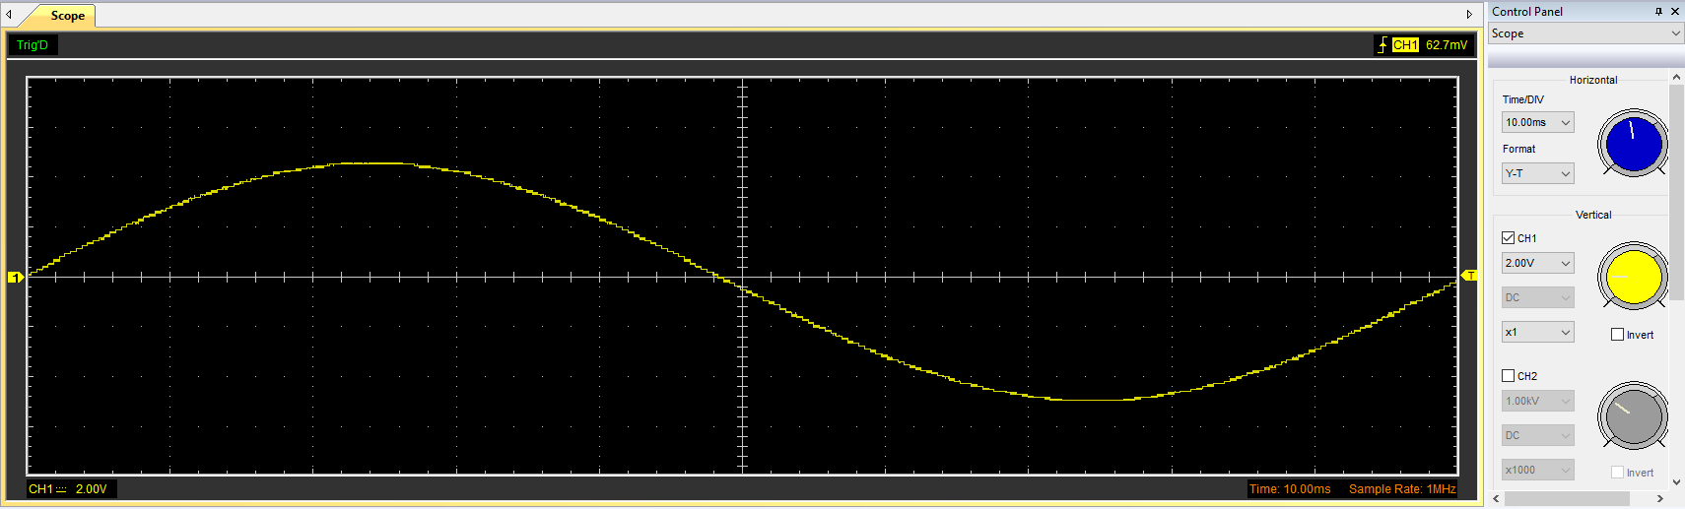

Data:
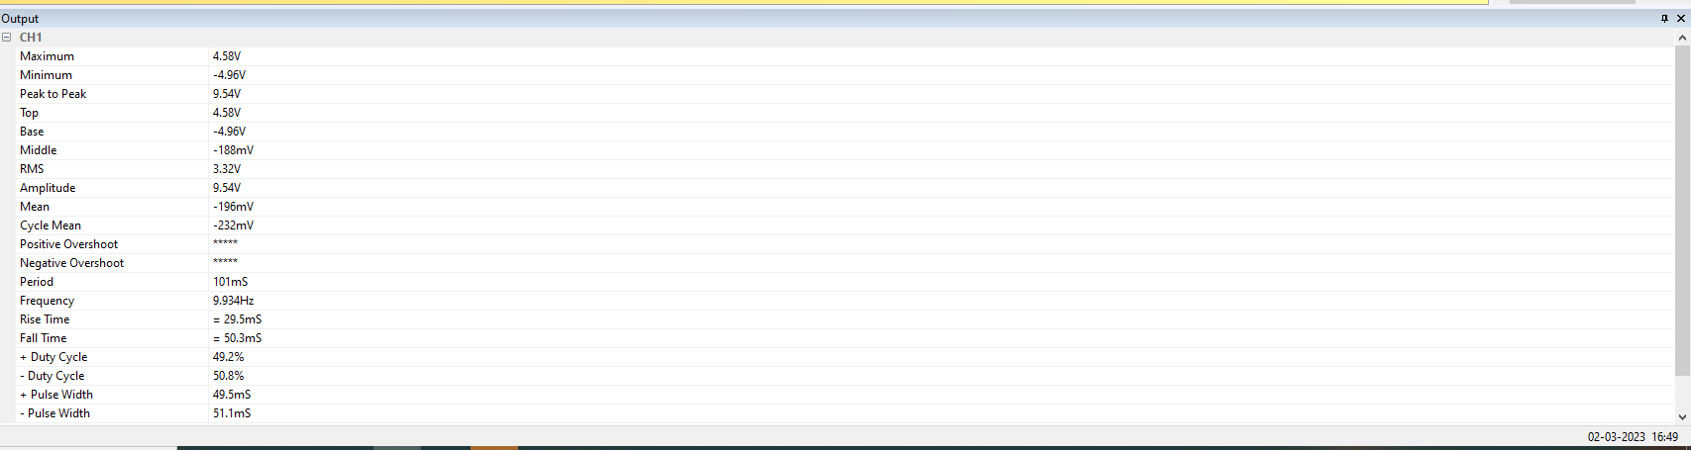

2.3 Rectifier Without Capacitor Before the Resistor:
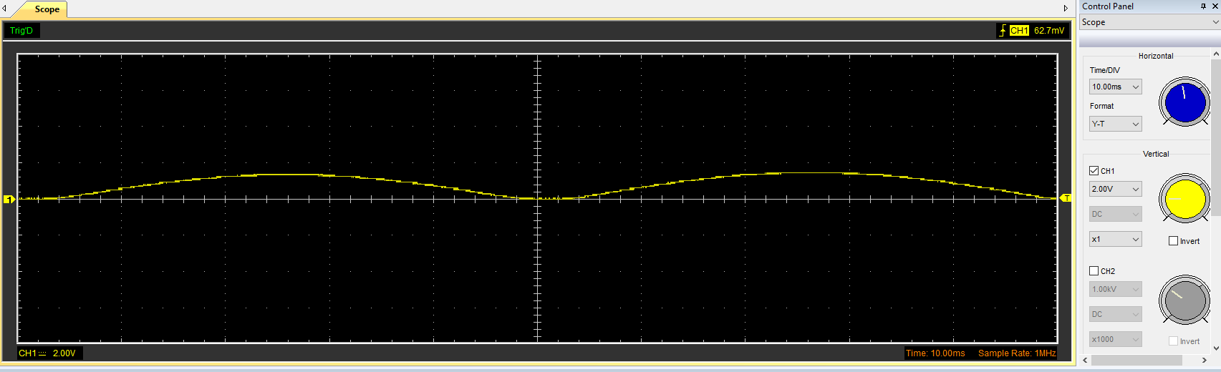
Data: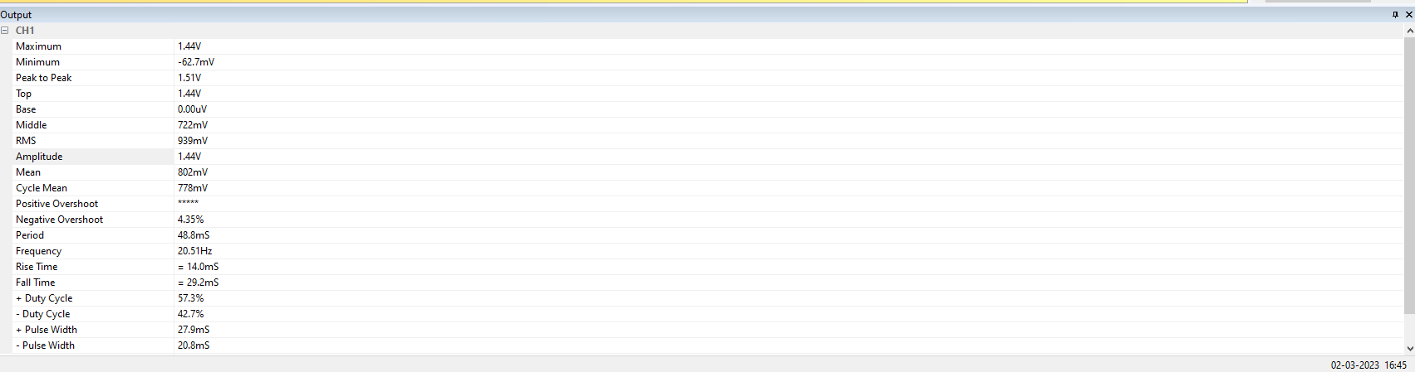

2.4 Rectifier with Capacitor Before the Resistor:
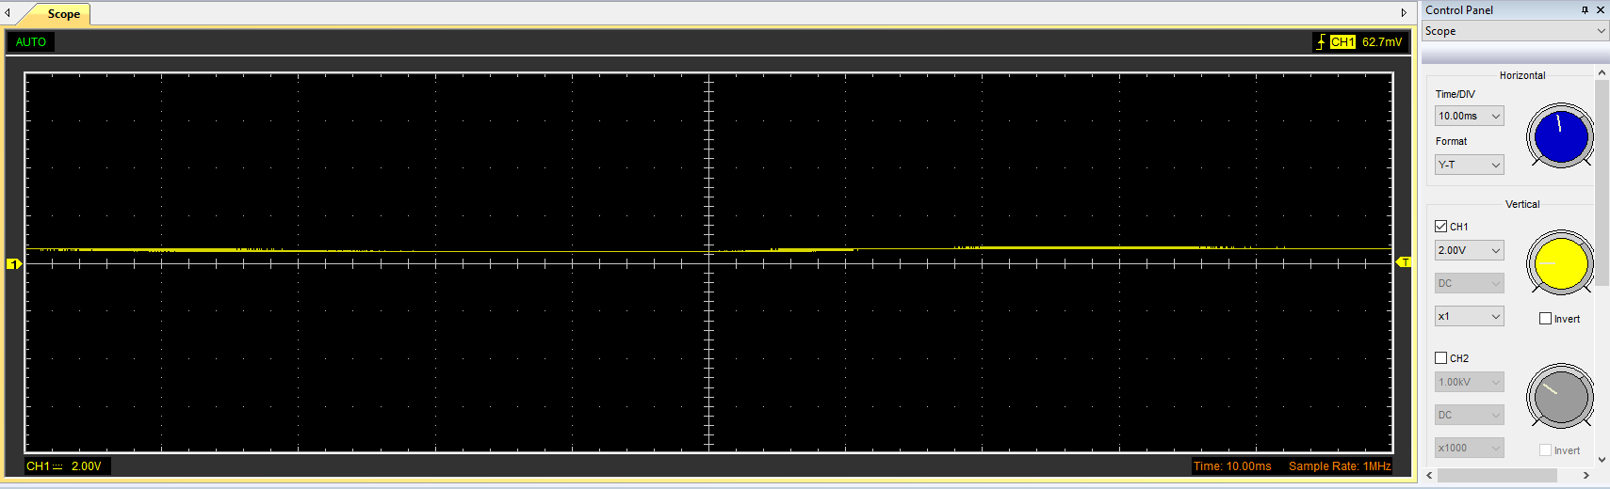

Data:
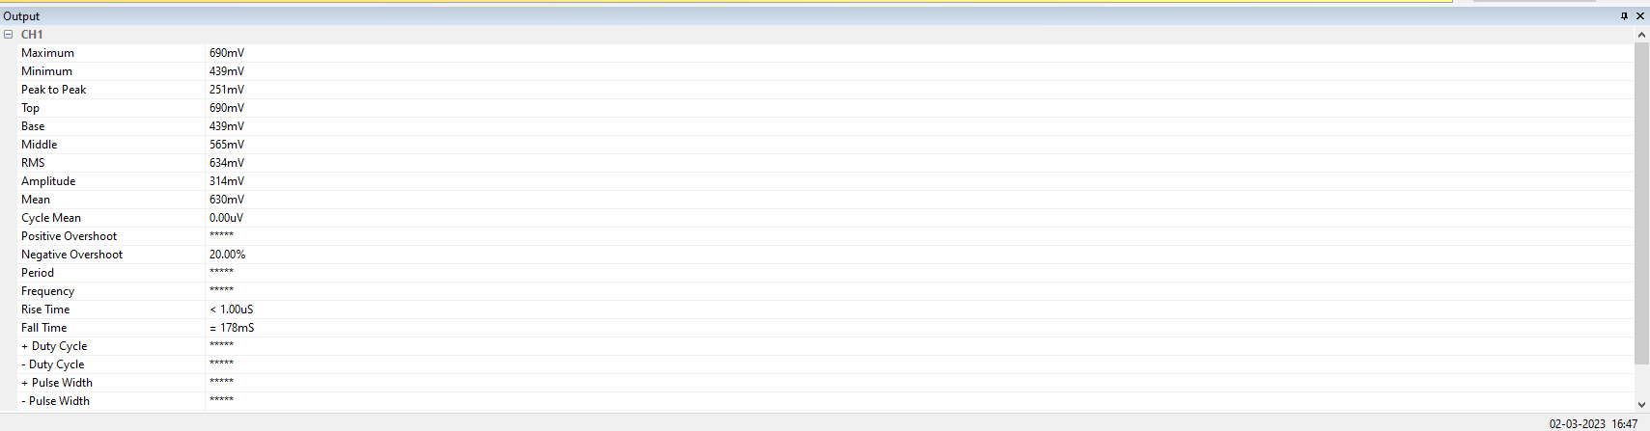

2.5 Drop in Voltage Question
The drop in voltage may be due to the strength signal, the level of equipment used not being satisfactory. The voltage drop may also be caused due to the capacitor. The rectifier type can vitally affect the peak of the sinewave input as a full wave rectifier also has a somewhat low but impactful voltage drop. The ripple voltage may also have a factor to play as it may have some AC ripple voltage this may cause the DC voltage to be lower than the peak that the function generator sine wave outputted.

2.6 Rectifiers use in Automotive Applications.
Rectifiers In automotive applications are from a variety of electronics, firstly a vital component the alternator which charges the battery on a vehicle. From an analysis on how an alternator works autoelectro.co.uk says “The rectifier is used to convert current from alternating current (AC) to direct current (DC) during the charging process.” (Autoelectro.co.uk, 2023). This supports the vehicle keeping the battery alive along with processes with it.
The ECU (Electronic Control Module) on a vehicle uses rectifiers for DC voltage this allows the ECU which microprocessors and electrical components associated, including but not limited to engine sensors, exhaust sensors, wheel sensors, gearbox sensors and so forth.
With rectifiers in automotive vehicles changing, AC to DC voltage is used in half wave rectifiers because they are cheap and reliable for most manufacturers wanting to produce on mass as cheaply as possible. Being of voltage drop on a half wave is less vital as it is needed for the most voltage possible for vital automotive systems. Along with this half-wave rectifiers are reliable, being electronics have one less thing that could go wrong or likelihood of. Rectifiers in automotive are used vitally in most, if not all, vehicle electronics, from alternators to lighting systems, to ignition of the ignition coil itself, creating reliability and cost-effective measures.

2.7 Question Probing
With the probing done in class, only one channel was used and not simultaneously probing the rectifiers. This can be done in a multitude of ways and for several reasons. First, the main reason is the scheme of the instrument grounding; this is looked at due to being a single-function generator in a single waveform with a single-ended reference to the ground. Many applications are better suited with two-channel instruments; this is supported by the following: “For many waveform-generator applications, only a single-ended signal referenced to ground is required. In such scenarios, a single-output generator will suffice. However, many other applications are simply better served with a two-channel instrument. Of course, it is possible to synchronize independent single-channel units, but a two-channel instrument provides synchronization that is more precise by virtue of operation from a single internal sampling clock. “ (TeledyneLecroy, 2014).
A solution in the waveform uses a differential probe with two inputs with no direct connection to the ground. This allows measurements of signals from different ground potentials. This could be done with the two-channel instrument and two-function generator. Allowing simultaneous probing on signals of a circuit can be done with multiple leads of a splitter. This provides for a device with two inputs, as mentioned previously, allowing multiple probes simultaneously. The issue with multiple probe leads is signal interference and noise; this may vary depending on the circuit setup with the ground and the quality of the equipment. If used on cheap equipment, this may become a further issue, although this may still be present even on higher-priced equipment.
A final solution could be an isolation transformer that isolates two circuits for simultaneous probing with input and output signals without shorting them together. These are two separate windings that are not connected through electricity; with this, the primary is always connected to the input, and the secondary is always to the output. It means that the windings are separated from each other wholly isolated. This, in turn, prevents unwanted shorting or distortion of the signals.
As a result, a simultaneous probe can be allowed if using isolating and two-function generators or with multiple leads; this allows for synchronisation and splitting. High-quality devices should ideally be used compared to low-quality, which have signal interference and can also short out a personal computer if plugged into using Hantek software; using the two USBs, if done incorrectly, should create a short. The probes must be correctly grounded for damage to the circuit or the computer and equipment.
Allowing for simultaneous probing, ideally, a signal splitter would be used.

3.0 Task 3 – Identify Capacitors

3.1 Scope Time Division and Resistor Calculations
Frequency = 10Hz Period = (1/10Hz) = 0.1s = 100mS Frequency = (1 / 0.1s) = 10Hz Cap Marking.
10 Ohms Capacitance = 10 μF (Microfarads) = 0.00001 F (Farads) T = (R * C) = (10 * 0.00001) = 0.0001s = 0.1mS 20T
This results to (20 * 0.0001) = 0.002s = 2mS 12T = (12 * 0.0001) = 0.0012s = 1.2mS

3.2 Function Generator Output
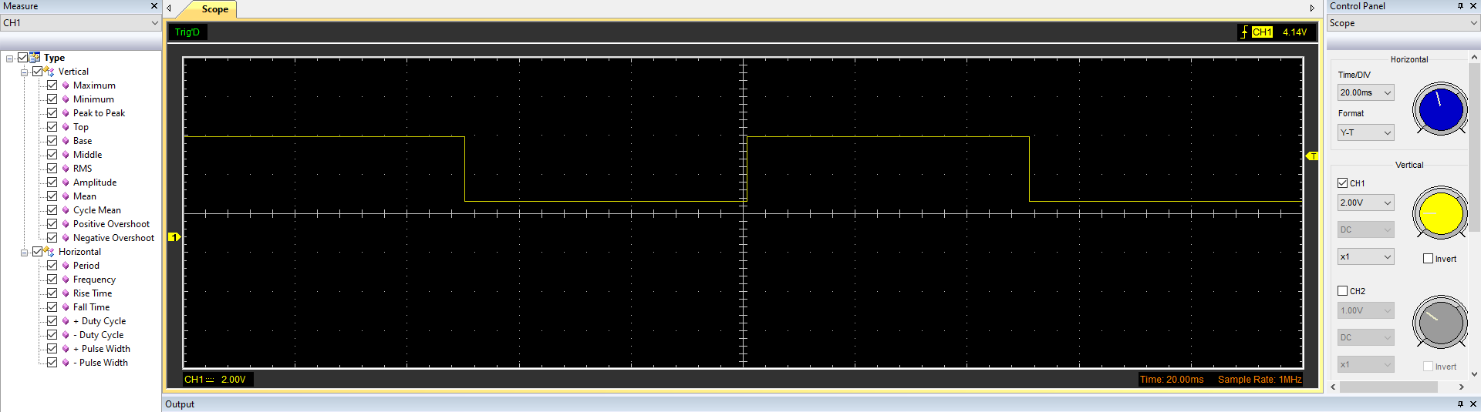

Data:
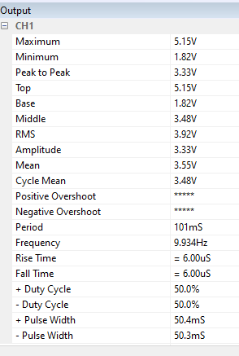

3.3 Scope Wave Across Capacitor Output with Capacitor Charge and Discharge Wave Marked at Correct Points
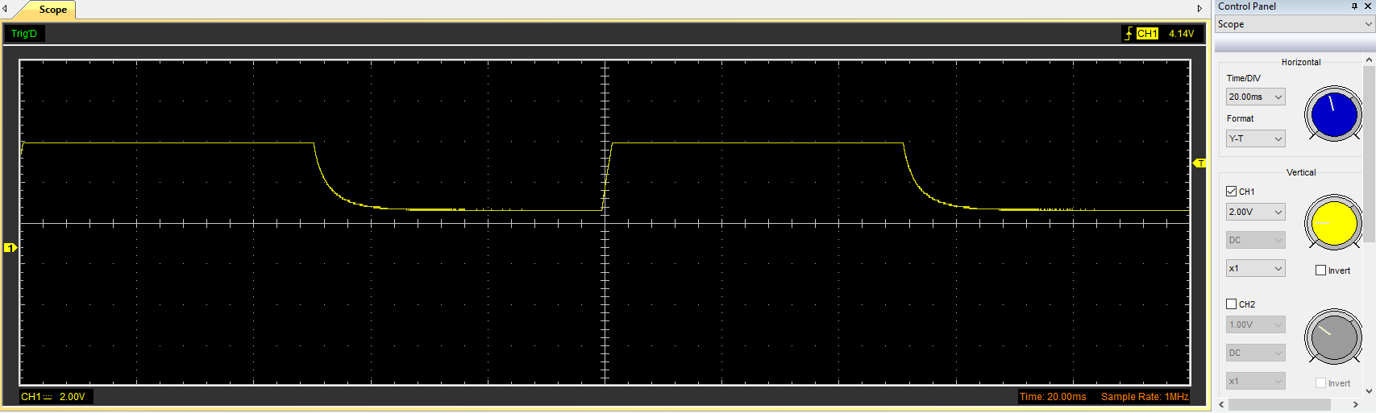
Start of Discharge
Start of Charge

Data:
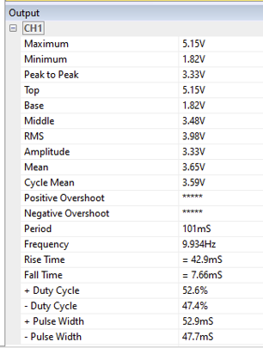

3.4 Basic Capacitor Calculations
t = RC = 0.0001s R = 10 Ohms C = (T / R) = (0.0001s / 10 Ohms) = 0.00001 F = 10 μF
From the answer displayed above it can be calculated for the capacitance of the capacitor, which is 0.00001 Farads, which is 10 Microfarads.

3.5 Capacitor Discharge Table

Time (s) | 0 | 0.02 | 0.04 | 0.06 | 0.08 | 0.1 | 0.12 | 0.14 | 0.16
Voltage (V) | 5.1451 | 4.7686 | 4.3294 | 3.8902 | 3.3882 | 2.9490 | 2.4471 | 2.0078 | 1.8196
In V | 1.638 | 201.638 | 401.638 | 601.638 | 801.638 | 1001.638 | 1201.638 | 1401.638 | 1601.638

3.6 Gradient Plot and Calculations

Time (s) | 0 | 0.02 | 0.04 | 0.06 | 0.08 | 0.1 | 0.12 | 0.14 | 0.16
Voltage (V) | 5.1451 | 4.7686 | 4.3294 | 3.8902 | 3.3882 | 2.9490 | 2.4471 | 2.0078 | 1.8196
In V | 1.638 | 201.638 | 401.638 | 601.638 | 801.638 | 1001.638 | 1201.638 | 1401.638 | 1601.638
Log V | 0.71139 | 200.6783 | 400.6364 | 600.5899 | 800.529 | 1000.469 | 1200.389 | 1400.303 | 1600.260
Delta | 0.92661 | 0.9597 | 1.0016 | 1.0481 | 1.109 | 1.169 | 1.249 | 1.335 | 1.378
% Difference | 43.43% | 99.524% | 99.7506% | 99.82% | 99.862% | 99.883% | 99.8961% | 99.905% | 99.914%

3.7 Inaccuracies Question
Inaccuracies during the test may be down to several reasons, including but not limited to Signal interference, human error, the precision of test equipment, and not being done under perfect conditions.
Signal interference comes from various places, such as equipment level, human interaction surface, wire connections, and the program used itself.
A quote from the engineering handbook follows along with these inaccuracies of equipment. “Dynamic test and measurement find application in many engineering and scientific disciplines. Although each has evolved uniquely in its types of equipment and methods employed, a degree of commonality exists in the operating principles and performance criteria of the various apparatuses used.” (Baird, 2004). This reference returns to the point of the test and measurement accuracy needed for efficiently testing circuits.
Human error is a vital key to play in inaccuracies during testing; human error being a slight movement in circuit wire pulling off the test to a 0.01v could lead, or simply not completing a test for long enough, ensuring the voltage and amps readings were the mean average and correct.
Perfect testing conditions come under the fact of test quality, the temperature of the room, the level of equipment involved, being the equipment used in the test was low quality compared to what a lab would have in comparison with highly perfect conditions, room lighting, wire connections, grounding, and ideal computer to run it for.

4.0 References
2.6 Rectifiers use in Automotive Applications – Accessed on 01/04/2023 -(https://www.autoelectro.co.uk/alternators#:~:text=The%20rectifier%20is%20used%20to,DC)%20during%20the%20charging%20process , 2023)
2.7 Question Probing – Accessed on 01/04/2023 – (https://teledynelecroy.com/doc/the-advantages-of-two-channels-in-arbitrary-waveform-generators , March 20, 2014)
3.7 Inaccuracies Question – Accessed on 02/04/2023 – (The Engineering Handbook Second Edition Terrance W Baird, Publish 2004) (Hewlett-Packard Company) -https://www.taylorfrancis.com/books/mono/10.1201/9781315220338/engineering-handbook-richard-dorf

