INTEGRATED PROJECT – PAD FOOTING CALCULATIONS
- Calculations followed for pad footing relating to the pile caps that are used on Matchstick Arena, as agreed with the client.
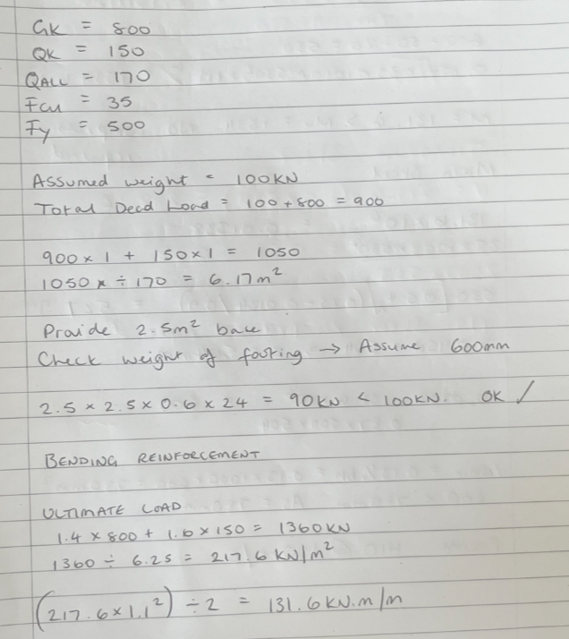

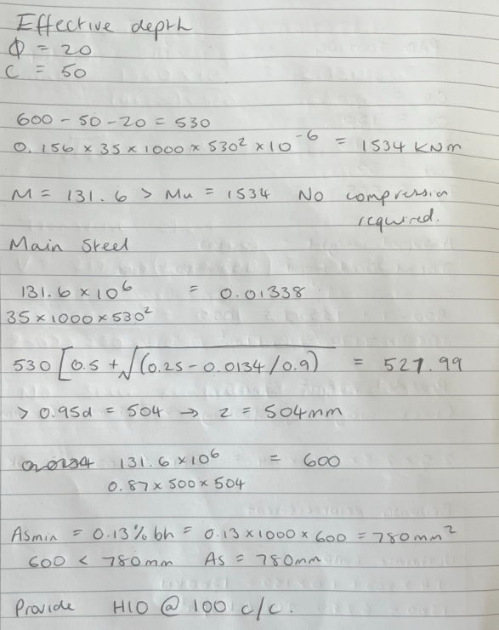

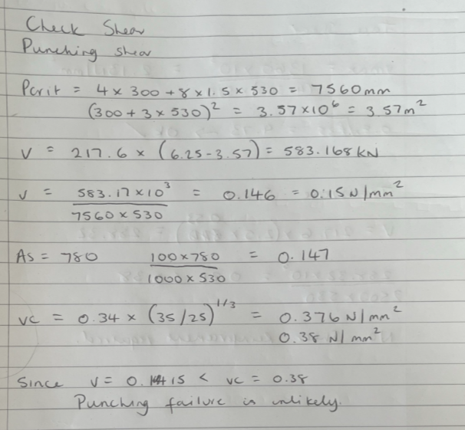
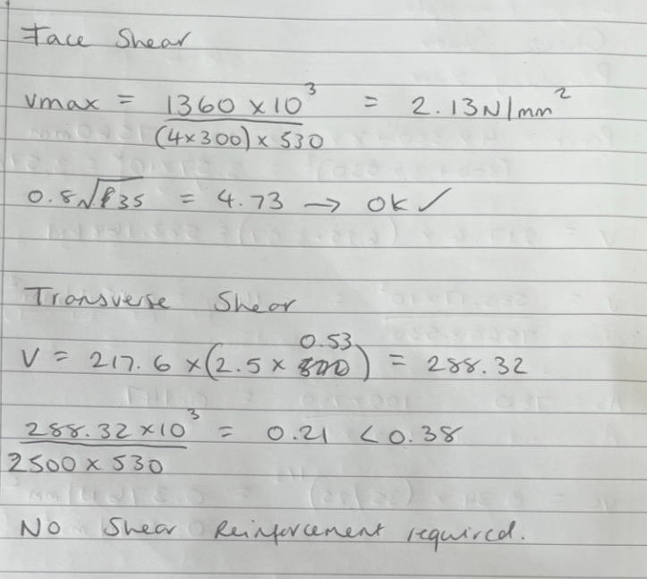
Pad footing size acceptable
Reinforcement to be used is C10 @100mm c/c

