Jersey Occupation Heritage and Memory: How can battlefield archaeology contribute positively to the process of bereavement, commemoration and reconciliation?

The German occupation of the Channel Islands between 1940 and 1945 represents a unique time within British wartime history as the only territory of Britain to fall under Nazi control (Sanders, 2005, pp. xix - xxviii). In Jersey, the material legacy of the occupation, including defensive fortifications and underground tunnels constructed as part of Hitler’s Atlantic Wall (Forty et al., 2016, pp. 64 - 65), remain highly visible within the contemporary landscape. Since liberation in May 1945 (Sanders, 2005, pp. xix - xxviii), this legacy has played a significant role in shaping local identity and heritage narrative and accentuated through commemorative performance on annual Liberation Day celebrations (see Carr, 2012), a public holiday on the island (Jersey’s Bailiff Chamber, 2025). Literature surrounding the occupation has traditionally focused upon themes of civilian endurance and hardships and the lived experience of indigenous islanders (see Cruickshank, 2004; Sanders, 2005), while more recent studies have begun to consider the implications of focusing on such a singular narrative (see Carr, 2012). Consequently, the occupation of Jersey can be seen not only as an historical event but as a tool for contemporary identity stabilisation (Connerton, 1989, p. 43).
The study of battlefield archaeology may contribute positively to the process of bereavement, commemoration and reconciliation by providing tangible points of engagement with which people can confront and interpret their difficult pasts; indeed, in Jersey, for the people that are largely represented by their heritage narrative, it does. However, heritage discourse is not neutral or inert; it shapes and is shaped by institutionally mandated ideas of identity as a tool (see Smith, 2006). Drawing upon Halbwachs’ (1980) concept of collective memory, Hirsch’s (2012) theory of postmemory and Smith’s (2006) notion of Authorised Heritage Discourse, this essay argues that whilst heritage in Jersey contributes positively to processes of bereavement and commemoration it simultaneously reinforces a particular dominant narrative of indigenous islanders which marginalised the experiences of victims of Nazism.
Processes of bereavement in post-conflict societies are not solely individual but are socially and politically mediated collectively, particularly driven by the state (Rijnoveanu, 2023, pp. 6-7). As Halbwachs (1980) argues, a difference exists between that of individual memory and collective memory, of which the latter is shaped and stabilised by a particular body of narratives and material environments. Indeed, the “memory turn” in cultural studies sees the construction of collective memory as a key aspect to how a people engage with their heritage (Rignoveanu, 2023, p. 5; Finney, 2014). In the case of Jersey, since the Nazi occupation of the second world war, increasingly the event lies outside of living memory as the “occupation generation” become fewer in number; consequently, contemporary engagements with the occupation are rooted in collective memory with living members of the occupation generation seen as potent loci of this memory (Carr, 2012, p. 95). The heritage framework of the island is today focused on a positive pride of endurance and survival, showcased at the Liberation Day parade that occurs annually in which the focus is on the survival of the occupiers and less so on the commemoration of the lost (ibid., pp. 88-92).
Marianne Hirsch’s (2012) concept of “postmemory” is particularly relevant to the discussion of occupation heritage. Postmemory is a form of memory mediated not through recollection of past events, but through “an imaginative investment and creation”, mediated through dominant narratives told to subsequent generations of an identity forming event (Hirsch, 2012, p. 662; Carr, 2012, p. 106). In Jersey, the material legacy of occupation (museums, monuments, fortifications) facilitates this postmemory engagement with the German occupation, whereby contemporary islanders feel a sense of connection and identity towards an otherwise abstract history. Carr (2012, p. 91) discusses Pierre Nora’s concept of lieux d’oubli et de mémoire (sites of memory) as a key concept in interpreting the occupation heritage of jersey; both intangible (ceremonies such as Liberation Day, testimonies from survivors) and tangible (museums, monuments, fortifications) concentrate this feeling of postmemory as sites of memory, places where the potency of the occupation is at its strongest and allows islanders to connect with their heritage. These sites of memory are controlled, focusing on the aforementioned positive pride of survival. Crucially, these sites actively neglect forced and slave workers or Jewish people that either fled or were persecuted on the island. Indeed, little attention is given to these people with their being small, secondary sites of remembrance in the form of plaques on the island that do not gain as much attention as the traditional narrative does (Carr, 2012, p. 105). 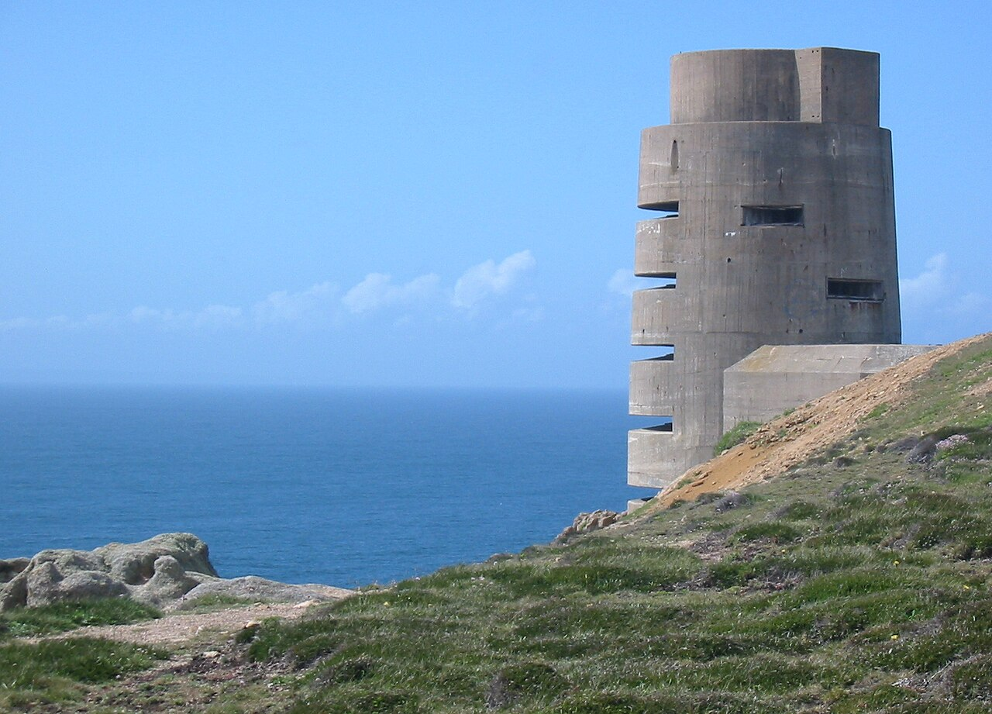
Figure 1: Battery Moltke, St. Ouen, Jersey (Man Vyi, 2005).
In this sense, conflict heritage contributes positively towards a process of bereavement of memories of suffering on the island. Through the preservation of museums, monuments and fortifications, subsequent generations are able to visualise and empathise with the occupation generation. However, in foregrounding a particular narrative of endurance and survival, the process of bereavement for marginalised and other groups of the island becomes difficult or nonexistent, and this highlights how state functions shape the terms in which remembrance is possible.
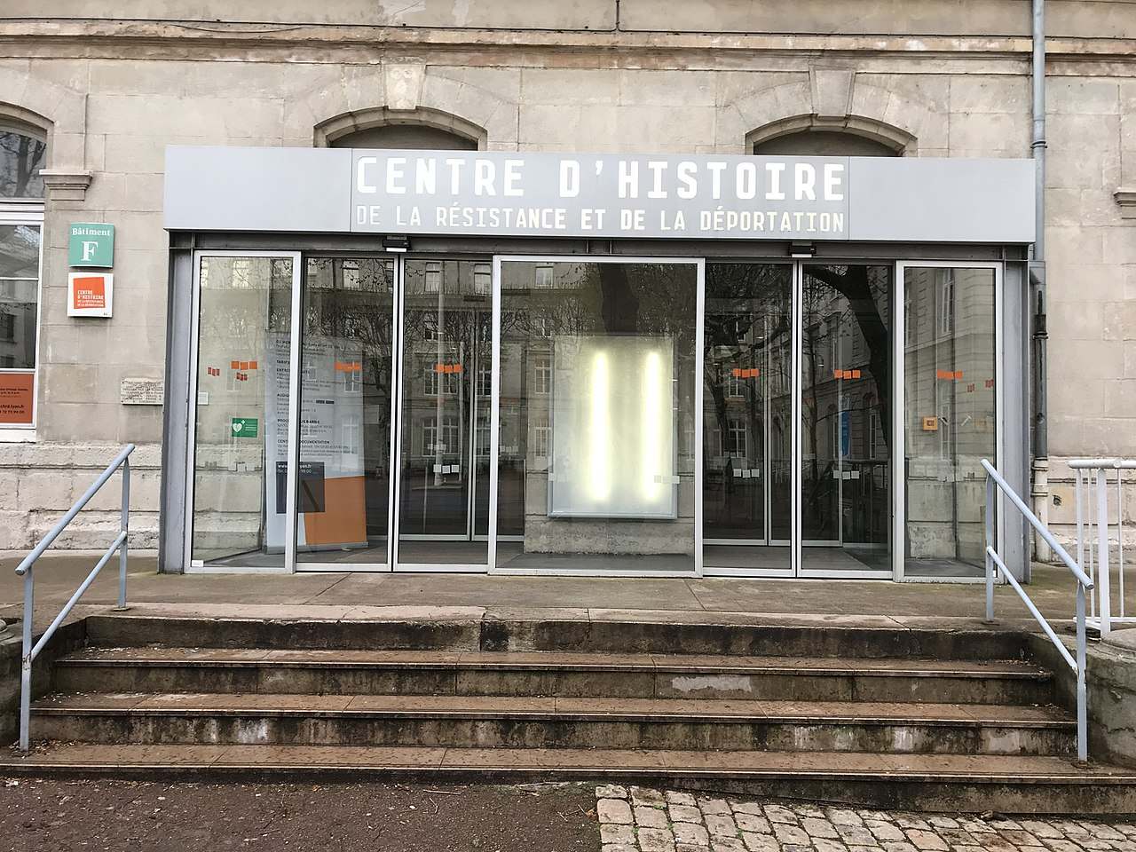
It is important then to recognise that heritage preservation is neither neutral or comprehensive. Heritage discourse and practice is shaped by what Laurajane Smith (Smith and Waterton, 2012, p. 154) terms an Authorised Heritage Discourse (AHD). Decisions regarding which sites are preserved, memorialised and incorporated into public heritage landscapes actively shapes and is shaped by a particular state sanctioned, political and cultural framework. Political regimes adopt a selective memory of conflict, “one which focuses on specific events and that may produce a powerful collective impact by placing certain events into the national consciousness while silencing or forgetting others” (Rijnoveanu, 2023, p. 7). Smith and Waterton (2012, p. 156) argue that heritage is not simply a tourist tool of museums and visitation sites but is an active participant in shaping the way in which a nation thinks of their identity. By utilising heritage as a proponent towards the telling of a singular narrative, AHD alienates a range of social and cultural experiences through the dominance of the AHD (Smith, 2006, p. 30). This can be seen in Jersey through the focus on material and physical artefacts of the occupation and historical literature surrounding the occupation (see Cruickshank, 2004; Sanders, 2005) focusing on the concepts of survival. The notion of AHD being individual in different contexts can be highlighted by the different approaches towards their occupational history by the Channel Islands compared with France, Belgium and the Netherlands. In these nations, the narrative of the occupation is in complete opposition to that of Jersey, whereby the categories of victims and martyrs have been dominant in post war narratives, not the survivors (Carr, 2012, p. 88). This can be seen perhaps best in France, in the many museums dedicated to la Résistance et la Déportation, whilst in the Channel Islands the museums are called “occupation” or “military” museums, highlighting a difference in focus (ibid.). Carr (ibid.) postulates that this comes from different political paradigms, of which the Channel Islands takes a particular British Churchillian paradigm of a “nation of victors, not victims”, whilst more of a victim and commemorative narrative is taken in these aforementioned mainland nations.
Figure 2: Centre d'histoire de la résistance et de la déportation (Centre for the History of the Resistance and Deportation), Lyon, France (Prieur, 2018).
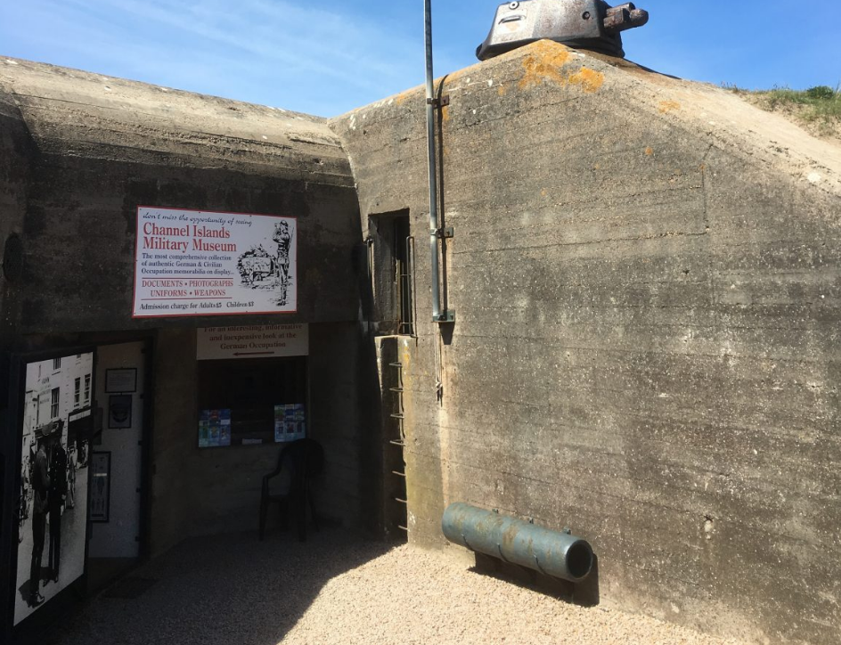
In Jersey, the material legacy of the occupation, as previously stated, foregrounds the experiences of the occupied civilian population. As Carr (2012, p. 92) discusses, the island’s sites of memory are presented as sites of pride and endurance. German bunkers and militaria, along with museum displays which show off patched and recycled items of “make-do-and-mend” all make a clear political statement: “Look what we endured! Look at what we survived!” (ibid.). The “we” here is importantly exclusionary, it refers to indigenous islanders and not to foreign forced workers or Jews who fled Nazi persecution. While the occupied civilian population has been memorialised into a singular narrative of survival, the experiences of people who suffered and died has been actively marginalised. This is perhaps seen at its most poignant in the preservation and presentation of the multitude of bunkers that are seen on the island, one of the most fortified areas of Hitler’s Atlantic Wall (Forty et al., 2016 p. 11; Saunders, 1989, p. 223). These are poignant sites of memory of the occupation, yet largely the history surrounding the context of the construction of them by slave labour has been omitted from heritage discourse and instead the focus is on the physicality of them. This can be seen best by the Channel Islands Occupation Society (CIOS), an amateur group dedicated to the preservation of these sites and the collection of war relics (Carr, 2012, p. 93). This is described as a process of fetishisation and decontextualising the traumatic past associated with them and instead becomes an “all-consuming and addictive pastime” of an almost antiquarian nature (ibid.). Built by the Nazi Organisation Todt (OT), the bunkers across Europe’s Atlantic Wall were built by a multitude of slaves from varying nationalities, totaling over a million strong by 1943 (Forty et al., 2016, p. 23). Whilst the CIOS’ activities provides and reinforces a tangible reminder of occupation hardship, the omission of the transnational experiences of suffering embedded within the context of their construction in any presentation of these sites obscures the history of these sites whilst also marginalising the experiences of the builders. Instead, the technological and physical aspects of these sites are highlighted, resulting in the production of a particularly selected AHD.
Figure 3: Channel Islands Military Museum, St. Ouen, Jersey (Vibrant Jersey, n.d.)
Carr (2012, pp. 99 - 106) discusses a broader pattern in the Channel Islands of sites of amnesia. In opposition to sites of memory, sites of amnesia are that of deliberate forgetting (ibid., p. 90). Alderney, the third largest Channel Island, saw the housing of four concentration camps, of which an official number of 389 deaths occurred there (Owen, 2023). The camp of SS Lager Sylt is the only of the four memorialised in any way with a plaque erected in 2008 by its former inhabitants, but no other camp has been (Carr, 2012, p. 100). These sites have been expressly avoided, being overgrown, neglected or built over (ibid.). This awkwardness to memorialise such a thing is an example of Sharon MacDonald’s (2009, p. 2) concept of difficult heritage. In her seminal text, Difficult Heritage (2009), she outlines phenomena in the latter half of the twentieth century of nations throughout the world to populate their landscape with markers of the past, to display their heritage and create identity (ibid., p. 1). This public concern with the past resulted in nations having to confront aspects of their past that are negative or awkward, aspects that perhaps nations do not want to proudly display (ibid.). This causes issues for identity building, as if these aspects are anthesisal to the building of a particular contemporary identity (such as issues of warfare, colonisation, slavery) then nations must decide on how to confront this difficult past. This issue is perhaps most potent in the confrontation of Nazi heritage, especially architecture (ibid.). In Jersey, the state has largely tended towards avoidance of confronting the contexts of Nazi architecture. The defensive bunkers are preserved as reminders of the aforementioned survival and hardship of the population but the context behind them has been deliberately omitted from narratives. The omission of counternarratives is also seen by the acts of Joe Miere. The former curator of the German Underground Hospital museum, he was interested in photos and stories surrounding political resistors and prisoners of the Nazi regime (ibid., p. 101). He pushed for an exhibition of this resistance in the museum and after initial declination by the Jersey state, a campaign ensued to memorialise these people. A plaque was unveiled for them but under trepidation. This was considered uncomfortable and the plaque was erected with little attention and even states that the acts of resistance would be perceived as crimes under normal law (ibid.). This showcases a concerted effort of forgetting such narratives by the Jersey state, and an aspect of difficult heritage.
Through this selective preservation, conflict archaeology contributes to processes of commemoration primarily for those incorporated within dominant national narratives of survival. By materially stabilising the experiences of the occupied civilians while overlooking the sites associated with a difficult nature, the AHD of Jersey is reinforced. In doing so, the heritage narrative of Jersey is uneven, rendering not only what is remembered but how it is remembered.
Importantly, this AHD that privileges fortifications is historically contingent and reflects changing attitudes. These tangible reminders of their difficult past were initially considered sites of amnesia. Many were covered in soil and deliberately buried from sight as part of an attitude by the island to put the past behind them (Carr, 2012, p. 92). Well into the 1970s, these bunkers were seen as “blots in the landscape”, and not part of Jersey identity (ibid.). After the passage of a generation, and the entering of the occupation into postmemory, attitudes shifted, showcased by the restoration and renovation of these bunkers by the CIOS (ibid.). This showcases a shifting of the AHD, with Smith (2006, p. 4) discussing that this discourse inevitably changes and develops over time in different cultural contexts. Rijnoveanu (2023, p. 8) states that across the European continent, public interest regarding the memory of war became significantly reframed in line with changing narratives; from one of progressive forgetting to one of commemoration and remembrance. This reframing is applicable to Jersey as it is in other occupied areas of Europe.
While the selective preservation of material shapes the possibilities of bereavement, commemoration and reconciliation, these processes are not enacted solely through tangible heritage but also in commemorative practices. As Connerton (1989, p. 43) argues, collective remembrance is facilitated through acts of commemorative ceremonies. These ceremonies are discussed as cult enacted, as not a story told but as a "metaphysical present”, as a tool for the stabilisation of contemporary identity. Liberation Day, celebrated annually on 9 May is a form of commemorative ceremony on the island (Jersey Bailiff’s Chamber, 2025). This celebration takes its form in processions, parades, themed floats and reenactments through the town of St. Helier (Carr, 2012, p. 93). Tangible and intangible heritage combine with old costumes, vintage cars and carrying or wearing occupation artefacts (ibid., p. 94). The large parade that occurs through the town is a result of the AHD of occupation heritage, rarely featuring slave workers, Jews or deported islanders (ibid.). In this sense, a particular sense of reconciliation is not simply enabled by the preservation of material culture but actively performed. 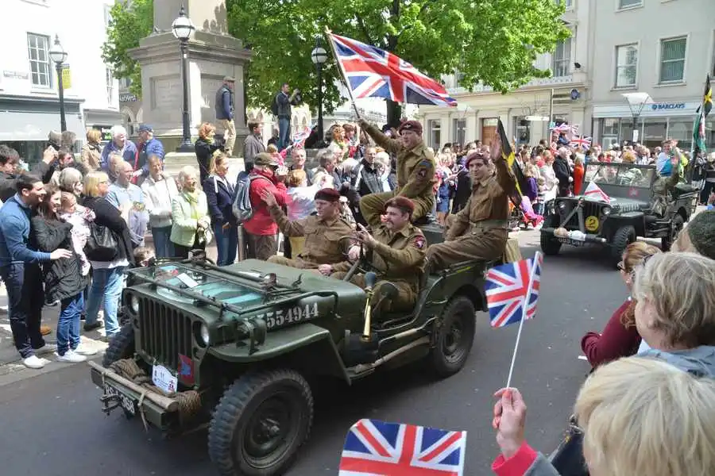
Figure 4: Liberation Day Parade, Jersey (Jersey Evening Post, 2015).
Such a celebration facilitates postmemory, enabling later generations without lived experience of the occupation to engage with heritage narratives (Hirsch, 2012; Carr, 2012, p. 106). Different members of the occupation generation can be seen as loci of this inherited memory, and members of this generation that still live today and their told experiences are brought to light during this celebration (ibid., p. 95). The memories and told experiences of marginalised peoples are crucially ignored, with stories of particular people facilitating postmemory through the AHD of Jersey.
Reconciliation is therefore enacted through a ritualised commemorative practice which draws upon selected aspects of the occupational history to produce a sense of shared identity. By privileging narratives of hardship and survival, such a performance risks marginalising the experiences of forced labourers and foreign victims and making them peripheral to understandings of Jersey history.
Conflict heritage can contribute positively to the processes of bereavement, commemoration and reconciliation by providing material points of engagement through which collective remembrance and inheritance can be experienced by subsequent generations. In Jersey, the preservation of occupation material remains, including museums, monuments and fortifications enables islanders to visualise and empathise with the hardships and survival of the occupied civilian population. As the occupation increasingly passes beyond living memory, this remembrance enters the realm of postmemory allowing later generations to engage effectively with their Jersey identity.
However, such contributions are not inert but are shaped by the selective preservation and interpretation of particular material remains. Through the incorporation of German bunkers into Jersey’s heritage landscape, narratives of hardship and survival have been materially stabilised. Consequently however, the narratives associated with certain peoples, particularly persecuted individuals and forced labour has become marginalised. In doing so, the Authorised Heritage Discourse (Smith, 2006) of occupation renders the suffering and narration of these marginalised peoples to be rendered peripheral within commemoration of Nazi occupation.
Reconciliation is not solely enabled through engagement with material remains but also enacted through ritualised commemorative performance in the annual public holiday of Liberation Day and the celebration that goes with it. This mobilises the AHD of Jersey and reaffirms state mandated shared narratives of hardship and resilience and builds a collective identity. Yet, again, this privileges particular experiences of occupation whilst marginalising the suffering of others. In doing so, a great risk arises of reinforcing a history in which the experiences of Nazi victimhood remain unacknowledged and undervalued.

Bibliography

Carr, G. (2012) ‘Occupation Heritage, Commemoration and Memory in Guernsey and Jersey’. History and Memory, 24(1), pp. 87-117. Available at: https://www.jstor.org/stable/10.2979/histmemo.24.1.87?seq=1 (Accessed on 21st of February 2026).

Connerton, P. (1989) How societies remember. Cambridge: Cambridge University Press.

Cruickshank, C. (2004) The German Occupation of the Channel Islands. Gloucestershire: The History Press.

Forty, G., Marriott, L. and Forty, S. (2016) Hitler’s Atlantic Wall: From Southern France to Northern Norway, Yesterday and Today. Oxford: Casemate Publishers.

Finney, P. (2014) ‘The ubiquitous presence of the past? Collective memory and international history’, The International History Review, 36(3), pp. 443-472. Available at: https://www.jstor.org/stable/24703184?seq=1 (Accessed on 21st of February 2026).

Halbwachs, M. (1980) The Collective Memory. Cambridge: Harper Colophon Books.

Hirsch, M. (2012) ‘Past Lives: Postmemories in Exile’, Poetics Today, 17(4), pp. 659-686.

Jersey’s Bailiff Chamber (2025) 80 years on: Marking 80 years of liberation in Jersey and freedom across Europe. Available at: https://liberationday.je/ (Accessed on 21st of February 2026).

Jersey Evening Post (2015) Liberation Day LIVE. Available at: https://jerseyeveningpost.com/news/2015/05/09/liberation-day-live/ (Accessed on 22nd of February 2026).

MacDonald, S. (2009) Difficult Heritage: Negotiating the Nazi Past in Nuremberg and Beyond. London: Routledge.

Man Vyi (2005) File:German World War II tower Jersey.jpg [photograph]. Available at: https://commons.wikimedia.org/wiki/File:German_World_War_II_tower_Jersey.jpg (Accessed on 22nd of February 2026).

Owen, B. (2023) ‘Alderney WW2 deaths review aims to put conspiracies to rest’, BBC News, 27th of July [online]. Available at: https://www.bbc.co.uk/news/world-europe-guernsey-66326728 (Accessed on 22nd of February 2026).

Prieur, B. (2018) File:Centre d'histoire de la résistance et de la déportation (2018).JPG [photograph]. Available at: https://commons.wikimedia.org/wiki/File:Centre_d%27histoire_de_la_r%C3%A9sistance_et_de_la_d%C3%A9portation_(2018).JPG (Accessed on 22nd of February 2026).

Rijnoveanu, C.-S. (2023) ‘Military History and Collective Identity’ in Sookermany, A. (ed.) Handbook of Military Sciences. [Online]. New York: Springer. Available at: https://link.springer.com/rwe/10.1007/978-3-030-02866-4_92-1#Abs1 (Accessed on 21st of February 2026).

Sanders, P. (2005) The British Channel Islands Under German Occupation 1940-1945. Jersey: Jersey Heritage Trust.

Saunders, A. (1989) Fortress Britain: Artillery Fortification in the British Isles and Ireland. Hampshire: Beaufort Publishing.

Smith, L. and Waterton, E. (2012) ‘Constrained by Commonsense: The Authorized Heritage Discourse in Contemporary Debates’ in Skeates, R., McDavid, C. and Carman, J. (eds.) The Oxford Handbook of Public Archaeology. Oxford: Oxford University Press.

Vibrant Jersey (n.d.) The Channel Islands Military Museum. Available at: https://www.vibrantjersey.je/destination/history-and-heritage/museums/the-channel-islands-military-museum/ (Accessed on 22nd of February 2026).

