CHEN XIAORUI (Sherry)_ (1814322)


Programme: DBA
Module: Identity and Approaches to Applied Business Research
Module code: BMDM7001
Lecturer: Professor Jill Venus
Assignment Title: Portfolio
Contribution to Overall Module Assessment (%): 50%
Return date of provisional marks & written feedback: May 28th
Word count (or equivalent): 3,500 words
Internal Verifier:
Table of Contents
Entry 1: Positionality and individuality (1st Draft) 4
• The concept of positionality 4
• The concept of individuality 5
Entry 1: Appendix 1 6
Entry 1: Appendix 2 8
Entry 1: Appendix 3 9
• Definitions – Individualism, Individualist, identity (need to organised) 9
Entry 1: Appendix 4 15
• What factors shape me? (need more details) 15
• The factors shape to my research positionality (move to appendix 4) 15
• My positionality in my research mainly based on my personal experiences 17
Entry 2: Reading and evaluating literature and information sources 18
• Types of literatures and information sources 18
• The approach to evaluate literatures 18
Entry 2: Appendix 1 20
Entry 2: Appendix 2 21
Entry 2: Appendix 3 22
• Table 1. Defining the types of sources for a review (especially in medical research) 22
• Quotations 1 22
• Different strategies of literatures searching 24
Entry 2: Appendix 4 25
• Personal self-development in answer sheet of “ Am I a smart reader?” 25
Entry 3: The contribution of research to knowledge and organisational development 29
• The contributions and outcomes of research 29
• The examples of published pieces of research 29
1. Maslow's hierarchy of needs 29
2. Frederick Herzberg - the hygiene motivation theory (two-factor theory) 29
3. Porter - the Five Competitive Forces That Shape Strategy 30
4. Hofstede- Hofstede’s Culture Dimensions 30
Entry 3: Appendix 1 31
Entry 3: Appendix 2 33
Entry 3: Appendix 3 34
• Academic contribution of Maslow, Hertzberg, Porter, Hofstede: 34
1. Maslow: 34
2. Hertzberg: 35
3. Porter: 37
4. Hofstede: 38
Entry 3: Appendix 4 39
• My a little thinking about the possible contributions of my future research 39
Entry 4. Defining the research question 40
• The ways to defining a good research question 40
• The ways to generate the research question 40
Entry 4: Appendix 1 42
Entry 4: Appendix 2 43
Entry 4: Appendix 3 44
• Quotation 1. 44
Entry 4: Appendix 4 45
• To develop a strong research question from your ideas, ask yourself the following questions – 45
Entry 5: Philosophical frameworks for research 46
• The general concepts of philosophical frameworks 46
• Is there a best philosophical framework for the research? 46
Entry 5: Appendix 1 48
Entry 5: Appendix 2 49
Entry 5: Appendix 3 50
Figure 5-1: Research philosophical framework map 50
Table 5-1: Some commonly used terms. Adapted from O’Gorman (2008) 51
• Table 5-2: Comparison of five research philosophies in business and management research 52
Entry 5: Appendix 4 53
• My research philosophical framework 53
• Research Philosophies - Personal Review 53
Entry 6. Types of research and research design 55
• The types of researches 55
• The types of research designs 55
Entry 6: Appendix 1 57
Entry 6: Appendix 2 58
Entry 6: Appendix 3 59
Table 6-1: Differences between Quantitative and Qualitative Research Approaches 59
Entry 6: Appendix 4 60
• My a little thinks about my research design 60
Entry 7. Research ethics and integrity 61
• Research ethics 61
• Research integrity 61
Entry 7: Appendix 1 62
Entry 7: Appendix 2 63
Entry 7: Appendix 3 64
• Table 7-1: Ethical principles and the ethical rationale for and development of each principle 64
Entry 7: Appendix 4 66
• My attitude in the standards of research ethics and integrity 66

Entry 1: Positionality and individuality (1st Draft)

The concept of positionality
The term of individuality is not only generally referred to self-identifications which can recognised from the society groups (Postmes and Jetten, 2006), but also specifically associated with researcher’s identity during the qualitative research (Srivastava, 2006). It always related to positionality in the qualitative researches. The concept of positionality are usually referred to the characteristics of researchers, such as genders, political positions, academic background and cultural elements, that can impact their research process such as the research approaches of data collections and the association of participants (Teye, 2012; Bourke, 2014). Furthermore, positionality is more likely to be a mixture of subjectivism and objectivism during the process of qualitative research. Since the author realised that an absolute objectivism is impossible to achieve, the mindfulness of subjectivism is important in the process of the research (Bourke, 2014). However, there is always an issue about the debate of insider and outsider positionality, which could impact all the stages of researches. The concept of insider and outsider is similar to the perspective of emic and etic accounts, respectively. Emic position is involved in the angle of view for cultural relativist, while etic position is associated with realist perspective (Holmes, 2014). It is difficult to say which positionality will be better to use in the research, but researchers should be conscious of themselves as an objective agent to deal with participant’s data in all the stages of the research (Qin, 2016).

As an example from cultural geographic research, the researchers consider their insider verus outsider status were actually affected their research data collections (kusek and Smiley, 2014). The researcher called ‘Weronika’, who is Polish as immigrant living in USA. This was allowed her as an insider to investigate wider population of Polish immigrants in Western countries. Additionally, her sample range was included those young professional migrants, her age and personal experiences also allowed her as insider to do the research. However, the other types of migrants were also involved in the participants in the research, the insider positionality were difficult to hold (kusek and Smiley, 2014). When we consider more factors (cultural element and socioeconomic variations) affect the process of the research, the insider and outside status are difficult to classified, and it will more tend to be the position of “betweenness” (kusek and Smiley, 2014).

The concept of individuality
Recognising the Individuality is an essential part in the social scientific research, the characteristics of individuality are always related to culture and society (Jenkins, 2001).
Currently, individuality are associated with a sense of personal identity, self-esteem, internal locus of control and post-conventional principled moral reasoning in their own cultural society. Participants who are individualist are less concern about sharing and frequently acting in their own interests in this study (Hui and Triandis, 1986). In my opinion, the individuality in western countries would more important than eastern countries, which means the individuals will much important than the society in the western countries. Contrastly, eastern countries are more relying on the society. My individuality in the research is the study of Chinese herbal medicine market is my interest to do the research in the UK, and Chinese herbal medicine culture and my religion which shaped me to do this particular research.

Entry 1: Appendix 1
Bourke, B. (2014). Positionality: Reflecting on the Research Process. The Qualitative Report, 19(33), 1-9.

Dictionary.cambridge.org. (2019). INDIVIDUALITY | meaning in the Cambridge English Dictionary. [online] Available at: https://dictionary.cambridge.org/dictionary/english/individuality [Accessed 1 Apr. 2019].

Hui, C. H., & Triandis, H. C. (1986). Individualism-Collectivism. Journal of Cross-Cultural Psychology, 17(2), 225–248. doi:10.1177/0022002186017002006

Holmes A.G.D. (2014) Researcher positionality – a consideration of its influence and place in research.

Jenkins A. H. (2000) Individuality in the Cultural context. The Case for Psychological Agency. Theory and Psychology Sage Publications. 11(3): 347-362.

Kusek A. W. and Smiley L. S. (2014) Navigating the city: gender and positionality in cultural geography research. Journal of Cultural Geography, 31(2)152–165. http://dx.doi.org/10.1080/08873631.2014.906852

Mohammad, R. (2001). Insiders and/or outsiders: Positionality, theory and practice. In M. Limb & C. Dwyer (Eds.), Qualitative methods for geographers: Issues and debates (pp. 101-117). London, England: Arnold.

Nicholls, D. (2009). Qualitative research: Part two - Methodologies. International Journal of Therapy and Rehabilitation, 16(11), 586–592. doi:10.12968/ijtr.2009.16.11.44939

Postmes T. and Jetten J. (2006) Individuality and the Group. Sage Publications Ltd.
Srivastava P. (2006) Reconciling Multiple Researcher Positionalities and Languages in International Research. Research in Comparative and International Education. 1(3) 210-222.

Qin, D. (2016). Positionality. The Wiley Blackwell Encyclopedia of Gender and Sexuality Studies, 1–2.doi:10.1002/9781118663219.wbegss619

Ricker B.(2017) “Reflexivity, Positionality and Rigor in the Context of Big Data Research,” in Thinking Big Data in Geography: New Regimes, New Research, University of Iowa Press, pp. 96–118.

Teye J.K (2012) Benefits, Challenges, and Dynamism of Positionalities Associated With Mixed Methods Research in Developing Countries: Evidence From Ghana. Journal of Mixed Methods Research, 6(4) 379–391. DOI: 10.1177/1558689812453332 http://jmmr.sagepub.com (The Journal in Moodle)

Entry 1: Appendix 2

Culbreath, M. (2019). Positionality in Qual Research. [online] YouTube. Available at: https://www.youtube.com/watch?v=C9wVgU9Ppk8 [Accessed 20 Mar. 2019].

Lacy, M. and Lacy, M. (2019). Just Tell Me What I Need To Know: Reflexivity and Positionality Statements. [online] Marvette Lacy. Available at: https://www.marvettelacy.com/blog/just-tell-me-what-i-need-to-know-reflexivity-and-positionality-statements [Accessed 14 Mar. 2019].

Decolonizing Research Methods. (2019). What is Your Researcher Positionality?. [online] Available at: https://decolonizingresearch.wordpress.com/2016/02/25/what-is-your-researcher-positionality/ [Accessed 19 Mar. 2019].

En.wikipedia.org. (2019). Identity. [online] Available at: https://en.wikipedia.org/wiki/Identity [Accessed 27 Apr. 2019].

Entry 1: Appendix 3

Definitions – Individualism, Individualist, identity

The definitions of identity
- who a person is, or the qualities of a person or group that make them different from others.
- an equation (= mathematical statement) that is true for every value given to a variable (= number that can change)
- the distinguishing character or personality of an individual.

Cited from: En.wikipedia.org. (2019). Identity. [online] Available at: https://en.wikipedia.org/wiki/Identity [Accessed 1 Apr. 2019].

The definitions of individuality
- the quality or character of a particular person or thing that distinguishes them from others of the same kind, especially when strongly marked.
- 2.separate existence.
- The individuality of a person or thing consists of the qualities that make them different from other people or things.
- a.the sum of the characteristics or qualities that set one person or thing apart from others; individual character. b. personal identity; personality

Cited from: Dictionary.cambridge.org. (2019). INDIVIDUALITY | meaning in the Cambridge English Dictionary. [online] Available at: https://dictionary.cambridge.org/dictionary/english/individuality [Accessed 27 Apr. 2019].

The definitions of Individualism
- Individualism is the moral stance, political philosophy, ideology, or social outlook that emphasizes the moral worth of the individual.
- Individualism, political and social philosophy that emphasizes the moral worth of the individual. Although the concept of an individual may seem straightforward, there are many ways of understanding it, both in theory and in practice. The term individualism itself, and its equivalents in other languages, dates—like socialism and other isms—from the 19th century.
- the idea that freedom of thought and action for each person is the most important quality of a society, rather than shared effort and responsibility
- the quality of being different or original
- social studies the idea that each person should think and act independently rather than depending on others.
- The concept of individualism is rooted in historical contexts where people’s personal differences were dismissed or even punished by the ruling body.

Cited from: En.wikipedia.org. (2019). Individualism. [online] Available at: https://en.wikipedia.org/wiki/Individualism [Accessed 27 Apr. 2019].

Entry 1: Appendix 4

What factors shape me?

The factors shape to my research positionality (move to appendix 4)
The factors influencing my future research positionality include my gender, my personal experience, my cultural and academic background, my religion and my family support. I am a Chinese young woman and my academic background is related to Chinese traditional medicine (CTM) and biomedical sciences. These two factors will allow me to be an insider positionality to investigate wider sample ranges which would be related to both my UK peer’s view about CTM and the view of young people, especially young women, who are same as my age. However, my personal experiences, my religion, and my culture elements could affect me from insider positionality to be an outsider, due to these three factors form my individuality in these research. For example, my religion is Buddhism which is related to the construction of CTM and it also shaped my personality. However, I believe that the British would have different religion and not everyone have same religion as me. Therefore, I will be outsider of my research in that moment.

My positionality in my research mainly based on my personal experiences
me

Entry 2: Reading and evaluating literature and information sources

Types of literatures and information sources
Different types of literatures and information sources will help the readers to develop their own understanding of knowledge and also critically evaluating the reliability of the information resources. The sorts of literature sources mainly referred to as: primary and secondary literature sources (Saunders et al., 2016; Definitions: see Appendix 3- Table 1 and Quotation 1). Variable kinds of information sources usually contain different levels of data reliability. For instance, academic sources from refereed academic journals (such as international small business journal and nature) with peer-reviewed are frequently the most reliable data sources to use in the researches, due to the evaluation from academic peers before the papers publishing. Additionally, the authors and these academic peers are the experts of particular research fields (Saunders et al., 2016). Therefore, this type of information sources are less bias and more subjectively to particular researches.

The approach to evaluate literatures
There are three main steps to critical review the literatures, the steps included initial assess of relevance, then assess the value of the academic sources, and the assess of sufficiency, shown on figure 2-1 (Appendix 3; Saunders et al., 2016). Initially, The relevance of academic sources in the specific research is based on the research questions and objectives. Generally, the literature will easily cause some issues that less relevant to the research topic (Gall et al., 2007). However, some research question are related to new or recent formed research fields could have less relevant academic sources, the researchers will keep broader range of reading and reviewing these sources and justify the reliability of these sources.

Secondly, the justifying the value of literatures are usually associate with the quality of research which have been finished. Some researches could have some issues about their research methodology design and data collections. Therefore, these literatures could be assessed as lower value to review. The final step of literature evaluation is justification of sufficiency in the amount of literatures reading. Generally, it would not start to write the literature review of the research without certain amount of literatures reading and also it could not be possible to read every literatures for writing the critical review for the project. The sufficient amount of literature reading will help researchers to start their critical review of their projects. Furthermore, the content of literatures is also important to evaluate. If the readers are the experts on this academic field, they may bring the bias to read and evaluate the content of literatures. For example, a very strong belief in the concept of sustainability that any literature in its favour is accepted. Additionally, the natures of knowledge are the important element to evaluate the content of the literature. For instance, the classical physic principles are stable knowledge and they would not change for a long period, if the literatures described the history or classical principles which would have high validity and reliability to read and evaluate.

Entry 2: Appendix 1

Bell, J. and Waters, S. (2014) Doing Your Research Project (6th edition). Maidenhead: Open University Press.

Colquitt, J.A. (2013) ‘Crafting references in AMJ submissions’, Academy of Management Journal, 56(5) 1221-4.

Colling J (2003) Demystifying the clinical nursing research process: the literature
review. Urol Nurs.23(4): 297–9.

Cronin, P., Ryan, F., & Coughlan, M. (2008). Undertaking a literature review: a step-by-step approach. British Journal of Nursing, 17(1), 38–43.doi:10.12968/bjon.2008.17.1.28059

Fisher, C. (2010) Researching and Writing a Dissertation for Business Students (3rd edition). London: Sage.

Gall M. D., Gall J.P and Borg W. R. (2007) Educational Research: An Introduction (8th Edition). Pearson.

Grewal A., Kataria H., and Dhawan I. (2016) Literature search for research planning and identification of research problem. Indian J Anaesth. 60(9): 635–639. doi: 10.4103/0019-5049.190618

Jankowicz, A. D. (2005) Business Research Projects (4th edition). London: Thomson Learning.

McNeill, P (2005) Research methods (3rd edition). London: Routledge.

Saunders M., Lewis P., Thornhill A. (2016) Research Methods for Business Students. 7th Edition. Pearson, pp. 70-121.

Entry 2: Appendix 2
Ethos.bl.uk. (2019). British Library EThOS - Search and order theses online. [online] Available at: https://ethos.bl.uk/Home.do;jsessionid=E1A88525227A758F7E52B438FAEC1C4 [Accessed 5 Apr. 2019].

Lor.usq.edu.au. (2019). [online] Available at: https://lor.usq.edu.au/usq/file/e281cbff-d55f-487f-b4fb-5e0061527f1d/1/evaluating-lit.pdf [Accessed 27 Apr. 2019].

Entry 2: Appendix 3

Table 1. Defining the types of sources for a review (especially in medical research)
Source | Definition
Primary source | Usually a report by the original researchers of a study
Secondary source | Description or summary by somebody other than the original researcher, e.g. a review article
Conceptual/theoretical | Papers concerned with description or analysis of theories or concepts associated with the topic
Anecdotal/opinion/clinical | Views or opinions about the subject that are not research, review or theoretical in nature. Clinical may be case studies or reports from clinical settings

Original Source from:
Colling J (2003) Demystifying the clinical nursing research process: the literature review. Urol Nurs.23(4): 297–9

Cited from:
Cronin, P., Ryan, F., & Coughlan, M. (2008). Undertaking a literature review: a step-by-step approach. British Journal of Nursing, 17(1), 38–43.doi:10.12968/bjon.2008.17.1.28059

Quotations 1
Definitions of general primary and secondary literature sources
“ secondary literature sources, these being formally published items such as journals and books;
Grey (or primary) literature sources, these being items produced by all levels of government, academics, business and industry in print and electronic formats, but which are not controlled by commercial publishers; including materials such as reports and conference proceedings.”
Cited from:
Saunders M., Lewis P., Thornhill A. (2016) Research Methods for Business Students (7th Edition). Pearson, pp. 70-121.

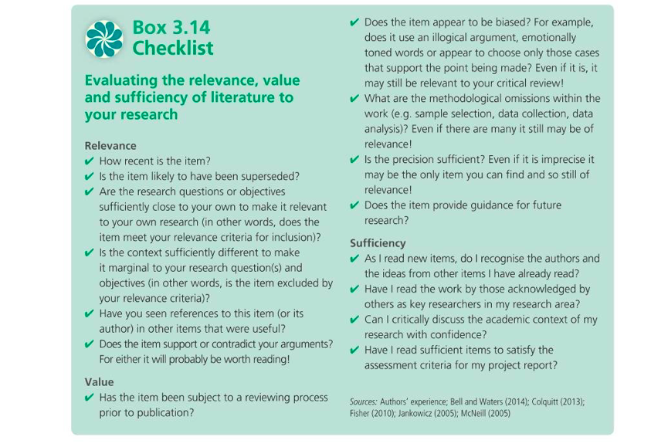Figure 2-1: The checklist of evaluating literature sources in the research
Original sources from:
- Bell, J. and Waters, S. (2014) Doing Your Research Project (6th edition). Maidenhead: Open University Press.
- Colquitt, J.A. (2013) ‘Crafting references in AMJ submissions’, Academy of Management Journal, 56(5) 1221-4.
- Fisher, C. (2010) Researching and Writing a Dissertation for Business Students (3rd edition). London: Sage.
- Jankowicz, A. D. (2005) Business Research Projects (4th edition). London: Thomson Learning.
- McNeill, P (2005) Research methods (3rd edition). London: Routledge.

Cited from:
Saunders M., Lewis P., Thornhill A. (2016) Research Methods for Business Students. 7th Edition. Pearson, pp. 70-121.

Entry 2: Appendix 4

Personal self-development in answer sheet of “ Am I a smart reader?”
Am I a smart reader?
(adapted from Cottrell, 2017)

Do I know exactly what I’m looking for?
Have I considered what questions I’m trying to answer?
My answer: yes, because I need to do literature review for narrow down my research topic, so I need to bring the questions when I read articles and try to find answers in different articles.
Have I considered what information I need?
My answer: Yes, I need to collect primary research paper methodology to get most reliable data collection methods and I also need to get more background information about my research topic from secondary review papers.
Using reading lists selectively
Have I looked at the recommended reading list?
Yes, but I didn’t read all of them, and also I will choose the chapters which may help me to do my research.
Do I know what I need to read?
Yes, I prefer to read academic journals (peer reviewed) and books, they have less bias in the research.
Examine sources for suitability
Have I considered each source?
Not really, like I answered before, I prefer journals and books. Because They contain more reliable information sources.
Have I considered:
- Whether it’s on the reading list? Yes.
- Whether it’s up to date or fairly recent? Yes, but if I have time, I will find out some original theory publish paper to critical review their recent findings.
- Whether it looks readable and manageable? Yes, usually I will use my own catalogues method to record the information and also I will use Harvard referencing to keep every paper I have read.
- Whether it has the information I want?
Most of them have, some of them does not contain relevant information which I need.

Select relevant parts of the book
Do I browse the book quickly? Yes, quite quick, usually about 2 to 3 minutes.
Do I use the contents page, the index, the headings and the sub-headings for guidance? Yes, I always read sub-headings for guidance.
Do I identify which parts of which chapters I need, and put markers in these? Yes, but if the books are belong to the library, I prefer to copy firstly, and then put markers in the copies of book.

Select relevant parts of the page
Do I read the chapter headings? Yes, always.
Do I read any sub-headings? Yes, always.
Do I read the first sentence of each paragraph (which should introduce the topic or idea)? Yes, always.
Do I look at any diagrams, graphs, or charts? Yes, always.
Do I read any summaries or conclusions? Yes, always.

Use photocopies / scans / print outs
Do I make photocopies of important pages? Yes, always.
Do I file electronic files? Yes, always.
Do I use marker pens to highlight important words and phrases (only)? Yes, always.
Do I jot down ideas and thoughts in the margins? Yes, always.
Do I make notes about the points I highlighted, to help me remember them? Yes, always.

Chart the main ideas
Do I map out ideas so that I can see how everything fits together? Not always, I will directly record them as a file and finally to summarised on the literature review.

Practice second guessing
Do I keep trying to anticipate what is coming next, or what the conclusions will be? Yes, for save the time. But if I have time, I prefer to read smoothly about these content.

Read interactively
Do I think about what I’m reading? Yes, I am searching the information rather than I am reading, so I am thinking as well.
Do I question what I’m reading? Do I look for answers to my questions? Yes, always.
Do I make notes of the important points, and ideas triggered by what I read? Yes, I keep the important notes, on my notebook.
Do I challenge the assumptions of the writer, logic of the arguments, & validity of the conclusions? Yes, sometime I even email to the authors why he gave this outcomes and argued with them.

Vary reading speed and method
Do I keep changing pace, according to the needs of the text? Yes.
Do I scan rapidly for specific information? Yes.
Do I read quickly to get the general sense of a passage, and then read difficult parts more slowly? Yes, also depend on the reading materials. If the academic paper use the terminology which I am not familiar, I will slow down a little bit to get the general sense. If the paper is my academic field, I will very quickly to get general sence.

Use markers
Do I label a corner of my own texts with a keyword summary? Yes.
Do I insert labelled bookmarks so that I can find details easily, and need fewer notes? Yes.
Do I give start ratings to valuable pages, making them easier to find later? Yes.

Maintain your attention
Do I take in what I read? Yes.
Do I make sure I’m doing so, by:
- Summing up each section? Not really, especially when I scan reading.
- Taking regular breaks? Well, it is depend on different situations. If I am sick, I prefer regular breaks. If the journals are boring, I try to break every one hour. If the papers are interesting and related to my research topic, I usually not take break, in case breaks will stop my inspiration.
- Reading interactively?
It is also depend on the situation. If I found some important or interesting information, I will share to my mom and my college, and they will also interact with me.

Entry 3: The contribution of research to knowledge and organisational development

The contributions and outcomes of research
The types of research outcomes can be classified either contributed to fill some fundamental knowledge gaps in human knowledge development (Firth, 2019), or the research findings can be applied for the organisation development. Alternatively, the outcomes of research can be contributed to both applied practical level and fundamental knowledge level by doing innovative and extensive researches. Especially, the researchers could contribute a novel theory to help the promotion of organisation development, or they can improve an existed theory to develop a particular organisation. Following examples can illustrate the points I mentioned above.

The examples of published pieces of research

Maslow's hierarchy of needs
Dr. Abraham Maslow’ biggest contribution is the development of the hierarchy of needs in the academic field of humanistic psychology (Selva, 2019; Figure 3-1, Appendix 3). Furthermore, his theory is further applied in today’s organisational development such as the implications of organisational culture, human resource and the performance of employees (Jerome, 2013). Since each new organisation passes through this lower order stage (Figure 3-2 and 3-3, Appendix 3) in which the employees frustrated for their basic survival demands (Upadhyaya, 2014). The human resource management would consider about how to motivate employees to perform more efficiently and effectively, according to the five hierarchical needs. Additionally, a well-developed organisational culture framework could also motivate employees to promote their self-worth by understanding their self-esteem needs (Upadhyaya, 2014).

Frederick Herzberg - the hygiene motivation theory (two-factor theory)
Herzberg’s theory is closely related to Maslow’s theory and both of them are psychologists (British Library, 2019). Herzberg’s research concentrated on the factors affecting employee’s job satisfaction and his contributions are more functional to organisational development, while Maslow’s theory are more focus on analysis of different level of human demands which can be used in both academic and practical level. Furthermore, the hygiene factors are associated with Maslow’s lower levels of need. If these needs from Maslow’s theory are achieved, the job content factors will become the motivators to affect employee’s performance positively (Amoako and Dartey-Baah, 2014).

Porter - the Five Competitive Forces That Shape Strategy
Porter’ theory illustrated the five key elements to construct the industry strategy (Figure 3-5, Appendix 3). The organisation managers are too narrowly defining the meaning of competition, they mostly understand the competitions only coming from their directly competitors, before Porter establish the theory. However, current industry strategies involve another four main competitive forces to influence current structure of industry. Therefore, Dr. Michael E. Porter was actually enriched the meanings of competitions in the industry development, but also he establish this new theory to accelerate the revolution in the strategy field (Porter, 2008).

Hofstede- Hofstede’s Culture Dimensions
Comparing to other models (Table 3-2, Appendix 3), Hofstede’s theory (Table 3-1, Appendix 3) can be widely used in the area of psychology, sociology, marketing, and management studies, due to his wide operationalization of cultures (Soares et al., 2007). This framework was not only contribute a fundamental knowledge of cross culture studies, but also due to today’s globalisation development, there are more international employees working for other countries, this theory would help the organisation to recognise their employee’s cultural value. Additionally, when the products from different countries enter to the international market, this theory could also tell us the scale of product acceptance (Soares et al., 2007).

Entry 3: Appendix 1
Amoako K.G. and Dartey-Baah K. (2011) Application of Frederick Herzberg’s Two-Factor theory in assessing and understanding employee motivation at work: a Ghanaian Perspective. European Journal of Business and Management. 3(9) ISSN 2222-1905 (Paper) ISSN 2222-2839 (Online)

Bassett‐Jones, N., & Lloyd, G. C. (2005). Does Herzberg’s motivation theory have staying power? Journal of Management Development, 24(10), 929–943.doi:10.1108/02621710510627064

Hofstede, G., & Bond, M. H. (1984). Hofstede’s Culture Dimensions. Journal of Cross-Cultural Psychology, 15(4), 417–433. doi:10.1177/0022002184015004003

Hofstede, G. (1991). Cultures and Organizations: Software of the Mind. Berkshire, England: McGraw-Hill Book Company Europe.

Jerome N. (2013) Application of the Maslow’s hierarchy of need theory; impacts and implications on organizational culture, human resource and employee’s performance. International Journal of Business and Management Invention, 2(3) 39-45.

Ozguner M. and Ozguner Z. (2014) A Managerial Point of View on the Relationship between of Maslow’s Hierarchy of Needs and Herzberg’s Dual Factor Theory. International Journal of Business and Social Science. 5(7) 207-215.

Porter M.E. (2008) The five competitive forces that shape strategy. Harvard Business Review. 86(1):78-93, 137.

Soares, A., Farhangmehr, M. and Shoham, A. (2007). Hofstede's dimensions of culture in international marketing studies. Journal of Business Research, 60(3), pp.277-284.

Upadhyaya C. (2014) Applications of the Maslow’s hierarchy of need theory to impacts and implications on organizational culture human resource and employee’s performance. International Journal of Education & Management Study, 4(4); 353-356.
Vroom, V. & Deci, E.(1970), “Management and Motivation”. Organisational Behaviour and Human Resource Performance, 8(2); 217-229.

Zhang D. and Lowry P. B. (2008). “Issues, Limitations, and Opportunities in Cross-Cultural Research on Collaborative Software in Information Systems,” Journal of Global Information Management (JGIM),16(1), pp. 61-84.

Entry 3: Appendix 2
Firth, V. (2019). What is knowledge and how do I contribute to it?. [online] Research Degree Insiders. Available at: https://researchinsiders.blog/2017/10/09/what-is-knowledge-and-how-do-i-contribute-to-it/ [Accessed 22 Apr. 2019].

Selva, J. (2019). Abraham Maslow, His Theory & Contribution to Psychology [Upd. 2019]. [online] Positivepsychologyprogram.com. Available at: https://positivepsychologyprogram.com/abraham-maslow/ [Accessed 23 Apr. 2019].

The British Library (2019). Frederick Herzberg: Hygiene Motivation Theory thinker. [online] Available at: https://www.bl.uk/people/frederick-herzberg [Accessed 23 Apr. 2019].

Entry 3: Appendix 3

Academic contribution of Maslow, Hertzberg, Porter, Hofstede:

Maslow:
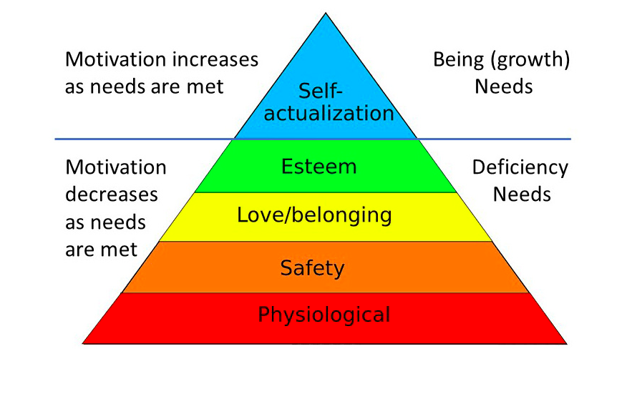
Figure 3-1: original theory of Maslow’s hierarchy of need.

Cited from: Vroom, V. & Deci, E.(1970), “Management and Motivation”. Organisational Behaviour and Human Resource Performance, 8(2); 217-229.

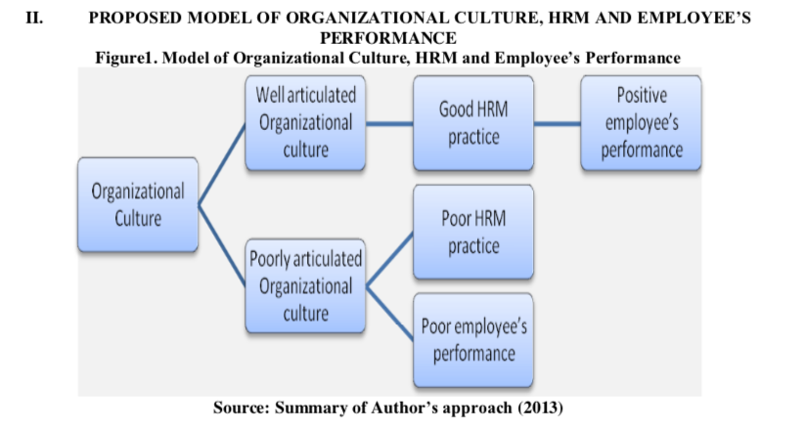
Figure 3-2: Maslow’ theory used in organisational culture.

Cited from: Jerome N. (2013) Application of the Maslow’s hierarchy of need theory; impacts and implications on organizational culture, human resource and employee’s performance. International Journal of Business and Management Invention, 2(3) 39-45.

Figure 3-3: Applied Maslow’s theory in motivation of employee’s performance.

Cited from: Ozguner M. and Ozguner Z. (2014) A Managerial Point of View on the Relationship between of Maslow’s Hierarchy of Needs and Herzberg’s Dual Factor Theory. International Journal of Business and Social Science. 5(7) 207-215.

Hertzberg:
Quotation 1: Vroom and Deci (1970) put it: "The question of what motivates workers to perform effectively is not an easy one to answer".

Cited from: Vroom, V. & Deci, E.(1970), “Management and Motivation”. Organisational Behaviour and Human Resource Performance, 8(2); 217-229.

Figure 3-4: Herzberg’s Two-Factor Theory
Cited from: Ozguner M. and Ozguner Z. (2014) A Managerial Point of View on the Relationship between of Maslow’s Hierarchy of Needs and Herzberg’s Dual Factor Theory. International Journal of Business and Social Science. 5(7) 207-215.

Porter:
Figure 3-5: Porter’s theory: the five competitive forces that shape strategy.

Cite from: Porter M.E. (2008) The five competitive forces that shape strategy. Harvard Business Review. 86(1):78-93, 137.

Hofstede:
Table 3-1: Hofstede’s Cultural Dimension Model (Hofstede, 1991, p.28)

Table 3-2: Comparison of Hofstede's cultural framework with other models
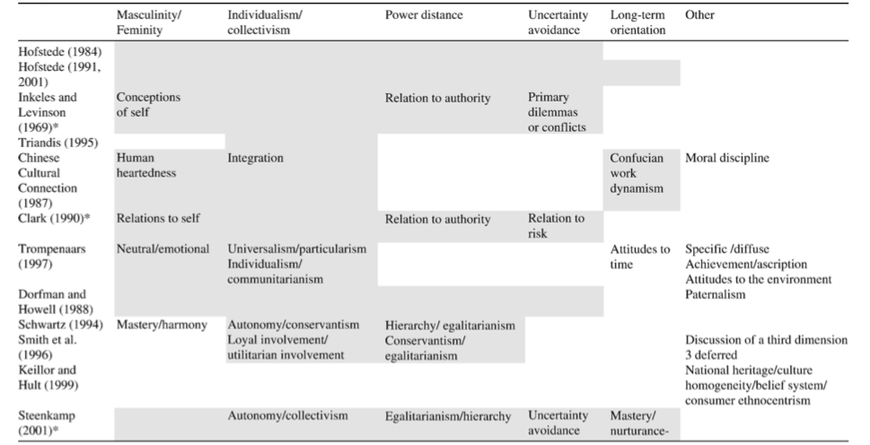
Cite from: Soares, A., Farhangmehr, M. and Shoham, A. (2007). Hofstede's dimensions of culture in international marketing studies. Journal of Business Research, 60(3), pp.277-284.

Entry 3: Appendix 4

My a little thinking about the possible contributions of my future research
Personally, I believed that the contributions of a research should be innovative and fundamental to a new subject, when I was doing my microbiological studies. For example, my previous researches were focus on the discovering new symbiotic bacterial genomes in the human and insect guts, in order to find out new antibiotics to contribute on new therapy and treatment of typical human diseases causing by bacterial infections and also food safety in agriculture development. However, these my previous scientific contributions are more likely to contribute on the fundamental knowledge to a particular scientific field.

When I realised my a little scientific contributions are less possible to use in the real world because the outcomes of these studies are more likely to give kind of suggestions that they may help the development of a special medical field or natural scientific knowledge, rather than generating a formal medical product which can enter to the market to help the patients suffering from various types of bacterial infections. Therefore, I am more interested in transforming scientific fundamental knowledges into productivity. I am hoping that my future researches or DBA stage two researches can really help the Chinese traditional herbal products enter to the market which can contribute the diversity of herbal product market. In spite of my little hoping of my future research, I have to come back to the original point of setting up my research questions. I think that it is very important to affect my research outcomes.

Entry 4. Defining the research question

The ways to defining a good research question
The features of a good research question should involve its originality, certain level of contributing to the knowledge of single or multiple academic fields, the research topic of interest to the researcher and the outside world, the feasibility of research question such as research time scale, ethics problem, economic support, and researcher’s expertise, the potentiality of altering established dogma to develop further projects with similar theme (Wyatt and Guly, 2002).

Formulation and clarification of a research topic is an initial stage of contracting the research question. Interest in a special research topic always happens in the all stages of research. However, the familiarity of the research subject is most likely to determine an appropriate research questions to investigate (Farrugia et al., 2010; Brian, 2006). According to different levels of perceived knowledge from the researchers, certain deficits will occurs within a subject area or field of study (Hulley et al., 2007). Therefore, it is important to know Brian Haynes R’ suggestions (Appendix 3). The importance of increasing more background knowledge about the subject of interest could help the researchers to understand how far they can approach a successful project. The following stage of define a research question will be considering the feasibility and appropriateness of the research questions (Saunders et al., 2016). The checklist of research feasibility and appropriateness shown on figure 4-1, Appendix 3. These two elements of formations of research question will decide the complexity of research design and data analysis (Farrugia et al., 2010).

The ways to generate the research question
After understanding the features of a good research question, the generation of the research question will be the process of time consumption. There are two main types of research to classified as primary and secondary research, according to their difference of data collection and hypothesis construction. If the researchers plan to do a primary research, the hypothesis setting up is more important than the data collection and it should be developed before the initial stage of the study. For instance, there is a database information which could be potentially to perform multiple various statistical comparisons of groups within the database to search a statistically significant relationship. It could result in one to work backward from the data to construct a “question”. This is a kind of counterintuitive process comparing to the way that setting up a question and then finding the answers by collecting the data. The previous existed data re-analysis from various statistical testing of relationship could be most likely causing the spurious positive results of association through chance alone (Farrugia et al., 2010). Therefore, the concept of a good hypothesis has to follow a good research question to drive the data collection servicing for the project.

The way to refine a good research could use Delphi technique (Loo, 2002). This method always used in significant decision-making. The researchers could use this way to construct a panel (people involved in the panel can be the colleagues, supervisors and classmates who are interested in this research area) to discuss the research question because they can give the researchers different views of research potentials, then researchers can evaluate the factors may affect the clarification of research questions. Finally, searching the existed literatures will further help them to confirm the refinement of research questions (Saunders et al., 2016).

Entry 4: Appendix 1
Brian Haynes R. (2006) Forming research questions. J Clin Epidemiol. 59:881–6.

Farrugia P., Petrisor B. A., Farrokhyar F. and Bhandari M. (2010) Research questions, hypotheses and objectives. Canadian Journal of Surgery, 53(4): 278–281.

Hulley S., Cummings S., Browner W., Grady D. and Newman T. (2007) Designing clinical research. 3rd ed. Philadelphia (PA): Lippincott Williams and Wilkins.

Loo, R. (2002). The Delphi method: a powerful tool for strategic management. Policing: An International Journal of Police Strategies & Management, 25(4), 762–769. doi:10.1108/13639510210450677

Saunders M., Lewis P., Thornhill A. (2016) Research Methods for Business Students. 7th Edition. Pearson, pp. 70-121.

Wyatt J. and Guly H. (2002) Identifying the research question and planning the project. Emergency Medicine Journal - British Medical Journal (BMJ), 19(4)318 -321.

Entry 4: Appendix 2
Study.com. (2019). Writing Research Questions: Purpose & Examples - Video & Lesson Transcript | Study.com. [online] Available at: https://study.com/academy/lesson/writing-research-questions-purpose-examples.html [Accessed 27 Apr. 2019].

Entry 4: Appendix 3

Quotation 1.
“Haynes suggests that it is important to know “where the boundary between current knowledge and ignorance lies”. (Brian, 2006; Farrugia et al., 2010).

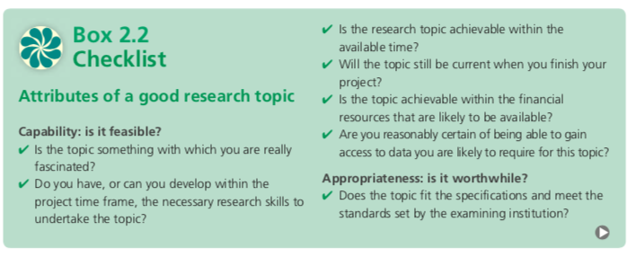
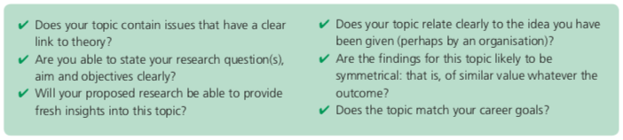
Figure 4-1: the checklist of feasibility and appropriateness of an project question.
Cited from: Saunders M., Lewis P., Thornhill A. (2016) Research Methods for Business Students. 7th Edition. Pearson, pp. 70-121.

Entry 4: Appendix 4

To develop a strong research question from your ideas, ask yourself the following questions –
- Do I know the field and the literature well?
My academic topic combine both Chinese herbal medicine and marketing strategy, I am professional to Chinese herbal medicine and I know well about the literatures of this part. However, I do not know well about marketing strategy. I will read more about this part.
- What are the important research questions in my field?
Currently, Chinese herbal products have been well known and higher popularity in global market. However, it did not open the UK market and unknown reason to cause this phenomenon, so my future study could fill this gap.
- What areas need further exploration?
The marketing strategy of Chinese herbal products
- Could my study fill a gap? Lead to greater understanding?
Yes, I hope that I can fill this gap to expand the understanding.
- Has this study been done before? If so, is there room for improvement?
Yes, my previous background is medical science and it has a lot of improvement need me to do.
- Is the timing right for this question to be answered? Is it a hot topic, or is it becoming obsolete?
It is a hot topic. So far I know that royal family in UK quite like the Chinese medicine, so I believe this is a hot topic.
- Most importantly, will my research have a significant impact on the field of interest?
I only can say I will make a little contributions to this field. Hopefully, it will be significant influence the field of interest.

Entry 5: Philosophical frameworks for research

The general concepts of philosophical frameworks
The concept of research philosophy originates from the system of beliefs and assumptions about the development of knowledge (Saunder et al., 2009). The nature of a research project will also be either exploratory, descriptive, explanatory, evaluative or a combination of these. In each stage of the research, there will be various kinds of assumptions created by the human motivations of doing research and the development of knowledge (Burrell and Morgan, 1979). More specifically, partial of these assumptions related to human knowledge (it is called epistemological assumptions), some of these associated to the realities which researchers encounter in the research process (it is defined as ontological assumptions) and some assumptions are related to researcher’s own values shape the research process (it is called axiological assumptions). These assumptions would influence how the researchers understand the research questions, the approaches they proposed and how the researchers interpret their research outcomes (Crotty 1998).

Is there a best philosophical framework for the research?
.As a researcher, we should have our own belief and assumption and we should recognise the presence of disagreements for chosen research philosophical frameworks as an intrinsic session in the research, especially in social scientific research (Saunder et al., 2016). Most of social scientists or researchers also disagree about the presence of one best philosophical framework in the whole process of the research (Tsoukas and Knudsen 2003). The definitions (Table 5-1) and the flowchart (Figure 5-1) represented the fundamental knowledge of research philosophical framework construction. The comparisons between five major research philosophies (Figure 5-2) suggested that these research philosophical frameworks may contain some limitations or issues.

For example, the ontological issues in business research are focus on the scale of objectivity and subjectivity. Furthermore, the main issue of epistemology is the difference of rigor standard in research quality and outcomes (Antwi and Hamza, 2015). The issues of research methodology are related to the different beliefs of research strategies (Sarantakos, 2005). It mainly because there are two broad contrasting positions (objectivism and subjectivism) in the concept of oncology. On the one hand, the position of objectivism is associated with the realist ontology which is consisting of the facts and unchanged or stable knowledge to generate world outlook and also hold a ‘objectivist’ perspective, but the reality of research can be control and manipulated by different data collection and analysis (Antwi and Hamza, 2015). On the other hand, the position of subjectivism is constituted from the people’s ‘subjective’ experiences of the ‘real’ world, the reality of world outlook is tend be more social constructed (Mutch, 2005). The different criteria of research rigor in the concepts of epistemological issues is related to different research design, positivists more concentrated on scientific logical explanation and data reliability, while interpretivist is more interpreted with social networking and trustworthiness and credibility in the research process (Antwi and Hamza, 2015). Personally, It is difficult to judge the research reliability and validity of these concepts. I believe that the researchers should consider the balance of subjectivism and objectivism during the all stages of research study, in order to investigate the research problem more comprehensively.

Entry 5: Appendix 1
Antiwi S.K. and Hamza K. (2015) Qualitative and Quantitative Research Paradigms in Business Research: A Philosophical Reflection. European Journal of Business and Management. 7(3)217-225.

Burrell, G. and Morgan, G. (1979) Sociological Paradigms and Organisational Analysis. London: Heinemann.

Mutch, C. (2005), “Doing Educational Research: A Practitioner’s Guide to Getting Started”. Wellington: NZCER Press.

O’Gorman, K. D. (2008). The Essence of Hospitality from the Texts of Classical Antiquity: The development of a hermeneutical helix to identify the philosophy of the phenomenon of hospitality. University of Strathclyde, Glasgow.

O’Gorman, K., MacIntosh, R. (2015) Research Methods for Business & Management A guide to writing your dissertation. THE GLOBAL MANAGEMENT SERIES Goodfellow Publishers Ltd Second edition

Sarantakos, S. (2005), “Social Research”. (3rd ed.). Melbourne: Macmillan Education.

Saunders M., Lewis P., Thornhill A. (2016) Research Methods for Business Students. 7th Edition. Pearson.

Saunders M., Lewis P., Thornhill A. (2009) Research Methods for Business Students. 5th Edition. Pearson.

Tsoukas, H. and Knudsen, C. (2003) The Oxford Handbook of Organization Theory: Meta-Theoretical Perspectives. Oxford: Oxford University Press.

Entry 5: Appendix 2
Research-Methodology. (2019). Research Philosophy - Research Methodology. [online] Available at: https://research-methodology.net/research-philosophy/ [Accessed 25 Apr. 2019].

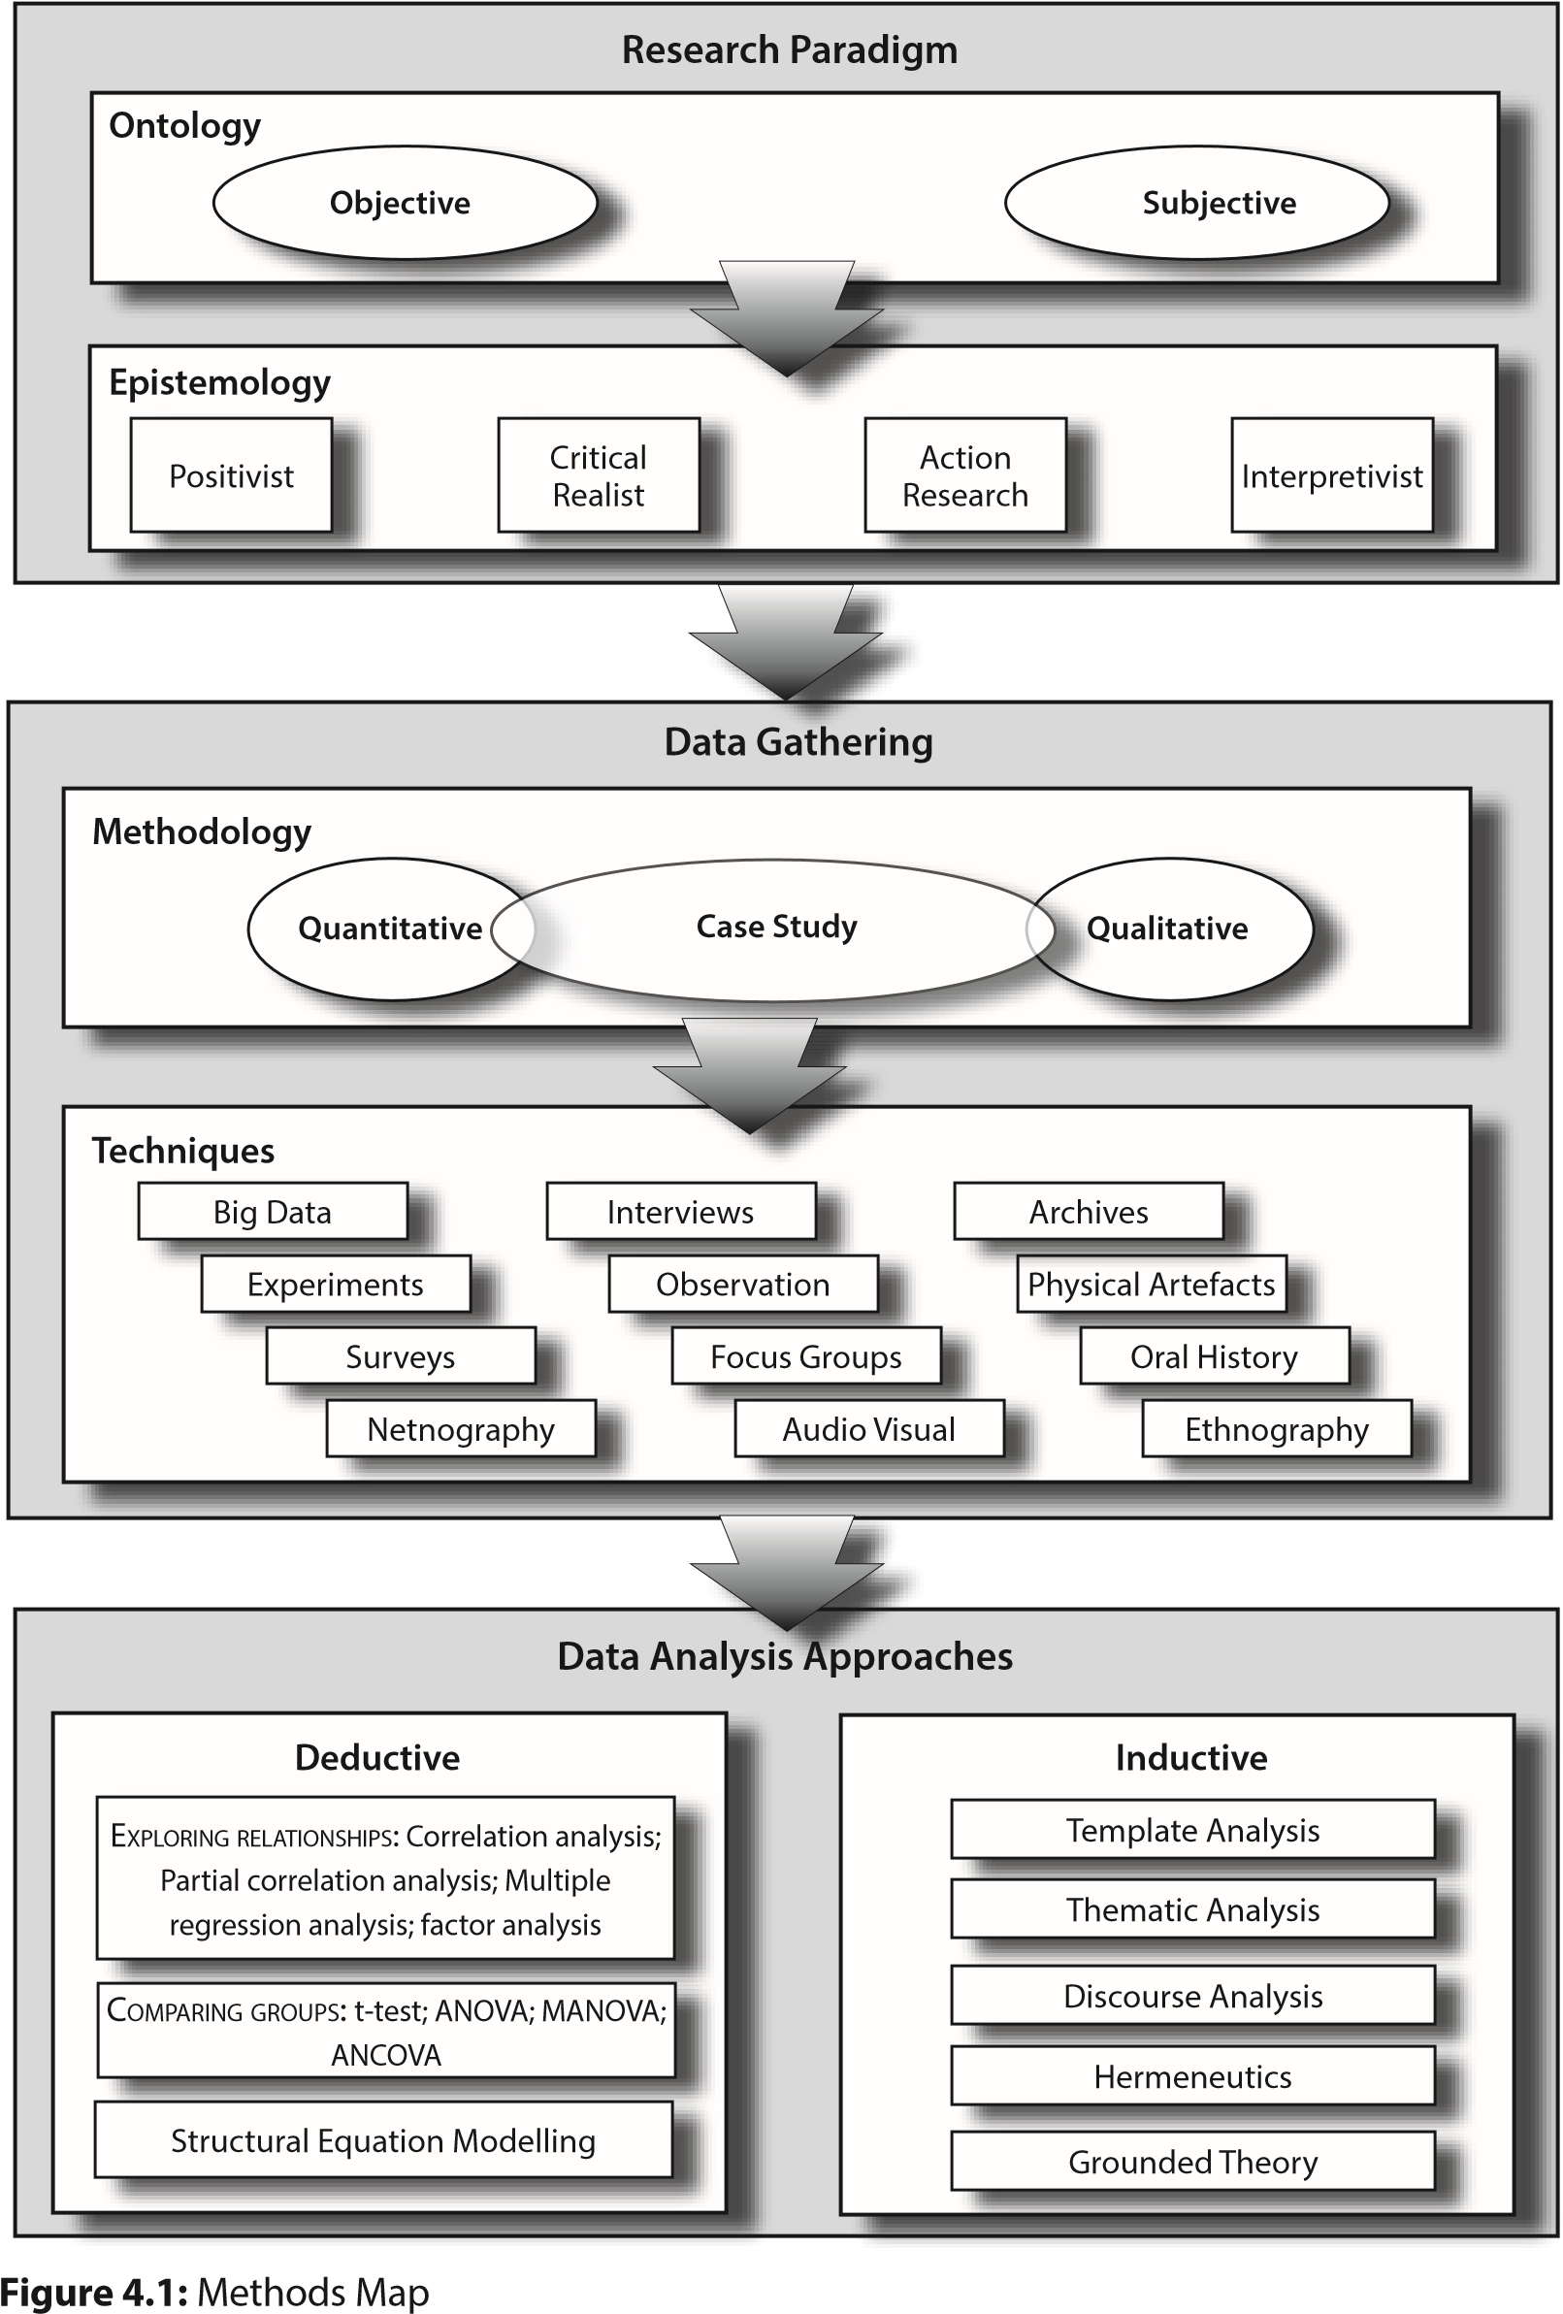
Entry 5: Appendix 3

Figure 5-1: Research philosophical framework map
Cited from: O’Gorman, K., MacIntosh, R. (2015) Research Methods for Business & Management A guide to writing your dissertation. THE GLOBAL MANAGEMENT SERIES Goodfellow Publishers Ltd Second edition

Table 5-1: Some commonly used terms. Adapted from O’Gorman (2008)
Term | Meaning
Axiology | The branch of philosophy dealing with values, as those of ethics, aesthetics, or religion.
Deduction | a priori argument: deriving a proof or using evidence to test a hypotheses.
Epistemology | The branch of metaphysics that deals with the nature of knowledge, its presuppositions and foundations, and its extent and validity.  - The study of knowledge  - Theories of what constitutes knowledge and understanding of phenomena  - How we explain ourselves as knowers, how we arrive at our beliefs
Induction | a posteriori argument, deriving knowledge from empirical investigation.
Metaphysics | The branch of philosophy concerned with the ultimate nature of existence.
Ontology | The branch of metaphysics that deals with the nature of being and of reality.
Methodology | The study and application of methods.
Paradigm | Theoretical framework, within which research is conducted.
Philosophy | The academic discipline concerned with making explicit the nature and significance of ordinary and scientific beliefs, and with investigating the intelligibility of concepts by means of rational argument concerning their presuppositions, implications, and interrelationships; in particular, the rational investigation of the nature and structure of reality (metaphysics), the resources and limits of knowledge (epistemology), the principles and import of moral judgment (ethics), and the relationship between language and reality (semantics).
Reflexivity | Critical self-awareness and examination of beliefs and knowledge-claims.  • Need for conscious, reflexive thinking about our own thinking, and critique our pre-understandings, and their effect on our research
Rhetoric | The art or study of using language effectively and persuasively.  • In particular the style of speaking or writing, especially the language of a particular subject as used in the dissertation process

Cited from: O’Gorman, K., MacIntosh, R. (2015) Research Methods for Business & Management A guide to writing your dissertation. THE GLOBAL MANAGEMENT SERIES Goodfellow Publishers Ltd Second edition

Table 5-2: Comparison of five research philosophies in business and management research

Entry 5: Appendix 4

My research philosophical framework
I prefer more objective ontology but pluralistic epistemology. Personally, I like the study have more objectivity. However, there are not 100% objectivity in any of the existed research studies, but the high objectivity always be required in any of the researches. Currently, I am moving from the natural scientist to the social scientist, there will be more qualitative elements than before, and those qualitative elements would more related to interpretivist rather than critical realist, but I would like to choose pluralistic epistemology to combine both interpretivist and critical realist philosophical framework together to do my research.

Entry 6. Types of research and research design

The types of researches
A scientific research is based upon finding a solution for a specific problem which can identify. The main types of research can be broadly classified as two quantitative and qualitative categories (Lakshman,et al., 2000). Quantitative research are more focus on the numbers which can be summarised and then figure out the problems. Qualitative research are related to understands of human beliefs, experiences, behaviours and interactions (Pathak et al., 2013). The good aspects of qualitative researchers could give a multi-dimensional reality during the study, while quantitative researchers are most likely containing “narrow-angle lens” to concentrate on a single or a few factors which closely related to the research (Antwi and Hamza, 2015). A good qualitative research should contain high level of the creativity, trustworthiness, authenticity, and goodness (Lincoln & Guba, 1985; Eisner, 1991; Guba & Lincoln, 1989; Emden & Sandelowski, 1998; Marshall, 1990). The standard of a good quantitative research would achieve high data validity and reliability (Heale and Twycross, 2015). Due to the scopes of today’s researches are more complex than before, the research designs would not be too direct to choose either types of research. In majority of current social scientific researches, there are always some qualitative research elements presented in quantitative research, or some quantitative research factors appeared in qualitative research. It is all depend on the research design for a clear research direction.

The types of research designs
The research design is actually the methodology that the basic planning of figuring out the research questions. It would include clear objectives derived from the settings of research question(s), the specification of the sources from data collection, the methods of data analysis, and the discussion of ethical issues that researchers may encounter and the constraints the researchers would inevitably encounter such as data accessory, time limitations, location and funding budget). More importantly, it should demonstrate that the researchers have carefully considered these elements in the particular research design (Saunder et al., 2016).

There are various methods to formulate a research design for the study and the differences between qualitative and quantitative research methods shown on Table 6-1. According to these differences, there are always some issues presented in these methods. For examples, the setting of questions in questionnaires could result in the misunderstanding of respondents, or some research topics are very sensitive to the respondents such as their political position or their culture. They may knowingly lie to project a desired image or because the respondents fears a negative consequence of a truthful response (Lakshman,et al., 2000). Alternatively, the respondents may answer what that they presume the interviewer wishes to hear, especially in in rural areas of developing countries, it is referred to as "courtesy bias'' (Mitchell, 1965). Additionally, the These linguistic problems maintain in a questionnaire even after pretesting and "back translations" into English or other languages (Lakshman, et al., 2000). Therefore, neither qualitative or quantitative research would fully answer the research questions, the combination of both types of research methods in the research study would improve the quality of research outcomes.

Entry 6: Appendix 1
Antiwi S.K. and Hamza K. (2015) Qualitative and Quantitative Research Paradigms in Business Research: A Philosophical Reflection. European Journal of Business and Management. 7(3)217-225.

Eisner, E. (1991). The enlightened eye: Qualitative inquiry and the enhancement of educational practices. New York: Macmillan.

Emden, C., & Sandelowski, M. (1998). The good, the bad and the relative, part one: Conceptions of goodness in qualitative research. International Journal of Nursing Practice, 4, 206-212.

Guba, E. G., & Lincoln, Y. S. (1989). Fourth generation evaluation. Newbury Park, CA: Sage.

Lakshman M., Sinha L., Biswas M., Charles M. and Arora N.K. (2000) Quantitative Vs Qualitative Research Methods. Indian Journal of Pediatrics. 67(5) 369-377.

Lincoln, Y. S., & Guba, E. A. (1985). Naturalistic inquiry. Beverly Hills, CA: Sage.

Marshall, C. (1990). Goodness criteria: Are they objective or judgement calls? In E. G. Guba (Ed.), The paradigm dialog (pp. 188-197). Newbury Park, CA: Sage.

Mitchell R. (i965) Survey materials collected in developing countries: Sampling, measurement and interviewing obstacles in intro and international comparisons. Intern SocialScienceJournaL.17 : 665-685.

Pathak V., Jena B., and Kalra S. (2013) Qualitative research. Perspect Clin Res. 4(3): 192.

Pope C. and Mays N. (1996) Qualitative Methods in Health and Health Services Research. In: Mays N, Pope N, editors. BMJ. London: Qualitative Research in Health Care;

Entry 6: Appendix 2
The British Library. (2019). What is Qualitative Research?. [online] Available at: https://www.bl.uk/business-and-ip-centre/articles/what-is-qualitative-research?gclid=CjwKCAjwtYXmBRAOEiwAYsyl3BJyMbEKilywXxjYvJCivV7aezLBy3ARgSDfppLEnfxCVAR_ogKOehoC9aQQAvD_BwE [Accessed 19 Apr. 2019].

Entry 6: Appendix 3

Table 6-1: Differences between Quantitative and Qualitative Research Approaches
Cited from: Antiwi S.K. and Hamza K. (2015) Qualitative and Quantitative Research Paradigms in Business Research: A Philosophical Reflection. European Journal of Business and Management. 7(3)217-225.

Entry 6: Appendix 4

My a little thinks about my research design
My research topic is related the Chinese herbal products in UK market, it is more related to the academic area of marketing strategy. I believe both qualitative and quantitative research designs presented in this academic field. I prefer to use quantitative research design to initiate my research process, but I believe when I set up my questionnaire or survey, there will be some qualitative elements presenting in the research design. I will see in that moment.

Entry 7. Research ethics and integrity

Research ethics
Research ethics should be a moral standard of research and it must be emerged in all the stages of research. There are two dimensions of ethics and they are procedural ethics and situational ethics or “ethics in practice” (Guillemin and Gillam, 2004). Procedural ethic of all kinds of research are that the research ethics committee in the earlier stage of research and research subjects contain humans, which will allow the researchers to complete the application form for ensuring the ethics of research passing through whole research process. Situational ethics are related to the legal solutions to deal with unpredictable conditions (Guillemin and Gillam, 2004). The issues of research ethics are mainly associated with the management of research containing human participants, which it had elevated the concerns of policy makers, solicitors, and scientists for decades of years (Yip et al., 2016). For example, emergency research studies happen where there are the subjects incapacitated and lack of informed consent (acute head trauma, cardiac arrest), researchers have to obtain informed consent as soon as possible for continued participation (Yip et al., 2016). It is difficult to judge the ethic standard in some researches, but every researcher should comply with the behaviours of maintaining the basic ethic principles (Table 7-1).

Research integrity
The research integrity should be active adherence to the ethical principles and progressing the research with professional standard and behaviours which is the most important element in the content of research integrity. Specifically, the researchers should recognise bias in the research, honesty and fairness in proposing, performing accurate data analysis and high efficiency of data collection, maintain the objectivity in the research process and avoid the conflicts of interests. Additionally, protection of experimental objectives and their privacy is also important to the integrity. Therefore, four main factors (honesty, accuracy & rigour, efficiency and objectivity) influence the progress of research integrity. Personally, I believe efficiency is very important to PhD students. The definitions of efficiency in the research (Quotation 1) as educational efficiency and two main types of efficiency- economic efficiency and technique efficiency can be a scale of efficiency measurement. Additionally, efficiency also can be defined as an ability to finish a research properly. In order to obtain this ability, the researchers should practice their relevant research skills. For example, if the researchers who are doing the medical research, they should have correspondent medical experimental skills or statistic skills. Alternatively, social scientific researchers usually have a good communication skill to do their research. As I mentioned on Entry 4, the familiarity of research topic from researchers is important to initiate the research, the acquirement of relevant skills for researchers could accelerate the research progress. Therefore, researcher should gain the corresponding research skills as earlier as they being able to learn, it will increase the research efficiency without waste resources.

Entry 7: Appendix 1
Erlendsson, J., (2002) Value For Money Studies in Higher Education http://www.hi.is/~joner/eaps/wh_vfmhe.htm accessed 4 January 2002, not available at this address 4 February 2011.

Fraser, M., 1994, ‘Quality in higher education: an international perspective’ in Green, D. (Ed.), 1994, What is Quality in Higher Education? pp. 101–111 (Buckingham, Open University press and Society for Research into Higher Education).

Guillemin M. and Gillam L. (2004) Ethics, Reflexivity, and “Ethically Important Moments” in Research. Qualitative Inquiry, 10(2): 261-280.

Saunders M., Lewis P., Thornhill A. (2016) Research Methods for Business Students. 7th Edition. Pearson.

Thursby, J. G., 2000, 'What Do We Say about Ourselves and What Does It Mean? Yet Another Look at Economics Department Research', Journal of Economic Literature, 38, p. 383.

Vlãsceanu, L., Grünberg, L., and Pârlea, D., 2004, Quality Assurance and Accreditation: A Glossary of Basic Terms and Definitions (Bucharest, UNESCO-CEPES) Papers on Higher Education, ISBN 92-9069-178-6.

Vlãsceanu, L., Grünberg, L., and Pârlea, D., 2007, Quality Assurance and Accreditation: A Glossary of Basic Terms and Definitions (Bucharest, UNESCO-CEPES) Revised and updated edition. ISBN 92-9069-186-7.

Yip C., Han N. R., and Sng B. L. (2016) Legal and ethical issues in research. Indian Journal of Anaesthesia. 60(9): 684-688.

Entry 7: Appendix 2
Grants.nih.gov. (2019). What is Research Integrity | grants.nih.gov. [online] Available at: https://grants.nih.gov/policy/research_integrity/what-is.htm [Accessed 26 Apr. 2019].

Qualityresearchinternational.com. (2019). Analytic Quality Glossary. [online] Available at: http://www.qualityresearchinternational.com/glossary/efficiency.htm [Accessed 27 Apr. 2019].

Wojtczak, A., (2002) Glossary of Medical Education Terms. http://www.iime.org/glossary.htm, December, 2000, Revised February 2002, accessed 2 September 2012, page not available 30 December 2016.

Entry 7: Appendix 3

Table 7-1: Ethical principles and the ethical rationale for and development of each principle
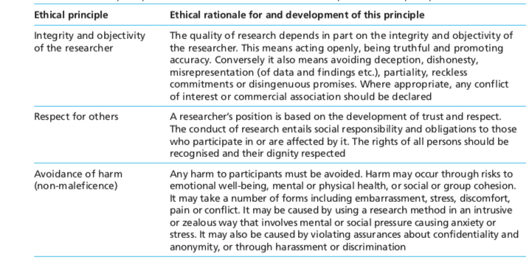

Cited from: Saunders M., Lewis P., Thornhill A. (2016) Research Methods for Business Students. 7th Edition. Pearson.

Quotation 1- The efficiency definitions:
Efficiency (educational): An ability to perform well or to achieve a result without wasted resources, effort, time, or money (using the smallest quantity of resources possible). Educational efficiency can be measured in physical terms (technical efficiency) or in terms of cost (economic efficiency). Greater educational efficiency is achieved when the same amount and standard of educational services are produced at a lower cost, if a more useful educational activity is substituted for a less useful one at the same cost, or if unnecessary educational activities are eliminated. A programme or a higher education institution may be efficiently managed, but not effective in achieving its mission, goals, or objectives. (Vlãsceanu et al., 2004, p. 38)

Fraser (1994, p. 104) defined it thus:
Efficiency. This is a measure of the resources used (costs) to achieve stated goals. It is unfortunate that governments frequently confuse quality in higher education with efficiency. Low-standard goals might well be achieved at low cost. (Fraser, 1994, p. 104)

Erlendsson (2002) defines efficiency as:
performing tasks with reasonable effort (‘doing things the right way’)

Thursby (2000, p. 400) analysed the efficiency of the Economics Research Departments in the United States. He defined efficiency as follows:
a department is deemed technically efficient if, when compared to departments with similar level of inputs, it could produce greater research outputs without increasing its inputs usage, or equivalently, it is one which, compared to departments with similar levels of outputs, could produce the current levels of outputs with fewer inputs.

Wojtczak (2002) defines efficiency in the context of medial education:
Efficiency: An ability to perform well or achieve a result without wasted energy, resources, effort, time or money. Efficiency can be measured in physical terms (technical efficiency) or terms of cost (economic efficiency). Greater efficiency is achieved where the same amount and standard of services are produced for a lower cost, if a more useful activity is substituted for a less useful one at the same cost or if needless activities are eliminated.

Entry 7: Appendix 4

My attitude in the standards of research ethics and integrity
As a natural scientist before, I was quit lucky because my research did not contain any human participants. Therefore, I had less ethic issues than my colleagues who were doing their clinical trail researches. In most of time, they were difficult to get potential participants to agree to get their smears or excrement and urine to do the microbial analysis, I think these issues were related to respecting and care participants, and the privacy of participants. Personally, I trust my colleagues that they would respect their participants and also would not tell any irrelevant people about their privacy. However, they have to delay their research submission time and cancelled or reschedule the equipment time that they had booked for data analysis, due to these ethic regulations. During that period, I was quite naïvely think that these research ethics really affected the research integrity, especially the research had short time limits.

Additionally, although I have less issues than my colleagues, I still had some ethic issues when I close to the thesis submission time. I had two publishing papers when I submit my thesis before. However, my published research outcomes are close related to my thesis result findings, I have been told from the ethic committee that you have to rewrite your thesis to avoid the problem of overlapping publishing findings. Additionally, I have to delay my third publish paper until I graduated. I was quite struggled about that period. My research integrity were really influenced by the research ethics regulations in my previous university. After I studied more comprehensively these research ethics and integrity in these DBA, I realised the importance of these two elements in research. My current attitude to the research integrity and ethics is my scale of objectivity which tend to more objective, maintaining the honesty as much as I can, especially in the data manipulations, increasing my efficiency e.g. learning more relevant skills, and following the ethic coding of practice in my future research.

