Business Plan for
ZOOLAND Coffee World

Produced By:
GROUP MEMBERS:
Student Name | Student No.
Anaida Adamache | 2026381
Ramona Barna | 2234369
Aura Ioana Pantiru | 2123786

Dated: 03.06.2024

Module Name: Entrepreneurship
Module Code: BMIH5001
Lecturer Name: Charlotte Joyner

Table of Contents
1. Executive Summary 3
2. THE BUSINESS IDEA 4
2.1 The Product/Service 4
2.2 SWOT Analysis Summary 5
3. THE TEAM 7
3.1 Key Personnel 7
3.2 Skills Gaps & Key Partners 9
3.2.1 Additional Staff Requirements (Roles and Responsibilities) 9
3.2.2 Training and Development: 9
3.2.3 Outsourced Support / Key Partners: 9
4. MARKET RESEARCH 10
4.1 Market Information, Trends and External Factors 10
4.2 Customer Profiles 11
4.3 Competitor Profiles 12
5. MARKETING PLAN 13
5.1 Price 13
5.2 Product 13
5.3 Placement 13
5.4 Promotion 13
6. KEY RESOURCES 14
6.1 Premises 14
6.2 Equipment 14
6.3 Key Suppliers 14
7. FINANCES AND START-UP SUPPORT 15
7.1 Financial Summary 16
APPENDICES 20
Appendix A – SWOT Analysis 20
Appendix B – PEST Analysis 21
Appendix C – Copy of Pitch Supporting Material 22
REFERENCE LIST: 23

1. Executive Summary
Zooland Coffee World is a mobile vegan coffee service located in Chester, UK that also operates within zoos. The business offers a range of 100% vegan coffee drinks as well as plant-based snacks, responding to the growing demand for ecological and health-conscious options. with a percentage of over 57% of the British population preferring oat milk in coffee and the Zooland Coffee World service thus targets zoo visitors looking for ethical and sustainable choices. The company's strong points thus include a unique vegan offer but also a flexible mobile service, while the opportunities thus consist in expanding the ecological and vegan consumer markets. Despite the challenges of the business such as the very limited recognition of the brand as well as the very fierce competition in the industry, it is proposed to mitigate it through aggressive marketing but also through strategic partnerships. The team's experience but also competitive prices as well as directional promotions and ecological branding thus support financial projects with revenues of approximately £140,000 with a profit in the first year of £50,000. The short-term objectives of the business thus include obtaining brand recognition but also the stability of profitability in the first year.

2. THE BUSINESS IDEA

2.1 The Product/Service
Zooland Coffee World is a mobile vegan coffee service located in Chester, Great Britain, operating in the zoo industry. The business thus offers a unique vegan coffee experience for zoo users, thus offering a range of coffee drinks as well as plant-based snacks. According to some statistics made in the year 2021, plant-based milk is gaining more and more popularity, showing that 57% of the population and 54% of coffee lovers in Great Britain said that they drink their coffee with milk of oats (Statista, 2021) (Graphic 1). The main customers of the cafe are thus the zoo visitors who are looking for a healthy, ethical and ecological coffee option.

Graph 1. Type of vegan milk prefeered by general public and vegan coffee lovers
Source: (Statista, 2021)

This business proposes the sale of snacks as well as drinks such as coffees to be 100% vegan, thus hosting the market in a continuous growth of health-conscious vegan consumers. The global market for vegan flavors grows to more than 11 billion dollars by the end of the year, as estimated (Ridler, G., 2024). The coffee is thus served from a mobile car, thus making it easier for visitors from the entire zoo to be accessible. This type of business has a commitment to sustainable practices, thus using cups made of biodegradable cardboard as well as eco-friendly materials. Another feature or advantage of the company is the unique experience of visiting the zoo and a unique and ethical coffee (Kansanen, I., 2013).
The value proposition is that Zooland Coffee World offers a unique vegan coffee option, convenient but also ecological, thus improving the zoo experience for health-conscious and environment-conscious visitors.

2.2 SWOT Analysis Summary
Strenghts: The strong points of this type of business are, first of all, the unique vegan offer on a niche market, as well as the mobile configuration that allows flexibility and ease of use by customers. Strong commitment to customer sustainability. With the passage of time, clients become more and more aware of the important positive impact that sustainability can bring, thus making this business idea a sustainable one Jansson, J., et al. (2017).
Weaknesses: The limited brand recognition is a very weak point of this business, but also the dependence on the traffic of visitors to the zoo.
Opportunities: The growing trends of veganism and eco-conscious consumerism (Gheihman, N., 2021), as well as the potential for expansion to other zoos and tourist attractions. This type of business has huge potential due to the fact that the UK is among the biggest importers of vegan coffee in Europe. The United Kingdom, according to the Ministry of Foreign Affairs (2022), imported approximately 148,000 tons in 2021, becoming the eighth importer of vegan decaf in Europe (Graph 2.)

Graph 2. The total number of coffee imports (in tons) in United Kingdom from Producing Countries
Source: (Ministry of Foreign Affairs, 2022)
Threats: Major competition from existing zoo cafes but also from external suppliers. Fluctuation in visitor numbers due to very busy seasons or external factors such as weather (Bager and Lambin, 2020)
Mitigation strategies: Aggressive marketing in building brand recognition (Upendranadh, C., & Subbaiah, C., 2021). Diversification of product offers to satisfy the wider public but also the stability of partnerships with zoos for joint promotions.

3. THE TEAM

3.1 Key Personnel
Name and Company Position: Anaida Adamache- Founder and CEO
Skills and Experience: 3 years of experience in the coffee industry certified barista and also background in the sustainable business practices
Role and Responsibilities: Overseeing the business operations, supploer relationships and strategic planning and also sustainability initiatives

Name and Company Position: Aura Ioana Pantiru – Finance Manager
Skills and Experience: 2 years of experience in financial management, CPA certified also
Role and Responsibilities: Handling all the financial planning, accounting tasks and also budgeting

Name and Company Position: Ramona Barna– Sales and Customer Service Management
Skills and Experience: 1 Year experience in sales and customer service management with also a proven track record of the improving customer satisfactions and increasing sales.
Role and Responsibilities: Responsible for driving saes, service operations, managing customers, developing and also implementing the sales strategies and also thus ensuring high levels of the customer satisfaction and also retention

3.2 Skills Gaps & Key Partners

3.2.1 Additional Staff Requirements (Roles and Responsibilities)
Baristas: To handle coffee preparations and also customer service
Sales Associates: Assisting with promotions and sales at the zoo

3.2.2 Training and Development:
Barista Training: Provided by a certified training center thus ensuring also a high-quality coffee preparation
Customer Service Training: In-house training sessions for improving the customer interaction skills

3.2.3 Outsourced Support / Key Partners:
Marketing Aggency: Needed for professional branding and also marketing campaigns
Eco-friendly Suppliers: For compostable cups and also sustainable packaging materials

4. MARKET RESEARCH

4.1 Market Information, Trends and External Factors
According to sources such as Statista (2024), there is a growing interest in reducing the consumption of meat or other animal products among consumers in the United Kingdom. According to the sources, this trend has turned meat consumers into both vegetarians and vegans.
The rates of veganism among different demographic groups thus follow several distinct patterns. The UK market for meat substitutes is already worth over a billion euros, which makes the UK the largest market in Europe (Statista, 2024). Also according to Statista (2022), retail sales of vegetarian and plant-based products in the United Kingdom amounted to approximately 1.15 billion pounds in 2022 (Statista, 2022) (Graph 3.).

Graph 3. Revenues from sales of food products and vegetarian and alternative plant-based drinks in the UK from 2017 to 2022
Source: (Statista, 2022)

Plant-based alternatives to milk, according to Brita Lapatza (2022), have been hugely successful among the population. The research carried out by Ipsos (Chiarelli, 2022) thus found that a percentage of 48% of adults in Great Britain use plant-based milk in their diet, thus demonstrating a major opportunity in the vegan coffee market. According to Mintel (2023), coffee shop market research summarizes how the rising cost of living crisis is leading to more polarized consumer behavior, thus leading to the adoption of new pricing strategies for coffee shops. This thus includes an increasing use of tiered pricing and subscription plans for an increase in the number of people. According to the same sources, the coffee industry's target market for the UK is both men and women and families. A percentage of 33% of consumers over the age of 65 thus prefer higher coffee prices to a decrease in quality, and 39% of coffee consumers thus agree that coffee prices are good value for money (Mintel, 2023).

4.2 Customer Profiles
- Vegan Families: The profile of vegan coffee consumers are mainly health-conscious vegan families who are looking for ethical food and drink options. Benofide Research (2024) thus reports that the increase in demand for food products as well as drinks with a clean label is thus expected to become a significant engine in the growth of the industry. Also, the increase in health awareness among consumers increases the demand for sustainable foods and drinks (Benofide Research, 2024).
- Environmentally conscious consumer: visitors engaged in sustainable living represent another consumer profile. According to the Office for National Statistics (2023), more than eight adults out of ten, which represents a percentage of over 86% of the UK, reports that they have made at least some lifestyle changes to help address the problems of life. environment such as lifestyle changes towards vegetarian or vegan (Office for National Statistics, 2023)
- Zoo Customers: A third profile is the customers from the zoo who come frequently and are thus looking for more convenient dining options but also more ethical options to consume products that do not come from animal sources such as milk in their coffee.

4.3 Competitor Profiles
Glo coffee: Based in Sheffield, Glo Coffee specializes in vegan, vegetarian and gluten-free options. The company emphasizes sustainability by sourcing its products locally, thus focusing on quality and respect for the environment (GloCoffee, 2016)
Coffee Blue: Coffee Blue is thus known for its award-winning coffee that serves a light-medium roast blend. It provides mobile coffee services for events such as weddings, festivals and corporate functions (Coffee Blue, 2023)
Camper Café: Camper Cafe has been operating since 2011, being recognized as such for its vintage fireplaces and high-quality services. It offers different events including even brand activations and TV and film production services. They focus on creating unique customer experience (Camper Cafe, 2023)

5. MARKETING PLAN

5.1 Price
Zooland Coffee World sets very competitive prices for products for sale, slightly above average in order to reflect the quality standards and the best. The prices will thus vary between 3 and 6 pounds for drinks and snacks

5.2 Product
The branding will emphasize durability, but thus earth tones and ecological packaging. The mobile car will also have a vibrant but welcoming design to attract customers

5.3 Placement
The products will thus be sold from the mobile coffee machine stationed in different but at the same time strategic places in the zoos. Online promotions and pre-orders will thus be available through social media channels

5.4 Promotion
Promotional activities include the following:
- Campaigns on social networks highlighting vegan and ecological aspects (Santos et al., 2023)
- Partnerships with zoos for joint events and promotions
- Loyalty programs with clients but also feedback incentives in order to build relationships with clients (Chen, J., 2024)
- Traditional advertising thus through local media but also through promotional flyers

6. KEY RESOURCES

6.1 Premises
Zooland cafe world will thus operate from a mobile coffee machine within the zoo. The car will thus be rented at an estimated cost of only 500 pounds per month. According to the Global Vans (2021) website, coffee van rental prices start at £200 per month plus maintenance costs.

6.2 Equipment
According to CPD (2023), the cost of setting up a mobile coffee business could vary between £3,000 and £100,000 (CPD, 2023). The cost of the essential equipment thus includes a high-quality presser, ecological serving materials but also grinding, was thus estimated at 10,000 pounds.

6.3 Key Suppliers
Coffee Beans: Ethical coffee bean companies costing around £5,000 a year
Packaging: Green packaging solutions costing an estimated £3,000 per year

7. FINANCES AND START-UP SUPPORT
EXPENDITURE | Year 1  £
Company Registration | 500
Rent/Rates | 6,000
Staff Wages | 40,000
Travel/Accomodation | 2,000
Telephone (mobile) | 500
Broadband | 600
Utilities | 1,200
Marketing and materials | 5,000
Insurance | 1,000
Capital Expenditure/Equipment | 10,000
Training & Development | 2,000
Accounting/Legal | 1,500
Outside Services | 2,000
Stock/Materials Purchases | 15,000
Bank Charges | 200
Office Consumables | 500
Loans Repayments | 3,000
Total Expenditure | £ 90,000
INCOME | Year 1  £
Sales snacks | 50,000
Sales beverage | 30,000
Sales oline products | 20,000
Capital Introduced | 10,000
Funding | 20,000
Loans/Borrowing | 10,000
Total Income | £ 140,000
YEAR ONE PROFIT/LOSS | £
Total Income | 140,000
Total Expenditure | 90,000
Profit/Loss | £50,000

7.1 Financial Summary
The projected figures are thus based on market studies but also on realistic sales objectives. The initial costs thus cover the equipment as well as marketing and operational expenses. The business thus aims to achieve profitability in the first year, thus capitalizing on strong marketing strategies and a unique value proposition. Start-up support thus includes a grant of £20,000 from a small business development program to help with initial capital requirements.
Sales categories
- Sales A (basic espresso drinks) - these include espresso, americano, cappuccino, latte, flat white, macchiato and mocha.
- Sales B (specialty drinks) - these include matcha latte, turmeric latte and chai latte
- Sales C (ice drinks) - includes iced americano, iced latte, as well as iced mocha and iced matcha latte.
Price Points
- Espresso-Based Drinks: £3.00 - £5.50
- Specialty Drinks: £4.50 - £5.50
- Iced Drinks: £4.00 - £5.50
Cost of Goods Sold (COGS)
- Ingredients Costs: £1.00 for espresso-based drinks, £1.50 for specialty drinks, and £1.20 for iced drinks.
- Packaging Costs: £0.30 per unit.
- Total COGS: Ingredient Costs + Packaging Costs per drink.
Fix costs.
The rental and maintenance of the van will cost around 600 lira per month, but also the staff salary of 10 lira per hour (2 baristas with 8 hours/day - 30 days/month). Permits and licenses will have a price of 200 lira per month and utilities somewhere around 100 lira per month.
Variable Costs
- Fuel: £200 per month
- Marketing: £150 per month
Sales Volume Estimates
  - Espresso-Based Drinks: 60 drinks/day at £4.00
  - Specialty Drinks: 20 drinks/day at £5.00
  - Iced Drinks: 20 drinks/day at £4.50
- Monthly Sales Calculation
  - Espresso-Based Drinks: 60 drinks/day * £4.00 * 30 days = £7,200
  - Specialty Drinks: 20 drinks/day * £5.00 * 30 days = £3,000
  - Iced Drinks: 20 drinks/day * £4.50 * 30 days = £2,700
  - Total Monthly Sales: £12,900
- Monthly COGS Calculation
  - Espresso-Based Drinks: 60 drinks/day * £1.30 * 30 days = £2,340
  - Specialty Drinks: 20 drinks/day * £1.80 * 30 days = £1,080
  - Iced Drinks: 20 drinks/day * £1.50 * 30 days = £900
  - Total Monthly COGS: £4,320
- Gross Profit Calculation
  - Total Monthly Sales: £12,900
  - Total Monthly COGS: £4,320
  - Gross Profit: £8,580
- Total Monthly Fixed Costs
  - Van Lease and Maintenance: £600
  - Staff Wages: £4,800 (2 baristas, £10/hour, 8 hours/day, 30 days/month)
  - Permits and Licenses: £200
  - Utilities: £100
  - Total Fixed Costs: £5,700
- Total Monthly Variable Costs
  - Fuel: £200
  - Marketing: £150
  - Total Variable Costs: £350
- Net Profit Calculation
  - Gross Profit: £8,580
  - Total Costs (Fixed + Variable): £6,050
  - Net Profit: £2,530
Annual Projections
- Annual Revenue: £154,800
- Annual COGS: £51,840
- Annual Gross Profit: £102,960
- Annual Fixed Costs: £68,400
- Annual Variable Costs: £4,200
- Annual Net Profit: £30,360

APPENDICES

Appendix A – SWOT Analysis
Strengths:  - Unique vegan offering in a niche market.  - Mobile setup allows the flexibility and also easy access to customers.  - Strong commitment to sustainability.  - Growing customer awareness of the positive impact of the sustainability. | Weaknesses:  - Limited brand recognition.  - Dependence on zoo visitor traffic.
Opportunities:  - Growing trends of veganism and eco-conscious consumerism.  - Potential expansion to another zoos and tourist attractions.  - UK as one of the largest importers of vegan coffee in the Europe. | Threats:  - Major competition from existing zoo cafes and external vendors.  - Fluctuations in visitor numbers due to seasonality and weather.
Mitigation Strategies:
- Aggressive marketing to build brand recognition.
- Diversification of product offerings.
- Establish partnerships with zoos for joint promotions.

Appendix B – PEST Analysis
Political:  - UK regulations for food safety and environmental standards.  - Government incentives for the sustainable businesses. | Economic:  - Increasing consumer spending on the vegan and plant-based products.  - Economic stability affecting the zoo visitor numbers.
Social:  - Rising health awareness and preference for vegan options.  - Growing environmental consciousness among consumers.  - Increased lifestyle changes towards vegetarian and vegan diets. | Technological:  - Advancements in eco-friendly packaging.  - Use of social media for marketing and customer engagement.
Legal:  - Compliance with health and safety regulations for mobile food vendors.  - Adherence to labor laws and fair trade practices. | Environmental:  - Commitment to reducing carbon footprint.  - Use of biodegradable and sustainable materials.  - Impact of weather on zoo visitor numbers.

Appendix C – Copy of Pitch Supporting Material
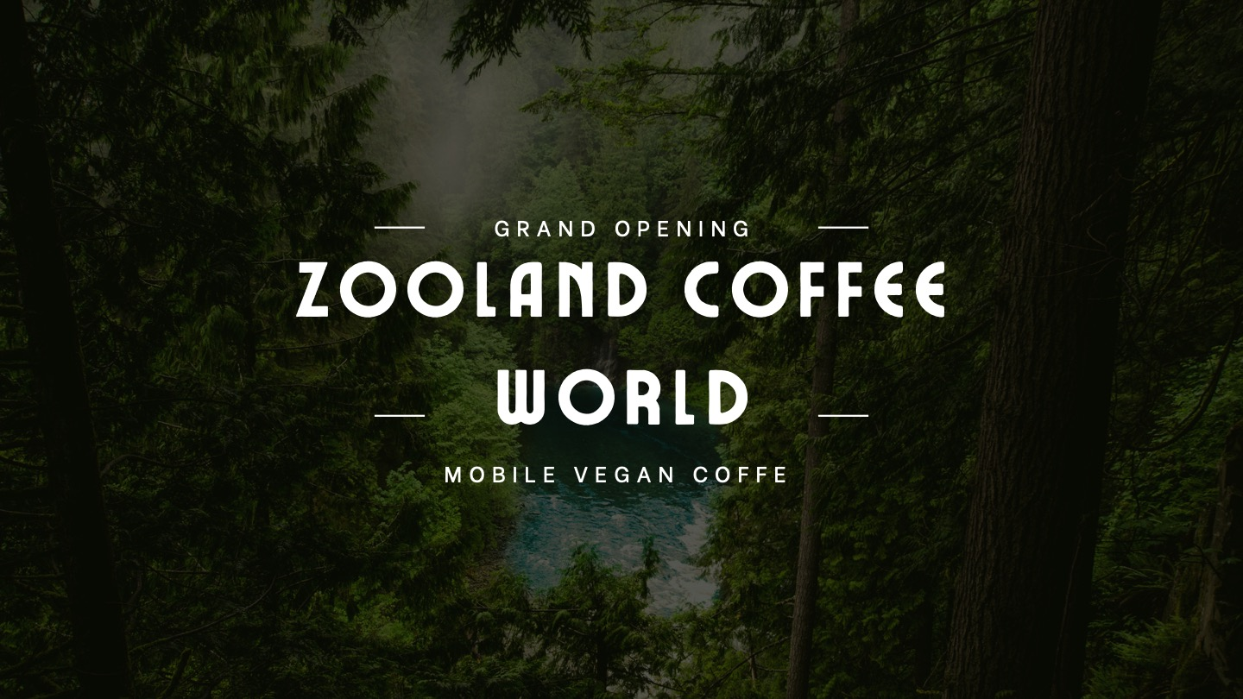
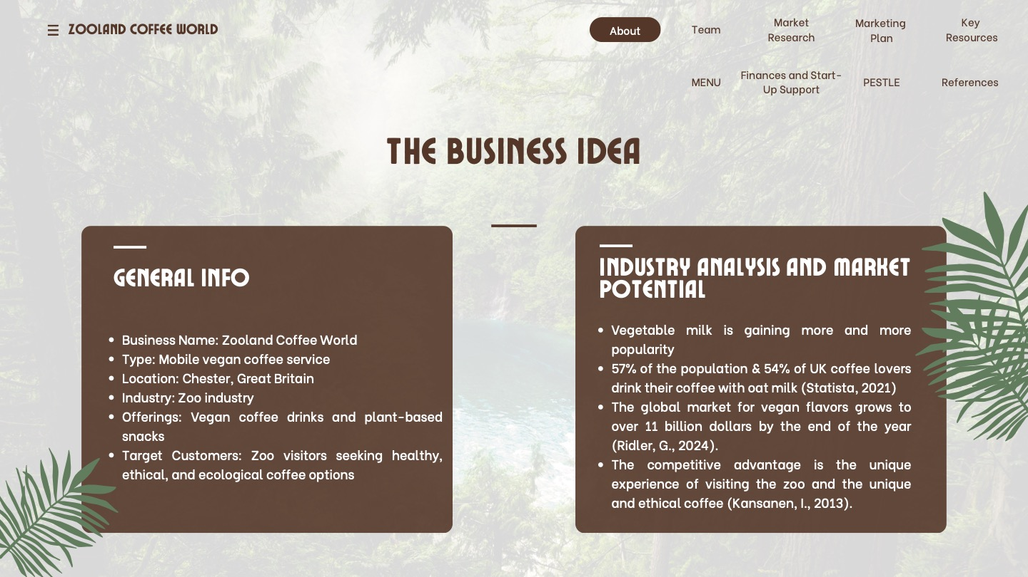
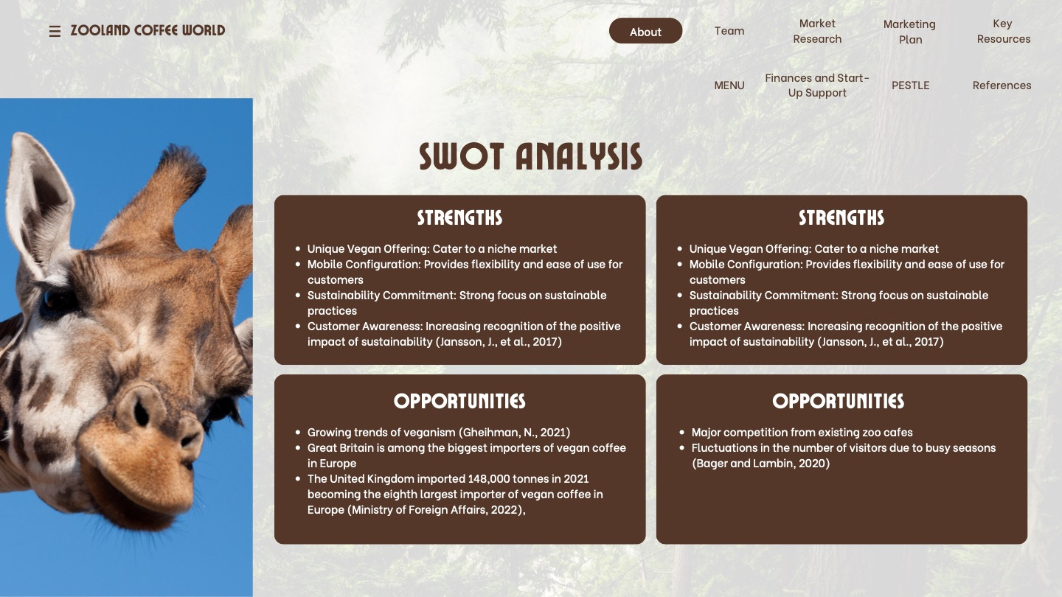
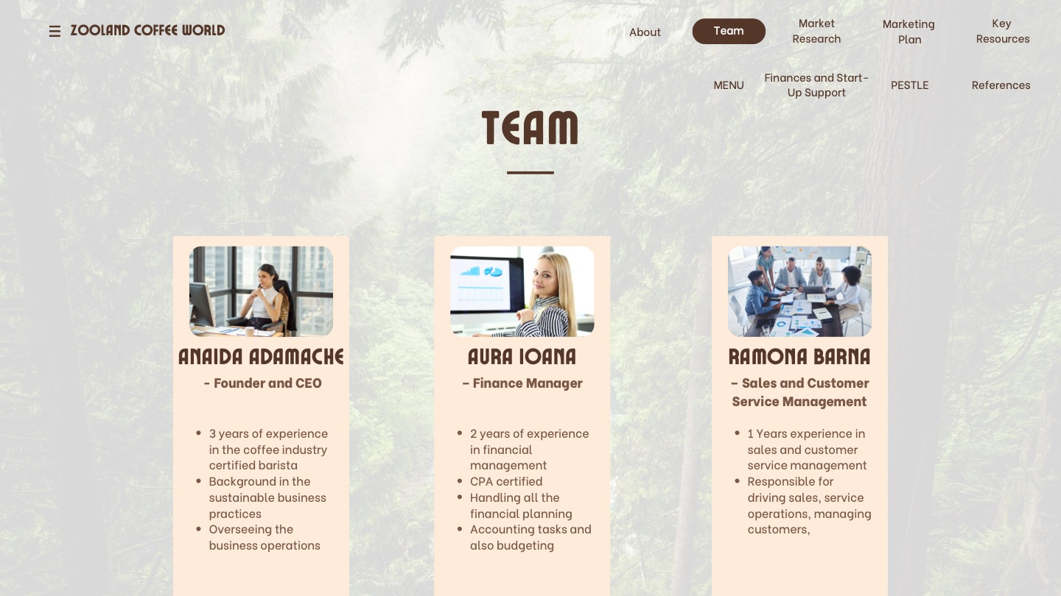
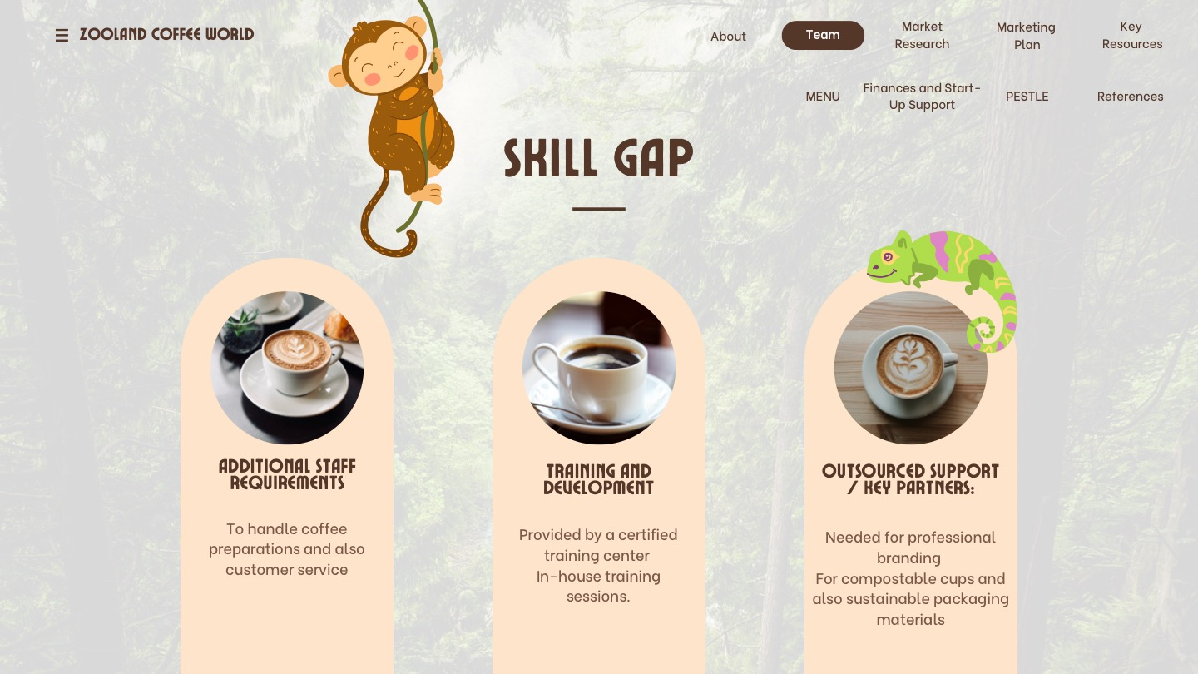
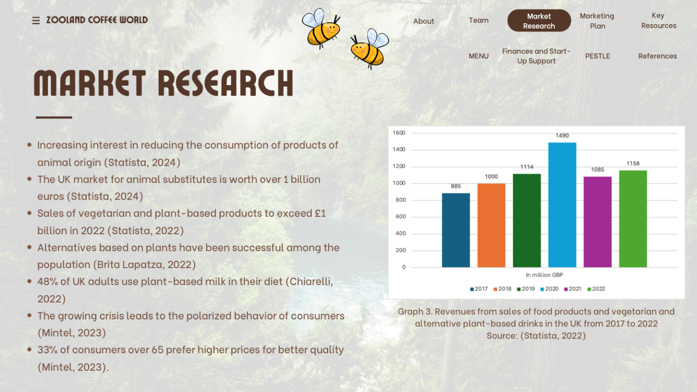
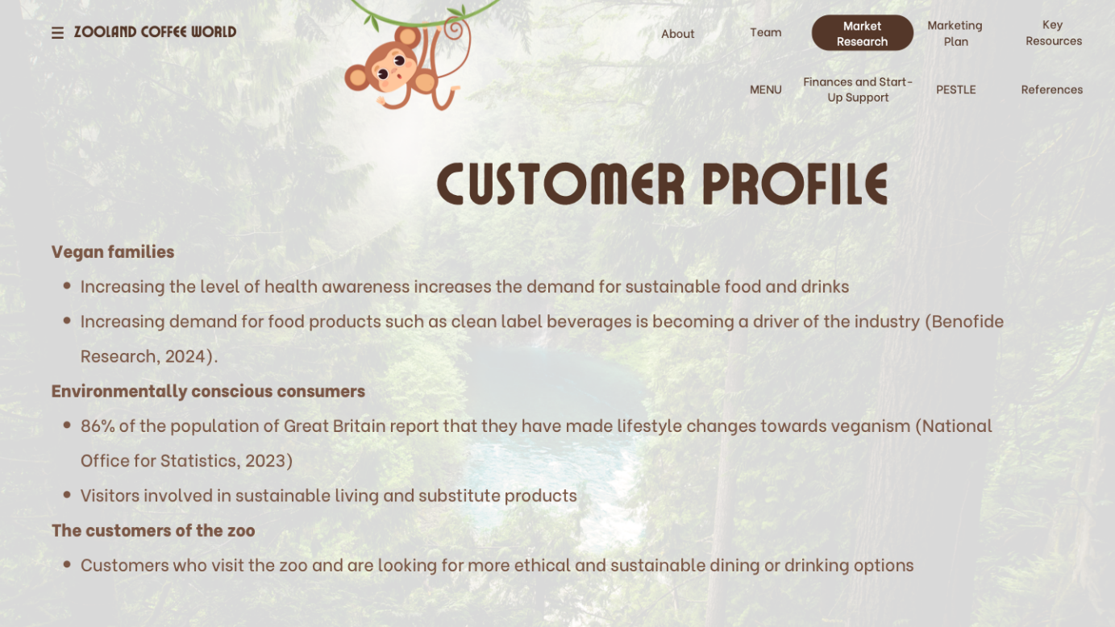
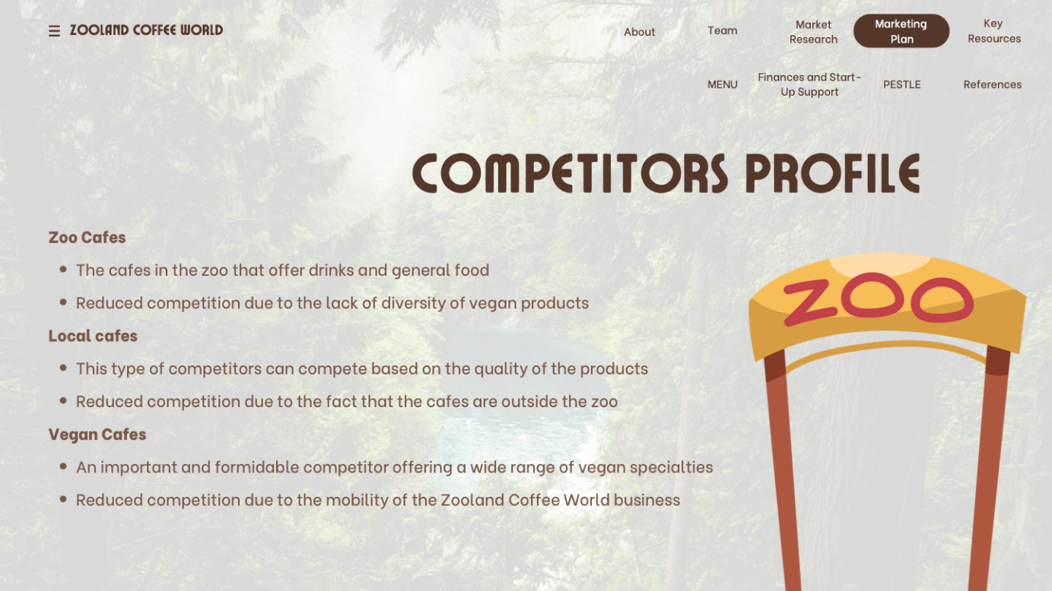
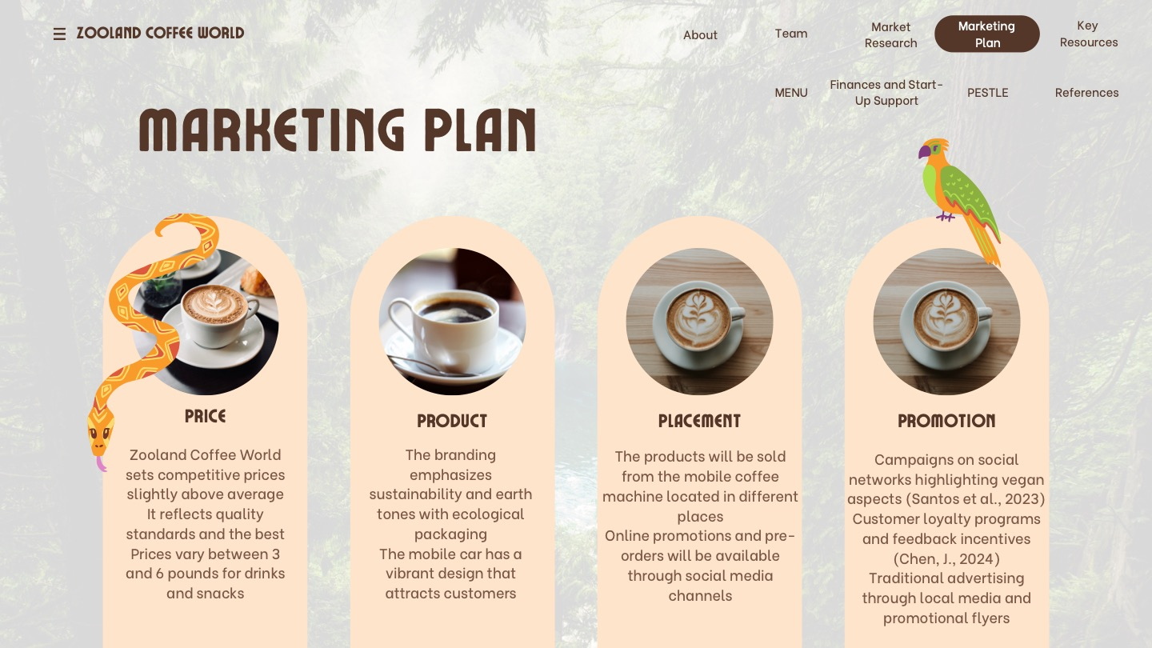
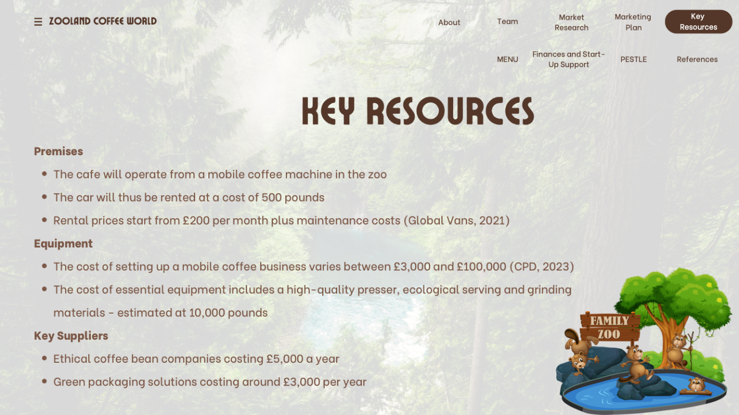
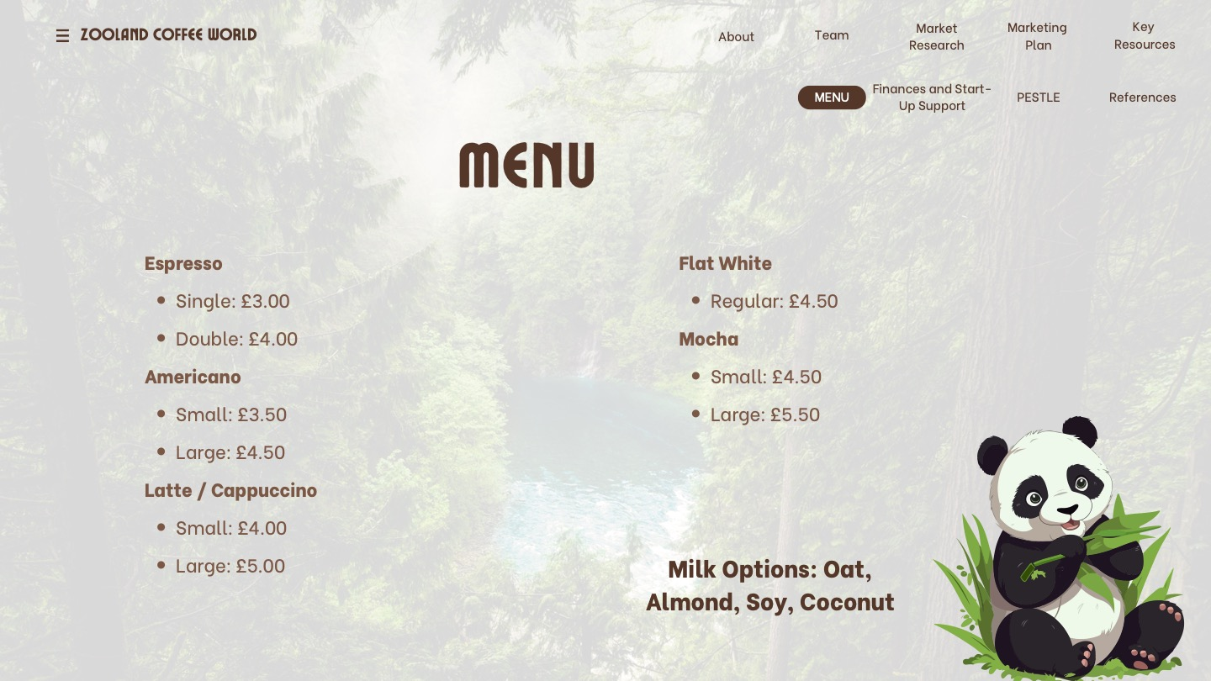
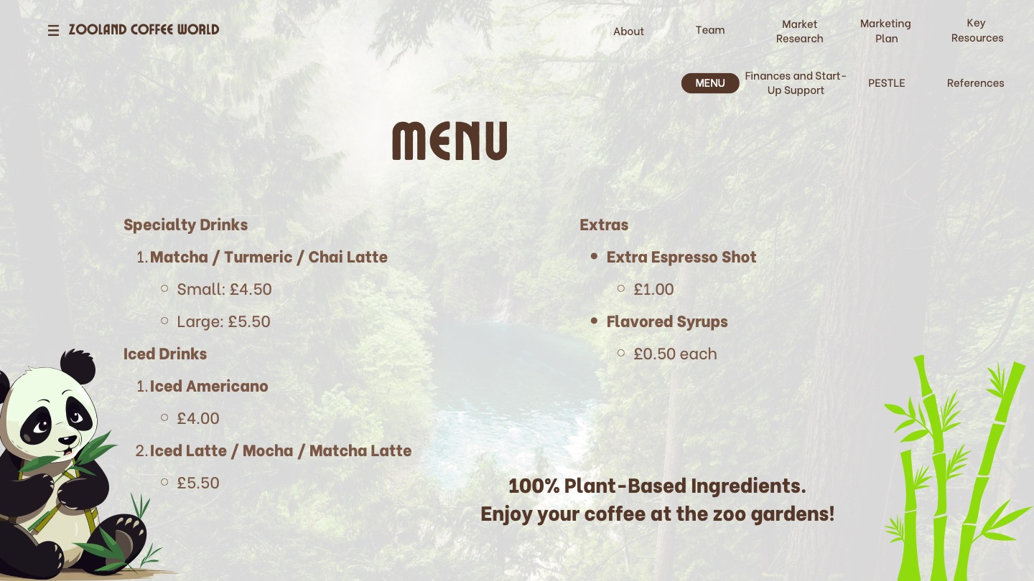
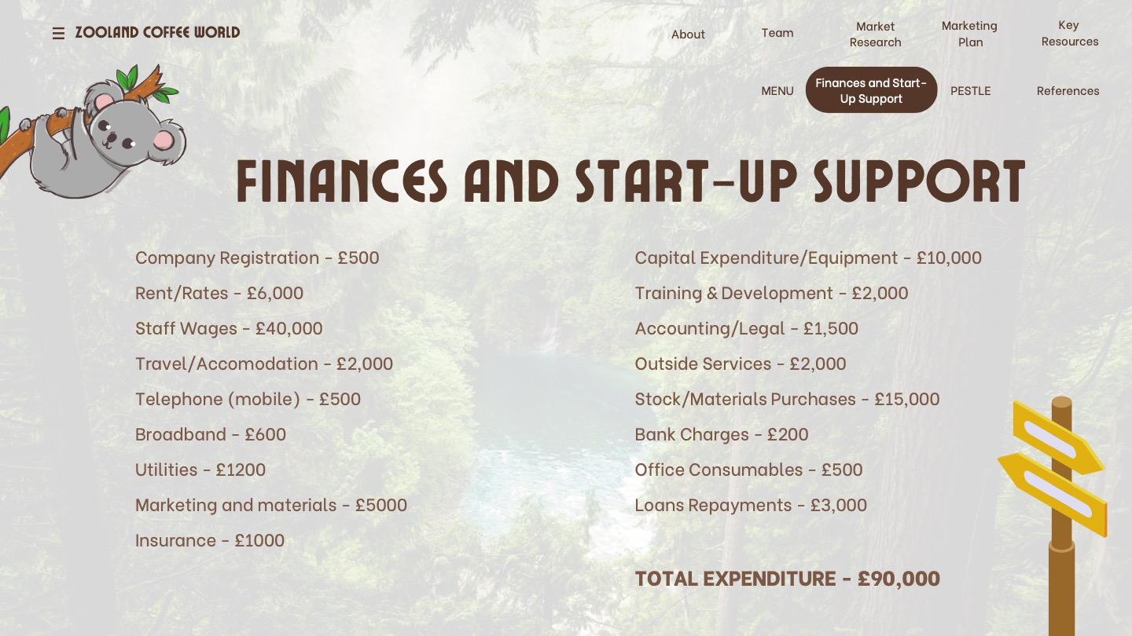
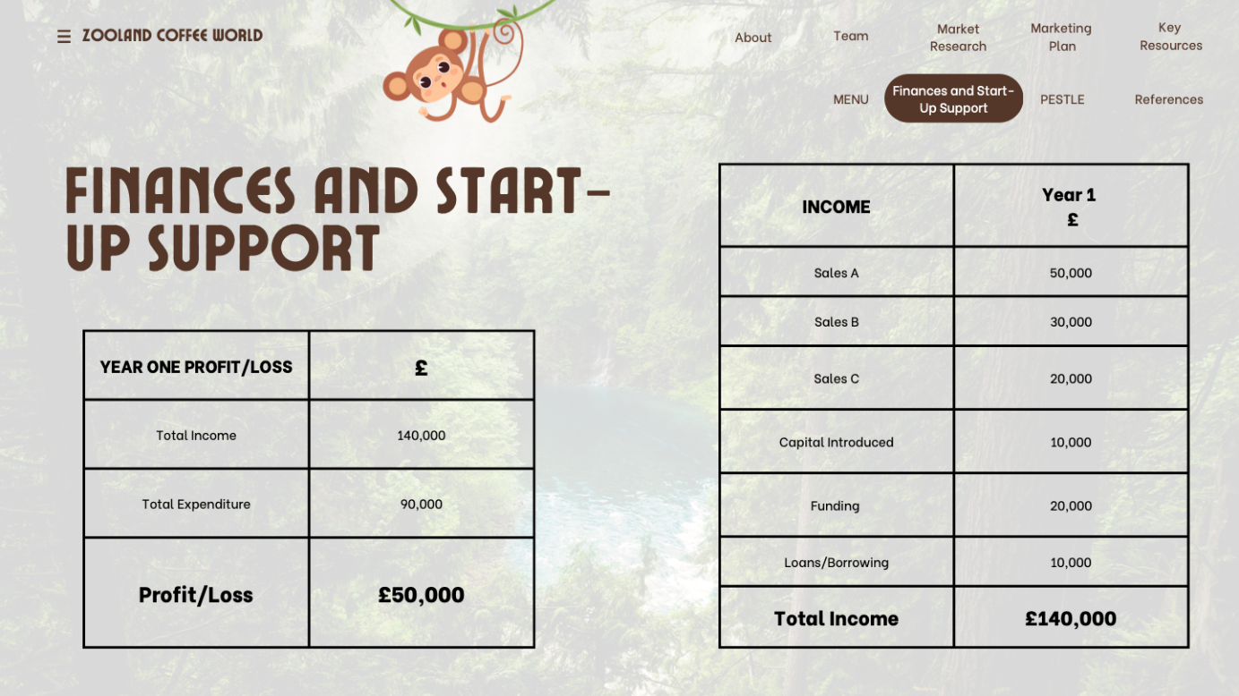

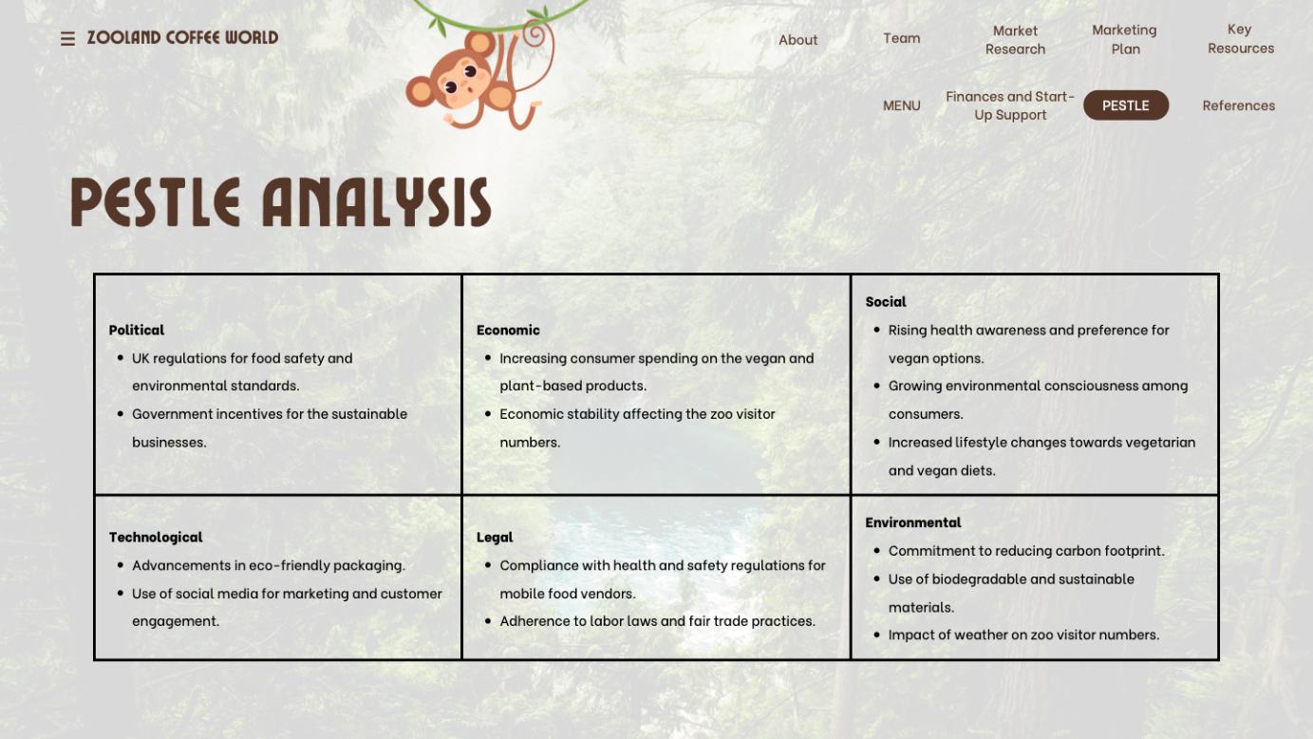

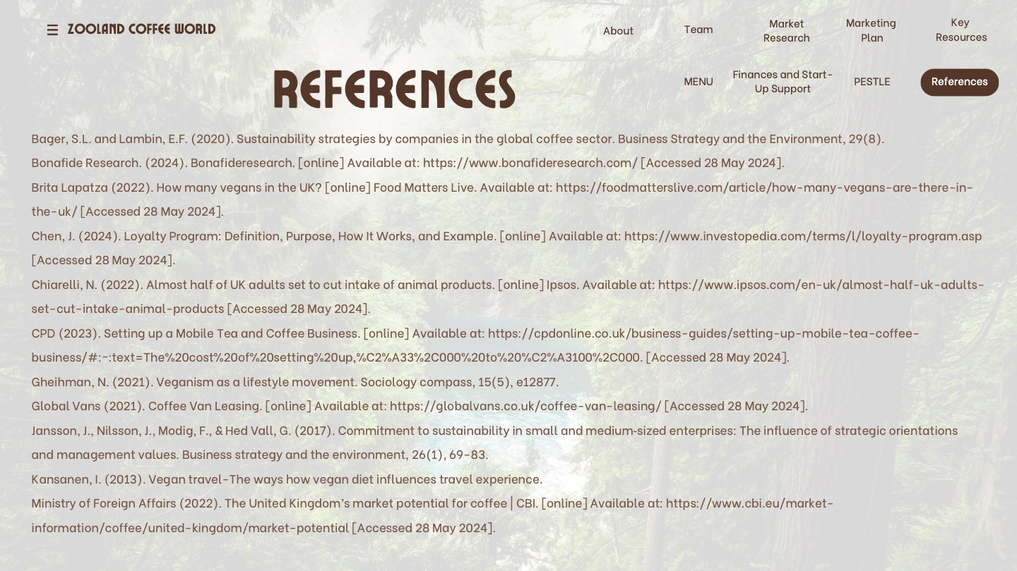
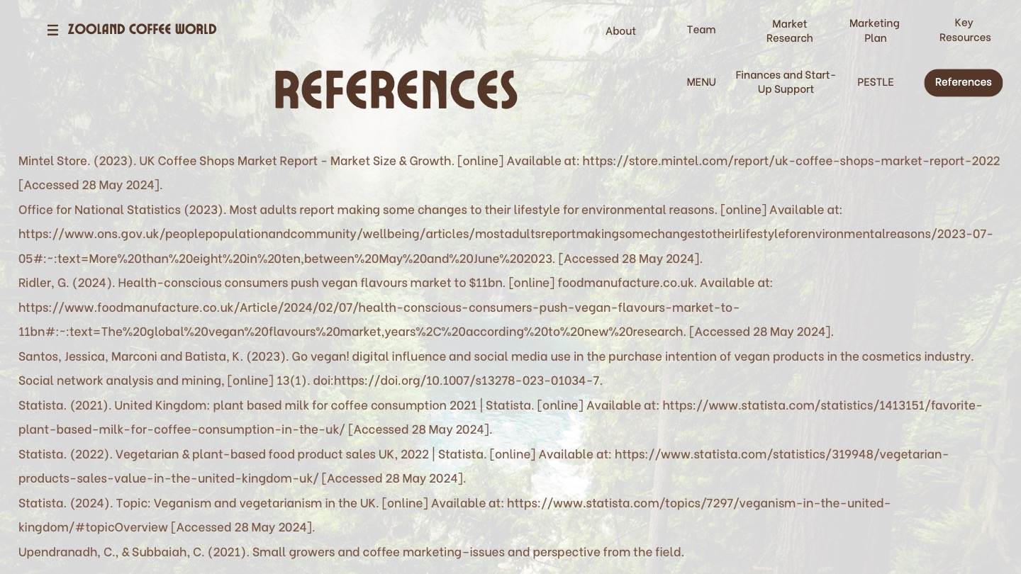

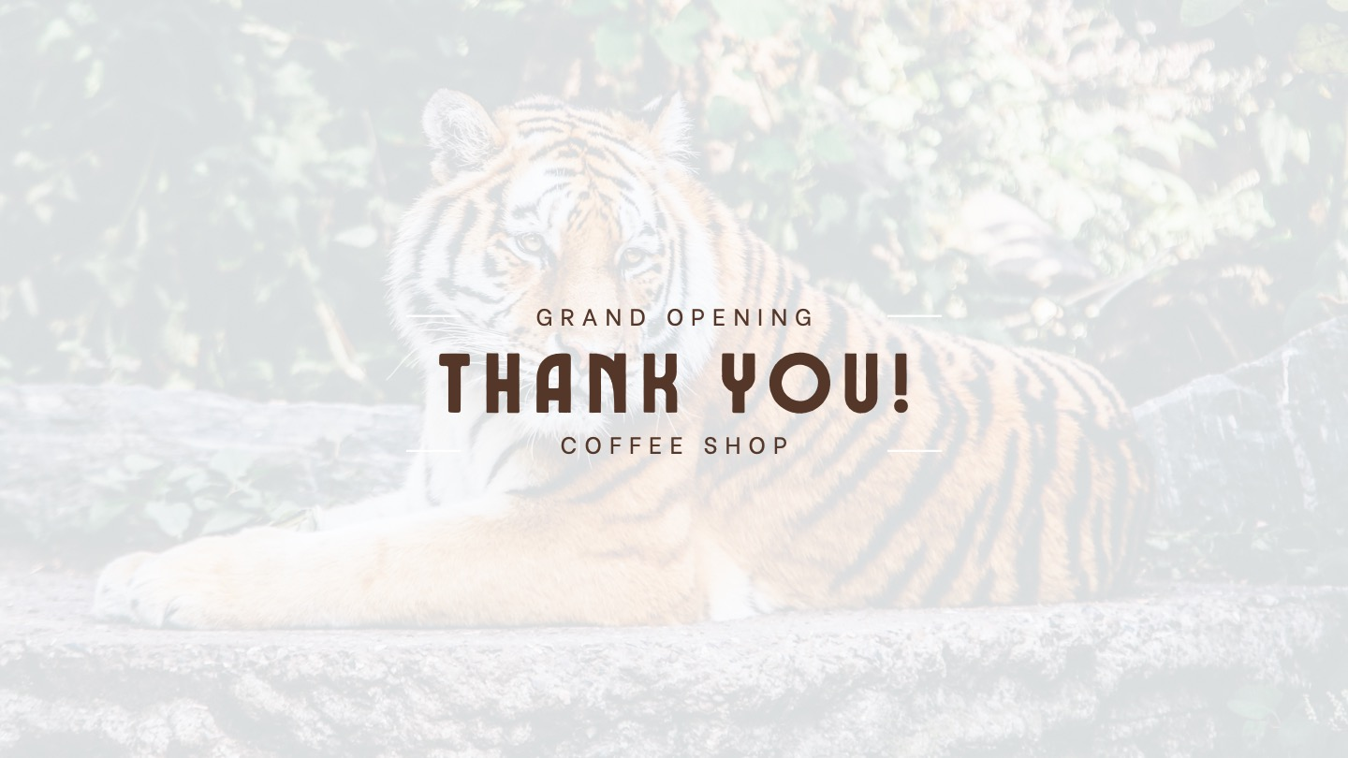

REFERENCE LIST:
Bager, S.L. and Lambin, E.F. (2020). Sustainability strategies by companies in the global coffee sector. Business Strategy and the Environment, 29(8).
Bonafide Research. (2024). Bonafideresearch. [online] Available at: https://www.bonafideresearch.com/ [Accessed 28 May 2024].
Brita Lapatza (2022). How many vegans in the UK? [online] Food Matters Live. Available at: https://foodmatterslive.com/article/how-many-vegans-are-there-in-the-uk/ [Accessed 28 May 2024].
Camper Cafe. (2023). Coffee Van | Mobile Coffee Trucks | Camper Cafe. [online] Available at: https://camper-cafe.co.uk/ [Accessed 30 May 2024].
Chen, J. (2024). Loyalty Program: Definition, Purpose, How It Works, and Example. [online] Available at: https://www.investopedia.com/terms/l/loyalty-program.asp [Accessed 28 May 2024].
Chiarelli, N. (2022). Almost half of UK adults set to cut intake of animal products. [online] Ipsos. Available at: https://www.ipsos.com/en-uk/almost-half-uk-adults-set-cut-intake-animal-products [Accessed 28 May 2024].
CPD (2023). Setting up a Mobile Tea and Coffee Business. [online] Available at: https://cpdonline.co.uk/business-guides/setting-up-mobile-tea-coffee-business/#:~:text=The%20cost%20of%20setting%20up,%C2%A33%2C000%20to%20%C2%A3100%2C000. [Accessed 28 May 2024].
Coffee Blue. (2023). About Us | Coffee Blue: The UK’s Leading Mobile Coffee Franchise. [online] Available at: https://coffeeblue.co.uk/about/ [Accessed 30 May 2024].
Gheihman, N. (2021). Veganism as a lifestyle movement. Sociology compass, 15(5), e12877.
Global Vans (2021). Coffee Van Leasing. [online] Available at: https://globalvans.co.uk/coffee-van-leasing/ [Accessed 28 May 2024].
GloCoffee (2016). Glo Coffee. [online] Available at: https://www.glocoffee.co.uk/ [Accessed 30 May 2024].
Jansson, J., Nilsson, J., Modig, F., & Hed Vall, G. (2017). Commitment to sustainability in small and medium‐sized enterprises: The influence of strategic orientations and management values. Business strategy and the environment, 26(1), 69-83.
Kansanen, I. (2013). Vegan travel-The ways how vegan diet influences travel experience.
Ministry of Foreign Affairs (2022). The United Kingdom’s market potential for coffee | CBI. [online] Available at: https://www.cbi.eu/market-information/coffee/united-kingdom/market-potential [Accessed 28 May 2024].
Mintel Store. (2023). UK Coffee Shops Market Report - Market Size & Growth. [online] Available at: https://store.mintel.com/report/uk-coffee-shops-market-report-2022 [Accessed 28 May 2024].
Office for National Statistics (2023). Most adults report making some changes to their lifestyle for environmental reasons. [online] Available at: https://www.ons.gov.uk/peoplepopulationandcommunity/wellbeing/articles/mostadultsreportmakingsomechangestotheirlifestyleforenvironmentalreasons/2023-07-05#:~:text=More%20than%20eight%20in%20ten,between%20May%20and%20June%202023. [Accessed 28 May 2024].
Ridler, G. (2024). Health-conscious consumers push vegan flavours market to $11bn. [online] foodmanufacture.co.uk. Available at: https://www.foodmanufacture.co.uk/Article/2024/02/07/health-conscious-consumers-push-vegan-flavours-market-to-11bn#:~:text=The%20global%20vegan%20flavours%20market,years%2C%20according%20to%20new%20research. [Accessed 28 May 2024].
Santos, Jessica, Marconi and Batista, K. (2023). Go vegan! digital influence and social media use in the purchase intention of vegan products in the cosmetics industry. Social network analysis and mining, [online] 13(1). doi:https://doi.org/10.1007/s13278-023-01034-7.
Statista. (2021). United Kingdom: plant based milk for coffee consumption 2021 | Statista. [online] Available at: https://www.statista.com/statistics/1413151/favorite-plant-based-milk-for-coffee-consumption-in-the-uk/ [Accessed 28 May 2024].
Statista. (2022). Vegetarian & plant-based food product sales UK, 2022 | Statista. [online] Available at: https://www.statista.com/statistics/319948/vegetarian-products-sales-value-in-the-united-kingdom-uk/ [Accessed 28 May 2024].
Statista. (2024). Topic: Veganism and vegetarianism in the UK. [online] Available at: https://www.statista.com/topics/7297/veganism-in-the-united-kingdom/#topicOverview [Accessed 28 May 2024].
Upendranadh, C., & Subbaiah, C. (2021). Small growers and coffee marketing–issues and perspective from the field.

